1. What is GIT?

Answer: GIT is a version controlling system now what is version controlling system? Well in programming a lot of people work together on a lot of files so for if I am building an application or a program there is going be a bunch of files or folders so if I upload a file on google drive or something like that my friend can access it but if he will work on it it might be overwrite my file. Now that’s where version controlling system comes in having VCS allows us to track what you worked on what your friends are working so we don’t clash with each other VCS is allow us to work together and collaborate in a more efficient manner.

1. What are the differences between GIT and SVN?

Answer: GIT is decentralized. You have a local copy that is a repository in which you can commit. In SVN you have to always connect to a central repository for check in. GIT becomes slow when it deals with large binary files that change frequently. While SVN can handle large binary files easily.

1. Write a command to commit your work in GIT?

Answer: git init

git add .

git commit –m “Commit”

1. Create a repository with your unique roll number in github

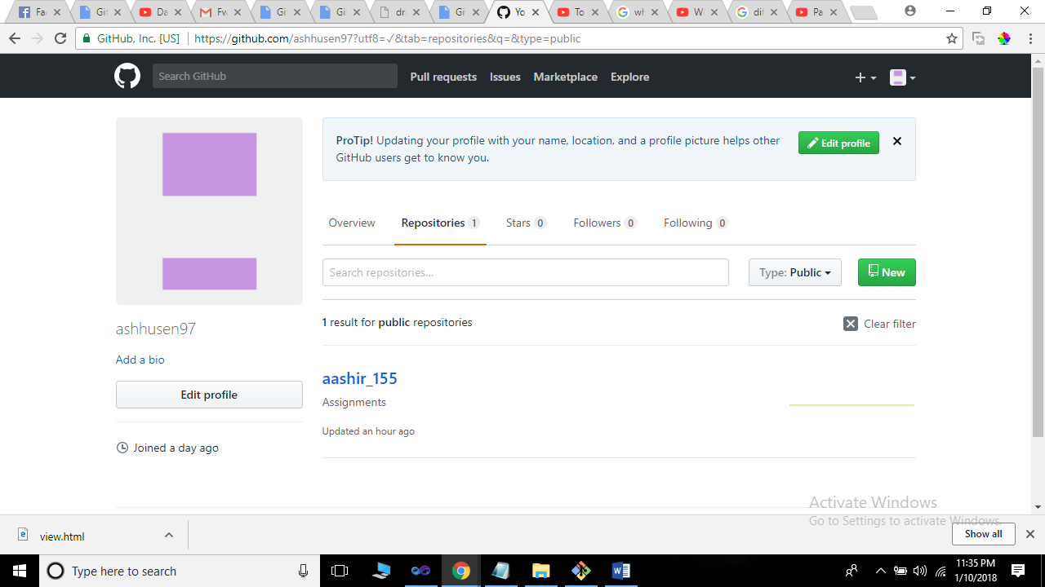

1. What are the advantages of using GIT?

Answer: The main and basic advantage of GIT is that it creates a local repository in our machines so that the data is saved in our local repository for a life time the data will not be deleted or corrupted.

The other advantage is that we can upload our work, programs to Remote from our local repository so it can be accessible anytime or anywhere.

1. What is GIT clone?

Answer: GIT clone is much similar to copy others code like we can download Source code for our program but the basic difference is if we download a code it wont be able to notify if a person will change something in their code but if we clone his code we will always be aware of the changes he will going to do in his program.

1. What is the command to delete branch in GIT?

Answer: git branch –d branch_name (small d for confirmation first).

git branch –D branch_name(delete).

1. Explain the architecture of GIT?

Clone

Git pull

Git push –u origin master

Remote or Master

Local Repository

PC or Laptop

Git init

Git commit

Working copy

1. How to resolve conflicts in GIT?

Answer: by making a team.

1. Name the different vendors of VCS?

Answer:

* GIT HUB
* GIT BUCKET