The Not So Simple Problem of Race and Technology

By Ashi Kamra

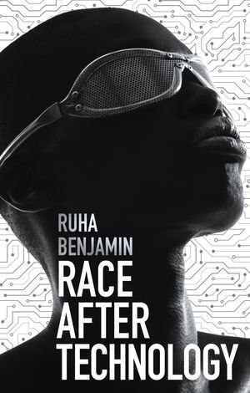

More often than not, the people I encounter don’t know what I am. My fair skin, American mannerisms, and broken Hindi tend to conceal my Indian heritage. Which is exactly why I am eternally grateful to my parents for my name.

Ruha Benjamin, relating names with technology and race puts it like this: “codes, in short, operate within powerful systems of meaning that render some things visible, others invisible, and create a vast array of distortions and dangers.”

Having a South Asian name stands as an immediate stamp of approval on my cultural identity, a social code that holds my family's history within. But, as a computer science major and a young woman born amidst a technological revolution, the resulting distortions and dangers are becoming increasingly clear.

A sociologist and professor of African American studies at Princeton, Benjamin seeks to untangle the non-White experience within a newly digital world – a project that culminates in her 2019 book *Race After Technology.* She traces the phenomena of forced digital visibility and invisibility from America’s history of racial discrimination, specifically the Jim Crow era. Her phrase “New Jim Code'' refers to the continued legacy of the Jim Crow era in a digital world. Now, racial discrimination is being legitimized by supposedly neutral technology. In the lengthy (and I must admit, dense) introduction to the book, Benjamin introduces the concept of race as a technology: a kind of knowledge currently being applied for lucrative purposes. Our race is being used against us by digital products and preserving social hierarchies. In turn, data-driven products use biased data to target marginalized communities and pacify us into submission— a truly cursed cycle.

*Race After Technology* draws on concepts from many spheres of life to guide this analysis. Popular culture, political theory, sociology, and private industry all find their place in the complicated tapestry Benjamin weaves. Guiding an audience through each panel is certainly no easy task, largely because technology has simply become so deeply pervasive. Benjamin’s efforts are not in vain.

The chapter titled “Technological Benevolence” is full of light-bulb inducing statements. Here, Benjamin disproves the widely claimed efficacy of technological solutions to social issues. We are all told the story of how technology is meant to “fix” our problems with each new product– making our lives safer, easier, and more pleasurable. But, the positive connotation associated with innovation must be reconsidered. Benjamin gives the bone-chilling example of Diversity Inc: a company that uses predictive models to take in a person's first and last name and determine their ethnicity to help clients develop targeted advertising campaigns. Diversity Inc even goes so far as to “create” new highly specific ethnicities for companies that would like to reach even smaller subgroups.

Though, because groups like African and Filipino-Americans often have last names historically taken from White colonizers, Diversity Inc uses individuals zip-codes to account for the uncertainty in predicting ethnic background. And therein lies a problem. Innovation is not simply a story of moving forward, past derelict systems; it requires molding the present, a present which was shaped by the (often violent, segregated) past. In this case, racially segregated zip-codes created by Jim Crow era policies like redlining, are used to profit those who want to target these communities in the digital age. Corporations may think they are fixing the problem of a lack of diversity, but we instead see the actualization of “a kind of racial (fix)ation in which those feasting at the table of cultural diversity assume that their own pleasure is shared with those who are being consumed.”

In the years since *Race After Technology* was published, the disproportionate negative impact of technology on marginalized communities has been made more aware to the general public. Whether in the destruction of culturally significant land, blatant racial profiling in biometric scans, or more, the impact of Silicon Valley is known. But Benjamin goes beyond common knowledge, cannonballing into the weeds and pulling at every shrouded intersectionality at play. This sometimes leaves readers biting off more than they can chew. The average reader, not intensely familiar with racial theory or literature, might be left behind trying to untangle Benjamin’s many illuminating sentences. With so many impacts of race on technology, and vice versa, understanding how to move through the word after reading the book is a paralyzing experience.

But, *Race After Technology* is a crucial rude awakening for the tech activists who think the solution is as simple as “diversity.” For tech ethicists yearning for deeper understanding of the forces at play, Ruha Benjamin is the perfect battlecry: that the problem was, is, and ends with us. If you choose to tackle this novel, perhaps have a reference sheet of political and social theory on standby, and get ready for a revelatory and galvanizing experience.

Word Count: 797