**LAB 1**

1.Write a Java program to print "Hello, World!" to the console.

**PROGRAM:**

**package** nDemo;

**public** **class** Hello {

**public** **static** **void** main(String[] args) {

// Printing "Hello world" message in the console

System.***out***.println("Hello world !");

}

}

**OUTPUT:**

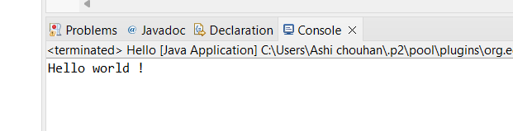

2.Write a program to find the sum of two numbers entered by the user.

**PROGRAM:**

**package** nDemo;

**import** java.util.Scanner;

**public** **class** Sum {

**public** **static** **void** main(String[] args) {

// Scanner object

Scanner sc = **new** Scanner(System.***in***);

System.***out***.println("Enter int a : ");

// Input from user of integer a

**int** a = sc.nextInt();

// Input from user of integer b

System.***out***.println("Enter int b : ");

**int** b = sc.nextInt();

sc.close();

// Calculating sum of a and b

**int** result = a + b;

// Printing result

System.***out***.println("The sum of a and b is : " + result);

}

}

**OUTPUT:**

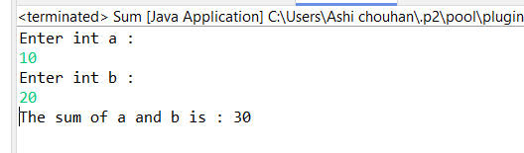

3.Write a Java program to check whether a given number is even or odd.

**PROGRAM:**

**package** NDemo;

**import** java.util.Scanner;

**public** **class** EvenOdd {

**public** **static** **void** main(String[] args) {

Scanner sc = **new** Scanner(System.***in***);

System.***out***.println("Enter int a : ");

**double** a = sc.nextDouble();

**if**( a % 2 == 0 ) {

System.***out***.println("The given number a is even.");

}

**else** {

System.***out***.println("The given number a is odd.");

}

}

}

**OUTPUT:**

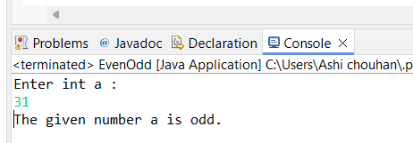

4.Write a java program to find greatest of 3 numbers.

**PROGRAM:**

**package** nDemo;

**import** java.util.Scanner;

**public** **class** greatestOfThreeNumber {

**public** **static** **void** main(String[] args) {

// Scanner object to take input

Scanner sc = **new** Scanner(System.***in***);

System.***out***.println("Enter integer a : ");

**int** a = sc.nextInt();

System.***out***.println("Enter integer b : ");

**int** b = sc.nextInt();

System.***out***.println("Enter integer c : ");

**int** c = sc.nextInt();

// closing scanner object

sc.close();

// If condition to check the greatest number

**if**(a > b && a > b ) {

System.***out***.println(a + " is the Greatest Number. ");

} **else** **if** ( b > a && b > c) {

System.***out***.println(b + " is the Greatest Number. ");

} **else** {

System.***out***.println(c + " is the Greatest Number. ");

}

}

}

**OUTPUT:**

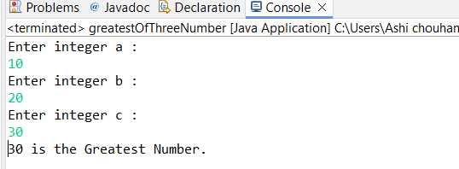

5.Write a program to implement a basic calculator that takes input and evaluates it.

**PROGRAM:**

**package** nDemo;

// Class containing calculator methods

**class** calculatorMethods {

// Add method

**public** **int** add( **int** x, **int** y) {

**return** x + y;

}

// Subtraction method

**public** **int** sub( **int** x, **int** y) {

**return** x - y;

}

// Division method

**public** **int** div( **int** x, **int** y) {

**return** x / y;

}

// Multiplication method

**public** **int** product( **int** x, **int** y) {

**return** x * y;

}

}

**public** **class** Calculator {

**public** **static** **void** main(String[] args) {

// Taking 2 integer values a and b

**int** a = 10;

**int** b = 2;

// creating object of class "calculatorMethods"

calculatorMethods cm = **new** calculatorMethods();

// Printing evaluated values

System.***out***.println("The addition is : " + cm.add(a, b));

System.***out***.println("The subtraction is : " + cm.sub(a, b));

System.***out***.println("The division is : " + cm.div(a, b));

System.***out***.println("The multiplication is : " + cm.product(a, b));

}

}

**OUTPUT:**

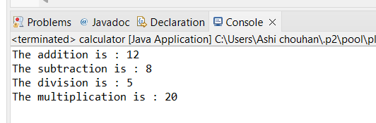

6.Write a Java program to check if a given number is prime or not.

**PROGRAM:**

**package** nDemo;

**import** java.util.Scanner;

**public** **class** PrimeNumberChecker {

**public** **static** **void** main(String[] args) {

// Creating a Scanner object for user input

Scanner scanner = **new** Scanner(System.***in***);

System.***out***.print("Enter a number to check if it is prime: ");

**int** number = scanner.nextInt();

// Closing the scanner

scanner.close();

// Initiating boolean value for prime number as true

**boolean** isPrime = **true**;

// Method to check if entered number is prime or not

**if** (number <= 1) {

isPrime = **false**;

} **else** {

**for** (**int** i = 2; i < number; i++) {

**if** (number % i == 0) {

isPrime = **false**;

**break**;

}

}

}

// Displaying the result

**if** (isPrime) {

System.***out***.println(number + " is a prime number.");

} **else** {

System.***out***.println(number + " is not a prime number.");

}

}

}

**OUTPUT:**

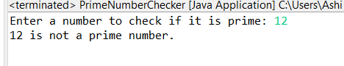

7.Create a Java program that compares two numbers and prints the larger one.

**PROGRAM:**

**package** nDemo;

**import** java.util.Scanner;

**public** **class** GreaterNumber {

**public** **static** **void** main(String[] args) {

// Scanner object

Scanner sc = **new** Scanner(System.***in***);

// Taking integer input for a and b

System.***out***.println("Enter int a : ");

**int** a = sc.nextInt();

System.***out***.println("Enter int b : ");

**int** b = sc.nextInt();

// Closing scanner object

sc.close();

// Declaring result variable

**int** result;

**if** ( a > b ) {

result = a;

System.***out***.println("a is greater than b.");

System.***out***.println("Greater Number is : " + result);

}

**else** **if** ( b > a ){

result = b;

System.***out***.println("b is greater than a.");

System.***out***.println("Greater Number is : " + result);

}

**else** {

System.***out***.println("a is equal to b.");

}

}

}

**OUTPUT:**

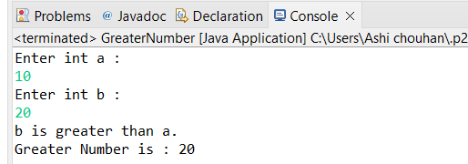

8.Write a Java program that takes an age input from the user and determines if they are eligible to vote (considering the legal voting age).

**PROGRAM:**

**package** nDemo;

**import** java.util.Scanner;

// Eligibility checker class

**class** votingEligibility {

**public** **void** elegibility(**int** age) {

**if** (age < 100 ) {

**if** ( age < 18 ) {

System.***out***.println("Not Eligible !");

}

**else** **if** ( age >= 18 ) {

System.***out***.println("Eligible !");

}

}

**else** {

System.***out***.println("Invalid age !");

}

}

}

**public** **class** VotingAge {

**public** **static** **void** main(String[] args) {

// Scanner object

Scanner sc = **new** Scanner(System.***in***);

System.***out***.println("Enter your age to check if you are eligible to vote : ");

// Age input

**int** age = sc.nextInt();

sc.close();

// "votingElibility" class object

votingEligibility ve = **new** votingEligibility();

// Calling elegibility() function from "votingEligibility" class using object.

ve.elegibility(age);

}

}

**OUTPUT:**

