**LAB 2**

**Solve following questions:**

1.     Write a program that takes a student's score as input and outputs the corresponding grade based on the following scale:

A: 90-100

B: 80-89

C: 70-79

D: 60-69

F: 0-59

**PROGRAM:**

**package** nDemo;

**import** java.util.Scanner;

**public** **class** examResult {

**public** **static** **void** main(String[] args) {

Scanner sc = **new** Scanner(System.***in***);

System.***out***.println("Enter Your Score : ");

**int** examScore = sc.nextInt();

sc.close();

String grade;

// if statement to check if the entered score is invalid

**if** (examScore < 0 || examScore > 100) {

System.***out***.println("Invalid score entered. Please enter a value between 0 and 100.");

} **else** {

// Switch statement to evaluate marks in grades

**switch** (examScore / 10) {

**case** 10: // This will handle the case when score is 100

**case** 9:

grade = "A";

**break**;

**case** 8:

grade = "B";

**break**;

**case** 7:

grade = "C";

**break**;

**case** 6:

grade = "D";

**break**;

**default**:

grade = "F";

**break**;

}

// Printing the grade

System.***out***.println("The grade is: " + grade);

}

}

}

**OUTPUT:**

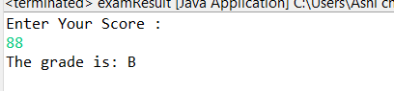

2.     Write a program to check if a given year is a leap year. (A year is a leap year if it is divisible by 4 but not by 100, or it is divisible by 400.)

**PROGRAM:**

**package** nDemo;

**import** java.util.Scanner;

**public** **class** LeapYear {

**public** **static** **void** main(String[] args) {

Scanner sc = **new** Scanner(System.***in***);

System.***out***.println("Enter year : ");

**int** year = sc.nextInt();

sc.close();

// If statement to check if entered year is divisible by 100 and 400 or not

// If the year is divisible by 100 and 400 then it is not a leap year

**if** ( (year % 100 != 0) && (year % 400 != 0) ) {

**if** ( year % 4 == 0 ) {

System.***out***.println("Leap Year !!!...");

}

}

**else** {

System.***out***.println("Not a Leap Year !");

}

}

}

**OUTPUT:**

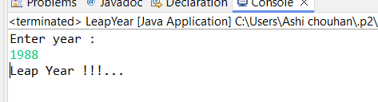

3.     Write a program that takes an integer as input and checks if it is positive, negative, or zero.

**PROGRAM:**

**package** nDemo;

**import** java.util.Scanner;

**class** IntegerType {

**public** **void** typeIdentifier (**int** num ) {

// If-else to check if a number is positive , Negative or Zero

**if** ( num > 0 ) {

System.***out***.println("Positive !!! ");

}

**else** **if** ( num < 0 ) {

System.***out***.println("Negative !!!");

}

**else** {

System.***out***.println("Zero !!!");

}

}

}

**public** **class** PositiveNegativeInteger {

**public** **static** **void** main(String[] args) {

Scanner sc = **new** Scanner(System.***in***);

// Taking integer input from user

System.***out***.println("Enter an Integer : ");

**int** num = sc.nextInt();

sc.close();

// IntegerType class object

IntegerType result = **new** IntegerType();

result.typeIdentifier(num);

}

}

**OUTPUT:**

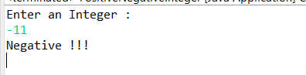

4.     Write a program that prints numbers from 1 to 10 using a loop.

**PROGRAM:**

**package** nDemo;

**public** **class** forLoopDemo {

**public** **static** **void** main(String[] args) {

**int** num = 1;

// For loop to print 1-10 integer

**for**(num = 1 ; num <= 10 ; num++ ) {

System.***out***.println(num);

}

}

}

**OUTPUT:**

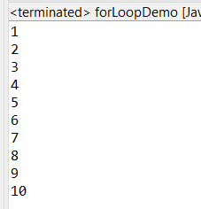

5.     Write a program that takes an integer N as input and calculates the sum of entered numbers.

**PROGRAM:**

**package** nDemo;

**import** java.util.Scanner;

**public** **class** sumOfEnteredNumber {

**public** **static** **void** main(String[] args) {

Scanner sc = **new** Scanner(System.***in***);

// Taking user input for length of integer

System.***out***.print("Enter the number of integers you want to sum: ");

**int** N = sc.nextInt();

**int** i = 0;

**int** result = 0;

// for loop to iterate the length if the integer

**for**(i = 0 ; i < N ; i++ ) {

**if**(i < N ) {

System.***out***.println("Enter the " + (i + 1) + " : ");

// Taking user input for integer

**int** num = sc.nextInt();

result += num;

}

**else** {

System.***out***.println("Enter valid integer of same length as entered before !");

}

}

System.***out***.println("The sum is : " + result);

sc.close();

}

}

**OUTPUT:**

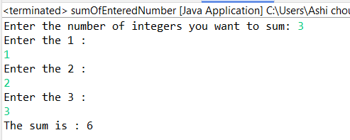

6.     Write a program that takes an integer as input and prints its multiplication table up to 10.

**PROGRAM:**

**package** nDemo;

**import** java.util.Scanner;

**public** **class** MultiplicationTable {

**public** **static** **void** main(String[] args) {

Scanner sc = **new** Scanner(System.***in***);

// Taking user input for integer

System.***out***.println("Enter the integer to print its multiplication table :");

**int** num = sc.nextInt();

// For loop to print multiplication table

**for**(**int** i = 1 ; i <= 10 ; i++ ) {

System.***out***.println(num + " x " + i + " = " + (num * i));

}

}

}

**OUTPUT:**

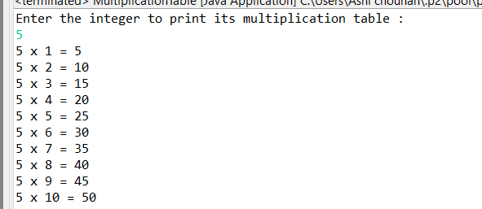

7.     Write a program that takes a positive integer as input and prints its digits in reverse order.

**PROGRAM:**

**package** nDemo;

**import** java.util.Scanner;

**public** **class** ReverseDigits {

**public** **static** **int** reverseDigits(**int** number) {

**int** reversedNumber = 0;

// WHile loop to check if the entered number is not 0.

**while** (number != 0) {

// Removing the unit place digit of number

**int** digit = number % 10;

// Storing unit place in reverseNumber

reversedNumber = reversedNumber * 10 + digit;

// Now the number is divided by 10 and stored in number variable

number /= 10;

}

**return** reversedNumber;

}

**public** **static** **void** main(String[] args) {

Scanner scanner = **new** Scanner(System.***in***);

// Taking user input

System.***out***.print("Enter a positive integer: ");

**int** userInput = scanner.nextInt();

// Print warning statement if entered invalid integer

**if** (userInput < 0) {

System.***out***.println("Enter a positive integer !");

} **else** {

// Function call

**int** reversedNumber = *reverseDigits*(userInput);

System.***out***.println("Reversed number: " + reversedNumber);

}

scanner.close();

}

}

**OUTPUT:**

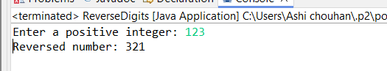

8.     Create a class Animal with a method makeSound() that prints "Some generic animal sound". Create another class Dog that extends Animal and overrides the makeSound() method to print "Bark". Write a main method to demonstrate calling the makeSound() method on an Animal reference holding a Dog object.

**PROGRAM:**

**package** nDemo;

**class** Animal {

// makeSound() function of Animal class

**void** makeSound() {

System.***out***.println("Some generic animal sound");

}

}

**class** Dog **extends** Animal {

// makeSound() function of Dog class

**void** makeSound() {

System.***out***.println("Bark");

}

}

**public** **class** MainAnimal {

**public** **static** **void** main(String[] args) {

// Creating object of Dog class

Dog d1 = **new** Dog();

// Calling makeSound() function in Dog class

d1.makeSound();

}

}

**OUTPUT:**

