**LAB 5**

1. **Write a Java program that reads a string from the user and uses StringTokenizer to split the string into individual words. Print each word on a new line.**

**PROGRAM:**

**package** Lab5;

**import** java.util.Scanner;

// Import StringTokenizer from java.util

**import** java.util.StringTokenizer;

**public** **class** TokenizerWords {

**public** **static** **void** main(String[] args) {

// Scanner object to take string input

Scanner sc1 = **new** Scanner(System.***in***);

System.***out***.println("Enter a string: ");

String str1 = sc1.nextLine();

// StringTokenizer object to define string and delimiter

StringTokenizer st = **new** StringTokenizer(str1," ");

// Loop to iterate through string if it has more than one tokens

**while** (st.hasMoreTokens()) {

// printing tokens or words in the array

System.***out***.println(st.nextToken());

}

sc1.close();

}

}

**OUTPUT:**

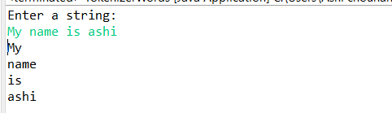

1. **Write a Java program that reads a string from the user and uses StringTokenizer to count the number of words in the string.**

**PROGRAM:**

**package** Lab5;

**import** java.util.Scanner;

// Import StringTokenizer from java.util

**import** java.util.StringTokenizer;

**public** **class** TokenizerNumberOfWords {

**public** **static** **void** main(String[] args) {

// Scanner object to take string input

Scanner sc1 = **new** Scanner(System.***in***);

System.***out***.println("Enter a string: ");

String str1 = sc1.nextLine();

**int** count = 0;

// StringTokenizer object to define string and delimiter

StringTokenizer st = **new** StringTokenizer(str1," ");

// Loop to iterate through string if it has more than one tokens

**while** (st.hasMoreTokens()) {

// Split string into tokens

st.nextToken();

count++;

}

System.***out***.println("The number of words is : " +count);

sc1.close();

}

}

**OUTPUT:**

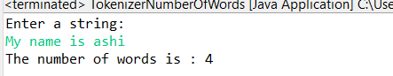

1. **Write a Java program to create a LinkedList of strings, add elements at specific positions (beginning, middle, end), and print the list.**

**PROGRAM:**

**package** Lab5;

**import** java.util.LinkedList; // Importing LinkedList CLass

**public** **class** StringLinkedList {

**public** **static** **void** main(String[] args) {

// Creating LinkedList object of String type to store animal names

LinkedList<String> animalLL = **new** LinkedList<String>();

// Adding animal names in the LinkedList

animalLL.add("dog");

animalLL.add("cat");

animalLL.add("horse");

animalLL.add("sheep");

animalLL.add("cow");

animalLL.add("mouse");

// Printing the initial LinkedList

System.***out***.println("Animal name string LinkedList : \n" + animalLL);

// Adding at first

animalLL.addFirst("monkey");

// Printing LinkedList After adding an element at first

System.***out***.println("Animal LinkedList after adding at first position: \n" + animalLL);

// To add element in the middle

// Storing size of LinkedList in a variable

**int** s = animalLL.size();

// If the size of LinkedList is even then add element after the half of the LinkedList size

// Else add element at the middle element

**if** (s%2==0) {

animalLL.add(((s/2)+1), "parrot");

} **else** {

animalLL.add((s+1)/2, "peacock");

}

System.***out***.println("Animal LinkedList after adding at middle : \n " + animalLL);

// To add element at last

animalLL.addLast("whale");

// Printing after adding element at last

System.***out***.println("Animal LinkedList after adding at last position: \n" + animalLL);

}

}

**OUTPUT:**

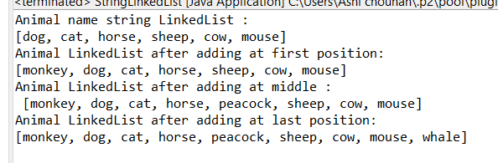

1. **Write a Java program to sort a given array list.**

**PROGRAM:**

**package** Lab5;

**import** java.util.Arrays;

**import** java.util.Collections;

**public** **class** ArraySortDemo {

**public** **static** **void** main(String[] args) {

Integer age[] = {10, 2, 7, 45, 30};

String name[] = {"ashi", "aryan", "suhani", "dinesh", "rajesh"};

// Descending order sorting

Arrays.*sort*(age, Collections.*reverseOrder*());

Arrays.*sort*(name, Collections.*reverseOrder*());

System.***out***.println("Age array sorted in descending order : ");

System.***out***.println(Arrays.*toString*(age));

System.***out***.println("Name array sorted in descending order : ");

System.***out***.println(Arrays.*toString*(name));

System.***out***.println();

// Integers - Ascending order

**int** num1[] = {8, 4, 3,5,6};

**int** num2[] = {10, 7, 9, 13, 17 };

Arrays.*sort*(num1);

Arrays.*sort*(num2);

System.***out***.println("num1 array sorted in descending order : ");

System.***out***.println(Arrays.*toString*(num1));

System.***out***.println("num2 array sorted in descending order : ");

System.***out***.println(Arrays.*toString*(num2));

// String - ascending order

String str1[] = {"C", "O", "I", "P", "U"};

String str2[] = {"E", "H", "G", "A", "C"};

Arrays.*sort*(str1);

Arrays.*sort*(str2);

System.***out***.println("str1 array sorted in ascending order : ");

System.***out***.println(Arrays.*toString*(str1));

System.***out***.println("str2 array sorted in ascending order : ");

System.***out***.println(Arrays.*toString*(str2));

}

}

**OUTPUT:**

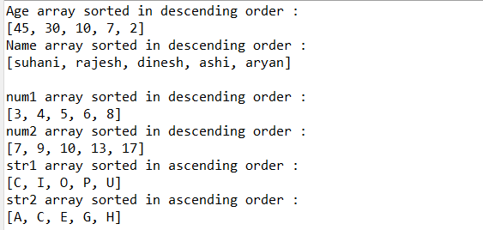

1. **Write a Java program to replace the second element of an ArrayList with the specified element.**

**PROGRAM:**

**package** Lab5;

**import** java.util.*; // Importing util and all its packages

**public** **class** ArrayListReplaceDemo {

**public** **static** **void** main(String[] args) {

// Creating an arrayList object of List Interface class ArrayList

List<Integer> arrList = **new** ArrayList<Integer>();

// Adding elements in the arrayList

arrList.add(10);

arrList.add(20);

arrList.add(40);

arrList.add(55);

arrList.add(20);

arrList.add(100);

arrList.add(34);

// Printing the arrayList

System.***out***.println("ArrayList : " + arrList);

// Replacing the element at index 2 with value 500

arrList.set(2, 500);

// Printing array after replacement

System.***out***.println("ArrayList after replaicng element at index 2: " + arrList);

}

}

**OUTPUT:**

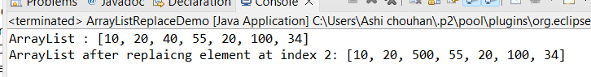

1. **Write a Java program to iterate a linked list in reverse order.**

**PROGRAM:**

**package** Lab5;

**import** java.util.Collections; // Importing Collections Superclass

**import** java.util.LinkedList; // Importing LinkedList class

**public** **class** LinkedListReverseOrder {

**public** **static** **void** main(String[] args) {

// Creating a LinkedList of string type for storing names of students

LinkedList<String> studLinkedList = **new** LinkedList<String>();

// Adding student names in the LinkedList studLinkedList

studLinkedList.add("ashi");

studLinkedList.add("aryan");

studLinkedList.add("suhani");

studLinkedList.add("ranjesh");

studLinkedList.add("dinesh");

studLinkedList.add("nikhil");

studLinkedList.add("adit");

studLinkedList.add("saroj");

// Printing the linkedList

System.***out***.println("Students LinkedList : " + studLinkedList);

// Sorting the linkedLIst in Reverse order

Collections.*sort*(studLinkedList, Collections.*reverseOrder*());

// Printing LinkedList after sorting in reverse order

System.***out***.println("Students LinkedList in reverse order : " + studLinkedList);

}

}

**OUTPUT:**



1. **Write a Java program to retrieve, but not remove, the last element of a linked list.**

**PROGRAM:**

**package** Lab5;

**import** java.util.LinkedList; // Importing LinkedList class

**public** **class** retrieveLastLinkedList {

**public** **static** **void** main(String[] args) {

// Creating LinkedList Object of integer type

LinkedList<Integer> intLL = **new** LinkedList<Integer>();

// Adding elements in the LinkedList

intLL.add(2);

intLL.add(5);

intLL.add(1);

intLL.add(7);

intLL.add(8);

intLL.add(9);

// Printing the initial linkedList

System.***out***.println("Integer LinkedList : " + intLL);

// Removing the last element From the LinkedList

intLL.removeLast();

// Printing the LinkedList after removing last Element

System.***out***.println("Integer LinkedList after removing Last element : " + intLL);

}

}

**OUTPUT:**

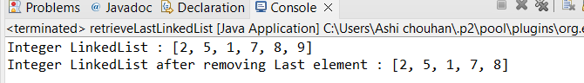

1. **Write a Java program to create a LinkedList of integers and print all the elements.**

**PROGRAM:**

**package** Lab5;

**import** java.util.LinkedList; // Importing LinkedList class

**public** **class** IntegerLinkedList {

**public** **static** **void** main(String[] args) {

LinkedList<Integer> intLL = **new** LinkedList<Integer>();

// Adding elements in the LinkedList

intLL.add(2);

intLL.add(5);

intLL.add(1);

intLL.add(7);

intLL.add(8);

intLL.add(9);

// Printing the initial linkedList

System.***out***.println("Integer LinkedList : " + intLL);

}

}

**OUTPUT:**

