LAB 8
1. Write the programme to open a text file named input 2, and copy its contents to an output text file output 2.
PROGRAM:
package Lab8;

import java.io.*;

public class InputFileCopyDemo {

public static void main(String[] args) {
// Define input and output file paths using File objects
File inputFile = new File("D:\\Notes\\Anudip\\input2.txt");
File outputFile = new File("D:\\Notes\\Anudip\\output2.txt");

// Initialize FileReader and FileWriter to null for later use
FileReader reader = null;
FileWriter writer = null;

try {
// Create FileReader for reading from input file
reader = new FileReader(inputFile);
// Create FileWriter for writing to output file
writer = new FileWriter(outputFile);

int character;
// Loop to read each character from input file until end-of-file (-1)
while ((character = reader.read()) != -1) {
// Write the character to the output file
writer.write(character);
}

// Print confirmation message after successful file copy
System.out.println("File copied successfully!");

} catch (IOException e) {
// Handle any IO exceptions during file operations
System.out.println("An error occurred: " + e.getMessage());
} finally {
try {
// Ensure FileReader is closed if it was opened
if (reader != null) {
reader.close();
}
// Ensure FileWriter is closed if it was opened
if (writer != null) {
writer.close();
}
} catch (IOException e) {
// Handle exceptions that might occur during the closing of files
System.out.println("An error occurred while closing the files: " + e.getMessage());
}
}
}
}
OUTPUT:
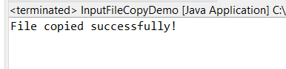
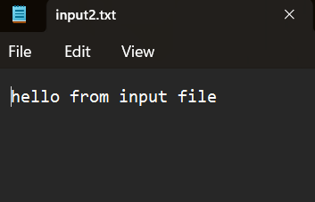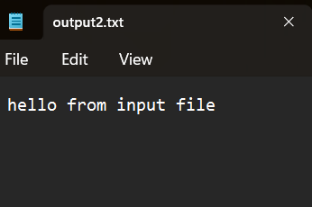
2. Write the programme to show multithreading for the string “multi threads”. Show the resulting output.
PROGRAM:
package Lab8;

class SimpleThread extends Thread {
private char character;

// Constructor to assign character to this thread
public SimpleThread(char character) {
this.character = character;
}

@Override
public void run() {
// Print the character
System.out.print(character + " ");
}
}

public class MultiThreadDemo {
public static void main(String[] args) {
String text = "multi threads";

// Loop through each character in the string
for (int i = 0; i < text.length(); i++) {
// Create a new thread for the current character
SimpleThread thread = new SimpleThread(text.charAt(i));
thread.start(); // Start the thread

try {
// Introduce a short delay based on the index
Thread.sleep(100 * i);
// Wait for the current thread to finish before starting the next
thread.join();
} catch (InterruptedException e) {
System.out.println("Thread interrupted: " + e.getMessage());
}
}
}
}
OUTPUT:
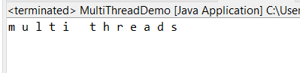

3. Implement a Java program that creates a thread using the Runnable interface. The thread should print numbers from 1 to 10 with a delay of 1 second between each number.
PROGRAM:
package Lab8;

public class RunnableInterfaceDemo implements Runnable {

@Override
public void run() {
for (int i = 1; i <= 10; i++) {
System.out.println(i);
try {
// Pause the thread for 1 second (1000 milliseconds)
Thread.sleep(1000);
} catch (InterruptedException e) {
System.out.println("Thread interrupted: " + e.getMessage());
}
}

}
public static void main(String[] args) {

RunnableInterfaceDemo R1 = new RunnableInterfaceDemo();

Thread t1 = new Thread(R1);
t1.start();
}
}

OUTPUT:
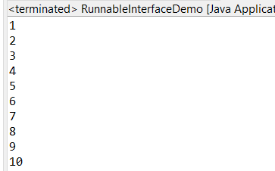
4. Write a Java program that creates and starts three threads. Each thread should print its name and count from 1 to 5 with a delay of 500 milliseconds between each count.
PROGRAM:
package Lab8;

public class ThreeThreadsDemo implements Runnable {

private String threadName;

// Constructor to set the thread name
public ThreeThreadsDemo(String threadName) {
this.threadName = threadName;
}

@Override
public void run() {
// Print numbers from 1 to 5 with a delay
for (int i = 1; i <= 5; i++) {
System.out.println(threadName + ": " + i);
try {
// Wait for 500 milliseconds
Thread.sleep(500);
} catch (InterruptedException e) {
System.out.println(threadName + " interrupted: " + e.getMessage());
}
}
}

public static void main(String[] args) {
// Create instances of ThreeThreadsDemo with different names
ThreeThreadsDemo D1 = new ThreeThreadsDemo("Thread 1");
ThreeThreadsDemo D2 = new ThreeThreadsDemo("Thread 2");
ThreeThreadsDemo D3 = new ThreeThreadsDemo("Thread 3");

// Create threads for each instance
Thread T1 = new Thread(D1);
Thread T2 = new Thread(D2);
Thread T3 = new Thread(D3);

// Start the threads
T1.start();
T2.start();
T3.start();
}
}

OUTPUT:
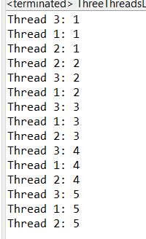
5. Create a Java program that demonstrates thread priorities. Create three threads with different priorities and observe the order in which they execute.
PROGRAM:
package Lab8;

public class ThreadPriorityDemo implements Runnable {

private String threadName;

// Constructor to set the thread's name
public ThreadPriorityDemo(String threadName) {
this.threadName = threadName;
}

@Override
public void run() {

// Print numbers with a delay
for (int i = 1; i <= 5; i++) {
System.out.println(threadName + ": " + i);
try {
Thread.sleep(500); // Wait for 500 milliseconds
} catch (InterruptedException e) {
System.out.println(threadName + " interrupted: " + e.getMessage());
}
}
}

public static void main(String[] args) {
// Create Runnable tasks with different names
Runnable task1 = new ThreadPriorityDemo("Low Priority Thread");
Runnable task2 = new ThreadPriorityDemo("Medium Priority Thread");
Runnable task3 = new ThreadPriorityDemo("High Priority Thread");

// Create threads with different priorities
Thread thread1 = new Thread(task1);
Thread thread2 = new Thread(task2);
Thread thread3 = new Thread(task3);

// Set priorities
thread1.setPriority(Thread.MIN_PRIORITY); // Lowest priority
thread2.setPriority(Thread.NORM_PRIORITY); // Default priority
thread3.setPriority(Thread.MAX_PRIORITY); // Highest priority

// Start threads
thread1.start();
thread2.start();
thread3.start();
}
}
OUTPUT:
