LAB 9
1. Perform the following tasks:
a. Create Student table with following attributes (STUDENT_ID , FIRST_NAME, LAST_NAME, PHONE_NUMBER, MARKS, COURSE_ID).
OUERY:
mysql> use lab9_1;
OUTPUT:

OUERY:
CREATE TABLE student (
student_id INT(10) PRIMARY KEY NOT NULL,
first_name VARCHAR(40) NOT NULL,
last_name VARCHAR(40) NOT NULL,
phone_number VARCHAR(15) NOT NULL,
marks INT(4),
course_id INT(10) NOT NULL,
FOREIGN KEY (course_id) REFERENCES course(course_id));
OUTPUT:
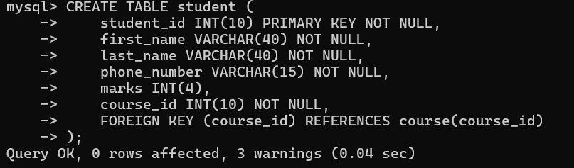
b. Create Course table with following attributes (COURSE_ID, COURSE_NAME).
QUERY:
CREATE TABLE course(
course_id int(10) PRIMARY KEY NOT NULL,
course_name varchar(100) NOT NULL
);
OUTPUT:
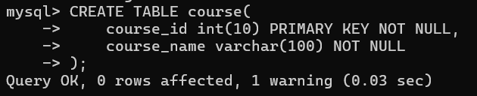
c. Write a SQL statement to insert 8 records with your own value into the tables.
ANSWER:
(1). Inserting into student table
INSERT INTO student (student_id, first_name, last_name, phone_number, marks, course_id) VALUES
(1, 'Ashi', 'Chouhan', '9876543210', 85, 1),
(2, 'Aryan', 'Chouhan', '9123456789', 90, 2),
(3, 'Suhani', 'Chouhan', '9988776655', 78, 3),
(4, 'Nikhil', 'Singh', '9765432109', 88, 1),
(5, 'Dinesh', 'Chaudhary', '9876512345', 92, 2),
(6, 'Ranjesh', 'Kushwaha', '9234567890', 80, 3),
(7, 'Riya', 'Yadav', '9887766554', 75, 4),
(8, 'Roshani', 'Singh', '9321654987', 83, 5);
OUTPUT:
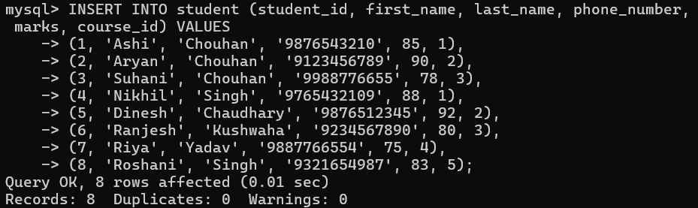

(2). Inserting into course table:
INSERT INTO course (course_id, course_name) VALUES
(1, 'Mathematics'),
(2, 'Physics'),
(3, 'Chemistry'),
(4, 'Biology'),
(5, 'Computer Science'),
(6, 'History'),
(7, 'Economics'),
(8, 'English Literature');
OUTPUT:

d. Write a query to get the number of students with the same course.
QUERY:
mysql> SELECT course_id, COUNT(student_id) AS number_of_students
-> FROM student
-> GROUP BY course_id;
OUTPUT:
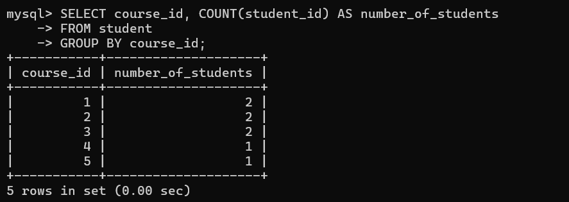
f. Write a query to get the student name, course name and marks of the students.
QUERY:
mysql> SELECT s.first_name, s.last_name, c.course_name, s.marks
-> FROM student s
-> JOIN course c ON s.course_id = c.course_id;
OUTPUT:
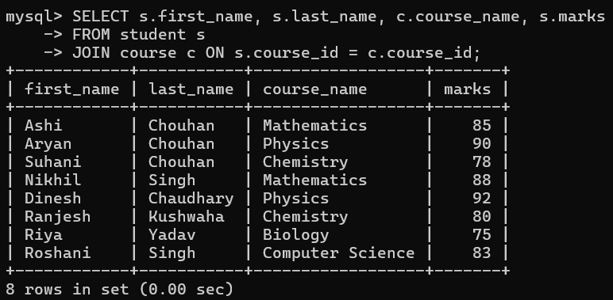
g. Write a query to get the Average marks of students course wise.
QUERY:
mysql> SELECT c.course_name, AVG(s.marks) AS average_marks
-> FROM student s
-> JOIN course c ON s.course_id = c.course_id
-> GROUP BY c.course_name;
OUTPUT:
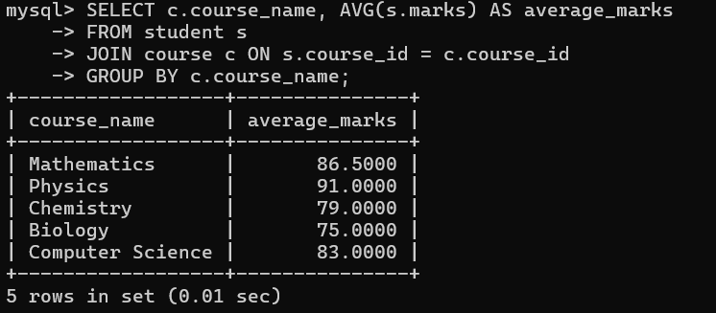
2. Create database for hospital management system & Perform the following tasks:
a. Create HEALTH CARE WORKERS table with following attributes (EMPLOYEE_ID , FIRST_NAME, LAST_NAME,EMAIL, PHONE_NUMBER, HIRE_DATE, SALARY, DESIGNATION).
QUERY:
CREATE DATABASE hospital_management_system;
OUTPUT:
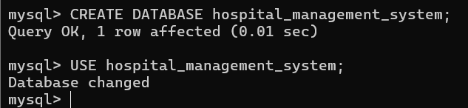
QUERY:
mysql> CREATE TABLE HEALTH_CARE_WORKERS (
-> EMPLOYEE_ID INT PRIMARY KEY,
-> FIRST_NAME VARCHAR(50),
-> LAST_NAME VARCHAR(50),
-> EMAIL VARCHAR(100),
-> PHONE_NUMBER VARCHAR(15),
-> HIRE_DATE DATE,
-> SALARY DECIMAL(10, 2),
-> DESIGNATION VARCHAR(50)
-> );
OUTPUT:
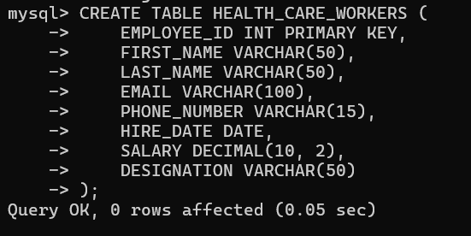
b. Create PATIENT table with following attributes (PATIENT_ID,NAME, PHONE_NUMBER).
QUERY:
mysql> CREATE TABLE PATIENT (
-> PATIENT_ID INT PRIMARY KEY,
-> NAME VARCHAR(100),
-> PHONE_NUMBER VARCHAR(15)
-> );
OUTPUT:
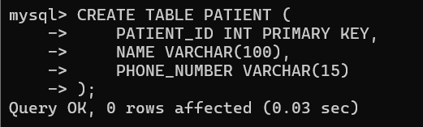
c. Write a SQL statement to insert 10 records with your own value into the tables.
QUERY:
INSERT INTO HEALTH_CARE_WORKERS (EMPLOYEE_ID, FIRST_NAME, EMAIL, PHONE_NUMBER, HIRE_DATE, SALARY, DESIGNATION)
VALUES
(1, 'Amit', 'amit@gmail.com', '9876543210', '2022-01-15', 30000.00, 'Doctor'),
(2, 'Sita', 'sita@gmail.com', '9123456789', '2021-11-20', 32000.00, 'Nurse'),
(3, 'Rajesh', 'rajesh@gmail.com', '9988776655', '2023-04-10', 40000.00, 'Surgeon'),
(4, 'Aarti', 'aarti@gmail.com', '9765432109', '2020-07-05', 45000.00, 'Doctor'),
(5, 'Vijay', 'vijay@gmail.com', '9876512345', '2019-09-15', 22000.00, 'Technician'),
(6, 'Neeta', 'neeta@gmail.com', '9234567890', '2021-03-12', 35000.00, 'Nurse'),
(7, 'Ravi', 'ravi@gmail.com', '9887766554', '2022-08-25', 37000.00, 'Physician'),
(8, 'Pooja', 'pooja@gmail.com', '9321654987', '2020-01-01', 27000.00, 'Technician'),
(9, 'Arun', 'arun@gmail.com', '9998887777', '2018-05-30', 31000.00, 'Doctor'),
(10, 'Kavita', 'kavita@gmail.com', '8887776666', '2023-02-10', 42000.00, 'Surgeon');
OUTPUT:

QUERY:
INSERT INTO PATIENT (PATIENT_ID, NAME, PHONE_NUMBER)
VALUES
(1, 'Ashi', '9876543210'),
(2, 'Aryan', '9123456789'),
(3, 'Suhani', '9988776655'),
(4, 'Nikhil', '9765432109'),
(5, 'Dinesh', '9876512345'),
(6, 'Ranjesh', '9234567890'),
(7, 'Riya', '9887766554'),
(8, 'Roshani', '9321654987'),
(9, 'Meera', '9998887777'),
(10, 'Ravi', '8887776666');
OUTPUT:
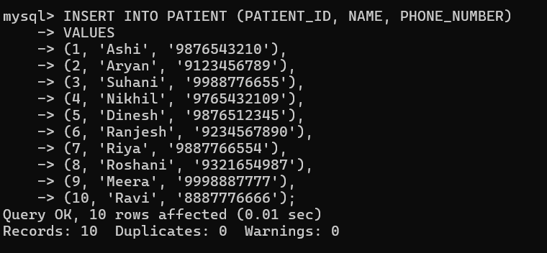
d. Write a query to get the names (first_name, last_name),Designation, salary.
QUERY:
mysql> SELECT FIRST_NAME, DESIGNATION, SALARY
-> FROM HEALTH_CARE_WORKERS;
OUTPUT:
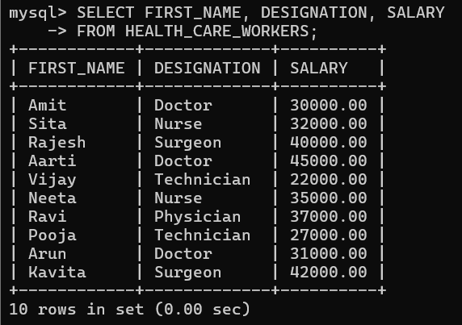
e. Write a query to get the number of employees with the same Designation
QUERY:
mysql> SELECT DESIGNATION, COUNT(*) AS NumberOfEmployees
-> FROM HEALTH_CARE_WORKERS
-> GROUP BY DESIGNATION;
OUTPUT:
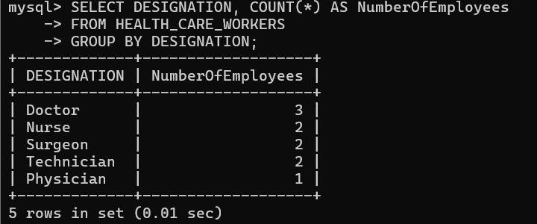
f. Write a query to get employee name who are getting salary more than 25000.
QUERY:
SELECT FIRST_NAME
FROM HEALTH_CARE_WORKERS
WHERE SALARY > 25000;
OUTPUT:
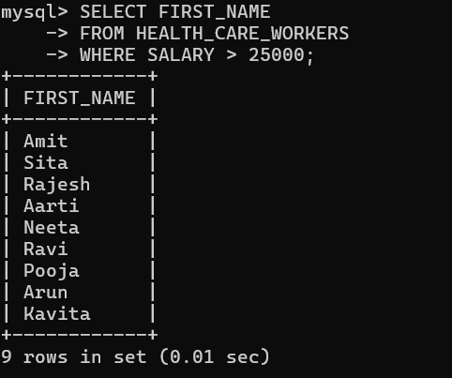
g. Fetch HEALTH CARE WORKERS name using their employee id.
QUERY:
mysql> SELECT FIRST_NAME
-> FROM HEALTH_CARE_WORKERS
-> WHERE EMPLOYEE_ID = 5;
OUTPUT:
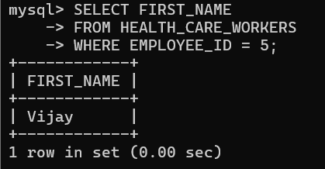

3.Consider two tables, customers and orders, with the following structures:
- Customers Table: customer_id (Primary Key) first_name Last_name
- Orders Table: order_id (Primary Key) customer_id (Foreign Key) order_date Total_amount
- Write an SQL query to retrieve the first and last names of customers along with the order date and total amount of their orders.
- Use an INNER JOIN to connect the two tables.

SETTING UP THE TABLES:
mysql> CREATE DATABASE LAB9_3;

mysql> CREATE TABLE customers (
-> customer_id INT PRIMARY KEY,
-> first_name VARCHAR(50),
-> last_name VARCHAR(50)
-> );
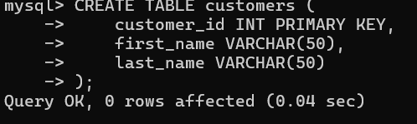
mysql> INSERT INTO customers (customer_id, first_name, last_name)
-> VALUES
-> (1, 'Ashi', 'Chouhan'),
-> (2, 'Aryan', 'Chouhan'),
-> (3, 'Suhani', 'Chouhan'),
-> (4, 'Nikhil', 'Singh'),
-> (5, 'Dinesh', 'Chaudhary'),
-> (6, 'Ranjesh', 'Kushwaha'),
-> (7, 'Riya', 'Yadav'),
-> (8, 'Roshani', 'Singh');
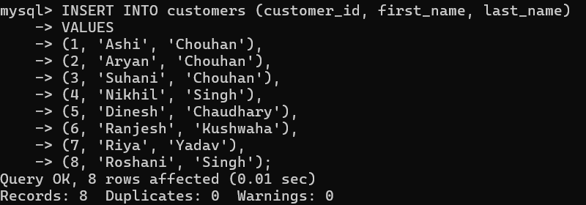
mysql> CREATE TABLE orders (
-> order_id INT PRIMARY KEY,
-> customer_id INT,
-> order_date DATE,
-> total_amount DECIMAL(10, 2),
-> FOREIGN KEY (customer_id) REFERENCES customers(customer_id)
-> );
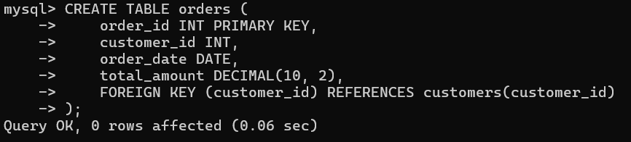
mysql> INSERT INTO orders (order_id, customer_id, order_date, total_amount)
-> VALUES
-> (101, 1, '2024-08-01', 250.75),
-> (102, 1, '2024-08-15', 150.00),
-> (103, 2, '2024-08-20', 320.50),
-> (104, 3, '2024-08-25', 180.00),
-> (105, 4, '2024-08-30', 275.20),
-> (106, 5, '2024-08-10', 200.00),
-> (107, 6, '2024-08-12', 150.00),
-> (108, 7, '2024-08-18', 120.00),
-> (109, 8, '2024-08-22', 300.00);
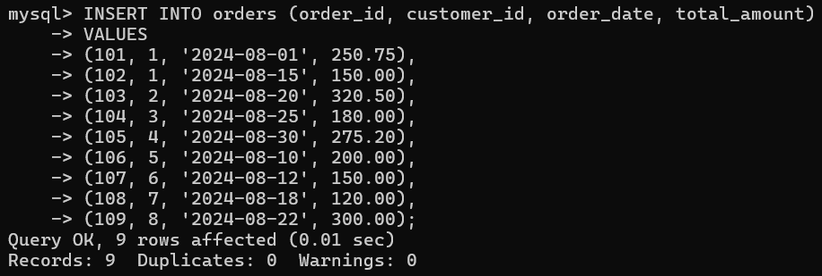

CUSTOMERS TABLE:
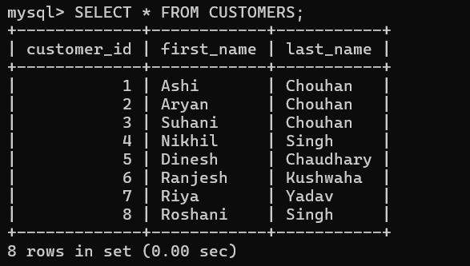
ORDERS TABLE:
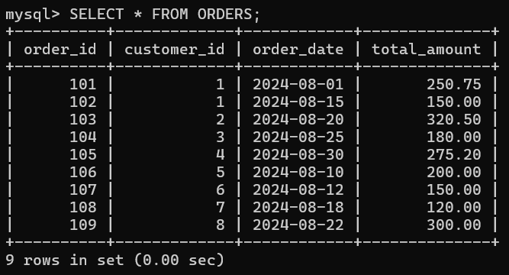
Now:
QUERY:
mysql> SELECT c.first_name, c.last_name, o.order_date, o.total_amount
-> FROM customers c
-> INNER JOIN orders o ON c.customer_id = o.customer_id;
OUTPUT:
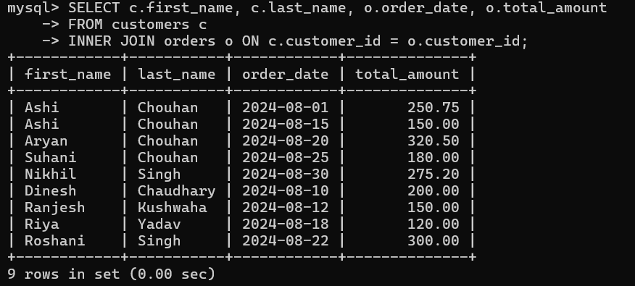

4.Consider two tables, departments and employees, with the following structures:
Departments Table: department_id (Primary Key) department_name
Employees Table: employee_id (Primary Key) first_name last_name department_id (Foreign Key)
Write an SQL query to retrieve a list of all departments and the names of employees who belong to each department. Use a LEFT JOIN to include departments that have no employees.

SETTING UP THE TABLES:
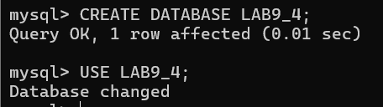
mysql> CREATE TABLE departments (
-> department_id INT PRIMARY KEY,
-> department_name VARCHAR(50)
-> );
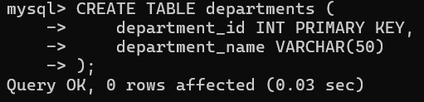
mysql> INSERT INTO departments (department_id, department_name)
-> VALUES
-> (1, 'HR'),
-> (2, 'Finance'),
-> (3, 'IT'),
-> (4, 'Marketing');
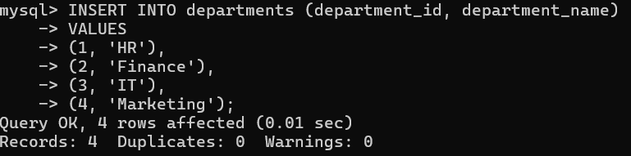
mysql> CREATE TABLE employees (
-> employee_id INT PRIMARY KEY,
-> first_name VARCHAR(50),
-> last_name VARCHAR(50),
-> department_id INT,
-> FOREIGN KEY (department_id) REFERENCES departments(department_id)
-> );
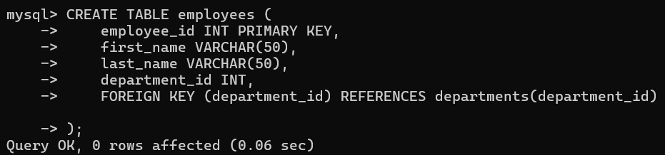
mysql> INSERT INTO employees (employee_id, first_name, last_name, department_id)
-> VALUES
-> (1, 'Ashi', 'Chouhan', 1),
-> (2, 'Aryan', 'Chouhan', 2),
-> (3, 'Suhani', 'Chouhan', 3),
-> (4, 'Nikhil', 'Singh', 1),
-> (5, 'Dinesh', 'Chaudhary', 2),
-> (6, 'Ranjesh', 'Kushwaha', NULL),
-> (7, 'Riya', 'Yadav', 4),
-> (8, 'Roshani', 'Singh', 3);
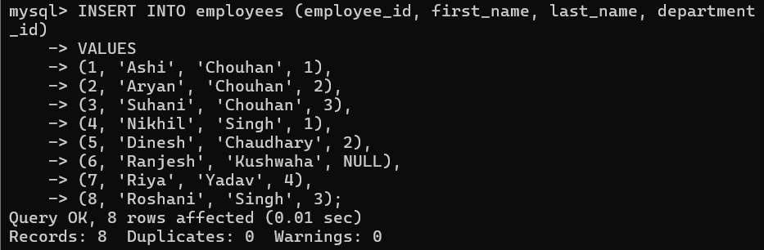
DEPARTMENTS TABLE:
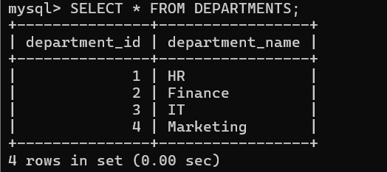
EMPLOYEES TABLE:
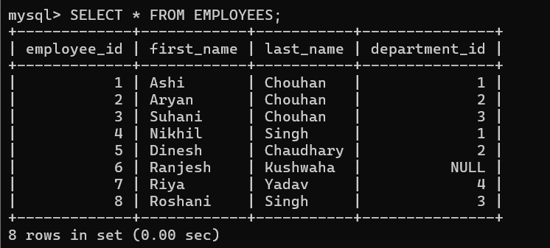
NOW,
QUERY:
mysql> SELECT d.department_name, e.first_name, e.last_name
-> FROM departments d
-> LEFT JOIN employees e ON d.department_id = e.department_id;
OUTPUT:
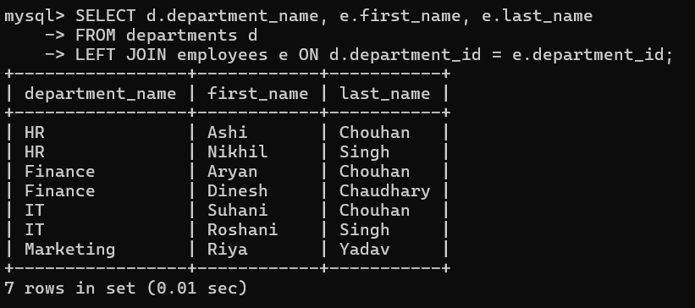

4. Write a program to show JDBC connection with MYSQL and perform the following operations:
Create table Customer with following fields:
Custno, Custame,Custaddress,Phoneno, City, Pincode, Country
Insert 5 records in Customer table.
a. Insert values
b. Delete values
c. update city name Shimla to Shilong.
d. Show table in the console

PROGRAM:
// ConnectJDBC
package LAB9_JDBC;
import java.sql.Connection;
import java.sql.DriverManager;
import java.sql.SQLException;

public class ConnectJDBC {

public static Connection getConnection() throws SQLException {
try {
Class.forName("com.mysql.cj.jdbc.Driver");
return DriverManager.getConnection("jdbc:mysql://localhost:3306/lab9_jdbc", "ashi", "123456");
} catch (ClassNotFoundException e) {
e.printStackTrace();
throw new SQLException("MySQL JDBC Driver not found.");
}
}
}

// DBOperations.java
package LAB9_JDBC;

import java.sql.Connection;
import java.sql.ResultSet;
import java.sql.SQLException;
import java.sql.Statement;

public class DBOperations {
public static void main(String[] args) {
Connection conn = null;
Statement stmt = null;
ResultSet rs = null;

try {
// Establish a connection to the database
conn = ConnectJDBC.getConnection();
stmt = conn.createStatement();

// Create the Customer table if it doesn't exist
String createTableSQL = "CREATE TABLE IF NOT EXISTS Customer (" +
"Custno INT AUTO_INCREMENT PRIMARY KEY, " +
"Custname VARCHAR(100), " +
"Custaddress VARCHAR(255), " +
"Phoneno VARCHAR(15), " +
"City VARCHAR(50), " +
"Pincode VARCHAR(10), " +
"Country VARCHAR(50))";
stmt.execute(createTableSQL); // Execute table creation
System.out.println("Customer table created.");

// Insert three records into the Customer table
String insertSQL1 = "INSERT INTO Customer (Custname, Custaddress, Phoneno, City, Pincode, Country) " +
"VALUES ('Ashi Chouhan', '12 MG Road', '9876543210', 'Indore', '452001', 'India')";
stmt.executeUpdate(insertSQL1); // Execute the insert operation

String insertSQL2 = "INSERT INTO Customer (Custname, Custaddress, Phoneno, City, Pincode, Country) " +
"VALUES ('Aryan Chouhan', '34 Brigade Road', '9123456789', 'Bengaluru', '560001', 'India')";
stmt.executeUpdate(insertSQL2); // Execute the insert operation

String insertSQL3 = "INSERT INTO Customer (Custname, Custaddress, Phoneno, City, Pincode, Country) " +
"VALUES ('Suhani Chouhan', '56 Marina Beach Road', '9988776655', 'Chennai', '600002', 'India')";
stmt.executeUpdate(insertSQL3); // Execute the insert operation

System.out.println("3 records inserted into Customer table.");

// Retrieve and display all records from the Customer table
String selectSQL = "SELECT * FROM Customer";
rs = stmt.executeQuery(selectSQL);

while (rs.next()) {
int custno = rs.getInt("Custno");
String custname = rs.getString("Custname");
String custaddress = rs.getString("Custaddress");
String phoneno = rs.getString("Phoneno");
String city = rs.getString("City");
String pincode = rs.getString("Pincode");
String country = rs.getString("Country");

System.out.println("Custno: " + custno + ", Custname: " + custname + ", Custaddress: " + custaddress +
", Phoneno: " + phoneno + ", City: " + city + ", Pincode: " + pincode + ", Country: " + country);
}
} catch (SQLException e) {
e.printStackTrace();
} finally {
// Close resources
try {
if (rs != null) rs.close();
if (stmt != null) stmt.close();
if (conn != null) conn.close();
} catch (SQLException e) {
e.printStackTrace();
}
}
}
}

OUTPUT:
