**HEURISTIC SEGMENTATION**

**The Term Heuristic**

A heuristic, or a heuristic technique, is any approach to problem-solving or **self-discovery** that uses a practical method or various shortcuts in order to produce **solutions that may not be optimal, perfect or rational but are sufficient for immediate, short term approximation**. When optimal solutions are practically impossible heuristic approach can find us a satisfactory solution. Heuristics can be mental shortcuts that ease the [cognitive load](https://en.wikipedia.org/wiki/Cognitive_load) of [making a decision](https://en.wikipedia.org/wiki/Decision-making).

**SEGMENTATION**

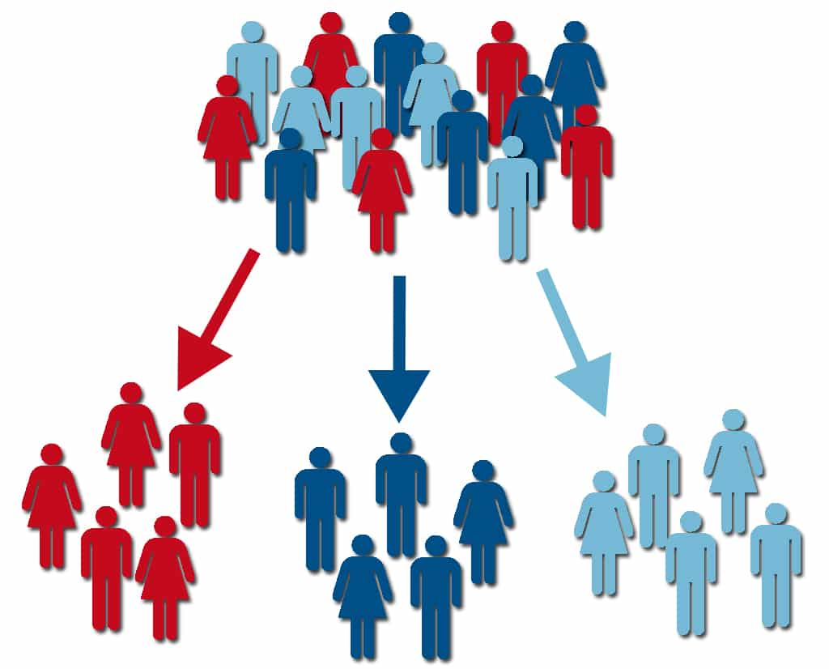

Data segmentation is the process of dividing the data into similar groups based on certain attributes so the it may be used for profitable strategies.

Segmenting is the process of putting customers into groups based on similarities, and clustering is the process of finding similarities in customers so that they can be grouped, and therefore **segmented**. They seem quite similar, but they are not quite the same.

**EXPLANATION:**

When we segment, we know who to target. **If I’m selling an expensive diamond jewellery**, I want to target women with high annual income. I am defining limits of the group-

“Women with annual income above some threshold (say 15 lakh p.a.) who have purchased similar product.”

This group’s women have a high probability (ability) of buying my expensive diamond jewellery.

**Identifying and grouping customers:**

* **who are women,**
* **have annual income 15 lakh p.a. or above is called process of segmentation.**

We can definitely add dimensions to increase specificity say **Age** can be one as women between age group 25-50 are more likely to buy diamond jewellery. Above traits comes under **customer characteristics**. Buying behaviour can also be taken into account such as **Brand preference, discount preference, time spent on site, browsing behaviour, length of call, etc**.

It’s clear there has been a shift towards more “**customer centric”** business models. There are several popular ways to segment customers**: life stage, lifestyle, value-based and RFM (recency, frequency, monetary)**. Each is useful, and combined they give a comprehensive view of the customer as an individual.

1. **Life stage segmentation**

# It deals with where a person is in the course of their life. Someone who is married with five children is likely to purchase different products than someone who is just entering college. While you can’t learn everything, you need to know about someone based on where they are in life, it's a good base for profiling**. Marketers Should Segment Based on Life Stages, Not Generations.** While we may be in the same age generation, we’re certainly in different stages of our lives.

**2. Value-based segmentation**

Value-based segmentation **differentiates customers by their economic value**, grouping customers with the same value level into individual segments that can be distinctly targeted.

 For example, customers who are price insensitive, costly to serve, and poorly served by competitors can be charged more than customers who are price sensitive, less costly to serve, and are served well by competitors. **The higher the price sensitivity, the more the customer is in control.**

Often, however, market segmentation focuses on customer attributes that are not really useful for pricing decisions. Value-based market segmentation helps to identify meaningful subgroups, which supports decision making.

**STEPS INVOLVED IN VALUE-BASED SEGMENTATION:**

1. Determine basic segmentation criteria.

There are many ways to segment markets to find the right target audience. Five ways to segment markets include **demographic, psychographic, behavioural, geographic and firmographics segmentation** (such as revenue, industry, and number of employees).

1. Identify Discriminating Value Drivers

Value drivers are **factors that increase the worth of a product, service, asset or business**. In the case of a product, it could be a differentiating capability that makes the product a must-have for customers.

1. **Determine Operational Constraints and Advantages.**
2. **Create primary and secondary segments.**
3. **Create detailed segment description.**
4. **Define segment metrics**

**EXAMPLE**: **Customer Segmentation in Banks**

How does a Bank operate? Customers deposit their savings in banks for interests at 3%-9% and banks use this amount **for giving loans at a higher rate of interest 8%-18%.** Banks can run profitably only when **customers pay on time (with interest monthly).** Else banks will go **in debt**. So, recovery must be high so that banks can thrive well.

Bank income can be categorized into interest income and non-interest income. Most income is via interest i.e., loans, deposits etc. Rest (~10%) of income can be grouped under non-interest products like rent on lockers, sale of gold coins etc**. A bank’s income is largely depends on loan recovery.**

For securing a loan from a bank, a customer has to pledge / hypothecate his / her movable or immovable property as security. **After customer repays loan with interest, he/she gets back title of movable or immovable property.**

* Bank customers with **a loan** can be segmented based on **loan over-due amount** and **security value into:** 1. High risk customer 2. Medium risk customer and 3. Low risk customer.
* If security value > (2 * due_loan_amt), then customer is low risk

Else if security_value < due_loan_amt, then customer is high risk.

Else if security_value <= (2 * due_loan_amt) and security_value >= due_loan_amt, then customer is medium risk.

* Repeat the above analysis for **all loan customers and group them**.

**Segment 1: High Risk, Segment 2: Low Risk, Segment 3: Medium Risk**

3**. Behavioural Segmentation:**

Behavioural segmentation refers to a process in marketing that divides customers into segments depending on their behaviour patterns when interacting with a particular business or website.

One of its type is **Loyalty Segmentation**: Segmentation based on customer loyalty. Loyalty-based segmentation **measures the level of loyalty a customer has with your brand**, either through a rewards program, number of purchases, or general engagement with marketing efforts.

**4. RFM:**

Recency (**how recent was a customer's last purchase**), Frequency (**how often do they purchase**), and Monetary value (**how much they spend**).

**RFM factors illustrate these facts:**

* **the more recent the purchase, the more responsive the customer is to promotions.**
* **the more frequently the customer buys, the more engaged and satisfied they are.**
* **monetary value differentiates heavy spenders from low-value purchasers.**

This data helps determine the value a customer brings to an organization. In order to create these segments**, one must first turn their customer data into scores and then those scores into segments.** These segments can be used to identify your **most valuable customers, and to tell you who is at risk of churn.** They can also be used to glean insights about the demographic similarities of high-value customers which, in turn, can predict who is likely to generate the most revenue — before they make purchases.