Name: **Dissanayake D.M.A.K**

Index No. : **220135N**

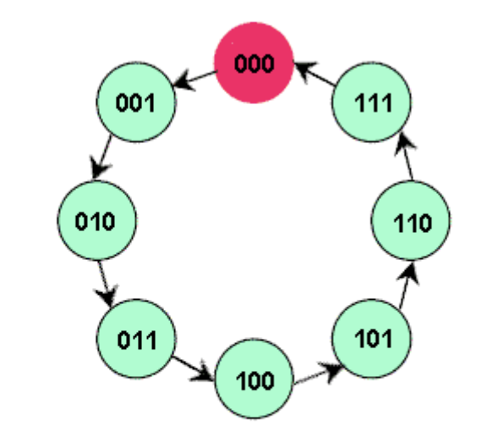**Build a 0 to 7 counter using D Flip Flops**

We want to buld a counter like above using D type Flip Flops.  
Following are the steps to do that:-

1. State table of the Counter
2. K-Maps for D2,D1,D0
3. Simplfied Boolean expressions of D2,D1,D0
4. Counter circuit diagram

**Excitation table of D Flip Flop**

**Counter**

**State table of Counter**

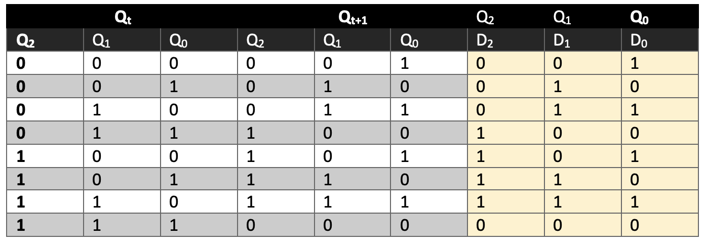

**K-Maps**

**D2 – Map**

D2 = Q2.Q0’ + Q2.Q1’+ Q2’.Q1.Q0

= Q2.(Q0’ + Q1’)+ Q2’.Q1.Q0

= Q2.(Q0.Q1)’+ Q2’.Q1.Q0

**D1 - Map**

D1 = Q1.Q0’ + Q1’.Q0

= Q1  Q0

**D0 - Map**

D0 = Q0’

**Counter Circuit Diagram**

Clk

D_FF_2

D_FF_1

D_FF_0