1. Forgot Password module not working
2. Email sent when execution triggered is not in proper format

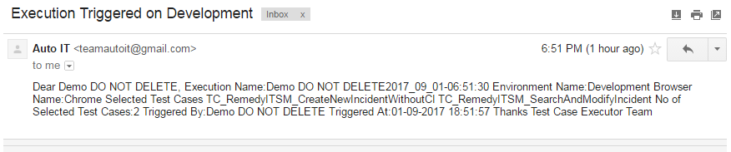

**More about Email:**

* We must have Email Configuration set in Super User
* Forgot Password mail should use email mentioned in Super User Email Setting
* Company Administrator must set email for his company
* Execution Email sent for company should use Company email id mentioned in Company Administrator email configuration
* If company Administrator has not configured email then for execution we should use Email account set by super user

1. I am logged in with [rahul4108@gmail.com](mailto:rahul4108@gmail.com) but on Users page we are seeing same user listed, which is wrong

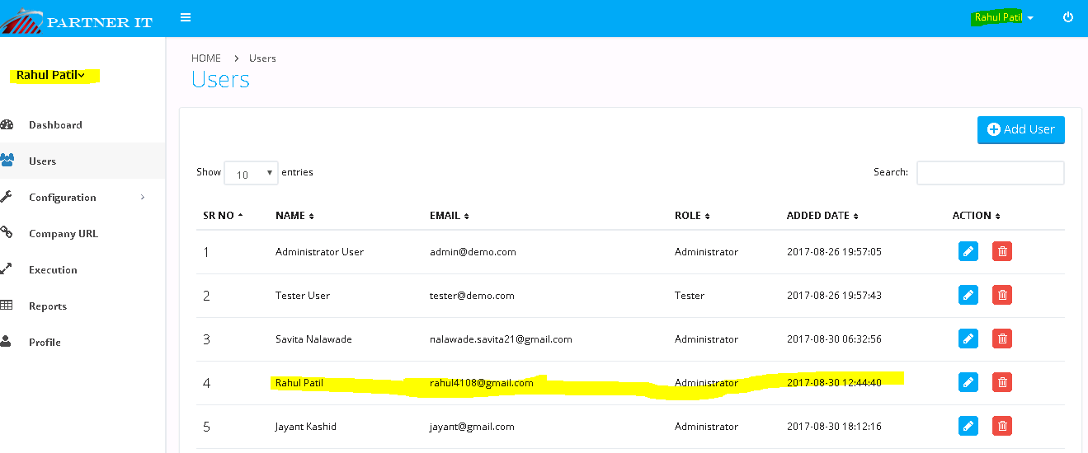

Issue: Sr No should be in sequence

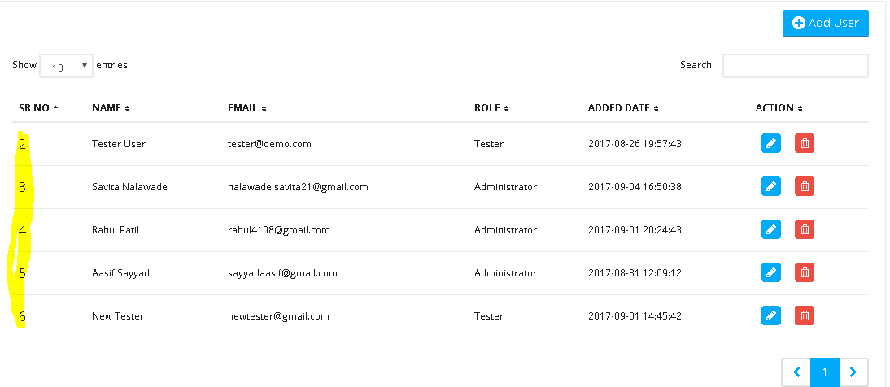

1. Execution name field should not be read only and there should be validation like it should not contains special characters.

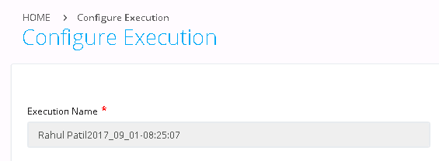

As we want to create Directory with same Execution name so it gives below error

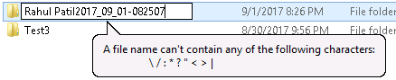

1. Download Excel link is not available

Path: F:\SeleniumAutomation_V1\TestData\<CompanyName>\<ApplicationName>\<TestCaseName>.xlsx

Highlighted path can be taken from Environment Variable or Property File

1. Upload Excel not working

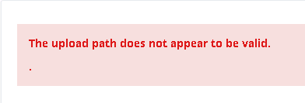

1. Reports should be sorted in descending order , latest executed should appear first

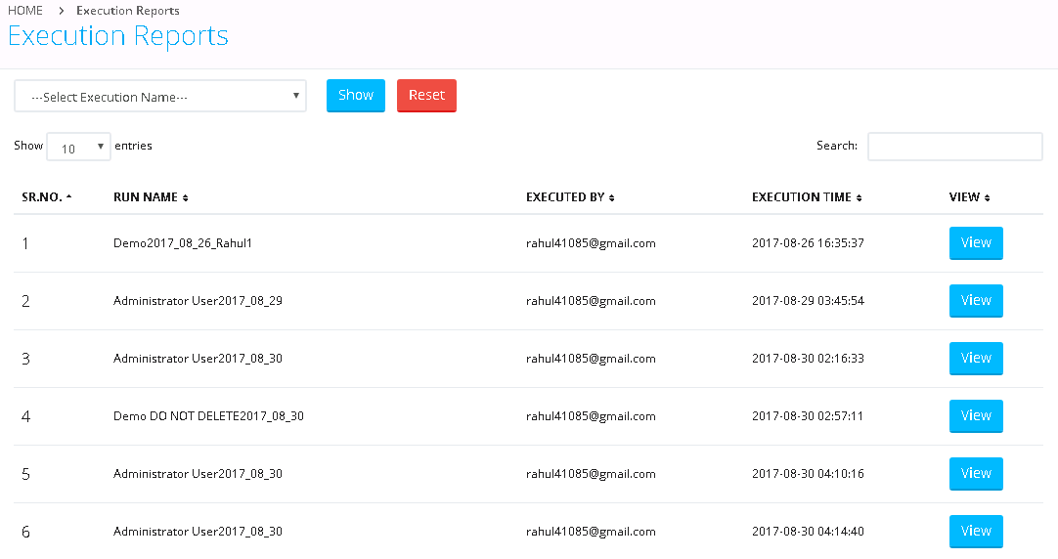

1. Pagination on Report Page
2. Failed Cases in Report must have link by which when user click on it there should be Java script popup showing screen shot from path

F:\SeleniumAutomation_V1\ScreenShots\<Company Name>\<RunName>\<TestCaseName>.png

Highlighted path can be taken from Environment Variable or Property File

1. Download Report in PDF, Excel format should be supported