**Enhancements and Issues List**

**Reports:**

1. In Report Page, remove auto refresh of complete page instead using JQuery or similar only refresh the progress bar section.

Issue with the complete page refresh is when user is view the report the after 30 seconds the View report page gets closed which is annoying.

1. Progress bar percentage are not visible as it is overlap with date, please show it in such a way that it should be visible
2. Add Refresh button on View Report Window, so that latest passed –failed results gets updated in reports
3. PDF Report is not showing the content properly
4. We need to enhance the report and for that add First column in the report which has “+” and “-“ buttons.

The purpose is when we execute any test case from application there are some test data associated with it. We want to show results of test case with all those test data. So to do that

The very first entry should be the Test case entry.

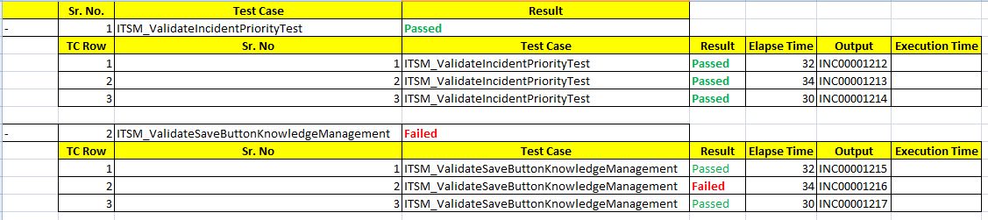

**Environment Tab**

We observed that there are hard code paths set in application for SeleniumAutomationV1, however user should set this path from Application.

So In Environment tab add below fields:

**Selenium Home:** Where user can set its selenium home for Environment

Based on this name there should be folder created in TestApps to store Screen shots, Test Data and Test Cases.

**Test Case and Test Data:**

1. As we are going to merge Test Case and Test Data, the First tab in excel will be a Test Case and Second tab will be Test Data.

In this case we need to remove the download test case section from Execution Page as we already have Test Data download Page.

1. We need to rename the “Upload Test Data” to “Refer Test Case and Data”
2. Also when user is uploading a Test Case or Data there should be separate folder for user under TestApps/SeleniumAutomationV1/TestData/<CompanyName>/<Application>/<UserName>/TestCaseName.xlsx
3. We don’t need separate directory for Test Case Name under Test Case and Test Data folder

**Dashboard:**

We would like to add one report which will give an high level information such as which are the test cases which are frequently failed which shows Unstable area in environment or unstable Automation scripts

**Performance:**

1. We need to add a “Performance Suite” check box in Manage Test Case >> Add New Test Case
2. When user select Performance Suite checkbox then such test case should be maintained separately.
3. Add New Page “Performance Monitor”, where user can specify
4. Execution Name
5. Browser
6. Environment
7. There will be list of test cases with check box sign so that user can select the check box
8. Execute Button
9. When user hit the execute button in background the process will be same to create .xml file, configurationfile and .bat file
10. User should be navigate to “Performance Report” page which is also a new page
11. On Performance Report page we have to show a Dropdown value with multi select feature
12. If user select 2 entries from dropdown then we need to show report in below manner

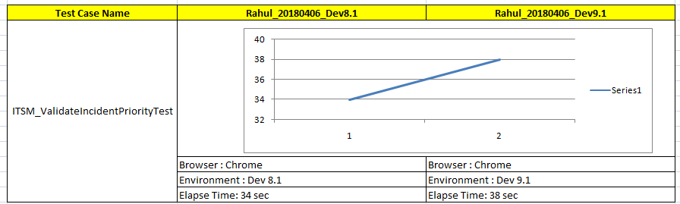

We will decide the perfect graph type for the same.