Complete E-Commerce Sales Analysis
This report contains the complete exploratory data analysis, sales analysis, customer analysis, geographic analysis, product analysis, cancellation analysis, and churn prediction performed in the notebook.

1. Dataset Overview
Total records: 49,203
Total columns: 19
Order date range: 2024-01-01 to 2026-06-30

Sample Records
OrderID | CustomerID | OrderDate | ProductID | Quantity | Discount | PaymentMethod | Status | Age | City | SignupDate | CustomerSegment | ProductName | Category | UnitPrice | Sales | OrderValue | Month | AgeGroup
500001 | 103695 | 2025-08-28 00:00:00 | 2003 | 4.00 | 10.00 | Gateway | Completed | 36.00 | Qom | 2024-03-05 | Regular | USB-C Cable | Accessories | 9.00 | 32.00 | 32.00 | 2025-08 | 26–39
500002 | 107935 | 2024-05-31 00:00:00 | 2014 | 1.00 | 10.00 | Wallet | Completed | 49.00 | Kerman | 2025-06-04 | Regular | Backpack | Accessories | 42.00 | 38.00 | 38.00 | 2024-05 | 40+
500003 | 105141 | 2025-08-10 00:00:00 | 2002 | 1.00 | 20.00 | CardToCard | Completed | 36.00 | Tehran | 2025-10-19 | Regular | Mechanical Keyboard | Electronics | 62.00 | 50.00 | 50.00 | 2025-08 | 26–39
500004 | 108780 | 2024-10-11 00:00:00 | 2012 | 1.00 | 10.00 | Gateway | Completed | 45.00 | Shiraz | 2023-12-07 | Regular | Office Chair | Home Office | 180.00 | 162.00 | 162.00 | 2024-10 | 40+
500005 | 101187 | 2024-02-19 00:00:00 | 2008 | 2.00 | 0.00 | Gateway | Completed | 24.00 | Karaj | 2023-12-02 | Regular | Phone Case | Accessories | 14.00 | 28.00 | 28.00 | 2024-02 | 18–25

Dataset Summary Statistics
index | count | unique | top | freq | mean | min | 25% | 50% | 75% | max | std
OrderID | 49,203.00 |  |  |  | 525,008.71 | 500,001.00 | 512,509.50 | 525,018.00 | 537,506.50 | 550,000.00 | 14,434.63
CustomerID | 49,203.00 |  |  |  | 105,002.14 | 100,001.00 | 102,503.50 | 105,005.00 | 107,497.00 | 110,000.00 | 2,888.89
OrderDate | 49203 |  |  |  | 2025-03-11 14:29:05.893543 | 2024-01-01 00:00:00 | 2024-08-05 00:00:00 | 2025-03-10 00:00:00 | 2025-10-09 00:00:00 | 2026-06-30 00:00:00
ProductID | 49,203.00 |  |  |  | 2,009.46 | 2,001.00 | 2,004.00 | 2,008.00 | 2,014.00 | 2,020.00 | 5.58
Quantity | 49,203.00 |  |  |  | 1.88 | 0.00 | 1.00 | 2.00 | 2.00 | 5.00 | 1.08
Discount | 49,203.00 |  |  |  | 7.49 | 0.00 | 0.00 | 5.00 | 10.00 | 30.00 | 7.75
PaymentMethod | 49203 | 4 | Gateway | 23882
Status | 49203 | 3 | Completed | 45258
Age | 49,203.00 |  |  |  | 41.28 | 18.00 | 29.00 | 41.00 | 53.00 | 65.00 | 13.68
City | 49203 | 10 | Tehran | 13996
SignupDate | 49203 | 1094 | 2023-03-07 | 105
CustomerSegment | 49203 | 3 | Regular | 27285
ProductName | 49203 | 20 | Notebook | 5437
Category | 49203 | 6 | Accessories | 18182
UnitPrice | 49,203.00 |  |  |  | 40.29 | 7.00 | 11.00 | 28.00 | 58.00 | 260.00 | 42.62
Sales | 49,203.00 |  |  |  | 70.03 | 0.00 | 17.00 | 38.00 | 84.00 | 1,300.00 | 94.47
OrderValue | 49,203.00 |  |  |  | 70.03 | 0.00 | 17.00 | 38.00 | 84.00 | 1,300.00 | 94.47
Month | 49203 | 30 | 2024-12 | 1837
AgeGroup | 49203 | 3 | 40+ | 26743

2. Monthly Sales Analysis
Highest sales month: 2025-05 (130,625.00)
Lowest sales month: 2026-02 (75,132.00)

Monthly Sales Data
Month | Sales
2024-01 | 121,921.00
2024-02 | 114,664.00
2024-03 | 128,150.00
2024-04 | 115,950.00
2024-05 | 123,700.00
2024-06 | 116,784.00
2024-07 | 128,689.00
2024-08 | 129,987.00
2024-09 | 116,032.00
2024-10 | 117,260.00
2024-11 | 121,378.00
2024-12 | 125,912.00
2025-01 | 118,603.00
2025-02 | 108,609.00
2025-03 | 119,432.00
2025-04 | 115,304.00
2025-05 | 130,625.00
2025-06 | 126,269.00
2025-07 | 119,743.00
2025-08 | 120,604.00
2025-09 | 120,077.00
2025-10 | 124,435.00
2025-11 | 125,300.00
2025-12 | 115,790.00
2026-01 | 130,550.00
2026-02 | 75,132.00
2026-03 | 84,082.00
2026-04 | 85,706.00
2026-05 | 85,986.00
2026-06 | 79,096.00

Monthly Sales Trend
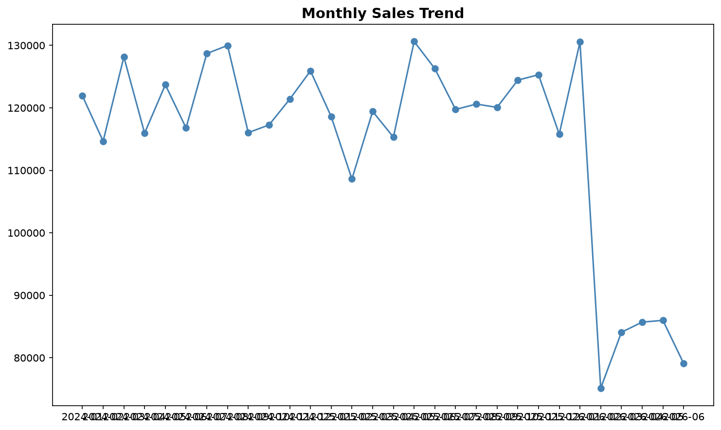

3. Category Analysis

Revenue by Category
Category | Sales
Electronics | 1,751,491.00
Accessories | 553,178.00
Home Office | 446,065.00
Wearables | 429,497.00
Gaming | 198,302.00
Stationery | 67,237.00

Sales by Product Category
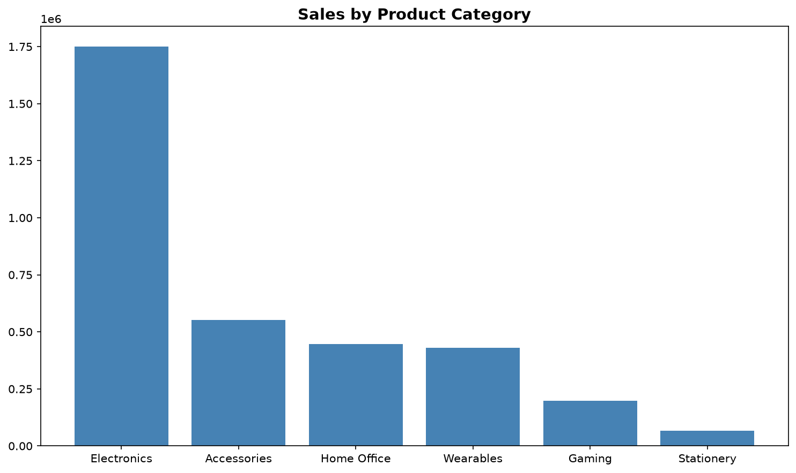

4. Customer Segment Analysis

Customer Segment Distribution
CustomerSegment | Count | Percentage
Regular | 27285 | 55.45
New | 17050 | 34.65
VIP | 4868 | 9.89

Discount by Customer Segment
CustomerSegment | AvgDiscount | TotalDiscount | TotalOrders
VIP | 7.58 | 36,915.00 | 4868
Regular | 7.50 | 204,665.00 | 27285
New | 7.43 | 126,765.00 | 17050

Average Order Value by Segment
CustomerSegment | AverageOrderValue | TotalOrders
Regular | 70.19 | 27285
New | 70.18 | 17050
VIP | 68.62 | 4868

Customer Segment Distribution
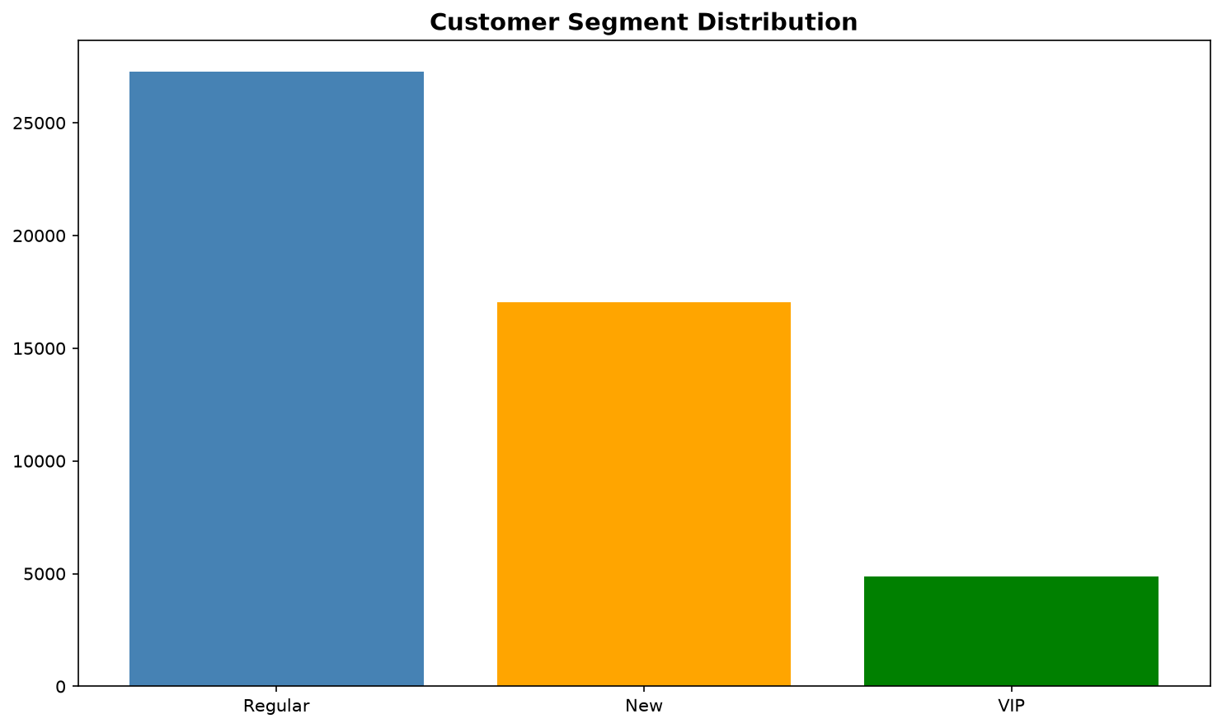

Average Discount by Customer Segment
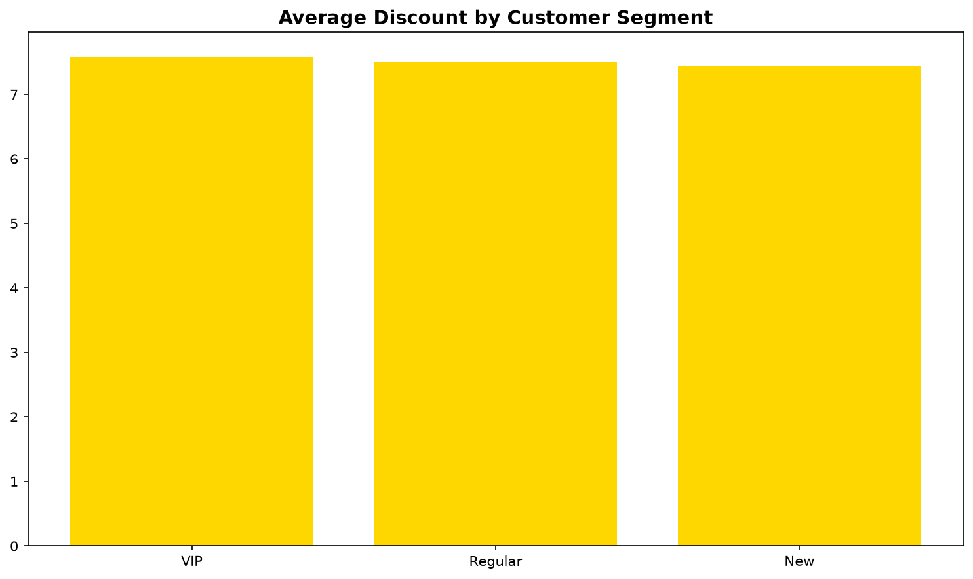

Average Order Value by Customer Segment
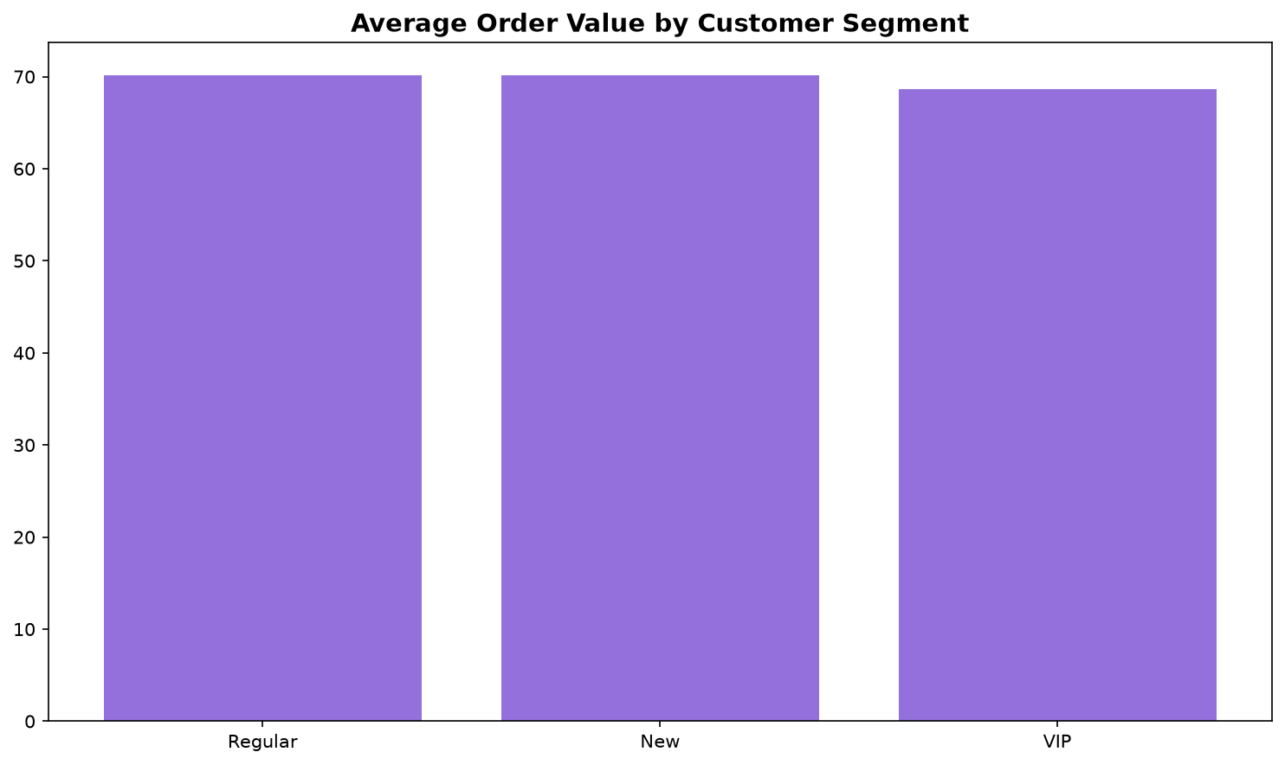

5. Order Status and Payment Methods

Order Status Distribution
Status | Count | Average
Completed | 45258 | 91.98
Cancelled | 2437 | 4.95
Returned | 1508 | 3.06

Payment Method Usage
PaymentMethod | count
Gateway | 23882
CardToCard | 11741
Wallet | 8658
Cash | 4922

Order Status Distribution
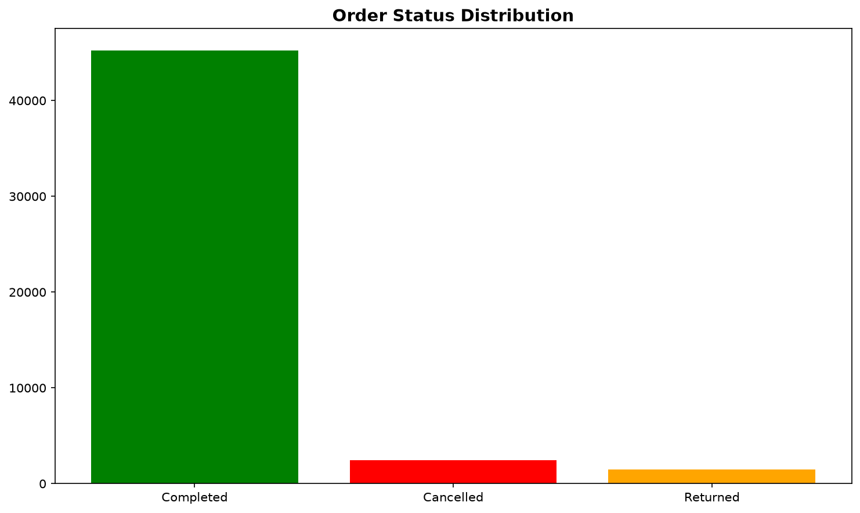

Payment Method Usage
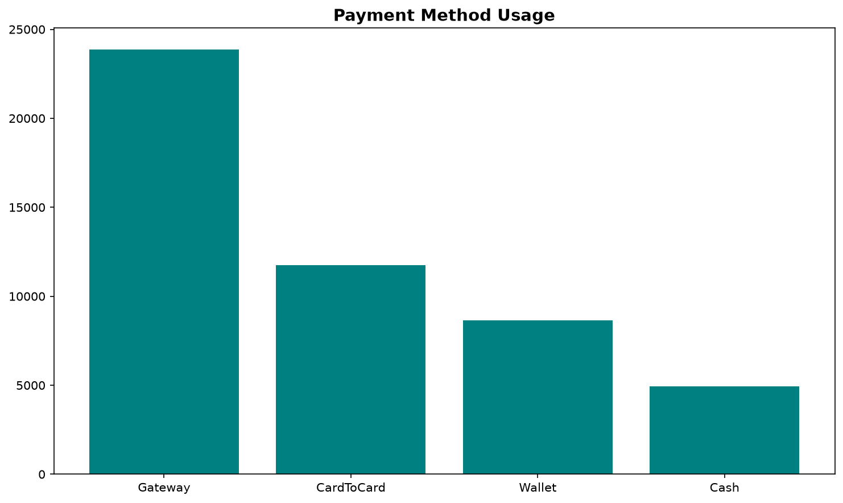

6. Geographic Analysis

Sales by City
City | Sales
Tehran | 964,119.00
Mashhad | 438,119.00
Karaj | 350,231.00
Isfahan | 334,686.00
Shiraz | 310,951.00
Tabriz | 292,225.00
Ahvaz | 211,181.00
Rasht | 205,882.00
Kerman | 175,199.00
Qom | 163,177.00

Customers by City
City | CustomerCount | Percentage
Tehran | 2784 | 28.35
Mashhad | 1278 | 13.01
Karaj | 1008 | 10.26
Isfahan | 949 | 9.66
Shiraz | 861 | 8.77
Tabriz | 840 | 8.55
Ahvaz | 584 | 5.95
Rasht | 558 | 5.68
Qom | 481 | 4.90
Kerman | 477 | 4.86

Sales by City
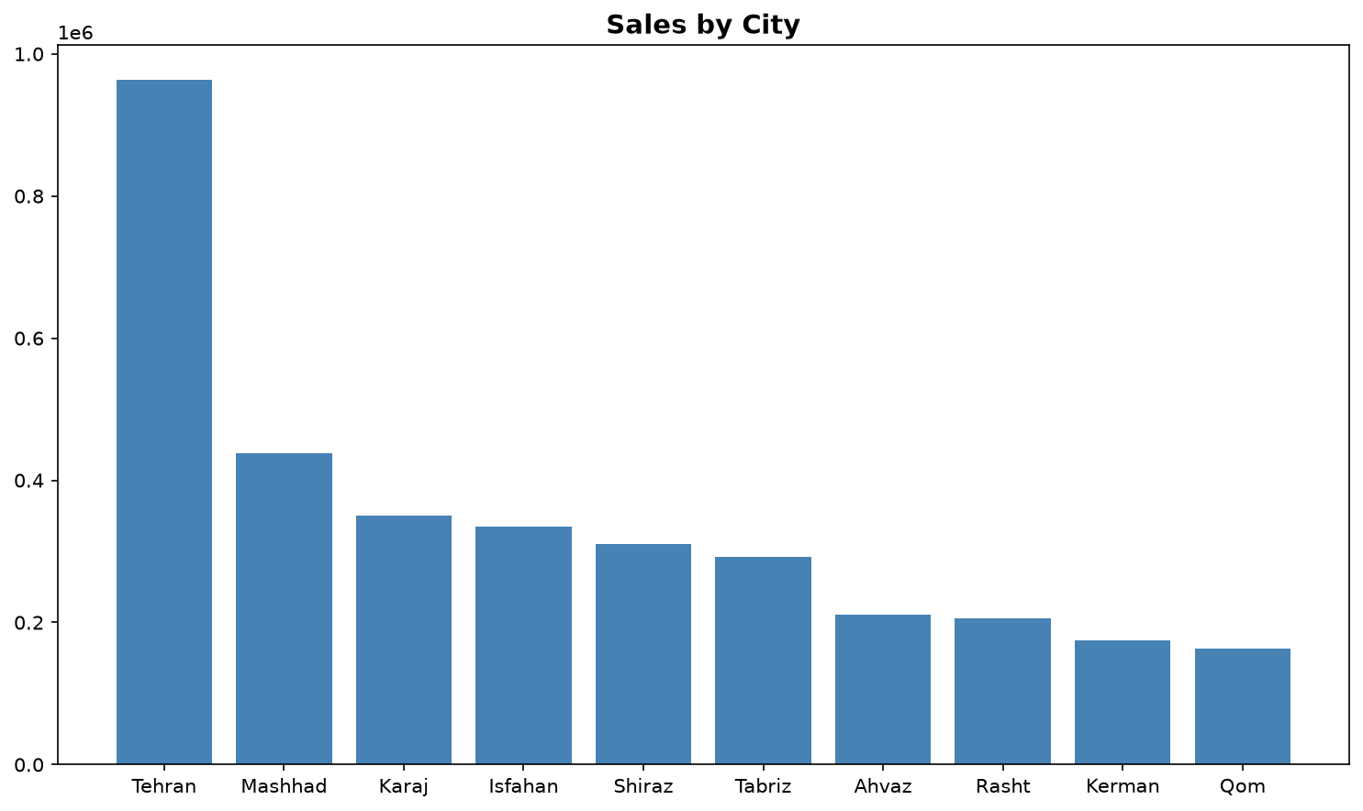

Customers by City
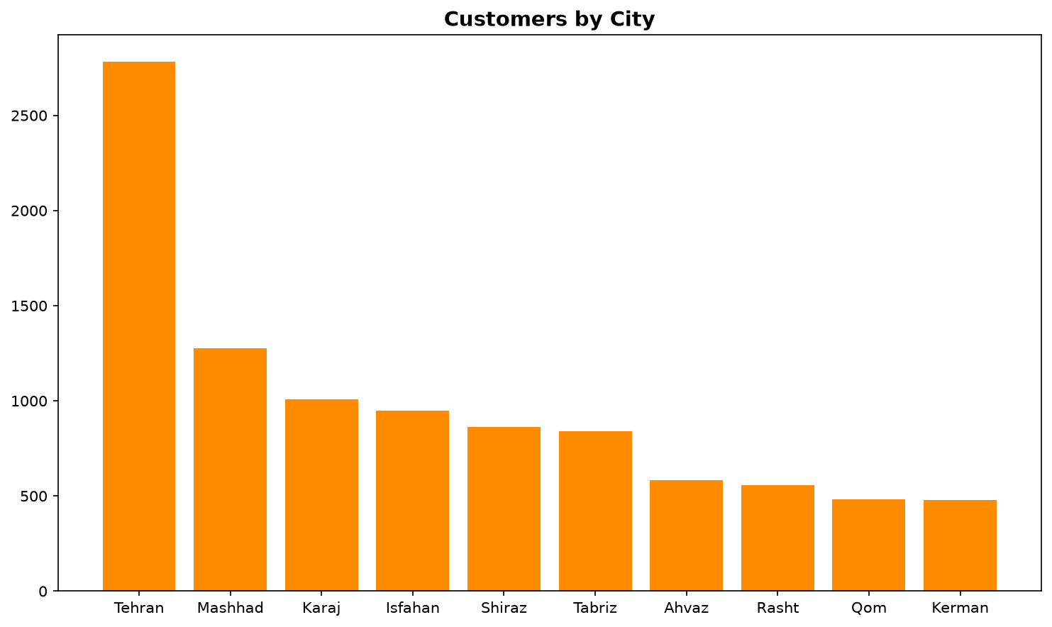

7. Age Group Analysis

Sales by Age Group
AgeGroup | Sales
18–25 | 574,897.00
26–39 | 1,007,885.00
40+ | 1,862,988.00

Highest-Selling Age Group by Category
Category | AgeGroup | Sales
Electronics | 40+ | 936,046.00
Accessories | 40+ | 302,647.00
Home Office | 40+ | 245,109.00
Wearables | 40+ | 234,478.00
Gaming | 40+ | 107,681.00
Stationery | 40+ | 37,027.00

Sales by Customer Age Group
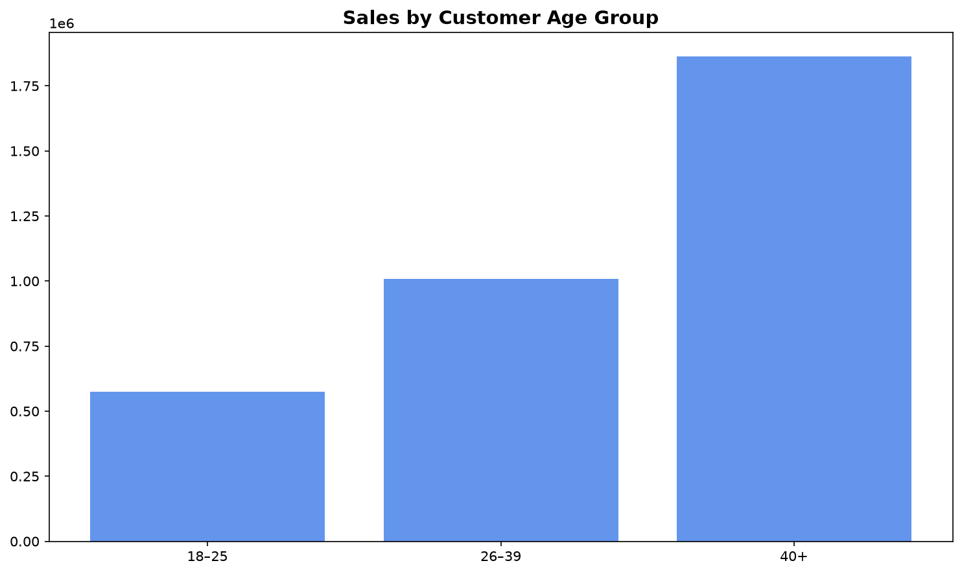

Sales by Age Group and Category
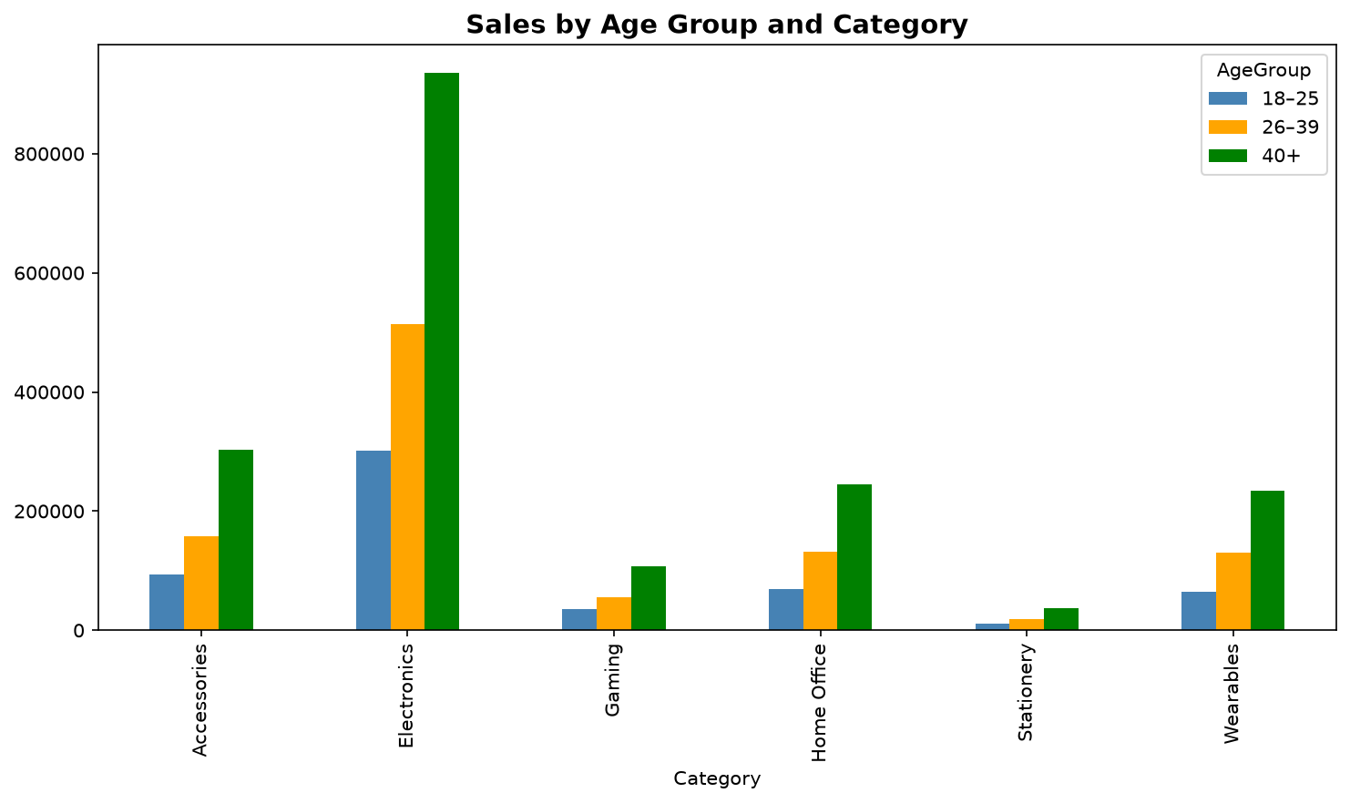

8. Product Analysis

Sales by Product
ProductName | Sales
Headphones | 333,531.00
Office Chair | 329,292.00
Tablet | 292,344.00
Smart Watch | 259,590.00
Microphone | 230,309.00
Mechanical Keyboard | 229,676.00
Bluetooth Speaker | 213,427.00
Gaming Controller | 198,302.00
Power Bank | 180,004.00
Fitness Band | 169,907.00
Backpack | 169,562.00
Webcam | 149,724.00
Phone Case | 123,019.00
Desk Lamp | 116,773.00
Laptop Stand | 109,879.00
Wireless Mouse | 99,863.00
HDMI Cable | 76,051.00
USB-C Cable | 74,667.00
Notebook | 67,237.00
Monitor | 22,613.00

Sales by Product
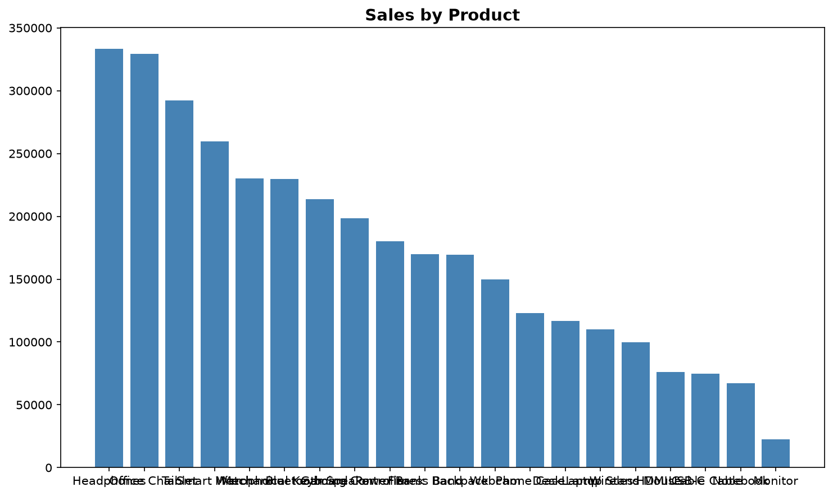

9. Tehran Analysis

Tehran Sales by Category
Category | Sales
Electronics | 486,690.00
Accessories | 157,918.00
Home Office | 127,081.00
Wearables | 118,838.00
Gaming | 55,071.00
Stationery | 18,521.00

Tehran Sales by Product
ProductName | Sales
Office Chair | 91,539.00
Headphones | 91,283.00
Tablet | 80,977.00
Smart Watch | 70,662.00
Microphone | 65,122.00
Mechanical Keyboard | 64,289.00
Bluetooth Speaker | 57,446.00
Gaming Controller | 55,071.00
Power Bank | 51,260.00
Fitness Band | 48,176.00
Backpack | 46,520.00
Webcam | 42,722.00
Desk Lamp | 35,542.00
Phone Case | 34,726.00
Laptop Stand | 33,217.00
Wireless Mouse | 27,396.00
HDMI Cable | 22,437.00
USB-C Cable | 21,018.00
Notebook | 18,521.00
Monitor | 6,195.00

Tehran Sales by Category
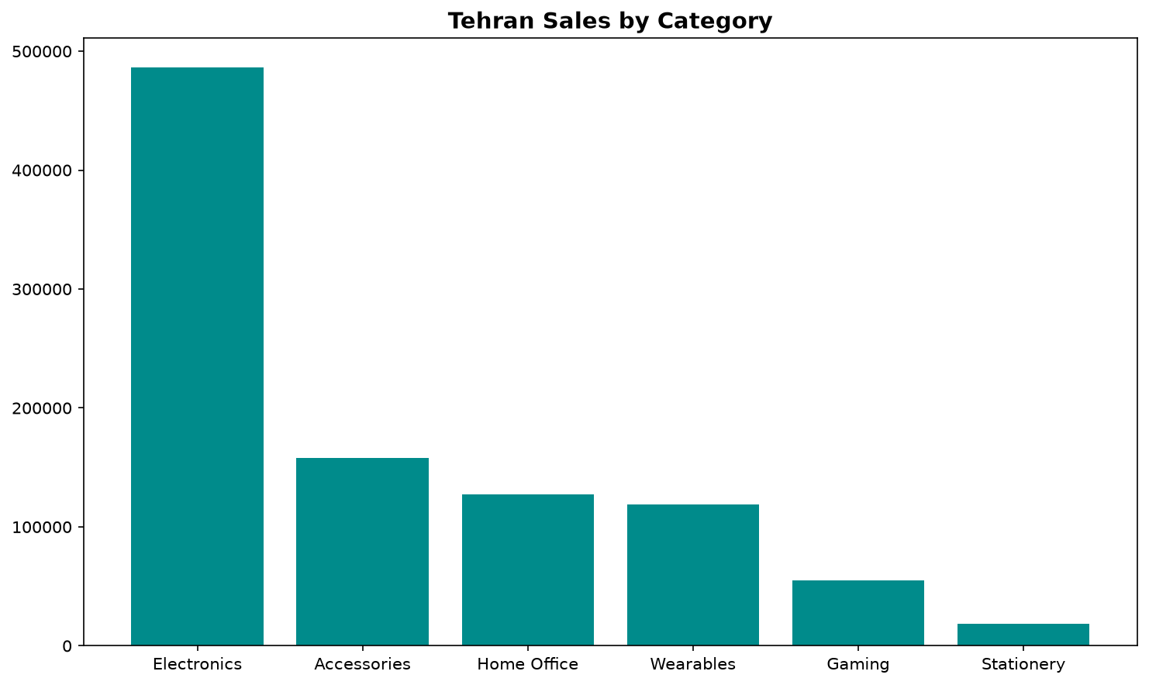

Tehran Sales by Product
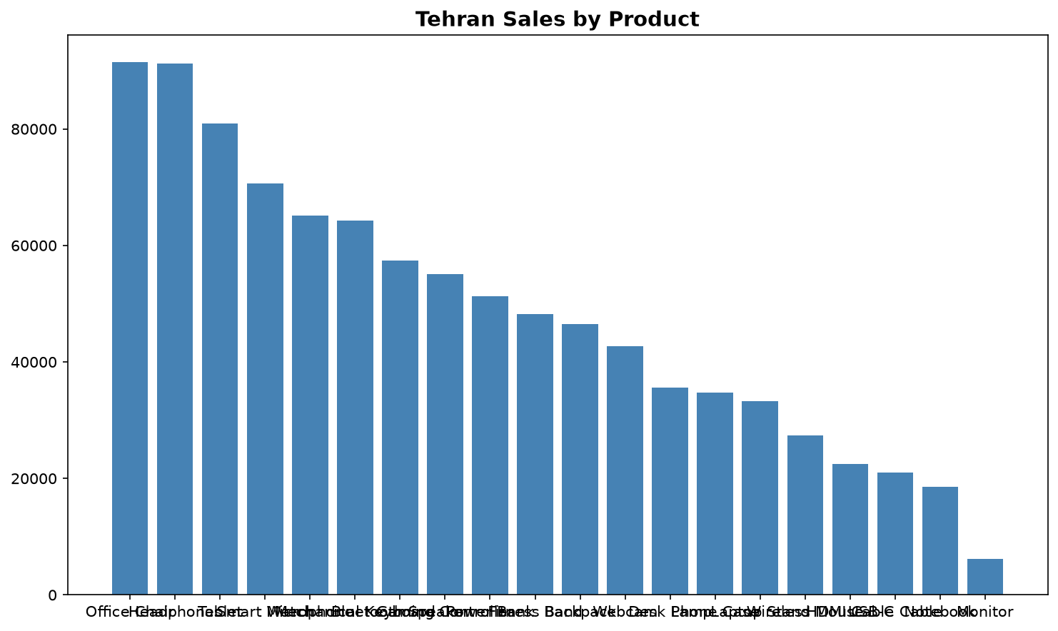

10. Category Sales in Other Cities

Other City Category Sales
City | Category | Sales
Ahvaz | Accessories | 32,564.00
Ahvaz | Electronics | 110,006.00
Ahvaz | Gaming | 12,472.00
Ahvaz | Home Office | 25,722.00
Ahvaz | Stationery | 3,884.00
Ahvaz | Wearables | 26,533.00
Isfahan | Accessories | 57,768.00
Isfahan | Electronics | 162,190.00
Isfahan | Gaming | 18,165.00
Isfahan | Home Office | 44,500.00
Isfahan | Stationery | 7,093.00
Isfahan | Wearables | 44,970.00
Karaj | Accessories | 53,857.00
Karaj | Electronics | 178,477.00
Karaj | Gaming | 22,277.00
Karaj | Home Office | 43,638.00
Karaj | Stationery | 7,034.00
Karaj | Wearables | 44,948.00
Kerman | Accessories | 29,641.00
Kerman | Electronics | 89,541.00
Kerman | Gaming | 10,530.00
Kerman | Home Office | 21,405.00
Kerman | Stationery | 3,639.00
Kerman | Wearables | 20,443.00
Mashhad | Accessories | 69,337.00
Mashhad | Electronics | 222,576.00
Mashhad | Gaming | 23,814.00
Mashhad | Home Office | 57,443.00
Mashhad | Stationery | 8,637.00
Mashhad | Wearables | 56,312.00
Qom | Accessories | 25,098.00
Qom | Electronics | 83,902.00
Qom | Gaming | 9,014.00
Qom | Home Office | 20,237.00
Qom | Stationery | 2,905.00
Qom | Wearables | 22,021.00
Rasht | Accessories | 32,039.00
Rasht | Electronics | 100,660.00
Rasht | Gaming | 13,350.00
Rasht | Home Office | 29,460.00
Rasht | Stationery | 3,845.00
Rasht | Wearables | 26,528.00
Shiraz | Accessories | 48,496.00
Shiraz | Electronics | 163,861.00
Shiraz | Gaming | 15,806.00
Shiraz | Home Office | 39,817.00
Shiraz | Stationery | 6,309.00
Shiraz | Wearables | 36,662.00
Tabriz | Accessories | 46,460.00
Tabriz | Electronics | 153,588.00
Tabriz | Gaming | 17,803.00
Tabriz | Home Office | 36,762.00
Tabriz | Stationery | 5,370.00
Tabriz | Wearables | 32,242.00

Sales by Category in Other Cities
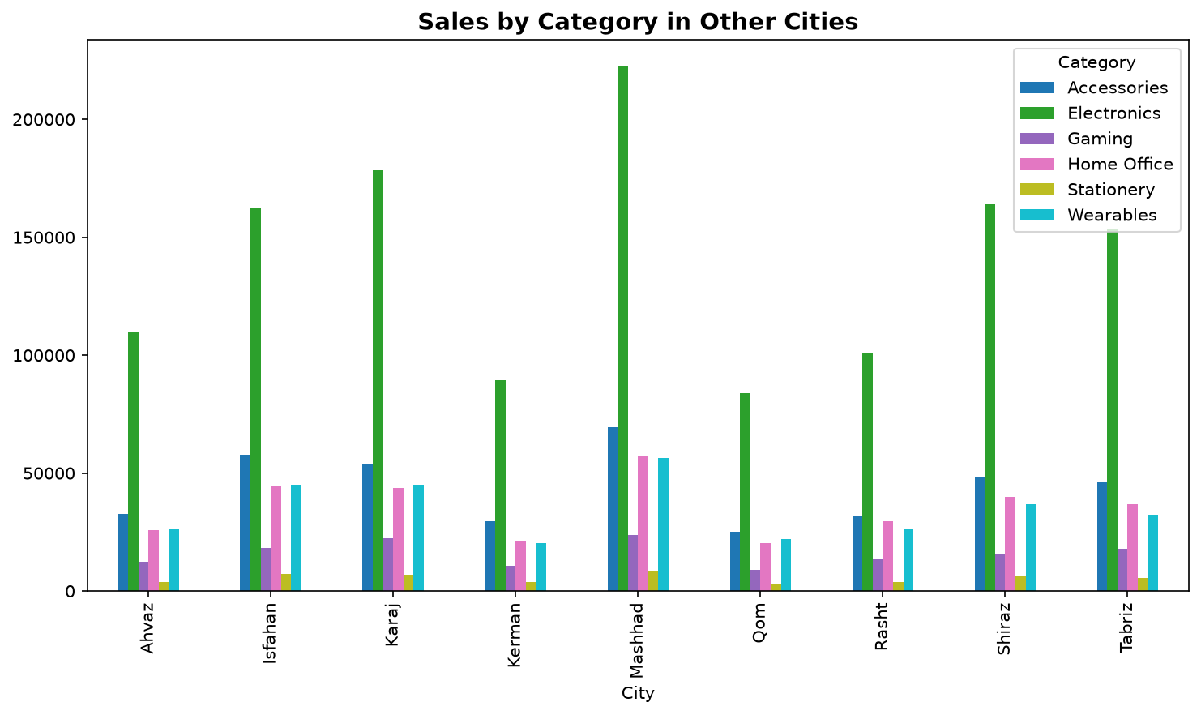

11. Yearly Sales Analysis

Sales by Year
Year | Sales
2,024.00 | 1,460,427.00
2,025.00 | 1,444,791.00
2,026.00 | 540,552.00

Sales by Year
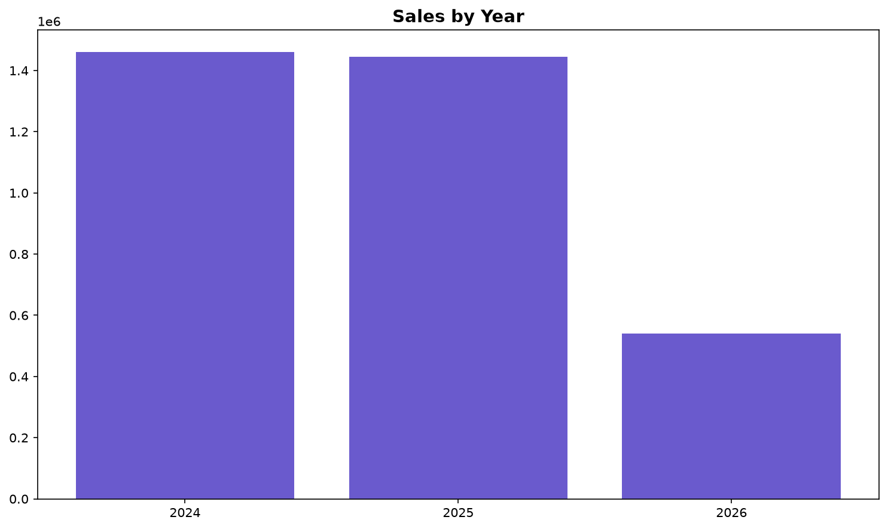

12. Cancelled Orders Analysis

Cancelled Orders by Category
Category | CancelledOrders | CancelledSales
Accessories | 912 | 27,751.00
Electronics | 889 | 95,932.00
Stationery | 270 | 3,251.00
Home Office | 144 | 22,753.00
Wearables | 141 | 20,223.00
Gaming | 81 | 10,281.00

Cancelled Orders by Category
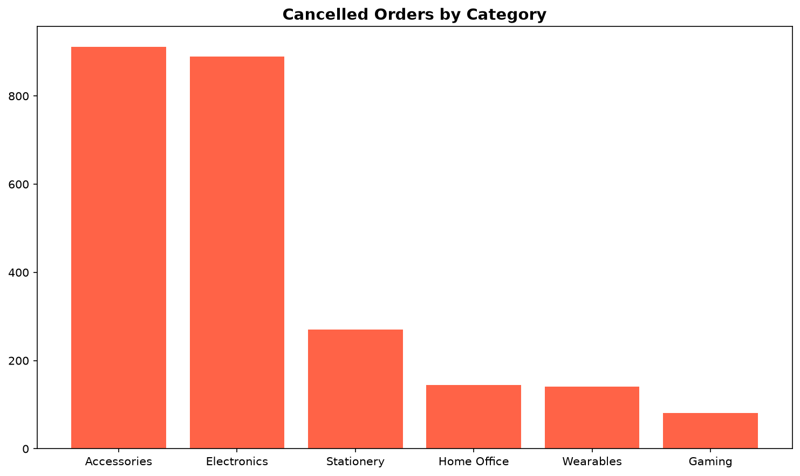

13. Customer Churn Analysis
Customers with a recency value greater than 90 days were classified as churned.
Customers analyzed: 9,820
Churned customers: 6,844
Non-churned customers: 2,976

Churn Risk Summary
RiskLevel | CustomerCount
High Risk | 6844
Low Risk | 2976
Medium Risk | 0

Highest-Risk Customers
CustomerID | Recency | Frequency | Monetary | ChurnProbability | RiskLevel | LastPurchaseDate | AverageDaysBetweenOrders | TotalOrders | AverageOrderValue | ExpectedNextPurchase | DaysUntilExpectedPurchase
110000 | 265 | 4 | 233.00 | 1.00 | High Risk | 2025-10-08 00:00:00 | 192.67 | 4 | 58.25 | 2026-04-18 16:00:00.000000002 | -73
109999 | 287 | 6 | 365.00 | 1.00 | High Risk | 2025-09-16 00:00:00 | 83.00 | 6 | 60.83 | 2025-12-08 00:00:00 | -204
100002 | 220 | 7 | 392.00 | 1.00 | High Risk | 2025-11-22 00:00:00 | 96.17 | 7 | 56.00 | 2026-02-26 04:00:00.000000002 | -124
100003 | 239 | 4 | 309.00 | 1.00 | High Risk | 2025-11-03 00:00:00 | 217.67 | 4 | 77.25 | 2026-06-08 16:00:00.000000002 | -22
100004 | 107 | 8 | 392.00 | 1.00 | High Risk | 2026-03-15 00:00:00 | 86.00 | 8 | 49.00 | 2026-06-09 00:00:00 | -21
100005 | 141 | 7 | 657.00 | 1.00 | High Risk | 2026-02-09 00:00:00 | 112.17 | 7 | 93.86 | 2026-06-01 04:00:00.000000002 | -29
100006 | 268 | 3 | 514.00 | 1.00 | High Risk | 2025-10-05 00:00:00 | 186.50 | 3 | 171.33 | 2026-04-09 12:00:00 | -82
100007 | 355 | 3 | 172.00 | 1.00 | High Risk | 2025-07-10 00:00:00 | 211.00 | 3 | 57.33 | 2026-02-06 00:00:00 | -144
100008 | 182 | 5 | 797.00 | 1.00 | High Risk | 2025-12-30 00:00:00 | 156.25 | 5 | 159.40 | 2026-06-04 06:00:00 | -26
100009 | 625 | 3 | 67.00 | 1.00 | High Risk | 2024-10-13 00:00:00 | 17.00 | 3 | 22.33 | 2024-10-30 00:00:00 | -608
109981 | 118 | 3 | 56.00 | 1.00 | High Risk | 2026-03-04 00:00:00 | 234.50 | 3 | 18.67 | 2026-10-24 12:00:00 | 116
109980 | 291 | 4 | 586.00 | 1.00 | High Risk | 2025-09-12 00:00:00 | 191.67 | 4 | 146.50 | 2026-03-22 16:00:00.000000002 | -100
109979 | 176 | 7 | 822.00 | 1.00 | High Risk | 2026-01-05 00:00:00 | 114.67 | 7 | 117.43 | 2026-04-29 16:00:00.000000002 | -62
109978 | 234 | 2 | 87.00 | 1.00 | High Risk | 2025-11-08 00:00:00 | 264.00 | 2 | 43.50 | 2026-07-30 00:00:00 | 30
109977 | 519 | 2 | 27.00 | 1.00 | High Risk | 2025-01-27 00:00:00 | 12.00 | 2 | 13.50 | 2025-02-08 00:00:00 | -507
109976 | 186 | 6 | 596.00 | 1.00 | High Risk | 2025-12-26 00:00:00 | 129.40 | 6 | 99.33 | 2026-05-04 09:36:00 | -57
109974 | 248 | 9 | 520.00 | 1.00 | High Risk | 2025-10-25 00:00:00 | 69.50 | 9 | 57.78 | 2026-01-02 12:00:00 | -179
109973 | 289 | 3 | 81.00 | 1.00 | High Risk | 2025-09-14 00:00:00 | 264.00 | 3 | 27.00 | 2026-06-05 00:00:00 | -25
109972 | 256 | 3 | 70.00 | 1.00 | High Risk | 2025-10-17 00:00:00 | 89.50 | 3 | 23.33 | 2026-01-14 12:00:00 | -167
109968 | 312 | 4 | 238.00 | 1.00 | High Risk | 2025-08-22 00:00:00 | 194.00 | 4 | 59.50 | 2026-03-04 00:00:00 | -118

Customer Churn Risk Distribution
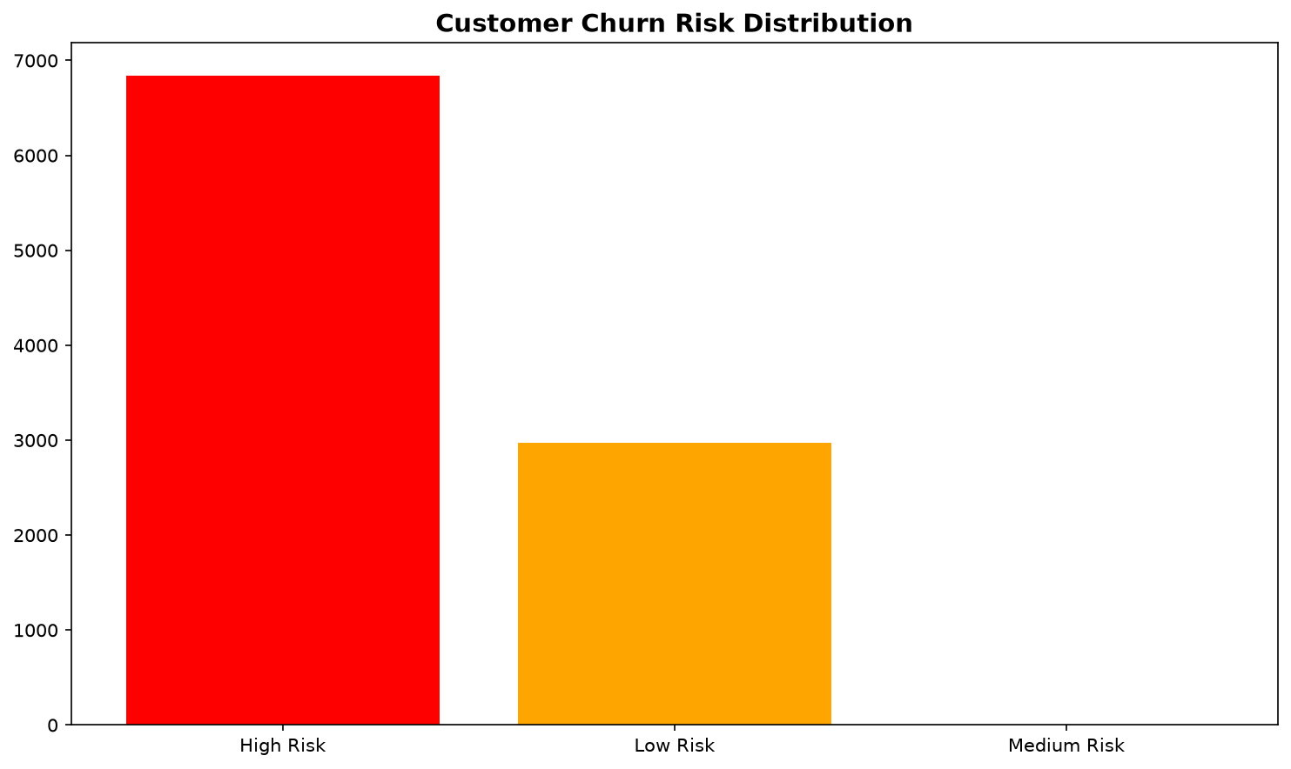

14. Churn Model Evaluation
Logistic Regression performance:
- Accuracy: 0.9827
- Precision: 1.0000
- Recall: 0.9749
- F1-Score: 0.9873

Highest-Risk Customers from Logistic Regression
CustomerID | ChurnProbability | RiskLevel
102042 | 1.00 | High Risk
109704 | 1.00 | High Risk
109577 | 1.00 | High Risk
105646 | 1.00 | High Risk
108948 | 1.00 | High Risk
109493 | 1.00 | High Risk
100689 | 1.00 | High Risk
105891 | 1.00 | High Risk
105892 | 1.00 | High Risk
104449 | 1.00 | High Risk
101318 | 1.00 | High Risk
106929 | 1.00 | High Risk
109733 | 1.00 | High Risk
104557 | 1.00 | High Risk
108056 | 1.00 | High Risk
103145 | 1.00 | High Risk
104767 | 1.00 | High Risk
108324 | 1.00 | High Risk
100987 | 1.00 | High Risk
103952 | 1.00 | High Risk

Logistic Regression Confusion Matrix
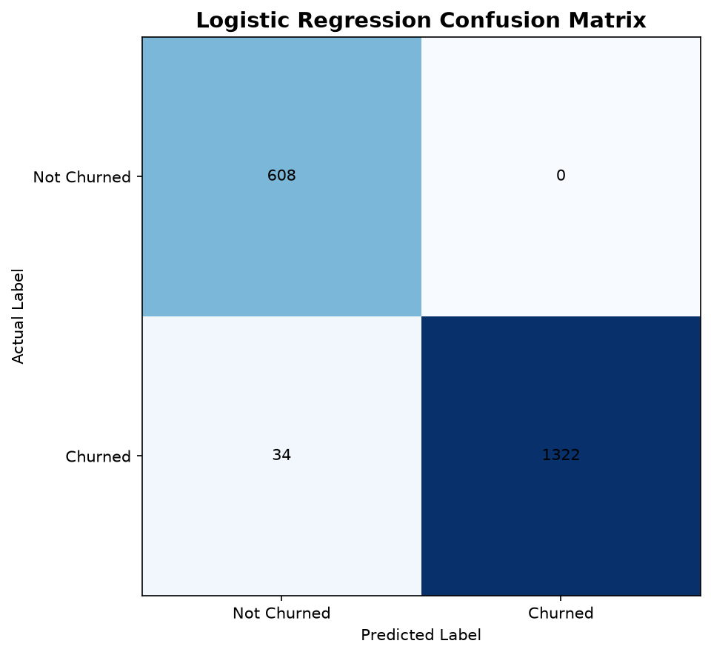

15. Business Conclusions
- Electronics is the leading category with sales of 1,751,491.00.
- Tehran has the highest city-level sales with 964,119.00.
- Headphones is the highest-selling product.
- VIP customers receive the highest average discount.
- Regular customers have the highest average order value.
- Customers with high recency should be targeted with retention campaigns.
- High-risk customers can receive personalized discounts and reminders.
- Cancelled orders should be monitored by category, especially in the categories with the highest cancellation counts.

