Supermarket Sales Analysis Report
SUPERMARKET SALES ANALYSIS REPORT
Reporting period: 2026-01-01 to 2026-07-01
Transactions analyzed: 500
Total sales: 244,411.08

Executive Summary
· Total Sales: ₹244,411.08
· Transactions: 500
· Average Transaction Value: ₹488.82
· Highest month: April — ₹52,569.77
· Highest category: Beverages — ₹56,108.24
· Highest city: Mumbai — ₹72,469.45
· Top product: Cheese — ₹27,906.30

1. MONTHLY SALES
Highest: 2026-04 — 52,569.77
Lowest: 2026-07 — 3,467.44
MONTH Sales
2026-01 43,415.53
2026-02 30,068.15
2026-03 37,306.42
2026-04 52,569.77
2026-05 42,542.31
2026-06 35,041.46
2026-07 3,467.44

2. SALES BY CATEGORY
Highest: Beverages — 56,108.24
Lowest: Bakery — 6,516.10
Category Sales
Beverages 56,108.24
Personal Care 45,943.96
Dairy 43,992.00
Grocery 40,470.47
Fruits 23,263.17
Snacks 16,992.97
Vegetables 11,124.17
Bakery 6,516.10

3. SALES BY GENDER
Highest: Female — 123,954.12
Lowest: Male — 120,456.96
Gender Sales
Female 123,954.12
Male 120,456.96

4. PAYMENT METHODS
Most used: UPI (127 transactions, 25.4%)
Least used: Cash (122 transactions, 24.4%)
Payment Count percentage
UPI 127 25.4%
Net Banking 126 25.2%
Card 125 25.0%
Cash 122 24.4%

5. CUSTOMER TYPES
Most common: Member (296 customers)
Least common: Normal (204 customers)
Customer type Count
Member 296
Normal 204

6. SALES BY CITY
City Sales
Mumbai 72,469.45
Delhi 64,116.26
Bengaluru 55,468.29
Jaipur 52,357.08

7. PRODUCT SALES
Top product overall: Cheese — 27,906.30
Highest month/product combination: Cheese in 2026-05 — 10,718.01
Lowest month/product combination: Tomato in 2026-05 — 43.78

8. TOP AND LOWEST-SELLING PRODUCTS BY CITY
Bengaluru: highest — Coffee (8,859.40); lowest — Eggs (370.20)
Delhi: highest — Coffee (10,613.18); lowest — Chips (279.88)
Jaipur: highest — Shampoo (6,919.41); lowest — Tomato (506.36)
Mumbai: highest — Cheese (11,590.73); lowest — Biscuits (641.62)

Monthly Sales Trend
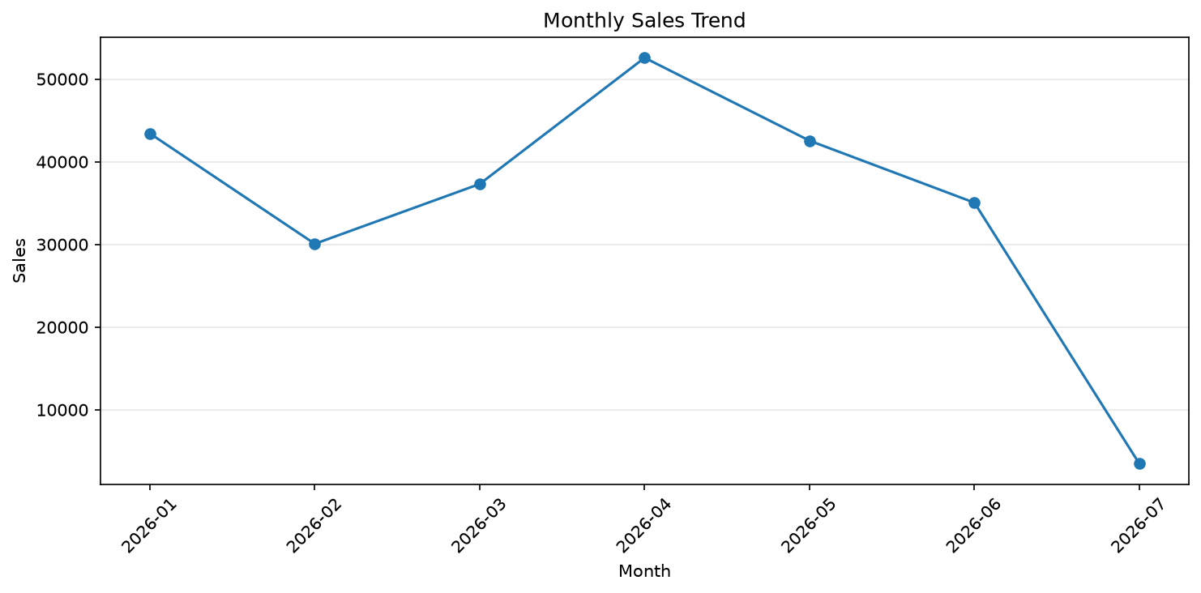

Sales by Category
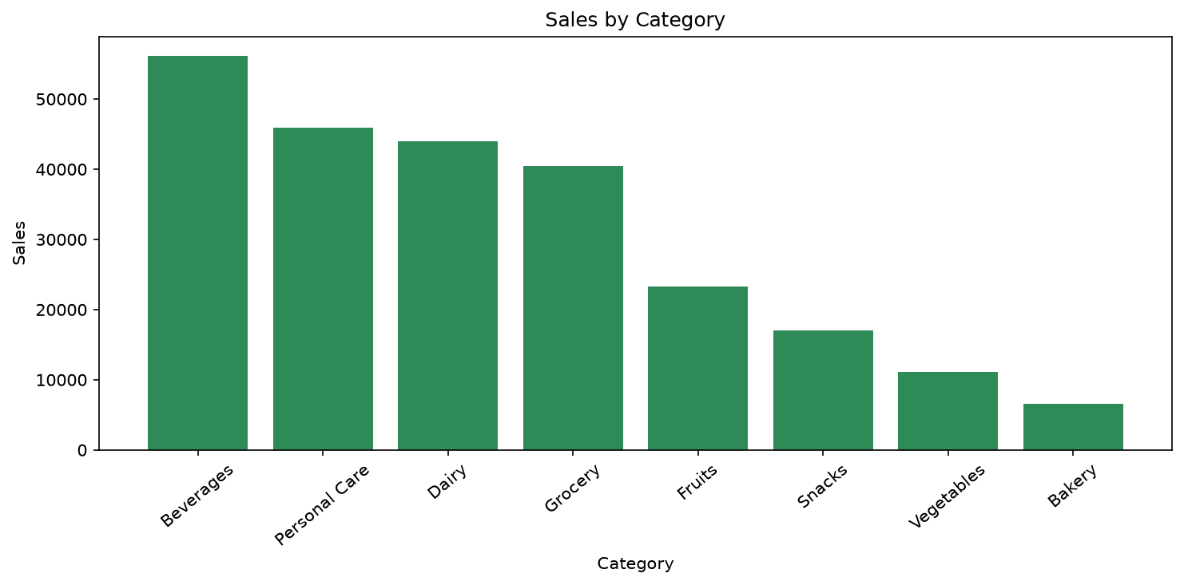

Sales Distribution by Gender
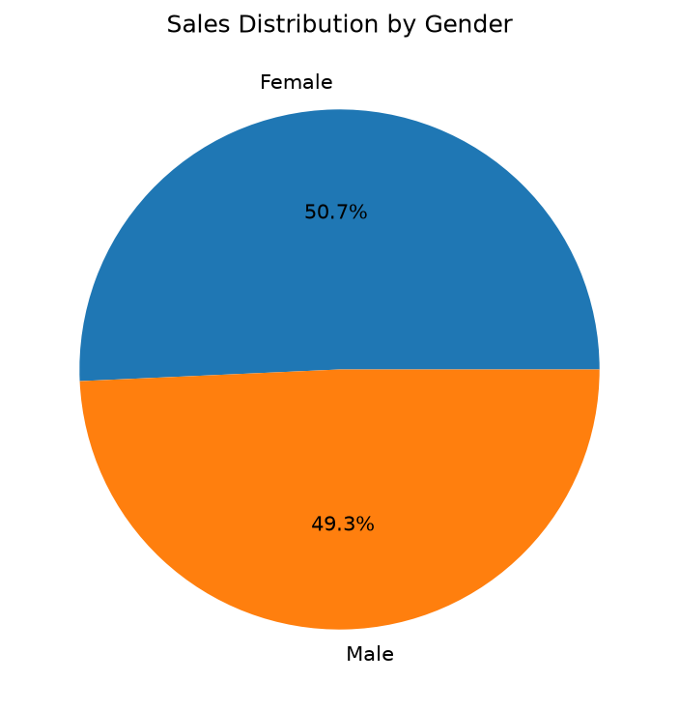

Payment Methods
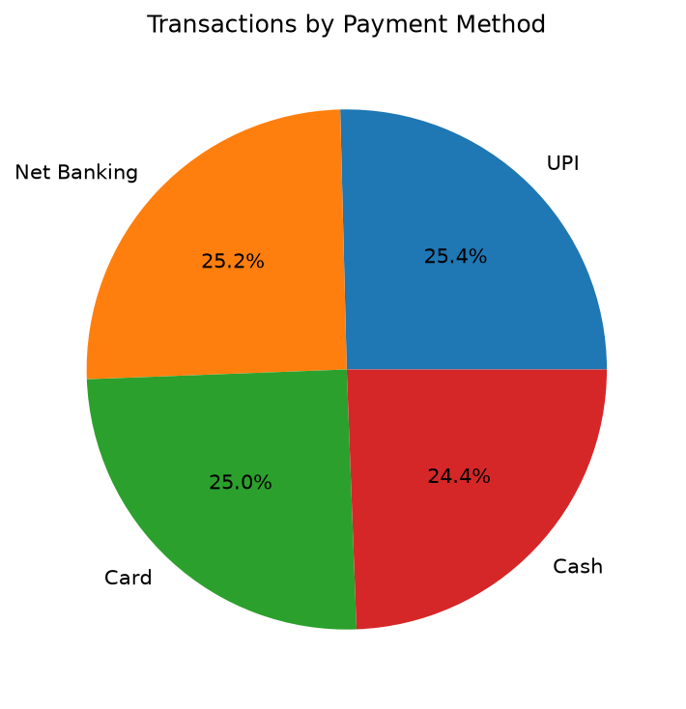

Customer Types
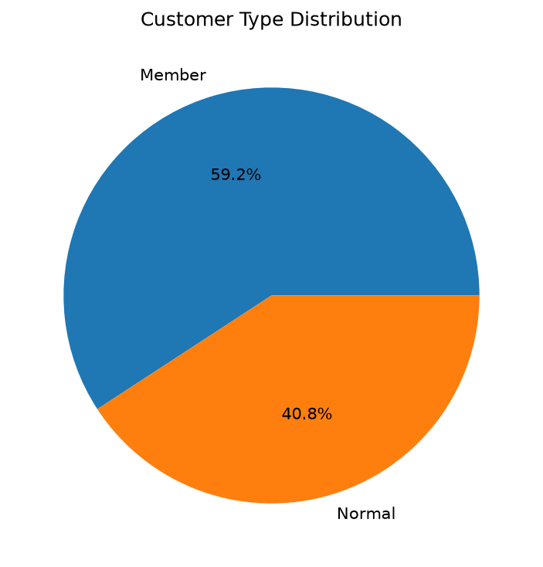

Sales by City
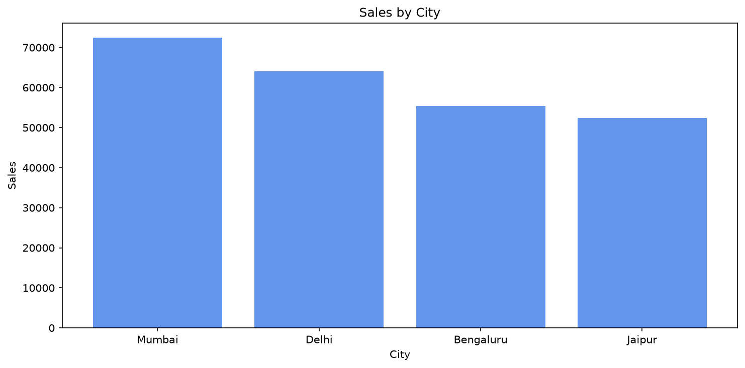

Top 10 Products by Sales
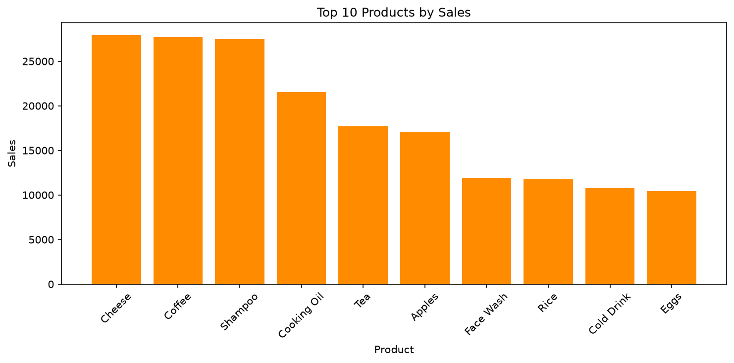

Top 10 Month–Product Sales
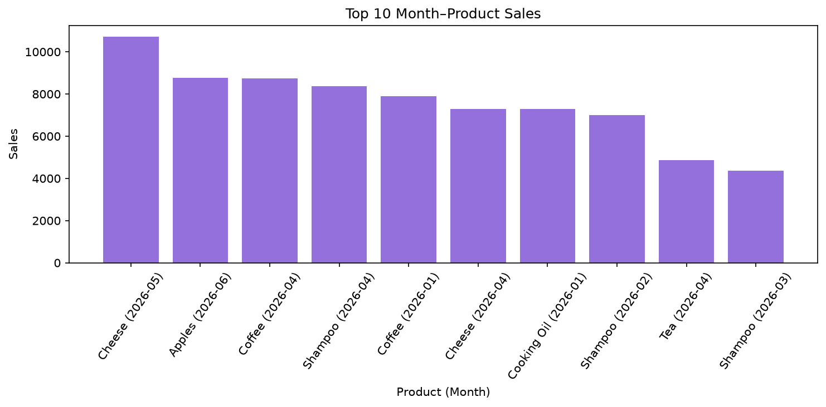

Product Sales in Bengaluru
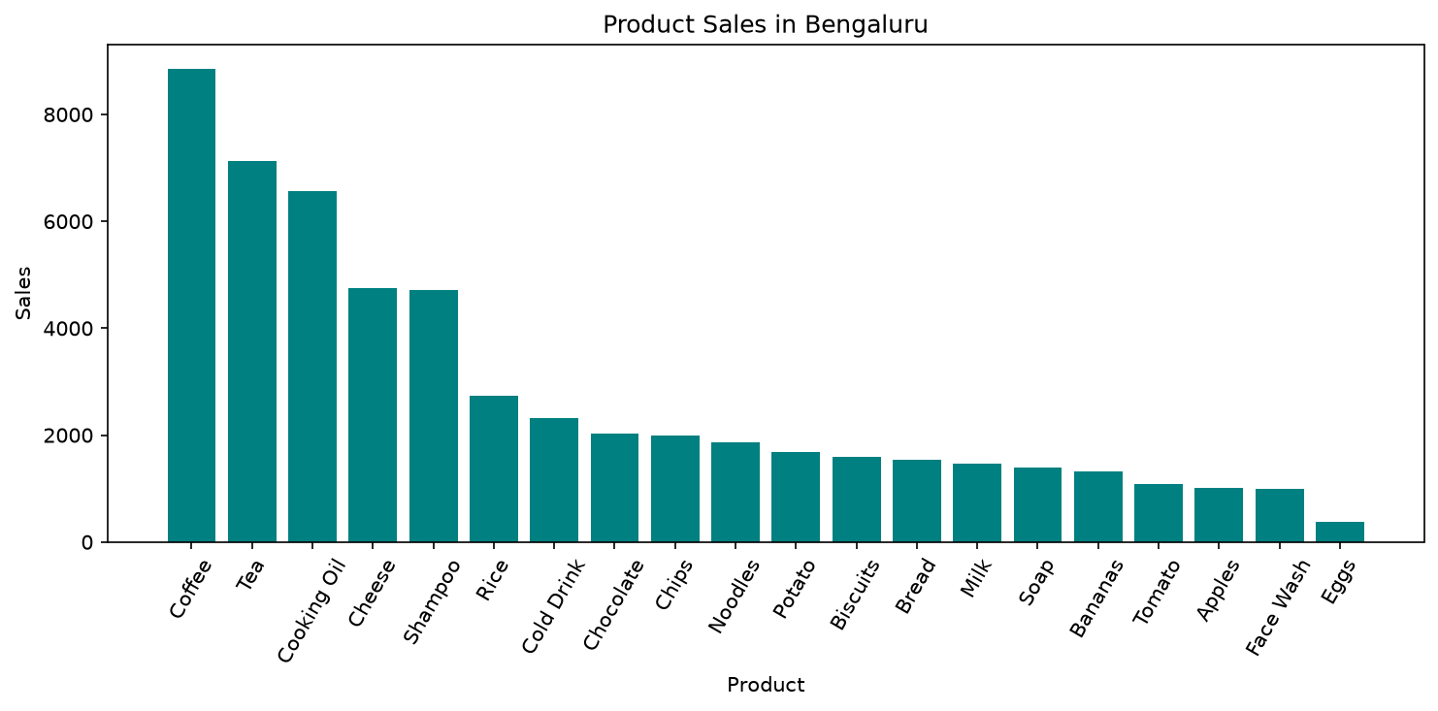

Product Sales in Delhi
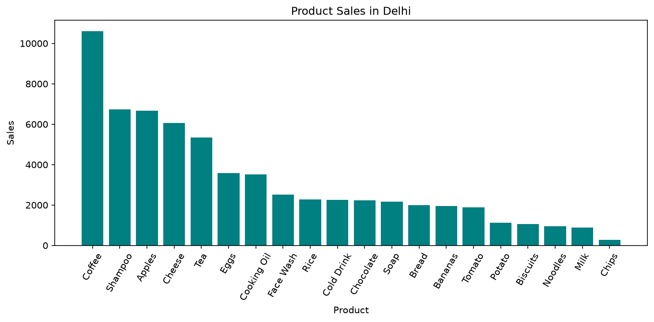

Product Sales in Jaipur
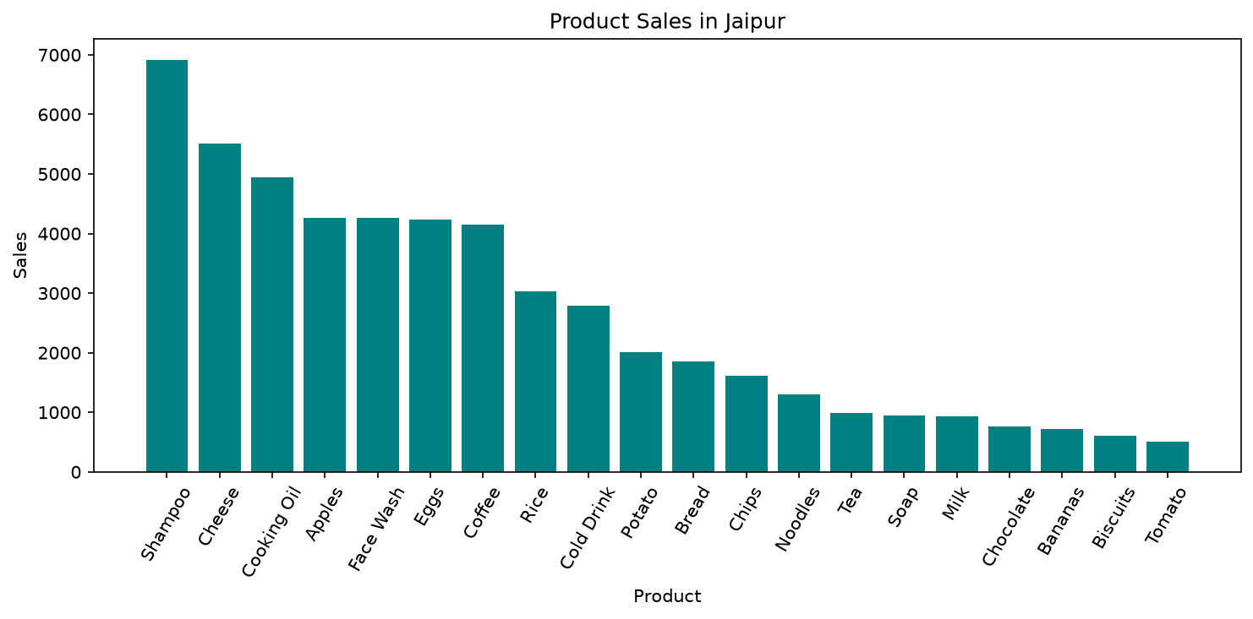

Product Sales in Mumbai
