School of Technology Management and Engineering
NMIMS, Chandigarh Campus



MAD Project Report
LIFE RPG
A gamified personal organisation app that turns everyday goals, routines, and progress into an RPG-style journey.
Platform: Android
Technology: Java, XML, SQLite

Submitted to:
Dr. Preetjot Kaur
Submitted by:
Ashna(D026), Reet(D009)

ABSTRACT
Life RPG is an Android application that helps users manage their daily tasks and personal goals in a fun way. It works like a game where users can create quests, complete tasks, earn XP and coins, and unlock achievements. The main aim of this application is to make daily activities more interesting and help users stay consistent with their goals.
The application includes features like login and registration, quest management, a goal tracker, a calendar with reminders, a Life Map, and a Knowledge Vault. It also allows users to check their progress, maintain streaks, complete challenges, and customize their experience. SQLite is used to store user details and other application data.
This project was developed using Android Studio and Java. Working on Life RPG helped us learn more about Android application development, database management, and user interface design. Overall, the application provides a simple and interactive way to organize daily tasks and track personal progress.

Acknowledgment
We would like to thank our faculty guide for guiding us throughout the development of our Life RPG project. Their suggestions and support helped us understand the different parts of the project and improve our work.
We are also thankful to our college and the Department of Computer Science for giving us the opportunity to work on this project as part of our Mobile Application Development subject.
While developing this application, we learned how to use Android Studio, Java, and SQLite to build a mobile application. We also got practical experience in designing screens, managing data, and adding different features to an application.
Finally, we would like to thank everyone who supported us and helped us complete this project successfully.

INDEX
S.no | Topic | Page no.
1. | Introduction | 5
2. | Objectives | 6
3. | Application features | 7 – 23
4. | Data Storage and implementation | 24
5. | Conclusion | 25

- Introduction
Life RPG is an Android application that makes daily tasks more interesting by turning them into a game. Users can create quests and goals, earn XP and coins, maintain streaks, unlock rewards, and check their progress. The main idea is to help users manage their daily activities and stay motivated to complete their tasks.
The application includes features like a Goal Tracker, calendar with reminders, Knowledge Vault, Life Map, and Life Gallery. Users can also take part in challenges, earn achievements, customize their experience, and manage their files. These features help users keep their tasks and important information organized in one place.
Life RPG was developed using Android Studio and Java, with SQLite used to store user details and other application data. While developing this project, we learned how to create an Android application, design its screens, manage a database, and connect different features. The project aims to make everyday planning easier and more enjoyable.

- Objectives
- To encourage consistency by turning tasks and goals into trackable activities.
- Provide a clear view of XP, levels, streaks, achievements, and completed work.
- Offer a reward system through coins, shop items, and personalisation options.
- Keep user-specific information stored locally in an SQLite database.
- Bring planning, memories, saved knowledge, and exportable records into app.
- To allow users to create, edit, complete, and manage their quests easily.
- To help users set personal goals and track their progress over time.
- To provide a calendar for managing important events and setting reminders.
- To allow users to save important locations using the Life Map feature.
- To provide a Knowledge Vault where users can save and manage useful notes into info.

- Application Features
The following sections describe the main modules. Screenshot spaces are included for you to insert your own app screenshots.

3.1 Registration and Login
Users can create an account and sign in using their credentials. The login screen validates the email and password fields and checks the stored account details. A “Remember Me” option can retain the user session between launches, while the account recovery screen allows a user to update a forgotten password.
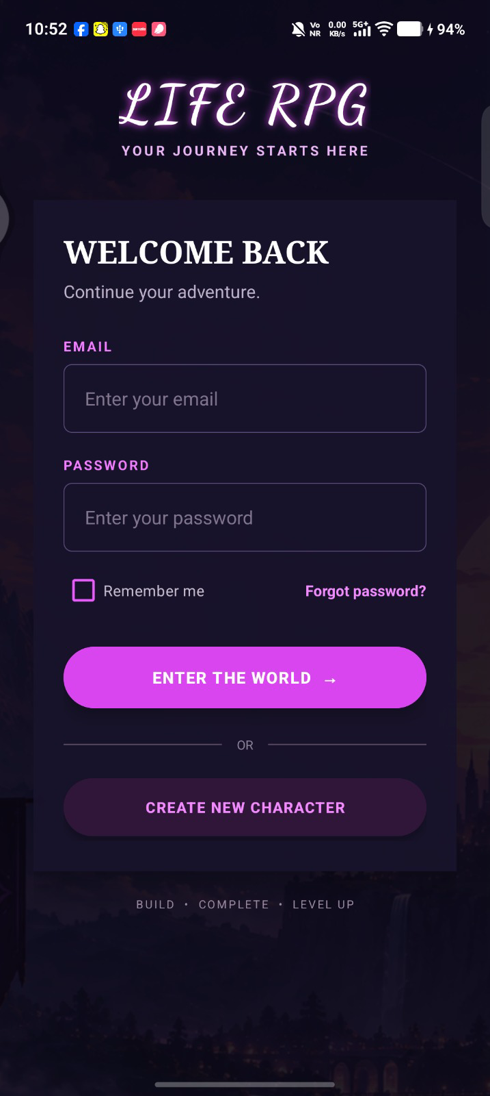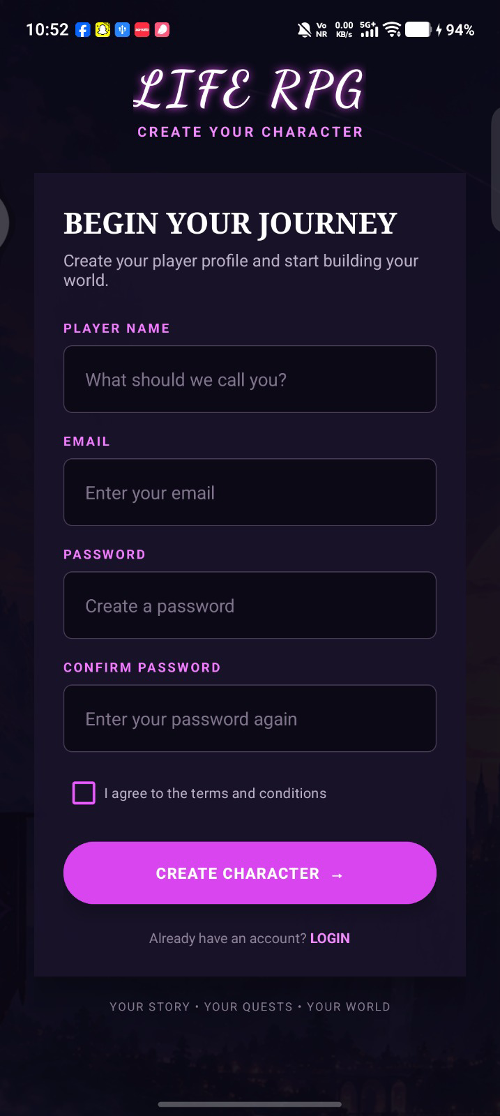

3.2 Home Dashboard
The dashboard acts as the central hub of Life RPG. It presents key player information and provides navigation to the app’s major modules, helping users move quickly between quests, progress, planning tools, and personal features.
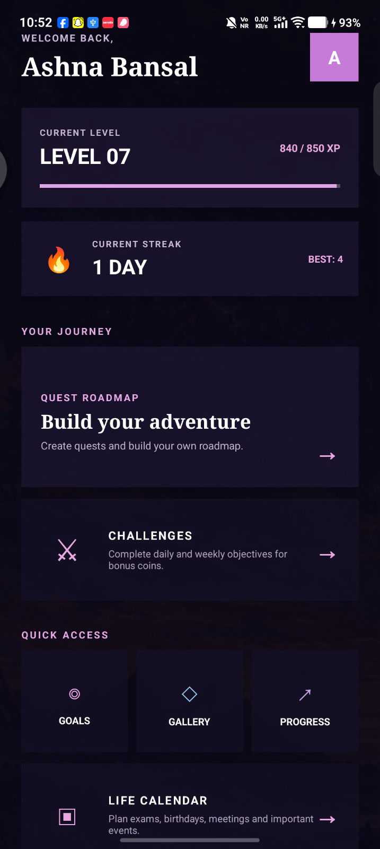

3.3 Quests and Quest Details
Quests represent tasks that users can work towards completing. The quest screens provide the information needed to understand a task and track its status. Completing activities can contribute to the app’s progression system, connecting day-to-day actions with XP and player advancement.
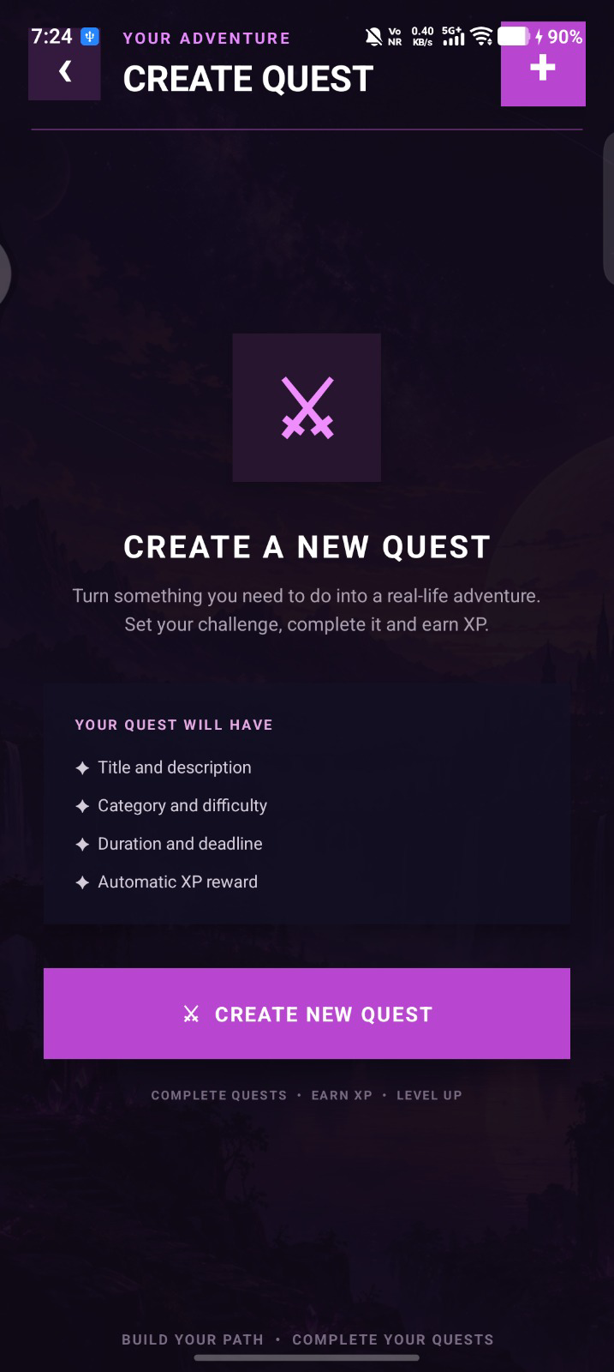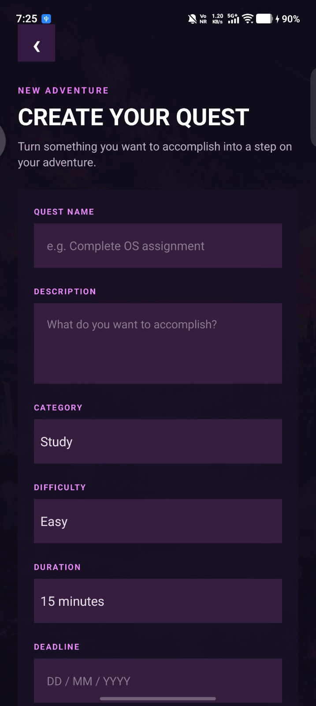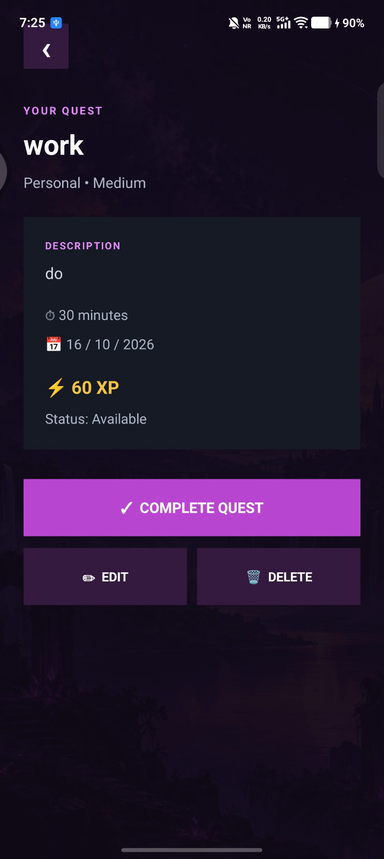

3.4 Life Roadmap
The roadmap presents quests as a visual path. Completed, available, and locked quests are shown with different states, allowing users to see their journey and what comes next. In the implemented flow, unlocking a locked quest uses in-app coins, and the roadmap displays overall quest completion progress.
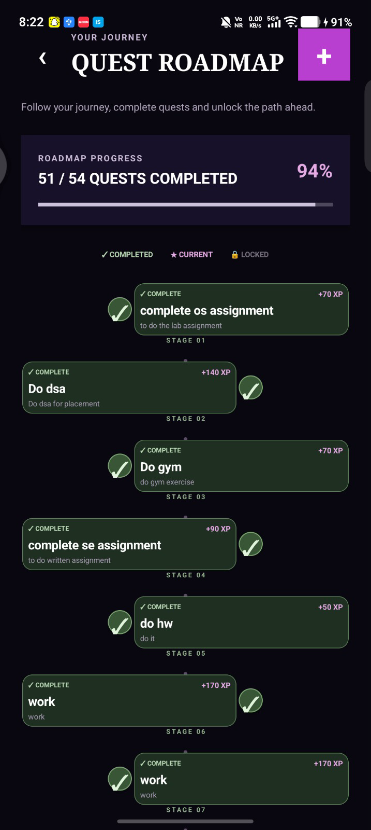

3.5 Challenges
The Challenges module adds short-term activities that give users additional structure and motivation. It provides a dedicated place to view challenges and engage with the app’s reward-based task system.
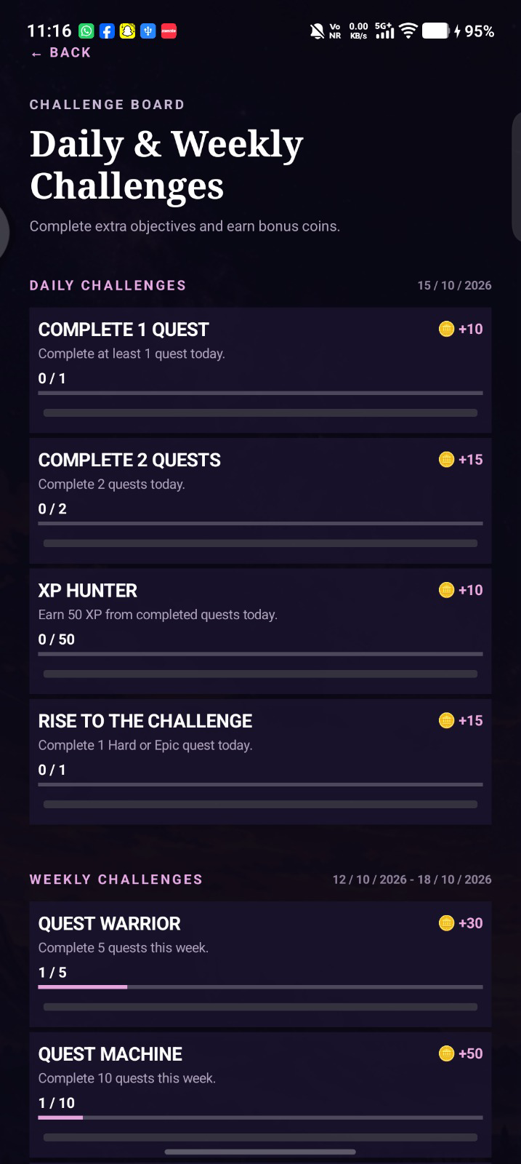

3.6 Goals Tracker
The Goals Tracker lets users create personal goals with details such as a title, category, and deadline. Each goal has a progress value that can be updated from 0% to 100%. The app displays goal counts and marks a goal as completed when its progress reaches 100%.
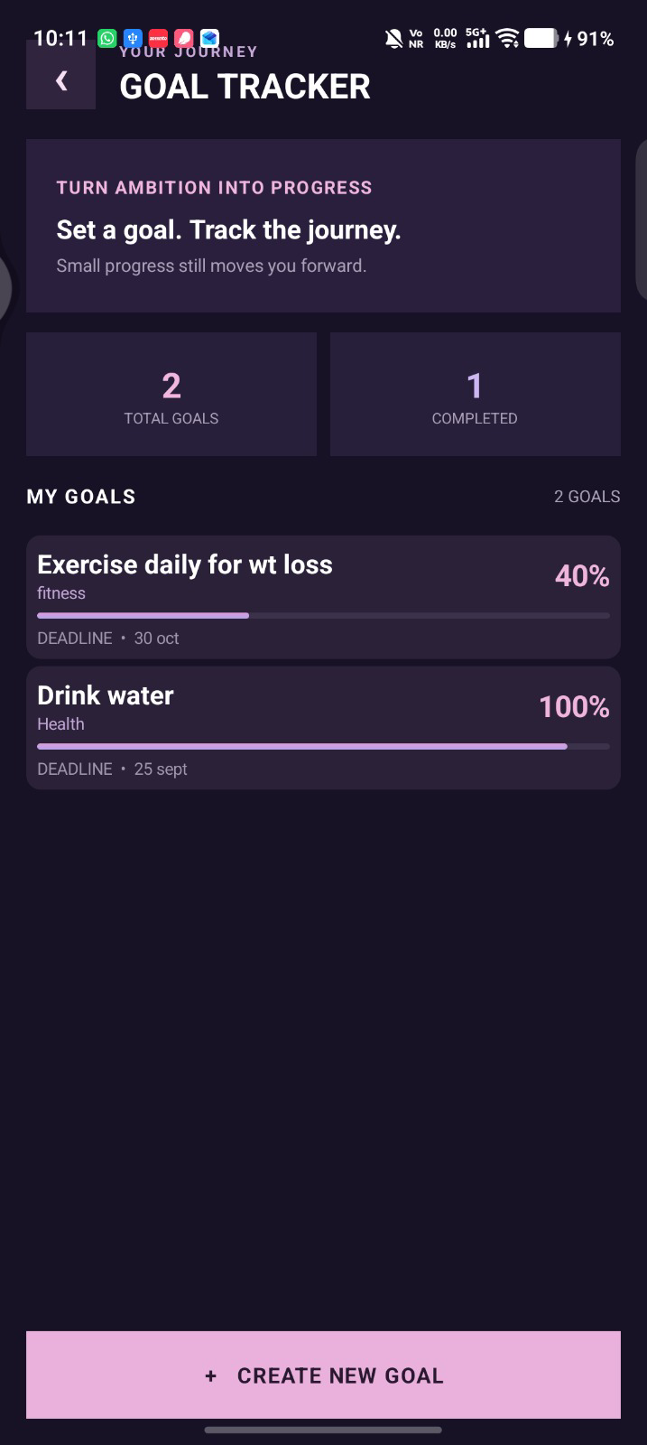

3.7 Progress and Statistics
The Progress screen brings together the user’s level and XP, quest completion totals, goal counts, streak information, and a history of completed quests. This gives users a summary of their activity rather than requiring them to check each module separately.
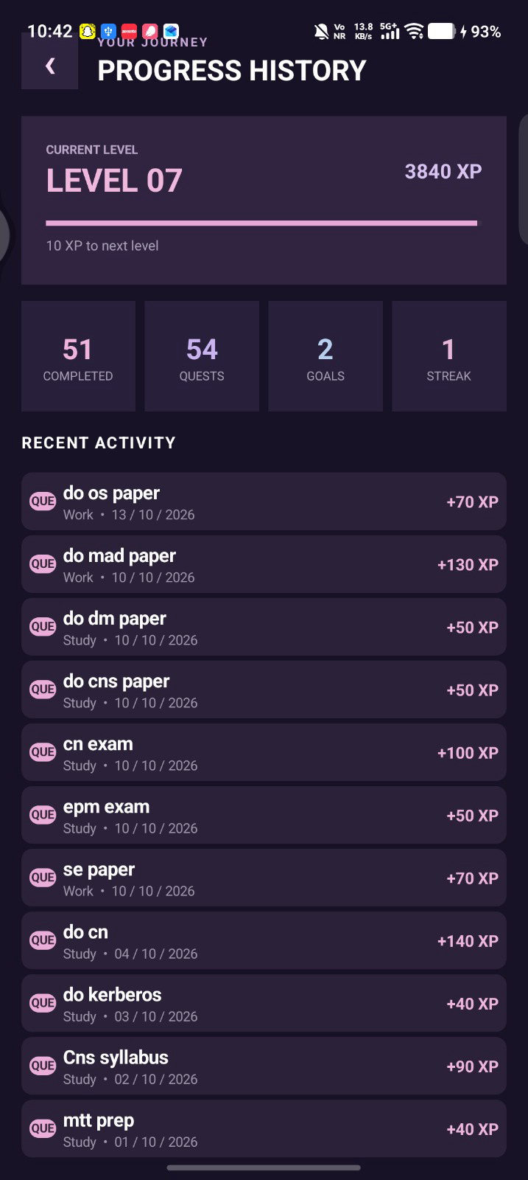

3.8 Achievements
The Achievements module recognises milestones and progress made within the app. It gives users a dedicated view of accomplishments, reinforcing the game-like structure and making progress easier to review.
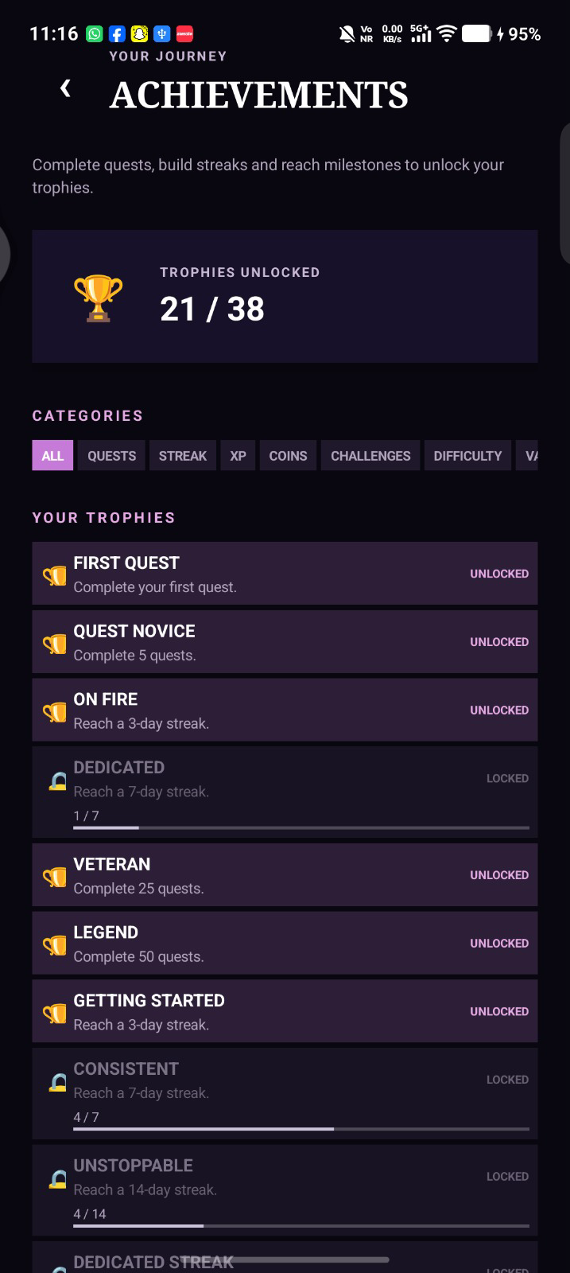

3.9 Coin Shop
The Shop uses the app’s coin-based reward system. Users can browse available items and spend earned coins on supported in-app rewards. This creates a link between completing activities and receiving customisable rewards.
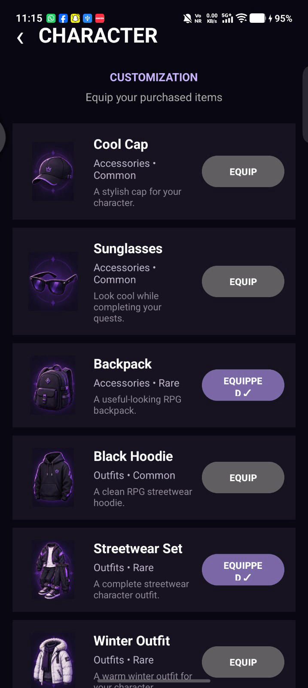

3.10 Customisation and Profile
The Profile area presents account-related information, while Customisation provides options for personalising supported aspects of the app. These modules make the experience more personal and provide a place to manage the player identity and preferences.
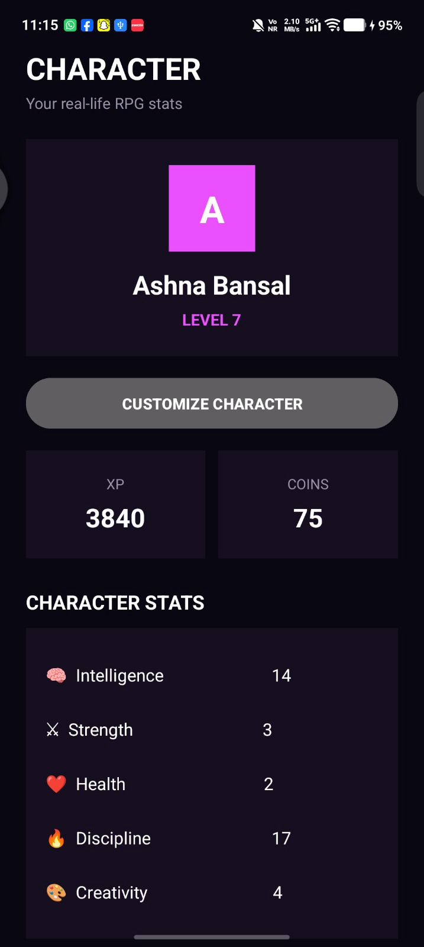

3.11 Calendar and Reminders
The Calendar module supports organising activities by date and reviewing scheduled items. Reminder-related functionality helps users keep track of planned events or tasks. Notification support is included so the app can use Android notification channels where required.
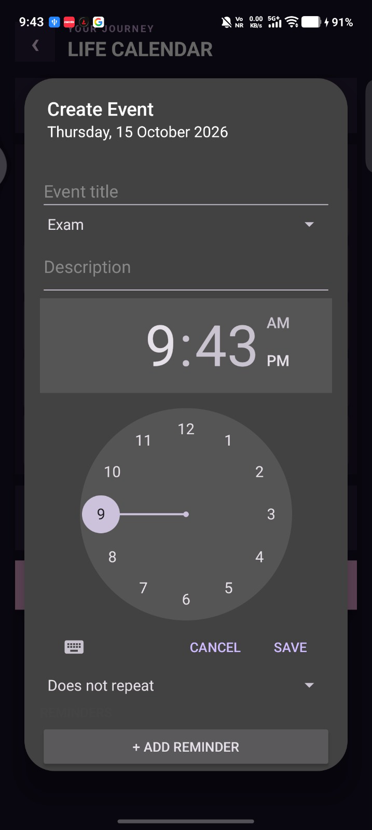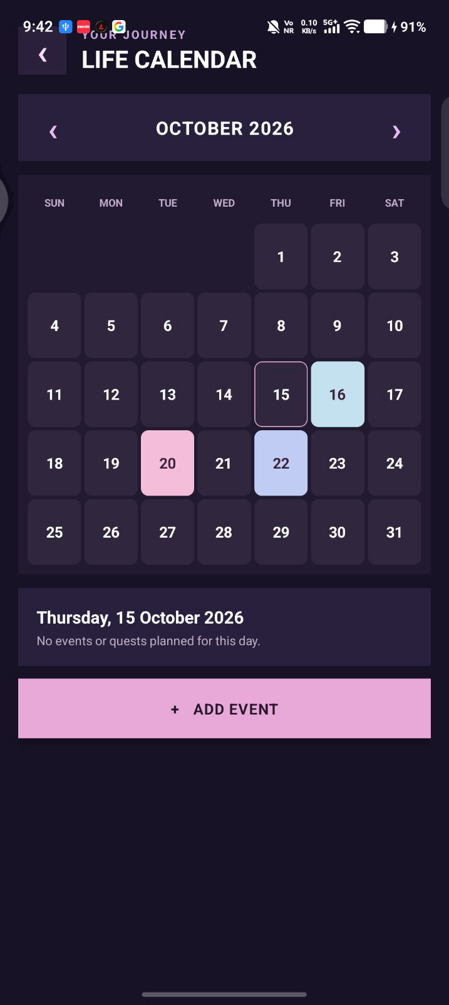

3.12 Knowledge Vault
The Knowledge Vault is a place to save and organise useful notes or learning material. Entries can be grouped by category, searched, and marked for reference, favourites, or learning status where supported. This helps keep information the user wants to revisit inside the app.
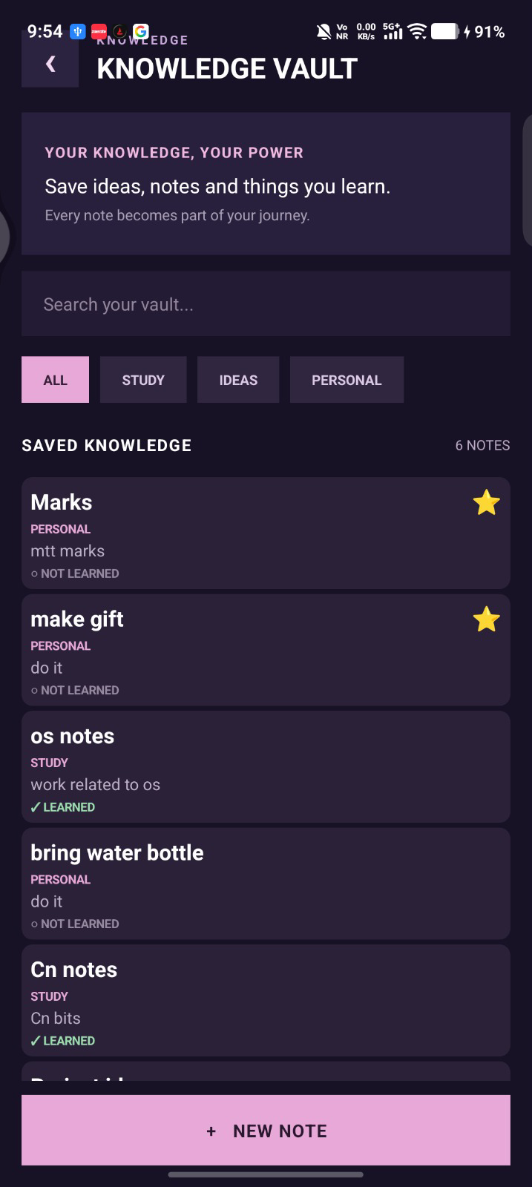

3.13 Life Map
Life Map provides a location-oriented space for saving and viewing meaningful places. The map interface helps users associate locations with personal plans or memories and manage saved place information within the feature.
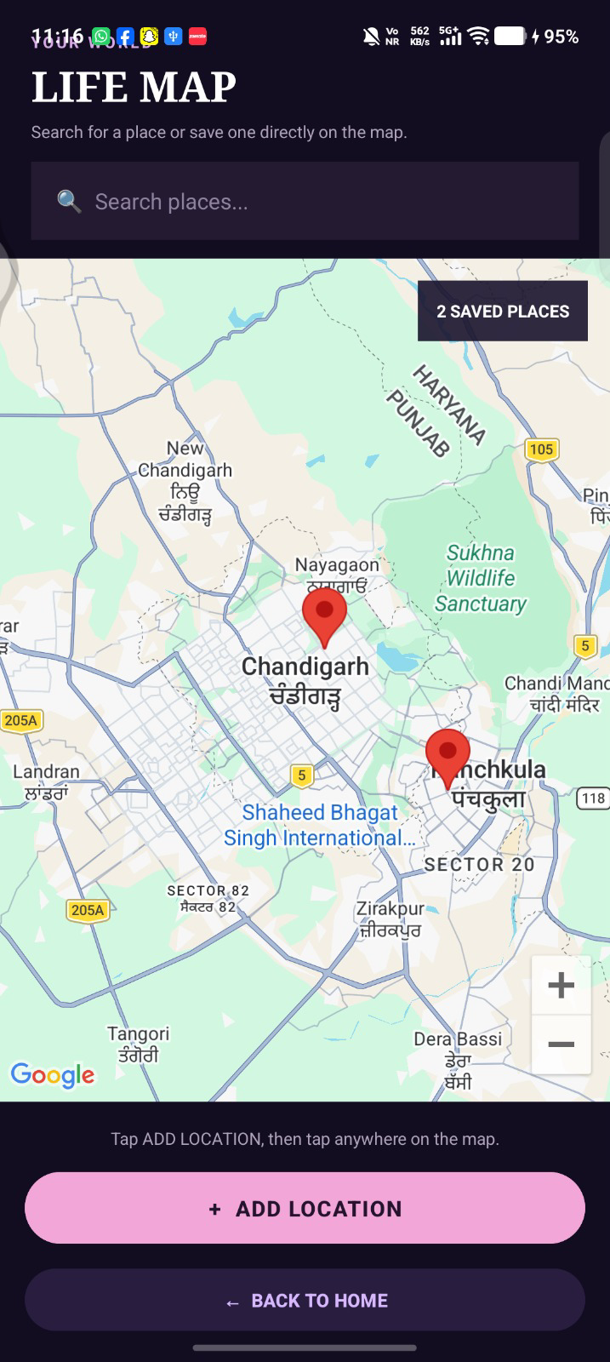

3.14 Life Gallery
Life Gallery is intended for keeping personal memories and images together. It provides a dedicated space to revisit saved visual moments, making the app useful for personal reflection in addition to task management.
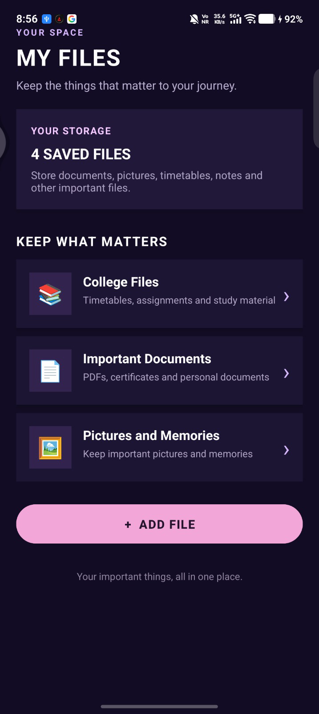

3.15 Files and Data Export
The Files/Data Export feature lets users export app records for use outside the application. The implementation can generate a text export and package multiple CSV data files into a ZIP archive. Android’s system file picker lets the user choose where to save the exported file.
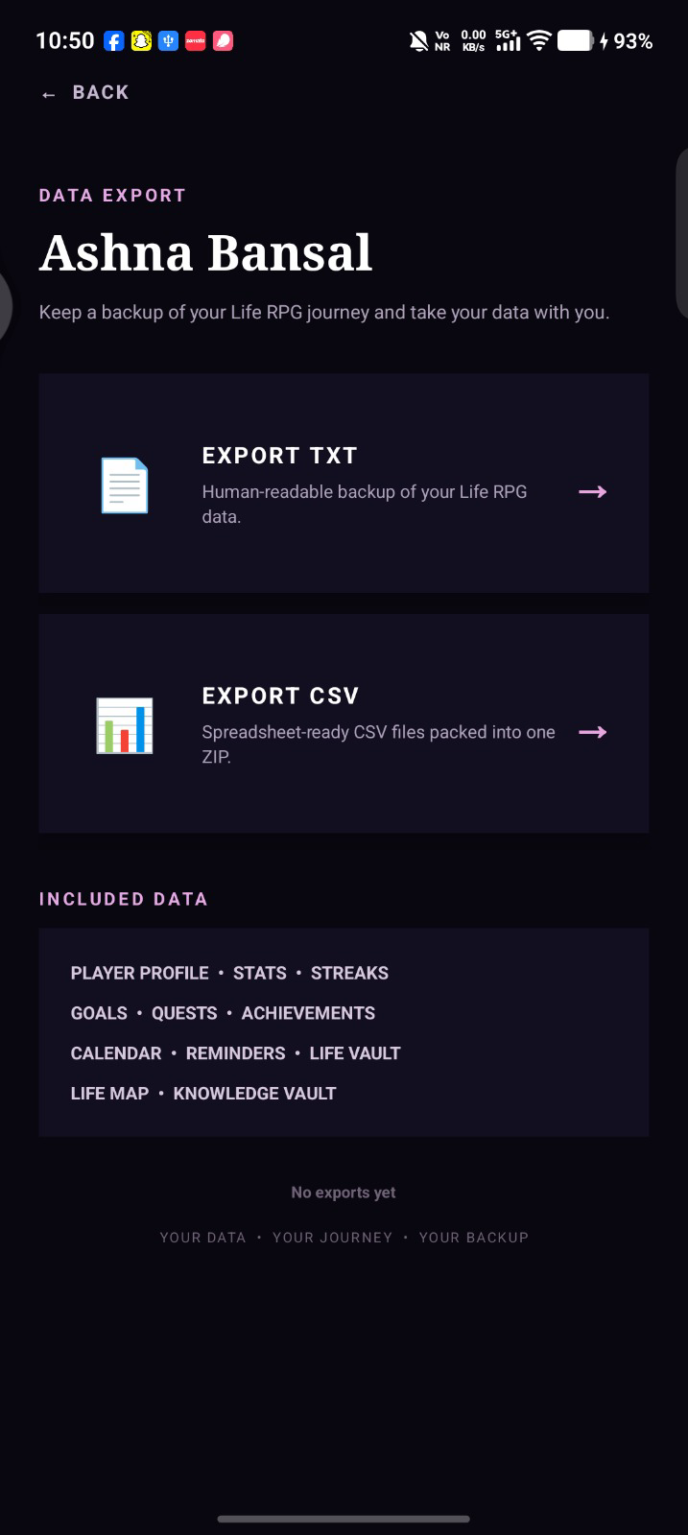

3.16 Notifications
The notification support code creates an Android notification channel on supported Android versions. A channel defines how app notifications are grouped and displayed by the operating system; creating the channel alone does not send a notification.
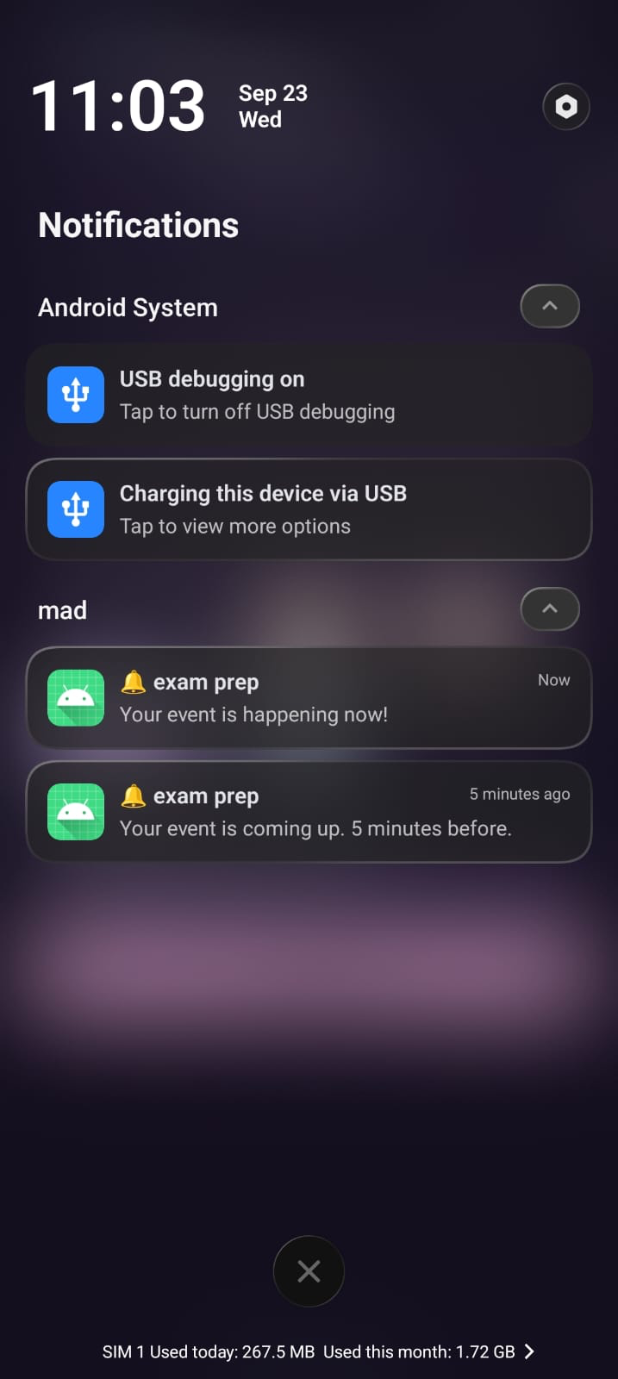

4. Data Storage and Implementation
The app uses Java for application logic and XML for screen layouts. SQLite is used to store structured information such as user records, quests, goals, and other feature data. Database operations are performed through the project’s database helper and SQLite queries. Activities pass relevant identifiers between screens so that the app can display information associated with the current user.
The export feature uses Android’s Storage Access Framework to let the user select a destination. The app then writes the prepared text or CSV content through output streams; CSV files can be packaged together with a ZIP output stream.
The app is divided into different screens, with each screen handling a particular feature. This makes the app easier to use and keeps the code organised. Buttons and other user actions are handled using Java code, which connects the screen to the required functions.
The app also checks the information entered by the user before saving it to the database. This helps avoid empty or incorrect entries. When the user adds, updates, or views information, the app uses the database to show the latest saved data.

5. Conclusion
Life RPG combines task management and personal organisation with game-inspired progression. Quests, goals, XP, levels, coins, challenges, achievements, and rewards are intended to make consistency more engaging, while the calendar, Knowledge Vault, Life Map, Life Gallery, and export tools support everyday planning and record keeping. The project demonstrates Android activity navigation, local database operations, form validation, progress tracking, and file export in a single application.
Overall, Life RPG aims to make daily tasks easier to manage by turning them into small challenges with clear progress and rewards. It brings different features together in one place, so users can manage their goals, save important information, and track their progress without switching between multiple apps. The project also provides scope for future improvements, such as adding more customisation options and making the user experience even better.

