**MD. ASIQ KHAN**

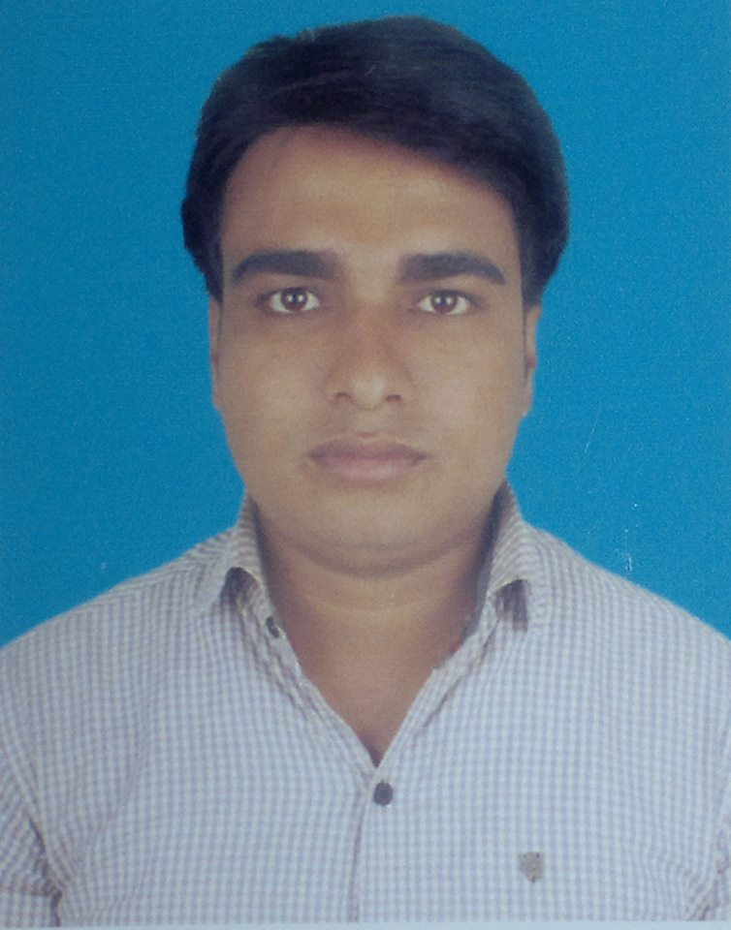

Diploma in Computer Engineering.

**Cell: 01726 97 94 26.**

**E-mail: ctashiqkhan@gmail.com**

**Career Objective:**

I’m the very fresher web programmer in PHP(Laravel) and also confidential web designer. I will try to learning new concept every time and practice programming side always. So, I’m try to better career establish in web Developing.

**Summary of Skills:**

* Two years of professional experience as a PHP Developer
* Two years’ experience of (cPanel).
* Excellent knowledge of developing web services and relational databases
* Passionate about giving best design and following coding practices
* Familiar with web development and content management systems
* Good in managing time and organizing tasks
* Career oriented, hardworking and ability to handle multiple tasks
* Quick learner and ability to learn new concepts

**Technical Skills:**

* Extensive knowledge of HTML/CSS, Bootstrap, PHP.
* MySQL, JavaScript, jQuery.
* Good knowledge of object oriented programming using language PHP.
* Database knowledge includes MySql.
* Framework: Laravel.
* Operating System: Windows (7, 8.1, 10).
* Microsoft Office.

**Educational Qualifications:**

**Diploma in Engineering:**

**Institution :** Bogra Polytechnic Institute, Bogra.

**Board :** BTEB.

**Department :** Computer.

**Session :** 2013-14.

**Result :** CGPA 3.22 (Out of 4).

**Secondary School Certificate (S.S.C):**

**Institution :** Janakalyan Model High School, Naogaon.

**Board :** Rajshahi Education Board**.**

**Group :** Arts.

**Passing year :** 2013.

**Result :** GPA 4.94 (Out of 5).

**Internship and work experience:**

**Course :** Web Development(Laravel), C#.

**Institution :** IT Q Solutions.

**Project I've recently completed:**

1.Paperless Office(staff.bograpoly.gov.bd).

2. Web Design(shastho-sheba.com).

**Personal Details:**

**Full Name :** Md. Asiq Khan.

**Father’s Name :** Md. Ansar Ali.

**Mother’s Name :** Mst. Nazma Begum.

**Present Address :** Moddho Durgapur, Naogaon.

**Permanent Address :** Moddho Durgapur, Naogaon.

**Date of Birth :** 28th November, 1998.

**Nationality :** Bangladeshi (By Birth).

**Religion :** Islam.

**Marital Status :** Single.

**Weight :** 77 Kg.

**Height :** 5 Feet 7 Inch.

**Cell Phone :** 01726-979426.

**E-mail :** ctashiqkhan@gmail.com.

**Language Proficiency :** Bengali and English.

**Hobbies:** Radio Jockeying, Football, Poet, novel.

**References:**

|  |  |
| --- | --- |
| **1. Md. Azizul Aman Al-Amin**  Head of computer Dept.  Bogra Polytechnic Institute.  Cell: 01712-685203. | **2. Mohammad Ali**  Junior Instructor of Computer Dept.  Bogra Polytechnic Institute.  Cell: 01712-710603. |