CHAPTER-3
ASSESSMENT OF
ON JOB TRAINING – 2

3.1 INTRODUCTION AND KEY OBJECTIVES
Introduction:
Water is one of the most important natural resources required for human survival. Access to safe and clean drinking water is essential for maintaining good health and preventing water-borne diseases. However, due to pollution, industrial waste, agricultural chemicals, and environmental factors, water quality can become unsafe for consumption.
Water quality is determined by several physical and chemical parameters such as pH, hardness, dissolved solids, chloramines, sulfate, conductivity, organic carbon, trihalomethanes, and turbidity. Monitoring these parameters helps in identifying whether water is safe for drinking.
In this project, a Water Quality Prediction System is developed using Machine Learning techniques. The system analyzes water quality parameters and predicts whether the water is potable (safe for drinking) or non-potable (unsafe for drinking). Machine learning algorithms such as Decision Tree and K-Nearest Neighbors (KNN) are used to build the prediction model.

Objectives:
- The main objectives of the Water Quality Prediction System are:
- To analyze water quality data using various physical and chemical parameters.
- To perform exploratory data analysis for understanding patterns and relationships in the dataset.
- To build machine learning models to predict whether water is safe for drinking or not.
- To compare the performance of different machine learning algorithms such as Decision Tree and K-Nearest Neighbors.
- To improve prediction accuracy using hyper parameter tuning techniques.

3.2 TOOLS/PLATFORM, HARDWARE AND
SOFTWARE SPECIFICATION
3.2.1. Hardware Requirements
- Computer / Laptop with minimum 4 GB RAM
- Processor: Intel i3 or higher
- Hard Disk: Minimum 10 GB free storage
- Internet Connection (for downloading dataset and libraries)
Software Requirements
- Operating System: Windows 10 / Windows 11
- Programming Language: Python
- IDE / Environment: Jupyter Notebook
- Libraries Used: NumPy, Pandas, Matplotlib, Scikit-learn
- Dataset Source: Kaggle

3.3 REPORT ON: ON JOB TRAINING -2(OJT2)
“Water Quality Prediction System” is used to analyze different parameters of water and determine whether the water is safe for drinking. The system uses a dataset that contains various water quality parameters such as pH, hardness, solids, chloramines, sulfate, conductivity, organic carbon, trihalomethanes and turbidity. These parameters help in identifying the quality of water.
The system loads the dataset and processes the data using Python libraries. The analysis and visualization of data are performed in Jupyter Notebook. Based on the analysis, the system predicts whether the water is potable or not. The results are displayed through graphs and output results.
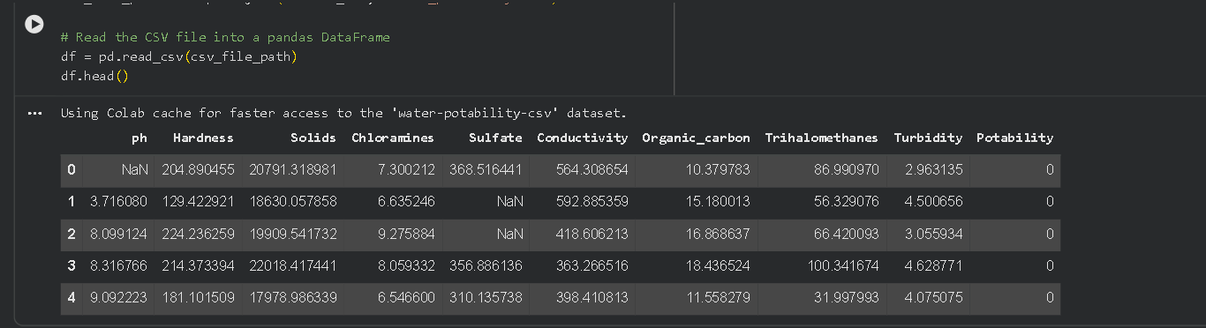
Fig 3.1: Water Quality Dataset
3.3.1 Dataset and Parameters
The dataset used in this project contains several attributes related to water quality. These parameters are used to analyze and predict whether the water is potable or not.
Fig 3.2: Water Quality Parameters
3.3.2 Technology Stack
The Water Quality Prediction System is developed using Python programming language. The project is implemented in Jupyter Notebook. Various Python libraries are used to perform data analysis, visualization and prediction of water quality.

Front-end:
Jupyter Notebook: Jupyter Notebook is an interactive environment used for writing and executing Python programs. It allows users to combine code, text and graphical outputs in a single document. It also supports visualization of graphs and analysis results. In this project, Jupyter Notebook is used to run the code and display graphs related to water quality parameters.
Matplotlib: Matplotlib is a Python library used for creating graphs and charts. It helps in visualizing the water quality parameters through different types of graphs which makes the analysis easier.

Back-end:
Python: Python is used as the main programming language for implementing the Water Quality Prediction System. It is widely used for data analysis, machine learning and scientific computing. Python helps in processing the dataset and performing the prediction of water quality.
Pandas: Pandas is a powerful data analysis library used for handling and analyzing structured data. It provides data structures such as DataFrames which help in loading, cleaning and analyzing the water quality dataset.
Scikit-learn: Scikit-learn is a machine learning library used for building prediction models. In this project, it is used to train the model and predict whether the water is potable or not.

Database:
Dataset(CSVFile):
The dataset used in this project acts as the data source for the system. The water quality dataset contains different parameters such as pH, hardness, solids, chloramines, sulfate, conductivity, organic carbon, trihalomethanes and turbidity. These parameters are stored in a CSV file and used for analysis and prediction in the system.
3.4 Data Visualization
Data visualization helps in understanding the water quality dataset easily. Different graphs are generated to analyze the distribution and relationship between water quality parameters using Jupyter Notebook.
3.4.1 Potability Count Analysis
- This graph shows the number of potable and non-potable water samples.
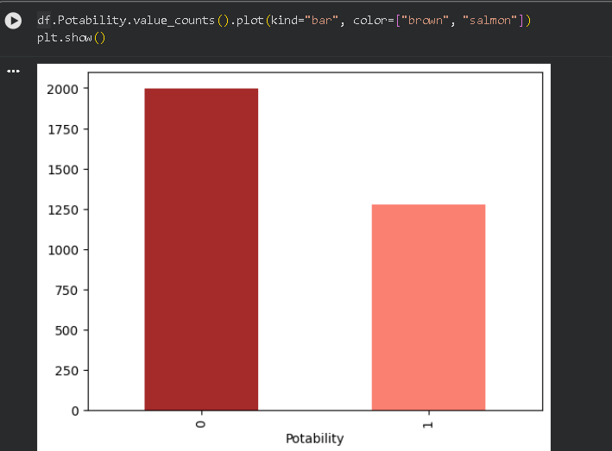
Fig 3.3: Potability Count Bar Graph

3.4.2 pH Distribution
- This graph shows the distribution of pH values in the dataset.
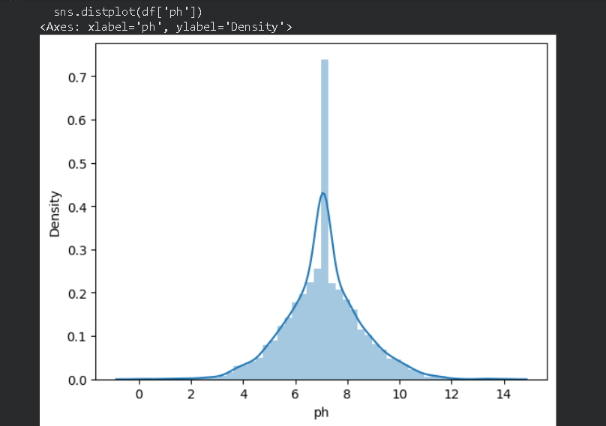
Fig 3.4: Distribution Plot of pH Values
3.4.3 Histogram Analysis
- This graph shows the distribution of different water quality parameters.
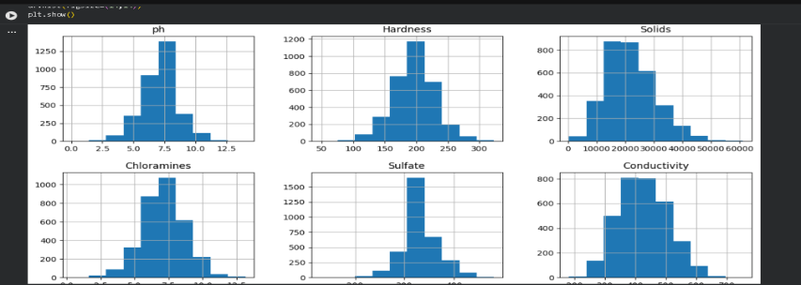
Fig 3.5: Histogram of Water Quality Dataset
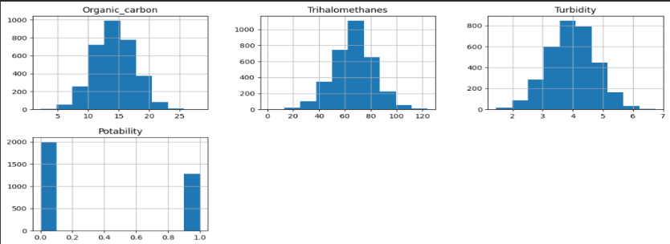

3.4.4 Pairplot Analysis
- This graph shows the relationship between different water quality parameters.
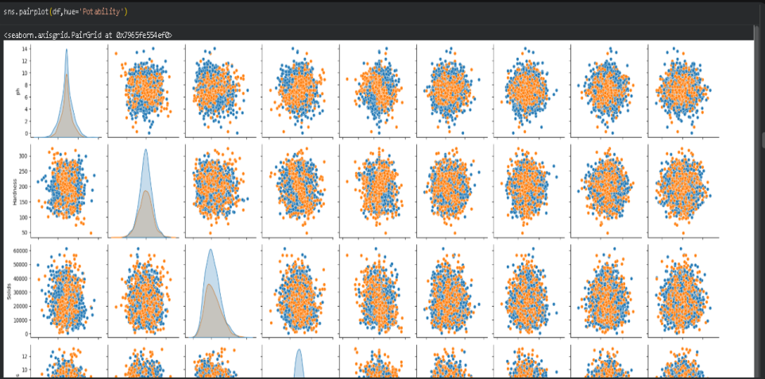
Fig 3.6: Pairplot of Water Quality Parameters
3.4.5 Hardness Scatter Plot
- This graph shows the distribution of hardness values.
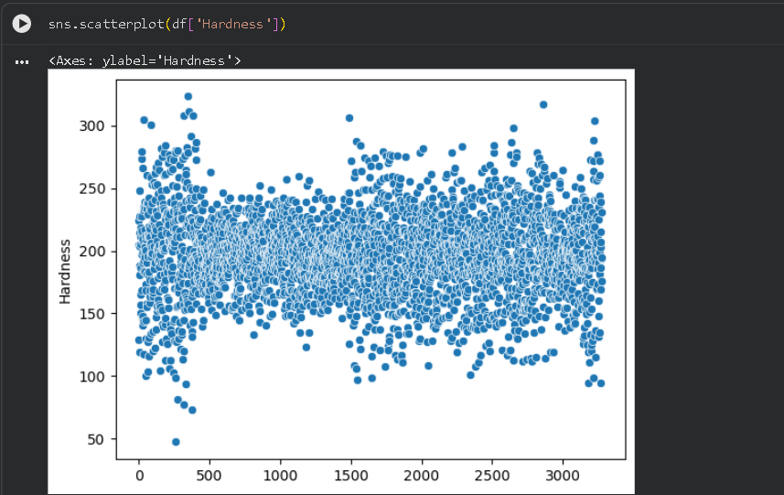
Fig 3.7: Scatter Plot of Hardness Parameter

3.4.6 Potability Scatter Plot
- This graph represents potable and non-potable samples.
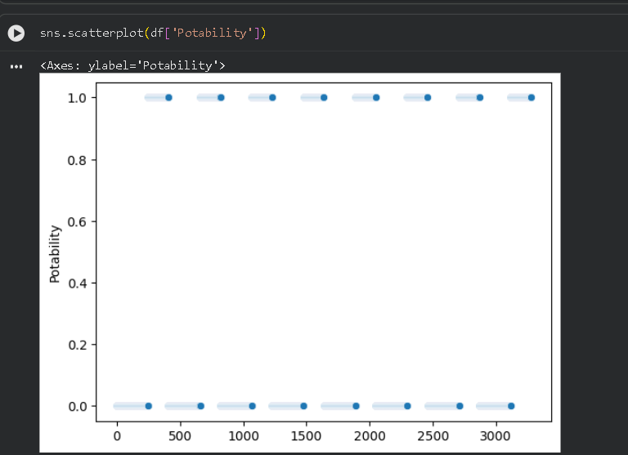
Fig 3.8: Scatter Plot of Potability
3.4.7 Correlation Heatmap
- This graph shows the correlation between different parameters.
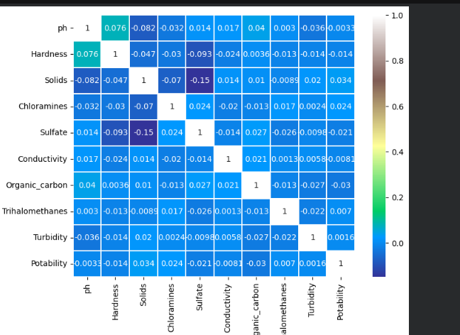
Fig 3.9: Correlation Heatmap of Water Quality Parameters

3.4.8 Box Plot Analysis
- This graph shows the variation of water quality parameters.
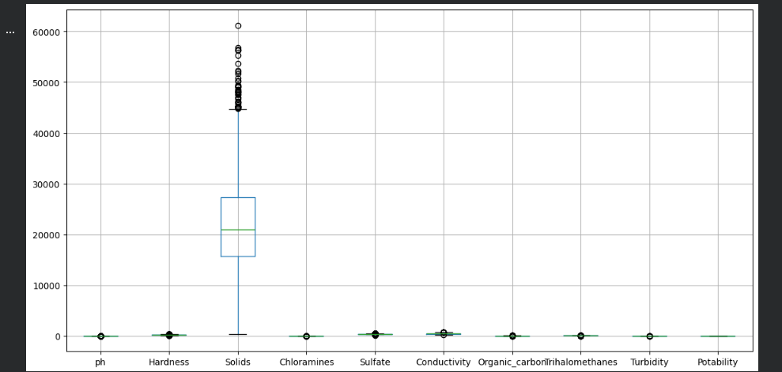
Fig 3.10: Box Plot of Water Quality Dataset
3.5 Result Analysis
The Water Quality Prediction System analyzes the dataset using different water quality parameters such as pH, hardness, solids, chloramines, sulfate, conductivity, organic carbon, trihalomethanes and turbidity. The graphs generated from the dataset help in understanding the distribution and relationship between these parameters.
Based on the analysis and visualization, the system identifies whether the water samples are potable or non-potable. The graphical representations help in better understanding of the dataset and provide clear insights about water quality.

