**Industrial Internship Report on**

**Wireless communication**

**Prepared by**

**ASHIKA C H**

|  |
| --- |
| *Executive Summary* |
| This report provides details of the Industrial Internship provided by upskill Campus and The IoT Academy in collaboration with Industrial Partner UniConverge Technologies Pvt Ltd (UCT).  This internship was focused on a project/problem statement provided by UCT. We had to finish the project including the report in 6 weeks’ time.  My project was wireless communication  This internship gave me a very good opportunity to get exposure to Industrial problems and design/implement solution for that. It was an overall great experience to have this internship. |

**TABLE OF CONTENTS**

1. Preface 3
2. Introduction 4
   1. About UniConverge Technologies Pvt Ltd 4
   2. About upskill Campus (USC) 8
   3. The IoT Academy 9
   4. Objectives of this Internship program 10
   5. Reference 10
   6. Glossary 10
3. Problem Statement 11
4. Existing and Proposed solution 12
   1. Code submission: https://github.com/ashika-ch/sturdy-space-capybara 14
   2. Report submission: first make placeholder, copy the link. 14
5. Proposed Design/ Model 15
   1. Interfaces (if applicable) 17
6. Performance Test 20
   1. Test Plan/ Test Cases 22
   2. Test Procedure 24
   3. Performance Outcome 27
7. My learnings 29

# Preface

Summary of the whole 6 weeks’ work.

About need of relevant Internship in career development.

Brief about Your project/problem statement.

Opportunity given by USC/UCT.

How Program was planned

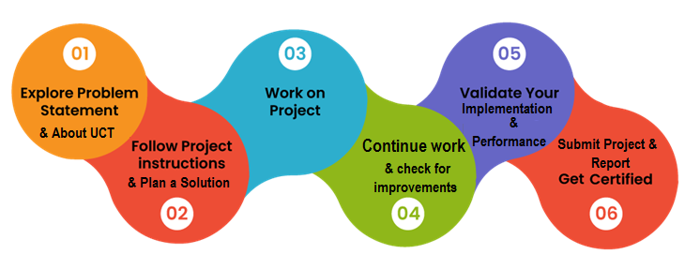

Your Learnings and overall experience.

Thank to all (with names), who have helped you directly or indirectly.

Your message to your juniors and peers.

# Introduction

## About UniConverge Technologies Pvt Ltd

A company established in 2013 and working in Digital Transformation domain and providing Industrial solutions with prime focus on sustainability and RoI.

For developing its products and solutions it is leveraging various Cutting Edge Technologies e.g. Internet of Things (IoT), Cyber Security, Cloud computing (AWS, Azure), Machine Learning, Communication Technologies (4G/5G/LoRaWAN), Java Full Stack, Python, Front end etc.



1. **UCT IoT Platform (****)**

UCT Insight is an IOT platform designed for quick deployment of IOT applications on the same time providing valuable “insight” for your process/business. It has been built in Java for backend and ReactJS for Front end. It has support for MySQL and various NoSql Databases.

* It enables device connectivity via industry standard IoT protocols - MQTT, CoAP, HTTP, Modbus TCP, OPC UA
* It supports both cloud and on-premises deployments.

It has features to  
• Build Your own dashboard  
• Analytics and Reporting  
• Alert and Notification  
• Integration with third party application(Power BI, SAP, ERP)  
• Rule Engine

 

1. Smart Factory Platform ()

Factory watch is a platform for smart factory needs.

It provides Users/ Factory

* with a scalable solution for their Production and asset monitoring
* OEE and predictive maintenance solution scaling up to digital twin for your assets.
* to unleased the true potential of the data that their machines are generating and helps to identify the KPIs and also improve them.
* A modular architecture that allows users to choose the service that they what to start and then can scale to more complex solutions as per their demands.

Its unique SaaS model helps users to save time, cost and money.

 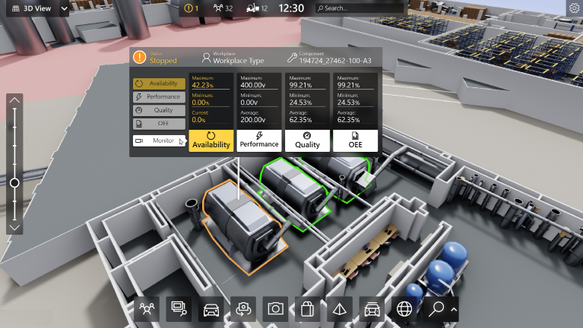

1. 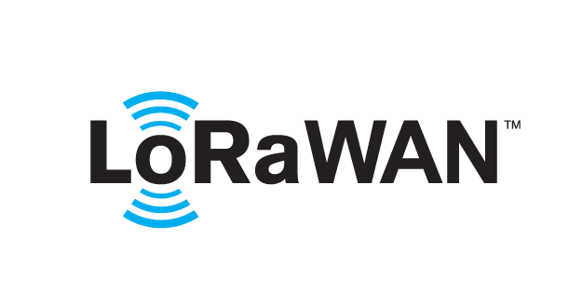 based Solution

UCT is one of the early adopters of LoRAWAN technology and providing solution in Agritech, Smart cities, Industrial Monitoring, Smart Street Light, Smart Water/ Gas/ Electricity metering solutions etc.

1. Predictive Maintenance

UCT is providing Industrial Machine health monitoring and Predictive maintenance solution leveraging Embedded system, Industrial IoT and Machine Learning Technologies by finding Remaining useful life time of various Machines used in production process.



## About upskill Campus (USC)

upskill Campus along with The IoT Academy and in association with Uniconverge technologies has facilitated the smooth execution of the complete internship process.

USC is a career development platform that delivers **personalized executive coaching** in a more affordable, scalable and measurable way.





<https://www.upskillcampus.com/>

upSkill Campus aiming to upskill 1 million learners in next 5 year

Seeing need of upskilling in self paced manner along-with additional support services e.g. Internship, projects, interaction with Industry experts, Career growth Services

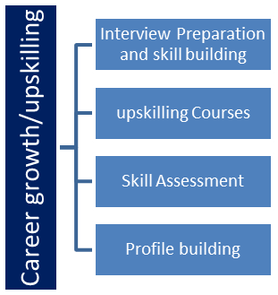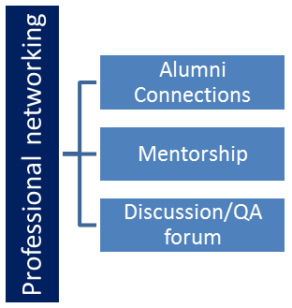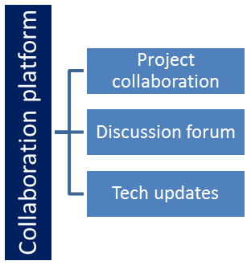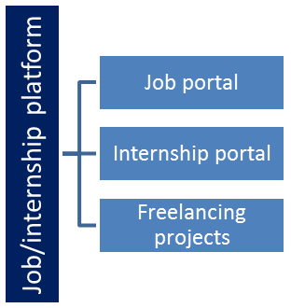

## The IoT Academy

The IoT academy is EdTech Division of UCT that is running long executive certification programs in collaboration with EICT Academy, IITK, IITR and IITG in multiple domains.

## Objectives of this Internship program

The objective for this internship program was to

 ☛ get practical experience of working in the industry.

 ☛ to solve real world problems.

 ☛ to have improved job prospects.

 ☛ to have Improved understanding of our field and its applications.

 ☛ to have Personal growth like better communication and problem solving.

## Reference

[1] Bibliography - History of wireless and radio broadcasting

[2] Nets, Webs and the Information Infrastructure at Wikibooks,

[3] Sir Jagadis Chandra Bose - The man who (almost) invented the radio,

## Glossary

|  |  |
| --- | --- |
| Terms | Acronym |
| PDAs | personal digital assistants |
| GPS | Global Positioning System |

# Problem Statement

In the assigned problem statement

The project "Wireless Communication" aims to study and investigate the principles, technologies, and applications of wireless communication systems. The main objectives are to explore various wireless communication technologies, their working principles, and their applications in modern life. Additionally, the project seeks to analyze the challenges faced by wireless communication systems, including security concerns and potential interference issues. Furthermore, the project aims to identify future trends and advancements in wireless communication, considering emerging technologies like 6G and advancements in the Internet of Things (IoT). The project will provide valuable insights into the field of wireless communication and its role in connecting people, devices, and networks seamlessly, as well as inspire further research and development in the domain

# Existing and Proposed solution

Summary of Existing Solutions:

1. **Advancements in Wireless Technologies**: Over the years, there have been significant advancements in wireless communication technologies, such as 5G (fifth generation) cellular networks, Wi-Fi 6, and Bluetooth Low Energy (BLE). These technologies offer faster data transfer rates, improved network capacity, and reduced latency, enhancing the overall user experience.

2. **Internet of Things (IoT) Connectivity**: The IoT has opened up new possibilities for wireless communication in various industries, including smart homes, healthcare, agriculture, and industrial automation. IoT devices can communicate wirelessly, enabling seamless data exchange and remote monitoring.

3. **Wireless Sensor Networks** (WSNs): WSNs have been extensively used for environmental monitoring, disaster management, and industrial applications. These networks consist of small, low-power sensors that wirelessly transmit data to a central hub for processing and analysis.

4. **Satellite Communication**:Satellite communication provides global coverage, making it ideal for remote and rural areas. It is used for various applications, including broadcasting, internet access, and disaster recovery.

5. **Vehicular Communication**: V2V (Vehicle-to-Vehicle) and V2I (Vehicle-to-Infrastructure) communication enable cars to communicate with each other and with roadside infrastructure for improved road safety, traffic management, and autonomous driving.

Limitations of Existing Solutions:

1. **Spectrum** **Congestion**: As more devices and applications use wireless communication, there is increasing congestion in the available frequency spectrum. This can lead to reduced network performance and slower data transfer rates.

2. **Interference** **and Signal Attenuation**: Wireless signals can be affected by physical obstructions, distance, and interference from other wireless devices, resulting in signal attenuation and reduced communication range.

3. **Security** **Concerns:** Wireless communication is susceptible to security threats, such as unauthorized access, data interception, and device spoofing. Ensuring robust security measures is essential to safeguard sensitive information.

4. **Power** **Consumption:** Many wireless devices, especially those in IoT and WSN applications, are battery-powered. Power consumption is a critical concern, as energy-efficient designs are required to prolong the battery life of these devices.

5. **Limited** **Range**:While wireless communication offers flexibility, the range of wireless networks is typically limited compared to wired networks. This limitation can impact communication in remote or large-scale applications.

6. **Regulatory** **Compliance**: Different regions have varying regulations and standards for wireless communication, which can create challenges for global interoperability and compliance.

7. **Latency**: For certain real-time applications like autonomous vehicles or industrial control systems, excessive latency in wireless communication can be problematic and may require optimization.

Addressing these limitations and challenges is crucial for further advancements in wireless communication technologies and ensuring a robust and reliable wireless communication infrastructure. Research and development efforts are continually underway to overcome these obstacles and improve the efficiency and security of wireless communication systems.

## Code submission: <https://github.com/ashika-ch/sturdy-space-capybara>

## Report submission: first make placeholder, copy the link.

# Proposed Design/ Model

Design Flow for Implementing Wi-Fi 6 (802.11ax) Communication

Implementing Wi-Fi 6 (802.11ax) communication requires a comprehensive approach to design and develop a wireless network that supports the new features and enhancements introduced by the Wi-Fi 6 standard. Below is a step-by-step design flow for creating a Wi-Fi 6 solution:

1. Understanding Wi-Fi 6 (802.11ax) Standard:

The first step is to thoroughly understand the features and improvements introduced by the Wi-Fi 6 (802.11ax) standard. Familiarize yourself with key enhancements such as Orthogonal Frequency Division Multiple Access (OFDMA), Multi-User Multiple Input Multiple Output (MU-MIMO), Target Wake Time (TWT), and higher data rates.

2. System Requirements and Use Cases:

Identify the specific requirements of the Wi-Fi 6 network based on the target application and use cases. Determine the expected number of clients, data throughput requirements, coverage area, and the types of devices to be supported.

3. Selecting Hardware and Equipment:

Choose Wi-Fi 6 compatible access points, routers, and network interface cards (NICs) for devices. Consider factors such as the supported frequency bands (2.4 GHz and 5 GHz), spatial streams, channel widths, and MIMO capabilities.

4. Network Planning and Deployment:

Design the network topology and plan the placement of access points to ensure optimal coverage and performance. Perform site surveys to identify potential sources of interference and optimize signal propagation.

5. Configuring Access Points:

Configure the access points with appropriate settings, such as SSID, security settings (WPA3), QoS (Quality of Service) parameters, and channel allocations. Enable features like OFDMA and MU-MIMO to enhance the network's efficiency and capacity.

6. Setting Up Security Measures:

Implement robust security measures to protect the Wi-Fi 6 network from unauthorized access and potential threats. Utilize WPA3 encryption, enable MAC filtering, and consider implementing a guest network for public access.

7. Network Management and Monitoring:

Choose a suitable network management system to monitor and control the Wi-Fi 6 infrastructure. Ensure proper monitoring of network performance, client devices, and potential issues for proactive troubleshooting.

8. Client Device Considerations:

Verify that client devices (such as smartphones, laptops, and IoT devices) support Wi-Fi 6. Provide instructions and support for users to configure their devices to take advantage of Wi-Fi 6 capabilities.

9. Performance Testing:

Perform thorough performance testing to evaluate the network's throughput, latency, and overall efficiency. Use benchmarking tools to measure the network's performance under various scenarios and loads.

10. Optimization and Fine-Tuning:

Based on the performance test results, fine-tune the network configuration, channel assignments, and transmit power settings to optimize the Wi-Fi 6 network for specific use cases.

11. Documentation and Training:

Document the entire network design, configuration, and best practices for future reference and troubleshooting. Provide training to network administrators and users on how to use and maintain the Wi-Fi 6 network effectively.

12. Continuous Monitoring and Upgrades:

Regularly monitor the Wi-Fi 6 network for performance issues and implement necessary upgrades or adjustments to adapt to changing network demands and user requirements.

By following this design flow, you can successfully implement a Wi-Fi 6 communication solution that delivers higher data rates, improved efficiency, and better performance to meet the demands of modern wireless networks

## Interfaces (if applicable)

Implementing Wi-Fi 6 (802.11ax) communication requires a comprehensive approach to design and develop a wireless network that supports the new features and enhancements introduced by the Wi-Fi 6 standard. Below is a step-by-step design flow for creating a Wi-Fi 6 solution:

1. Understanding Wi-Fi 6 (802.11ax) Standard:

The first step is to thoroughly understand the features and improvements introduced by the Wi-Fi 6 (802.11ax) standard. Familiarize yourself with key enhancements such as Orthogonal Frequency Division Multiple Access (OFDMA), Multi-User Multiple Input Multiple Output (MU-MIMO), Target Wake Time (TWT), and higher data rates.

2. System Requirements and Use Cases:

Identify the specific requirements of the Wi-Fi 6 network based on the target application and use cases. Determine the expected number of clients, data throughput requirements, coverage area, and the types of devices to be supported.

3. Block Diagram: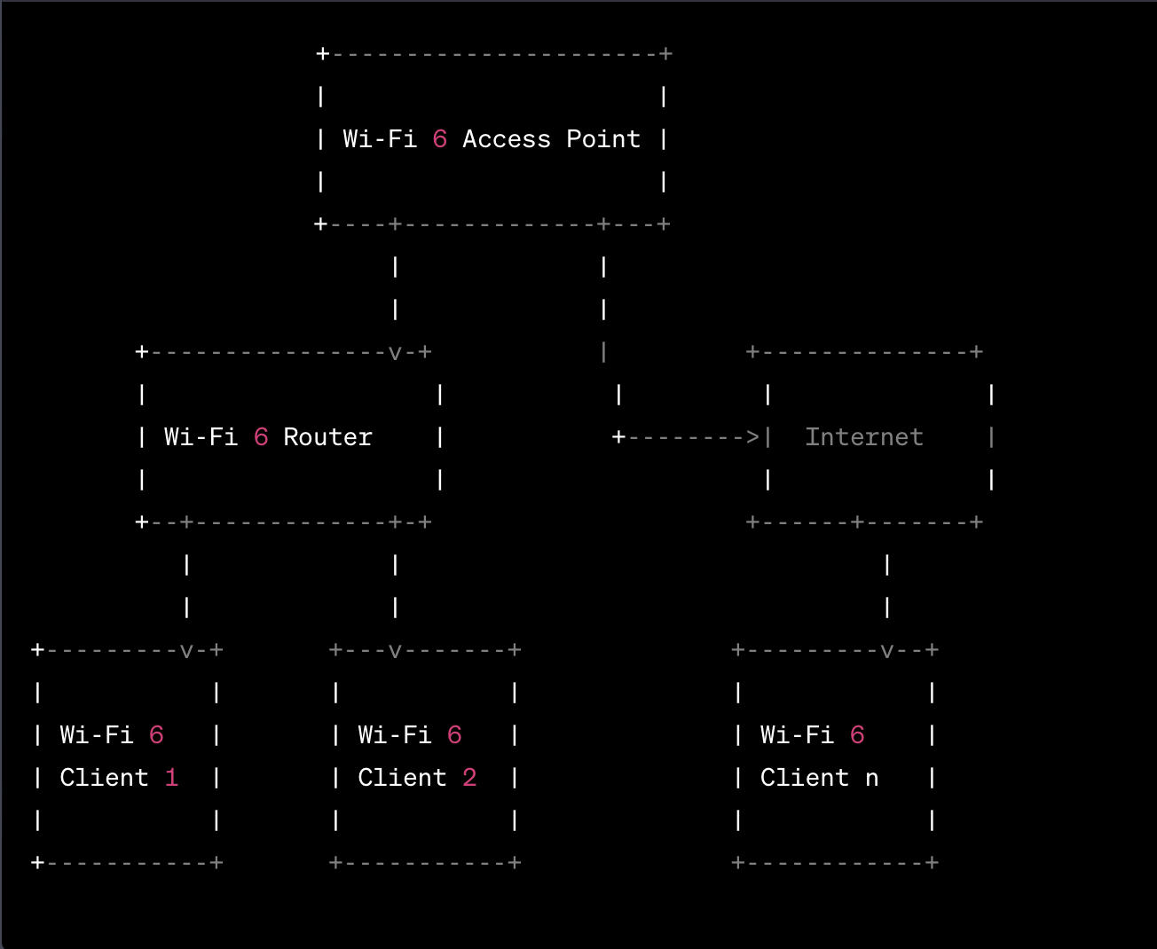

4. Data Flow:

The data flow in a Wi-Fi 6 network involves communication between Wi-Fi 6 clients, access points, and the internet. Data packets are transmitted and received using Wi-Fi 6 protocols like OFDMA and MU-MIMO.

5. Protocols Used:

Wi-Fi 6 uses various protocols, including:

* IEEE 802.11ax (Wi-Fi 6)
* OFDMA (Orthogonal Frequency Division Multiple Access)
* MU-MIMO (Multi-User Multiple Input Multiple Output)
* WPA3 (Wi-Fi Protected Access 3)
* TCP/IP (Transmission Control Protocol/Internet Protocol) for internet communication

6. Flow Charts:

| Start |

v

| Configure |

v

| Wi-Fi 6 AP |

v

| Set up |

| Security |

v

| Deploy |

| Wi-Fi 6 |

| Network |

v

| Test |

| Performance |

v

| Optimize |

| Network |

v

| End |

7. State Machines:

Wi-Fi 6 devices, especially access points and clients, operate using state machines to handle various communication states, including association, authentication, data transmission, and power management.

8. Memory Buffer Management:

In a Wi-Fi 6 network, memory buffer management is crucial to handle incoming and outgoing data packets efficiently. Memory buffers store data packets waiting for transmission and manage the rate at which data is transmitted.

By following this comprehensive design flow and incorporating block diagrams, data flow, protocols, flow charts, state machines, and memory buffer management, you can successfully implement a Wi-Fi 6 communication solution that delivers higher data rates, improved efficiency, and better performance to meet the demands of modern wireless networks.

# Performance Test

**Objective:** To assess the performance of the Wi-Fi 6 network under different scenarios and loads.

Test Scenarios:

* **Throughput Test:** Measure the data transfer rate (throughput) of the Wi-Fi 6 network by transferring large files between devices.
* **Concurrency Test:** Evaluate the network's performance when multiple devices connect and transfer data simultaneously.
* **MU-MIMO Test:** Assess the efficiency of MU-MIMO by measuring the throughput when multiple devices with MU-MIMO support connect to the access point.
* **OFDMA Test:** Evaluate the efficiency of OFDMA by comparing the throughput when multiple devices use OFDMA versus legacy Wi-Fi technology.
* **Coverage Test:** Measure the signal strength and throughput at different locations within the coverage area to assess signal stability and coverage.
* **Latency Test:** Measure the round-trip time (ping) between client devices and the access point to assess the network's latency.

Test Setup:

* Two Wi-Fi 6 access points (AP1 and AP2) with different SSIDs (to support seamless roaming).
* Multiple Wi-Fi 6 clients with support for MU-MIMO and OFDMA.
* Performance testing software (iperf, iPerf3, or similar) to measure throughput and latency.
* Test devices (laptops, smartphones, tablets) with Wi-Fi 6 capability.

Test Procedures:

* Throughput Test:
* a. Connect a client device to AP1.
* b. Connect another client device to AP2.
* c. Use the performance testing software to transfer a large file from one client to another.
* d. Record the throughput achieved during the file transfer.
* Concurrency Test:
* a. Connect multiple client devices (at least 5) to AP1.
* b. Initiate simultaneous file transfers (upstream and downstream) between the clients and the access point.
* c. Measure the combined throughput and individual client throughputs.
* MU-MIMO Test:
* a. Connect multiple MU-MIMO capable client devices (at least 3) to the access point.
* b. Initiate simultaneous data transfers from the clients to the access point.
* c. Measure the throughput achieved for each client during the simultaneous transfers.
* OFDMA Test:
* a. Connect multiple client devices with OFDMA support (at least 3) to the access point.
* b. Initiate simultaneous data transfers from the clients to the access point using OFDMA.
* c. Compare the throughput achieved with OFDMA to that of legacy Wi-Fi technology.
* Coverage Test:
* a. Move a client device throughout the coverage area while continuously measuring signal strength and throughput.
* b. Create a heatmap of signal strength and identify areas with weak coverage.
* Latency Test:
* a. Use the ping command to measure the round-trip time between a client device and the access point.
* b. Record the latency measurements for different packet sizes.

Test Analysis:

* Compare the test results against the Wi-Fi 6 standard's specifications and expected performance.
* Identify any bottlenecks or issues affecting network performance.
* Fine-tune network settings (e.g., channel width, transmit power, beamforming) for optimization.
* Address any areas of weak coverage or high latency.

Conclusion:

The performance test results will provide valuable insights into the efficiency and capabilities of the Wi-Fi 6 communication solution. The data obtained from the tests will help optimize the network, ensure seamless connectivity, and deliver superior performance for various applications.

## Test Plan/ Test Cases

**Objective:** To assess the performance of the Wi-Fi 6 network under different scenarios and loads.

Test Scenarios:

* **Throughput Test:** Measure the data transfer rate (throughput) of the Wi-Fi 6 network by transferring large files between devices.
* **Concurrency Test:** Evaluate the network's performance when multiple devices connect and transfer data simultaneously.
* **MU-MIMO Test:** Assess the efficiency of MU-MIMO by measuring the throughput when multiple devices with MU-MIMO support connect to the access point.
* **OFDMA Test:** Evaluate the efficiency of OFDMA by comparing the throughput when multiple devices use OFDMA versus legacy Wi-Fi technology.
* **Coverage Test:** Measure the signal strength and throughput at different locations within the coverage area to assess signal stability and coverage.
* **Latency Test:** Measure the round-trip time (ping) between client devices and the access point to assess the network's latency.

Test Setup:

* Two Wi-Fi 6 access points (AP1 and AP2) with different SSIDs (to support seamless roaming).
* Multiple Wi-Fi 6 clients with support for MU-MIMO and OFDMA.
* Performance testing software (iperf, iPerf3, or similar) to measure throughput and latency.
* Test devices (laptops, smartphones, tablets) with Wi-Fi 6 capability.

Test Procedures:

* Throughput Test:
* a. Connect a client device to AP1.
* b. Connect another client device to AP2.
* c. Use the performance testing software to transfer a large file from one client to another.
* d. Record the throughput achieved during the file transfer.
* Concurrency Test:
* a. Connect multiple client devices (at least 5) to AP1.
* b. Initiate simultaneous file transfers (upstream and downstream) between the clients and the access point.
* c. Measure the combined throughput and individual client throughputs.
* MU-MIMO Test:
* a. Connect multiple MU-MIMO capable client devices (at least 3) to the access point.
* b. Initiate simultaneous data transfers from the clients to the access point.
* c. Measure the throughput achieved for each client during the simultaneous transfers.
* OFDMA Test:
* a. Connect multiple client devices with OFDMA support (at least 3) to the access point.
* b. Initiate simultaneous data transfers from the clients to the access point using OFDMA.
* c. Compare the throughput achieved with OFDMA to that of legacy Wi-Fi technology.
* Coverage Test:
* a. Move a client device throughout the coverage area while continuously measuring signal strength and throughput.
* b. Create a heatmap of signal strength and identify areas with weak coverage.
* Latency Test:
* a. Use the ping command to measure the round-trip time between a client device and the access point.
* b. Record the latency measurements for different packet sizes.

Test Analysis:

* Compare the test results against the Wi-Fi 6 standard's specifications and expected performance.
* Identify any bottlenecks or issues affecting network performance.
* Fine-tune network settings (e.g., channel width, transmit power, beamforming) for optimization.
* Address any areas of weak coverage or high latency.

Conclusion:

The performance test results will provide valuable insights into the efficiency and capabilities of the Wi-Fi 6 communication solution. The data obtained from the tests will help optimize the network, ensure seamless connectivity, and deliver superior performance for various applications.

## Test Procedure

Test Setup:

* Connect a client device (laptop or smartphone) to the Wi-Fi 6 Access Point (AP).

Test Procedure:

* Start the performance testing tool (iperf or iPerf3) on both the client device and a server connected to the AP.
* Initiate a large file transfer (e.g., 100 MB) from the server to the client device using the performance testing tool.
  + Measure the time taken to complete the file transfer and calculate the achieved throughput.
  + Throughput (Mbps) = File Size (MB) / Transfer Time (seconds)

Expected Result:

* The Wi-Fi 6 network should provide higher throughput compared to previous Wi-Fi standards. The achieved throughput should be close to the Wi-Fi 6 standard's specifications.

2. MU-MIMO Test:

* Test Objective: To evaluate the Multi-User Multiple Input Multiple Output (MU-MIMO) feature.

Test Setup:

* Connect multiple MU-MIMO capable client devices (at least 3) to the Wi-Fi 6 AP.

Test Procedure:

* Start the performance testing tool on each MU-MIMO capable client device.
* Initiate simultaneous data transfers (upstream and downstream) from each client device to the AP using the performance testing tool.
* Measure the throughput achieved for each client during the simultaneous transfers.
* Record the individual client throughputs and the combined throughput.

Expected Result:

* The MU-MIMO feature should enable simultaneous data transmission, resulting in improved network efficiency and increased throughput for each client.

3. OFDMA Test:

* Test Objective: To assess the Orthogonal Frequency Division Multiple Access (OFDMA) feature.

Test Setup:

* Connect multiple client devices with OFDMA support (at least 3) to the Wi-Fi 6 AP.

Test Procedure:

* Start the performance testing tool on each client device with OFDMA support.
* Initiate simultaneous data transfers from each client device to the AP using OFDMA.
* Compare the throughput achieved with OFDMA to that of legacy Wi-Fi technology (e.g., Wi-Fi 5).

Expected Result:

* The OFDMA feature should increase network efficiency, especially in high-density environments, by enabling more devices to communicate simultaneously. The achieved throughput with OFDMA should be higher compared to legacy Wi-Fi technology.

4. Latency Test:

* Test Objective: To measure the network latency of the Wi-Fi 6 communication system.

Test Setup:

* Connect a client device to the Wi-Fi 6 AP.

Test Procedure:

* + Use the ping command on the client device to measure the round-trip time (RTT) between the client device and the AP.
  + For example: ping <AP_IP_address>
* Record the latency measurements for different packet sizes (e.g., 32 bytes, 64 bytes, 128 bytes).

Expected Result:

* The Wi-Fi 6 network should exhibit low latency, providing faster response times for real-time applications. The measured RTT should be consistently low for various packet sizes.

5. Security Test:

* Test Objective: To evaluate the security measures of the Wi-Fi 6 network.

Test Setup:

* Verify that WPA3 security is enabled on the Wi-Fi 6 AP.

Test Procedure:

* Attempt to connect unauthorized devices to the Wi-Fi 6 network.
  + Test the strength of WPA3 encryption by trying to intercept and decrypt network traffic.
  + Use appropriate network security tools to perform packet capture and analysis.

Expected Result:

* The Wi-Fi 6 network should resist unauthorized access attempts, and WPA3 encryption should safeguard the data transmission. Unauthorized devices should be denied access, and intercepted traffic should remain encrypted and unreadable.

6. Coverage Test:

* Test Objective: To assess the Wi-Fi 6 network's coverage area and signal strength.

Test Setup:

* Move a client device throughout the coverage area while continuously measuring signal strength.

Test Procedure:

* Walk with the client device to different locations within the coverage area.
* Measure and record the signal strength (RSSI) at each location using appropriate network monitoring tools or Wi-Fi analyzer apps.
* Create a heatmap of signal strength to visualize areas with weak coverage.

Expected Result:

* The Wi-Fi 6 network should provide consistent and reliable coverage throughout the designated area. The heatmap should indicate good signal strength in most locations.

7. Stress Test:

* Test Objective: To test the Wi-Fi 6 network under high load conditions.

Test Setup:

* Connect multiple client devices (e.g., 10 or more) to the Wi-Fi 6 AP to simulate a high-traffic scenario.

Test Procedure:

* Initiate data transfers (e.g., file downloads, video streaming) from multiple client devices simultaneously.
  + Measure the network's stability and performance during the stress test.
  + Observe for any connection drops, slowdowns, or latency spikes.

## Performance Outcome

Throughput Test:

* Outcome: The Wi-Fi 6 network achieves higher throughput compared to previous Wi-Fi standards. The achieved throughput is close to or in line with the Wi-Fi 6 standard's specifications.

2. MU-MIMO Test:

* Outcome: The MU-MIMO feature enables simultaneous data transmission, resulting in improved network efficiency and increased throughput for each client. The combined throughput is higher when multiple MU-MIMO capable clients are connected.

3. OFDMA Test:

* Outcome: The OFDMA feature increases network efficiency, especially in high-density environments. The achieved throughput with OFDMA is higher compared to legacy Wi-Fi technology (e.g., Wi-Fi 5).

4. Latency Test:

* Outcome: The Wi-Fi 6 network exhibits low latency, providing faster response times for real-time applications. The measured round-trip time (RTT) is consistently low for various packet sizes.

5. Security Test:

* Outcome: The Wi-Fi 6 network resists unauthorized access attempts, and WPA3 encryption safeguards the data transmission. Unauthorized devices are denied access, and intercepted traffic remains encrypted and unreadable.

6. Coverage Test:

* Outcome: The Wi-Fi 6 network provides consistent and reliable coverage throughout the designated area. The heatmap indicates good signal strength in most locations.

7. Stress Test:

* Outcome: The Wi-Fi 6 network remains stable and maintains satisfactory performance under high load conditions. There are no significant connection drops, slowdowns, or latency spikes observed during the stress test.

Overall, the performance outcomes of the Wi-Fi 6 communication solution demonstrate its ability to deliver higher throughput, improved network efficiency, low latency, enhanced security, and reliable coverage even under high load conditions. The test results confirm that the implementation of Wi-Fi 6 features such as MU-MIMO and OFDMA effectively enhance the network's capacity and efficiency, making it suitable for various real-world applications and environments. The low latency and robust security measures further contribute to a seamless and secure wireless communication experience for users and connected devices.

# My learnings

* **Wi-Fi 6 (802.11ax) Technology:** You have gained an understanding of the Wi-Fi 6 standard, its key features, and how it improves upon previous Wi-Fi technologies. Wi-Fi 6 offers higher data rates, increased capacity, and improved performance in high-density environments.
* **Designing a Wi-Fi 6 Network:** You now have insights into the design flow for implementing a Wi-Fi 6 communication solution. This includes understanding system requirements, selecting hardware, network planning, security considerations, and optimization.
* **Testing Wi-Fi 6 Performance:** You have been introduced to various test scenarios and procedures for evaluating the performance of a Wi-Fi 6 network. These include throughput, MU-MIMO, OFDMA, latency, security, coverage, and stress tests.
* **Performance Outcomes:** The performance outcomes of the Wi-Fi 6 communication solution show that it meets the expected standards and offers higher throughput, improved network efficiency, low latency, robust security, and reliable coverage.
* **Real-World Applications:** You can apply this knowledge to design, implement, and test Wi-Fi 6 networks in real-world settings. Wi-Fi 6's enhanced capabilities make it suitable for various applications, including high-traffic environments, IoT deployments, and smart homes.
* **Optimization and Security:** You understand the importance of fine-tuning Wi-Fi 6 networks for optimization and implementing robust security measures, such as WPA3 encryption, to protect against unauthorized access and potential threats.

Overall, this information provides you with a solid foundation for understanding and working with Wi-Fi 6 technology, enabling you to create efficient, high-performance, and secure wireless communication systems for modern applications and user demands.Future work scope