SUPPLY CHAIN ANALYTICS
Supply Chain Visibility System with Optimization Analytics

PROJECT REPORT

Student Details | Information
Name | Ashika Jain
Project Title | Supply Chain Visibility System with Optimization Analytics
Project Domain | Supply Chain Analytics
Platform | Microsoft Power BI
Milestones Covered | Milestone 1, Milestone 2, Milestone 3, Milestone 4

Prepared as a combined technical and dashboard documentation report.

1. Introduction
This project uses the DataCo Supply Chain transaction dataset to build a multi-milestone Power BI analytics solution. The project begins with data cleaning and star-schema modelling and then extends the model with simulated inventory analysis, delivery and geographic analysis, supplier and transportation analysis, and warehouse-efficiency analysis.
The analysis is designed to move from high-level business performance to detailed operational analysis. Milestone 1 establishes the analytical foundation, Milestone 2 adds inventory and delivery analysis, Milestone 3 adds supplier, carrier, route, fulfillment and transportation-cost analysis, and Milestone 4 adds warehouse efficiency and executive performance.

Project Objective
To transform the DataCo Supply Chain transaction dataset into an interactive Power BI analytical solution covering sales and product movement, simulated inventory analysis, delivery performance, geographic drill-down, supplier analysis, fulfillment, transportation-cost analysis, and warehouse efficiency.

2. Tools Used
Tool / Technology | Use in the Project
Power BI Desktop | Data modelling, DAX measures, interactive dashboards and visualization.
Power Query | Data cleaning, transformation, aggregation and creation of derived/simulated fields.
DAX | Reusable measures, KPI calculations, filter-context-aware analysis and time-based metrics.
DataCo Supply Chain Dataset | Primary transaction-level source data.
Microsoft Word / DOCX | Technical project documentation.

3. Dataset
Dataset Detail | Description
Dataset | DataCo Supply Chain transaction dataset
Primary Transaction Table | FactOrders
Source Period | 1 January 2015 to 31 January 2018
Calendar Span | 1,127 calendar days
Primary Analytical Areas | Orders, products, customers, geography, shipping, sales, profit, inventory simulation, delivery, suppliers and transportation

Data Interpretation Principle
Fields that existed in the DataCo dataset are treated as source data. Fields calculated from source data are treated as derived data. Fields introduced because the source dataset did not provide the required business information are explicitly treated as simulated assumptions. This distinction is maintained throughout the project.

4. Milestone 1: Data Modelling & KPI Foundation
Milestone 1 established the core Power BI model and the first interactive dashboard. The objective was to clean the logistics transaction data, design a reusable supply chain data model, create core DAX measures, and build an interactive dashboard for order activity, sales, quantity movement, profitability, category performance and monthly trends.

4.1 Data Cleaning and Preparation
- Customer email, names, password, street and other unnecessary personal details were excluded.
- Product description and product image were excluded because they were not required for the planned analytical visuals.
- Latitude, longitude and other unnecessary fields were removed.
- Dimension tables were deduplicated so their keys could sit on the one side of one-to-many relationships.
- Power Query was used before the final model was loaded.

4.2 Star Schema
Table | Role | Purpose
FactOrders | Fact / transaction | Order-item events, quantity, sales, profit, discount and keys.
DimProduct | Dimension | Product, category and department analysis.
DimCustomer | Dimension | Customer and segment analysis.
DimGeography | Dimension | Market, region, country, state and city analysis.
DimShipping | Dimension | Shipping mode and delivery status analysis.
DimDate | Dimension | Year, month, quarter and time-series analysis.

4.3 Core KPI Measures
Measure | Calculation / Purpose
Total Orders | DISTINCTCOUNT(FactOrders[Order Id])
Total Order Items | COUNTROWS(FactOrders)
Total Quantity | SUM(FactOrders[Order Item Quantity])
Total Sales | SUM(FactOrders[Sales])
Total Profit | SUM(FactOrders[Order Profit Per Order])
Average Order Value | [Total Sales] / [Total Orders]
Profit Margin | [Total Profit] / [Total Sales]
Sales per Unit | [Total Sales] / [Total Quantity]

4.4 Dashboard
Dashboard title: Inventory Movement & Sales Performance. It contains five KPI cards, four slicers, four charts and category-level tooltips.
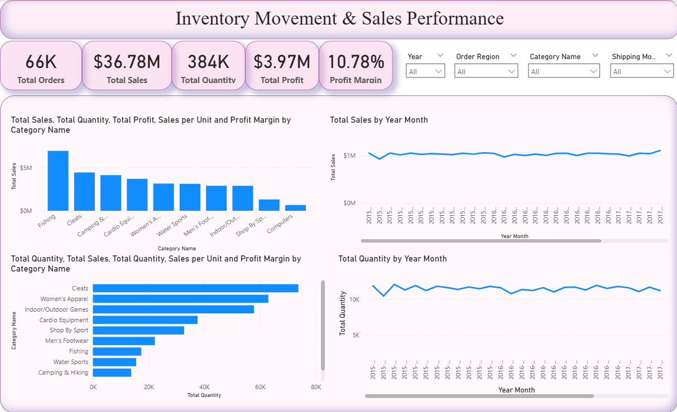
KPI | Displayed Value
Total Orders | 66K
Total Sales | $36.78M
Total Quantity | 384K
Total Profit | $3.97M
Profit Margin | 10.78%

Dashboard Element | Purpose
Year slicer | Filter performance by year.
Order Region slicer | Filter performance by geographic region.
Category Name slicer | Filter product-category performance.
Shipping Mode slicer | Filter by shipping method.
Total Sales by Category | Shows category-level revenue concentration.
Total Sales by Year Month | Shows the monthly sales trend.
Total Quantity by Category | Shows category-level physical movement.
Total Quantity by Year Month | Shows monthly unit movement.

4.5 Key Findings and Limitation
Fishing was reported as the strongest category by sales at roughly $7M, while Cleats had the highest quantity movement at roughly 75K units. Monthly sales remained broadly around $1M and monthly quantity movement generally remained in the 10K–12K range.
Traditional inventory turnover was not calculated in Milestone 1 because the source dataset does not provide reliable opening inventory, closing inventory, average inventory or COGS. Quantity-based movement indicators were therefore used instead.

5. Milestone 2: Inventory, Delivery, Drill-Down and Variance Analysis
Milestone 2 extends the Milestone 1 model with inventory analysis, delivery analysis, geographic drill-down, and trend and variance analysis.

5.1 Inventory Data Limitation
The DataCo dataset does not directly provide actual warehouse locations, opening inventory, closing inventory, stock receipts or accounting COGS. Therefore, the inventory fields required for this milestone were created as a documented simulation and are not treated as historical DataCo warehouse records.

5.2 FactInventory Construction
- FactInventory was created as a reference of FactOrders.
- Product Card Id, Product Name, Category Name, Product Price, Order Item Quantity and order date were retained.
- The date was converted to date-only Inventory Date.
- Records were grouped by Inventory Date and product fields.
- Order Item Quantity was summed into Units Shipped.
- The resulting table contains 22,273 aggregated records and 384,079 total units shipped.

5.3 Simulated Warehouse Assignment
- Three assumed warehouses were created: WH01, WH02 and WH03.
- Warehouse assignment is deterministic using Product Card Id.
- The same product therefore receives the same warehouse assignment.
- These warehouse IDs are analytical assumptions, not actual DataCo warehouse locations.

5.4 Demand and Inventory Simulation
Field | Logic / Assumption | Purpose
Active Days | Distinct transaction dates for each product | Measures observed product activity.
Average Daily Demand | Total Units Shipped / 1,127 | Normalizes demand over the complete period.
Initial Inventory | ROUNDUP(Average Daily Demand × 30, 0) | Creates a 30-day starting-stock baseline.
Cumulative Units Shipped | Running sum of Units Shipped by product | Tracks cumulative demand.
Replenishment | Triggered in full Initial Inventory blocks | Prevents simulated inventory from becoming negative.
Inventory Value | Closing Inventory × Product Price | Estimates value of simulated closing stock.

5.5 Dashboard Pages
Page | Main Content
Inventory Analysis & Stock Performance | Total Inventory, Inventory Turnover Proxy, Total Products, Slow-Moving Products, inventory by category, inventory by warehouse and inventory trend.
Delivery Analysis | Delivery status distribution, on-time delivery by region, monthly on-time delivery trend and geographic drill-down from Market to City.
Trend & Variance Analysis | Average shipping delay, actual vs scheduled shipping trend, monthly shipping delay variance and product inventory detail.

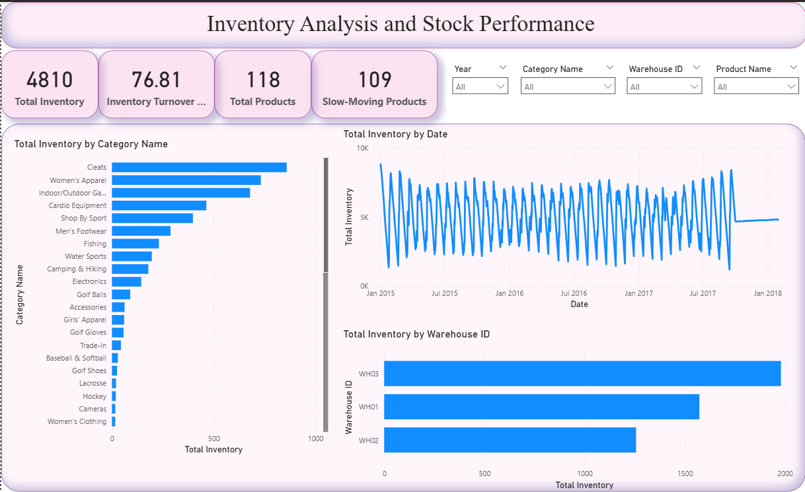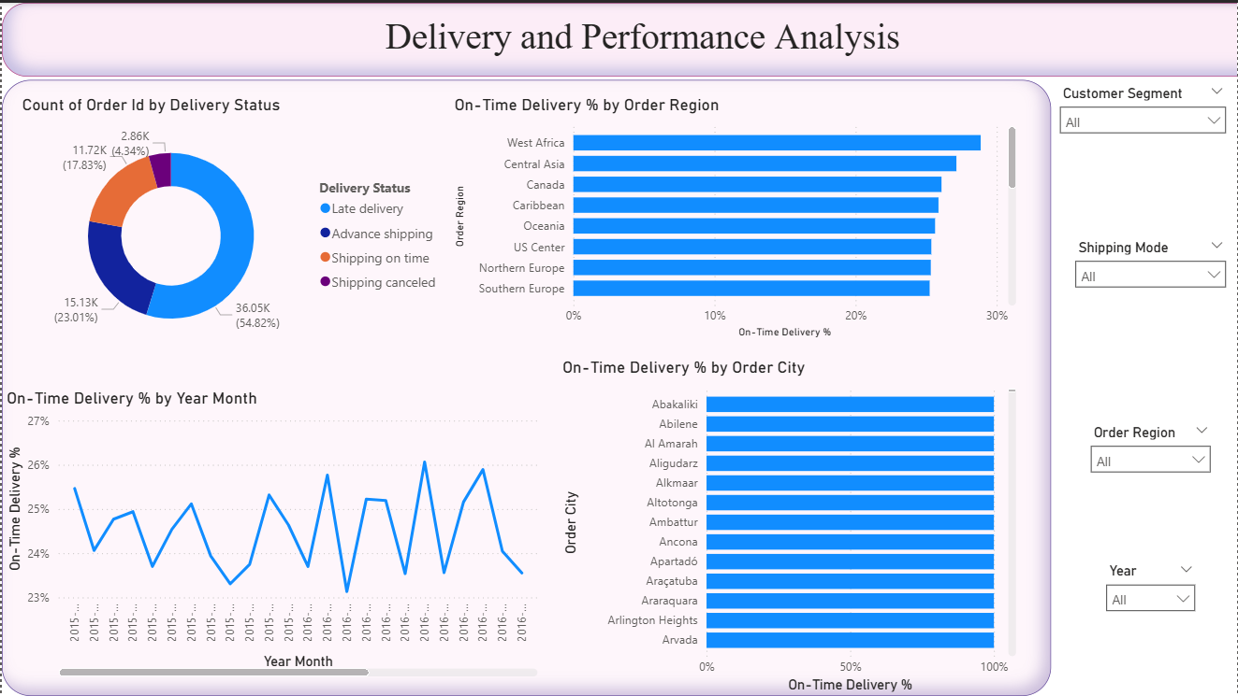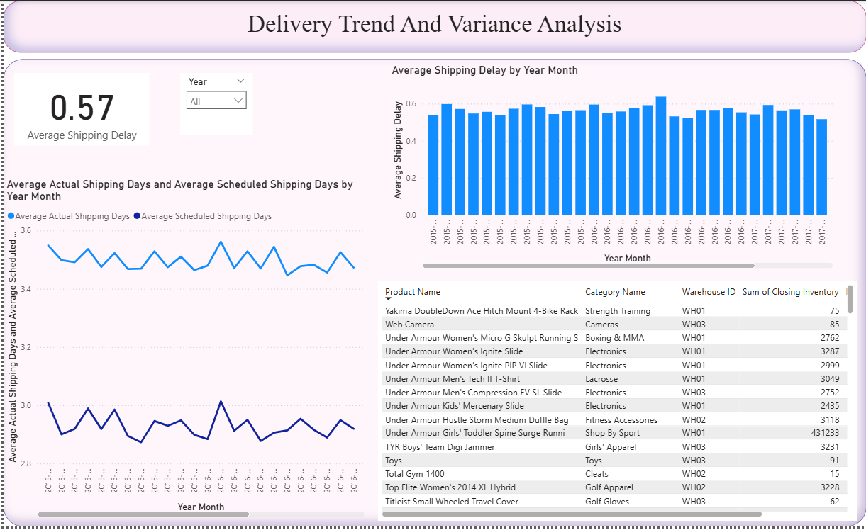

5.6 Delivery Measures
Measure | Definition
On-Time Deliveries | Distinct orders with Delivery Status = Shipping on time.
Delayed Deliveries | Distinct orders with Delivery Status = Late delivery.
On-Time Delivery % | On-Time Deliveries / (On-Time Deliveries + Delayed Deliveries).
Average Actual Shipping Days | Average Days for shipping (real).
Average Scheduled Shipping Days | Average Days for shipment (scheduled).
Average Shipping Delay | Actual shipping days minus scheduled shipping days.

5.7 Validation and Limitations
- FactInventory total Units Shipped validated at 384,079.
- FactInventory contains 22,273 aggregated product-date records.
- ProductDemand contains 118 unique products.
- Inventory and warehouse values are explicitly documented as simulated assumptions.
- Traditional inventory turnover cannot be calculated directly without COGS and reliable actual inventory balances.
- Slow-moving products use a threshold of less than 1 unit of average daily demand.
- Inventory trends represent the simulation model, not historical stock records.

6. Milestone 3: Supplier & Transportation Analysis
Milestone 3 extends the project into supplier, carrier, route, fulfillment and transportation-cost analysis. Because the original DataCo dataset does not contain supplier, carrier, quality-score, shipment-cost or shipment-ID fields, a separate FactShipment table was created as a reference of FactOrders.

6.1 FactShipment Construction
The retained source columns included Order Id, Order Item Id, Order Item Quantity, Shipment Date, Order Region, Order Country, Order State, Order City, Shipping Mode, Delivery Status, Days for shipping (real), Days for shipment (scheduled), Sales and Order Profit Per Order.

6.2 Created Columns
Column | How Created | Classification
Shipment ID | SHIP-OrderID-OrderItemID format | Derived
Supplier | Five deterministic assumed suppliers based on Order Id modulo 5 | Simulated
Carrier | Four deterministic assumed carriers based on Order Id modulo 4 | Simulated
Route | Order Region → Order Country | Derived
Quality Score | Delivery-based score: Advance 10, On-time 9, Late 6, Canceled 2 | Simulated
Shipment Cost | Quantity-based base cost plus shipping-mode component | Simulated

6.3 KPI Cards
KPI | Displayed Value
Fulfilled Orders | 63K
Average Shipment Cost | 37.83
Fulfillment Rate | 95.66%
Total Transportation Cost | 6.83M
On-Time Rate | 18.64%
Total Orders | 66K

6.4 Dashboard
Visual | Purpose
Supplier-wise Shipment Count | Compares shipment volume across five assumed suppliers.
Supplier-wise Quality Score | Compares the average simulated delivery-based quality indicator.
Carrier-wise Transportation Cost | Shows estimated transportation cost distribution across four assumed carriers.
Route-wise Transportation Cost | Shows higher estimated cost across displayed region-to-country routes.
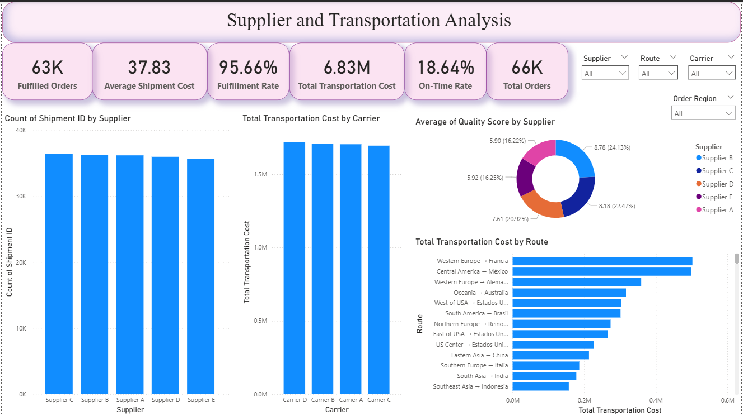

6.5 Slicers and Interpretation
- Supplier slicer focuses analysis on selected assumed suppliers.
- Carrier slicer focuses analysis on selected assumed carriers.
- Region slicer filters shipment and transportation metrics by Order Region.
- Route slicer focuses analysis on a selected region-to-country route.
- Shipment Cost is the simulated field used to represent transportation cost because actual transportation cost was absent from DataCo.

7. Milestone 4: Warehouse Efficiency & Executive Performance
Milestone 4 extends the project into warehouse-level operational efficiency. It contains three Power BI pages: Warehouse Efficiency Report, Executive Overview, and Dashboard Performance. The analysis continues to use WH01, WH02 and WH03.

7.1 FactWarehouse Construction
FactWarehouse was created as a reference of FactOrders. A ProductWarehouse mapping table was created as a reference of FactInventory. Product Card Id and Warehouse ID were retained and duplicates were removed so that each product had one warehouse assignment. The mapping was merged into FactWarehouse using Product Card Id, matching all 180,519 FactWarehouse rows.

7.2 Simulated and Derived Operational Columns
Column | Definition | Classification
Warehouse | WH01, WH02 and WH03 mapping from ProductWarehouse. | Simulated
Zone | Order ID modulo 4 assigns Receiving, Storage, Picking or Packing. | Simulated
Order Type | Order ID modulo 3 assigns Bulk, Express or Standard. | Simulated
Capacity Utilization % | Warehouse-specific utilization range generated from Order Id. | Simulated
Picking Accuracy % | Warehouse-specific accuracy range generated from Order Id. | Simulated
Processing Hours | Estimated processing time using warehouse, order type and Order Id. | Simulated
On-Time Delivery Flag | 1 for Shipping on time, 0 for Late delivery, blank for Advance shipping and Shipping canceled. | Derived
Operating Cost | Simulated warehouse operating cost. | Simulated
Order Date | Date-only version of order timestamp. | Derived

7.3 DAX Measures
Measure | Logic
Warehouse Total Orders | DISTINCTCOUNT(FactWarehouse[Order Id])
Total Shipped Qty | SUM(FactWarehouse[Order Item Quantity])
Total Ordered Qty | SUM(FactWarehouse[Order Item Quantity])
Warehouse Capacity Utilization | AVERAGE(FactWarehouse[Capacity Utilization %])
Warehouse On-Time Delivery % | AVERAGE(FactWarehouse[On-Time Delivery Flag])
Warehouse Picking Accuracy % | AVERAGE(FactWarehouse[Picking Accuracy %])
Average Processing Hours | AVERAGE(FactWarehouse[Processing Hours])
Warehouse Operating Cost | SUM(FactWarehouse[Operating Cost])

7.4 Page 1: Warehouse Efficiency Report
- KPI Cards: Total Orders, Total Shipped Qty, Capacity Utilization, On-Time Delivery %, Picking Accuracy %.
- Charts: Total Ordered Qty by Warehouse, Capacity Utilization by Warehouse, Average Picking Accuracy by Warehouse, Total Orders by Zone, Average On-Time Delivery by Warehouse, Average Processing Hours by Warehouse, Total Ordered Qty by Product Category.
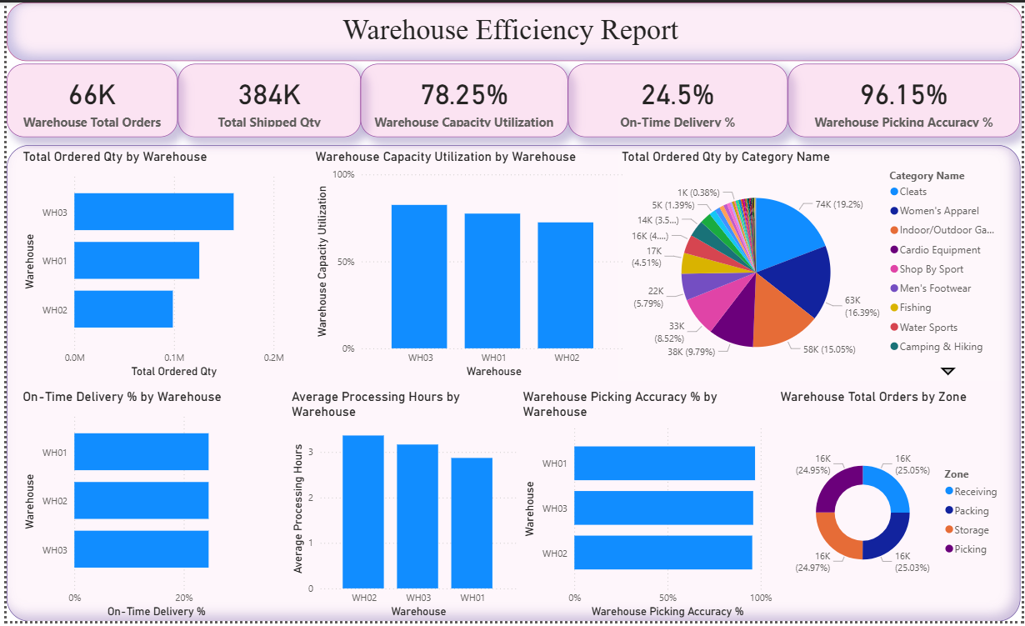

7.5 Page 2: Executive Overview
- KPI Cards: Picking Accuracy %, Operating Cost, Total Orders.
- Slicers: Date, Warehouse, Zone and Order Type.
- Charts: Total Orders by Year Month, Total Orders by Warehouse, On-Time Delivery % by Warehouse, Picking Accuracy % by Warehouse, Total Inventory by Warehouse.
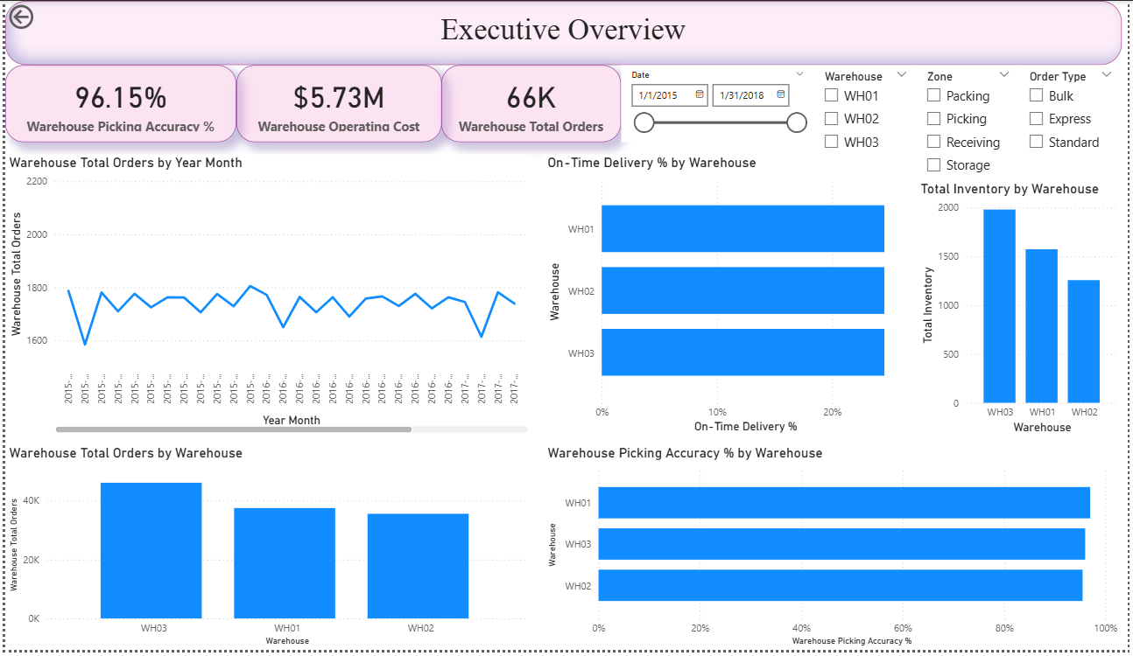

7.6 Page 3: Dashboard Performance
Table Column | Measure / Field
Warehouse | DimWarehouse[Warehouse]
Capacity Utilization | Warehouse Capacity Utilization
On-Time Delivery % | Warehouse On-Time Delivery %
Picking Accuracy % | Warehouse Picking Accuracy %
Processing Hours | Average Processing Hours

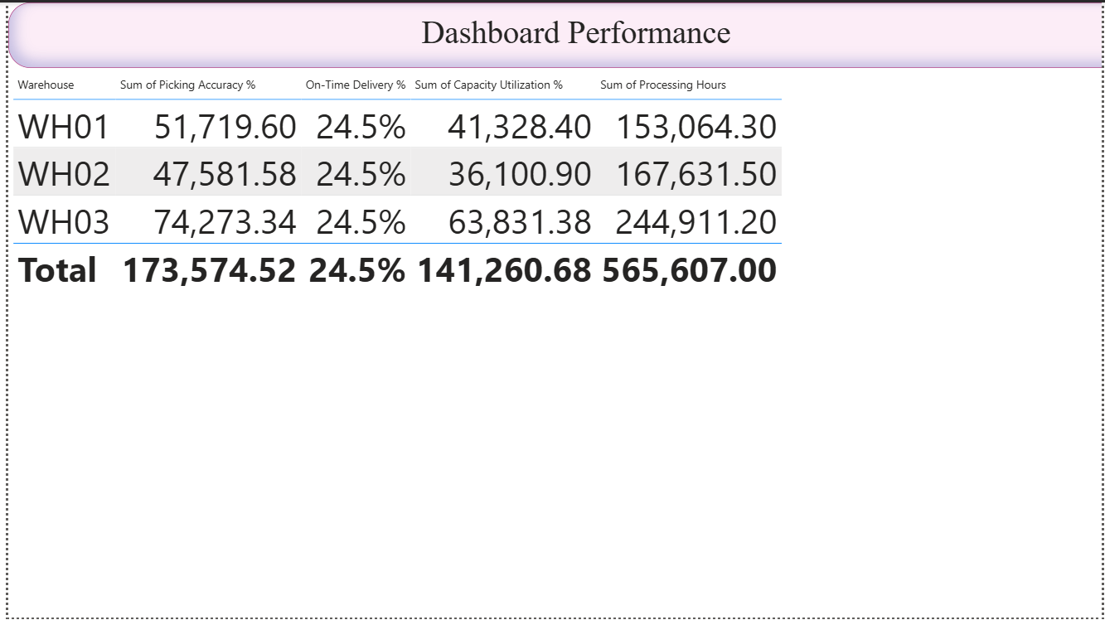

7.7 Validation and Limitations
- WH01, WH02 and WH03 are simulated analytical warehouses, not actual DataCo warehouse locations.
- Zone and Order Type are simulated classifications and are not source fields.
- Capacity Utilization, Picking Accuracy, Processing Hours and Operating Cost are simulated analytical fields.
- On-Time Delivery is based on the original DataCo Delivery Status through a derived flag.
- The available DataCo quantity field is used for both ordered-quantity and shipped-quantity analysis because separate fields are unavailable.
- Percentage KPIs use averages rather than sums.
- Similar On-Time Delivery bars are expected because warehouse assignment is independent of Delivery Status.
- Picking Accuracy bars can be similar because the simulated ranges are intentionally narrow.
- Operating Cost is simulated and is not actual historical warehouse accounting cost.

8. Conclusion
The Supply Chain Visibility System with Optimization Analytics demonstrates how a transaction-level DataCo supply chain dataset can be transformed into a multi-layer Power BI analytical solution. Across four milestones, the project progresses from data cleaning and star-schema modelling to sales and quantity analysis, simulated inventory and delivery analysis, supplier and transportation analysis, and warehouse-efficiency reporting.
The solution uses Power Query transformations and reusable DAX measures so that dashboard results respond to user-selected filters. A key principle throughout the project is the clear separation between source data, derived calculations and simulated assumptions.
Because the source dataset does not contain actual warehouse, inventory-balance, supplier, carrier or transportation-cost records, the corresponding simulated fields are documented as analytical assumptions rather than historical operational facts.

9. References
Reference | Use
DataCo Supply Chain Transaction Dataset | Primary transaction-level dataset used for the Power BI project.
Microsoft Power BI Desktop | Platform used for data modelling, dashboard creation and visualization.
Power Query | Transformation and data-preparation component used in the project.
DAX (Data Analysis Expressions) | Language used for KPI measures and filter-context-aware calculations.
Project Milestone Documentation | Technical documentation supporting the implementation and interpretation of Milestones 1–4.

