________________________________________________________________________________
Date : 17th April 2019
Student Name : SRIASHIKA ADDALA
Student ID : 11712155
Student RollNo: B50
Email ID : ashika2k8@gmail.com
GITHUB Links: 1. https://github.com/ashika29/os-1.git
2. https://github.com/ashika29/os-2.git
________________________________________________________________________________
------------------------------------------------------------------------------------------------------------------------
________________________________________________________________________________
DESCRIPTION:
The BANKER’S ALGORITHM is a resource allocation and deadlock avoidance algorithm that tests for safety by simulating the allocation for predetermined maximum possible amounts of all resources, then makes an “s-state” check to test for possible activities, before deciding whether allocation should be allowed to continue. The program that I made on Banker’s algorithm in C language, collects input from the user of all the processes and their respective data and hence finds out whether there exists any safe sequence which shows the possibility of deadlock with the given conditions.
Fixed priority preemptive scheduling method (FPPS)– Each queue has absolute priority over lower priority queue. Consider the following priority order queue 1 > queue 2 > queue 3. According to this algorithm no process in the batch queue(q3) can run unless queue 1 and 2 are empty. If any batch process (q3) is running and any system (q1) or Interactive process(q2) entered the ready queue the batch process is preempted.
Round Robin Scheduling Method (RR)- Round Robin is a CPU scheduling algorithm where each process is assigned a fixed time slot in a cyclic way.
We’ve chosen Queue 1 as FPPS and Queue 2 as RR. The processes execute accordingly.
________________________________________________________________________________
CODE SNIPPETS:
Program 1 ---> Ques. 23) Write a multithreaded program that implements the banker's algorithm. Create n threads that request and release resources from the bank. The banker will grant the request only if it leaves the system in a safe state. It is important that shared data be safe from concurrent access. To ensure safe access to shared data, you can use mutex locks.

// A Multithreaded Program that implements the banker's algorithm and prints safe sequence if any:
#include <stdio.h>
#include <stdlib.h>
#include <unistd.h>
#include <pthread.h>
#include <stdbool.h>
#include <time.h>
//variable declarations ahead
pthread_mutex_t r_lock;
pthread_cond_t limit;
int num_res,num_process;
int *resources;
int **num_allocated;
int **max;
int **need;
int *s_state;
int pro_ready = 0;
char choice;
//function declarations ahead
bool get_safe_sequence();
void* final_p_execution(void* );

void thankyou(){
printf("\n*****************************************************************************************\n");
printf("\n\n\t\tTHANKS FOR USING BANKER'S SOLUTION DESIGNED BY ASHIKA!\n\n");
printf("\n*****************************************************************************************\n");
exit(1);
}

int main() {
A:
srand(time(NULL));
printf("\n*****************************************************************************************\n");
printf("\n\n\t\t\t ASHIKA's PROJECT-BANKER's SAFE SEQUENCE:\n\n");
printf("\n*****************************************************************************************\n");
printf("\n 1. Enter number of PROCESSES\t: ");
scanf("%d", &num_process);
printf("\n 2. Enter number of RESOURCES\t: ");
scanf("%d", &num_res);

num_allocated = (int **)malloc(num_process * sizeof(*num_allocated));
for(int i=0; i<num_process; i++)
num_allocated[i] = (int *)malloc(num_res * sizeof(**num_allocated));

max = (int **)malloc(num_process * sizeof(*max));
for(int i=0; i<num_process; i++)
max[i] = (int *)malloc(num_res * sizeof(**max));

// allocated resources
for(int i=0; i<num_process; i++) {
printf("\n 3.%d. Enter number of resources allocated to P%d of each Rj:\n ", i+1,i+1);
for(int j=0; j<num_res; j++){
printf("\n\t R%d :\t",j+1);
scanf("%d", &num_allocated[i][j]);
}
}
printf("\n");

// maximum required resources
for(int i=0; i<num_process; i++) {
printf("\n 4.%d. Enter max number of resources required by P%d of each Rj:\n ", i+1, i+1);
for(int j=0; j<num_res; j++){
printf("\n\t R%d :\t",j+1);
scanf("%d", &max[i][j]);
}
}
printf("\n");
resources = (int *)malloc(num_res * sizeof(*resources));
printf("\n 5. Enter total number of R(available) of each Rj:\n ");
for(int i=0 ; i<num_res; i++){
printf("\n\t R%d :\t",i+1);
scanf("%d", &resources[i]);
}
printf("\n");

// calculate need matrix
printf("\n Calculating need matrix from the formula:\n\tN E E D \t=\tM A X\t-\tA L L O C A T E D....\n");
need = (int **)malloc(num_process * sizeof(*need));
for(int i=0; i<num_process; i++)
need[i] = (int *)malloc(num_res * sizeof(**need));

for(int i=0; i<num_process; i++)
for(int j=0; j<num_res; j++)
need[i][j] = max[i][j] - num_allocated[i][j];

// get safe sequence
printf("\n Checking for the possibility of a s-state....\n");
s_state = (int *)malloc(num_process * sizeof(*s_state));
for(int i=0; i<num_process; i++) s_state[i] = -1;

if(!get_safe_sequence()) {
printf("\n\tUNSAFE STATE!!!\n\n These processes lead to a deadlock state! Kindly check. \n\n");
C:
printf("\n Would you like to reuse this Banker's program? (y/n)\n");
scanf("%c",&choice);
if(choice != 'y' && choice != 'n' && choice != 'Y' && choice != 'N'){
printf("\nSorry, invalid choice entered. Please enter again.. \n");
goto C;
}
else if(choice == 'n' || choice == 'N') thankyou();
else goto A;s
}

printf("\n\n\tSAFE STATE! Safe Sequence Found : ");
for(int i=0; i<num_process; i++) {
printf("%5d --> ", s_state[i]+1);
}

printf("\nExecuting Processes...\n\n");
sleep(1);

// run threads
pthread_t processes[num_process];
pthread_attr_t attribute;
pthread_attr_init(&attribute);

int processNumber[num_process];
for(int i=0; i<num_process; i++) processNumber[i] = i;

for(int i=0; i<num_process; i++)
pthread_create(&processes[i], &attribute, final_p_execution, (void *)(&processNumber[i]));

for(int i=0; i<num_process; i++)
pthread_join(processes[i], NULL);

printf("\nAll Processes Executed Succesfully\n");

B:
printf("\n Would you like to reuse this Banker's program? (y/n)\n");
scanf("%c",&choice);
if(choice != 'y' && choice != 'n' && choice != 'Y' && choice != 'N'){
printf("\nSorry, invalid choice entered. Please enter again.. \n");
goto B;
}
else if(choice == 'n' || choice == 'N') thankyou();
else goto A;
// free resources
free(resources);
for(int i=0; i<num_process; i++) {
free(num_allocated[i]);
free(max[i]);
free(need[i]);
}
free(num_allocated);
free(max);
free(need);
free(s_state);

thankyou();
return 0;
}

bool get_safe_sequence() {
// get safe sequence
int temp[num_res];
for(int i=0; i<num_res; i++) temp[i] = resources[i];

bool execute[num_process];
for(int i=0; i<num_process; i++) execute[i] = false;
int executable=0;
while(executable < num_process) {
bool safe = false;

for(int i=0; i<num_process; i++) {
if(!execute[i]) {
bool mumkin = true;

for(int j=0; j<num_res; j++)
if(need[i][j] > temp[j]) {
mumkin = false;
break;
}

if(mumkin) {
for(int j=0; j<num_res; j++)
temp[j] += num_allocated[i][j];
s_state[executable] = i;
execute[i] = true;
++executable;
safe = true;
}
}
}

if(!safe) {
for(int k=0; k<num_process; k++) s_state[k] = -1;
return false; // no safe sequences were found
}
}
return true; //a safe sequence was encountered
}

// process code
void* final_p_execution(void *kuchbhi) {
int momo = *((int *) kuchbhi);

// lock resources
pthread_mutex_lock(&r_lock);

// bound check
while(momo != s_state[pro_ready])
pthread_cond_wait(&limit, &r_lock);

// process
printf("\n--> Process %d", momo+1);
printf("\n\tAllocated : ");
for(int i=0; i<num_res; i++)
printf("%3d", num_allocated[momo][i]);

printf("\n\tNeeded : ");
for(int i=0; i<num_res; i++)
printf("%3d", need[momo][i]);

printf("\n\tAvailable : ");
for(int i=0; i<num_res; i++)
printf("%3d", resources[i]);

printf("\n"); sleep(1);

printf("\tResources allocated!");
printf("\n"); sleep(1);
printf("\tProcess is executing...");
printf("\n"); sleep(rand()%3 + 2); // process code
printf("\tProcess' execution completed...");
printf("\n"); sleep(1);
printf("\tProcess is now releasing resources...");
printf("\n"); sleep(1);
printf("\tResources Released!");

for(int i=0; i<num_res; i++)
resources[i] += num_allocated[momo][i];

printf("\n\tFreshly available resources are: ");
for(int i=0; i<num_res; i++)
printf("%3d", resources[i]);
printf("\n\n");

sleep(1);

// bound broadcast
pro_ready++;
pthread_cond_broadcast(&limit);
pthread_mutex_unlock(&r_lock);
pthread_exit(NULL);
}
________________________________________________________________________________
Program 2 ---> Q50) Design a scheduling program to implements a Queue with two levels:
Level 1: Fixed priority pre-emptive Scheduling
Level 2: Round Robin Scheduling
For a Fixed priority preemptive Scheduling (Queue1), thePriority 0 is highest priority. If one process P1 is scheduled and running, another process P2 with higher priority comes. The New process (high priority) process P2 preempts currently running process P1 and process P1will go to second level queue. Time for which process will strictly execute must be considered in the multiples of 2. All the processes in second level queue will complete their execution according to round robin scheduling.
Consider:
1. Queue 2 will be processed afterQueue 1 becomes empty.
2. Priority of Queue 2 has lower priority than in Queue 1.

//Program to implement multi-level queue scheduling
# include <stdio.h>
# include <stdlib.h>
#include <time.h>
# define BOUND 100

struct code{ //for queue 1 scheduling
int at,bt,priority,pid,cot;
int wt,tat, at2, bt2, pid2, priority2;
}Q2[BOUND];

void kuchbhi(struct code);
void RoundRobin(int);
void thankyou();

int main(){

int num_process, k, count=0, flag=0 , ct=0, cnt, check,tik;
char choice;
FIRST:
printf("\n*****************************************************************************************\n");
printf("\n\n\t\t\t WELCOME\n");
printf("\n\t\t ASHIKA's PROJECT-MULTILEVEL QUEUE SCHEDULING:\n\n");
printf("\n*****************************************************************************************\n");

printf("\n\n Enter the number of processes: ");
scanf("%d",&num_process);
struct code Q1[num_process];
for(int i = 0; i < num_process ; ++i)
{
printf("\n Enter details for P%d:\n",i);
printf("\n\t PID\t\t: "); scanf("%d",&Q1[i].pid);
printf("\n\t Priority\t: "); scanf("%d",&Q1[i].priority);
printf("\n\t AT\t\t: "); scanf("%d",&Q1[i].at);
printf("\n\t BT\t\t: "); scanf("%d",&Q1[i].bt); Q1[i].cot=Q1[i].bt;
}

printf("\nWe're entering into Queue 1 now: \n");
sleep(rand()%3 + 2);

int cro=0;
int i=0,lbt;
for( i ; i<num_process ; i++)
{
//1.1 Loop for individual process processing
int lbt=Q1[i].cot;
int measure=0; k=1;
for(int j=0;j<lbt;j++)
{
//1.2 loop for processing through the burst time until the new process arrives
if(i==0 && Q1[i].at!=0){
for(int l=0;l<Q1[i].at;l++){
count++ ;
}
tik=Q1[i].at;
printf("\n\n %3d <----\tNULL\t----> %3d",0,0,tik);
}
else if(i==0 && Q1[i].at==0 && measure==0){
for(int l=0;l<Q1[i+1].at;l++){
count++;
Q1[i].bt--;
}
cro=1;
printf("\n");
printf("\n %3d <----\tP[%d]\t---->%3d",Q1[i].at,Q1[i].pid,count);
tik=Q1[i].at+count;
}
if(i==(num_process-1)){
if(check==1);
for(int m=0;m<Q1[i].bt;m++){
count++; //Q1[i].bt--;
}
printf("\n");
printf("\n %3d <----\tP[%d]\t---->%3d",tik,Q1[i].pid,count);
break;
}
if( count!=0 && ((count%2)==0) && (Q1[k+i].priority > Q1[i].priority)){
printf("\n");
printf("\n %3d <----\tP[%d]\t---->%3d",tik,Q1[i].pid,count);
tik=count;
count++;
Q1[i].bt--;
flag++;
k++;
measure=1;
continue;
}
else if( count!=0 && ((count%2)==0) && (Q1[i+k].priority < Q1[i].priority))
{
if(k==2)
{
printf("\n");
printf("\n %3d <----\tP[%d]\t---->%3d",tik,Q1[i].pid,count);
ct++;
transfer(Q1[i+1]);
i=i+1;
measure=1;
tik=count;
count++;
Q1[i+1].bt--;
check=1;
break;
}
if(cro!=1)
{
printf("\n");
printf("\n %3d <----\tP[%d]\t---->%3d",tik,Q1[i].pid,count);//printing the first queue
}
cro=0;
if(Q1[i].bt>0)
{
ct++; //ct tracks the # of processes entering Queue2
transfer(Q1[i]);
}
measure=1;
tik=count;
count++;
Q1[i+1].bt--;
check=1;
break;
}
else
{
flag++;
Q1[i].bt--;
count++;
measure=1;
}
}
}
sleep(2);
printf("\n Queue 1 is now empty \n");
sleep(rand()%3+2);
RoundRobin(ct);
B:
printf("\n Would you like to reuse this Scheduling program? (y/n)\n ");
scanf("%c",&choice);
if(choice != 'y' && choice != 'n' && choice != 'Y' && choice != 'N'){
printf("\n Sorry, invalid choice entered. Please enter again.. \n");
goto B;
}
else if(choice == 'n' || choice == 'N') thankyou();
else goto FIRST;
thankyou();
return 0;
}

void RoundRobin(int c){
//RoundRobin code executing q2:
int i, limit, total = 0, x, counter = 0, tq;
int wt = 0, tat = 0, arrivaltime[BOUND], bursttime[BOUND], temp[BOUND];
float avgwt, avgtat;
limit=c;
//struct code proc2[BOUND];
x = limit;
for(i = 0; i <limit ; i++)
{
arrivaltime[i]=Q2[i].at2;
bursttime[i]=Q2[i].bt2;
temp[i] = bursttime[i];
}
D:
printf("\n\n Enter Time Quantum(even):\t");
scanf("%d", &tq);
if((tq%2)!=0){
printf("\n Sorry, invalid Time quantum. Please enter an even TQ again.. \n");
goto D;
}
printf("\n\tPID\t\tArrival Time\tRemaining Burst Time\tCompletion time\t Turnaround Time\t Waiting Time\n");
for(total = 0, i = 0; x != 0; )
{
if(temp[i] <= tq && temp[i] > 0)
{
total = total + temp[i]; //if burst time < tq then process executes without pause
temp[i] = 0; //bt = 0 since process has executed
counter = 1;
}
else if(temp[i] > 0 && temp[i] > tq)
{
temp[i] = temp[i] - tq; //when bt > tq, p executes until time tq and BTi+1 = bt - tq;
total = total + tq; //total denotes the time taken to execute in one go
}
if(temp[i] == 0 && counter == 1) //checks for finished processes
{
x--;
printf("\nP-%d\t\t%d\t\t%d\t\t%d\t\t %d\t\t\t %d",Q2[i].pid2,Q2[i].at,bursttime[i],total,total-arrivaltime[i],total-arrivaltime[i]-bursttime[i]);
wt = wt + total - arrivaltime[i] - bursttime[i];
tat = tat + total - arrivaltime[i];
counter = 0;
}
if(i == limit - 1)
{
i = 0;
}
else if(arrivaltime[i + 1] <= total)
{
i++;
}
else
{
i = 0;
}
}
avgwt = wt * 1.0 / limit;
avgtat = tat * 1.0 / limit;
printf("\n\n Average Waiting Time for queue2 :\t%.1f", avgwt);
printf("\n Average Turnaround Time for queue2:\t%.1f\n", avgtat);
}

void transfer(struct code kuchbhi){ //copying the info of queue2 process that has entered
int cnt = 0;
Q2[cnt].bt2 = kuchbhi.bt;
Q2[cnt].at2 = kuchbhi.at;
Q2[cnt].priority2 = kuchbhi.priority;
Q2[cnt].pid2 = kuchbhi.pid;
cnt++;
}

void thankyou(){
printf("\n*****************************************************************************************\n");
printf("\n\n\t\tTHANKS FOR USING MULTILEVEL-QUEUE-PROGRAM DESIGNED BY ASHIKA!\n\n");
printf("\n*****************************************************************************************\n");
exit(1);
}
________________________________________________________________________________________

EXPLANATION OF PROJECT AND USE OF DATA STRUCTURES:
- Q23:
- In the given solution I used the following data structures:
1. Max[ ] 2.Need[ ] 3.Allocated[ ] 4.Available[ ]
Allocated indicates the number of instances of each resource type already assigned to the process(es). Max indicates the maximum number of resources/instances the process, in all, needs to successfully execute the program. Need indicates the required instances of each resource type in order to execute succesfully, after prehand allocation of some resources. Whereas available indicates the currently available instances of each resource type.
- Main formulae used:
i. NEED = MAX – ALLOCATED
ii. TOTAL = AVAILABLE + ALLOCATED
- This algorithm is beneficial to us in a way such that we can easily find out whether the processes/order of execution of the process will encounter a deadlock. This program not only finds out if the system is in s-state, but also lists out atmost 1 possible safe sequence post-tabulation using the provided resource-processes data.
- As the strengths, there are some weak points in this program, i.e., its not in its best complexity and also my program lists out just 1 safe sequence as tabulated according to my personal computer’s scheduler.
II. Q50:
- This multilevel queue scheduling program is advantageous in situations where processes are prioritised.
- The main formulae used are:
i. Wait time = Turnaround time - Burst time
ii. Turnaround time = Completion time - Arrival time
3. This program was a challenge indeed as the code made by me was right in logic but seemed erroneous in the implementation. I kept working on the program and dragged it some level of presentation. The perfect code snippet is yet to be presented. This may be noted down as the biggest drawback of this program.
4. Coming to the perks of this program, we can easily track the slimy movement of processes into different queues, their manner of execution, resource management and hence this project can be very useful in scheduling some nasty processes.
______________________________________________________________________________
COMPLEXITY:
I. Q23::BANKERS ALGORITHM
- Collecting inputs from the user ------------------> O(n) time
- Looping conditions --------------------------------> O(n²) time
- Mutex locks -----------------------------------------> O(1) time
- All other statements in the entire program ------> O(1) time
- Hence, overall complexity of Banker’s algorithm = O(n²)
II. Q50::MULTILEVEL QUEUE SCHEDULING ALGORITHM
- Collecting inputs from the user --------------------------------> O(n)
- General looping conditions -------------------------------------> O(n²)
- Worst-case looping conditions ---------------------------------> O(n³)
- Conditional restraints --------------------------------------------> O(n)
- All other general statements consume O(1) each so complexity can be expressed as Big-Oh of constant time or O(1) time
- Tabulating all the above complexities, the worst case complexity, is O(n³).
________________________________________________________________________________

ALGORITHM:
I. BANKERS ALGO:
- Take input from user: number of processes.
- Take input from user the following:
number of resource types = num_resource
loop1: i --> 0 to num_resource
number of instances of R_{i}
exit loop1
loop2: i --> 0 to num_process
number of-allocated, max-resource instances of each resource type.
exit loop2
- Calculate need matrix for given n number of processes.
Need = Max – Allocated
- Using the given data, we use Banker’s algorithm to find out a safe sequence to escape deadlocks..
- (get_safe_seq == true) ? “System is in s-state. \n printf(safe_seq)” : “System is in unsafe state”
II. MULTILEVEL QUEUE SCHEDULING ALGORITHM
- Take input from user: num of processes
- loop1: i --> 0 to n
input(“arrival time[i]” , “burst time[i]” , “priority[i]”)
exit loop1;
- Using this data, generate a gantt chart and tabulate completion time (ct).
- Using ct, evaluate the following for each process:
i --> 0 to n
Turnaround time[i] = completion time [i] – arrival time[i]
Waiting time[i] = turnaround time[i] – burst time[i]
- Consider scenario1 where pri(Q1) < pri(Q2) ==> Q1 is of greater importance
For eg: 0 is the highest priority process here.
The process with the earliest arrival time P_{a} arrives usually and executes until another process P_{b} takes in. Once P_{b} comes in, the priorities of P_{a} & P_{b} shall be compared. The one with lower priority will execute and the other will be in Ready Queue of Queue2. This procedure will go on until we reach the last process. Finally, all processes in Queue1 will finish execution and then the CPU scheduler moves to Queue2 and executes as per the order already made in RQ.
- Most importantly, in both the scenarios, the time quantum of RR scheduling must strictly be in multiples of 2. (#constraint)
- Consider scenario2 where pri(Q1) > pri(Q2) ==> Q2 is of greater importance
For eg: 0 is the least priority process here.
The process with the earliest arrival time P_{a} arrives usually and executes until another process P_{b} takes in. Once P_{b} comes in, the priorities of P_{a} & P_{b} shall be compared. The one with higher priority will execute and the other will be in Ready Queue of Queue1. This procedure will go on until we reach the last process. Finally, all processes in Queue2 will finish execution and then the CPU scheduler moves to Queue1 and executes as per the order already made in RQ.

GITHUB LINKS:
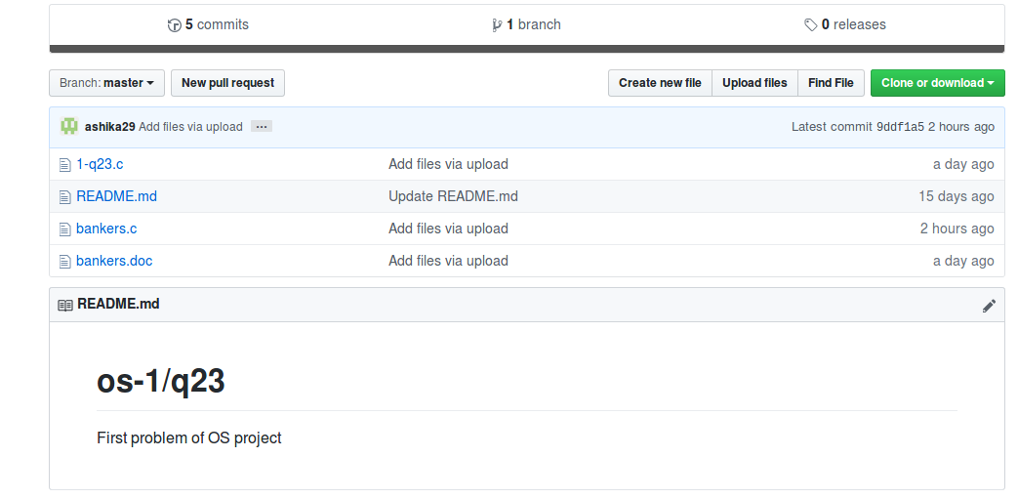

I. Q23:
https://github.com/ashika29/os-1.git

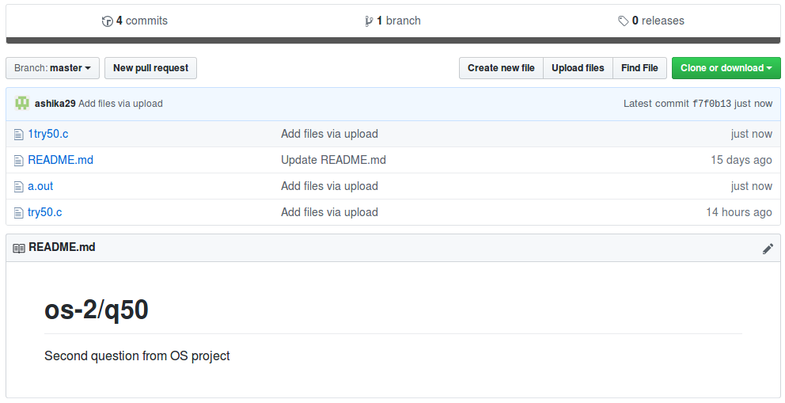

II. Q50:
https://github.com/ashika29/os-2.git

TEST CASES:
BANKERS ALGO:
- User provides data such that NEED > AVAILABLE so,
output should be UNSAFE STATE.
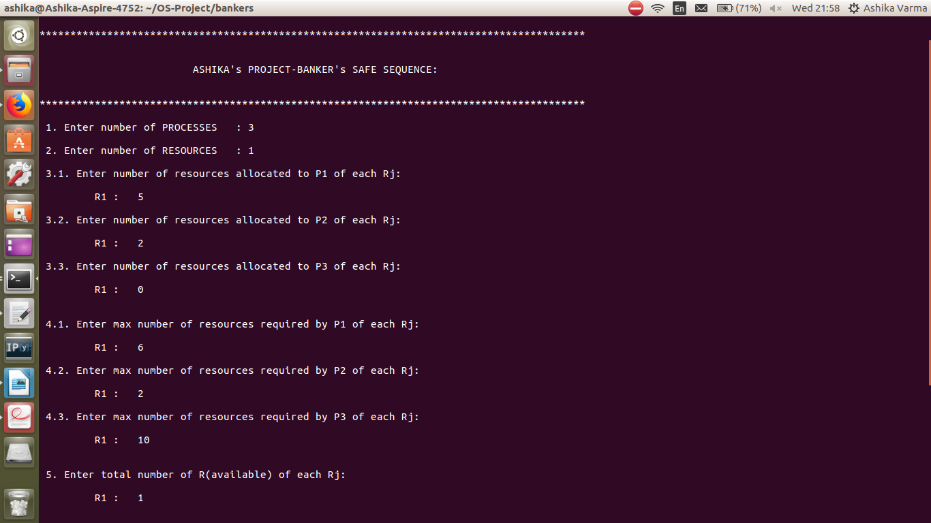
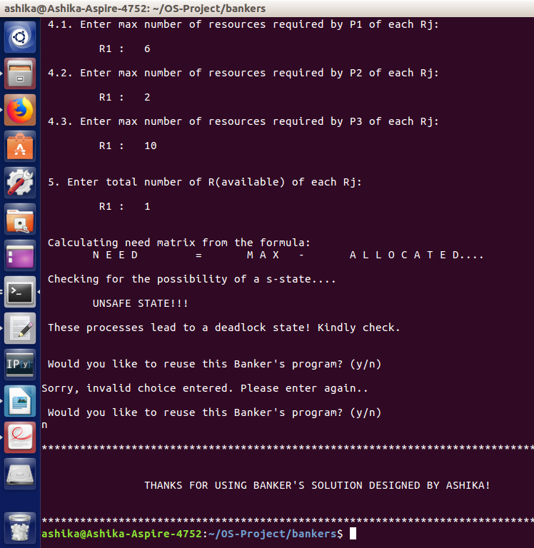
2. User provides data such that NEED = AVAILABLE then the output must be SAFE STATE and it should print a safe sequence.
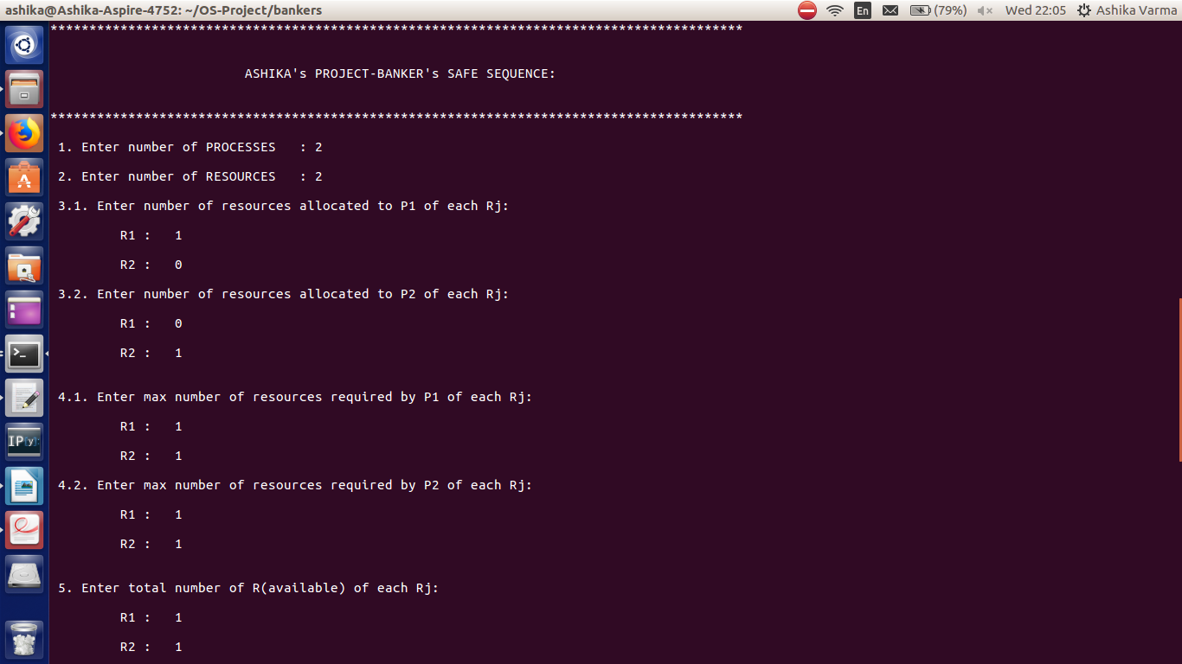
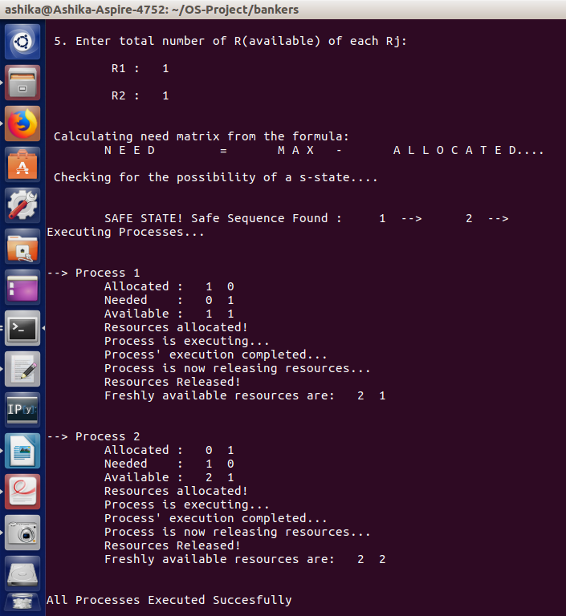

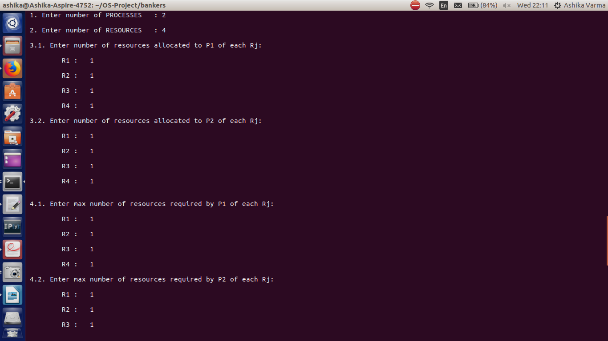
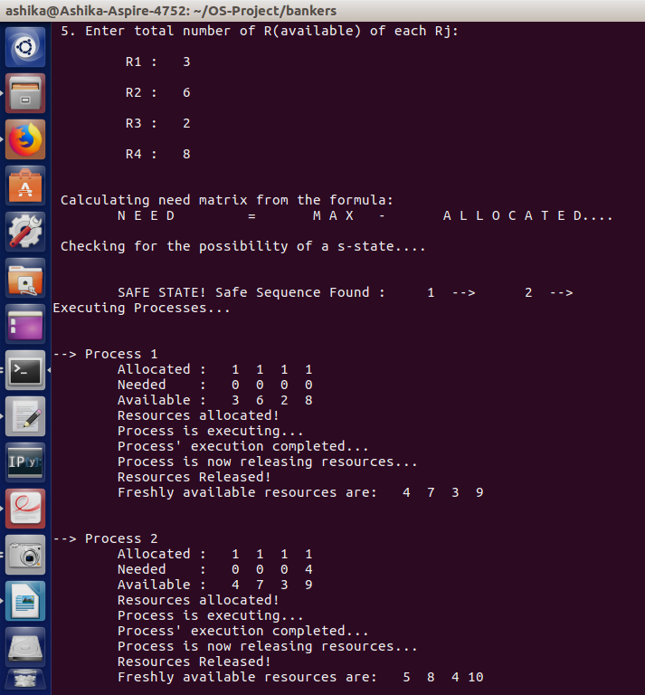
3. User provides data such that NEED < AVAILABLE, then output must be a SAFE STATE along with a safe sequence.

MULTILEVEL QUEUE SCHEDULING

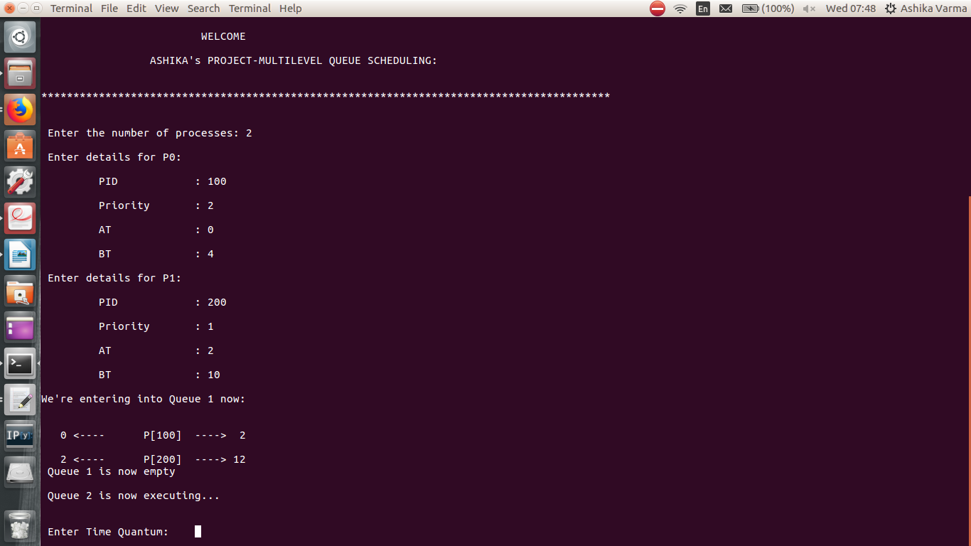
1. User enters the priorities such that P₁ > P₂ and Q₁ < Q₂ hence, P₁ should execute usually until the arrival of P₂ . As soon as P₂ arrives P₁ should be preempted and must wait for Q1 to be emptied and then execute P₂ afterwards using RR scheduling algorithm.
2. If user provides data such that processes do not need to go to Q2 at all, the output from Q2 should by NULL.
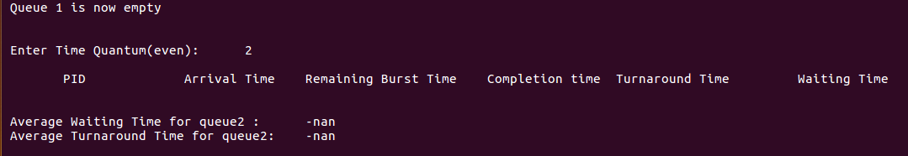
3. User enters the priorities such that P_{1 <} P₂ and Q₁ > Q₂ hence, P₁ should execute usually until the arrival of P₂ . As soon as P₂ arrives, P₂ must wait for P₁ to execute until its Time Quantum expires and then P₂ executes afterwards, using RR scheduling algorithm. As soon as Q₂ becomes empty Q₁ shall execute.

OUTPUT: Not available (N/A)

Hence, 1/2 scenario test cases, 2/3 point test cases were successful.

BIBILIOGRAPHY:
Internet:
http://www.google.in
https://www.geeksforgeeks.org
www.youtube.com

Books:
Operating Systems by Galvin

________________________________________________

THANK
YOU
_________________

