MICRPROCESSORS AND MICROCONTROLLERS

PROJECT REPORT

**ULTRASONIC RADAR**

B.TECH – SEMESTER 4

COMPUTER ENGINEERING

DIV - B

Members:

Aadit Khanolkar (A140)

Ashika Babydasan (A150)

Apoorva Pevekar (A161)

**Problem Statement:**

Design a radar system using an ultrasonic sensor and servo motor that detects obstacles in real-time and visualizes their presence on a screen. The system accurately measure distances, scan a defined area, and display detected obstacles as red dots on the screen.

**Model:**

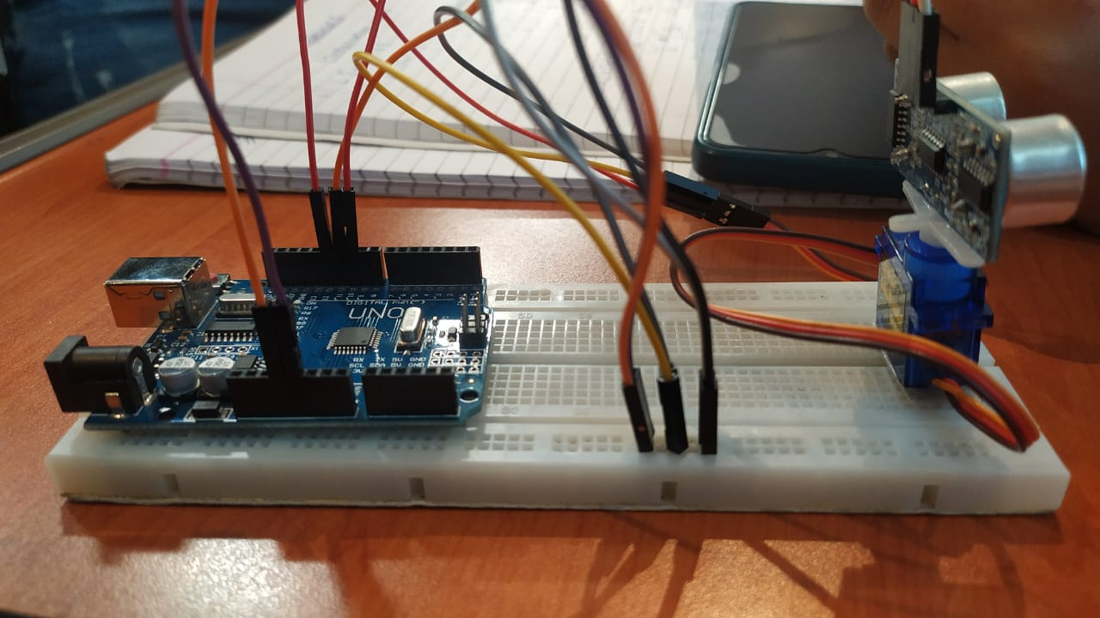

**Components Used:**

|  |  |  |
| --- | --- | --- |
| Sr. No. | Component | Quantity |
| 1 | Arduino Uno | 1 |
| 2 | Ultrasonic Sensor | 1 |
| 3 | Servo Motor | 1 |
| 4 | Breadboard | 1 |
| 5 | Jumper Wires | 8-10 |

**Working Principle:**

Our radar system operates by continuously scanning the surrounding environment. The ultrasonic sensor emits ultrasonic waves and measures the time it takes for the waves to bounce back after hitting an object. This duration is used to calculate the distance to the object based on the speed of sound.

When an obstacle is detected within a certain range, the system registers its presence and marks it as a target. These detected obstacles are then shown on a screen as red dots.

The radar system's automated detection and visualization process enable efficient monitoring and identification of obstacles in the scanned area.

**CODE:**

Arduino Code:

#include <Servo.h>

// Defines Tirg and Echo pins of the Ultrasonic Sensor

const int trigPin = 10;

const int echoPin = 11;

// Variables for the duration and the distance

long duration;

int distance;

Servo myServo; // Creates a servo object for controlling the servo motor

void setup() {

pinMode(trigPin, OUTPUT); // Sets the trigPin as an Output

pinMode(echoPin, INPUT); // Sets the echoPin as an Input

Serial.begin(9600);

myServo.attach(12); // Defines on which pin is the servo motor attached

}

void loop() {

// rotates the servo motor from 15 to 165 degrees

for(int i=15;i<=165;i++){

myServo.write(i);

delay(30);

distance = calculateDistance();// Calls a function for calculating the distance measured by the Ultrasonic sensor for each degree

Serial.print(i); // Sends the current degree into the Serial Port

Serial.print(","); // Sends addition character right next to the previous value needed later in the Processing IDE for indexing

Serial.print(distance); // Sends the distance value into the Serial Port

Serial.print("."); // Sends addition character right next to the previous value needed later in the Processing IDE for indexing

}

// Repeats the previous lines from 165 to 15 degrees

for(int i=165;i>15;i--){

myServo.write(i);

delay(30);

distance = calculateDistance();

Serial.print(i);

Serial.print(",");

Serial.print(distance);

Serial.print(".");

}

}

// Function for calculating the distance measured by the Ultrasonic sensor

int calculateDistance(){

digitalWrite(trigPin, LOW);

delayMicroseconds(2);

// Sets the trigPin on HIGH state for 10 micro seconds

digitalWrite(trigPin, HIGH);

delayMicroseconds(10);

digitalWrite(trigPin, LOW);

duration = pulseIn(echoPin, HIGH); // Reads the echoPin, returns the sound wave travel time in microseconds

distance= duration*0.034/2;

return distance;

}

**Conclusion**:

In this project, we have developed a radar system using Arduino Uno, an ultrasonic sensor, and a servo motor. By integrating real-time distance measurements with servo motor control, our system offers an efficient solution for detecting and visualizing obstacles. This technology has wide-ranging applications in robotics, security systems, navigation, and industrial automation, showcasing the potential for enhanced situational awareness and decision-making in various domains