**ASHIKA SRINIVASAN**

**C2066221**

**DETECTION OF MALICIOUS URLS AND FINDING THEIR ATTACK TYPES**

**Table of Contents**

1.Introduction 3

1.1 Aim 3

1.2 Research Questions 4

1.3 Objectives 4

1.4 Deliverables 4

2. Literature Review 4

2.1 Malicious URLs and their Attack Types 5

2.1.1 Definition of Malicious URLs 5

2.1.2 Attack Types Associated with Malicious URLs 5

*a) Phishing Attacks* 6

*b) Malware Distribution* 6

*C) Unauthorized Access Attempts* 6

2.2 Traditional Approaches for URL Analysis 6

2.2.1 Blacklisting-based Techniques 7

2.2.2 Heuristic-based Techniques 7

2.2.3 Reputation-based Techniques 7

2.3 Machine Learning Techniques for Malicious URL Detection 8

2.3.1 Feature selection for detection of attack types 8

2.3.2 Classification Algorithms 9

2.4 Challenges and Limitations 10

3. Conclusion 11

References 12

# 1.Introduction

Examining the existing literature on malicious URL detection and classification systems was the objective of this study. Malicious Uniform Resource Locators (URLs) are web addresses that direct users to malicious content or websites, such as those used in phishing attacks, malware distribution, and attempted break-ins. The majority of examined studies applied machine learning techniques to the problem of detecting and classifying hazardous URLs. The Internet has become an indispensable instrument for modern life over the past decade, facilitating innumerable interactions and providing simple access to immense knowledge databases. However, the escalation of cyber threats has made it imperative that cybersecurity professionals swiftly identify and stop fraudulent online activity.

URL structure, host information, and content can all be analyzed by machine learning algorithms to identify malicious trends. By being trained on massive datasets containing both malicious and benign URLs, these algorithms can learn to effectively classify new URLs and differentiate between various types of attacks. The past resulted in the use of blacklisting-based, heuristic, and reputation-based methods for URL analysis. The increasing complexity of malicious URLs necessitates more inventive and preventative measures to combat the constantly evolving nature of cyber threats. Machine learning approaches have become a potentially useful instrument in this regard.

## 1.1 Aim

This study examines previous works on hazardous URL recognition and classification systems to determine how well machine-learning methods can recognize and label dangerous URLs.

## 1.2 Research Questions

1. What are the traditional approaches for URL analysis and their limitations?
2. How can machine learning techniques be applied to detect and classify malicious URLs?
3. What are the key features and characteristics used in machine learning models for malicious URL detection?

## 1.3 Objectives

* To investigate how machine learning techniques can be utilized to identify hazardous URLs.
* To ascertain the challenges and limitations of machine learning-based methods for identifying hazardous URLs.
* To provide recommendations for improving the accuracy and reliability of malicious URL detection systems.

## 1.4 Deliverables

In this investigation, machine learning techniques are employed to identify and classify malicious URLs. Numerous other types of attacks are included, such as phishing, infection distribution, and attempted break-ins. The research focuses primarily on a literature review and discussions of conventional methods, machine learning techniques, and the challenges of identifying and classifying hazardous URLs. No new detection technologies are required, nor are empirical investigations necessary.

# 2. Literature Review

Recognizing and classifying hazardous URLs is essential due to the increasing sophistication of cyberattacks. Traditional approaches have limitations, leading to the use of machine learning techniques for detection. However, challenges such as data imbalances and adversarial attacks necessitate continued research and collaboration to develop dependable and accurate hazardous URL detection systems.

## 2.1 Malicious URLs and their Attack Types

### 2.1.1 Definition of Malicious URLs

Malicious URLs redirect users to unreliable websites, posing a significant threat to internet security. Fraudsters create and distribute these URLs to compromise computers, steal private information, spread malware, and obtain unauthorized access. As per the view of Abdul et al. (2020), forgeries of legitimate websites or the utilization of URL shorteners may be used to conceal their true location. Attacks can target web browsers, plugins, and operating systems.

### 2.1.2 Attack Types Associated with Malicious URLs

URLs that are malicious can lead to a variety of attacks. Accurate detection and classification systems require a comprehensive comprehension of these various types of attacks.

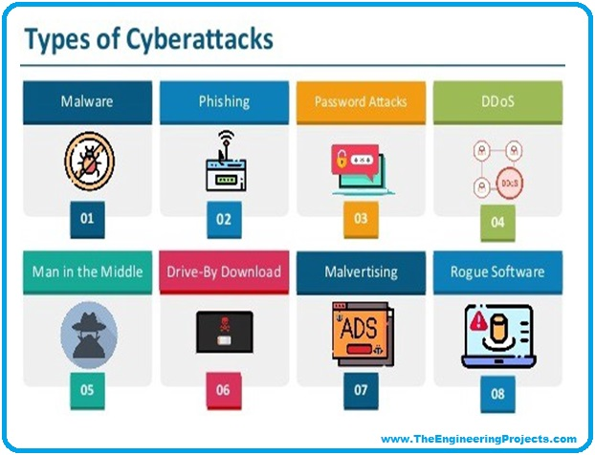

**Figure 1: Various types of Malicious URLs and Attacks**

(Source: Fu *et al.* 2023)

### *a) Phishing Attacks*

The login credentials, credit card information, and other private data of users are often stolen in phishing attempts because of the use of malicious URLs. To be successful, a phishing attack requires attackers to create convincing-looking but fraudulent websites or content. As cited by Alazab *et al.* (2022), phishing attacks often use the tactic of social engineering to coerce targets into divulging private information.

### *b) Malware Distribution*

Malware, which is software designed to damage or exploit users' computers, is frequently distributed via malicious URLs. As stated by Alfredo *et al.* (2022), these URLs may direct the user to malicious websites that download and install malware without their knowledge. One type of malware is ransomware, which encrypts user data until a ransom is paid; another is keyloggers, which record keystrokes and capture sensitive information.

### *C) Unauthorized Access Attempts*

Some malicious URLs are created with the express intent of facilitating computer or account intrusions. These connections may lead to malicious websites or applications that can gain access to your system by exploiting security vulnerabilities. Unauthorized access attempts can potentially result in data intrusions, identity theft, and system compromise.

## 2.2 Traditional Approaches for URL Analysis

URL analysis enables the detection and mitigation of threats posed by malicious URLs. There are established methods for discovering and categorizing these URLs that employ various techniques. Blacklisting-based methods, heuristic-based techniques, and reputation-based strategies are discussed as examples of traditional approaches to URL analysis that are still prevalent today.

### 2.2.1 Blacklisting-based Techniques

Blacklisting-based methods maintain a database of malicious URLs, which are regularly added and verified. As Binsaeed et al. (2020) illustrated, users are warned or denied access if a match is detected. However, blacklisting has drawbacks, such as false negatives and difficulty maintaining an up-to-date and exhaustive blacklist due to the constant introduction of new malicious URLs.

### 2.2.2 Heuristic-based Techniques

Heuristic-based algorithms attempt to identify potentially hazardous URLs using patterns or characteristics associated with known malicious behavior. The methods assess the URL's structure, content, or behavior, and then assign a risk rating. The malicious potential of the URL is then evaluated based on the risk score.

Heuristics-based approaches using patterns and heuristics can detect new or zero-day malicious URLs. As per the view of Catillo *et al.* (2022), the limitations of specified principles, however, may generate false positives or false negatives. The quality and precision of the utilized heuristics contribute substantially to the effectiveness of heuristic-based procedures.

### 2.2.3 Reputation-based Techniques

Reputation-based approaches use historical data and user feedback to determine a URL's credibility and predict harmful content. They are useful for phishing victims but may generate false positives if reputation data is outdated or falsified. Conventional URL analysis techniques struggle with precision, inefficiency, and adaptability, leading experts to use machine learning and AI techniques to better identify and classify malicious URLs.

## 2.3 Machine Learning Techniques for Malicious URL Detection

Advances in machine learning have made it possible to identify and categorize malicious URLs effectively in recent years. Algorithmic learning methods rely on algorithmic learning to identify data patterns and then use those patterns to make accurate predictions. The identification of hazardous URLs may involve machine-learning algorithms that consider a variety of qualities and characteristics. The section discusses the fundamentals of machine learning approaches for identifying malicious URLs.

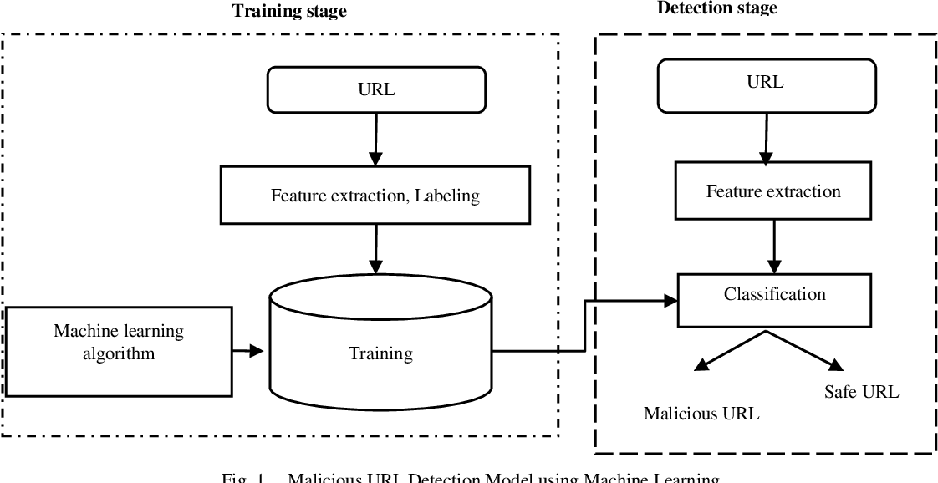

**Figure 2: Various process of machine learning for detection of Malicious activities**

(Source: Moruf *et al.* 2023)

### 2.3.1 Feature selection for detection of attack types

Feature engineering is exemplified by selecting and gathering pertinent properties from URLs that may provide discriminating information for categorization. Several distinct feature classes for identifying malicious URLs have been investigated. Functionalities based on URL structure analyze the components and patterns of the URI. The URL's length, the presence of peculiar characters, the number of subdomains, and the presence of particular keywords or suspicious phrases are examples of these characteristics. As per the view of Salat *et al.* (2023), analyzing the structure of malicious URLs allows machine-learning models to identify patterns associated with them. Host-based features analyze data that is unique to the URL's host, or domain. This includes the age of the domain, the reputation of the hosting server, and the physical location of the website. These characteristics may aid in differentiating between safe and dangerous web addresses.

### 2.3.2 Classification Algorithms

Once the relevant characteristics have been gathered, URLs are classified as secure or dangerous using machine learning techniques. Using Support Vector Machines to detect malicious URLs is a common practice. As cited by San & Vasupongayya (2019), using these extracted attributes, they expect to identify the hyperplane that divides the data into two distinct categories most effectively. SVMs are effective at distinguishing between secure and hazardous URLs and are able to operate in high-dimensional feature spaces. Random Forests use a group of decision trees to classify URLs. Individually, the aggregate of trees makes predictions, and a vote determines the final label. Frequently, Random Forests are extolled for their dependability, scalability, and flexibility.

Deep learning algorithms can identify malicious URLs using raw URL or content data, capturing intricate patterns with high detection accuracy. Ensemble methods, like bagging and boosting, enhance the robustness and generalizability of the detection system by training multiple classifiers with different weights or subsets.

Methods based on machine learning have proven effective at distinguishing hazardous URLs from secure ones. To further increase the efficacy and resiliency of these models, however, data imbalance, the development of attack strategies, and adversarial attacks remain areas of ongoing research.

# 2.4 Challenges and Limitations

Machine learning techniques, although they offer a great deal of promise for identifying and classifying malicious URLs, are not without their own limitations. The development of more reliable and effective systems requires a thorough comprehension of these obstacles. The ratio of secure to dangerous URLs in the training set, when distorted, may result in an unjust distribution of data. Malicious URLs, in reality, are extremely uncommon in comparison to secure URLs. Models that favor benign URLs may have lower detection rates than models that favor malicious URLs due to this disparity. To mitigate the effects of data asymmetry, the use of oversampling, undersampling, or cost-sensitive learning techniques may be employed. Cybercriminals are constantly devising new attack techniques to circumvent security measures. Machine learning algorithms trained on historical data may struggle to accurately identify new and previously unknown malicious URLs. To maintain a high detection rate in the face of evolving attack techniques, regular model updates and retraining with current data are required.

Adversarial assaults alter input data in order to deceive machine learning systems. Cybercriminals who are aware of malicious URL detection systems may alter or obfuscate URLs to avoid detection. The false negatives result from an adversary's attack when potentially malevolent URLs are inaccurately identified as safe. Research is actively conducted on how to construct models that can withstand assaults from malicious actors. Ongoing research and development efforts are required to overcome these obstacles. The collaboration between cybersecurity professionals, machine learning researchers, and industry stakeholders is required to surmount these obstacles and enhance the effectiveness and dependability of malicious URL detection systems.

# 3. Conclusion

The increasing sophistication of cyberattacks necessitates the recognition and classification of hazardous URLs. Traditional approaches, such as blacklisting, heuristics, and reputation-based, have limitations in accuracy, efficiency, and adaptability. Machine learning and ensemble techniques can help detect and label hazardous URLs. However, data imbalances can negatively impact model precision and dependability, and regular data updates and retraining are necessary to maintain high detection rates.

Adversarial attacks add an additional layer of complexity. Fraudsters may alter URLs deliberately to avoid being discovered. Continuing research is being conducted toward the development of adversary-resistant, dependable models. Cybersecurity professionals, researchers in machine learning, and industry stakeholders must collaborate to surmount these obstacles and improve the accuracy and reliability of hazardous URL detection systems.

# References

Abdul, G. J., Saiful, A. I., Mohd, S. A., Kama, N., Azmi, A., & Othman, M. Y. (2020). Recent analysis of forged request headers constituted by HTTP DDoS. Sensors, 20(14), 3820. doi:https://doi.org/10.3390/s20143820

Alazab, A., Khraisat, A., Alazab, M., & Singh, S. (2022). Detection of obfuscated malicious JavaScript code. Future Internet, 14(8), 217. doi:https://doi.org/10.3390/fi14080217

Alfredo, C., Edoardo, F., & Enzo, M. (2022). Cyber-attack detection via non-linear prediction of IP addresses: An innovative big data analytics approach. Multimedia Tools and Applications, 81(1), 171-189. doi:https://doi.org/10.1007/s11042-021-11390-1

Binsaeed, K., Stringhini, G., & Youssef, A. E. (2020). Detecting spam in twitter microblogging services: A novel machine learning approach based on domain popularity. International Journal of Advanced Computer Science and Applications, 11(11) doi:https://doi.org/10.14569/IJACSA.2020.0111103

Catillo, M., Del Vecchio, A., Pecchia, A., & Villano, U. (2022). Transferability of machine learning models learned from public intrusion detection datasets: The CICIDS2017 case study. Software Quality Journal, 30(4), 955-981. doi:https://doi.org/10.1007/s11219-022-09587-0

Fu, H., Guo, C., Jiang, C., Yuan, P., & Lv, X. (2023). SDSIOT: An SQL injection attack detection and stage identification method based on outbound traffic. Electronics, 12(11), 2472. doi:https://doi.org/10.3390/electronics12112472

Moruf, A. A., Lwin, K. T., & Hossain, M. A. (2023). Intelligent phishing detection scheme using deep learning algorithms. Journal of Enterprise Information Management, 36(3), 747-766. doi:https://doi.org/10.1108/JEIM-01-2020-0036

Salat, L., Davis, M., & Khan, N. (2023). DNS tunnelling, exfiltration and detection over cloud environments. Sensors, 23(5), 2760. doi:https://doi.org/10.3390/s23052760

San, K. Z., & Vasupongayya, S. (2019). A case-based reasoning approach for automatic adaptation of classifiers in mobile phishing detection. Journal of Computer Networks and Communications, 2019, 14. doi:https://doi.org/10.1155/2019/7198435