

**Project Archive System**

A course project (SE231- System Analysis & Design Project) submitted in fulfillment of the requirement for the degree of Bachelor of Science in Software Engineering

Department of Software Engineering

DAFFODIL INTERNATIONAL UNIVERSITY

Fall-2020

**DECLARATION**

It hereby declared that this course project title on “**Project-Archive**” under the supervision of Mr. Md. Mushfiqur Rahman, Lecturer, Department Of Software Engineering, Daffodil International University. It is also declared that neither this project nor any part of this has been submitted elsewhere for award or any Degree.

**Presented By:**

Name: Ashik Bhuyan

ID: 183-35-2585

Batch: 27th Department of Software Engineering Faculty of Science & Information Technology

Daffodil International University

**Presented To:**

Mr. Md. Mushfiqur Rahman

Lecturer

Department of Software Engineering

Faculty of Science and Information Technology

Daffodil International University

**Executive Summary**

Project Archive System is a system that store and manage student’s projects in one system. Nowadays, the organization prefers to use manual record base to manage any student project without a proper arrangement. This project is basically for the information storing about the students. It is a clean and elegant Multipurpose Landing Page Template. It will fit perfectly for Startup, Web App or any type of Web Services. All variations are organized separately so you can use / customize the template very easily.

It has all the needed tools and features to build a super-fast responsive software.

**List of Figures:**

1. **Use Case Diagram**
   1. **Use Case Description**
2. **Activity Diagram**
   1. **Registration**
   2. **Login**
   3. **Dashboard**
   4. **View Profile**
   5. **Update Information**
   6. **View Student**
   7. **Add Student**
   8. **Insert Project Information**
   9. **Show available project**
3. **Sequence Diagram**
4. **Class Diagram**
5. **Schema Diagram**

**Table of Content**

* **Project Title and Declaration name, id and Teachers name………………………**
* **Executive Summary…………………………………………………………………………………..**
* **List of Figures……………………………………………………………………………………………**
* **Table of Content……………………………………………………………………………………….**
* **Problem Statement…………………………………………………………………………………..**
* **Proposed Solution…………………………………………………………………………………….**
* **Gantt chart for project timeline/schedule………………………………………………..**
* **Functional Requirement……………………………………………………………………………..**
* **Non-Functional Requirement…………………………………………………………………….**
* **Use Case Diagram with Description………………………………………………………….**
* **Activity Diagram………………………………………………………………………………………**
* **Sequence Diagram…………………………………………………………………………………..**
* **Class Diagram…………………………………………………………………………………………..**
* **Schema Diagram………………………………………………………………………………………**
* **Technology………………………………………………………………………………………………**
* **Screenshots of codes (Classes) according to Class Diagram……………………**
* **User manual…………………………………………………………………………………………..**
* **GitHub Link ……………………………………………………………………………………………**
* **Future Work Plan……………………………………………………………………………………**

**Problem Statement:**

* Students copy the project every semester to website. So teachers can use this project to solve this problem.
* Specific student project information can be found very difficult.
* Teacher cannot supervised all the project
* This project is for depositing university projects.
* There is no space to keep the university project so the project was created to overcome this problem.
* Need much memory and space.

**Proposed Solution:**

* Creating this project for university project submission.
* Compatible with any device.
* User can visit the website with no fear of insecurity from Project Archive.
* It is easy to record information.
* Easy to handle and maintain.
* Compatible with any device and system.

**Gantt chart For Project Timeline/Schedule:**

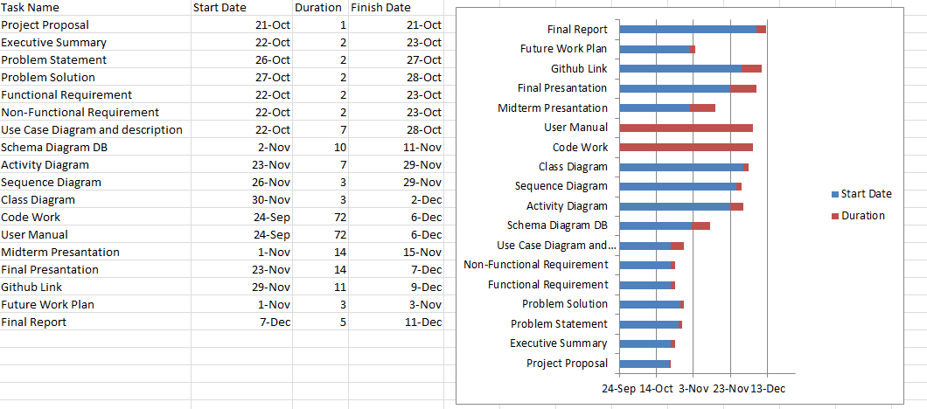

**Requirement Analysis**

**Functional Requirement:**

* Student/Teacher Registration
* Student/Teacher Login
* view Information
* View Profile
* Update Information
* Add Student
* View Student
* Insert Project Information

**Non-Functional Requirement:**

* Many student will add there data easily.
* All pages shall load only click.
* Project background color is fixed.

**System Design (Corrected System Design Diagrams using draw.io/creatly.com)**

**Use Case Diagram:**

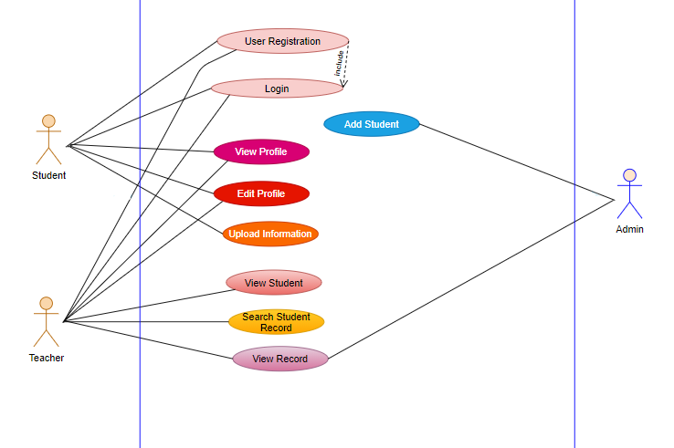

**Use Case Description:**

**1.**

**Use Case Name: Registration**

* + **Actor(s):Student(Primary) ,Teacher(Primary)**
  + **Summary Description: Allow any student to registration for appointment the teacher.**
  + **Pre-Condition:**
  + **Post-Condition: user have to register fast**
  + **Priority: Must have**

**2.**

**Use Case Name: Login**

* + **Actor(s):Student(Primary),Teacher(Primary),Admin(Secondary)**
  + **Summary Description: Student, Teacher, Admin have to login input in his username and password.**
  + **Pre-Condition: register**
  + **Post-Condition: user have to login fast**
  + **Priority: Must have**

**3.**

**Use Case Name: Upload Project & document**

* + **Actor(s):Student(Primary)**
  + **Summary Description: After logging in, students will upload project documents, source code, thumbnails and all required fields. Basically when a student chooses a field he has to fill this section which is the most imported because all the information is stored here.**
  + **Pre-Condition: Select field**
  + **Post-Condition: Have to fill up the information form**
  + **Priority: Must have**

**4. Use Case Name: View Profile**

* + **Actor(s):Student(Primary)**
  + **Summary Description: Teacher and students will check their profile.**
  + **Pre-Condition : login**
  + **Post-Condition : View his/her profile information**
  + **Priority: Medium**

**5. Use Case Name: Edit Profile**

* + **Actor(s):Student(Primary), Teacher(Primary)**
  + **Summary Description: This section students/teacher can update information. If any information is changed he/she can update it and if he wants to add something he also can.**
  + **Pre-Condition : Insert Information**
  + **Post-Condition : If he wants to update something he update**
  + **Priority: Must have**

**6. Use Case Name: View Information**

* + **Actor(s):Teacher(Primary)**
  + **Summary Description: Teacher will view this section. After student completing his insert section all these data or information will store there and as per there need they will check it.**
  + **Pre-Condition : login**
  + **Post-Condition : He can check all the information’s**
  + **Priority: Must have**

**7.**

**Use Case Name: View Student**

**Actor(s): Teacher (Primary)**

* + **Summary Description: After login teacher can show**

**Students which are under the same teacher**

* + **Pre-Condition : must login**
  + **Post-Condition : view specific students**
  + **Priority: Must have**

**8.**

**Use Case Name: Add Student**

* + **Actor(s):Admin (Secondary)**
  + **Summary Description: Admin aware Add Student.**
  + **Priority: Must have**

**Activity Diagram:**

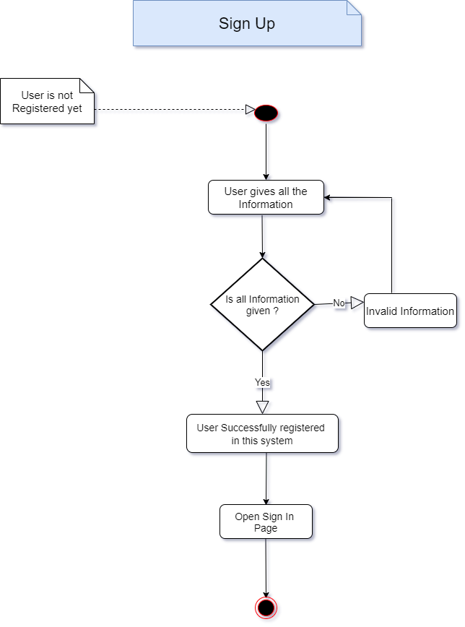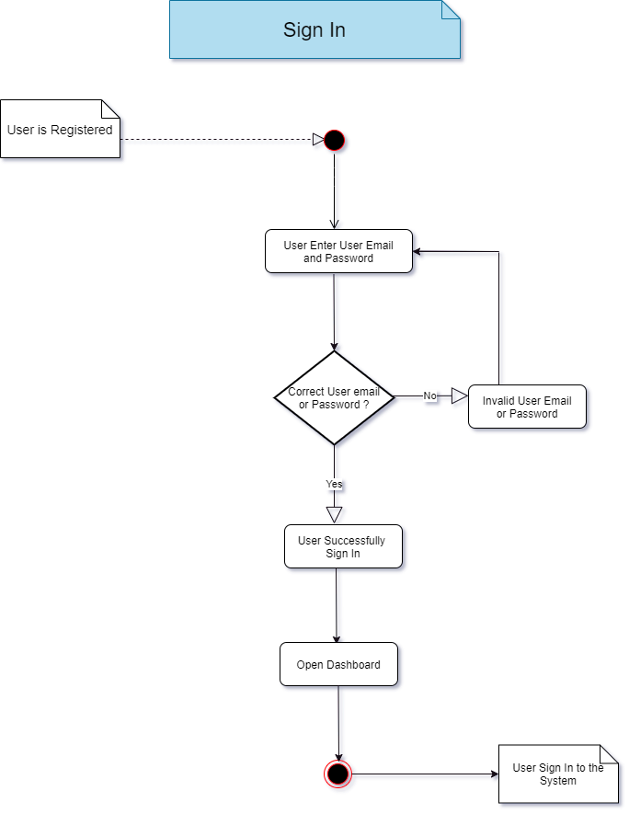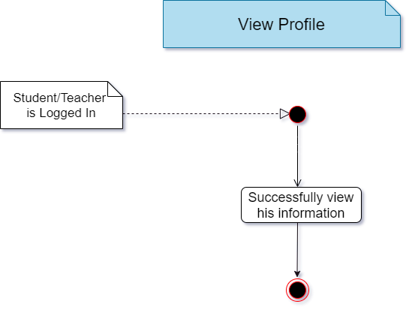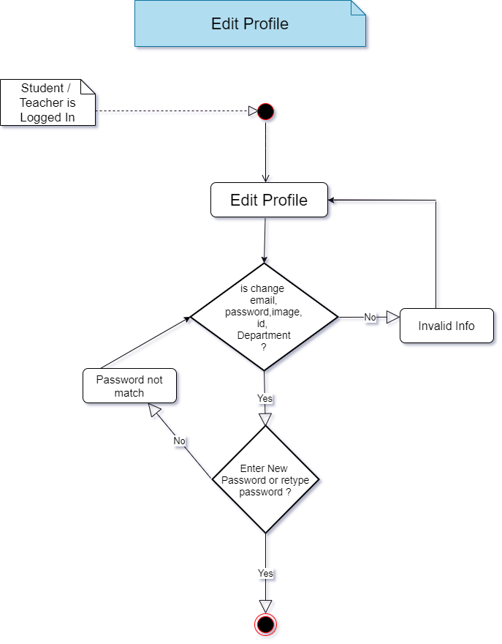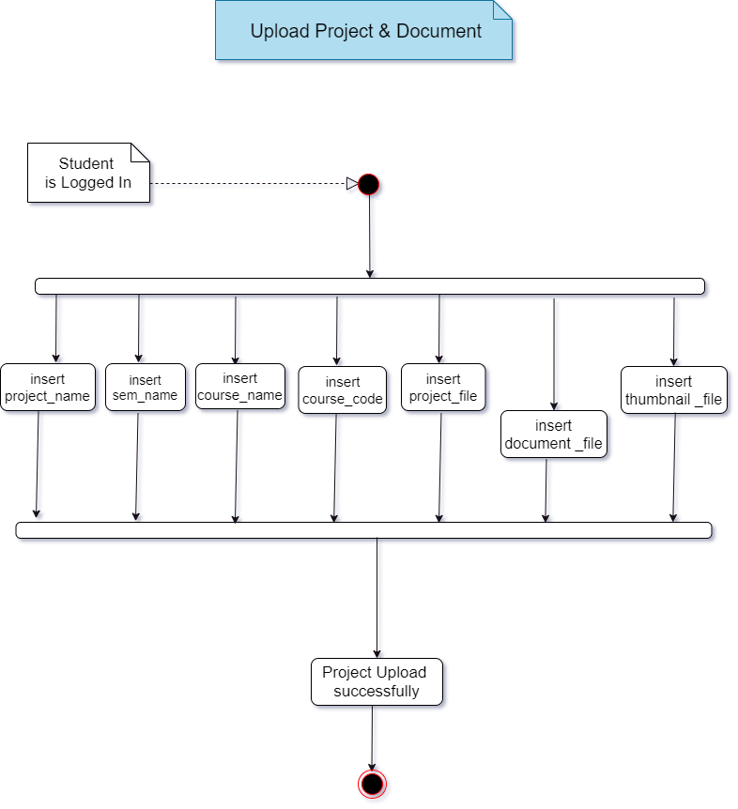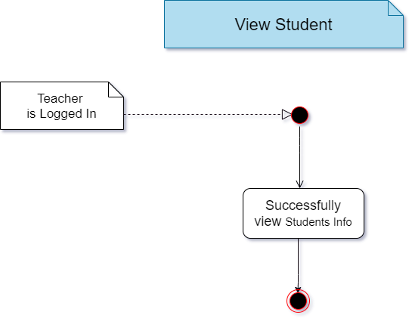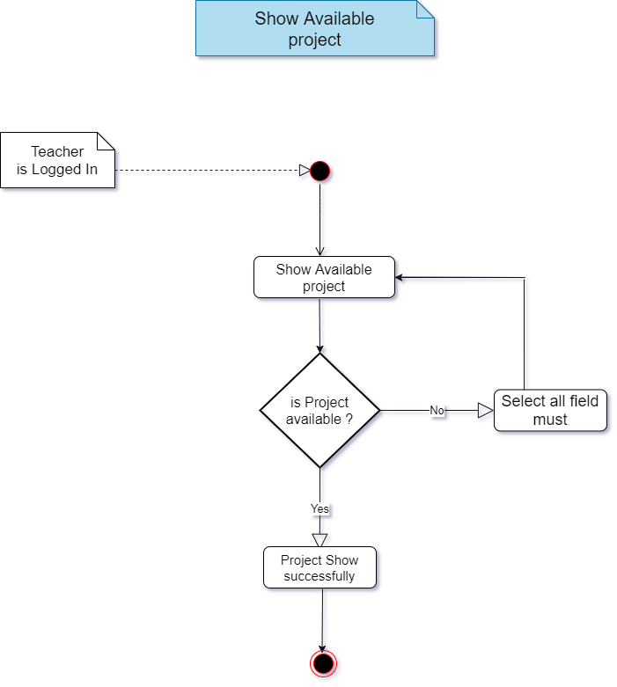

**Class Diagram:**

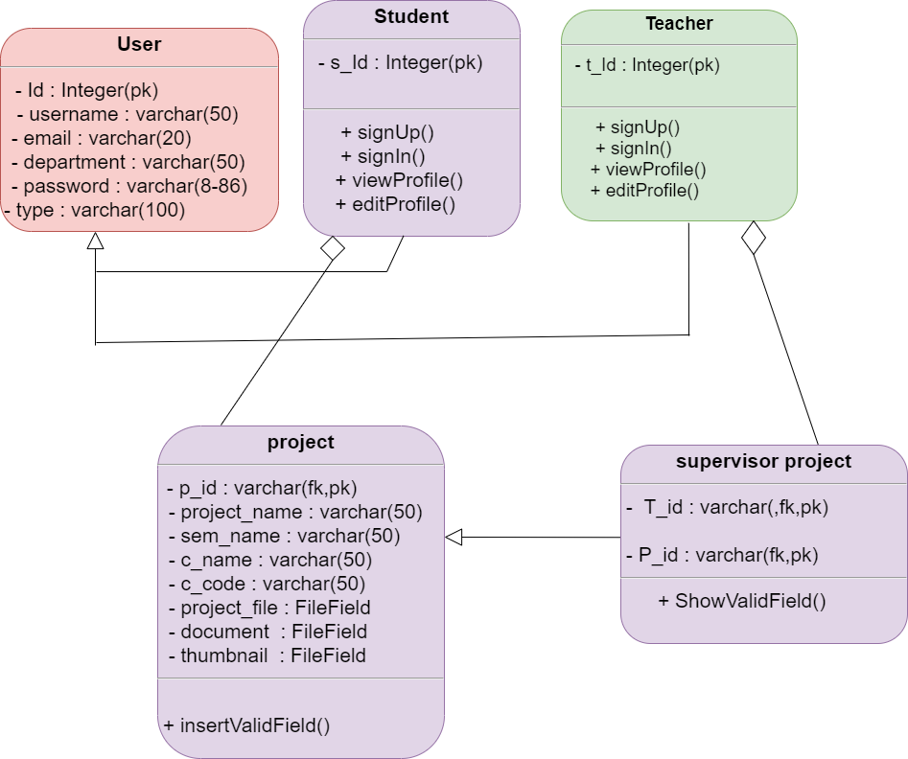

**Schema Diagram DB:**

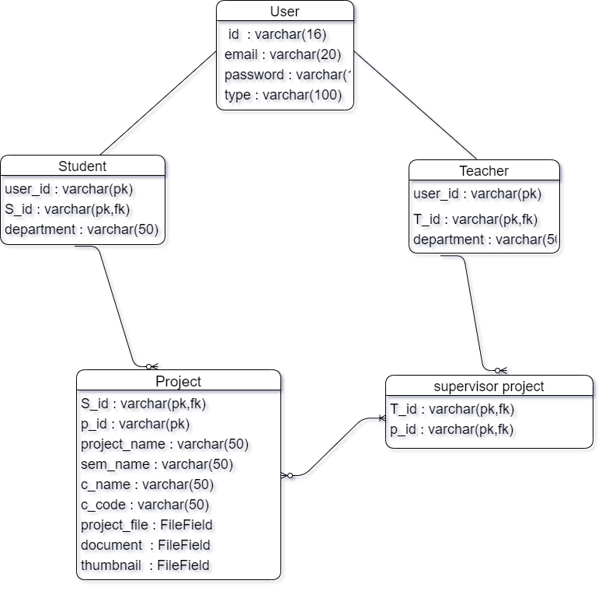

**Sequence Diagram:**

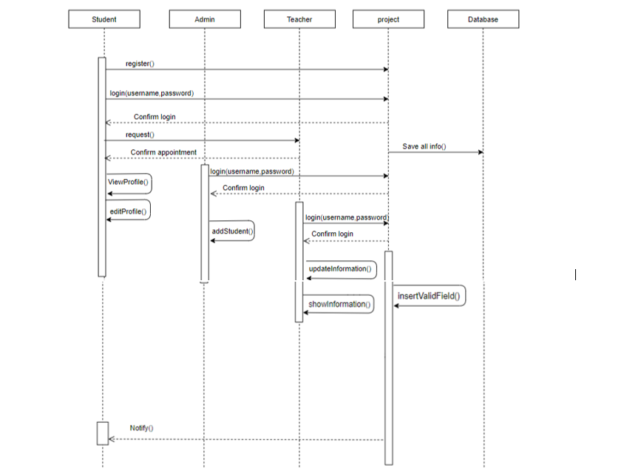

**Technology:**

**Programming Language:**

**Python**

**FRAMEWORK: Django**

**For this project I totally used python. Which is the main core of language and use most comfortable framework Django.**

**Screenshots of code (classes) according to class diagram User Class:**

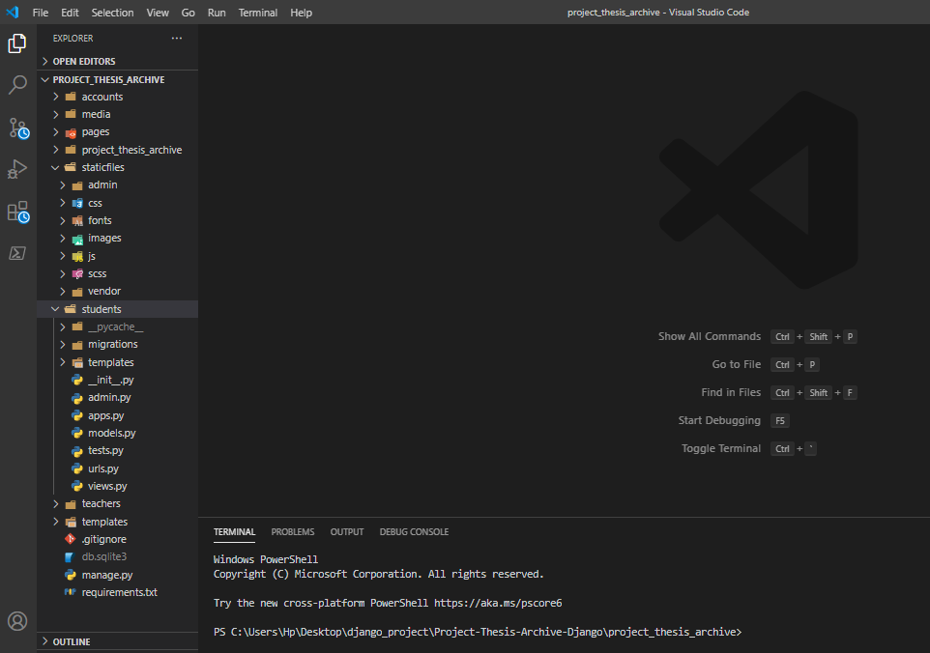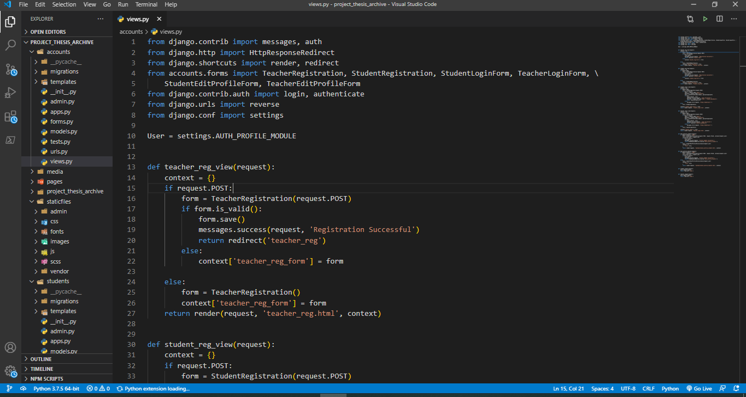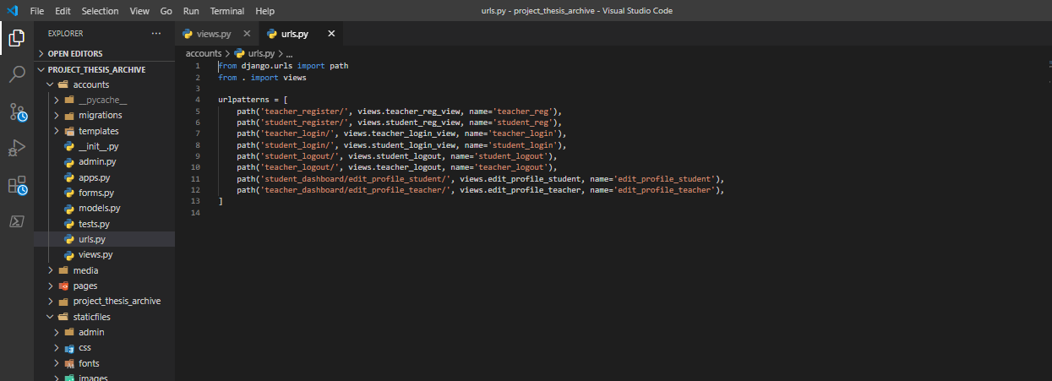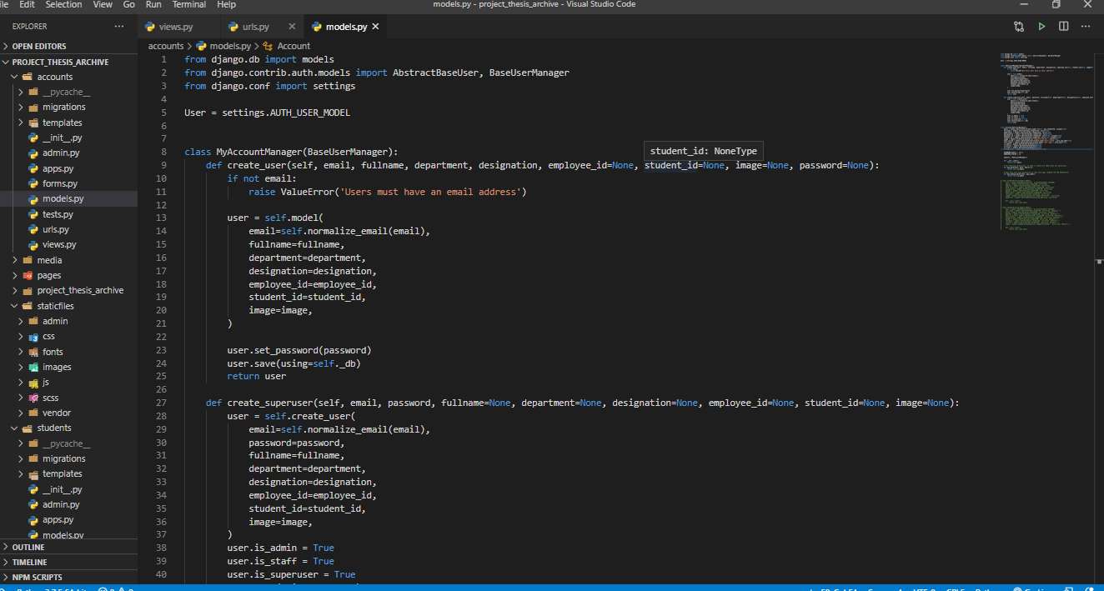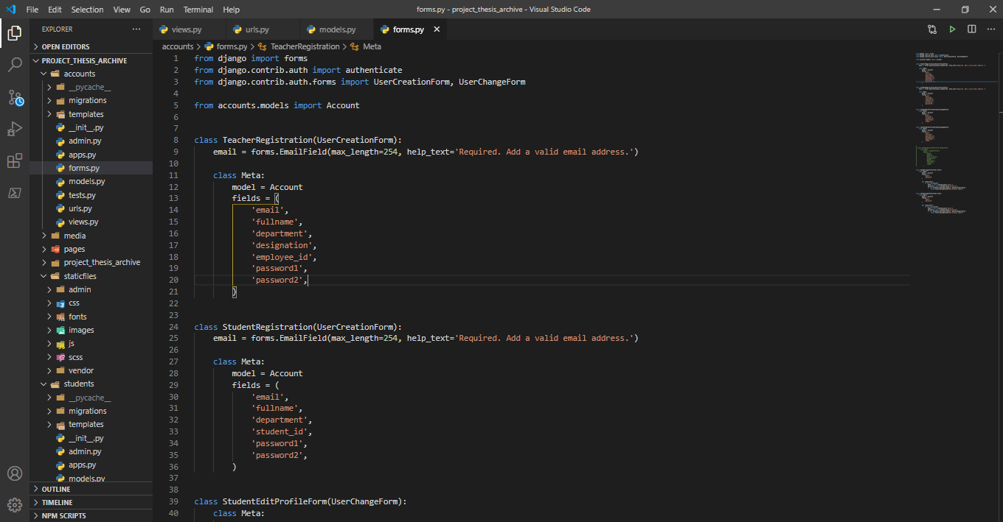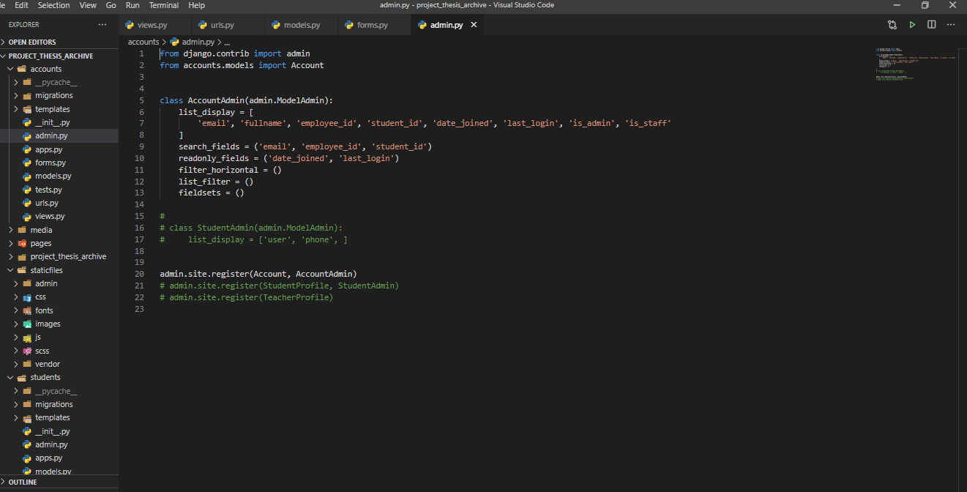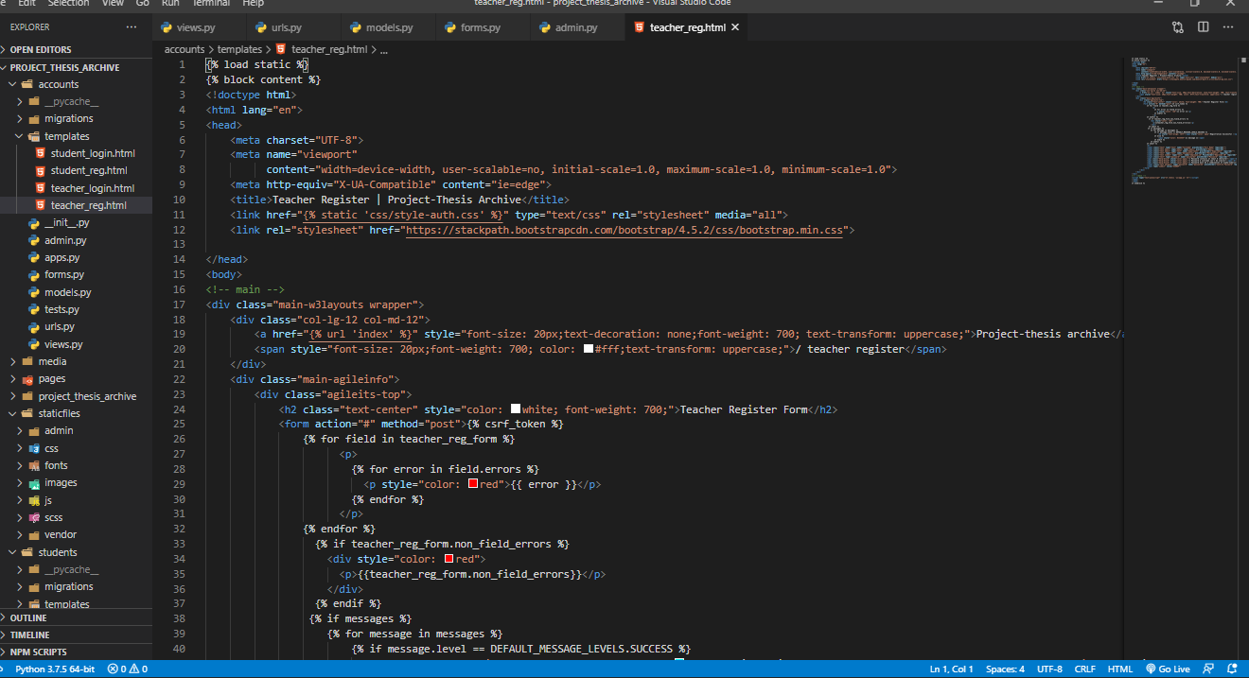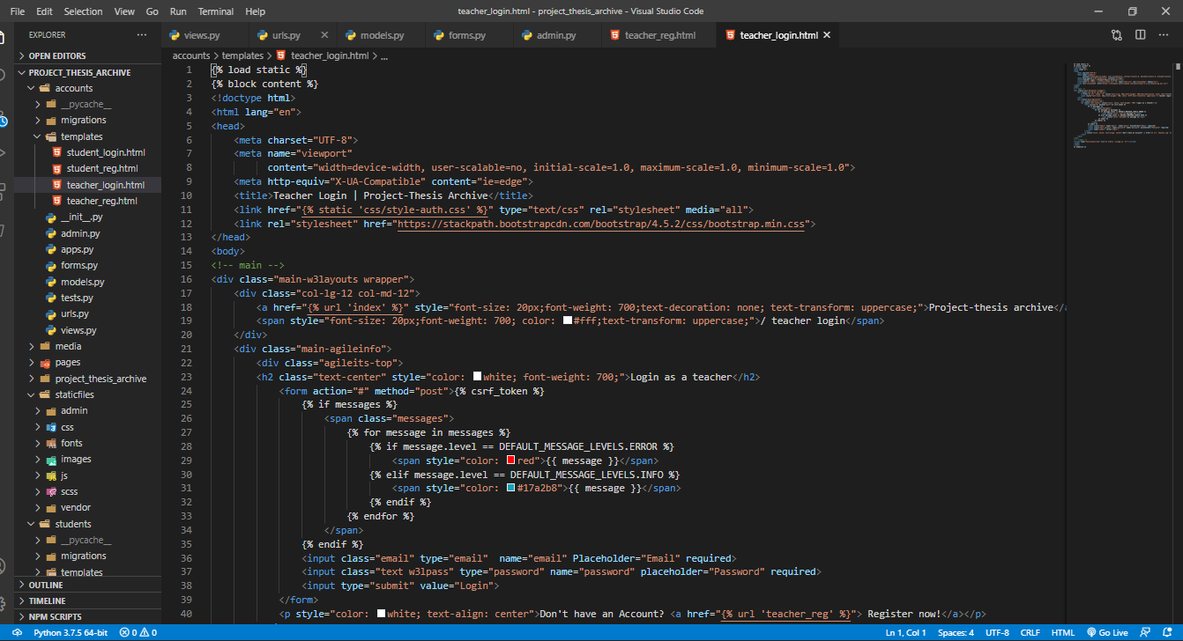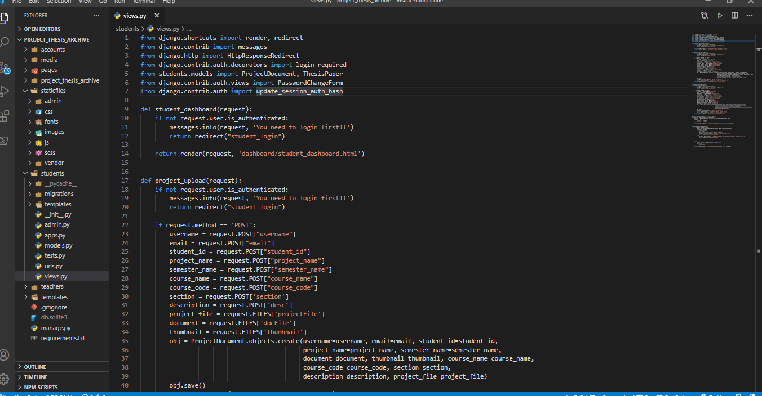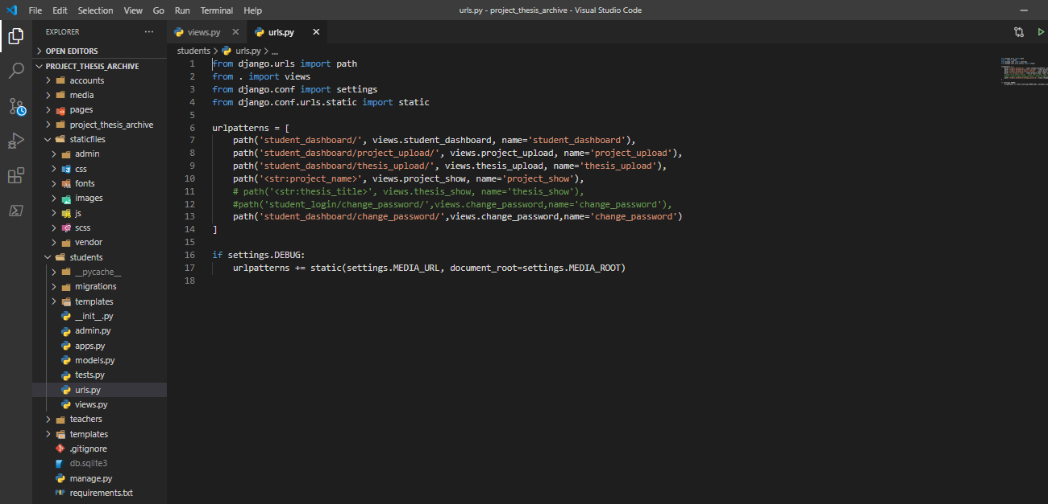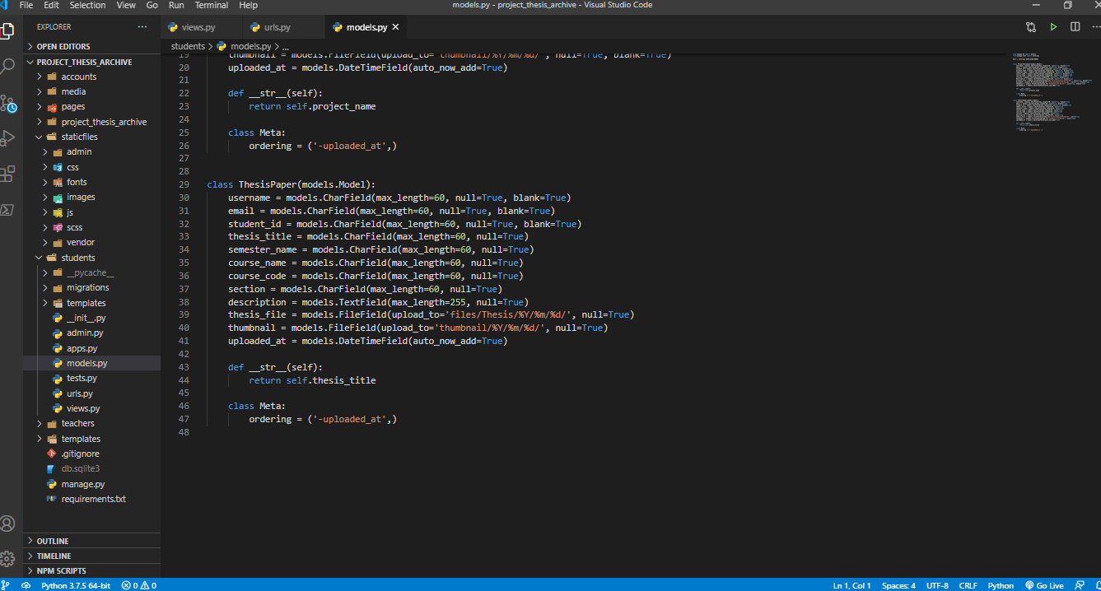

**User Manual:**

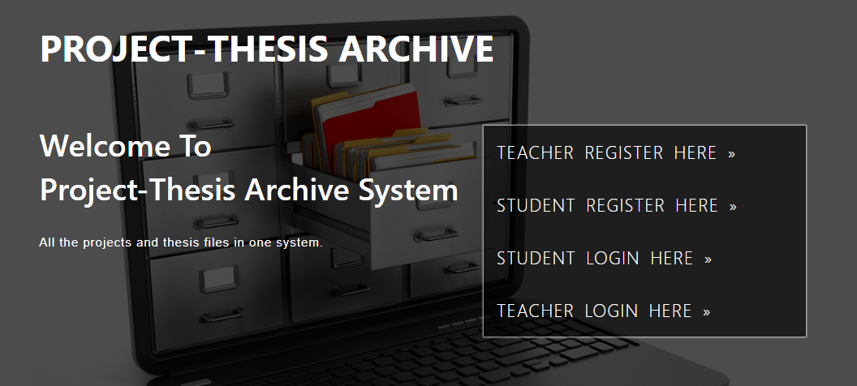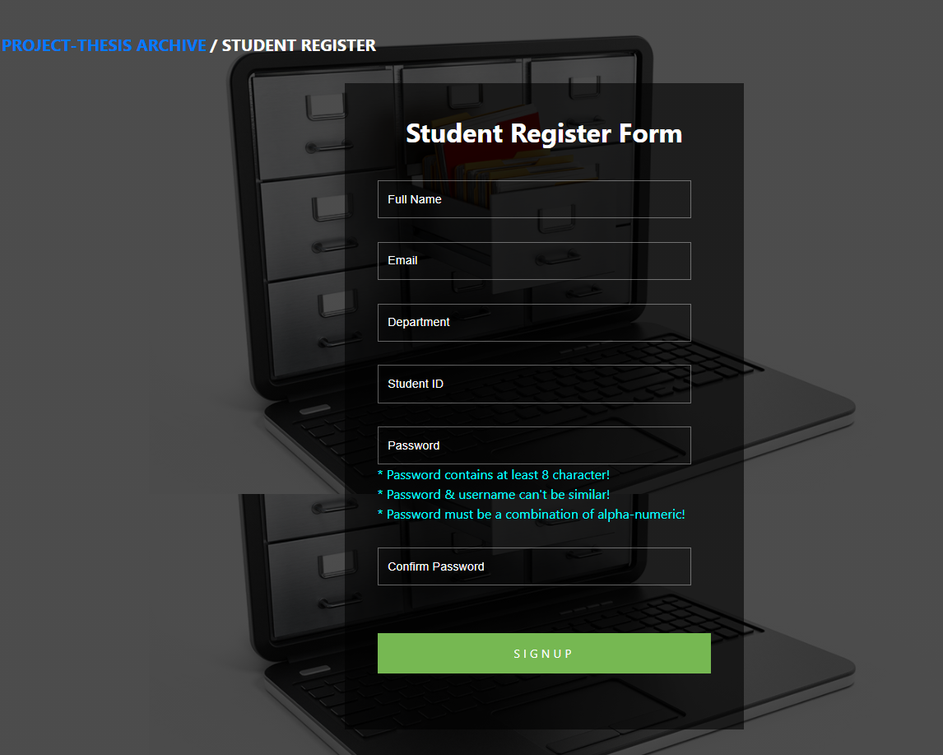

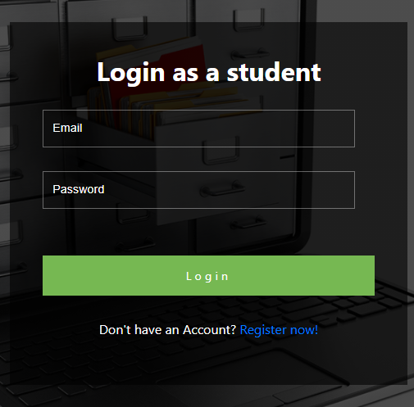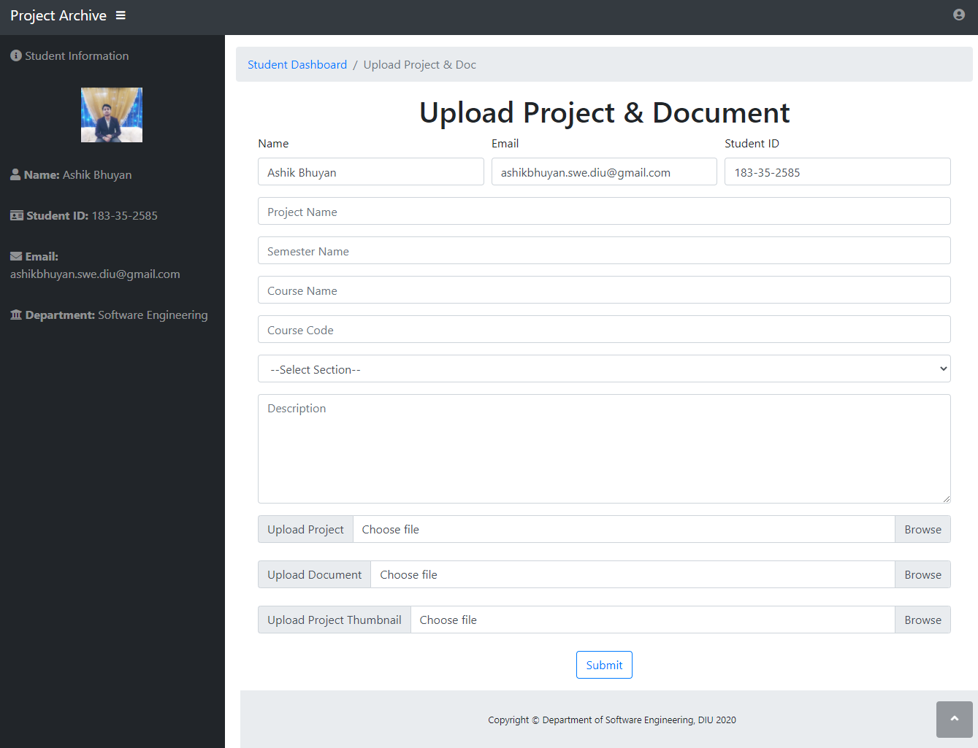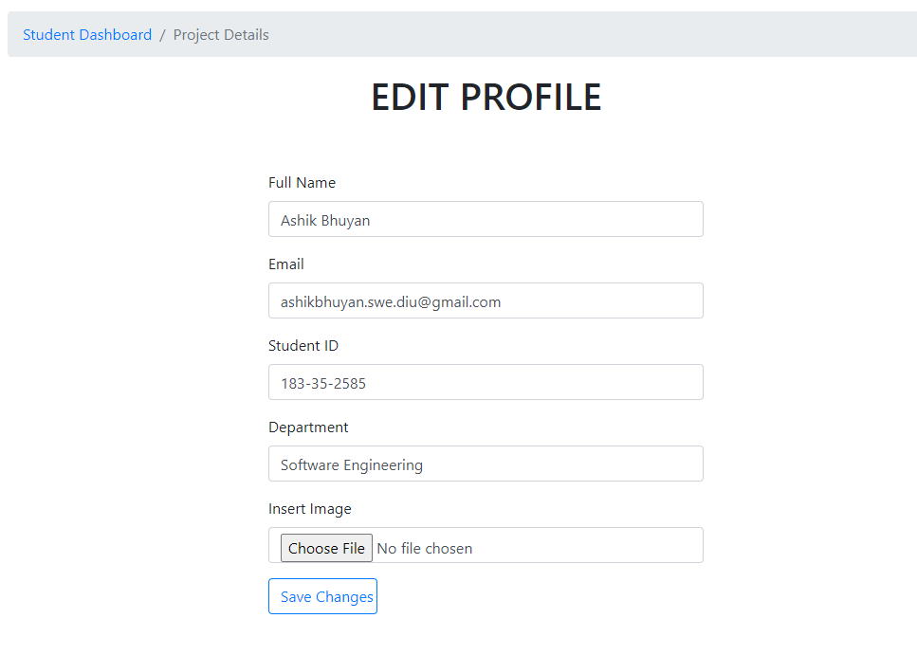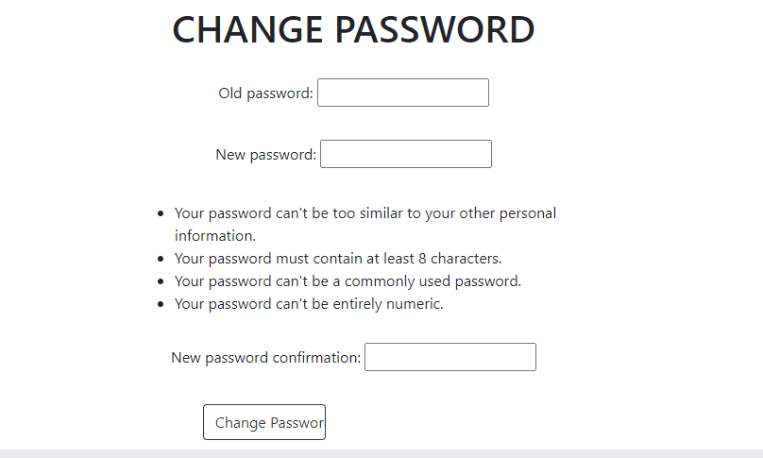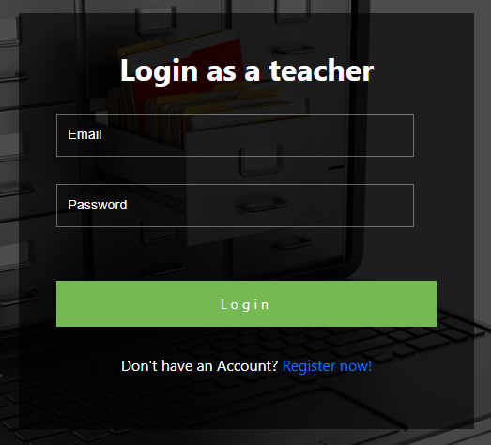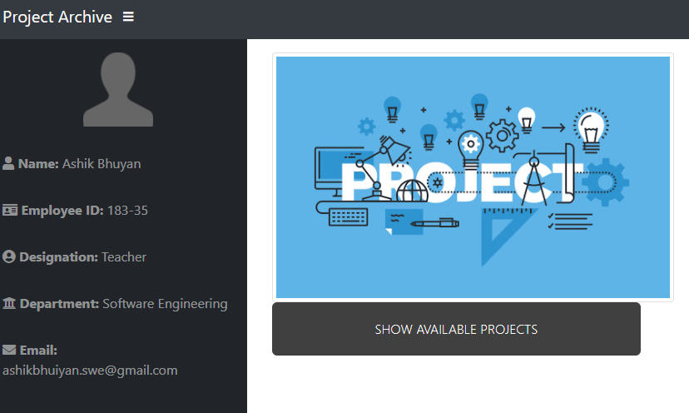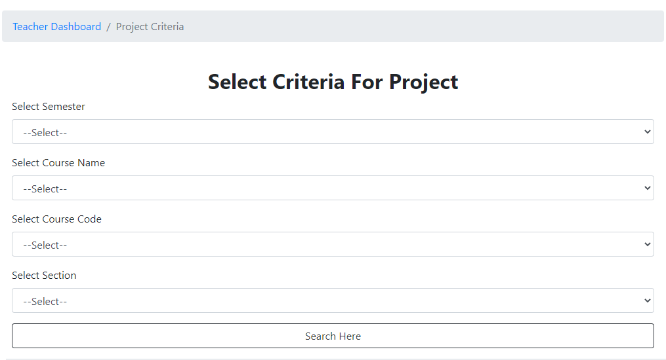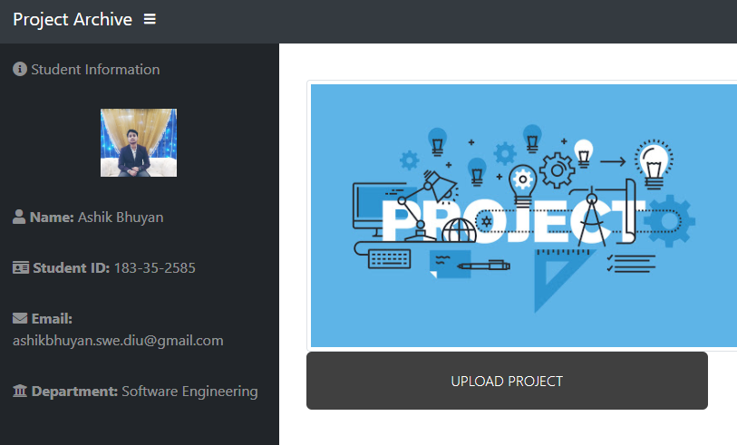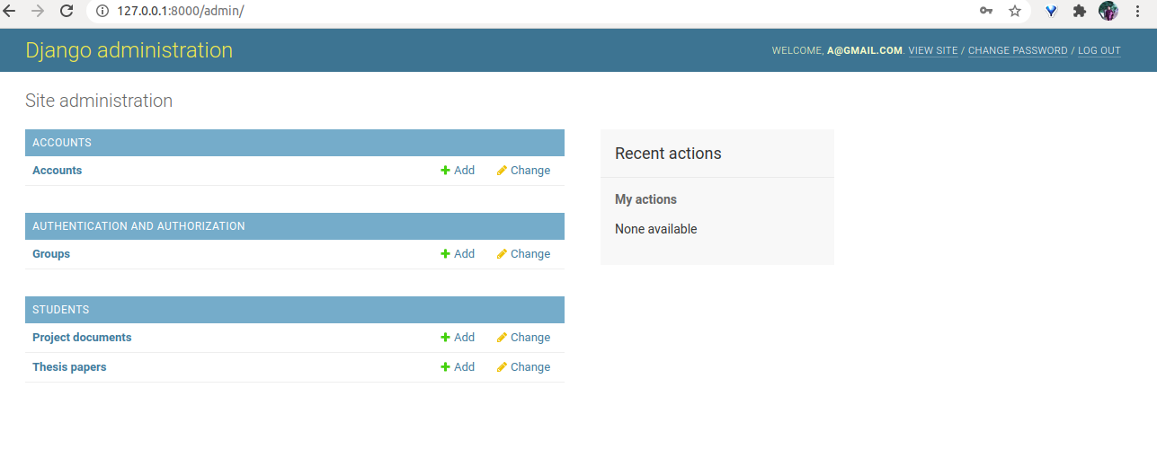

**GitHub link:**

**https://github.com/ashikbhuyan17/Project-Thesis-Archive-Django/tree/master/project_thesis_archive**

**FUTURE WORK PLANS:**

* This project is not a simple or small project it can be modified and extend a lot because I want to extend it in future days.
* The panel work should be done.
* The main visual vision will be great where this project will be installed and provided services to the end customers.

***Thank You***