* **+880 15-21505230**
* [**ashikcse321@gmail.com**](mailto:ashikcse321@gmail.com)
* **Rajshahi, Bangladesh**

***SKILLS***

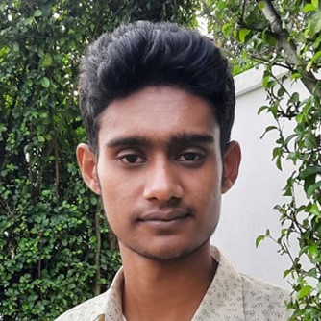

***ASHIK SARKER***

**Full-stack web developer**

**+880 15-21505230**

[**ashikcse321@gmail.com**](mailto:ashikcse321@gmail.com)

**Rajshahi, Bangladesh**



***LANGUAGES***

* **+880 15-21505230**
* [**ashikcse321@gmail.com**](mailto:ashikcse321@gmail.com)
* **Rajshahi, Bangladesh**