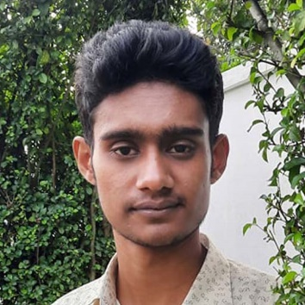

**1. React Calculator**

In this project, I use React with Vite. I use react functional components and manage state with the useReducer hook.

<https://roaring-halva-23ad9a.netlify.app/>

**2. Facebook Clone**

In this project, I use Tailwind css to clone facebook homepage.

<https://eclectic-frangollo-3299a1.netlify.app/>

**3. Travel app Clone**

In this project, I use Tailwind css to clone a travel application landing page.

<https://stellular-blancmange-e560c9.netlify.app/>

**4. Academic Thesis/Project Information Registry**

This project is mainly for a university to register their student's academic thesis/project information. In this project, I used HTML, CSS and JS for front-end design. On the backend, I used PHP and MySQL. I used JQuary for front-end functionality and **'PhpSpreadsheet'** for student data entry from Excel files.

<https://github.com/ashikcse045/thesis-project-information-registry>

***PROJECTS***

***EDUCATION***

**B.Sc. In Computer Science and Engineering**

Varendra University, Rajshahi, Bangladesh

Jan 2019 – Jan 2023

* **English**
* **Bengali**

***LANGUAGES***

* **React.JS**
* **Tailwind CSS**
* **PHP**
* **SQL**
* **jQuary**
* **javaScript**
* **git & github**
* **Bootstrap**
* **CSS**
* **HTML**
* **C++**

I am a self-taught passionate web designer specializing in HTML, CSS, Bootstrap, Tailwind CSS, JavaScript and React.js. I can convert a Figma design or a PSD design into a responsive web template using HTML, CSS, Bootstrap, Tailwind CSS and JS. I can develop the backend of an application using PHP and MySQL database.

***ABOUT ME***

***SKILLS***

**🕽 +880 1785-327802**

**→** [**ashikcse321@gmail.com**](mailto:ashikcse321@gmail.com)

[**///////// ashikcse045**](https://github.com/ashikcse045)

[**/ ashikcsevu**](https://www.linkedin.com/in/ashikcsevu/)

** Rajshahi – Bangladesh**

**ASHIK SARKER**

**WEB DESIGNER**