SOFTWARE REQUIREMENTS SPECIFICATION
for
HOTEL BOOKING SYSTEM
Version 1.0
Prepared: September 2026

Table of Contents
1. Introduction
1.1 Purpose
1.2 Scope
1.3 Definitions, Acronyms and Abbreviations
1.4 References
1.5 Overview
2. Overall Description
2.1 Product Perspective
2.2 Product Functions
2.3 User Classes and Characteristics
2.4 Operating Environment
2.5 Design and Implementation Constraints
2.6 Assumptions and Dependencies
3. Functional Requirements
4. Non-Functional Requirements
5. External Interface Requirements
6. System Models (UML Diagrams)
6.1 Use Case Diagram
6.2 Class Diagram
6.3 Sequence Diagram
6.4 Collaboration Diagram
6.5 Activity Diagram
6.6 State Chart Diagram
7. Appendix

1. Introduction

1.1 Purpose
This Software Requirements Specification (SRS) document describes the functional and non-functional requirements for the Hotel Booking System (HBS). It is intended to serve as a reference for the development team, project stakeholders, and quality assurance team throughout the design, development, and testing phases of the project.

1.2 Scope
The Hotel Booking System is a web/mobile-based application that allows guests to search for hotel rooms, view availability, make reservations, process payments online, and manage their bookings. It also provides hotel administrators and staff with tools to manage room inventory, bookings, check-in/check-out operations, and generate business reports. The system aims to automate the manual booking process, reduce booking errors, and provide a seamless experience for both guests and hotel staff.

1.3 Definitions, Acronyms and Abbreviations
Term | Description
SRS | Software Requirements Specification
HBS | Hotel Booking System
UML | Unified Modeling Language
UI | User Interface
DB | Database
Guest | An end-user who searches for and books hotel rooms
Admin | Hotel staff/administrator who manages rooms and bookings
Payment Gateway | Third-party service used to process online payments

1.4 References
- IEEE Std 830-1998, IEEE Recommended Practice for Software Requirements Specifications
- UML 2.5 Specification, Object Management Group (OMG)
- Project stakeholder discussions and business requirement notes

1.5 Overview
The remainder of this document is organized as follows: Section 2 gives an overall description of the product. Section 3 lists functional requirements. Section 4 lists non-functional requirements. Section 5 describes external interface requirements. Section 6 presents the system models using six UML diagrams. Section 7 contains supporting appendix material.

2. Overall Description

2.1 Product Perspective
The Hotel Booking System is a standalone, self-contained web/mobile application with a centralized database. It interfaces with an external Payment Gateway for processing transactions and an email/SMS service for sending notifications. It is designed to be used by guests over the internet and by hotel staff through an administrative panel.

2.2 Product Functions
- Guest registration, login, and profile management
- Search and filter available rooms by location, dates, price, and room type
- View detailed room information, images, and amenities
- Book a room and make secure online payment
- View, modify, and cancel existing bookings
- Admin management of hotels, rooms, and room availability
- Admin management of bookings, check-in/check-out processing
- Automated email/SMS notifications and booking confirmations
- Generation of occupancy and revenue reports for administrators

2.3 User Classes and Characteristics
User Class | Characteristics
Guest | General public users who search for and book rooms; require an intuitive, easy-to-use interface
Admin / Hotel Staff | Manage hotel and room data, oversee bookings, and require access to reporting tools
System Administrator | Manages user accounts, system configuration, and overall system maintenance

2.4 Operating Environment
- Client Side: Modern web browsers (Chrome, Firefox, Safari, Edge) and Android/iOS mobile devices
- Server Side: Cloud-hosted application server (e.g., Linux-based) with a relational database (e.g., MySQL/PostgreSQL)
- Third-Party Integration: Payment gateway API, Email/SMS gateway API

2.5 Design and Implementation Constraints
- The system must comply with PCI-DSS guidelines for handling payment data
- The system must support at least 1,000 concurrent users
- The application must be responsive and accessible on mobile devices

2.6 Assumptions and Dependencies
- Users have access to the internet and a valid email address / phone number
- The payment gateway service is available and reliable
- Hotel room data is accurately maintained by administrators

3. Functional Requirements
ID | Requirement | Priority
FR-1 | The system shall allow a guest to register a new account and log in securely. | High
FR-2 | The system shall allow a guest to search for rooms by city, check-in/check-out dates, and room type. | High
FR-3 | The system shall display real-time room availability and pricing. | High
FR-4 | The system shall allow a guest to book a room and enter guest details. | High
FR-5 | The system shall integrate with a payment gateway to process payments securely. | High
FR-6 | The system shall send a booking confirmation via email/SMS upon successful payment. | Medium
FR-7 | The system shall allow a guest to view, modify, or cancel a booking within the allowed policy window. | High
FR-8 | The system shall process refunds for eligible cancellations. | Medium
FR-9 | The system shall allow admin users to add, update, or remove room and hotel information. | High
FR-10 | The system shall allow admin users to manage bookings and perform check-in/check-out. | High
FR-11 | The system shall allow admin users to generate occupancy and revenue reports. | Medium
FR-12 | The system shall allow guests to submit ratings and reviews for a completed stay. | Low

4. Non-Functional Requirements

4.1 Performance
- The system shall respond to search queries within 2 seconds under normal load.
- The system shall support at least 1,000 concurrent users without performance degradation.

4.2 Security
- All sensitive data (passwords, payment details) shall be encrypted in transit and at rest.
- The system shall implement role-based access control (Guest, Admin, System Administrator).

4.3 Reliability & Availability
- The system shall maintain 99.5% uptime, excluding scheduled maintenance.
- The system shall provide automated database backups on a daily basis.

4.4 Usability
- The user interface shall be intuitive and require no more than 3 clicks to complete a room search.
- The system shall be accessible on both desktop and mobile devices (responsive design).

4.5 Maintainability & Scalability
- The system architecture shall support horizontal scaling to accommodate business growth.
- The codebase shall follow modular design principles to ease future maintenance.

5. External Interface Requirements

5.1 User Interfaces
- Web-based responsive interface for guests and administrators
- Mobile-friendly interface for on-the-go bookings

5.2 Hardware Interfaces
- Standard client devices: desktops, laptops, tablets, and smartphones with internet connectivity

5.3 Software Interfaces
- Payment Gateway API (e.g., Stripe, PayPal, Razorpay) for transaction processing
- Email/SMS Gateway API for sending notifications
- Relational Database Management System (RDBMS) for data persistence

5.4 Communication Interfaces
- HTTPS protocol for all client-server communication
- RESTful APIs for communication between front-end and back-end services

6. System Models (UML Diagrams)
This section presents six UML diagrams that model the structure and behavior of the Hotel Booking System: Use Case, Class, Sequence, Collaboration, Activity, and State Chart diagrams.

6.1 Use Case Diagram
The use case diagram illustrates the interactions between the actors (Guest, Admin/Hotel Staff, Payment Gateway) and the main functions of the system.
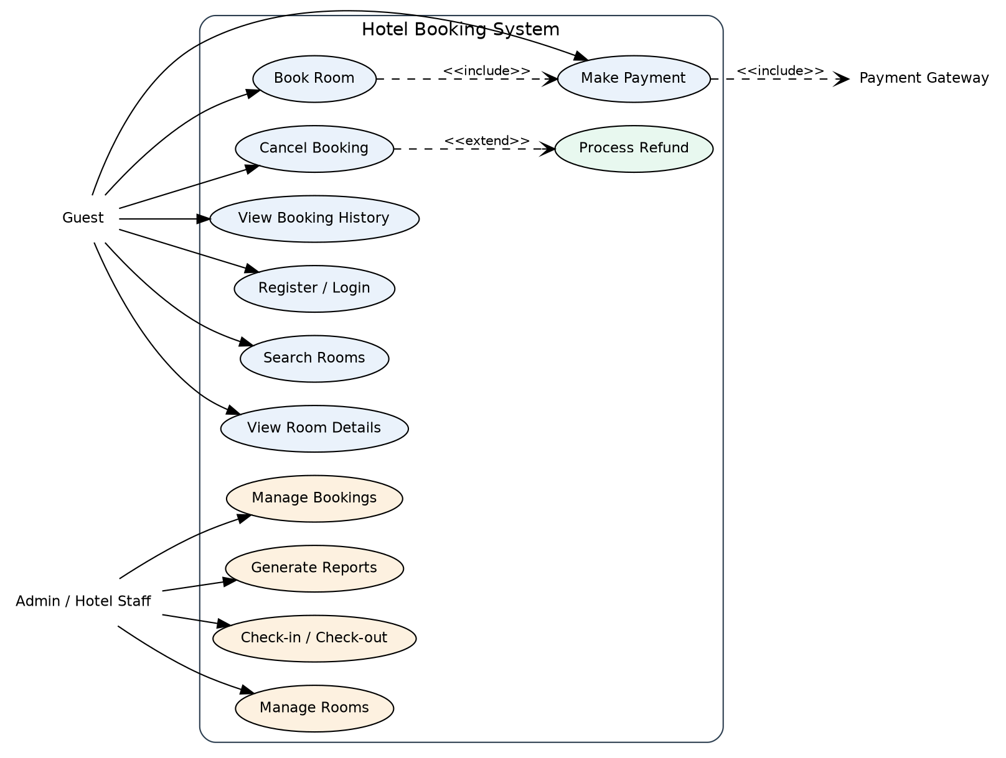
Figure 6.1: Use Case Diagram of the Hotel Booking System

6.2 Class Diagram
The class diagram represents the static structure of the system, showing the key classes, their attributes, operations, and relationships.
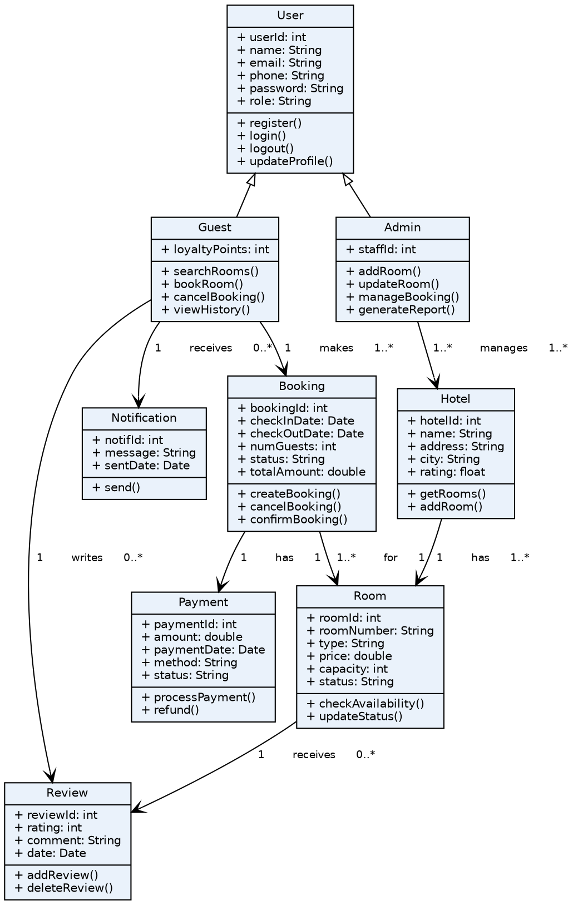
Figure 6.2: Class Diagram of the Hotel Booking System

6.3 Sequence Diagram
The sequence diagram below models the interaction flow for the primary scenario: a guest booking a room, from search through payment confirmation.
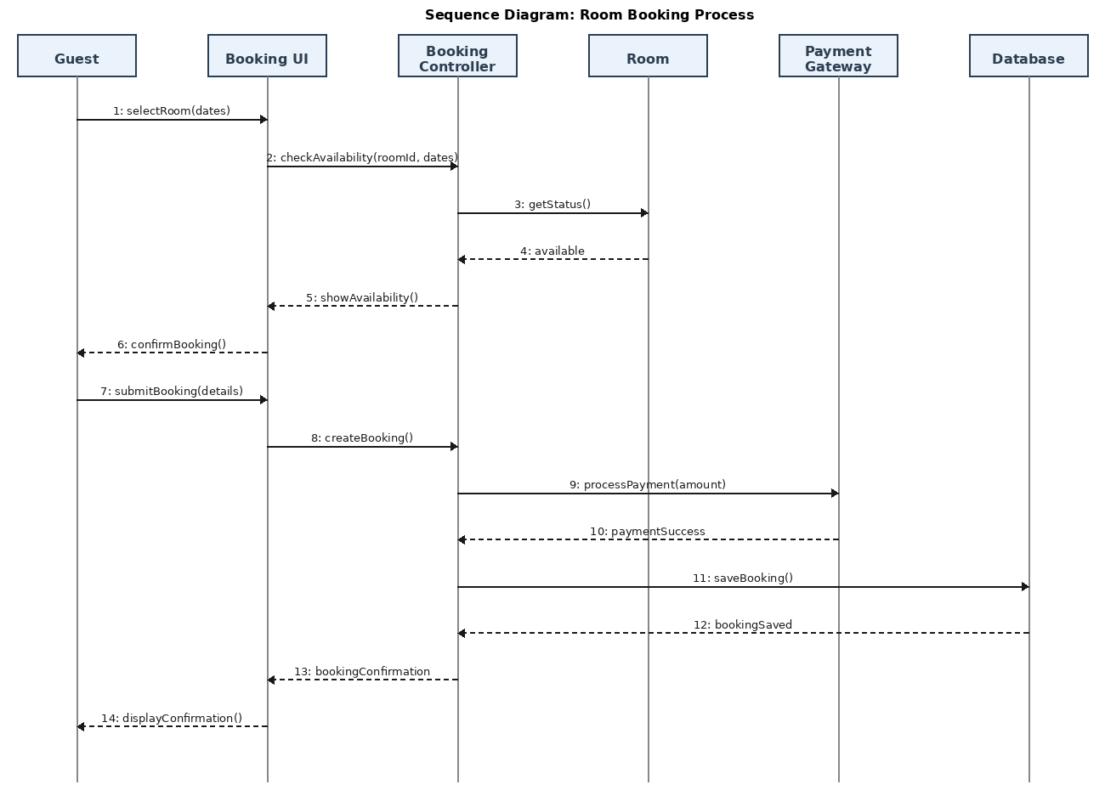
Figure 6.3: Sequence Diagram – Room Booking Process

6.4 Collaboration Diagram
The collaboration diagram presents the same room booking scenario as the sequence diagram, emphasizing the relationships between objects and the sequence of messages exchanged.
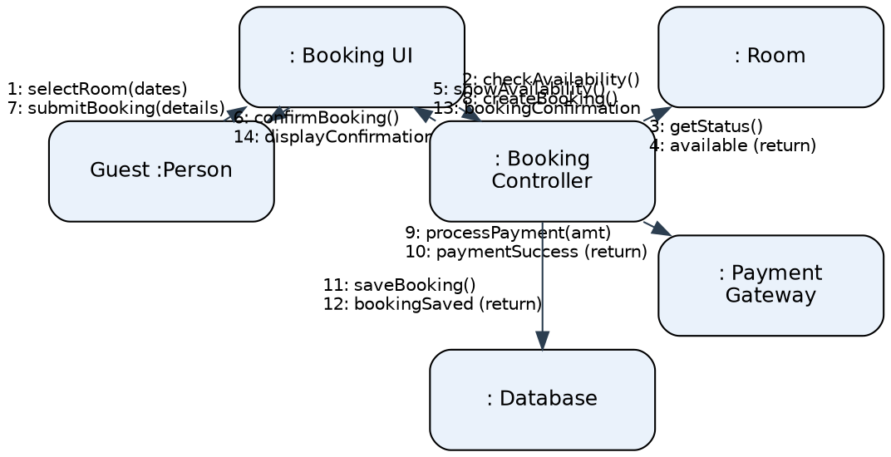
Figure 6.4: Collaboration Diagram – Room Booking Process

6.5 Activity Diagram
The activity diagram models the workflow of the room booking process from the guest's perspective, including decision points for availability, validation, and payment.
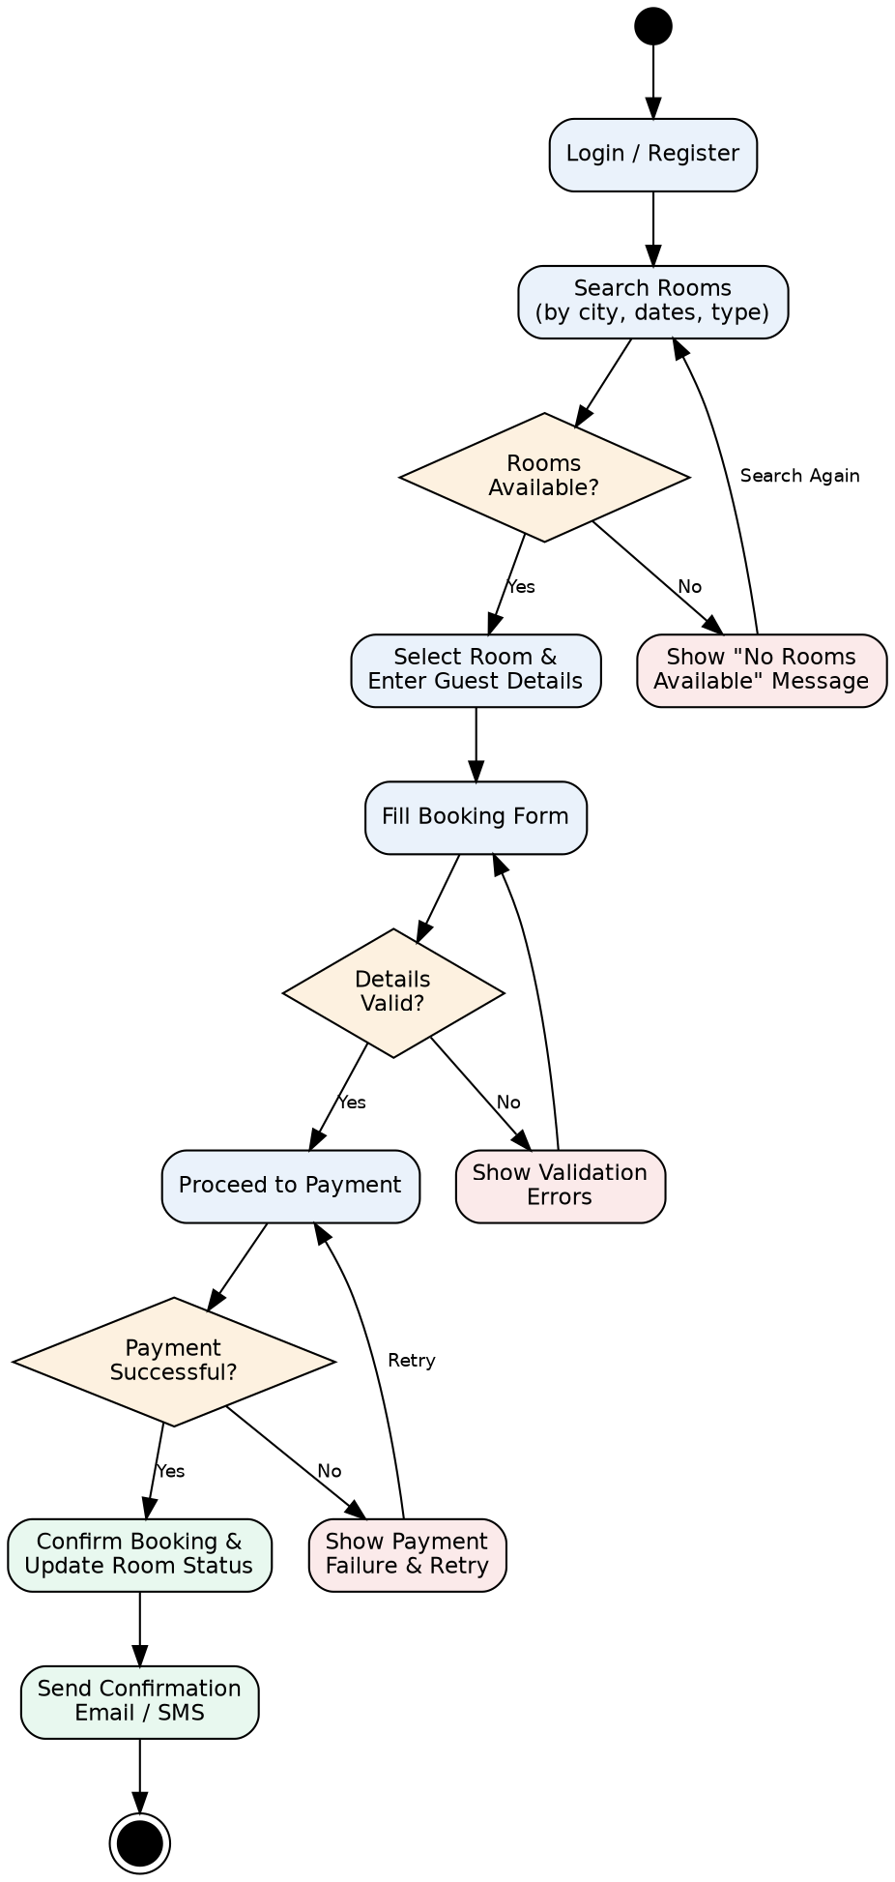
Figure 6.5: Activity Diagram – Room Booking Workflow

6.6 State Chart Diagram
The state chart diagram shows the various states a Booking object can be in throughout its lifecycle, from initiation through completion or cancellation.
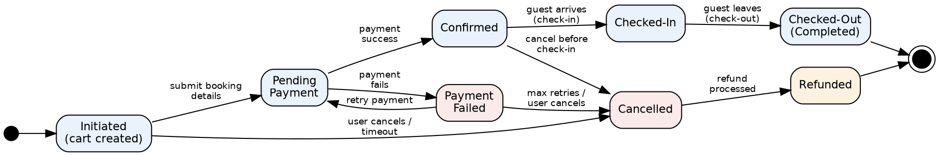
Figure 6.6: State Chart Diagram – Booking Lifecycle

7. Appendix

7.1 Sample Data Dictionary
Entity | Key Attributes
User | userId, name, email, phone, password, role
Hotel | hotelId, name, address, city, rating
Room | roomId, roomNumber, type, price, capacity, status
Booking | bookingId, checkInDate, checkOutDate, numGuests, status, totalAmount
Payment | paymentId, amount, paymentDate, method, status

7.2 Revision History
Version | Date | Description
1.0 | Sep 2026 | Initial draft of SRS with UML diagrams

