Sampling Distribution and Order Statistics

|  |  |  |
| --- | --- | --- |
| Name | : | Tithi Rani |
| ID | : | 2212424127 |
| Course Title | : | Sampling Distributions and Order Statistics |
| Course Code | : | B.Stat.-209 (Session I) |

**Binomial Distribution**

set.seed(11)  
par(mfrow=c(1, 3))  
n = c(9, 9, 9)  
p = c(0.55, 0.35, 0.4)  
color = c("red", "green", "blue")  
for(i in 1:3) {  
 x = rbinom(1000, n[i], p[i])  
 hist(x, col=color[i], main = paste("Histogram with n =", n[i], "and p=", p[i]))  
}

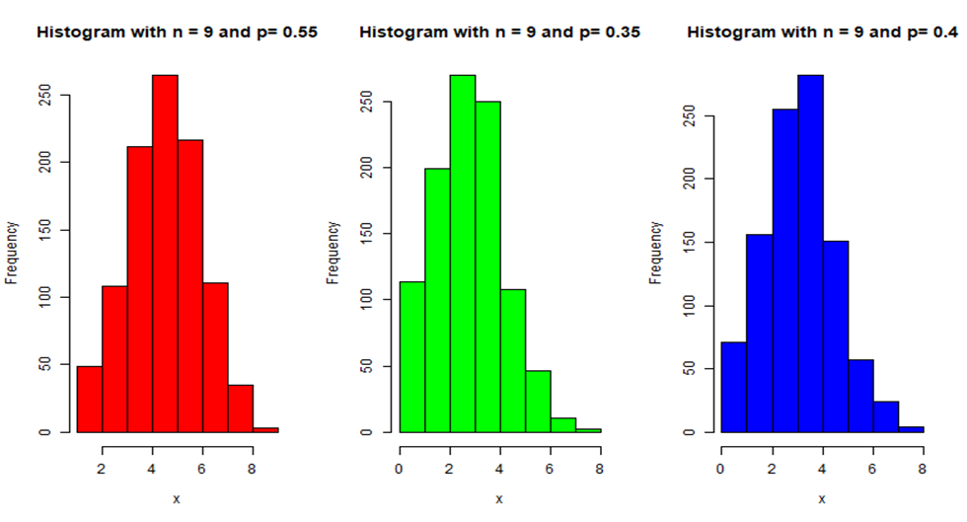

**Poisson Distribution**

set.seed(12)  
par(mfrow=c(1,3))  
p <- c(3,5,9)  
color <- c("red", "green", "blue")  
for(i in 1:3) {  
 x = rpois(1000, p[i])  
 hist(x, col=color[i], main=paste("Poisson with lemda =", p[i]))  
}

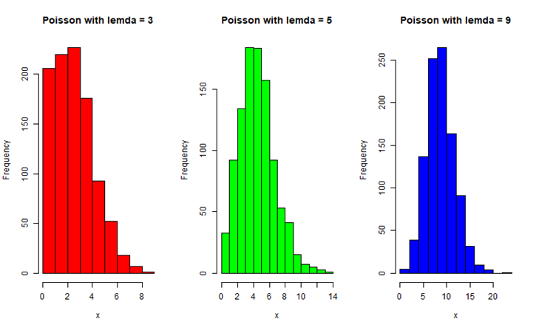

**Problem: 1 - Suppose X follows a normal distribution with mean $μ$ and variance $σ^{2}$.**

**(i) Plot the distributions on a graph paper separately with ($μ=3,σ^{2}=16),\left(μ=5,σ^{2}=16\right)$, and ($μ=4,σ^{2}=16$) and compare the graphs.**

**(ii) Plot the distributions on same graph paper with ($μ=4,σ^{2}=4),\left(μ=4,σ^{2}=9\right)$, and ($μ=4,σ^{2}=16)$**

#### Solution 1 (i):

set.seed(21)  
par(mfrow=c(1, 3))  
  
mu = c(3, 5, 4)  
sigma = c(4, 4, 4)  
colors = c("red", "green", "blue")  
labels = paste0("N(", mu, ",", sigma, ")")  
  
x = seq(-20, 20, length.out=1000)  
  
for(i in 1:3) {  
 fx <- dnorm(x, mean= mu[i], sd = sigma[i])  
 plot(x, fx, type = "l", main = labels[i], col=colors[i], lwd=3,  
 xlab = "X ->", ylab = "Frequency f(x)")  
   
 segments(x0=mu[i], x1=mu[i], y=0, y1 = max(fx), lwd=2, lty=3)  
}

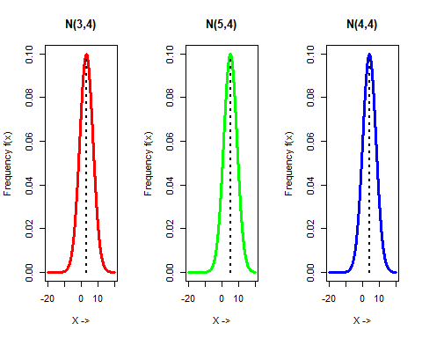

#### Solution 1 (ii):

set.seed(21)  
par(mfrow=c(1, 1))  
  
mu = c(4, 4, 4)  
sigma = c(2, 3, 4)  
colors = c("red", "green", "blue")  
labels = paste0("N(", mu, ",", sigma, ")")  
  
x = seq(-20, 20, length.out=1000)  
  
for(i in 1:length(mu)) {  
 fx <- dnorm(x, mean= mu[i], sd = sigma[i])  
 if(i==1) {  
 plot(x, fx, type = "l", main = "Normal Distribution with different means", col=colors[i], lwd=3,  
 xlab = "X ->", ylab = "Frequency f(x)")  
 } else {  
 lines(x, fx, col=colors[i], lwd=3)  
 }  
}  
abline(v=mu[1], lty=3)   
  
legend("topright", inset = 0.05, title = "Distribution", labels, fill= colors)

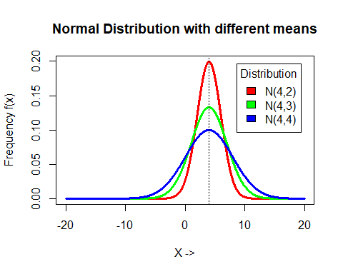

**Problem 2: Generate 1200 random samples of size n = 12 with $μ=4$ and $σ^{2}=9$. Suppose $s^{2}=\frac{1}{n-1}\sum_{i}^{n}{{\left(x_{i}-\overset{‾}{x}\right)}^{2}}$. Using sitable graph, justify that $\frac{\left(n-1\right)s^{2}}{σ^{2}}$ follows a chi-square distribution with (n-1) degress of freedom.**

set.seed(11)  
n = 12  
mu = 4  
sigma = 3  
it = 1200  
  
xvar = array()  
for(i in 1:it) {  
 x = rnorm(n, mu, sigma)  
 xvar[i] = var(x)   
}  
  
equation <- expression((n-1)*s^2/sigma^2)  
  
test_statistic = ((n-1)*xvar)/sigma^2   
hist(test_statistic, breaks = 15, freq = F, col="gray", xlab = equation, main="Chi-square distribution")  
  
x2 = seq(0, 120, 0.01)   
chisq_pdf = dchisq(x2, df=n-1)  
lines(x2, chisq_pdf, col="purple", lwd=3)  
  
legend("topright", inset = 0.1, title = "Distribution", c("Chi Square", equation), fill = c("gray", "purple"))

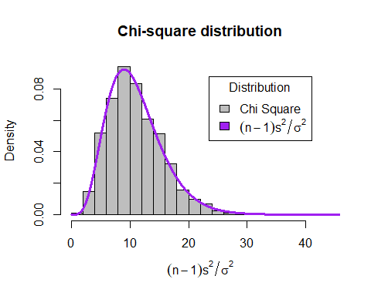

**Problem 3: A random sample of size 4 is drawn from a population that has a uniform distribution on the interval (0, 5). The resulting order statistics are $X_{1:4},X_{2:4},X_{3:4}$ and $X_{4:4}$. Determine the cumulative distribution function (CDF) of the $3^{rd}$ order statistics $\left(X_{3:4}\right)$ and plot the CDF of the $3^{rd}$ order statistic. Evaluate the probability $P\left[X_{3:4}≥2\right]$**

a = 0  
b = 5  
x = seq(a, b, length.out=1000)  
  
Fr_n_value = function(x, r, n, a, b) {  
 cdf_unif = punif(x, a, b)  
 sum_value = 0  
   
 for(j in r:n) {  
 sum_value = sum_value + choose(n, j)*(cdf_unif^j)*(1-cdf_unif)^(n-j)  
 }  
   
 return(sum_value)  
}  
  
Fr_n_eqn = function(r, n) {  
 sum_eqn <- array()  
 for(j in r:n) {  
 term <- paste0("(", n, "C", j, ") F(x)^", j, " [1-F(x)]^", (n-j))  
 sum_eqn[j-r+1] = term   
 }  
  
 return(paste0(sum_eqn, collapse ="+"))  
}  
  
# Calculation  
r <- 3  
n <- 4  
a <- 0  
b <- 5  
x <- seq(a, b, length.out=100)  
Fr_n_values <- Fr_n_value(x, r, n, a, b)  
Fr_n_eqn(r, n)

## [1] "(4C3) F(x)^3 [1-F(x)]^1+(4C4) F(x)^4 [1-F(x)]^0"

plot(x, Fr_n_values, main="CDF of Order Statistics", type="l", xlab = "x ->", ylab = "Cumulative Frequency")

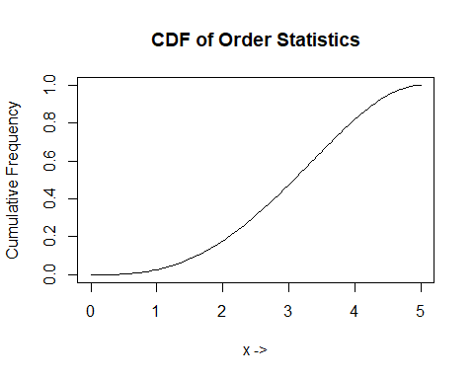

# P(x_3:4 > 2)  
x_threshold <- 2  
p_x3_gt_x <- 1 - Fr_n_value(x_threshold, r, n, a, b)  
p_x3_gt_x

## [1] 0.8208

**Problem 4: A random sample of size 7 is drawn from a population that has a uniform distribution on the interval (0, 5). The resulting order statistics are $X_{1:7},X_{2:7},X_{3:7},X_{4:7},X_{5:7},X_{6:7}$ and $X_{7:7}$. Determine the PDF, mean and variance of $4^{th}$ order (median) statistic. Also find mean and variance of smallest and largest order statistics**

fr_n = function(x, r, n, a, b) {  
 pdf_x <- dunif(x, min=a, max=b)  
 cdf_x <- punif(x, min=a, max=b)  
   
 numerator <- factorial(n) / (factorial(r-1)*factorial(n-r))  
 prob_dis <- numerator * cdf_x^(r-1) * (1 - cdf_x)^(n-r) * pdf_x  
   
 return(prob_dis)  
}  
  
moment_k <- function(k, r, n, a, b) {  
 integrand <- function(x) x^k * fr_n(x, r, n, a, b)  
 moment <- integrate(integrand, a, b)$value  
   
 return(moment)  
}  
a = 0  
b = 5  
n = 7  
  
r = 4  
x = seq(a, b, length.out = 100)  
  
mean_median <- moment_k(k=1, r, n, a, b)  
var_median <- moment_k(k=2, r, n, a, b) - mean_median^2  
  
cat("Mean of median order statistics:", mean_median, "\n")

## Mean of median order statistics: 2.5

cat("Variance of median order statistics:", var_median, "\n")

## Variance of median order statistics: 0.6944444

plot(x, fr_n(x, r, n, a, b), type = "l", main = "PDF of medin order statistics", xlab = "x->", ylab = "Frequency")

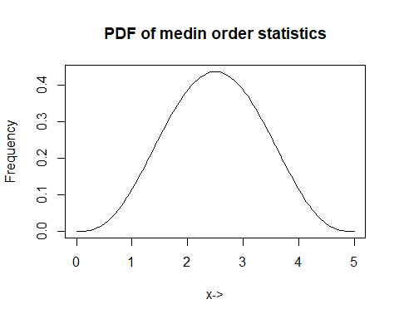

mean_x1_n = moment_k(k=1, r=1, n, a, b)  
var_x1_n = moment_k(k=2, r=1, n, a, b) - mean_x1_n^2  
  
mean_xn_n = moment_k(k=1, r=n, n, a, b)  
var_xn_n = moment_k(k=2, r=n, n, a, b) - mean_xn_n^2  
  
cat("Smallest order statistics: mean =", mean_x1_n, "and variance =", var_x1_n, "\n")

## Smallest order statistics: mean = 0.625 and variance = 0.3038194

cat("Largest order statistics: mean =", mean_xn_n, "and variance =", var_xn_n, "\n")

## Largest order statistics: mean = 4.375 and variance = 0.3038194

**Problem 5: Suppose $X_{1:7}<X_{2:7}<X_{3:7}<X_{4:7}<X_{5:7}<X_{6:7}<X_{7:7}$ denote the order statistics based on a random sample of size 7 from the distribution having probability density function (pdf) $f\left(x\right)=\frac{1}{10};0≤x≤10$. Evaluate the mean and variance of the $5^{th}$ order statistic $\left(X_{5:7}\right)$ and plot the CDF of the $5^{th}$ order statistic.**

fr_n = function(x, r, n, a, b) {  
 pdf_x <- dunif(x, min=a, max=b)  
 cdf_x <- punif(x, min=a, max=b)  
   
 numerator <- factorial(n) / (factorial(r-1)*factorial(n-r))  
 prob_dis <- numerator * cdf_x^(r-1) * (1 - cdf_x)^(n-r) * pdf_x  
   
 return(prob_dis)  
}  
  
moment_k <- function(k, r, n, a, b) {  
 integrand <- function(x) x^k * fr_n(x, r, n, a, b)  
 moment <- integrate(integrand, a, b)$value  
   
 return(moment)  
}  
a = 0  
b = 10  
r = 5  
n = 7  
x = seq(a, b, length.out = 100)  
  
mean_x5 <- moment_k(k=1, r, n, a, b)  
var_x5 <- moment_k(k=2, r, n, a, b) - mean_x5^2  
  
cat("Mean of X_{(5)}:", mean_x5, "\n")

## Mean of X_{(5)}: 6.25

cat("Variance of X_{(5)}:", var_x5, "\n")

## Variance of X_{(5)}: 2.604167

Fr_n_values <- array()  
for(i in 1:100) {  
 Fr_n_values[i] = integrate(fr_n, a, x[i], r=r, n=n, a=a, b=b)$value  
}  
  
plot(x, Fr_n_values, type = "l", xlab = "x->", ylab=paste0("F", r, ":", n, "(x)"))

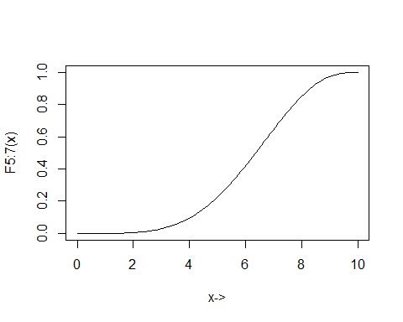

**Problem 6: A random sample of size 3 is drawn from a population that has a uniform distribution on the interval (0, 1). The resulting order statistics are $X_{1:3},X_{2:3}$ and $X_{3:3}$. Determine the mean and variance of smallest and largest order statistic.**

fr_n = function(x, r, n, a, b) {  
 pdf_x <- dunif(x, a, b)  
 cdf_x <- punif(x, a, b)  
   
 numerator <- factorial(n) / (factorial(r-1)*factorial(n-r))  
 prob_dis <- numerator * cdf_x^(r-1) * (1-cdf_x)^(n-r) * pdf_x  
   
 return(prob_dis)  
}  
  
moment_k <- function(k, r, n, a, b) {  
 integrand <- function(x) x^k * fr_n(x, r, n, a, b)  
 moment <- integrate(integrand, a, b)$value  
 return(moment)  
}  
  
a = 0  
b = 1  
n = 3  
  
colors = c("red", "blue")  
  
x <- seq(a, b, length.out = 100)  
mean_x1_3 = moment_k(k=1, r=1, n, a, b)   
var_x1_3 = moment_k(k=2, r=1, n, a, b) - mean_x1_3^2   
mean_x3_3 = moment_k(k=1, r=3, n, a, b)   
var_x3_3 = moment_k(k=2, r=3, n, a, b) - mean_x3_3^2  
  
cat("Smallest order statistics: mean =", mean_x1_3, "and variance =", var_x1_3, "\n")

## Smallest order statistics: mean = 0.25 and variance = 0.0375

cat("Largest order statistics: mean =", mean_x3_3, "and variance =", var_x3_3, "\n")

## Largest order statistics: mean = 0.75 and variance = 0.0375

**Problem 7: A random sample of size 3 is drawn from a population that has a uniform distribution on the interval (0, 1). The resulting order statistics are $X_{1:3},X_{2:3},X_{3:3}$. Determine the mean and variance of sample range.**

fr_n = function(x, r, n, a, b) {  
 pdf_x = dunif(x, min=a, max=b)  
 cdf_x = punif(x, min=a, max=b)  
   
 numerator <- factorial(n) / (factorial(r-1)*factorial(n-r))  
 prob_dist <- numerator * cdf_x^(r-1) * (1 - cdf_x)^(n-r)*pdf_x  
   
 return(prob_dist)  
}  
  
a = 0  
b = 1  
n = 3  
x = seq(0, 1, length.out=100)  
  
moment_k <- function(k, r, n, a, b) {  
 integrand <- function(x) x^k * fr_n(x, r, n, a, b)  
 moment <- integrate(integrand, a, b)$value  
 return(moment)  
}  
  
exp_xy <- function(n, a, b) {  
 integrand <- function(x) {  
 f_y <- function(y) n*(n-1)*x*y*(y-x)  
 integrate(Vectorize(f_y), x, b)$value   
 }  
   
  
 result <- integrate(Vectorize(integrand), a, b)$value  
 return(result)  
}  
  
mean_x1_n = moment_k(k=1, r=1, n, a, b)  
var_x1_n = moment_k(k=2, r=1, n, a, b) - mean_x1_n^2  
  
mean_xn_n = moment_k(k=1, r=n, n, a, b)  
var_xn_n = moment_k(k=2, r=n, n, a, b) - mean_xn_n^2  
  
cat("Smallest order statistics: mean =", mean_x1_n, "and variance =", var_x1_n, "\n")

## Smallest order statistics: mean = 0.25 and variance = 0.0375

cat("Largest order statistics: mean =", mean_xn_n, "and variance =", var_xn_n, "\n")

## Largest order statistics: mean = 0.75 and variance = 0.0375

cov_order = exp_xy(n, a, b) - (mean_x1_n * mean_xn_n)  
  
cat("Covariance of smallest and largest order statistics =", cov_order, "\n")

## Covariance of smallest and largest order statistics = 0.0125

mean_sample_range = (mean_xn_n - mean_x1_n)  
var_sample_range = var_x1_n + var_xn_n - 2*cov_order  
  
cat("Mean of sample range:", mean_sample_range, "\n")

## Mean of sample range: 0.5

cat("Variance of sample range:", var_sample_range, "\n")

## Variance of sample range: 0.05

**Problem 8: The random sample $X_{1},X_{2},...,X_{9}$ of size 9 is drawn from a population that has a uniform distribution with the interval (0, 10). Evaluate the mean and variance of 7th order statistic. Also find the value of $P\left(X_{7}>2\right)$**

fr_n = function(x, r, n, a, b) {  
 pdf_x <- dunif(x, a, b)  
 cdf_x <- punif(x, a, b)  
   
 numerator <- factorial(n) / (factorial(r-1)*factorial(n-r))  
 prob_dis <- numerator * cdf_x^(r-1) * (1-cdf_x)^(n-r) * pdf_x  
   
 return(prob_dis)  
}  
  
a <- 0  
b <- 10  
n <- 9  
r <- 7  
  
x <- seq(a, b, length.out=100)  
  
fr_n_values <- fr_n(x, r, n, a, b)  
  
plot(x, fr_n_values, type = "l", xlab = "x->",   
 ylab = paste0("f", r, ":", n, "(x)"),   
 main = paste0("Probability Density Function of X", r, ":", n))

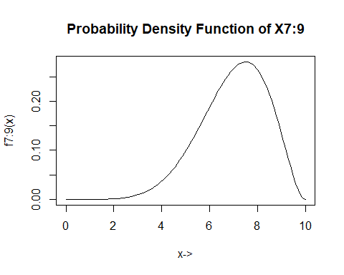

moment_k <- function(k, r, n, a, b) {  
 integrand <- function(x) x^k * fr_n(x, r, n, a, b)  
 moment <- integrate(integrand, a, b)$value  
 moment  
}  
  
mean_x7 <- moment_k(1, r, n, a, b)  
var_x7 <- moment_k(2, r, n, a, b) - mean_x7^2  
  
cat("Mean of X_{(7)}:", mean_x7, "\n")

## Mean of X_{(7)}: 7

cat("Variance of X_{(7)}:", var_x7, "\n")

## Variance of X_{(7)}: 1.909091

# int 2 to 10  
p_x7_gt_2 <- integrate(fr_n, 2, b, r=r, n=n, a=a, b=b)$value  
cat("P(X_{(7)} > 2):", p_x7_gt_2, "\n")

## P(X_{(7)} > 2): 0.9996861