CONFIDENTIAL — STRATEGIC PROPOSAL
HALLOR TECHNOLOGIES INC.
Hallor Defense Equipment Inc.

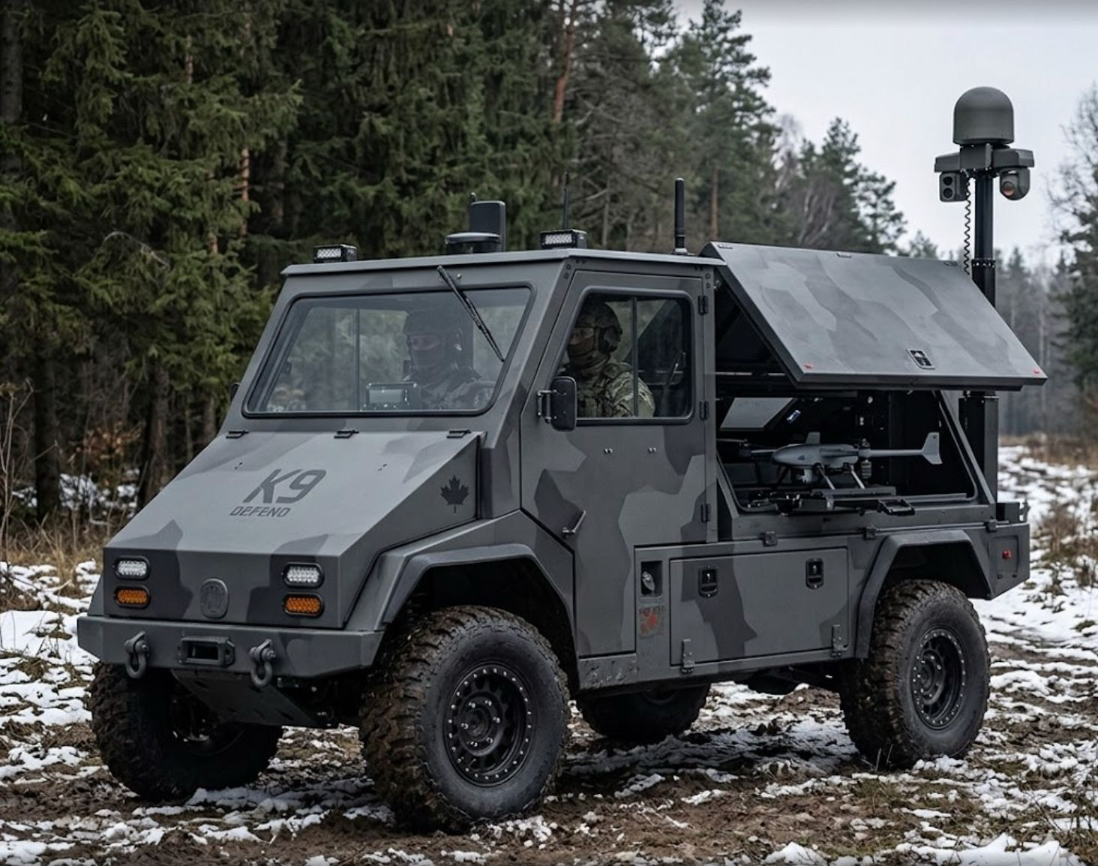
K9 Defend — Manned Tactical Ground Vehicle Concept | Canadian-Made, Field-Proven Platform

CORPORATE RESTRUCTURING & DEFENSE DIVISION LAUNCH
Strategic Proposal for Investors, Brokers & Defense Partners
May 2026 | STRICTLY CONFIDENTIAL

Prepared by:
Hallor Technologies Board
In consultation with Going Public Consulting
www.hallor.ca

This document contains forward-looking statements and projections. It is intended solely for the use of the named recipient(s) and may not be reproduced or distributed without written consent of Hallor Technologies Inc.

Table of Contents
Table of Contents 2
Executive Summary 4
Corporate Restructuring Plan 5
2.1 Current Structure 5
2.2 Proposed Structure 5
2.3 Cap Table Migration — GSE Shareholders → HTI Parent 5
Why Hallor — Why Now 7
3.1 Seven Years of Proof 7
3.2 Canada's Defense Moment 7
3.3 The NATO UGV Imperative 7
3.4 Platform Advantages No Competitor Can Replicate Immediately 7
K9 Defend — Manned Prototype v1 Specification 9
4.1 Full Feature Specification — K9 Defend Manned v1 9
4.2 UGV Conversion Pathway 11
Build Timeline & Cost Budget 13
5.1 12-Month Build Schedule 13
5.2 Detailed Prototype Cost Breakdown 14
Defense Team Structure & Cost 15
6.1 HDE Core Team — Year 1 15
6.2 Growth Hiring — Defense Division Scaling Plan 15
Addressable Military Market 17
7.1 Market Sizing — TAM / SAM / SOM 17
7.2 Why This Market Lasts a Decade+ 17
Canada Defense Alignment & Funding Programs 19
8.1 Available Funding Programs (C$) 19
8.2 Compliance Roadmap 19
Hallor IP & Competitive Moat 21
9.1 IP Portfolio Components 21
9.2 Competitive Landscape 21
Broker & Investor Value Proposition 23
10.1 Deal Structure 23
10.2 How Investors Win 23
Predictive Valuation Milestones 24
11.1 Milestone-by-Milestone Valuation (C$M) — HDE Only 24
11.2 Valuation Methodology — Global Standard Metrics 24
Employment Scaling Projections 26
Appendix — Defense Concept Imagery 27
A.1 K9 Defend Manned v1 — Full Concept 27
A.2 K9 Defend Unmanned (UGV) — Phase 2 Concept 27
A.3 Hallor Defense Long-Range Platform Vision 28
Key Risks & Mitigations 29

Executive Summary

Hallor Technologies Inc. (HTI) has spent seven years proving the impossible: a Canadian-built electric ground vehicle that starts reliably at -47°C, runs a full shift without charging, and survives the harshest ground service environments in North America. That platform — the Green Ox — is the foundation for something larger.

This proposal outlines a strategic expansion: the creation of Hallor Defense Equipment Inc. (HDE), a wholly owned subsidiary of HTI, purpose-built to design, manufacture, and sell military-grade electric tactical ground vehicles to the Canadian Armed Forces and allied nations. HDE will adapt the proven Green Ox platform into a manned K9 Defend prototype — a silent, cold-weather-hardened, modular 4x4 tactical vehicle — and establish a credible pathway to an unmanned (UGV) conversion variant within 18 months of prototype validation.

Simultaneously, this proposal recommends a corporate restructuring that migrates existing Hallor GSE subsidiary shareholders into Hallor Technologies Inc. (the parent), simplifying governance, unlocking CSE listing potential, and aligning all shareholders behind a single, scalable enterprise.

Highlight | Detail
Company | Hallor Technologies Inc. (HTI) — proposed listed parent entity
New Subsidiary | Hallor Defense Equipment Inc. (HDE)
Platform | Green Ox EV — 7 years field-proven, -47°C rated, AWD, modular
First Product | K9 Defend Manned v1 — Military tactical 4x4 EV prototype
Build Timeline | 12 months total (3 mo. engineering + 2 mo. design/tooling + 4.5 mo. build + 2.5 mo. validation)
Prototype Budget | C$2.1M (prototype build + first-year core team)
Capital Raise | C$2.0–2.5M private placement at C$0.15/unit (defense seed round)
TAM (Military UGV) | US$1.96B (2025) → US$3.08B (2031) at 7.82% CAGR
Canada Funding Available | C$244.2M NRC IRAP DI Assist + C$4B BDC + C$357.7M RDIIF
IP Carried Value (IFRS floor) | C$4.27M (book floor; market value significantly higher)
Prototype Valuation (Low–High) | C$15M – C$28M on working prototype milestone
First Contract Valuation | C$40M – C$80M (signed DND or allied nation contract)

Corporate Restructuring Plan

2.1 Current Structure
Today, Hallor operates through Hallor Group Inc. (HGI) / Hallor Industries Inc. (HII) as the operating GSE company, with shareholders holding equity at the subsidiary level. This structure creates complexity for institutional investment, public listing, and the launch of a defense subsidiary.

Current shareholder base: ~31.9 million issued shares at the subsidiary level, with an additional ~25.2M in options, warrants, and convertible instruments — yielding approximately 57.1M fully diluted. Based on the May 2026 corporate deck, the post-RTO structure targets ~91M basic / ~111M fully diluted shares at HTI level.

2.2 Proposed Structure
HALLOR TECHNOLOGIES INC. (HTI)
Listed Parent Entity | CSE via Non-Offering Prospectus | IFRS Audited
HALLOR INDUSTRIES INC. (HII)  GSE / Commercial Division  Green Ox EV | Airport Ground Support |  | HALLOR DEFENSE EQUIPMENT INC. (HDE)  Defense Division | NEW — 2026  K9 Defend | UGV | Tactical EV

2.3 Cap Table Migration — GSE Shareholders → HTI Parent
All existing Hallor GSE / HII shareholders will receive equivalent shares in Hallor Technologies Inc. (HTI) at a defined exchange ratio. This migration eliminates the structural subordination of shareholder equity, consolidates governance, and creates a single share class that trades on the CSE post-listing. The exchange is structured as a shares-for-debt/equity conversion to preserve existing economic entitlement while enabling the clean parent balance sheet required for institutional investors and defense procurement counterparties.

Share Class / Layer | Shares (Basic / Diluted) | Notes
Existing HII Issued (migrated) | ~31.9M | Current subsidiary shareholders → HTI shares 1:1 exchange
Options & Warrants (existing) | ~8.8M | Rolled to equivalent HTI options/warrants at same strike
Convertible Instruments | ~16.4M | Notes convert at HTI level upon listing
Defense Seed Raise (C$2.0–2.5M @ $0.15) | 13.3M – 16.7M | New capital for HDE prototype + first-year team
Fully Diluted (post-migration) | ~70M – 74M | Pre-RTO; RTO target 91–111M fully diluted

The CSE listing via Non-Offering Prospectus (NOP) proceeds in parallel: IFRS audit completion (est. Q3 2026), prospectus filing (est. Q4 2026), and trading commencement (est. Q1 2027).

Why Hallor — Why Now

3.1 Seven Years of Proof
While defence primes spend years and hundreds of millions engineering cold-weather electric drivetrains from scratch, Hallor has been running one at -47°C since 2019. The Green Ox platform has operated in some of the harshest airport ground environments in Canada — including Arctic-adjacent operations — accumulating real operational hours on a 72V AC brushless AWD drivetrain with no major powertrain failures. The only recurring issue identified over seven years of fleet operation has been brake wear — a standard maintenance item. This is the kind of reliability data that defence OEMs cannot buy; they have to earn it. Hallor already has it.

3.2 Canada's Defense Moment
Canada's February 2026 Defence Industrial Strategy — announced by Prime Minister Carney — commits to a historic rebuild of Canadian defence industrial capacity. The government has pledged to reach NATO's 2% GDP defence spending target by 2030, representing an incremental C$20B+ annually in defence investment. Explicit priorities include sovereign Canadian manufacturing, electric and autonomous ground vehicles, and domestic technology companies. Hallor is positioned at the exact intersection of all three mandates: Canadian-built, electric, autonomous-capable, and proven.

3.3 The NATO UGV Imperative
Every major NATO ally is actively fielding or procuring unmanned and optionally-manned ground vehicles. Ukraine has accelerated a decade of UGV development into 18 months of battlefield deployment. The US, UK, France, Germany, and Australia all have active UGV programs. Canada has none — and that gap is now a sovereignty risk. Hallor can fill it.

3.4 Platform Advantages No Competitor Can Replicate Immediately
Advantage | Hallor | Typical Start-Up Competitor
Cold Weather | 7 years proven at -47°C | Unproven — development risk
Build Infrastructure | Active fabrication team, 3-month build cycles | No existing production capability
Drivetrain IP | 72V AC AWD — engineered, refined, owned | Procured/licensed from third parties
Modular Platform | Purpose-built modular rail and payload deck | Single-purpose fixed designs
Made in Canada | 100% domestic design, assembly, and IP | Foreign IP, foreign assembly
Procurement Speed | Prototype in 12 months from funding | 3–5 years typical ground-up development
Regulatory Standing | Existing Canadian company, CGP-eligible | Foreign or newly formed — no DND relationship

K9 Defend — Manned Prototype v1 Specification

The K9 Defend Manned v1 is a military-specification 4x4 all-electric tactical ground vehicle designed for surveillance, perimeter security, personnel transport in contested environments, and rapid drone deployment. It is derived directly from the field-proven Green Ox platform with deliberate military-grade enhancements.


K9 Defend Manned v1 — Concept Render | Armoured cabin, surveillance mast, drone launch bay, Canadian Armed Forces configuration

4.1 Full Feature Specification — K9 Defend Manned v1
System / Feature | Specification | Military Benefit
DRIVETRAIN
Motor System | Dual 120V–240V AC brushless, AWD (upgraded from 72V commercial) | Silent running, zero thermal signature at idle, no IR exhaust plume
Drivetrain Config | All-Wheel Drive, independent suspension, locked differentials | Off-road capability, mud/snow/sand traversal
Speed | 0–45 km/h operational; 30 km/h governed off-road | Tactical pace matching infantry and convoy ops
Range | 80–120 km per charge (mission profile dependent) | Full operational shift without charging
Temperature Range | -47°C to +55°C operational (field-proven baseline) | Arctic sovereignty, Northern Canada, Eastern European NATO deployments
Charging | V2G capable; 240V shore power; NATO STANAG generator input | Powers field equipment from vehicle battery; no generator logistics required
CHASSIS & PROTECTION
Frame | Reinforced steel space frame, military load rating 1,500 kg payload | Armour-panel ready, blast-mitigation geometry
Ballistic Panels | Bolt-on UHMWPE / NIJ Level IIIA side panels (v1 optional; v2 standard) | Protects occupants from small arms at mission discretion
Tyres | Run-flat inserts, 37" all-terrain military spec | Continue mission after tyre strike
Ground Clearance | 380 mm minimum (military off-road standard) | IED-resistant underside geometry
CABIN & CREW
Occupancy | 2-person armoured operator cab (driver + tactical officer) | Dedicated pilot and sensor/weapons system operator configuration
Climate Control | Military-grade HVAC, -47°C start-up heating, NBC filter-ready housing | Arctic operations, CBRN environment compatibility pathway
Comms Integration | NATO radio mount points, encrypted mesh radio wiring loom | Drop-in DND-supplied comms without vehicle modification
Crew Interface | Dual 10" ruggedized displays, CAN-bus sensor integration, night-mode dash | Situational awareness from all sensors in-cab
SURVEILLANCE & SENSOR MAST
Mast Height | Deployable 4.5 m pneumatic mast (stows to 1.8 m) | Over-terrain visibility, obstacle-top surveillance
Camera System | Day/thermal PTZ dome (30x optical, FLIR-compatible), 360° coverage | Target acquisition, perimeter security, force protection
Radar/Lidar Mount | NATO STANAG rail at mast apex for customer-supplied radar | Radar, LiDAR, or EW payload compatible
DRONE LAUNCH BAY
Bay Configuration | Rear open deck bay, 2x medium UAS hardpoints (DJI M30/Skydio-class) | Organic ISR; launched and recovered without dismounting
Charging | Onboard 240V drone charging station (2 positions) | Continuous drone operations without returning to base
Drone Control | In-cab relay station for encrypted drone datalink | Operator flies drones from protected cab
MODULAR PAYLOAD RAIL
Rail System | NATO STANAG 4569 modular rail, full deck length | Accepts any NATO-compatible payload without modification
Payload Capacity | 800 kg deck payload (static); 500 kg mobile | Litter (medevac), supply pallet, weapon system, sensor array
Power Export | 5 kW continuous V2G export at 240V / 120V | Forward operating base power; reduces generator logistics
UGV CONVERSION PATH
Drive-by-Wire | Full steer/throttle/brake DBW system in v1 (dual-mode: manual + remote) | Enables teleoperation overlay without cabin modification
Autonomy Ready | Compute bay with GPU mount point, CAN-bus autonomy interface wiring loom | Retrofit path to full UGV: remove cab, add autonomy stack
Remote Ops | 5G/satcom mesh radio bracket; ground-control station interface spec | Teleoperation from up to 5 km (LOS)

4.2 UGV Conversion Pathway
The K9 Defend Manned v1 is explicitly engineered as the first step toward a fully unmanned UGV. The drive-by-wire architecture, CAN-bus autonomy interface, and modulaer cabin design mean the transition to unmanned operation is a software and sensor addition — not a vehicle redesign. This is the critical differentiator: Hallor builds one platform that can be field-reconfigured from manned to unmanned as the mission requires.

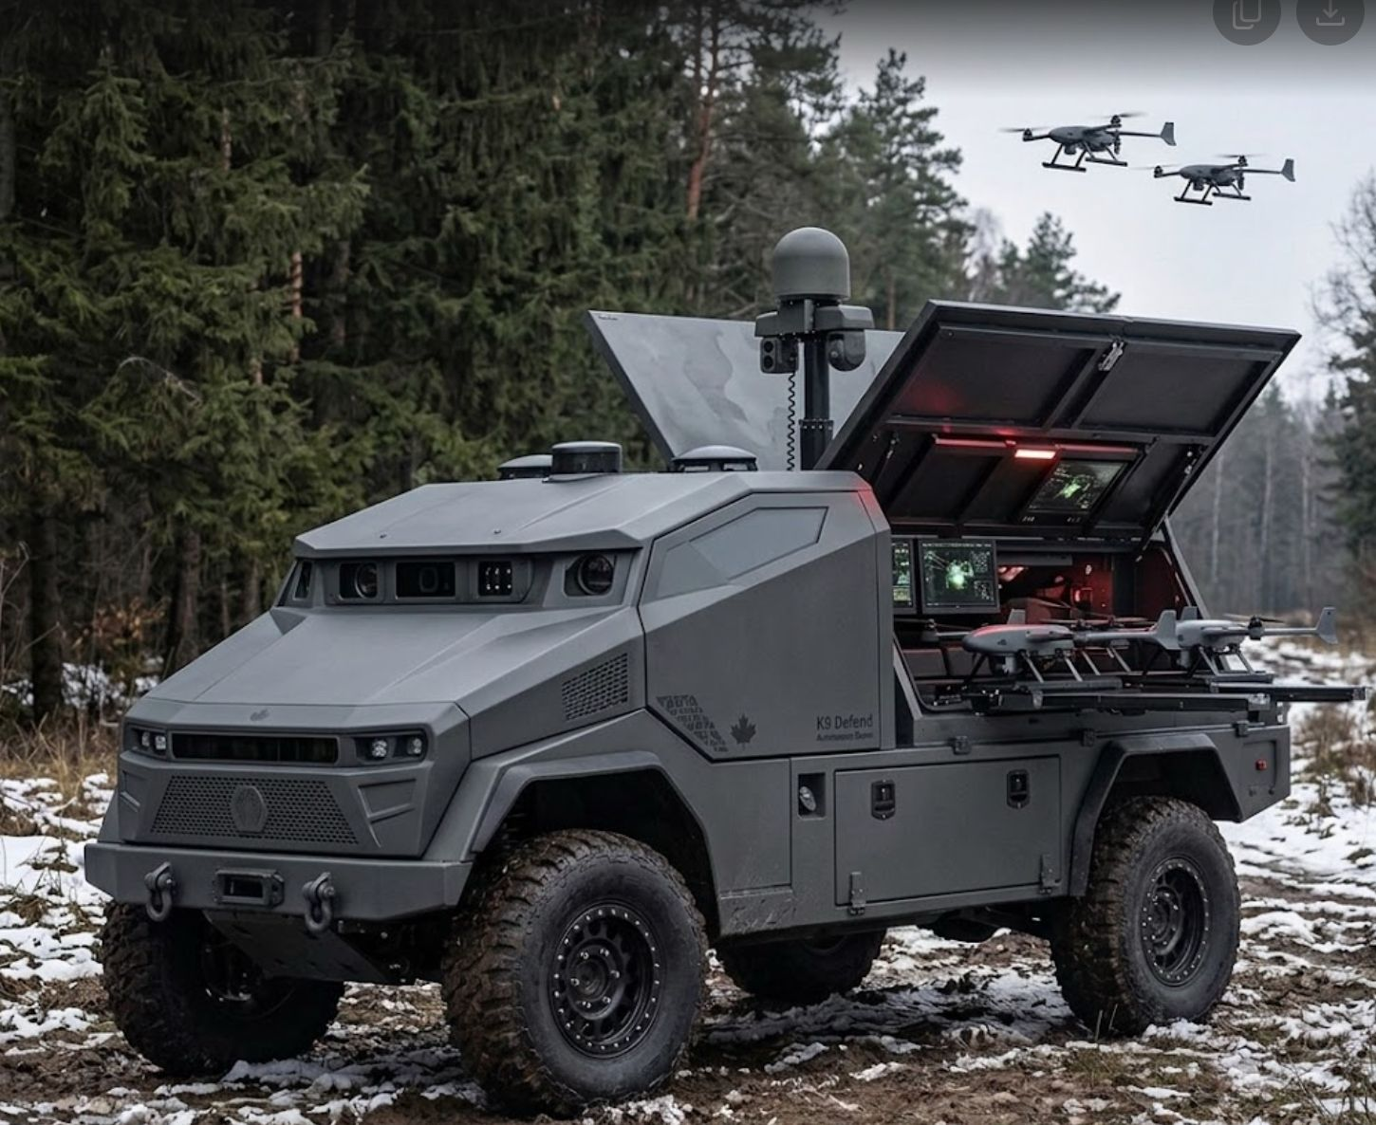
K9 Defend Unmanned UGV — All-armoured box body, dual drone launch, surveillance mast | Phase 2 product

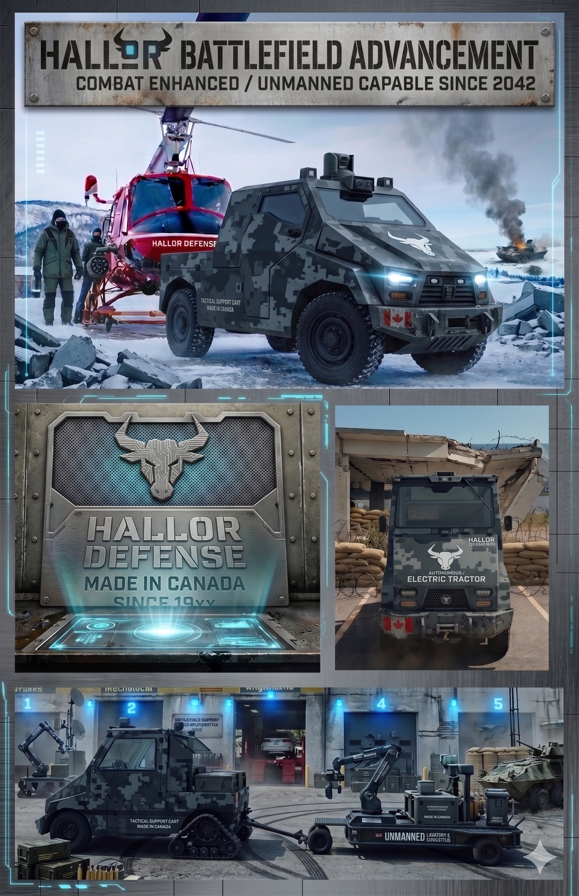
Hallor Defense — Long-range platform vision: tracked variants, armed configurations, and mass production pathway (illustrative)

Build Timeline & Cost Budget

Hallor's existing production team builds a Green Ox GSE vehicle in approximately 3 months. The K9 Defend Manned v1 is a substantially more complex build — military-spec chassis, upgraded drivetrain, ballistic integration, mast installation, and drive-by-wire system — requiring a phased approach across 12 months from funding confirmation.

5.1 12-Month Build Schedule
Phase | Activities | Duration | Month | Budget (C$) | Key Milestones
Phase 1 Engineering | Military requirements analysis; DND consultation; chassis structural engineering; drivetrain upgrade spec; DBW architecture; BOM finalization | 3 months | M1–M3 | $175,000 | Completed spec sheet; DND letter of interest; CGP application filed
Phase 2 Design & Tooling | 3D CAD design; finite element analysis (FEA); military EMC testing plan; tooling procurement; supplier qualification; ballistic panel sourcing | 2 months | M4–M5 | $140,000 | Approved design package; tooling ordered; supplier contracts signed
Phase 3 Fabrication | Chassis fabrication; drivetrain installation; cabin assembly; mast integration; payload rail installation; wire harness | 3 months | M6–M8 | $380,000 | Rolling chassis complete; all major systems installed
Phase 4 Integration | DBW commissioning; surveillance system install; drone bay integration; V2G testing; comms wiring; security systems | 1.5 months | M9–M10 | $145,000 | Fully integrated prototype; all systems operational on bench
Phase 5 Test & Validation | Off-road performance testing; cold-weather trial (-30°C minimum); DBW validation; drone ops trial; DND/observer demonstration event | 2 months | M11–M12 | $110,000 | Test report package; DND demo event; LOI or procurement discussion initiated
TOTAL BUILD COST | (excluding team salaries) | 12 months |  | $950,000 | Working military prototype delivered

Note: Build cost is prototype-only. Team salaries (Section 6) are budgeted separately at C$985,000 for year one, bringing total Year 1 investment to approximately C$1.935M. With contingency, the defense seed raise of C$2.0–2.5M provides full coverage through to prototype demonstration.

5.2 Detailed Prototype Cost Breakdown
Component / System | Cost (C$) | Notes
Base Green Ox chassis & frame (military-spec) | $95,000 | Fabricated in-house; upgraded steel spec
Drivetrain upgrade: dual 120–240V AC AWD system | $145,000 | Motor, inverter, controller, wiring
LiFePO4 battery pack (55 kWh military spec) | $98,000 | Canadian/North American supply chain
2-person armoured cab (structure + ballistic panels) | $62,000 | NIJ IIIA side panels; bolt-on
Surveillance mast system (4.5m deployable + PTZ thermal) | $78,000 | Commercial-off-the-shelf COTS military grade
Drone launch bay hardware (2 positions + charging) | $22,000 | Hardpoints, wiring, in-cab relay hardware
Drive-by-Wire (DBW) system | $55,000 | Steer, throttle, brake actuators + control unit
Modular payload rail (NATO STANAG) | $18,000 | Full-deck length; in-house fabricated
Run-flat tyres and military wheel assemblies | $24,000 | 37" AT military spec × 4 + spares
V2G power export system (5 kW) | $21,000 | Bidirectional inverter; NATO STANAG power outputs
In-cab command display system (dual 10" ruggedized) | $28,000 | CAN-bus integration, CMS software
Comms wiring loom & radio mounts (NATO spec) | $14,000 | Ready for DND-supplied radios
Climate control (military HVAC + arctic heating) | $31,000 | -47°C cold start; 2-zone
Testing, shipping, and demonstration logistics | $65,000 | Cold-weather trials, DND demo event
Contingency (10%) | $94,000
TOTAL PROTOTYPE BUILD COST | C$950,000 | Excluding team salaries

Defense Team Structure & Cost

HDE leverages existing Hallor leadership (no new CEO or CFO required). The CEO and CFO of HTI/HII provide corporate governance, financial oversight, and strategic direction to HDE at no incremental cost. The HDE team is a purpose-built engineering and business development unit, reporting to the existing C-suite.

6.1 HDE Core Team — Year 1
Role | Headcount | Annual Cost (C$) | Responsibilities
Chief Engineer / VP Engineering | 1 | $145,000 | Technical lead, military spec ownership, DND interface
Senior Mechanical Engineer | 2 | $210,000 | Chassis, suspension, ballistic integration design
Electrical / Embedded Systems Engineer | 1 | $110,000 | DBW system, CAN-bus, power management, autonomy interface
Systems Integration Engineer | 1 | $115,000 | Platform integration, test protocols, qualification documentation
Defense Business Development Manager | 1 | $125,000 | DND relationship, procurement navigator, allied-nation BD
Senior Fabricators (military build) | 3 | $225,000 | Chassis build, military-spec welding, system installation
Project Manager (defense) | 1 | $105,000 | Timeline management, compliance, procurement tracking
TOTAL CORE TEAM | 10 FTE | C$1,035,000 | + HTI CEO / CFO at zero incremental cost

Benefits and payroll taxes (EI, CPP, health) add approximately 18–20%, bringing fully-loaded Year 1 team cost to C$1.22–1.24M. Total Year 1 investment (team + prototype build): approximately C$2.17M.

6.2 Growth Hiring — Defense Division Scaling Plan
As HDE progresses from prototype to first contract and then to production, the team scales systematically. The hiring plan below reflects a disciplined, milestone-triggered expansion — no speculative hiring.

Department | Year 1 (Prototype) | Year 2 (Pre-Contract) | Year 3 (First Contract) | Year 5 (Scale) | Year 8 (Production)
Engineering | 5 | 7 | 12 | 22 | 35
Fabrication / Manufacturing | 3 | 6 | 15 | 40 | 90
Business Development / Sales | 1 | 3 | 5 | 9 | 14
Program / Project Management | 1 | 2 | 4 | 7 | 12
Quality / Compliance (CGP/ITAR) | 0 | 1 | 2 | 5 | 8
Finance / Admin (shared HTI) | 0* | 0* | 1 | 2 | 4
TOTAL HDE HEADCOUNT | 10 | 19 | 39 | 85 | 163
Annual Payroll (fully loaded C$M) | $1.24M | $2.4M | $5.5M | $13M | $29M

*Finance and admin shared with HTI parent at no incremental HDE cost in Years 1–2.

Addressable Military Market

Hallor is entering two convergent, high-growth military markets: unmanned/optionally-manned ground vehicles (UGV) and military electric vehicle electrification. Both markets are accelerating due to NATO spending commitments, Ukraine conflict learnings, and decarbonization mandates across allied militaries.

7.1 Market Sizing — TAM / SAM / SOM
Market Segment | 2025 Size | 2031 / 2034 | CAGR | Source / Notes
Military UGV — Global | US$1.96B | US$3.08B (2031) | 7.82% | MarketsandMarkets / Mordor Intelligence 2025
Military EV — Global | US$6.48B | US$17.90B (2034) | 12.40% | Grand View Research 2025
Combined TAM (2031) | — | US$10B+ | — | UGV + military EV overlap; conservative cross-tab
SAM — Canada + Five Eyes | ~US$280M | ~US$440M (2031) | ~8% | Canada, USA, UK, AUS, NZ defense procurement
SAM — NATO + allied nations | ~US$680M | ~US$1.1B (2031) | ~8.5% | 32 NATO members + Australia, Japan, South Korea
SOM — Hallor (Year 5 target) | — | US$25–45M revenue | — | <1% of SAM; 2–3 allied nation contracts

7.2 Why This Market Lasts a Decade+
Military procurement cycles are long, predictable, and sticky. A single DND contract for 25–50 units generates C$50–150M in revenue. Re-order rates on well-performing platforms exceed 85%. The global shift to autonomous/electric military ground vehicles is in its first decade — no NATO country has a fully-fielded fleet. The opportunity window for a first-mover with a proven cold-weather platform is measured in years, not months.

Structural tailwinds supporting a decade+ addressable market:
- NATO 2% GDP spending commitments — Canada alone represents C$20B+ incremental annual spending through 2030
- Ukraine conflict: demonstrated UGV utility for logistics, medevac, surveillance, and force multiplication
- Arctic sovereignty: Canada's DIS specifically identifies Northern operations as a strategic priority — Hallor's -47°C proven capability is uniquely suited
- Military decarbonization: NATO Sustainability Target 2030 mandates emissions reduction across all fleets; electric ground vehicles are the primary pathway
- Aging ICE fleet: allied nations operating 15–30 year-old tactical vehicles face urgent replacement cycles in the 2026–2035 window
- Cyber/EW advantage: electric drivetrains have dramatically reduced electromagnetic signatures and fewer attack surfaces than ICE-powered vehicles

Canada Defense Alignment & Funding Programs

Canada's February 2026 Defence Industrial Strategy (DIS) explicitly calls for domestic manufacturing capability in autonomous systems, electric platforms, and sovereign Arctic-capable vehicles. Hallor is one of a small number of Canadian companies that can credibly respond to this mandate today.

8.1 Available Funding Programs (C$)
Program | Org. | Value | Relevance to HDE
NRC IRAP Defence Industry Assist | NRC IRAP | $244.2M total; up to $2M/project | R&D for defence-application of proven tech; military UGV qualifies
BDC Defence Technology Platform | BDC | $4B facility | Loans and equity for Canadian SMEs supplying defence; Hallor qualifies
Regional Defence Ind. Investment Fund (RDIIF) | ISED | $357.7M | Supports capital investment in domestic defence industrial facilities
SRCC (Strategic Innovation Fund — Defence) | ISED | $100M+ | Innovation Stream for Canadian companies with defence tech readiness
IRAP SME Assistance Grant | NRC | Up to $500K | Non-dilutive; available immediately for eligible R&D
SR&ED Tax Credit | CRA | 15–35% of QREs | Engineering and prototype costs are SR&ED eligible; significant cash refund
Made-in-Canada Procurement Policy | PSPC | Policy preference | DND procurement policy mandates Canadian-content preference for all vehicle contracts

8.2 Compliance Roadmap
HDE's compliance plan ensures that Hallor can participate in DND procurement and allied nation exports within 18 months of incorporation:

Compliance Requirement | Target Date | Action
Controlled Goods Program (CGP) | M4 (2026) | Register HDE under CGP; security screening of all defense personnel
ITAR/EAR (Export Controls) | M6 (2026) | Legal review; ensure no ITAR-controlled components in v1 design; Canadian IP priority
Ottawa Treaty (Anti-Personnel Mines) | Ongoing | HDE vehicles are unarmed platforms (surveillance/logistics); fully compliant
CSA/DND Procurement Registration | M6 (2026) | Register with PSPC as defence supplier; obtain vendor qualification number
SOC 2 / Cybersecurity Baseline | M12 (2027) | Cyber hygiene standard for DND vendor qualification; ISO 27001 pathway
NATO STANAG Compliance | M12 (2027) | Payload rail (STANAG 4569), power export, and comms interfaces designed to spec

Hallor IP & Competitive Moat

Hallor's competitive moat is not a single patent — it is a compound of operational data, proven design, manufacturing know-how, cold-weather IP, and Canadian manufacturing heritage that takes years to replicate. The formal IP portfolio sits on top of an operational advantage that cannot be purchased.

9.1 IP Portfolio Components
IP Asset | Type | What It Covers | Defense Moat Value
Green Ox Electric Drivetrain | Trade Secret / Design | 72V→240V AC AWD architecture; thermal management; cold-start system | 7 years of refinement; no competitor has -47°C proven data
Cold-Weather Performance Data | Proprietary Data / Trade Secret | Real operational hours in -40°C+ environments; failure mode library | Defence OEMs require this data; Hallor has it; competitors cannot buy it
Modular Chassis Architecture | Registered Design / Patent Pending | Modular payload rail system; reconfigurable mission bay geometry | Single platform serves 5+ military roles; eliminates variant tooling cost
Drive-by-Wire Integration System | Trade Secret / Provisional Patent | DBW overlay on proven EV platform; dual-mode manual/autonomous interface | UGV conversion pathway without redesign; 12-month lead over ground-up competitors
V2G Military Power Export System | Trade Secret / Design | 5 kW bidirectional power from vehicle battery to field equipment | Eliminates generator logistics; unique value prop to DND
Canadian Manufacturing Process IP | Trade Secret | 3-month build cycle for complex EV platforms; trained fabrication team | Delivery speed is a competitive weapon; DND values predictable delivery
Sensor Mast Integration Architecture | Design / Patent Pending | Deployable mast with STANAG payload interface on wheeled EV platform | Unique integration of surveillance + electric mobility + drone ops

IFRS Carried IP Value: Approximately C$4.27M based on current development costs capitalized under IAS 38. This is an accounting floor — the strategic market value of the IP, measured by the cost and time to replicate, is substantially higher. A comparable US company with equivalent EV drivetrain data and cold-weather test history would command a technology premium of C$15–40M in an M&A transaction.

9.2 Competitive Landscape
Competitor | Origin | Type | Cold Weather? | Hallor Advantage
VictorySoft Gulliver UGV | Ukraine | Unmanned only | Unknown | No manned variant; no Canadian procurement; no -47°C data
INKAS HEEMAR (Toronto) | Canada | Armoured ICE | Yes | ICE drivetrain; no UGV pathway; 350+ staff but legacy architecture
Rheinmetall Mission Master | Germany / Canada (QC) | Full-stack UGV | Limited | Full-stack prime — too large for rapid procurement; Hallor = agile Canadian SME
Textron / FLIR ground UGV | USA | UGV (tracked) | Limited | Foreign; ITAR-controlled; DND prefers Canadian-content for sovereignty
HALLOR K9 DEFEND | Canada | Manned + UGV-ready | -47°C Proven | Only Canadian-made EV + manned + UGV-convertible + -47°C proven platform

Broker & Investor Value Proposition

The defense seed round is structured to offer investors a compelling risk-adjusted return profile anchored by hard assets (a working prototype), non-dilutive grants, and a clear path to DND procurement and CSE listing.

10.1 Deal Structure
Parameter | Detail
Raise Amount | C$2.0M – C$2.5M (defense seed round)
Price per Unit | C$0.15 per unit (shares in HTI at parent level)
Units Issued (seed) | 13.3M – 16.7M shares
Warrant Coverage | 1/2 warrant per share at C$0.25 (12-month expiry)
Use of Proceeds | 70% prototype build (C$950K), 30% first-year defense team ($740K partial)
Non-Dilutive Grants (target) | C$500K–$1.5M via NRC IRAP + SR&ED (partially offsets investor capital)
Listing Vehicle | CSE listing via NOP (Non-Offering Prospectus); targeting Q1 2027
Broker Commission | 8% cash + 8% broker warrants at C$0.15
Finder's Fee | Negotiable; standard 6% cash for qualified referrals
Hold Period | 4-month hold on private placement shares (CSE standard)

10.2 How Investors Win
- Entry price C$0.15 — against a pre-prototype valuation of C$8–12M HTI enterprise value, investors enter at a significant discount to anticipated post-prototype value (C$15–28M)
- Warrant kicker at C$0.25 provides additional upside if the stock re-rates post-listing or post-DND letter of intent
- Non-dilutive grants (NRC IRAP, SR&ED) reduce effective use of investor capital — grants offset up to 30% of prototype build cost
- Defense sector re-rating: global defense company EV/revenue multiples average 2.5–6x; Hallor's GSE business currently trades on commercial multiples — adding a defense business is expected to compress discount to NAV and re-rate the stock
- Acquisition optionality: NATO prime contractors (Rheinmetall, L3Harris, Kongsberg) actively acquire Canadian defense technology companies with proven platforms; Hallor's IP portfolio and cold-weather data creates credible M&A optionality at Year 3–5

Predictive Valuation Milestones

Hallor Defense Equipment's valuation trajectory is benchmarked against global comparable transactions, defense technology company public market multiples, and milestone-specific risk-adjusted discounting. The table below presents Low and High scenarios at each meaningful milestone.

11.1 Milestone-by-Milestone Valuation (C$M) — HDE Only
Milestone | Low (C$M) | High (C$M) | Valuation Basis
Pre-Prototype (current) IP + team + platform data | $5M | $10M | Cost-to-replicate IP ($4.27M IFRS floor) + team + 7-yr data premium; seed round entry
Working Prototype Complete (Month 12) | $15M | $28M | Comparable pre-revenue defense tech companies: 1.5–3x development cost; Canadian defense premium; DND engagement
IP Package Defined + CGP Compliant (Month 14) | $18M | $35M | Defensible IP portfolio + CGP certification = procurement-eligible; strategic buyer optionality emerges
DND Letter of Intent / Evaluation Contract (Year 2) | $30M | $60M | DND LOI removes primary de-risking event; comparable: NGRAIN, L3 WESCAM transactions in Canada at similar stage
First Revenue Contract Signed (Year 2–3: 10–25 units DND or allied) | $40M | $80M | Revenue contract: C$5–15M ARR; defense SaaS/hardware comps trade at 4–8x revenue; platform licensing optionality
Production Scale (Year 4–5: 50+ units/year, 2 nations) | $120M | $250M | C$25–45M ARR; 3–5x revenue multiple for defense prime; manufacturing + IP platform value
Full Defense Platform (Year 7–8: manned + UGV + accessories, export-approved) | $300M | $600M+ | Rheinmetall/L3/Textron comparable M&A multiples; C$80–150M ARR; full-stack platform acquiree target

Note: Valuations are for the HDE defense division only. HTI's commercial GSE business (HII) carries a separate and additive valuation based on the $30M-$88M Y1–Y3 revenue pipeline in the May 2026 corporate deck. Total HTI enterprise value at each milestone = HDE value + HII commercial value.

11.2 Valuation Methodology — Global Standard Metrics
Method | Stage Applicable | Multiple / Input | Application to HDE
Cost-to-Replicate | Pre-prototype | 1.5–3x capitalized R&D + team value | IFRS IP floor C$4.27M × 2–3x = C$8–13M
Comparable Transactions (M&A) | IP / prototype stage | C$10–50M for pre-revenue Canadian defense tech | NGRAIN (2019), Allen Vanguard, Canadian defense M&A comps
Revenue Multiple (EV/Revenue) | First contract+ | 3–8x defense hardware; 6–12x if recurring | C$10M ARR × 5x = C$50M; C$30M ARR × 6x = C$180M
EV/EBITDA | Production scale | 12–18x defense prime comparable | C$15M EBITDA × 15x = C$225M enterprise value
Discounted Cash Flow (DCF) | All stages | WACC 12–15%; terminal growth 3% | Terminal value anchored to 10-yr procurement contract duration
Strategic Acquirer Premium | Year 3–5 | 1.5–2.5x market cap (defense M&A premium) | NATO prime contractors pay control premium for sovereign IP and DND relationships

Employment Scaling Projections

Hallor Defense Equipment is designed to be a significant Canadian employer. The employment scaling model below is milestone-driven, not speculative — every hire is triggered by revenue or contract events. The combined HDE + HII employment projection shows how the HTI group scales from its current ~20 FTE to over 200 within 8 years.

Metric | Year 1 | Year 2 | Year 3 | Year 4 | Year 5 | Year 8
HDE Defense Headcount | 10 | 19 | 39 | 60 | 85 | 163
HII GSE Headcount | 20* | 35 | 55 | 75 | 100 | 120
TOTAL HTI Group Headcount | 30 | 54 | 94 | 135 | 185 | 283
Engineering & Technical (%) | 53% | 48% | 45% | 40% | 38% | 35%
Manufacturing / Trade (%) | 30% | 33% | 38% | 42% | 45% | 48%
Avg Salary (fully loaded, C$) | $103K | $100K | $98K | $97K | $95K | $93K
Total Payroll (C$M) | $3.1M | $5.4M | $9.2M | $13.1M | $17.6M | $26.3M
Annual Tax Revenue (est., C$M) | $0.4M | $0.7M | $1.2M | $1.7M | $2.3M | $3.4M

*Current estimated HTI/HII headcount. The defense division launches as an additive hire on top of the existing commercial team.

The employment multiplier effect for a defense manufacturing company at scale is 3–4x direct employment in indirect and supply chain jobs. At Year 8 with 163 direct HDE employees, the estimated induced employment impact is 490–650 total jobs in the Canadian economy — a significant public policy argument for government funding support.

Appendix — Defense Concept Imagery

A.1 K9 Defend Manned v1 — Full Concept

K9 Defend Manned v1 | Camouflage-painted 4x4 EV | 2-soldier cab | Surveillance mast with PTZ dome | Rear drone launch bay | Canadian Armed Forces configuration

A.2 K9 Defend Unmanned (UGV) — Phase 2 Concept

K9 Defend UGV (Phase 2) | Fully armoured box body | No operator cab | Dual drone launch with active deployment | Surveillance and comms mast | Teleoperated or autonomous

A.3 Hallor Defense Long-Range Platform Vision

Hallor Defense future platform vision | Tracked and wheeled variants | Armed configuration pathways | Mass production facility concept | "Battlefield Advancement — Combat Enhanced — Unmanned Capable"

Key Risks & Mitigations

Risk | Assessment | Mitigation
DND procurement cycle (18–36 months) | Medium — known timeline; manageable with bridge financing | IRAP grants provide non-dilutive bridge; allied nation (NATO) sales can precede DND contract
Engineering over-run | Low-medium — platform is proven; extensions are evolutionary | Existing fabrication team + 10% contingency budget; Chief Engineer hire de-risks technical lead
Competitive displacement (Rheinmetall, INKAS) | Low for SME segment — Hallor competes in C$2–15M contract size not multi-hundred-million prime contracts | Focus on DND's SME procurement stream (SBRI/SBTT equivalent); Made-in-Canada mandate creates protection
Capital availability (seed round not fully raised) | Medium — defense market fundraising requires specialized brokers | Going Public Consulting engaged; NRC IRAP + SR&ED offset up to 30% of build cost if round closes at C$2.0M floor
Key person dependency (CEO / Chief Engineer) | Medium — mitigated by team depth and documentation | Chief Engineer hire creates redundancy; IP documentation program from Day 1 under CGP
Export control / ITAR compliance | Low — no ITAR-controlled components in v1 design mandate | Canadian IP priority; legal review at M6; CGP registration at M4

Hallor Technologies Inc. | The cold-weather electric platform Canada's defense needs.

For investor inquiries and partnership discussions:
invest@hallor.ca | defense@hallor.ca | www.hallor.ca
This document is confidential and intended solely for qualified investors and strategic partners. May 2026.

