KMJ PUBLIC SCHOOL, NOCHIMA
CLASS: I | YEARLY EXAMINATION- 2024-2025 | MARK: 30
 | GENERAL KNOWLEDGE | TIME: 45mnts
NAME:________________________________________________________________
ROLL NO:____________________________

- Write the names of the people who do the following jobs. Choose from the words given below. (10X1=10)
(Deliveryman , Tailor , Doctor , Greengrocer , Barber , Flight attendant , Postman , Plumber , Baker , Carpenter)
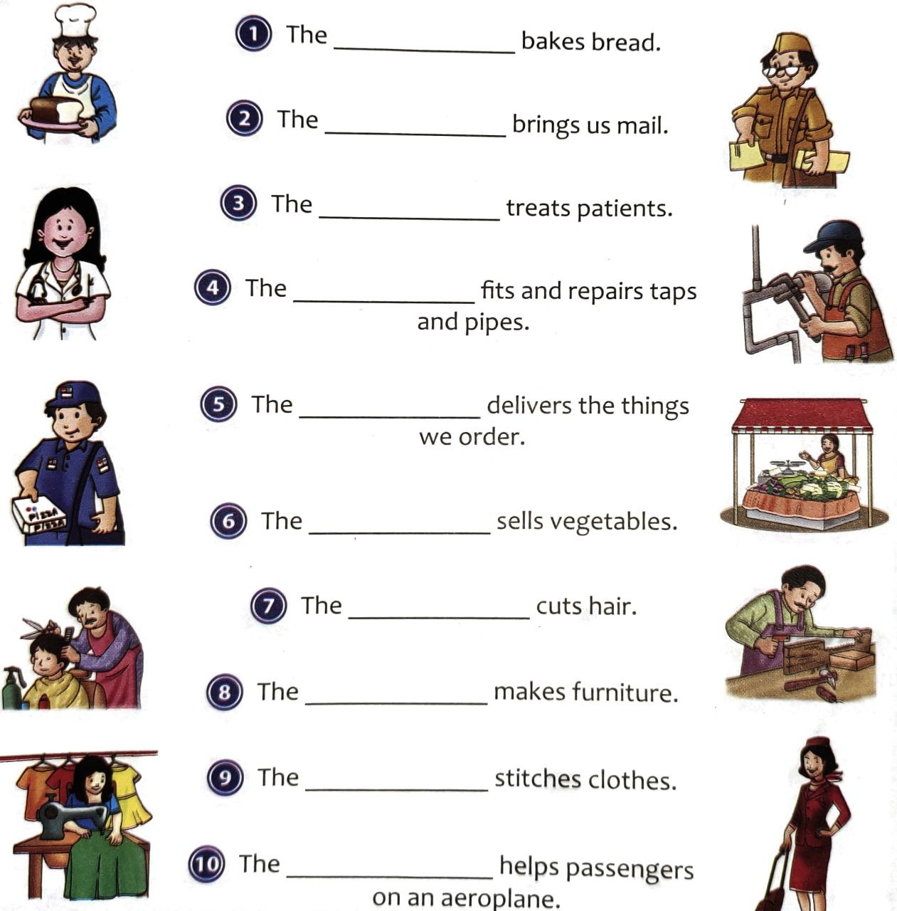
- Look at the pictures given below. Write L if the vehicle moves on land, W if it moves on water, A if it moves in air and T if it moves on a track. (10x1=10)
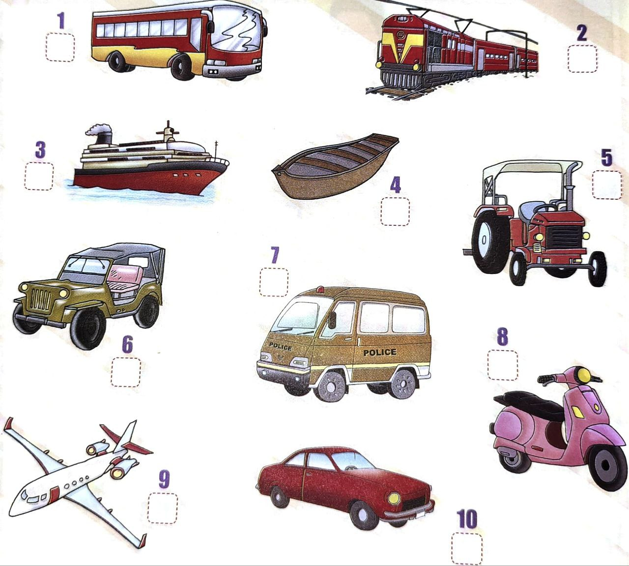
- Match the following. (3x1=3)
- President of India - Droupadi Murmu
- Prime minister of India - Pinarayi Vijayan
- Chief minister of Kerala - Narendra Modi
- Look at the pictures and name the vehicle each animal is riding. (4x1=4)
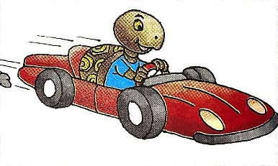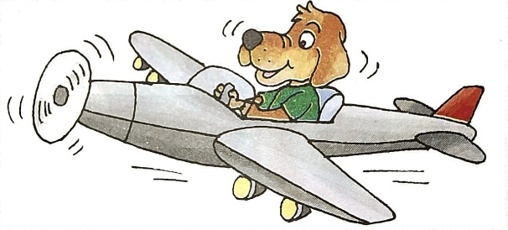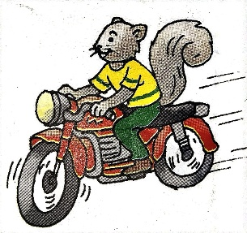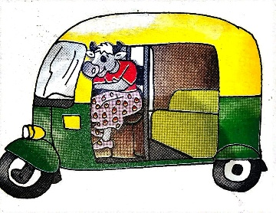
Muffy Cow in an __________________________________________
Teeny Tortoise in a racing___________________________________
Debby Dog in a flying _______________________________________
Squeaky Squirrel on a speedy ________________________________
- Answer the following question. (1x3=3)
Write the names of any three seasons.
- ________________________________________
- ________________________________________
- _________________________________________

