BLUESTOCK MUTUAL FUND ANALYTICS
Capstone Project Report

Submitted By
Ashik Saju

Technologies Used
- Python
- Pandas
- NumPy
- SQLite
- SQL
- Power BI

Submitted On
July 2026
Abstract
The Bluestock Mutual Fund Analytics project is an end-to-end financial data analytics platform developed to analyze mutual fund performance, investor behavior, portfolio characteristics, and investment risk using Python, SQLite, SQL, and Power BI.
The project begins with an automated ETL pipeline that collects, validates, cleans, and stores mutual fund datasets into a structured SQLite database. Exploratory Data Analysis (EDA) is then performed to identify trends in fund performance, investor transactions, portfolio holdings, and benchmark indices.
Advanced financial metrics such as Compound Annual Growth Rate (CAGR), Sharpe Ratio, Sortino Ratio, Alpha, Beta, Maximum Drawdown, Tracking Error, Historical Value at Risk (VaR), Conditional Value at Risk (CVaR), Rolling Sharpe Ratio, Investor Cohort Analysis, SIP Continuity Analysis, and Portfolio Concentration (HHI) are calculated using Python.
The processed data is visualized through an interactive Power BI dashboard consisting of four analytical pages: Executive Overview, Performance Analytics, Investor Analytics, and Portfolio Analytics. These dashboards provide actionable insights for investors and business users through KPIs, charts, slicers, and comparative analysis.
The project demonstrates the complete data analytics lifecycle, including data ingestion, preprocessing, financial analysis, business intelligence, and reporting, making it a practical application of modern data analytics techniques in the financial domain.

1. Introduction
The mutual fund industry has experienced significant growth over the past decade due to increasing financial awareness, digital investment platforms, and systematic investment options available to retail investors. With the growing volume of investment data, financial institutions require analytical solutions that can transform raw data into meaningful insights for investors and decision-makers.
The Bluestock Mutual Fund Analytics project was developed as a comprehensive data analytics solution to analyze mutual fund performance, investor behavior, portfolio composition, and financial risk. The project follows a complete analytics pipeline beginning with data collection and preprocessing, followed by exploratory analysis, financial metric computation, business intelligence reporting, and insight generation.
The project utilizes Python for data processing and analytics, SQLite for structured data storage, SQL for querying, and Power BI for interactive dashboard development. By combining these technologies, the project demonstrates the complete lifecycle of a modern data analytics application.
The primary objective is not only to evaluate historical mutual fund performance but also to provide investors with actionable insights through risk-adjusted performance metrics, investor analytics, portfolio analysis, and an interactive recommendation system.
The project reflects real-world financial analytics practices and provides a scalable framework that can be extended with machine learning models, live market data integration, and predictive investment analytics.
2. Project Objectives
The major objectives of the Bluestock Mutual Fund Analytics project are:
- Build an automated ETL pipeline for mutual fund datasets.
- Clean, validate, and preprocess raw financial datasets.
- Store processed data in a structured SQLite database.
- Perform exploratory data analysis to identify trends and patterns.
- Calculate key mutual fund performance indicators such as CAGR, Sharpe Ratio, Sortino Ratio, Alpha, Beta, Maximum Drawdown, and Tracking Error.
- Perform advanced risk analysis using Historical VaR and Conditional VaR.
- Analyze investor behavior using cohort analysis and SIP continuity analysis.
- Evaluate portfolio diversification using the Herfindahl-Hirschman Index (HHI).
- Develop an interactive Power BI dashboard for business users.
- Build a rule-based mutual fund recommendation system based on investor risk appetite.
- Generate business insights to support better investment decisions.
- Demonstrate an end-to-end financial data analytics workflow using modern data analysis tools.

3. Dataset Description
The project uses multiple datasets representing different aspects of the mutual fund ecosystem. These datasets were cleaned, validated, and integrated during the ETL process before analysis.
The major datasets include:
- Fund Master
Contains scheme-level information including AMFI code, scheme name, fund house, category, and risk classification.
- NAV History
Contains historical Net Asset Value (NAV) records used for return calculation, trend analysis, volatility estimation, and risk metrics.
- Scheme Performance
Provides historical returns across different investment horizons together with expense ratio, AUM, benchmark information, and other performance indicators.
- Investor Transactions
Contains transaction-level information including investor ID, transaction type, amount invested, transaction date, state, city, payment mode, gender, age group, annual income, and KYC status.
- Portfolio Holdings
Contains portfolio composition including stock symbol, company name, sector, portfolio weight, market value, and reporting date.
- Benchmark Indices
Contains benchmark index values used to compare fund performance and compute Alpha, Beta, and Tracking Error.
These datasets collectively provide sufficient information for evaluating fund performance, investor behavior, risk characteristics, and portfolio diversification.

4. Tools and Technologies
The project was developed using multiple software tools and programming technologies.
Python was used for the complete analytics workflow including ETL, preprocessing, financial calculations, statistical analysis, and report generation.
Libraries used include:
- Pandas
- NumPy
- Matplotlib
- SQLite3
SQLite
SQLite was used as the relational database management system for storing cleaned datasets and enabling structured SQL queries.

SQL
Structured Query Language (SQL) was used to retrieve, summarize, aggregate, and analyze data stored within the SQLite database.

Power BI
Power BI was used to design an interactive dashboard consisting of multiple analytical pages with slicers, KPIs, trend charts, and business visualizations.

Visual Studio Code
VS Code was used as the primary development environment for Python scripts and SQL files.

Microsoft Word
Microsoft Word was used to prepare the project documentation and final report.

Microsoft PowerPoint
PowerPoint was used to prepare the final project presentation summarizing the project's objectives, methodology, analytics, dashboard, and findings.

5. System Architecture
The Bluestock Mutual Fund Analytics platform follows a modular data analytics architecture that transforms raw mutual fund datasets into meaningful business insights. The architecture is designed to ensure that data flows systematically through multiple stages, including data ingestion, preprocessing, storage, analytics, visualization, and reporting.
The workflow begins with the collection of raw CSV datasets containing information about mutual fund schemes, historical NAV, investor transactions, benchmark indices, portfolio holdings, AUM, and SIP inflows. These datasets are processed using an automated ETL pipeline developed in Python.
During the preprocessing stage, duplicate records are removed, missing values are handled appropriately, incorrect data types are corrected, date columns are converted into datetime format, and categorical values are standardized. The cleaned datasets are then stored in a structured SQLite database.
Python scripts and Jupyter notebooks are used to perform exploratory data analysis, financial performance analysis, risk analysis, investor analytics, and portfolio analytics. The processed outputs are exported as CSV files and charts.
Finally, Power BI is connected to the processed datasets to create an interactive dashboard consisting of Executive Overview, Performance Analytics, Investor Analytics, and Portfolio Analytics pages. The dashboard enables users to filter data dynamically and explore insights through interactive visualizations.
This modular architecture improves maintainability, scalability, and reproducibility while demonstrating the complete data analytics lifecycle.

Raw CSV Files
ETL Pipeline

Cleaned CSV Files
Business Insights
SQLite Database
Power BI Dashboard
CSV Outputs
Python Analytics

6. ETL Pipeline
The ETL (Extract, Transform, Load) pipeline automates the movement of data from raw datasets into a structured analytical environment.
Extract
Raw mutual fund datasets were collected from multiple CSV sources. These datasets included information regarding NAV history, fund master data, investor transactions, benchmark indices, AUM, SIP inflows, and portfolio holdings.
Transform
The transformation stage included:
- Removing duplicate records.
- Handling missing values.
- Standardizing categorical values.
- Converting date columns into datetime format.
- Validating AMFI codes.
- Correcting numerical data types.
- Creating processed datasets suitable for analytics.
Load
The cleaned datasets were exported into the processed folder and loaded into a SQLite database using Python. SQL queries were then used for structured data retrieval and validation.
Automating the ETL pipeline ensured consistency, reduced manual effort, and improved reproducibility across the entire analytics workflow.
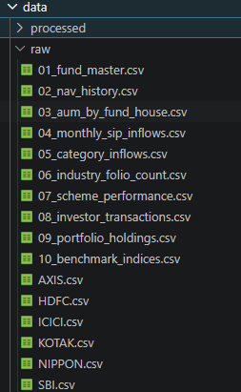

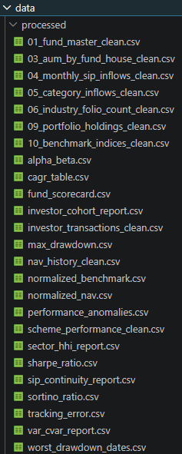

7. Data Cleaning and Preprocessing
Data quality directly affects the accuracy of analytical results. Therefore, extensive preprocessing was performed before conducting any analysis.
The following preprocessing steps were applied:
- Removal of duplicate records.
- Identification and treatment of missing values.
- Standardization of text fields.
- Conversion of numerical columns into appropriate data types.
- Conversion of date columns into datetime format.
- Validation of AMFI scheme codes.
- Formatting categorical variables for consistency.
- Preparation of normalized datasets for benchmark comparison.
The cleaned datasets were stored separately from the raw data to preserve data integrity and support reproducibility.
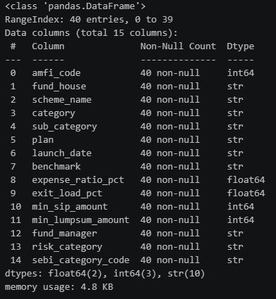
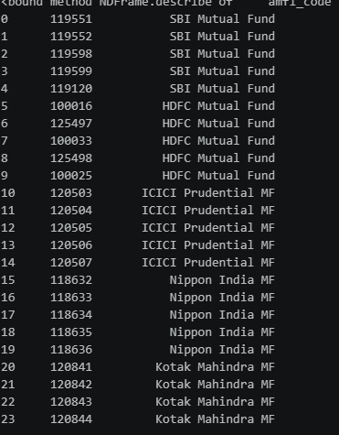

8. Exploratory Data Analysis
Exploratory Data Analysis (EDA) was performed to understand the structure of the datasets and identify trends before advanced financial analysis.
The analysis included:
- Distribution of mutual fund categories.
- NAV trends over time.
- AUM comparison across fund houses.
- Monthly SIP inflows.
- Investor transaction distribution.
- Portfolio sector allocation.
- Benchmark movement analysis.
Several visualizations were created using Matplotlib to summarize the characteristics of the data.
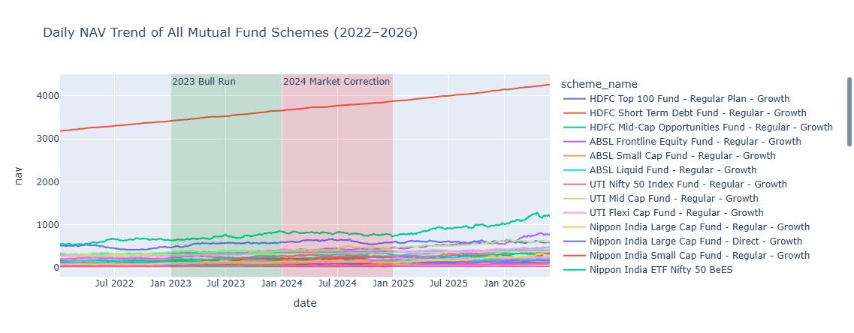
EDA provided important insights that guided the subsequent stages of financial and risk analytics.

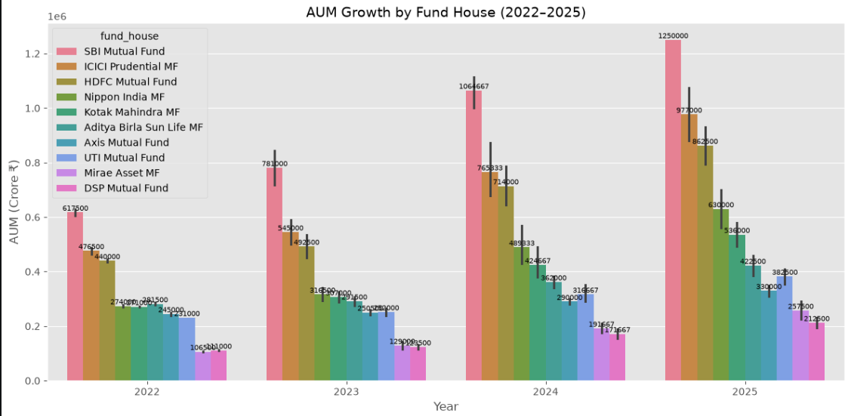
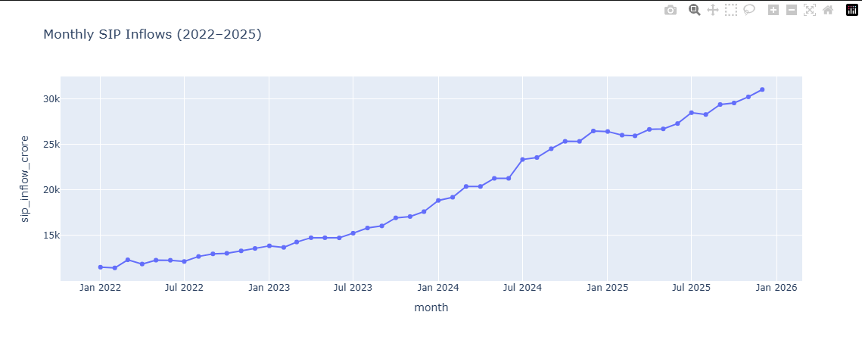

9. Performance Analytics
Multiple financial performance metrics were calculated to evaluate the effectiveness of mutual fund schemes.
The primary metrics included:
Compound Annual Growth Rate (CAGR)
Measures the annualized return of a mutual fund over a specified investment period.
Sharpe Ratio
Evaluates risk-adjusted returns by comparing excess returns against overall volatility.
Sortino Ratio
Measures risk-adjusted returns using downside deviation instead of total volatility.
Alpha
Represents excess returns generated relative to the benchmark.
Beta
Measures the sensitivity of a fund relative to market movements.
Maximum Drawdown
Measures the largest observed decline from peak value during the investment period.
Tracking Error
Measures how closely a mutual fund follows its benchmark index.
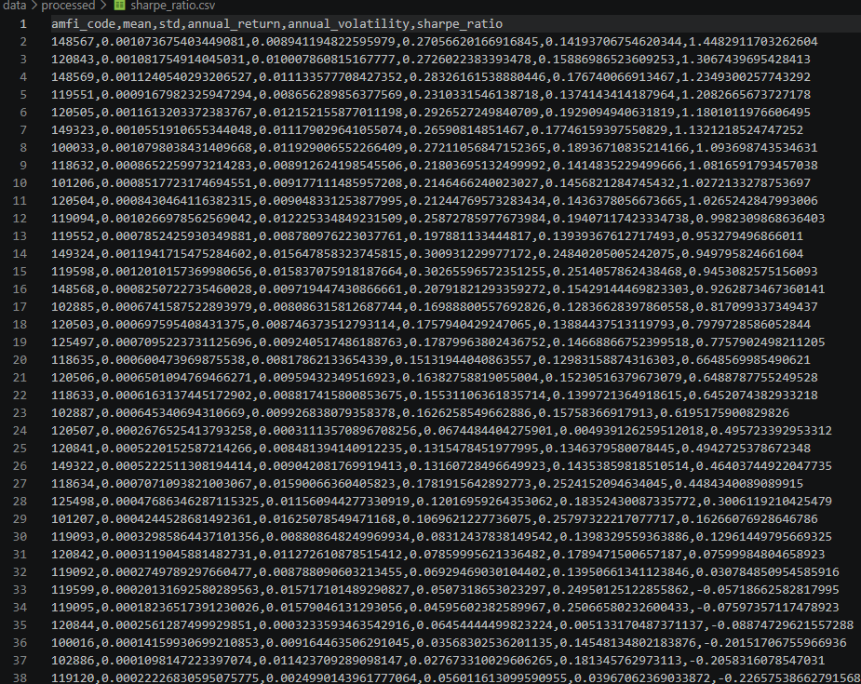
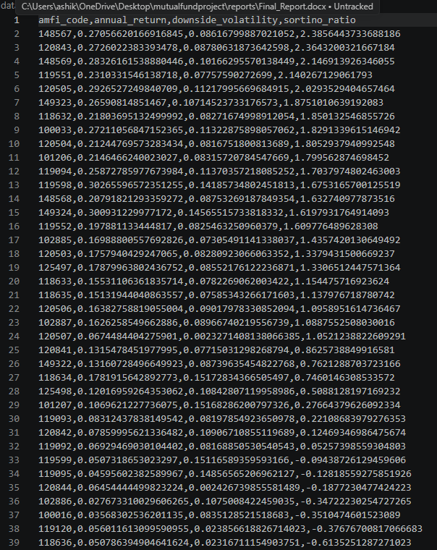
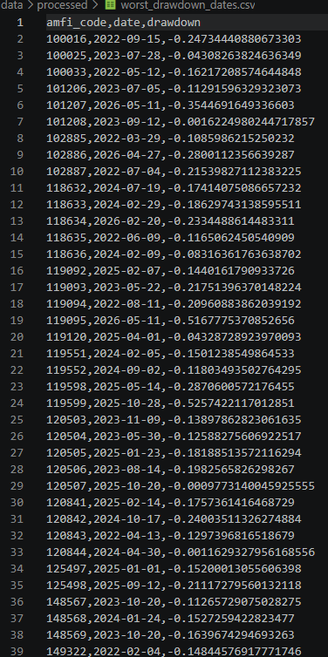
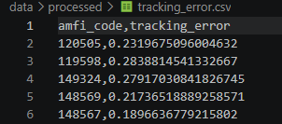
These metrics collectively provide a comprehensive understanding of both return and investment risk.
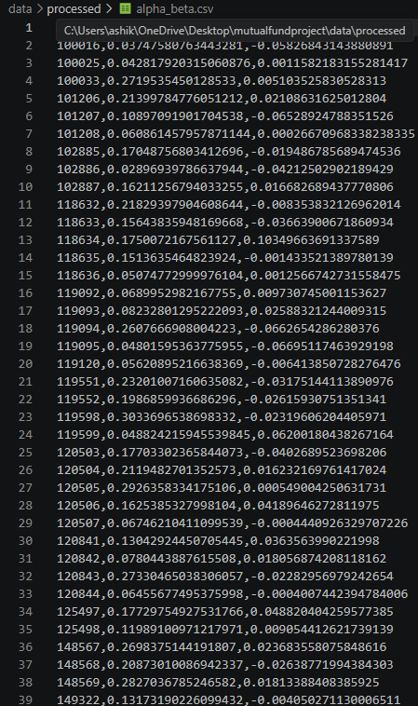
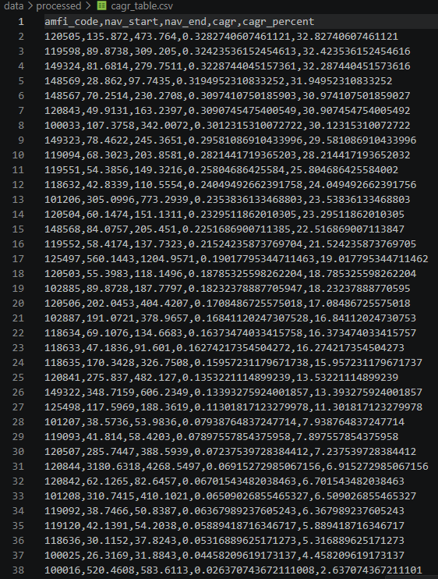

10. Advanced Analytics
Advanced analytics techniques were implemented to provide deeper insights into mutual fund performance, investment risk, investor behaviour, and portfolio diversification. These analyses extend beyond traditional return metrics and help evaluate funds from a practical investment perspective.
10.1 Historical Value at Risk (VaR)
Historical Value at Risk (VaR) at the 95% confidence level was calculated using the historical distribution of daily returns. VaR estimates the maximum expected loss over a single trading day under normal market conditions. It provides investors with an understanding of downside risk associated with each mutual fund.
10.2 Conditional Value at Risk (CVaR)
Conditional Value at Risk (CVaR), also known as Expected Shortfall, was calculated as the average loss beyond the VaR threshold. Unlike VaR, CVaR measures the severity of losses during extreme market conditions, making it a more conservative risk metric.
10.3 Rolling 90-Day Sharpe Ratio
A rolling Sharpe Ratio was calculated using a 90-day moving window. This analysis illustrates how the risk-adjusted performance of selected funds changes over time rather than relying on a single historical value. Rolling analysis helps identify periods of consistent performance and increased market volatility.
10.4 Investor Cohort Analysis
Investors were grouped according to the year of their first investment transaction. For each cohort, average SIP amount, total investment value, and preferred mutual fund schemes were analysed. This analysis helps understand changing investment patterns across different investor groups.
10.5 SIP Continuity Analysis
Systematic Investment Plan (SIP) continuity was analysed by measuring the average interval between SIP transactions. Investors with an average transaction gap greater than 35 days were classified as "At Risk," indicating irregular investment behaviour.
10.6 Rule-Based Mutual Fund Recommendation System
A recommendation system was developed using Sharpe Ratio and fund risk classification. Based on the investor's selected risk appetite (Low, Moderate, or High), the system recommends the top-performing mutual funds within the corresponding risk category.
10.7 Portfolio Concentration Analysis
Portfolio diversification was evaluated using the Herfindahl-Hirschman Index (HHI). A higher HHI indicates greater concentration in a limited number of holdings, whereas a lower HHI represents a more diversified portfolio. This metric helps assess concentration risk across equity mutual funds.
The advanced analytics module demonstrates how quantitative techniques can assist investors in making informed decisions by combining return analysis, risk assessment, investor behaviour, and portfolio diversification.
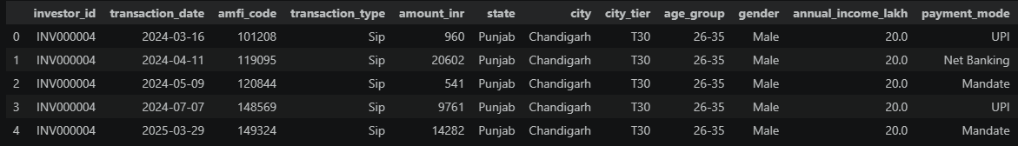
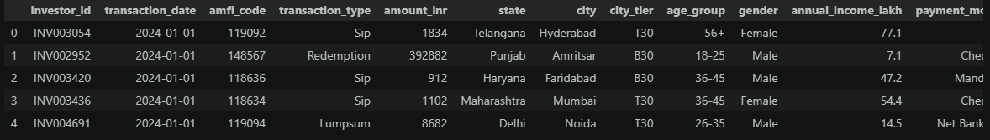
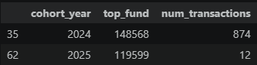

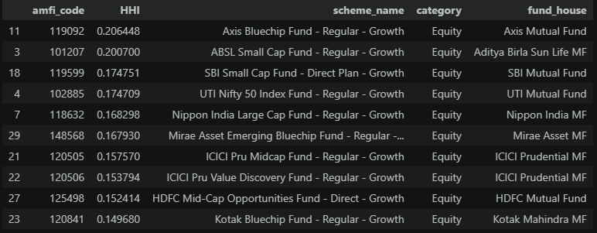

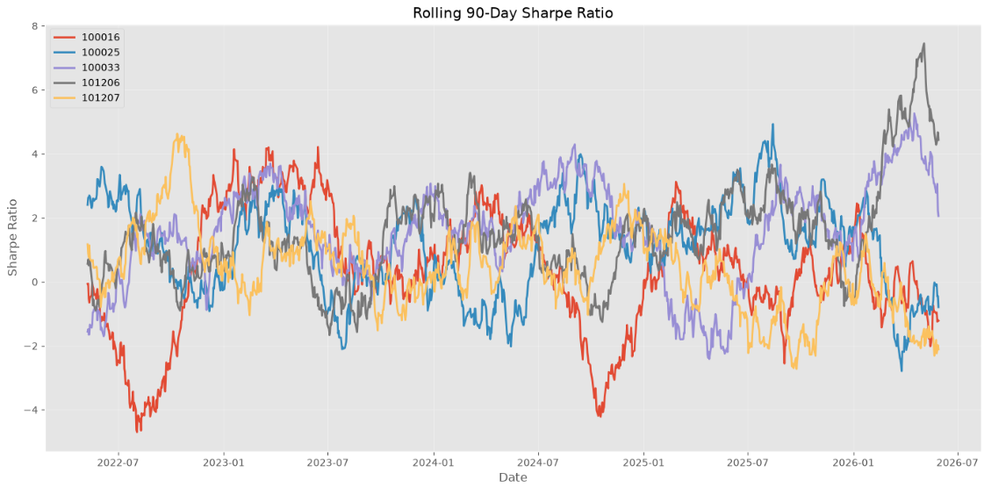

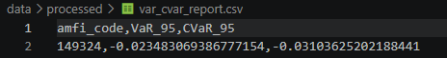

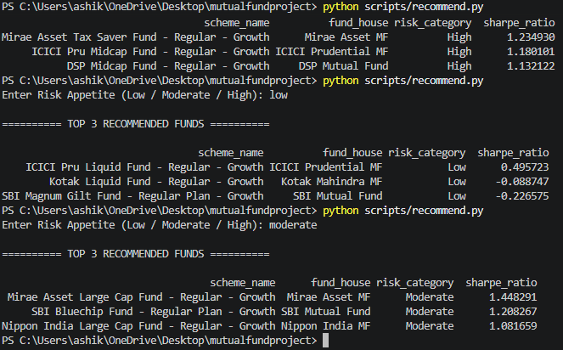

11. Interactive Power BI Dashboard
An interactive Power BI dashboard was developed to present the analytical results in an intuitive and business-friendly manner. The dashboard enables users to explore mutual fund performance through dynamic visualizations and interactive filters.
The dashboard consists of four major pages:
Executive Overview
This page provides a high-level summary of the mutual fund ecosystem. It includes key performance indicators such as total assets under management, total SIP inflows, number of schemes, and benchmark summaries.
Performance Analytics
The Performance Analytics page visualizes financial metrics including CAGR, Sharpe Ratio, Sortino Ratio, Alpha, Beta, Maximum Drawdown, and Tracking Error. Users can compare multiple funds using interactive charts and slicers.
Investor Analytics
This page focuses on investor behaviour and demographic trends. Visualizations include transaction distribution, investor segmentation by state and age group, cohort analysis, and SIP continuity metrics.
Portfolio Analytics
Portfolio composition is analysed using sector allocation, stock holdings, portfolio weights, and concentration metrics. This page enables users to understand diversification and sector exposure across different mutual funds.
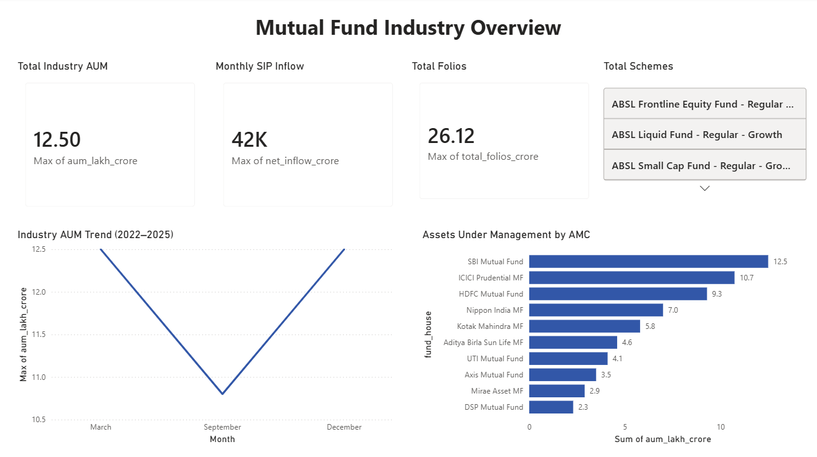
Interactive slicers were implemented to allow filtering by fund house, scheme category, risk category, transaction year, and other dimensions. These interactive features improve usability and support efficient business decision-making.
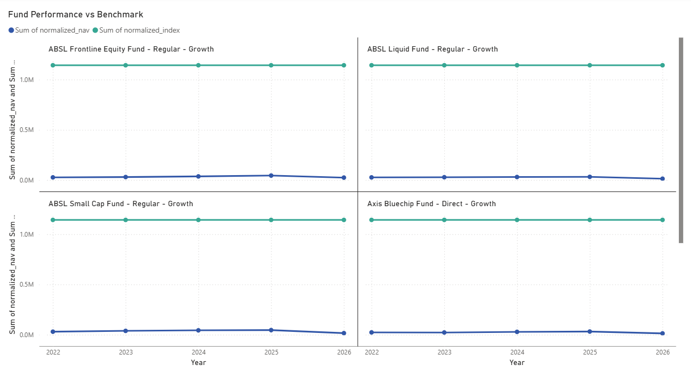
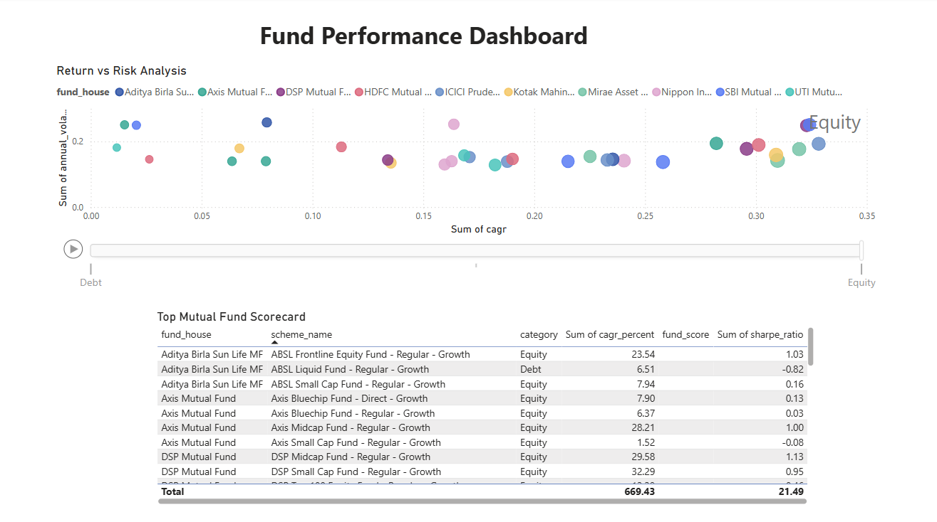
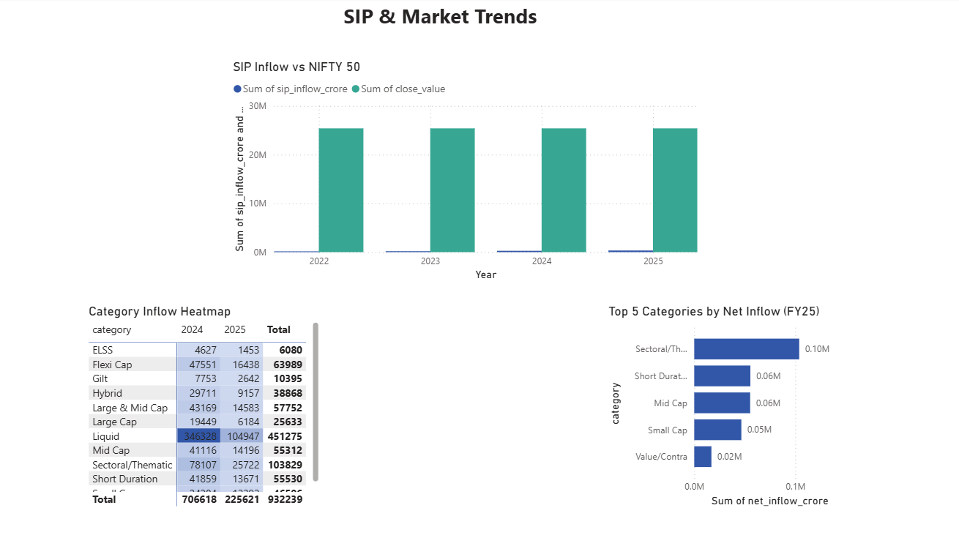
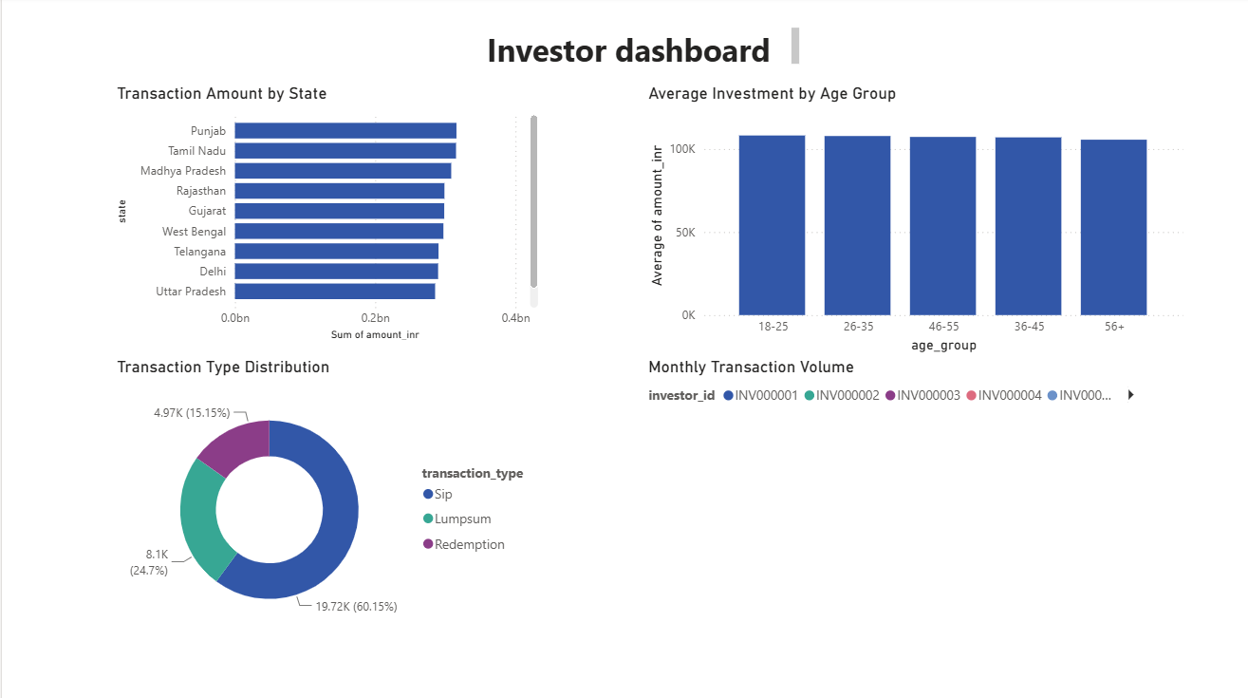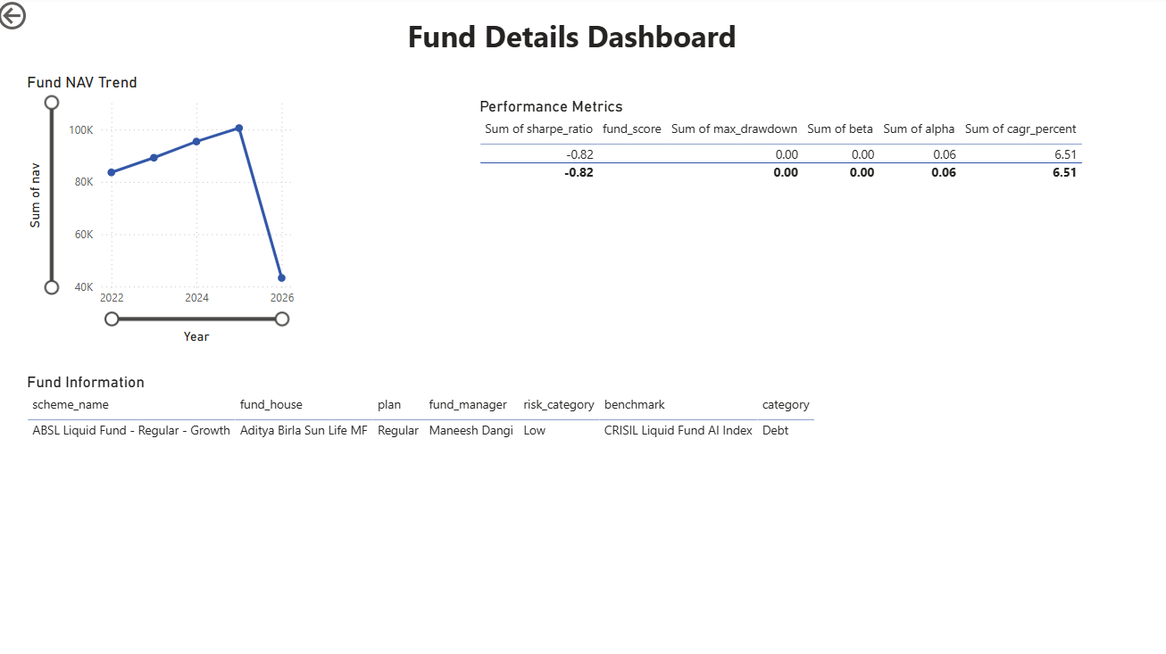
12. Findings
The analysis performed throughout the project generated several important business insights:
- Mutual funds with consistently high Sharpe Ratios demonstrated superior risk-adjusted performance compared to other schemes.
- Historical VaR and CVaR analysis revealed that certain high-return funds also exhibited significantly greater downside risk during volatile market conditions.
- Investor cohort analysis showed that more recent investor groups displayed higher average SIP investments, indicating increasing investor confidence and financial awareness.
- SIP continuity analysis identified investors with irregular investment patterns, enabling financial institutions to proactively engage with at-risk investors.
5. Portfolio concentration analysis revealed that some equity funds maintained highly concentrated sector allocations, increasing concentration risk despite strong historical returns.
These findings demonstrate how advanced analytics can support both investment decision-making and customer relationship management.

13. Conclusion
The Bluestock Mutual Fund Analytics project successfully demonstrates the complete lifecycle of a financial data analytics solution. Beginning with raw data ingestion and preprocessing, the project progressed through database development, exploratory data analysis, financial performance evaluation, advanced risk analytics, investor behaviour analysis, portfolio assessment, and interactive dashboard creation.
The implementation of metrics such as CAGR, Sharpe Ratio, Sortino Ratio, Alpha, Beta, Maximum Drawdown, Tracking Error, Historical VaR, Conditional VaR, Rolling Sharpe Ratio, Investor Cohort Analysis, SIP Continuity Analysis, and Portfolio Concentration Index provided insights into mutual fund performance and investment risk.
The interactive Power BI dashboard enables users to analyse data using visual reports and filters, making the analytical results accessible to both technical and non-technical stakeholders.
Overall, the project demonstrates practical application of Python, SQL, SQLite, and Power BI in solving real-world financial analytics problems. The modular design and scalable architecture provide a strong foundation for future enhancements involving machine learning, real-time data integration, and portfolio optimization.

