Servlet & JSP- part-1

=========================

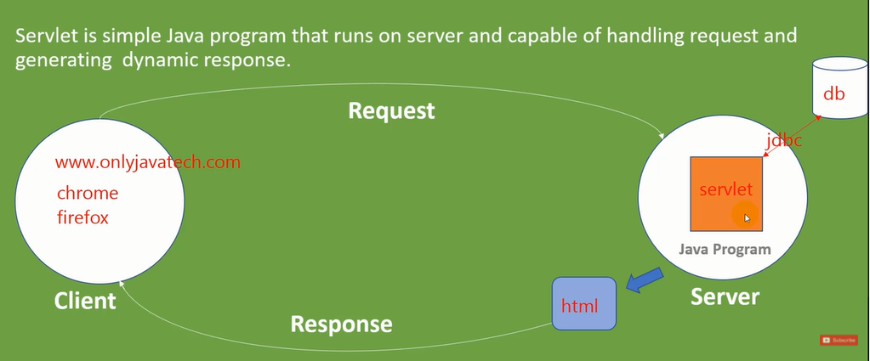

Installing apache tomcat:

Step-1: download tomcat 9([32-bit/64-bit Windows Service Installer](https://downloads.apache.org/tomcat/tomcat-9/v9.0.52/bin/apache-tomcat-9.0.52.exe) ([pgp](https://downloads.apache.org/tomcat/tomcat-9/v9.0.52/bin/apache-tomcat-9.0.52.exe.asc), [sha512](https://downloads.apache.org/tomcat/tomcat-9/v9.0.52/bin/apache-tomcat-9.0.52.exe.sha512))

Step-2: check on host-manager(installation time).

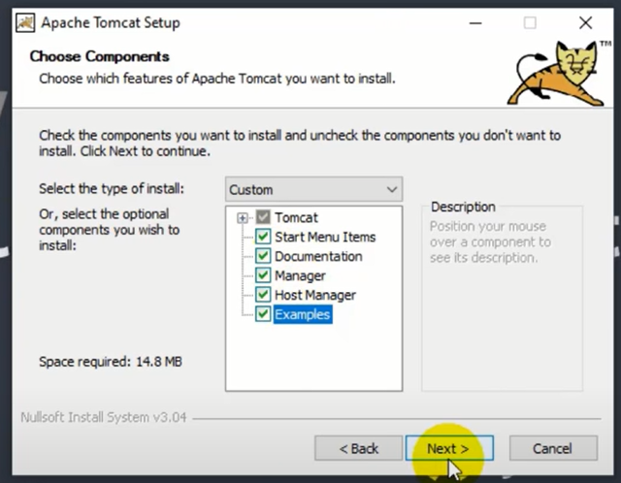

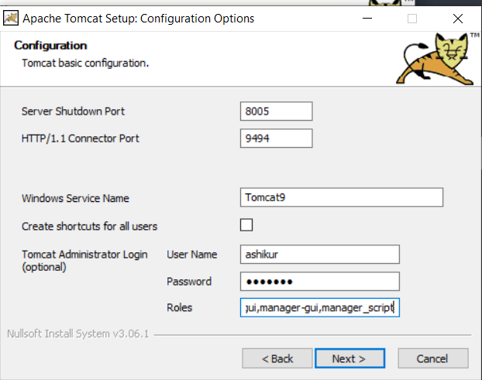

Password: ashikur

* Now access on browser on port localhost://9494

Security allow for (tomcat with IJ):

============================

1. Go to program files 🡪 apache software foundation
2. Click on tomcat 9.0 file and find properties.
3. Go to security 🡪 and give all permissions.

Tomcat server configuration in IntelliJ:

Successful tutorial: <https://www.youtube.com/watch?v=JIRDMGJ66SE>

Creating servlet using implementing servlet:

===============================================

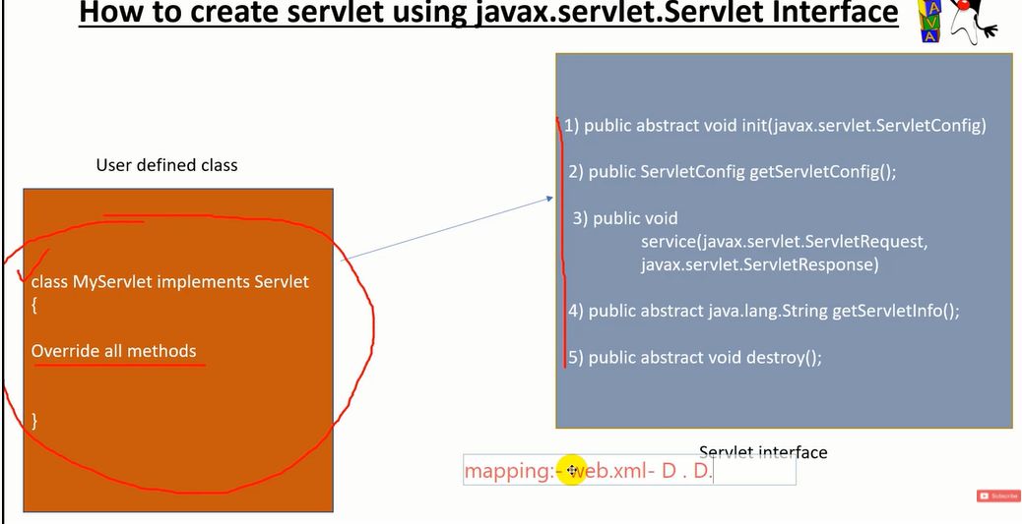

Creating servlet using GenericServlet class :

===============================================

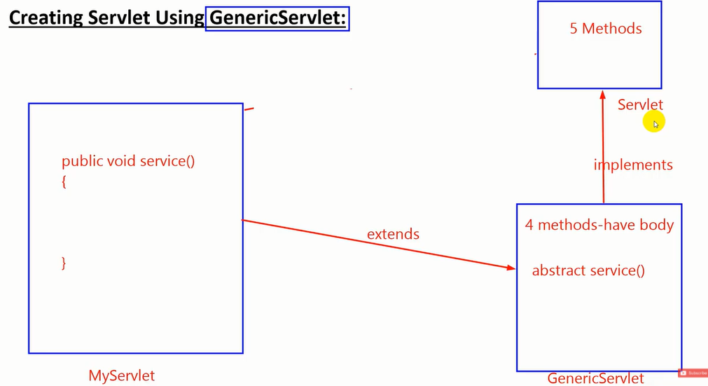

Creating servlet using HttpServlet

======================================

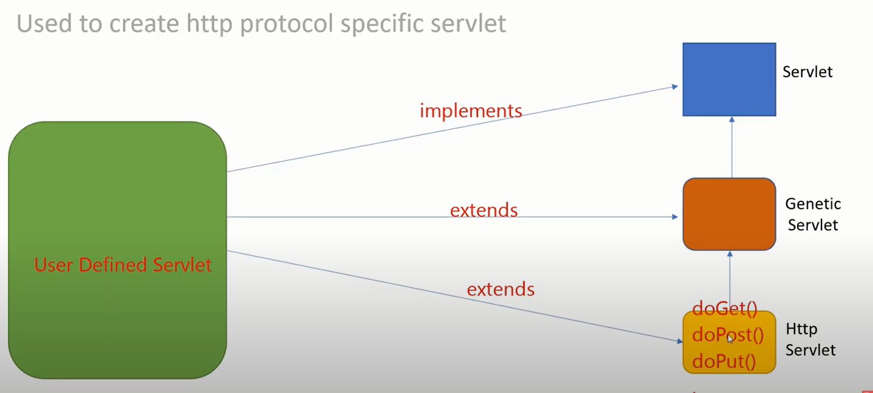

User panel

|  |
| --- |
| Register |
| Login |
| Deposit Money |
| Withdraw money |
| Transfer money |
| Take Loan |
| Pay Loan |
| Balance Enquiry |
| Update/Edit an account |
| Logout |

Admin panel

|  |
| --- |
| Account holder list |
| Search account by account number |
| Search account by owner name |
| Search accounts by balance |
| Sort account (optional) |
| Close or delete an account |