Overview:

==========

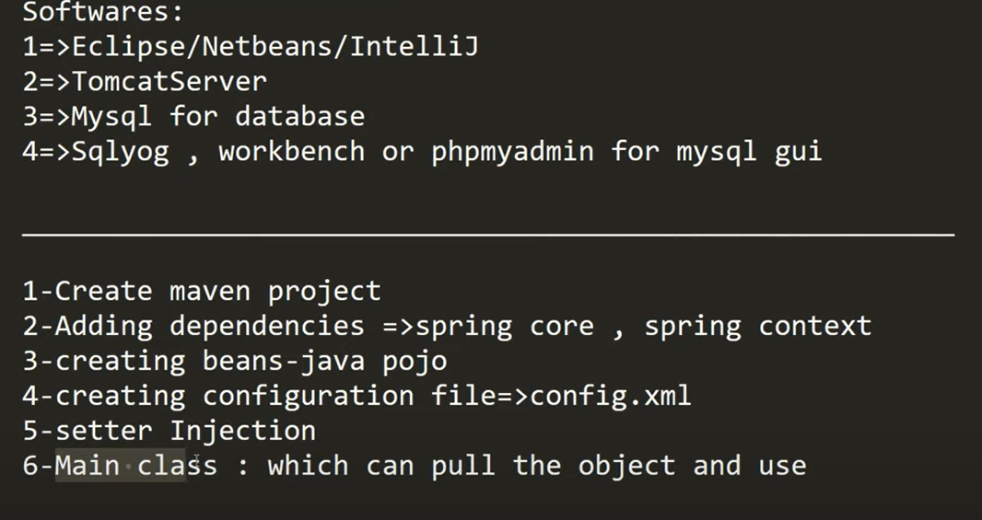

Life cycle method of Spring bean:

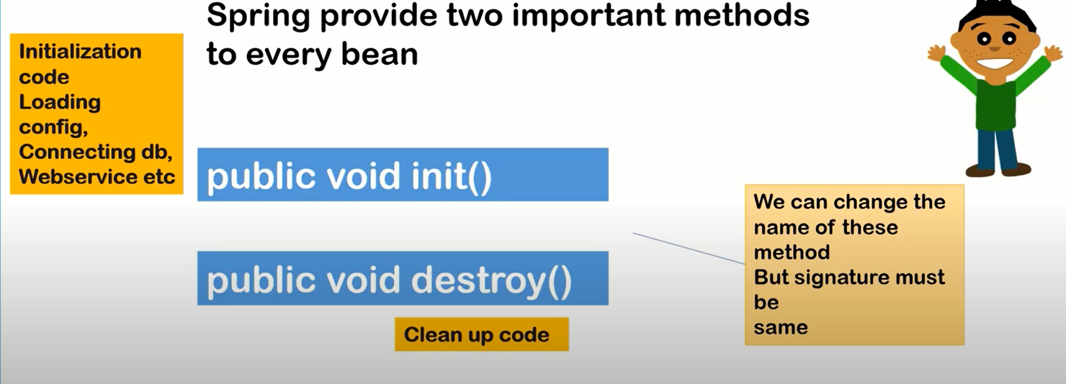

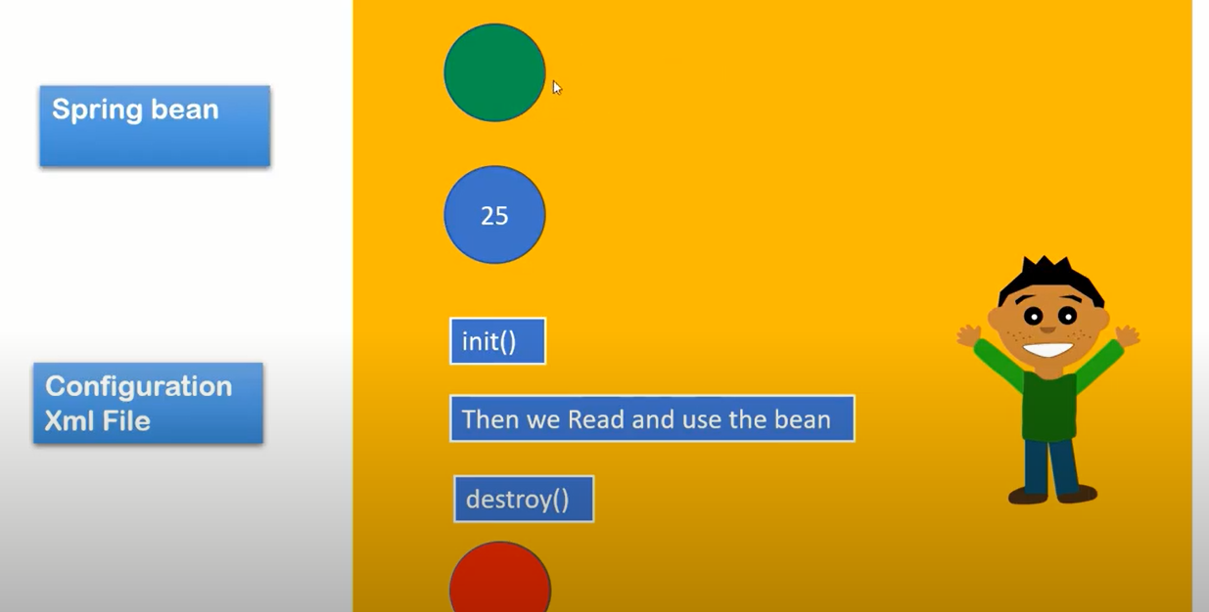

Green color balls means object creation and red color balls means object destroy.

* Object creation 🡪 value initialization 🡪 then init() then others.

Bean configuration life cycle implement using 3 techniques:

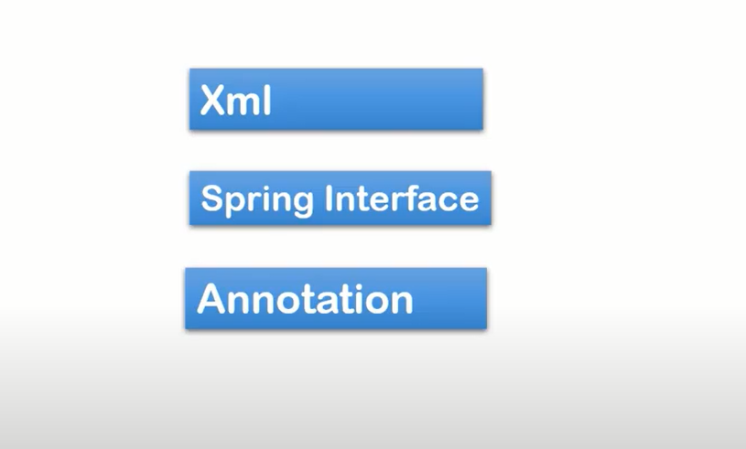

Using interface:

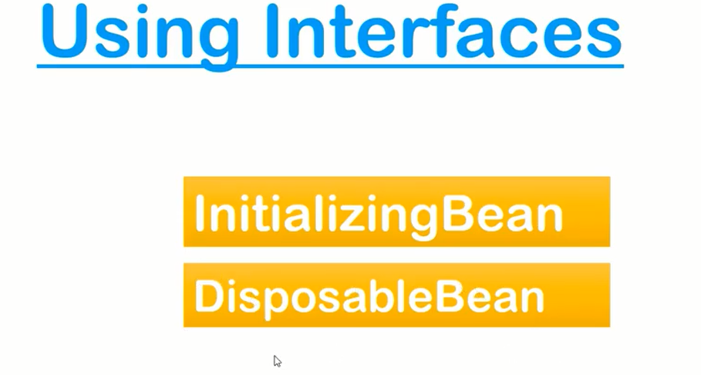

* InitializingBean will work as init()
* DisposableBean will work as destroy()

