Autowiring in Spring

=========================

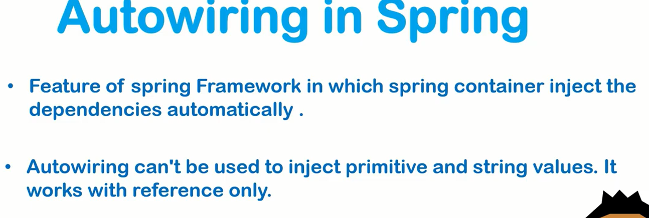

Autowiring means: Spring will do automatic linking.

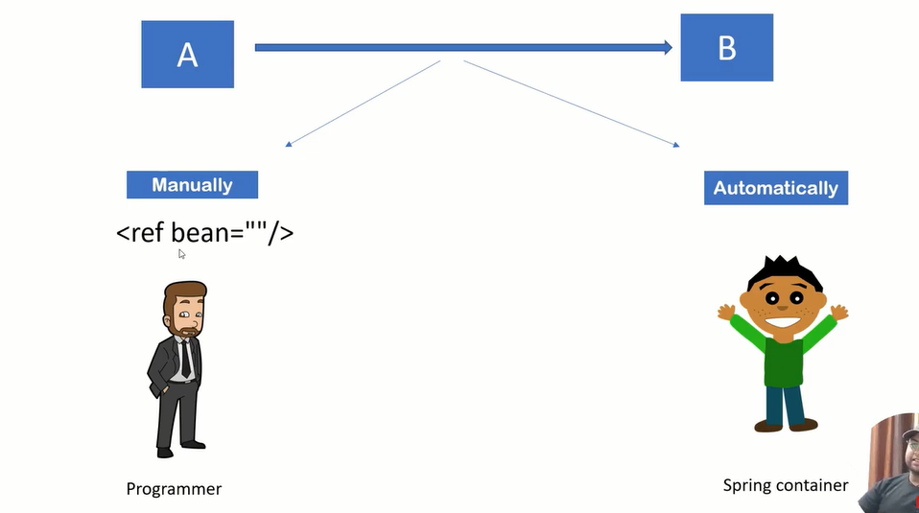

@Autowired : Dependency insert in object.

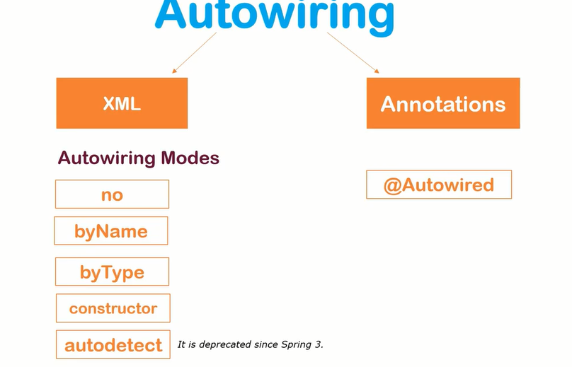

Advantages and disadvantages of Autowiring:

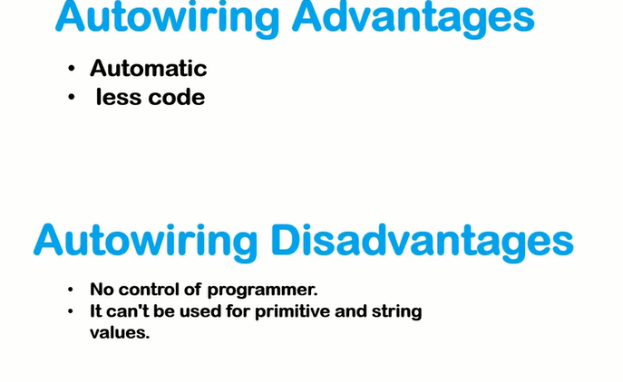



Note: In run time object will create.



Singletone: Create one object and use everywhere.

Prototype: Everytime will create new object.