Spring JDBC

=================

JDBC and Spring JDBC is different.

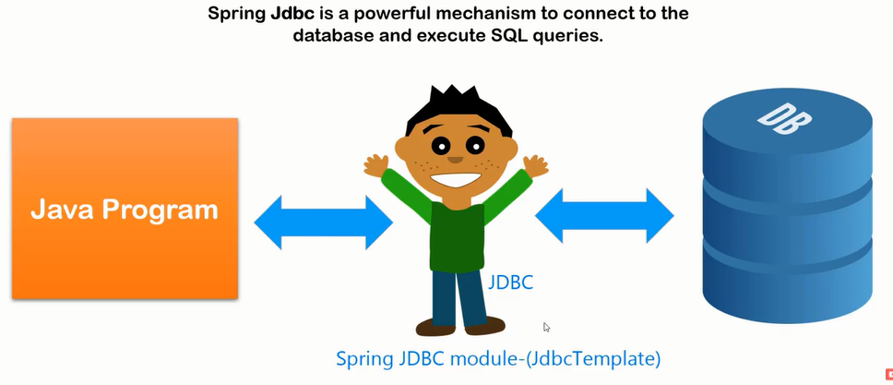

JDBC Concept:

JDBC is API to perform operation with database.

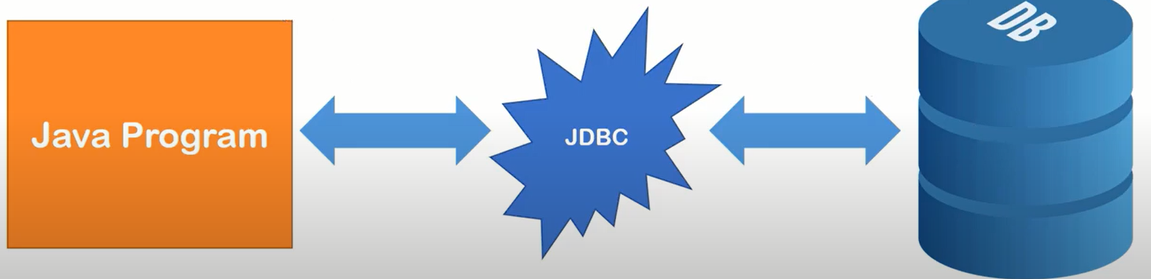

Problems of JDBC:

* We need to write a lot of code.
* Connection open
* Statement
* Execute
* Connection close

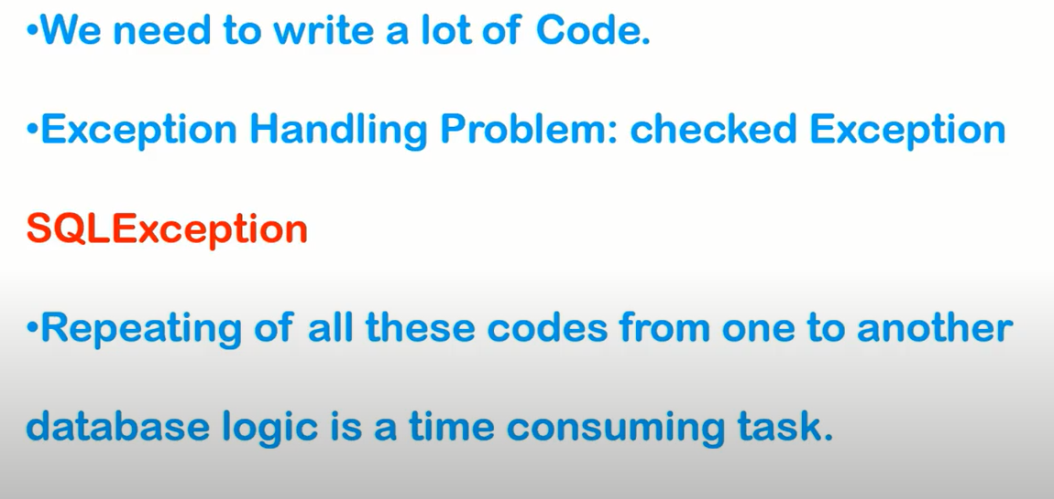

Spring JDBC:

=====================

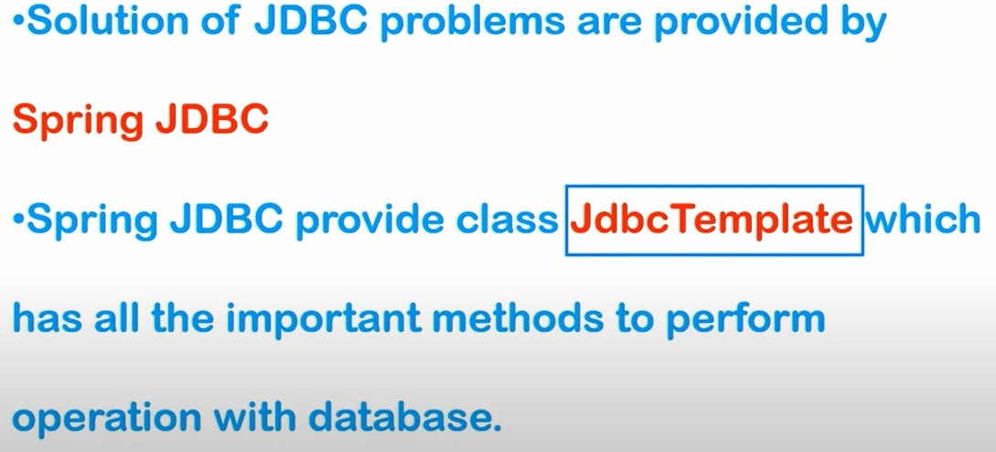

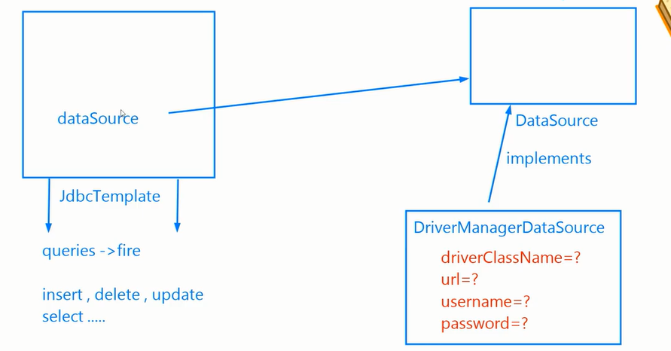

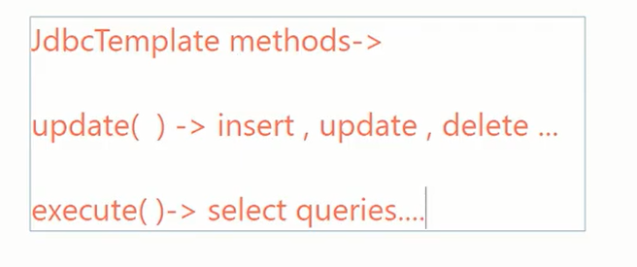

Selecting Data Using Spring JDBC

===============================

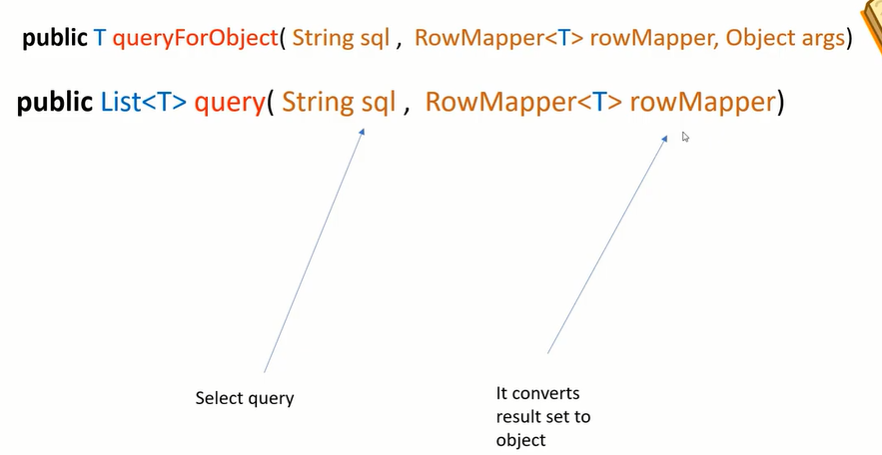

Row mapper:

Row mapper is an interface which can convert ResultSet object(row) to classObject.

