**PRAN-RFL Group**

**A RISING MARKET GIANT of BANGLADESH**

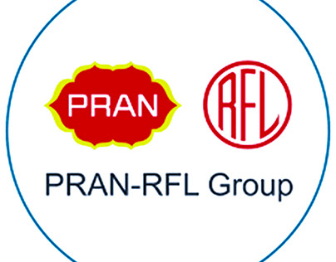

**Md Ashikur Rahman**

**Batch name: 03**

**Date :01/06/2024**

**Table of Contents**

1. Executive Summery 3

2.Products of PRAN-RFL Group 3

2.1 List of PRAN products 4

2.1.1 Juices 4

2.1.2 Drinks 5

2.1.3 Hyper Link: 5

4. Business Plan 6

5.Sales and Cost Statistics 7

6. Formatting: 8

Total employee of Pran-RFL Group 8

# 1. Executive Summery

PRAN-RFL Group is a leading food, beverage &amp; plastic industrial conglomerate &amp; market leader in Bangladesh. It is one of the most profitable companies of Bangladesh. Their mission and vision is to eliminate poverty and develop the agricultural sector of Bangladesh. Their motto is to generate employment and earn dignity and self-respect for our competitors. Since 1981 they are trying to develop our countries agricultural and rural area. Besides this they are the largest agro-processing company in Bangladesh. In this Term paper, we worked on the various factors on PRAN-RFL Group. At first we discussed about their organizational overview, history, aim, mission, vision industries, corporate office, and methodology. We took information from both primary and secondary sources like, total concern, employee, product, export list and other topics. We analyse SWOT, marketing strategy, financial condition, HRD &amp; HRM on PRAN-RFL. We also discussed in this paper about the contribution to economy of this company in our country.

# 2.Products of PRAN-RFL Group

PRAN takes a comprehensive approach to all kinds of agro processed food products, considering all of the ways to make their products hygienic and qualitable. With HACCP compliance to ensure best quality products reach to the consumers, PRAN places great importance on hygienic manufacturing processes. This encompasses everything from choosing quality materials to the use of storage facilities and careful monitoring of products using electronic sorting Skilled and experienced personnel select finished products which are then examined in a laboratory to verify their quality and to check for residual substances both before and after the production process. Furthermore, company's computer systems offer continuous monitoring of all manufacturing process to ensure the highest levels of quality. PRAN food and beverage industry produces over 422 products and with their margering partner RFL. they produce Over 2000 kinds of products.

## 2.1 List of PRAN products

### 2.1.1 Juices

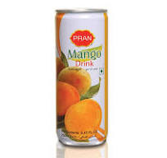

### 2.1.2 Drinks



### 2.1.3 Hyper Link:

[Click hear to go PRN RFL group product list](http://www.thedailystar.net/business/pran-starts-potato-export-789643)

# 4. Business Plan

Store Manager makes Materials Recovering Report

SCM Making

Perchas Requisition from operation

Perchas order from SCM

Bill Submit to account for supplier Payment

Supplier delivery the product to Warehouse

# 5.Sales and Cost Statistics

|  |  |  |  |  |
| --- | --- | --- | --- | --- |
| **Particulars** | **2018** | **2019** | **2020** | **2021** |
| **Cost of Goods sold** | 9,502,875,643 | 7,845,674,020 | 10,689,087,341 | 11,155,820,768 |
| **Average Inventories** | 2,786,767,051 | 2,399,288,691 | 3,415,043,879 | 3,900,636,632 |
| **Inventory Turnover Ratio** | 3.41 | 3.27 | 3.13 | 2.86 |

# 6. Formatting:

## Total employee of Pran-RFL Group

PRAN-RFL Group puts a lot of importance on their employees. They always try to recruit efficient, dedicated, creative and hardworking employees for their organization. Equal opportunity is given in both male and female workers. Their recruitment structure is very developed and fair, so that they could build a strong team of employees. After the recruitment PRAN-RFL provides them proper training to develop working skills, good salary, commission on the profit, reward among the best employees and many more. They consider the employees as asset. From one example about their responsibility is; they always try to give salary before 29th day of the month, so that the employees don’t have to suffer from any kind of financial problem. There are a huge number of employees in

PRAN-RFL group. The number of employee details is given below:

* General workers – 28,
* Overall workers – 40,
* Current workers – 28,
* Factory workers – 20,
* Sales workers – 8,
* corporate employees – 2000