A System Design Project Report on

**Alumni Website**

**Submitted in partial fulfillment of the degree of  
Bachelor of Computer Applications**

**VI Semester**

Submitted by

**Akshat Mathur (203501006)**

**Aryan Arora (203501016)**

**Ashim Mehar (203501018)**

**Lakshit Jain (203501071)**

Under the Supervision of  
**Mrs. Harshita Mathur**

Faculty of Computer Science



**Faculty of Computer Science  
Lachoo Memorial College of Science & Technology (Autonomous)**

**Jodhpur**

*2023*



##### **Faculty of Computer Science**

**Lachoo Memorial College of Science & Technology (Autonomous)**

# CERTIFICATE

This is to certify that the System Design Project entitled

**Alumni Website**

has been designed and developed by

**Akshat Mathur (203501006)**

**Aryan Arora (203501016)**

**Ashim Mehar (203501018)**

**Lakshit Jain (203501071)**

in partial fulfillment of the degree of BCA VI Semester Examination 2023, under our supervision and guidance.

**Prof. (Dr.) Priyadarshi Patni Mrs. Harshita Mathur**

Director Assistant Professor

Faculty of Computer Sc Faculty of Computer Sc

Date: 11/07/2023

**Acknowledgement**

*The satisfaction and euphoria that accompany the successful completion of any task would incomplete without the mention of the people who made it possible, whose constant guidance and encouragement crowned our effort with success.*

*We express our sincere gratitude to our Principal Prof (Dr.) Rohit Jain for providing facilities.*

*We wish to place on record our grateful thanks to Prof. (Dr.) Priyadarshi Patni providing encouragement and guidance.*

*Also we thank the faculty members of the Computer Sc department whose suggestions enabled us to surpass many of the seemingly impossible hurdles.*

*We also thank our guides and lastly we thank everybody who has directly or indirectly helped us in the course of this project.*

**Akshat Mathur (203501006)**

**Aryan Arora (203501016)**

**Ashim Mehar (203501018)**

**Lakshit Jain (203501071)**

**Contents**

|  |  |
| --- | --- |
| 1. Introduction |  |
| 1. Recognition of Need |  |
| 1. Existing System with Limitations |  |
| 1. Proposed System with Advantages |  |
| 1. Process/Working |  |
| 1. Feasibility Study |  |
| 1. Data Flow Diagrams |  |
| 1. E R Diagram and Database Tables |  |
| 1. Project Design (Screenshots) |  |
| 1. Future Enhancement |  |
| 1. Conclusion |  |
| 1. References |  |
| 13. Appendix |  |

**1. Introduction**

*Introducing Alumni Application: Connecting and Empowering Alumni*

*Welcome to Alumni Application, a dynamic platform designed to foster meaningful connections and empower alumni around the world. Built with ReactJS for the frontend and powered by Firebase for backend and authentication, our application provides a seamless and secure environment for alumni to connect, network, and engage with their alma mater and fellow graduates.*

*At Alumni Application, we understand the value of maintaining strong alumni relationships beyond graduation. Our platform aims to bridge the gap between alumni and their educational institutions, creating a thriving network where graduates can stay connected, leverage their collective knowledge and experiences, and explore new opportunities.*

**Key Features :**

**1. User-Friendly Interface:** *We've crafted an intuitive and user-friendly interface to ensure that alumni of all technical backgrounds can easily navigate and utilize our application. Whether you're a recent graduate or a seasoned professional, connecting with your alumni community has never been easier.*

**2. Secure Authentication:** *Our application leverages the robust authentication capabilities of Firebase, ensuring that your personal*

*information and interactions within the platform are safe and protected. Alumni can create profiles, manage their privacy settings, and connect with confidence.*

**3. Alumni Directory:** *Our comprehensive alumni directory enables users to search and connect with fellow graduates based on various criteria such as graduation year, location, industry, and more. Expand your professional network, reconnect with old friends, and forge new connections within your alumni community.*

**4. Events and Reunions:** *Discover and participate in alumni events, reunions, and networking opportunities. Our application provides a centralized platform to promote and coordinate gatherings, enabling you to reconnect with classmates, share memories, and foster new collaborations.*

**5. Mentorship and Career Support:** *Facilitate mentorship connections between alumni and current students or recent graduates. Alumni can offer guidance, share career insights, and provide valuable advice to help the next generation succeed. Likewise, explore mentorship opportunities and benefit from the wisdom of experienced professionals.*

**6. Professional Development:** *Access resources and tools to support your ongoing professional growth. From webinars and workshops to job boards and industry insights, our application aims to empower alumni with the knowledge and skills needed to thrive in their careers.*

**2. Recognition of Need**

**Introduction:**

*Introduce the alumni application developed using React.js for the frontend and Firebase for the database and authentication.*

*Explain the purpose of the application: The alumni application aims to provide a platform for alumni to connect, engage, and stay connected with their alma mater and fellow graduates.*

**Importance of an Alumni Application:**

*Foster a strong alumni community: The application serves as a virtual space where alumni can connect and interact, fostering a sense of community and belonging.*

**1. Facilitate networking opportunities:** *Alumni can utilize the platform to network with fellow alumni, professionals, and students, creating valuable connections for career growth and mentorship.*

**2. Enhance alumni-institution engagement:** *The application promotes active engagement between alumni and the institution by sharing updates, organizing events, and facilitating collaborations on various initiatives.*

**3. Streamline communication:** *Alumni can easily communicate with each other and with the institution, enabling efficient information sharing, event coordination, and alumni updates.*

**4. Provide a central hub for resources:** *The application can serve as a repository for alumni resources, career opportunities, event information, and other relevant materials.*

**Overview of the proposed alumni application:**

*Seamless alumni networking: The application will provide features such as alumni profiles, searchable directories, and messaging capabilities to facilitate networking among alumni.*

**Event management:** *Alumni can view and participate in various events organized by the institution or fellow alumni, fostering networking opportunities and engagement.*

**Information centralization:** *The application will serve as a centralized platform for alumni-related information, including alumni updates, news, and resources.*

**Resource sharing**: *Alumni can access and share valuable resources, such as job opportunities, mentorship programs, and career development materials.*

**Secure authentication:** *The use of Firebase for authentication ensures secure access to the application and protects alumni data.*

**User-friendly interface:** *The application will have an intuitive and user-friendly interface, making it easy for alumni to navigate and utilize its features.*

**3. Existing System with Limitations**

**1.Scalability:**

*Firebase is a great choice for getting started quickly, but it may have limitations in terms of scalability for larger alumni communities. As your user base grows, you might need to implement additional optimizations or consider migrating to a more scalable backend solution.*

**2. Customization:**

*While Firebase provides a solid set of features out-of-the-box, you might face limitations when it comes to customizing certain functionalities according to your specific needs. You may need to find workarounds or consider switching to a more flexible backend solution if extensive customization is required.*

**3. Offline Support:**

*Firebase offers offline capabilities through its Realtime Database, but this might not be sufficient for all use cases. If your alumni application requires extensive offline support, such as allowing users to access and update data while offline, you might need to explore alternative offline storage options or consider a different backend technology.*

**4. Pricing and Cost:**

*While Firebase offers a free tier, there may be costs associated with certain features or when your application exceeds the free tier limits. As*

*your user base and usage increase, it's important to monitor and plan for potential cost implications to ensure it remains sustainable.*

**5. Limited Querying and Data Modeling:**

*Firebase Realtime Database, which is a NoSQL database, has limitations in terms of complex querying and data modeling compared to traditional SQL databases. If your application requires complex data relationships or advanced querying capabilities, you might need to consider alternative database solutions or implement additional data manipulation on the frontend.*

**6. Dependency on Third-Party Services:**

*By utilizing Firebase as your backend service, your application becomes dependent on the availability and reliability of Firebase services. It's important to consider potential downtime or disruptions in Firebase services and have contingency plans in place to ensure uninterrupted functionality for your application.*

**4. Proposed System With Advantages**

**1. User Authentication and Security:**

*Firebase Authentication provides a robust and secure system for user authentication, allowing alumni to create accounts, log in securely, and protect their personal information. This ensures that only authorized users can access the application's features and data.*

**2. Real-time Data Syncing:**

*Firebase's Realtime Database offers real-time data synchronization, enabling instant updates across multiple devices. This feature allows alumni to view the latest information, such as event updates or notifications, without needing to manually refresh the application. Real-time syncing enhances the overall user experience and promotes engagement.*

**3. Cloud-based Database:**

*Firebase's cloud-based database eliminates the need for setting up and managing your own server infrastructure. It provides a scalable solution with automatic scaling capabilities, ensuring that your application can handle a growing number of users and data without performance issues. This saves you time and resources that would have otherwise been spent on server management.*

**4. Seamless Frontend Development:**

*ReactJS is a popular JavaScript library for building user interfaces. Its component-based architecture and virtual DOM enable efficient development and maintenance of the frontend codebase. ReactJS, when combined with Firebase, offers a smooth development experience, allowing you to create dynamic and responsive user interfaces with ease.*

**5. Easy Integration with Firebase Services:**

*Firebase provides a suite of services beyond authentication and database, such as cloud storage, cloud functions, and analytics. These services can be seamlessly integrated into your application. For example, you can use Firebase Cloud Storage to handle file uploads or Firebase Analytics to gain insights into user behavior. The integration of these services enriches your application's functionality and enhances its performance.*

**6. Mobile App Development:**

*Firebase offers tools and libraries that facilitate mobile app development for iOS and Android platforms. By leveraging Firebase's mobile development capabilities, you can extend your alumni application to mobile devices and reach a broader audience. Firebase also provides features like push notifications and in-app messaging, enabling effective communication with alumni on mobile devices.*

**7. Rapid Prototyping and Iteration:**

*The combination of ReactJS and Firebase enables rapid prototyping and*

*iterative development. React's component reusability and Firebase's real-time syncing allow you to quickly build and test new features or UI changes. This agile development process promotes faster iterations, making it easier to gather feedback and refine your application based on user needs.*

**8.Cost-Effective Solution:**

*Firebase offers a free tier that allows you to start building your alumni application without immediate cost implications. This provides an affordable option for early-stage development. As your user base grows, Firebase offers flexible pricing plans that align with your application's usage, ensuring scalability without requiring significant upfront investment.*

**9. Strong Community and Resources:**

*ReactJS and Firebase both have vibrant communities with extensive documentation, tutorials, and support forums. This means you can easily find resources and seek help when encountering challenges during development. The strong community support makes it easier to learn, troubleshoot, and continuously improve your application.*

1. **Process / Working**

**User Registration and Authentication:**

*The user launches the alumni application and is presented with the registration/login screen. If the user is a new user, they can register by providing their necessary details such as name, email, and password. The registration details are sent to the Firebase Authentication API for user creation and authentication. If the user is already registered, they can log in using their registered email and password. The login credentials are validated against the Firebase Authentication API to grant access to the application.*

**User Profile Management:**

*Once authenticated, the user can access their profile page to manage their personal information. The user can update their profile details such as name, contact information, profile picture, and other relevant information. The updated profile data is stored in the Firebase Database, associated with the user's unique identifier.*

**Alumni Networking:**

*The application provides features to connect and network with fellow alumni. Users can search for other alumni based on various criteria such as graduation year, course,*

*location, or interests. The search results are fetched from the Firebase Database, filtered based on the user's search parameters. Users can view the profiles of other alumni, send connection* *requests, and engage in direct messaging for networking purposes.*

**Event Management:** *Alumni can view and participate in various events organized by the institution or fellow alumni. The application displays a list of upcoming events, including details such as date, time, location, and description. Alumni can register or RSVP for events through the application, indicating their participation. Event-related data is stored in the Firebase Database, allowing real-time updates and ensuring event information remains consistent.*

**Alumni Resources:** *The application serves as a repository for alumni resources, including career opportunities, mentorship programs, and helpful materials. Users can access and browse through available resources, which are organized and categorized for easy navigation. Resource data is stored in the Firebase Database and retrieved based on user requests.*

**Secure Data Storage and Synchronization:** *All user data, including profiles, event registrations, and interactions, is securely stored in the Firebase Database. Firebase's real-time data synchronization ensures that any updates made by one user are immediately reflected across all instances of the application. This synchronization enables seamless collaboration and consistent information for all users of the alumni application*.

*Overall, the process/working of the alumni application involves user registration/authentication, profile management, alumni networking, event management, news and updates, alumni resources, and secure data storage and synchronization using React.js for the frontend and Firebase for the database and authentication. The application provides a user-friendly interface for alumni to connect, engage, and stay connected with their alma mater and fellow graduates.*

**6. Feasibility Study**

**1. Technical Feasibility**

**Frontend Feasibility:**

* **ReactJS:** *ReactJS is a popular JavaScript library for building user interfaces. It provides a component-based architecture, which simplifies UI development and promotes code reusability. ReactJS is well-suited for building interactive and responsive frontend applications, making it a feasible choice for your alumni application.*
* **UI/UX Design:** *The feasibility of the frontend design depends on the complexity and scope of your application. Considerations such as navigation, user flows, responsiveness, and accessibility should be addressed to ensure a user-friendly experience. Conduct user testing and iterate on the design to optimize usability.*

**Backend Feasibility:**

* **Firebase Authentication:** *Firebase offers a user authentication service that provides secure authentication methods, including email/password, social logins (Google, Facebook, etc.), and more. Firebase Authentication is a feasible and reliable solution for handling user authentication in your alumni application.*
* **Firebase Realtime Database:** *Firebase Realtime Database is a NoSQL database that provides real-time data synchronization. It*

*allows you to store and retrieve data in real-time, making it suitable for real-time collaboration, messaging, and instant updates in your application. Ensure that the data structure aligns with your application's requirements.*

**Integration Feasibility:**

**ReactJS and Firebase:** *ReactJS can easily integrate with Firebase using the Firebase JavaScript SDK. Firebase offers comprehensive documentation and libraries that enable seamless integration between the frontend and backend components of your application. The integration feasibility between ReactJS and Firebase is high, facilitating efficient development.*

**Performance:**

* **ReactJS Optimization:** *ReactJS offers performance optimizations such as virtual DOM diffing and efficient rendering. Use techniques like code splitting, lazy loading, and caching to improve the application's performance. Optimize data fetching and minimize unnecessary API calls to Firebase to reduce latency and improve the overall user experience.*
* **Firebase Performance Monitoring:** *Firebase provides Performance Monitoring, which allows you to track your application's performance, including network latency, database operations, and frontend rendering times. Utilize this to identify performance bottlenecks and optimize your application accordingly.*

**Security:**

**Firebase Security Rules:** *Firebase offers security rules that allow you to define fine-grained access control to your database and storage. You can restrict read and write operations based on user roles or specific conditions. Implement appropriate security rules to ensure data privacy and prevent unauthorized access.*

**2. Behavioural Feasibility**

**User Adoption:**

* **Feasibility:***An alumni application can be well-received if it fulfills the needs and expectations of the target audience. By providing valuable features, ease of use, and a user-friendly interface, you can encourage user adoption.*
* **Limitation:** *Adoption might be limited by factors such as alumni engagement levels, the willingness of alumni to use the application, and the availability of alternative platforms or communication channels. Ensuring continuous communication, promoting the benefits of the application, and addressing any concerns can help overcome these limitations.*

**User Engagement:**

* **Feasibility:** *An engaging alumni application can provide features such as networking opportunities, mentorship programs, event notifications, and valuable resources. By facilitating active*

*participation and interaction among alumni, you can enhance engagement levels.*

* **Limitation:** *Maintaining consistent and high levels of user engagement can be challenging. Alumni may have varied levels of interest or availability. To overcome this limitation, focus on creating compelling content, fostering a sense of community, and encouraging regular participation through incentives or gamification elements.*

**Data Accuracy and Updates:**

* **Feasibility:** *Your application can facilitate alumni updating their contact information, employment details, and other relevant information. By providing easy-to-use profile editing features and notifications for data updates, you can ensure data accuracy.*
* **Limitation:** *The application's effectiveness relies on alumni proactively updating their information. Limitations can arise if alumni are hesitant to share personal details, do not regularly update their profiles, or provide inaccurate information. Implementing data validation checks and periodically prompting users to update their profiles can help address this limitation.*

**Privacy and Data Protection:**

* **Feasibility:** *Your application should prioritize user privacy and*
* *comply with data protection regulations. By implementing appropriate security measures, encrypted connections, and user consent mechanisms, you can provide a secure platform for alumni interactions.*
* **Limitation:** *Despite security measures, there may still be concerns*

*among users regarding data privacy and security. Some alumni may be reluctant to share personal information or engage in activities that require sensitive data. Clearly communicating your privacy policies, ensuring transparent data handling practices, and providing control over data sharing can help alleviate these concerns.*

**Alumni Relationship Management:**

* **Feasibility:** *Application can help foster and maintain relationships between alumni, current students, and the institution. By facilitating communication, collaboration, and mentoring opportunities, you can strengthen the alumni community and promote positive relationships.*
* **Limitation:** *Building and sustaining relationships among alumni can be challenging, especially if the platform lacks active participation or if the alumni community is dispersed geographically. Encouraging consistent engagement, organizing relevant events, and facilitating meaningful interactions can help overcome this limitation.*

**Technical Proficiency:**

* **Feasibility:** *ReactJS and Firebase are widely used and well-documented technologies, making it feasible for users with basic technical proficiency to navigate the application.*
* **Limitation:** *Some alumni may have limited technological familiarity or may struggle with using the application if the user interface or features are not intuitive. Providing clear instructions, user guides, and support resources can mitigate this limitation and assist users in navigating the application effectively.*

**3. Economic Feasibility**

**Development Costs:**

* **Feasibility:** *ReactJS is an open-source library, which reduces development costs as you can leverage a vast range of pre-built components and libraries. Firebase offers a free tier, allowing you to start building your application without immediate financial investment.*
* **Limitation:** *Development costs can increase as your application scales and requires additional features, customizations, or integrations. Consider the potential need for hiring developers,*

*designers, or Firebase experts to handle more complex requirements.*

**Infrastructure Costs:**

* **Feasibility:** *Firebase provides a cloud-based infrastructure, which eliminates the need for maintaining and managing your own servers. This can significantly reduce infrastructure costs, as Firebase automatically scales and adjusts pricing based on usage.*
* **Limitation:** *While Firebase offers a free tier, there may be costs associated with increased usage or when your application exceeds the free tier limits. As your user base grows and data storage requirements increase, monitor your usage and plan for potential cost implications to ensure economic feasibility.*

**Maintenance and Support Costs:**

* **Feasibility:** *ReactJS has a large and active community, which means access to a wealth of resources, tutorials, and support forums. Firebase also provides documentation, support channels, and troubleshooting resources.*
* **Limitation:** *Maintenance and support costs can arise in terms of bug fixes, updates, and ongoing improvements. As your application evolves and new versions of ReactJS or Firebase are released, you may need to allocate resources for ensuring compatibility and addressing any issues that arise.*

**Integration Costs:**

* **Feasibility:** *ReactJS and Firebase offer seamless integration capabilities, reducing the time and effort required for integration with the frontend and backend components of your application.*
* **Limitation:** *If you plan to integrate third-party services or APIs beyond the capabilities of ReactJS and Firebase, additional costs may be incurred for licensing, API usage fees, or development efforts to establish those integrations.*

**Cost-Benefit Analysis:**

*Conduct a cost-benefit analysis to evaluate the financial viability of your alumni application. Consider the development costs, ongoing maintenance expenses, infrastructure costs, potential revenue streams, and the value the application provides to users.*

**7. Data Flow Diagrams**

1. **Context Level Diagram**

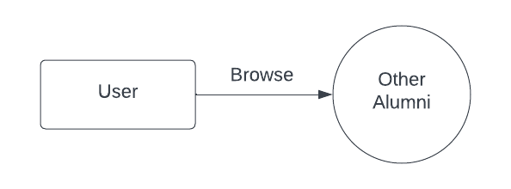

**2. Level 1 Diagram**

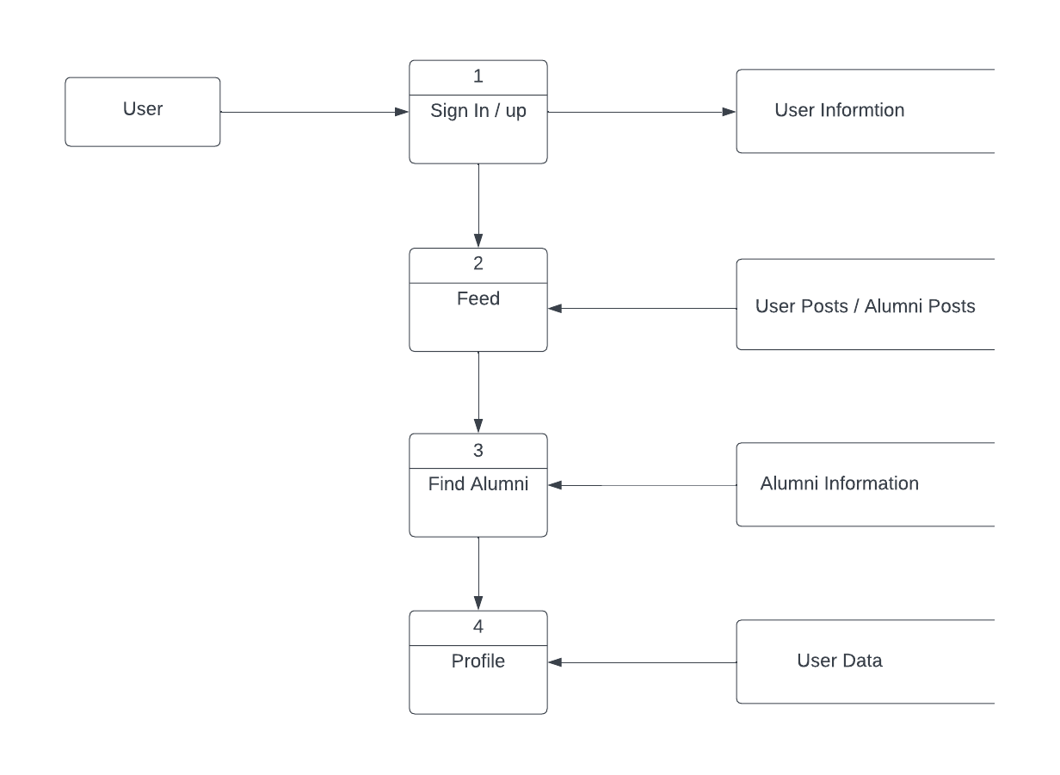

**3. Level 2 Diagram**

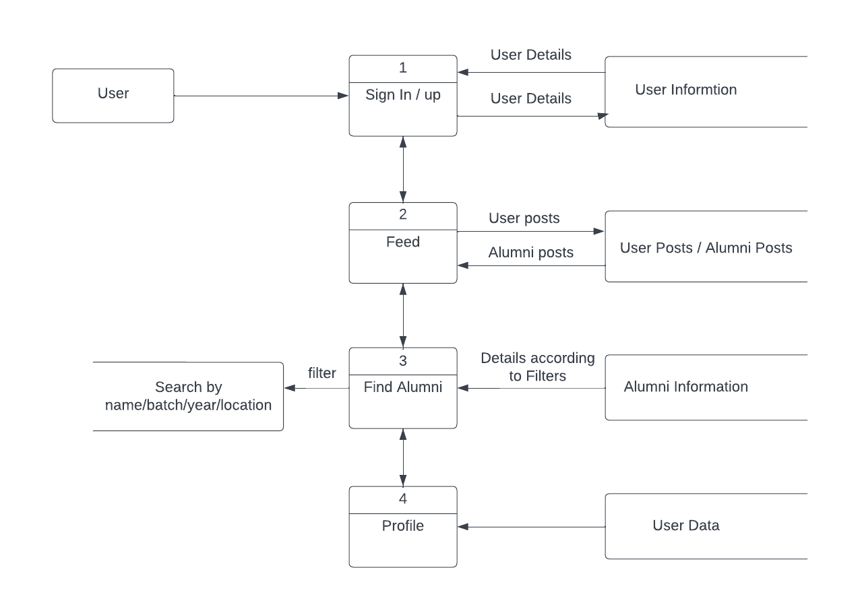

**8. E R Diagram and Database Tables**

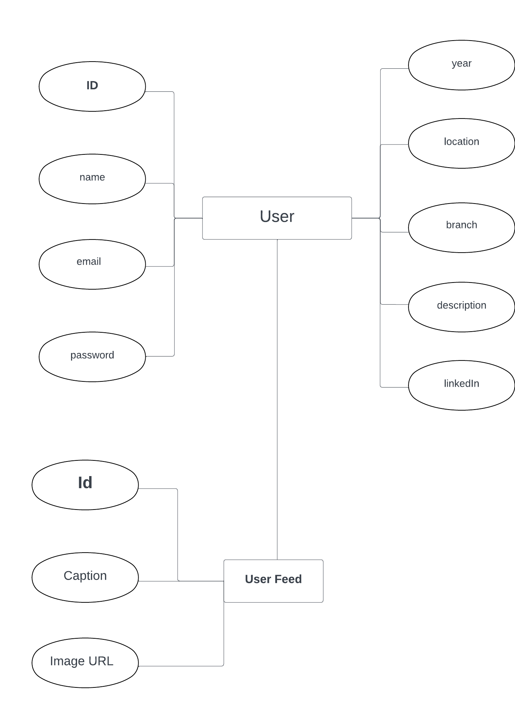

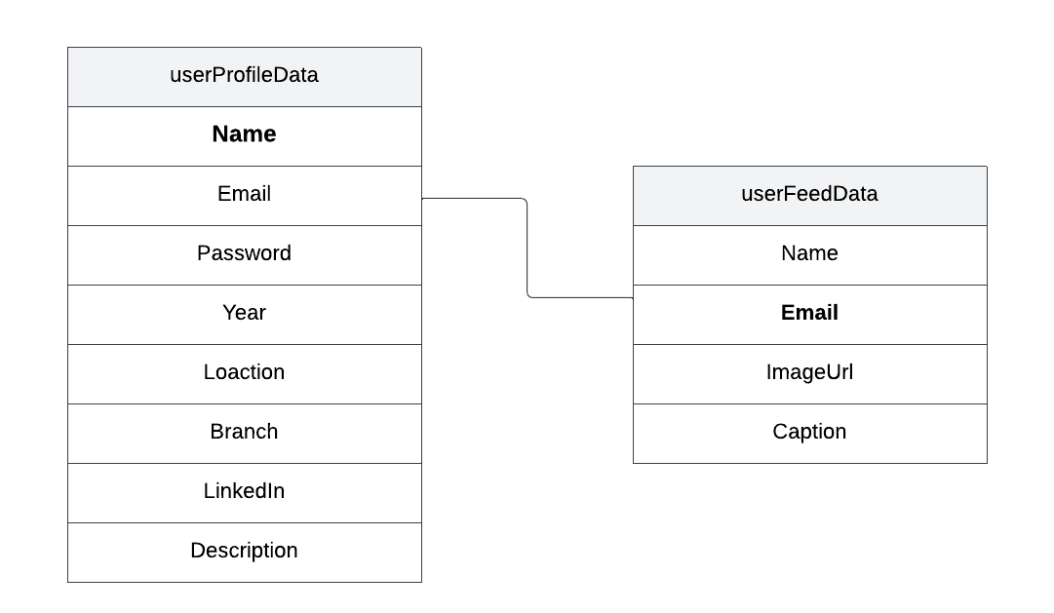

**9. Project Design (Screenshots)**

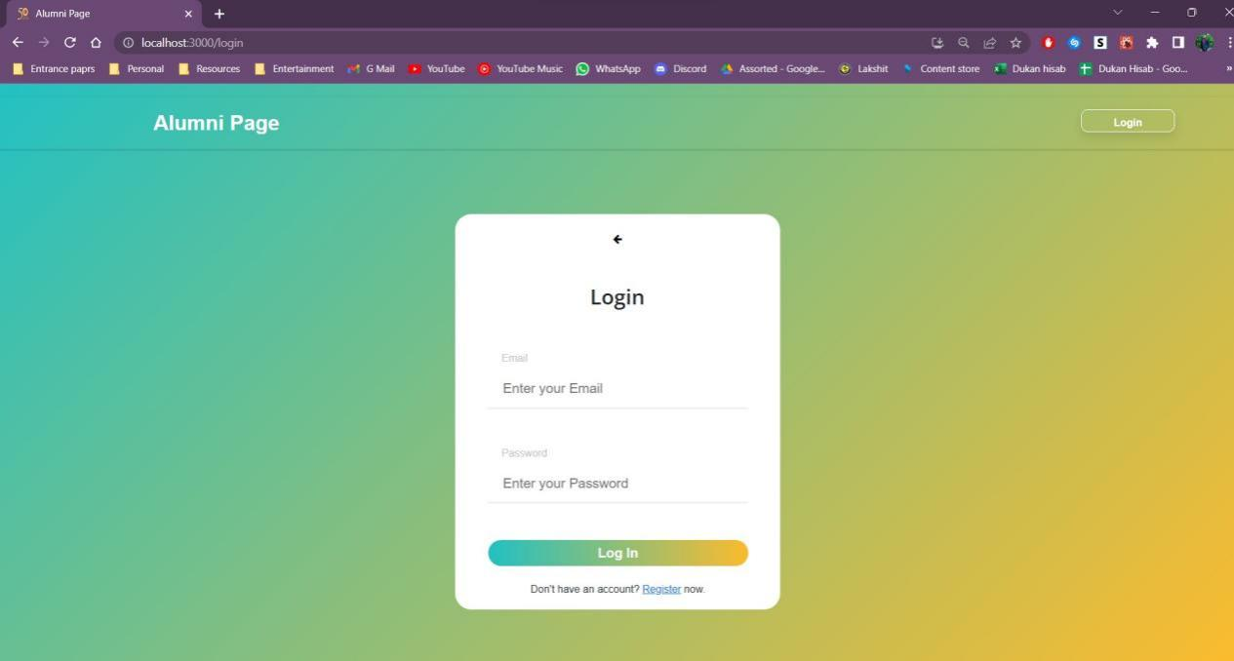

**Login Page**

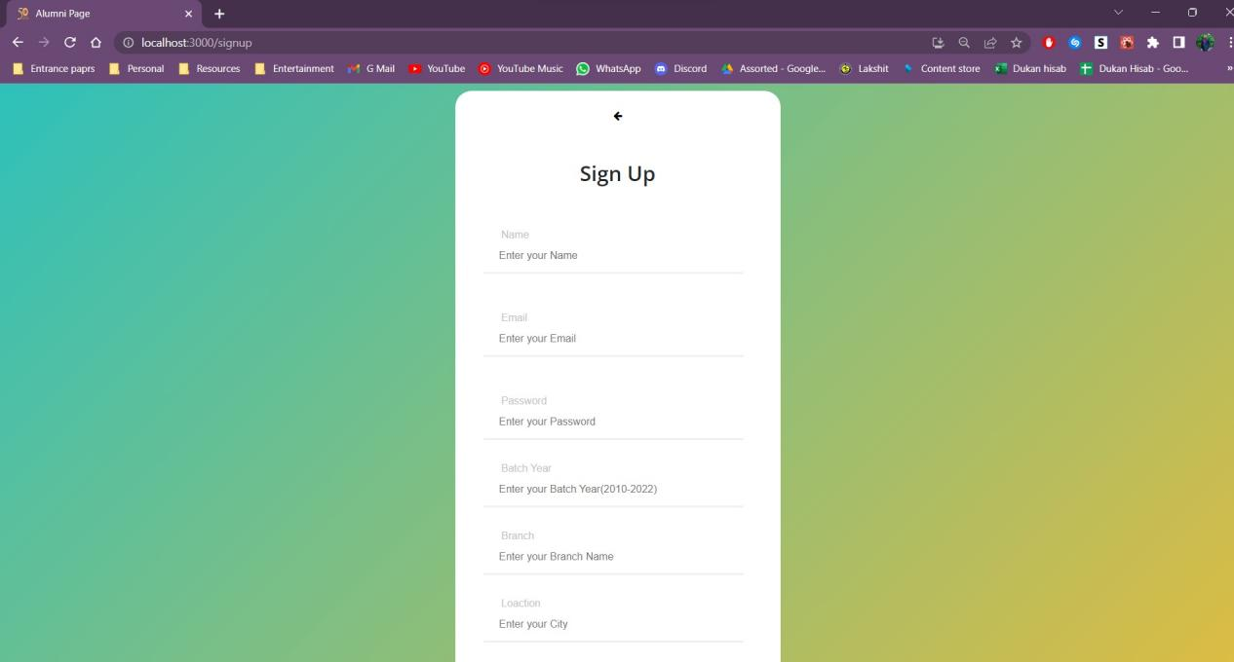

**Sign Up Page**

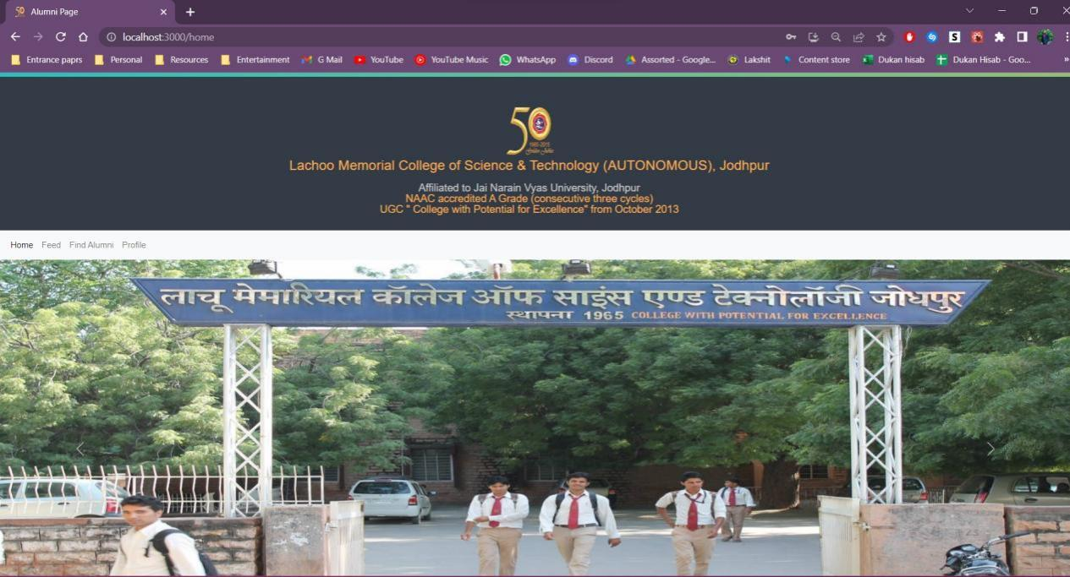

**Home Page**

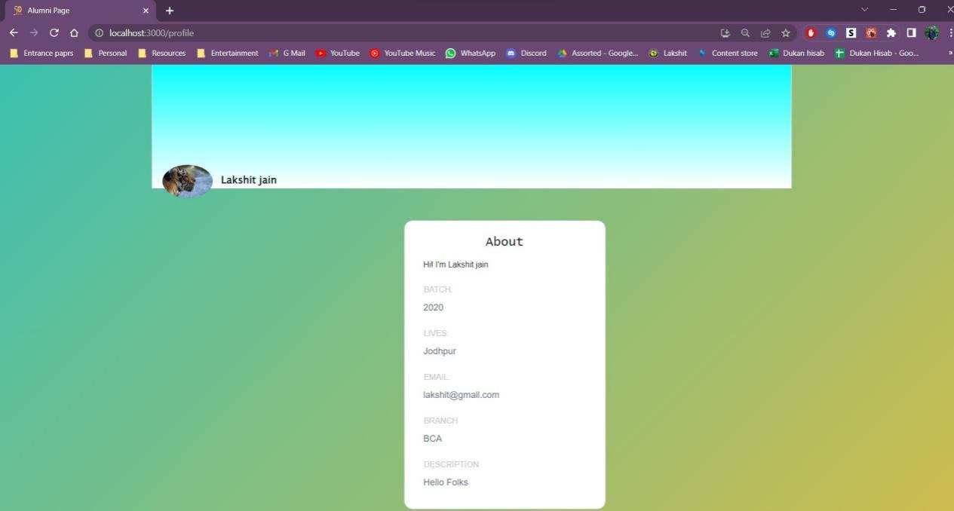

**Profile**

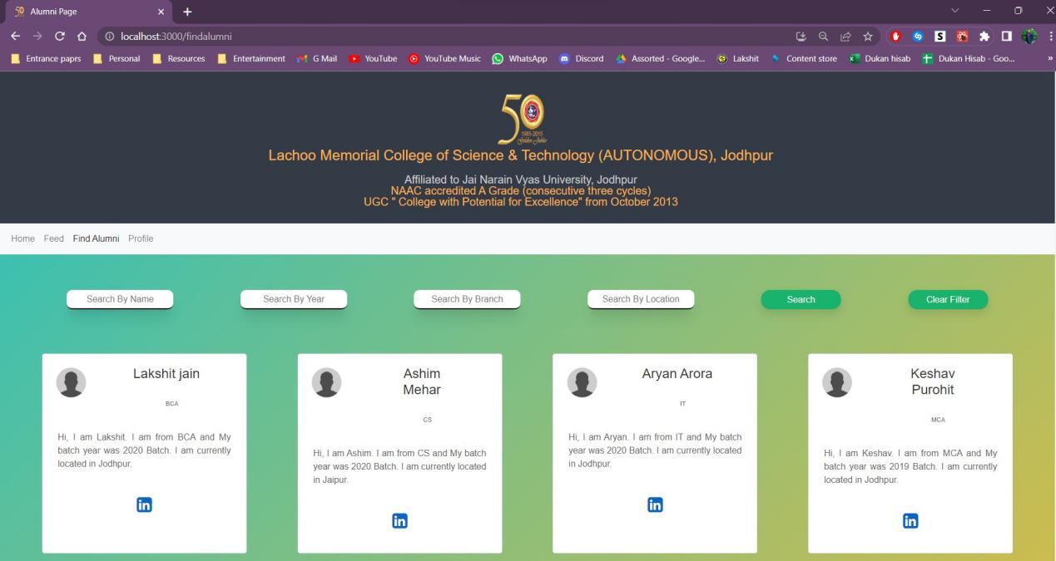

**Find Alumni**

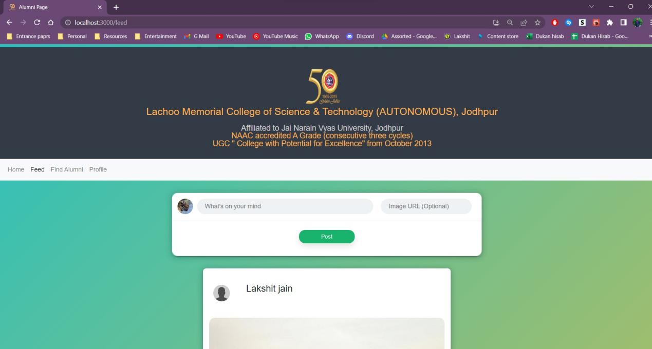

**Post Form**

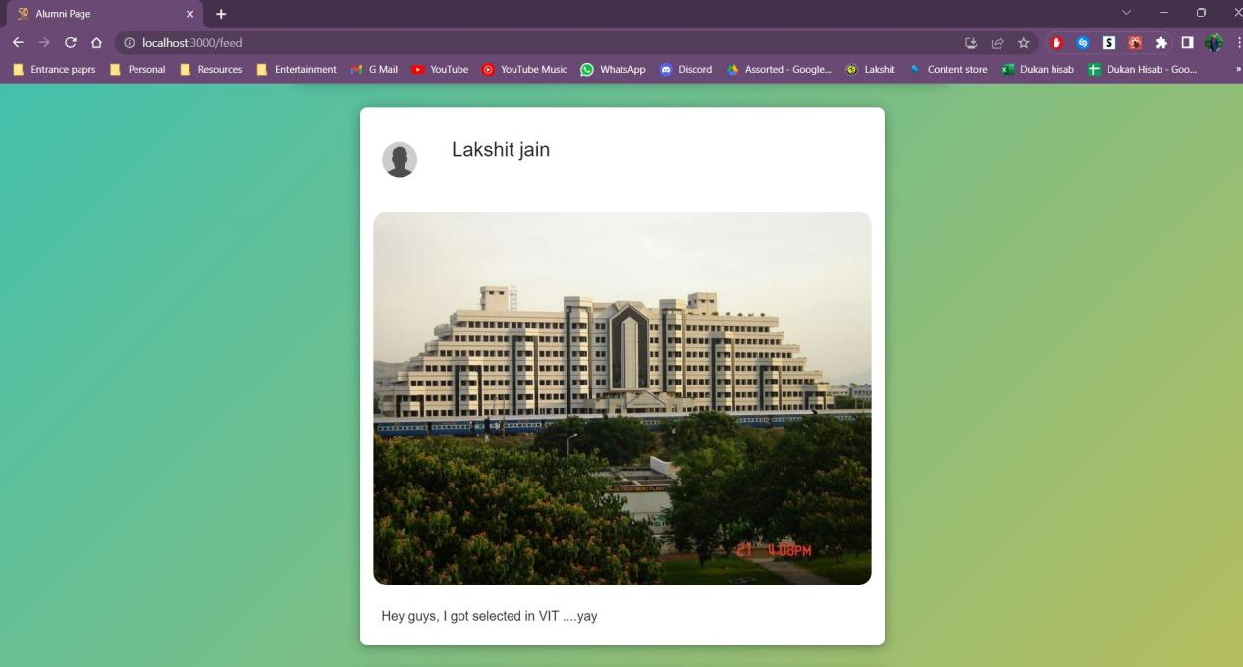

**Feed**

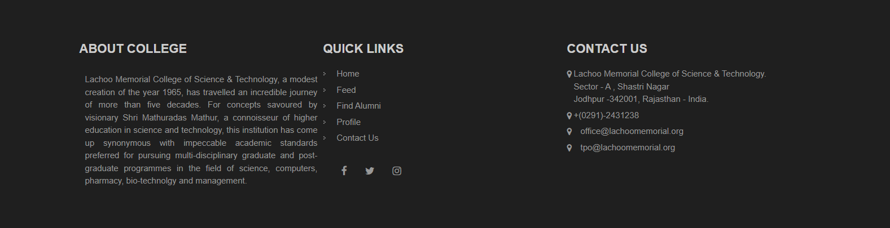

**Footer**

**10. Future Enhancements**

*To further enhance and expand the capabilities of your system, here are some future enhancements you can consider:*

**1. Mobile Application Development:**

*Consider developing a dedicated mobile application for iOS and Android platforms to provide a seamless user experience on mobile devices. Limitation: Mobile application development requires additional resources, including expertise in mobile development frameworks and potential costs for app store deployment and maintenance.*

**2.Integration with Additional Authentication Providers:**

*Expand the authentication options by integrating with more third-party providers such as LinkedIn, GitHub, or Twitter. This allows alumni to log in using their existing accounts and increases convenience. Limitation: The availability of third-party authentication providers may vary, and integrating with each provider requires additional development effort and maintenance.*

**3. Alumni Marketplace:**

*Create a marketplace feature where alumni can buy, sell, or exchange goods and services within the alumni community. This can foster business opportunities and strengthen the alumni network. Limitation: Implementing a marketplace introduces complexities such as transaction*

*management, user reviews, and ensuring trust and security within the platform.*

**4. Alumni Mentorship Network:**

*Enhance the mentorship program by introducing a comprehensive mentorship network where alumni can connect with mentors based on their specific career goals, industries, or interests. Limitation: The success of a mentorship network depends on the availability of mentors and their willingness to actively participate. Encouraging mentor engagement and addressing potential mismatches between mentors and mentees may require ongoing management.*

**5. Alumni Surveys and Feedback:**

*Implement a feedback mechanism where alumni can provide feedback, participate in surveys, or share their opinions on various topics related to the alumni community or the application itself. Limitation: Encouraging participation in surveys or feedback initiatives can be challenging. Alumni may have limited time or interest in providing feedback, requiring incentives or creative approaches to engage a significant portion of the community.*

**6. Enhanced Data Analytics:**

*Enhance the analytics capabilities by integrating advanced analytics tools or services to gain deeper insights into user behavior, engagement patterns, and application usage. Limitation: Advanced analytics tools*

*may come with additional costs, and integrating them requires expertise in data analysis and management. Consider the cost-benefit ratio when choosing and implementing analytics solutions.*

**7.Alumni Recognition and Awards:**

*Create a system to recognize and award outstanding alumni achievements in various fields such as entrepreneurship, leadership, philanthropy, or social impact. This can help showcase alumni accomplishments and inspire others. Limitation: Implementing a recognition system requires defining criteria, evaluating nominations, and managing the award process. Consider the resources needed to manage the recognition program effectively.*

**8. Social Integration and Sharing:**

*Integrate social media sharing features to allow alumni to share their achievements, events, or other relevant content from the application directly to their social media networks. Limitation: Social media integration may require compliance with platform-specific policies and user permissions, and it may also introduce additional complexities related to data privacy and security.*

**11. Conclusion**

*In conclusion, the development of the alumni application for Lachoo Memorial College of Science and Technology using ReactJS for the frontend and Firebase for the database and authentication has been a significant undertaking with promising outcomes. The application provides a powerful platform for graduates of Lachoo College to register, connect, and engage with fellow alumni, fostering a strong and supportive alumni network.*

*By leveraging ReactJS, the frontend of the application offers a modern and user-friendly interface, ensuring a seamless and intuitive experience for alumni. The use of Firebase as the backend infrastructure, including the database and authentication services, ensures secure and reliable data management, as well as streamlined user registration and login processes.*

*The application serves multiple purposes, facilitating networking opportunities among alumni, enabling job and internship postings, promoting alumni events and reunions, facilitating mentorship programs, and supporting fundraising efforts. These functionalities enhance the overall alumni experience and contribute to the growth and development of both individual alumni and the college community as a whole.*

*The alumni application not only connects graduates with their peers but also strengthens their ties with the college. It serves as a bridge between*

*alumni and their alma mater, providing regular updates on college news, achievements, and initiatives. Additionally, the application showcases the impact of alumni contributions and provides a convenient platform for alumni to contribute through donations and fundraising campaigns.*

*Overall, the alumni application holds great potential to create a vibrant and engaged alumni community for Lachoo Memorial College of Science and Technology. It empowers graduates to connect, collaborate, and support each other, fostering lifelong relationships and professional growth. The successful development and implementation of this application highlight your dedication, technical skills, and commitment to enhancing the alumni experience at Lachoo College.*

*With continuous updates and improvements, the alumni application has the potential to become an indispensable tool for both current and future alumni. It will serve as a testament to the value of creating digital platforms that bridge the gap between educational institutions and their graduates, promoting collaboration, knowledge sharing, and mutual support.*

*In conclusion, the development of this alumni application marks a significant achievement in leveraging technology to build a thriving alumni network for Lachoo Memorial College of Science and Technology. It paves the way for continued engagement, networking, and collaboration among alumni, contributing to the growth and success of both individuals and the institution as a whole.*

**12. References**

<https://stackoverflow.com/>  
<https://github.com/>

<https://www.figma.com/fr/>

<https://www.google.com/>

<https://www.youtube.com/>

<https://www.geeksforgeeks.org>

<https://www.w3schools.com/>

**13. Appendix**

**Technology Stack:**

**Frontend:** *React.js*

**Backend:** *Firebase (Authentication, Database)*

**Features of the Alumni Application:**

*User Registration and Authentication*

*User Profile Management*

*Alumni Networking*

*Alumni Resources*

*Secure Data Storage and Synchronization*

**Firebase Services Used:**

**Firebase Authentication:** *Used for user registration, login, and authentication.*

**Firebase Realtime Database:** *Used to store and retrieve alumni data, event information, news updates, and resources.*

**User Interface:**

*The user interface is designed using React.js components to provide a seamless and intuitive experience for alumni.*

*Material-UI or other UI frameworks may be utilized for styling and component libraries.*

**Data Flow:**

*User interactions and requests flow from the frontend components to the backend API, which processes and handles the requests.*

*User data, profiles, event registrations, and other relevant information are stored and retrieved from the Firebase Database.*

*Real-time data synchronization ensures consistency across the application.*

**Security Measures:**

*User authentication and access control are implemented using Firebase Authentication to ensure secure access to the application and protect user data.*

*Firebase security rules can be configured to restrict unauthorized access to specific data and functionalities.*

**Thank You**