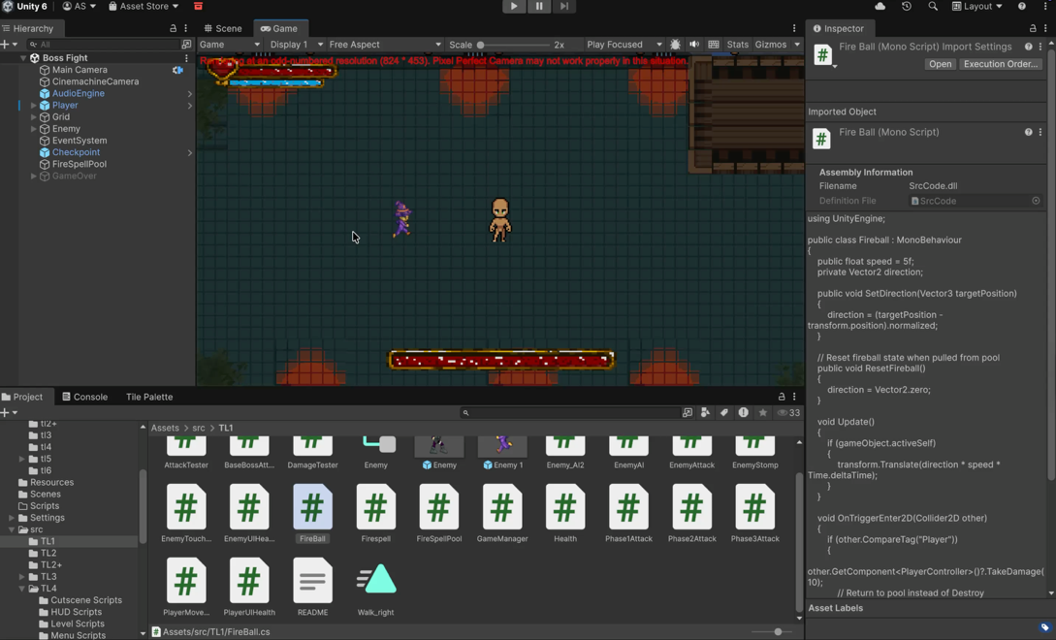
Fireball
Author: Asim Sapkota
Version: 1.0

Description:
This prefab represents a basic Fireball projectile in Unity. It is designed for enemy attacks and includes movement, collision detection, and object pooling support for optimized performance.
The Fireball travels toward a target direction, deals damage upon hitting the player.

Components

Fireball Script
Controls movement and interaction.
- Moves toward a target using a direction vector
- Adjustable speed
- Deals damage to objects tagged "Player"
- Returns to object pool on hit or when off-screen

Sprite Renderer
Displays the Fireball sprite.
- Assign sprite (FB000_0)
- Adjust sorting layer and order if needed

Rigidbody 2D
Used for collision handling.
- Body Type: Kinematic
- Gravity Scale: 0

Circle Collider 2D
Defines collision boundary.
- Is Trigger enabled
- Detects collision with Player

Setup Instructions
- Add the prefab to the scene or spawn via script
- Ensure components are properly configured
- Set direction using:
fireball.SetDirection(targetPosition);
- Player must have tag "Player" and a TakeDamage method
- Ensure object pooling system (FireballPool) is set up

Requirements
- Unity 2022.3 or later
- FireballPool system
- PlayerController script with damage handling

