Name Camden Mark _____________________/50
I’m having a fundamental problem understanding what is required of me. I sent an e-mail to Dr. B.C.

Brief introduction __/3
My feature is character control and interaction with the environment. Anything that happens internally within the character is my domain. Additionally, I am responsible for handling most player input and will interface with any external game objects, such as triggering traps when I step over them or activating noisy flooring.

Use case diagram with scenario __14
[Use the lecture notes in class.
Ensure you have at least one exception case, and that the <<extend>> matches up with the Exceptions in your scenario, and the Exception step matches your Basic Sequence step.
Also include an <<include>> that is a suitable candidate for dynamic binding]
Example:

Use Case Diagrams
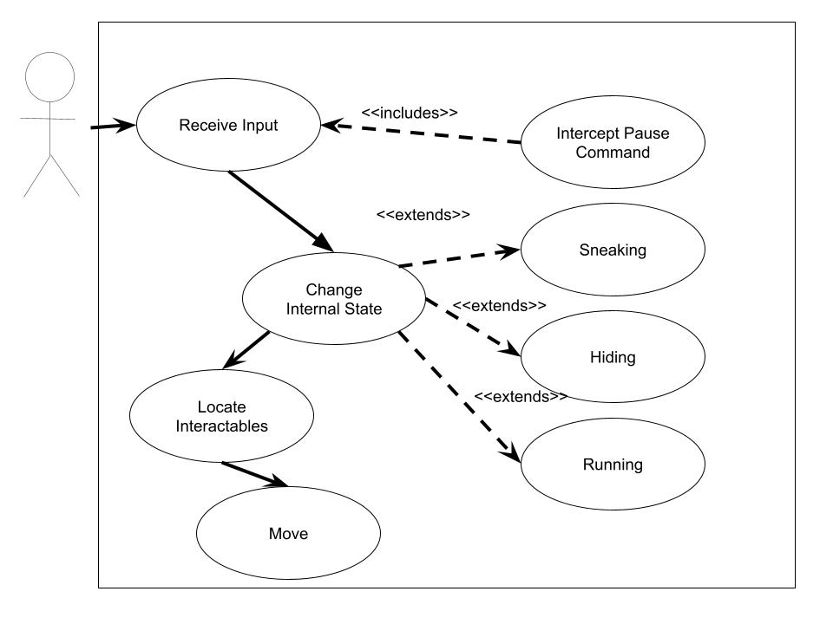

Scenarios
Name: Manage Character
Summary: The program processes input from the user and dynamically updates the internal state machine of the character
Actors: User.
Preconditions: Game has started, character loaded into level.
Basic sequence:
Step 1: Accept keyboard and mouse input
Step 2: Update internal state. (Sneaking, Hiding, Running)
Step 3: Find any interactables nearby the character and activate them.
Step 4: Move the character
Exceptions:
Step 1: Controls are disabled: Do nothing.
Step 2: Can’t change state due to external conditions: remain in current state.
Step 3: No interactables nearby: Do nothing.

Post conditions: Continuous until character unloaded.
Priority: 1*
ID: Ca01

*The priorities are 1 = must have, 2 = essential, 3 = nice to have.

Data Flow diagram(s) from Level 0 to process description for your feature _______/14
[Get the Level 0 from your team. Highlight the path to your feature]
Example:

Data Flow Diagrams

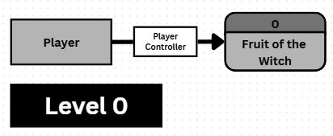
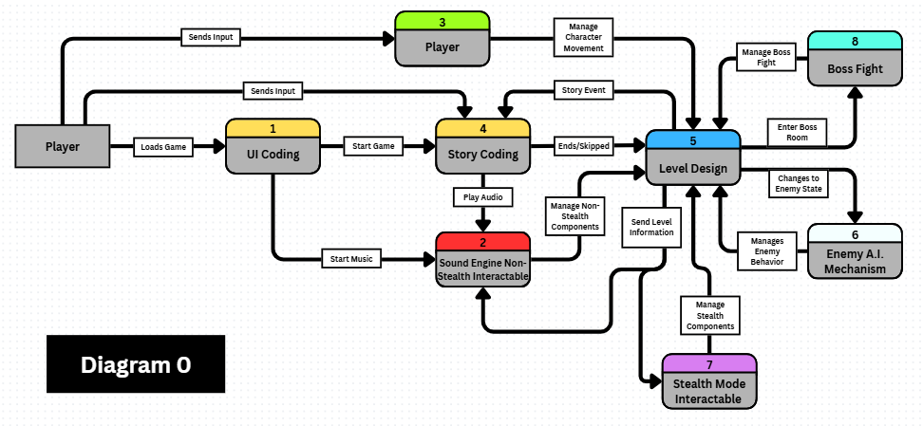
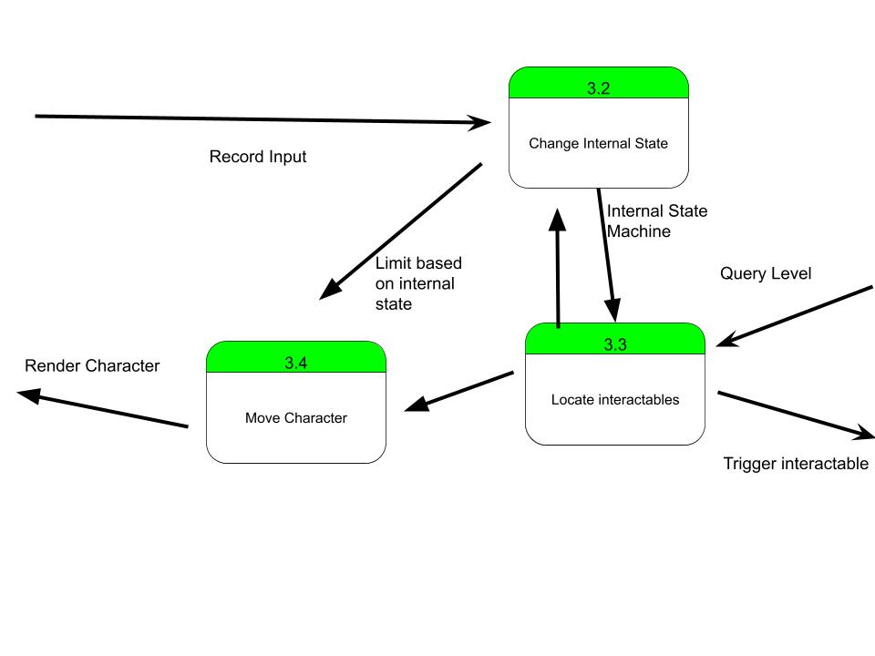

Process Descriptions
Change Internal State:

Current State | Conditions | New State
Normal/Sneak | Run Key Pressed | RUN
Run/Normal | Sneak Key Pressed | Sneak
Normal/Run/Sneak | Interacted with Hiding Spot | Hiding
Hiding | Interact Key pressed | Normal
Sneaking | Sneak Key Released | Normal
Running | Sneak Key Released | Normal

*Notes: Yours should be much longer. You could use a decision tree or decision table instead if it is more appropriate.

Acceptance Tests ________9
[Describe the inputs and outputs of the tests you will run. Ensure you cover all the boundary cases.]
Test for Input Commands
Run feature 1000 times sending output to a file.
The test will generate a series of fake inputs and calculate where the character should end up and what state it should be in. It will then send those inputs to the main character class and record where it ends up and what state it is in the file, and compare how different the results are.

Timeline _________/10
[Figure out the tasks required to complete your feature]
Example:

Work items
Task | Duration (Hours) | Predecessor Task(s)
1. Movement | 1 | -
2. Animation state machine | 2 | 6
3. Stealth Behavior | 2 | 2
4. Attack Behavior | 4 | 2
5. Assorted Powerups | 8 | 2
6. Internal State Machine | 3 | 3,4,5
7. Respawn system | 1 | 1
8. Art | 8 | -

Pert diagram
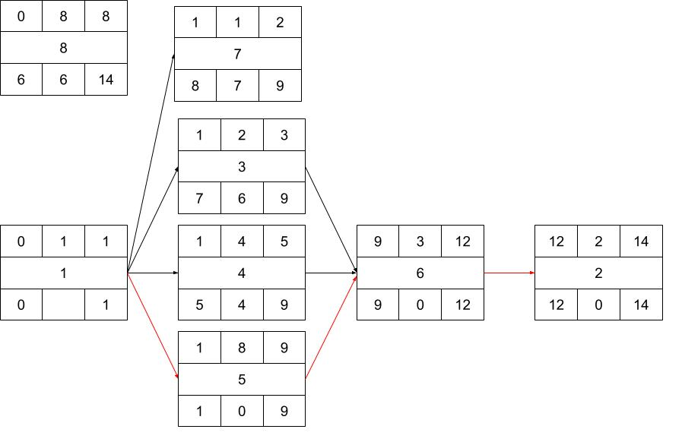

Gantt timeline
1
2
3
4
5
6
7
8
 | 0 | 1 | 2 | 3 | 4 | 5 | 6 | 7 | 8 | 9 | 10 | 11 | 12 | 13 | 14

