Table of Content

S.N. Title Page No.

1. Introduction 1
2. Objective 2
3. System Study 3
3.1 Existing System 3
3.2 Problem Identification 3
3.3 Methodology 3
4. System Analysis 4
4.1 Requirement Specification 4
4.2 Data Flow Diagram 4
4.3 Data Dictionary 5
4.4 Feasibility Analysis 6
5. System Design 7
5.1 Flowchart 7
5.2 Database 8
5.3 Back and Front End Tool 8
6. Program Source Code 9
7. User Manual Guide 14
8. Conclusion 18

1. Introduction

This is the project of Marksheet Management System, which is helpful for the college management to create mark sheet of different faculty as well as to keep records in systematic way. This project is applicable for any mark sheet management section of any college.
2. Objective

The basic objective of the project:
- To create a project using C-programming and its features.
- To implement features like control statement, structures and file handlings.
- To be familiar with resource reusability by making user defined function.
- To make the program easy while running it.
- To concise the memory of program as far as possible.
- To get an idea about making a simple project using C.
- To be able to solve problems by Compiling and Debugging.
- For the partial fulfilment of Computer Science education of BSc CSIT First Semester
- Replacement of current manual system by automated system,

3. System Study

The system is first studied to find whether there are problems or not. This initial investigation may also reveal that a new system is not required or not or the old one could be modified to handle the problem. If the detail investigation is recommended then we gather as many facts as possible about the current operating procedures and problems.

3.1 Existing System

Errors or problems in existing systems can trigger requests for systems projects. System errors must be corrected, but analysts often spend too much time reacting to day-to-day problems without looking at underlying causes. This approach can turn an information system into a patchwork of corrections and changes that cannot support the company's overall business needs.
The present situation of Mark sheet Management System of MBM College is manual. So if any quicker information is to be gained regarding any student then it may results in slow process. So, regarding this problem establishment of automatic marks sheet management is mostly required.

3.2 Problem Identification

The problems identified in the current system are:
-Order wise entry of Mark sheet Management System is difficult.
-Problem in updating and accessing data.

3.3 Methodology

Methodologies are the main method used in fact finding or information collection.
The number of methodology used for data collection are:
-We interviewed the members of mark sheet management section.
-We discussed with some of the faculty members.
4. System Analysis

A detailed problem analysis is undertaken to better understand the nature, scope, requirements and feasibility of the new system.

4.1 Requirement Specification

Software requirements specification contains the requirements for the new system describes the alternatives that were considered and makes a specific recommendation to management.
This system of “Mark sheet Management System” can work on computer from Pentium III to above having OS as Windows XP

4.2 Data Flow Diagram

Data flow diagram (DFD) is a method to illustrate how data flows in a system. DFD uses a number of symbols to represent systems. Most data flow modeling methods use four kinds of symbols to represent four kinds of system components: processes, data stores, data flows and external entities.

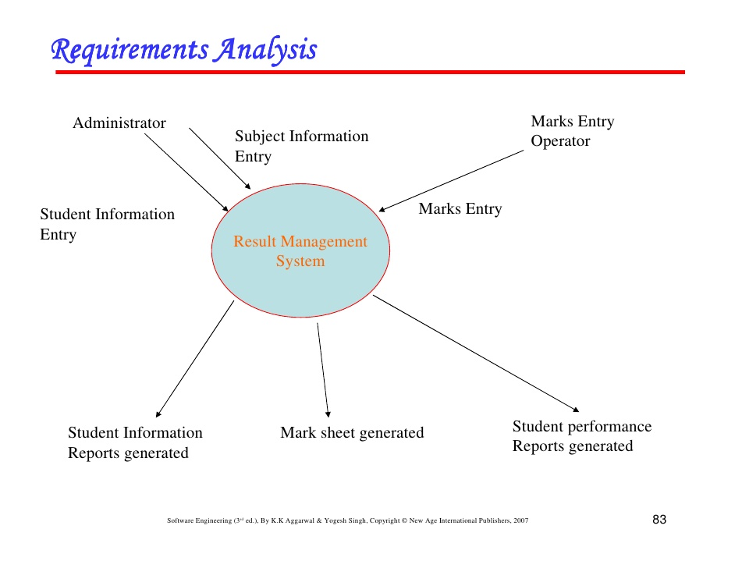

Data Flow Diagram

4.3 Data Dictionary

A relational database system needs to maintain information about the entities attributes and constraints applied on them. This information is called the data dictionary or system catalogue. Among many of information the system must store the following:
- Name of Entity
- Names of Attributes
- Domain of Attributes (value that may be assigned to that attributed e.g. Y/N)
- Integrity constraints of each attribute and relation such as Primary Key for an Entity

S.N. | Variable Name |  | Type
1 | a |  | Charater
2 | b |  | Character
3 | I |  | Integer
4 | n |  | Integer
5 | found | Integer
6 | recordno | Integer
7 | roll | Character
8 | level | Character
9 | spider | Character
10 | name | Character
11 | it | Float
12 | c | Float
13 | calculus | Float
14 | prob | Float
15 | stat | Float
16 | total | Float
17 | per | Float

4.4 Feasibility Analysis

In feasibility study for each solution it is checked whether it is practical to implement that solution. The outcome of feasibility study should answer: Is there an alternate way to do the job in a better way or what is recommended?

4.4.1 Technical Feasibility

In technical feasibility following points are taken into consideration:
Can the development of the proposed system be done with current equipment, existing software technology, and available personnel? Does it require new technology? Whether the required technology is available or not?

4.4.2 Economic Feasibility

In economic feasibility, cost benefit analysis is done in which expected costs and benefits are evaluated. The system is said to be economically feasible if the expected benefits equal or exceed the expected costs.

4.4.3 Operational Feasibility

Operational feasibility mainly concerned with issues like whether the system will be used if it is developed and implemented. Whether there will be resistance from users that will affect the possible application benefits. We have to consider some points as Does management support the project? Are the users not happy with current practices? Etc.

5. System Design
The system design defines the functions and features of the system and the relationships among its components. The logical design includes the output that must be produced by the system, the input needed by the system, and the processes that must be performed by the system without regard to how tasks will be accomplished physically.

5.1 Flow chart
Flowchart is a technique used to depict or show the logical structure of computer programs. Logical control structure correspond different techniques like sequence, condition and iteration which refers the way in which the instruction in a program flow. Flowchart is independent of the language or it is common to all. So flowchart will be same for all languages. With the help of flowchart one can easily understand the program. He/she may run it efficiently and debugging can be done very easily.

- Main view: -
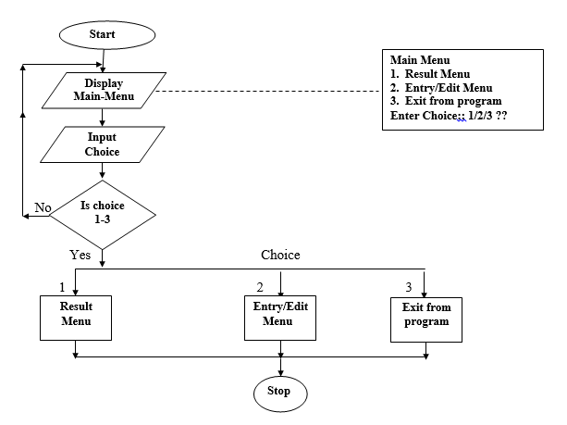

Flowchart diagram of Mark sheet Management System

- Detail View:-

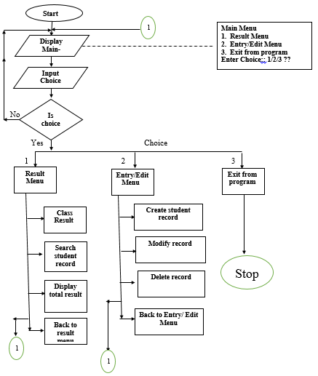

- Create record flowchart
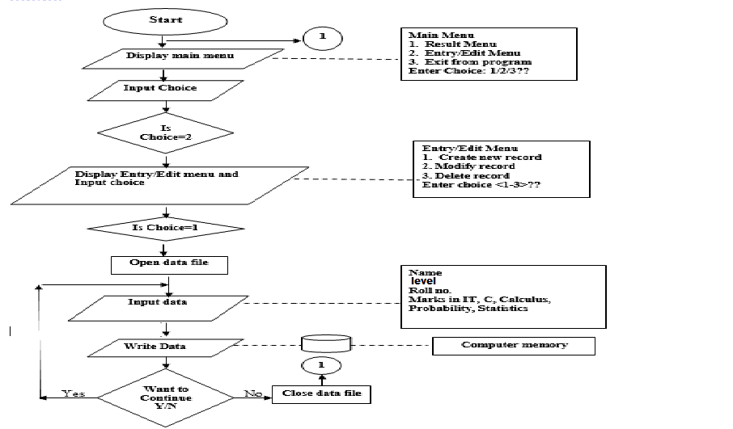

- Search record flowchart

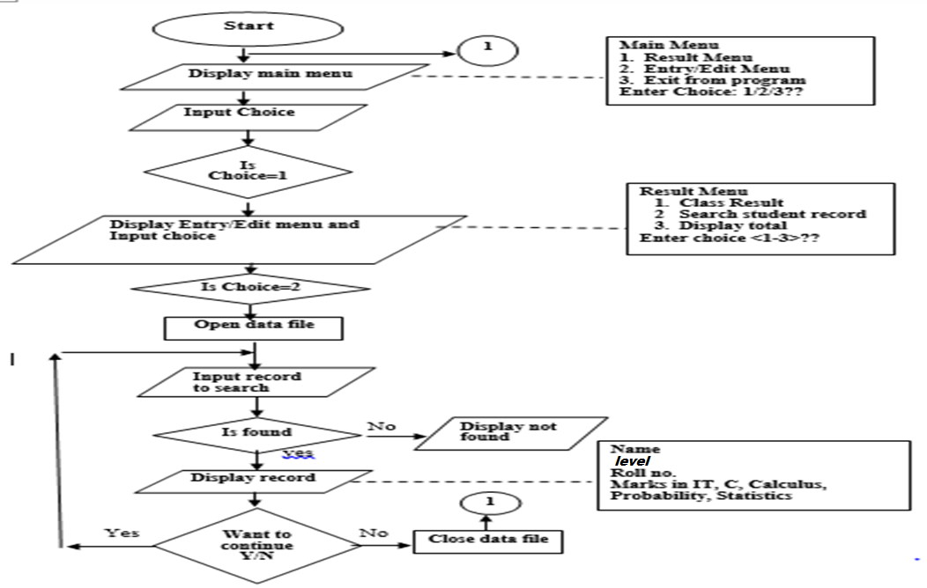

- Display record flowchart:

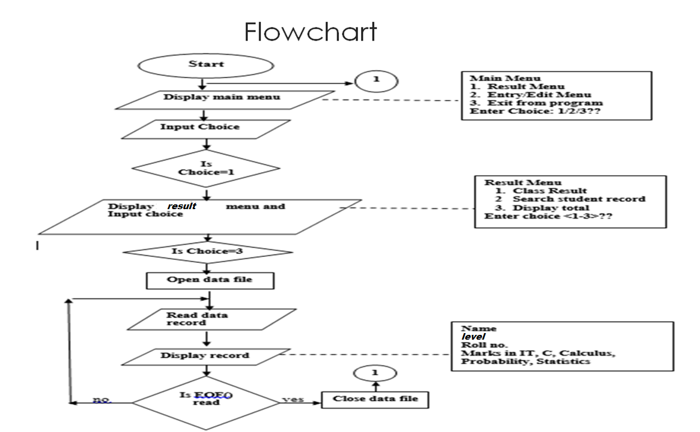

- Modify Student Record flowchart:

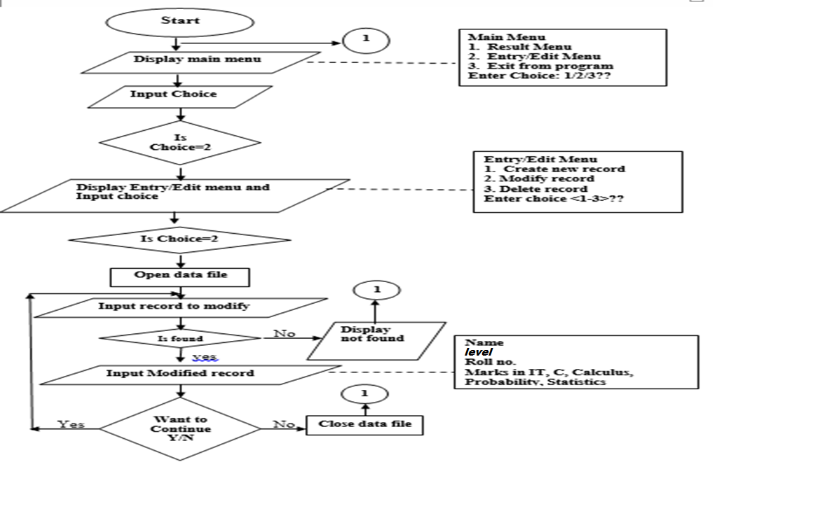

- Delete Student Record Flowchart:

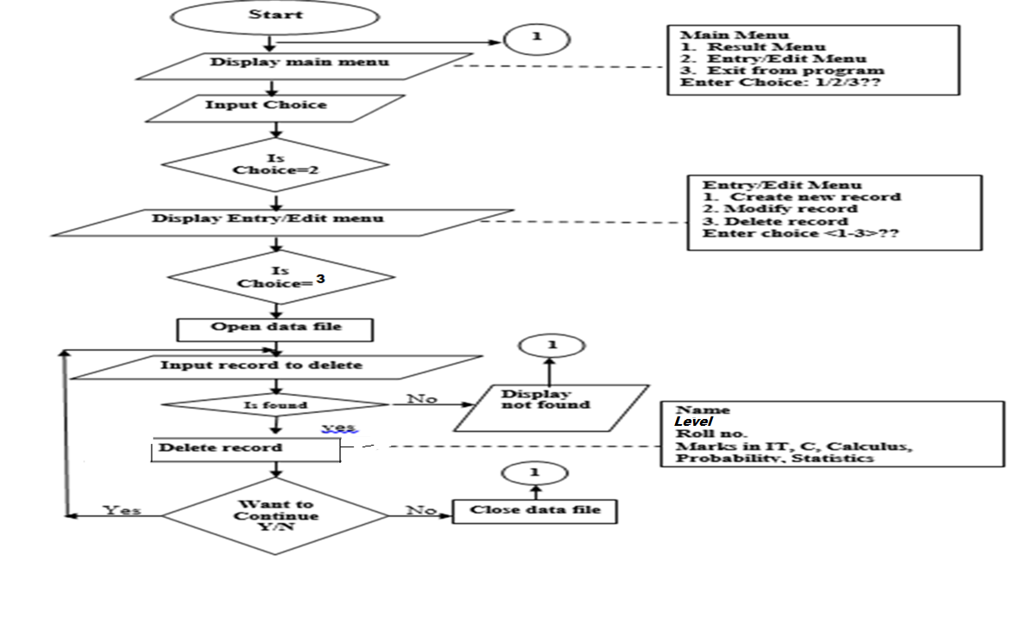

5.2 Database

A database contains a collection of related items or facts arranged in a specific structure. So database is a repository for collection of related data or facts. Database programs can also sort lists of data arranged them in alphabetical, numerical or chronological order.

Name Level Roll No. IT C Calculus Probab Stat Total Percent

5.3 Back and Front End Tool

As the front end the exe screen of the c Language is used and the data is stored in the notepad file so it becomes the back end of the system.
6. Program Source Code

#include<stdio.h>
#include<conio.h>
#include<string.h>
#include<graphics.h>
void starting();
void heading();
void design();
void menu();
void create();
void result();
void entry_edit();
void class_result();
void search();
void modify();
void display();
void removestd();
void close();
int gd,gm;
int i,n,choice,found=0,recordno=0;
char roll[10],level[50];
char a,b,spider;
FILE *superman,*temp;
struct student
{
char name[50];
char level[50];
char roll[20];
float it;
float c;
float calculus;
float prob;
float stat;
float total;
float per;
}std;
void main()
{
starting();
menu();
getch();
}
void menu()
{
clrscr();
heading();
design();
setcolor(MAGENTA);
settextstyle(7,0,3);
outtextxy(230,170,"MAIN MENU");
setcolor(YELLOW);
settextstyle(7,0,2);
outtextxy(150,230,"1. RESULT MENU");
outtextxy(150,260,"2. ENTRY/EDIT MENU");
outtextxy(150,290,"3. EXIT FROM PROGRAM");
setcolor(WHITE);
outtextxy(150,375,"Enter choice <1-3>. . .");
gotoxy(50,25);
scanf("%d",&i);
switch(i)
{
case 1 : result();
break;
case 2 : entry_edit();
break;
case 3 : close();
getch();
break;
default :
printf("Please try again ... ");
menu();

}

}
void result()
{
clrscr();
heading();
design();
setcolor(YELLOW);
settextstyle(7,0,3);
outtextxy(230,170,"RESULT MENU");
setcolor(BLUE);
settextstyle(7,0,2);
outtextxy(150,230,"1. CLASS RESULT");
outtextxy(150,260,"2. SEARCH STUDENT RESULT");
outtextxy(150,290,"3. DISPLAY TOTAL RESULT");
outtextxy(150,320,"4. BACK TO MENU");
setcolor(WHITE+BLINK);
outtextxy(150,375,"Enter choice <1-4>. . .");
gotoxy(50,25);
scanf("%d",&i);
switch(i)
{
case 1 : class_result();
break;
case 2 : search();
break;
case 3 : display();
break;
case 4 : menu();
break;

default :
printf("Please try again ... ");
getch();
menu();
break;

}
}

void entry_edit()
{
clrscr();
heading();
design();
setcolor(YELLOW);
settextstyle(7,0,3);
outtextxy(230,170,"ENTRY-EDIT MENU");
setcolor(BLUE);
settextstyle(7,0,2);
outtextxy(150,230,"1. CREATE");
outtextxy(150,260,"2. MODIFY");
outtextxy(150,290,"3. DELETE");
outtextxy(150,320,"4.BACK TO MENU");
setcolor(WHITE);
outtextxy(150,375,"Enter choice <1-4>. . .");
gotoxy(50,25);
scanf("%d",&choice);
switch(choice)
{
case 1 : create();
break;
case 2 : modify();
break;
case 3 : removestd();
break;
case 4 : menu();
break;

default :
printf("Please try again ... ");
getch();
menu();
break;

}

}
void class_result()
{
clrscr();
heading();
superman=fopen("student.txt","r+b");
if(superman==NULL)
{
gotoxy(1,16);
printf("File cannot be accessed");
}
else
{
fseek(superman,0,SEEK_SET);
setcolor(MAGENTA);
settextstyle(3,0,1);
outtextxy(225,175," Record by Class");
setcolor(RED);
settextstyle(4,0,4);
outtextxy(0,178,"------------------------------");
outtextxy(0,205,"------------------------------");
gotoxy(1,14);
printf("Name");
gotoxy(10,14);
printf("Level");
gotoxy(18,14);
printf("Roll No.");
gotoxy(29,14);
printf("IT");
gotoxy(34,14);
printf("C");
gotoxy(38,14);
printf("Calculus");
gotoxy(49,14);
printf("Probab");
gotoxy(59,14);
printf("Stat");
gotoxy(66,14);
printf("Total");
gotoxy(73,14);
printf("Perent");
setcolor(WHITE);
settextstyle(2,0,5);
outtextxy(100,144," Enter class :");
gotoxy(39,10);
gets(level);
fseek(superman,0,SEEK_SET);
while (fread(&std,sizeof(std),1,superman)==1)
{
if(strcmp(std.level,level)==0)
{
found=1;
break;
}
}
if(found==1)
{

i=16;
while(fread(&std,sizeof(std),1,superman)==1)
{

gotoxy(1,i);
printf("%s",std.name);
gotoxy(10,i);
printf("%s",std.level);
gotoxy(18,i);
printf("%s",std.roll);
gotoxy(29,i);
printf("%g",std.it);
gotoxy(34,i);
printf("%g",std.c);
gotoxy(38,i);
printf("%g",std.calculus);
gotoxy(49,i);
printf("%g",std.prob);
gotoxy(59,i);
printf("%g",std.stat);
gotoxy(66,i);
printf("%g",std.total);
gotoxy(73,i);
printf("%g",std.per);
i++;
}
}
else
{
gotoxy(20,23);
printf("class record not found !!! ");
}
gotoxy(20,25);
printf("Search Another class record (y/n) ?");
fflush(stdin);
spider=getche();
fflush(stdin);
if(spider =='y')
{
class_result();
}
else
{
menu();
}
}
}
void create()
{
clrscr();
heading();
design();
superman=fopen("Student.txt","r+b");
if(superman==NULL)
{
superman=fopen("student.txt","w+b");
if(superman==NULL)
{
printf("FIle cannot be created !!! \n");
exit();
}
}
fseek(superman,0,SEEK_END);
setcolor(MAGENTA);
settextstyle(4,0,4);
outtextxy(190,150,"--------------");
outtextxy(190,189,"--------------");
settextstyle(8,0,3);
setcolor(YELLOW);
outtextxy(225,177,"ADD NEW RECORD");
gotoxy(10,17);
printf("Enter the name : ");
scanf("%s",std.name);
gotoxy(10,18);
printf("Enter the level : ");
scanf("%s",std.level);
gotoxy(10,19);
printf("Enter the roll no. : ");
scanf("%s",std.roll);
gotoxy(10,20);
printf("Enter Marks in IT : ");
scanf("%g",&std.it);
gotoxy(10,21);
printf("Enter Marks in C : ");
scanf("%g",&std.c);
gotoxy(10,22);
printf("Enter Marks in Calculus : ");
scanf("%g",&std.calculus);
gotoxy(10,23);
printf("Enter Marks in probability and statistics : ");
scanf("%g",&std.prob);
gotoxy(10,24);
printf("Enter Marks in Statistics-I : ");
scanf("%g",&std.stat);
std.total = (std.it+std.c+std.calculus+std.prob+std.stat);
std.per= std.total/5;
fwrite(&std,sizeof(std),1,superman);
fflush(stdin);
settextstyle(2,0,6);
setcolor(YELLOW);
outtextxy(90,400,"Add more record (y/n) ? ");
fflush(stdin);
a=getche();

if(a=='y')
{

create();
}
else
{
menu();
}

}
void display()
{
clrscr();
heading();
superman=fopen("student.txt","r+b");
if(superman==NULL)
{ gotoxy(1,15);
printf("File cannot be accessed");
}

fseek(superman,0,SEEK_SET);
setcolor(RED);
settextstyle(4,0,4);
outtextxy(0,161,"------------------------------");
outtextxy(0,187,"------------------------------");
setcolor(MAGENTA);
settextstyle(3,0,2);
outtextxy(225,144," Students Record");
gotoxy(1,13);
printf("Name");
gotoxy(10,13);
printf("Level");
gotoxy(18,13);
printf("Roll No.");
gotoxy(29,13);
printf("IT");
gotoxy(34,13);
printf("C");
gotoxy(38,13);
printf("Calculus");
gotoxy(49,13);
printf("Probab");
gotoxy(59,13);
printf("Stat");
gotoxy(66,13);
printf("Total");
gotoxy(73,13);
printf("Perent");
i=15;
while(fread(&std,sizeof(std),1,superman)==1)
{
gotoxy(1,i);
printf("%s",std.name);
gotoxy(12,i);
printf("%s",std.level);
gotoxy(20,i);
printf("%s",std.roll);
gotoxy(30,i);
printf("%g",std.it);
gotoxy(34,i);
printf("%g",std.c);
gotoxy(41,i);
printf("%g",std.calculus);
gotoxy(51,i);
printf("%g",std.prob);
gotoxy(60,i);
printf("%g",std.stat);
gotoxy(67,i);
printf("%g",std.total);
gotoxy(74,i);
printf("%g",std.per);
i++;

}
getch();
menu();

}
void search()
{
clrscr();
heading();
superman=fopen("student.txt","rb+");
if(superman==NULL)
{
gotoxy(1,16);
printf("File cannot be accessed");
}
else
{
fseek(superman,0,SEEK_SET);
setcolor(MAGENTA);
settextstyle(3,0,1);
outtextxy(225,175," Students Record");
setcolor(RED);
settextstyle(4,0,4);
outtextxy(0,178,"------------------------------");
outtextxy(0,205,"------------------------------");
gotoxy(1,14);
printf("Name");
gotoxy(10,14);
printf("Level");
gotoxy(18,14);
printf("Roll No.");
gotoxy(29,14);
printf("IT");
gotoxy(34,14);
printf("C");
gotoxy(38,14);
printf("Calculus");
gotoxy(49,14);
printf("Probab");
gotoxy(59,14);
printf("Stat");
gotoxy(66,14);
printf("Total");
gotoxy(73,14);
printf("Perent");
setcolor(WHITE);
settextstyle(2,0,5);
outtextxy(100,144," Enter Student's roll no. :");
gotoxy(39,10);
gets(roll);
fseek(superman,0,SEEK_SET);
while (fread(&std,sizeof(std),1,superman)==1)
{
if(strcmp(std.roll,roll)==0)
{
found=1;
break;
}
}
if(found==1)
{

i=16;
while(fread(&std,sizeof(std),1,superman)==1)
{
gotoxy(1,i);
printf("%s",std.name);
gotoxy(12,i);
printf("%s",std.level);
gotoxy(20,i);
printf("%s",std.roll);
gotoxy(30,i);
printf("%g",std.it);
gotoxy(34,i);
printf("%g",std.c);
gotoxy(41,i);
printf("%g",std.calculus);
gotoxy(51,i);
printf("%g",std.prob);
gotoxy(60,i);
printf("%g",std.stat);
gotoxy(67,i);
printf("%g",std.total);
gotoxy(74,i);
printf("%g",std.per);
i++;
}
}
else
{
gotoxy(20,23);
printf("Student record not found !!! ");
}
gotoxy(20,25);
printf("Search Another student record (y/n) ?");
fflush(stdin);
spider=getche();
fflush(stdin);
if(spider =='y')
{
search();
}
else
{
menu();
}
}
}
void modify()
{
clrscr();
heading();
design();
superman=fopen("student.txt","rb+");
if(superman==NULL)
{
gotoxy(10,15);
printf("File cannot be accessed");
}
else
{
fseek(superman,0,SEEK_SET);
rewind(superman);
settextstyle(8,0,3);
setcolor(YELLOW);
outtextxy(175,180,"MODIFY STUDENT RECORD");
setcolor(MAGENTA);
settextstyle(4,0,4);
outtextxy(140,160,"------------------");
outtextxy(140,190,"------------------");
gotoxy(9,15);
printf("Enter the student roll no. : ");
gets(roll);
while(fread(&std,sizeof(std),1,superman)==1)
{
if(strcmp(std.roll,roll)==0)
{
found=1;
break;
}
recordno++;
}
if(found==1)
{
gotoxy(9,16);
printf("Old record is ");
gotoxy(9,18);
printf("Name : ");
printf("%s",std.name);
gotoxy(9,19);
printf("Level : ");
printf("%s",std.level);
gotoxy(9,20);
printf("Roll No. : ");
printf("%s",std.roll);
gotoxy(9,21);
printf("IT : ");
printf("%g",std.it);
gotoxy(9,22);
printf("C : ");
printf("%g",std.c);
gotoxy(9,23);
printf("Calculus : ");
printf("%g",std.calculus);
gotoxy(9,24);
printf("Probab : ");
printf("%g",std.prob);
gotoxy(9,25);
printf("Stat : ");
printf("%g",std.stat);
gotoxy(9,26);
printf("Total : ");
printf("%g",std.total);
gotoxy(9,27);
printf("Perent : ");
printf("%g",std.per);
gotoxy(45,16);
printf("Enter new information");
gotoxy(45,18);
printf("Name : ");
gets(std.name);
gotoxy(45,19);
printf("Level : ");
gets(std.level);
gotoxy(45,20);
printf("Roll No. : ");
gets(std.roll);
gotoxy(45,21);
printf("IT : ");
scanf("%g",&std.it);
gotoxy(45,22);
printf("C : ");
scanf("%g",&std.c);
gotoxy(45,23);
printf("Calculus : ");
scanf("%g",&std.calculus);
gotoxy(45,24);
printf("Probab : ");
scanf("%g",&std.prob);
gotoxy(45,25);
printf("Stat : ");
scanf("%g",&std.stat);
gotoxy(45,26);
printf("Total : ");
printf("%g",std.total);
gotoxy(45,27);
printf("Perent : ");
printf("%g",std.per);
fseek(superman,sizeof(std)*(recordno),SEEK_SET);
if(fwrite(&std,sizeof(std),1,superman)==1)
{
setcolor(WHITE);
settextstyle(4,0,3);
outtextxy(170,410,"The record has been modified !!!!!");
}

else
{
printf("Error during modification !!!!!");
}

}
else
{
settextstyle(7,0,2);
setcolor(WHITE);
outtextxy(170,410,"Student Record not found !!!");
}
settextstyle(7,0,2);
setcolor(WHITE);
outtextxy(170,440,"Modify another record (y/n) ? ");
fflush(stdin);
gotoxy(15,28);
scanf("%c",&spider);
fflush(stdin);
if(spider=='y')
{
modify();
}
else
{
menu();
}
}
}
void removestd()
{
clrscr();
heading();
design();
superman=fopen("student.txt","rb+");
if(superman==NULL)
{
gotoxy(10,15);
printf("File cannot be accessed");
}
else
{
fseek(superman,0,SEEK_SET);
rewind(superman);
settextstyle(8,0,3);
setcolor(YELLOW);
outtextxy(175,180,"DELETE STUDENT RECORD");
setcolor(MAGENTA);
settextstyle(4,0,4);
outtextxy(147,160,"------------------");
outtextxy(147,189,"------------------");
gotoxy(9,15);
printf("Enter the student roll no. : ");
gets(roll);
while(fread(&std,sizeof(std),1,superman)==1)
{
if(strcmp(std.roll,roll)==0)
{
found=1;
break;
}
recordno++;
}
if(found==1)
{
gotoxy(9,16);
printf("Old record is ");
gotoxy(9,17);
printf("Name : ");
printf("%s",std.name);
gotoxy(9,18);
printf("Level : ");
printf("%s",std.level);
gotoxy(9,19);
printf("Roll No. : ");
printf("%s",std.roll);
gotoxy(9,20);
printf("IT : ");
printf("%g",std.it);
gotoxy(9,21);
printf("C : ");
printf("%g",std.c);
gotoxy(9,22);
printf("Calculus : ");
printf("%g",std.calculus);
gotoxy(9,23);
printf("Probab : ");
printf("%g",std.prob);
gotoxy(9,24);
printf("Stat : ");
printf("%g",std.stat);
gotoxy(9,25);
printf("Total : ");
printf("%g",std.total);
gotoxy(9,26);
printf("Perent : ");
printf("%g",std.per);
gotoxy(35,19);
printf("Are you sure to delete (y/n) ? ");
b=getche();
if( b=='y')
{

temp=fopen("tempstudent.txt","wb+");
rewind(superman);
while(fread(&std,sizeof(std),1,superman)==1)
{
if(strcmp(std.roll,roll)!=0)
fwrite(&std,sizeof(std),1,temp);
}
fclose(superman);
fclose(temp);
remove("student.txt");
rename("tempstudent.txt","student.txt");
superman=fopen("student.txt","rb+");
gotoxy(35,21);
printf("SUCESSFULLY DELETED !!!!!!");
}
}
else
{
gotoxy(27,25);

printf("Student Record not found !!!");
}
setcolor(WHITE);
settextstyle(2,0,5);
outtextxy(225,450,"DELETE ANOTHER RECORD (y/n) ?");
fflush(stdin);
spider=getche();
fflush(stdin);
if(spider=='y')
{
removestd();
}
else
{
fclose(superman);
menu();
}
}
}
void close()
{
clrscr();
settextstyle(4,0,8);
setcolor(GREEN);
outtextxy(150,10,"FINALLY");
settextstyle(7,0,2);
setcolor(YELLOW);
outtextxy(0,110,"Thank you very much for accessing our small project");
outtextxy(120,140,"related to a useful small program. ");
setcolor(RED);
outtextxy(90,170,"MARKSHEET MANAGEMENT SYSTEM.");
setcolor(YELLOW);
outtextxy(0,200,"This task provided by MBM college will be very useful for");
outtextxy(3,230,"our upcoming career. This project would be incomplete if ");
outtextxy(40,260,"there was no extreme help from our respected sir. ");
setcolor(MAGENTA);
outtextxy(170,290,"Mr.Ashim Lamichhane.");
setcolor(YELLOW);
outtextxy(0,320,"So we want to grant unexplainable thank to him. As well");
outtextxy(0,350,"as we want to thank whole IT department of MBM college ");
outtextxy(0,380,"for providing a wonderful platform and helping us in");
outtextxy(0,410,"each and every steps towards the upliftment of our career. ");
getch();
}
void starting ()
{
gd=DETECT;
initgraph(&gd,&gm,"C:\\TC\\BGI");
setcolor(RED);
settextstyle(4,0,7);
outtextxy(200,10,"Welcome");
outtextxy(250,70,"To");
outtextxy(1,120,"Marksheet Management");
setcolor(YELLOW);
settextstyle(5,0,4);
outtextxy(100,200,"Prepared by :- ");
setcolor(GREEN);
outtextxy(100,250,"1. Shishir Shrestha ");
outtextxy(100,275,"2. Aashish Shrestha ");
outtextxy(100,300,"3. Rajesh Kafle ");
outtextxy(100,325,"4. Rojina Dhakal ");
setcolor(BLUE);
settextstyle(4,0,4);
outtextxy(100,375,"Date: 2073/01/15 ");
settextstyle(8,0,2);
setcolor(WHITE);
outtextxy(100,425,"Press any key to continue... ");
getch();
}
void heading ()
{
gd=DETECT;
initgraph(&gd,&gm,"C:\\TC\\BGI");
setcolor(GREEN);
settextstyle(4,0,3);
outtextxy(65,25,"MADAN BHANDARI MEMORIAL COLLEGE");
settextstyle(1,0,1);
outtextxy(200,50,"Binayaknagar,Kathmandu");
settextstyle(1,0,2);
outtextxy(260,70,"2011 A.D");
setcolor(BLUE);
settextstyle(4,0,4);
outtextxy(105,90,"Marksheet Management System");
}
void design()
{
gd=DETECT;
initgraph(&gd,&gm,"C:\\TC\\BGI");
clrscr();
heading();
setcolor(RED);
settextstyle(4,1,4);
outtextxy(25,150,"***********************");
settextstyle(4,0,4);
outtextxy(60,130,"****************************************");
settextstyle(4,1,4);
outtextxy(560,150,"***********************");
settextstyle(4,0,4);
outtextxy(57,417,"****************************************");

}

7. User Manual Guide

- Welcome phase of program
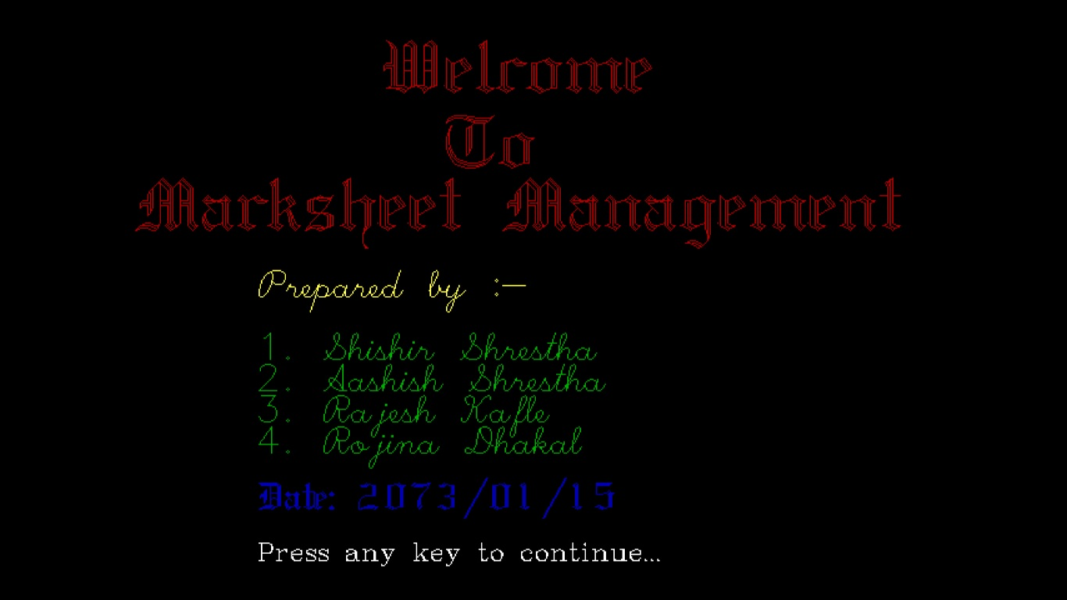
This is a welcome page of our project on Mark sheet Management System.

- Main menu phase of program
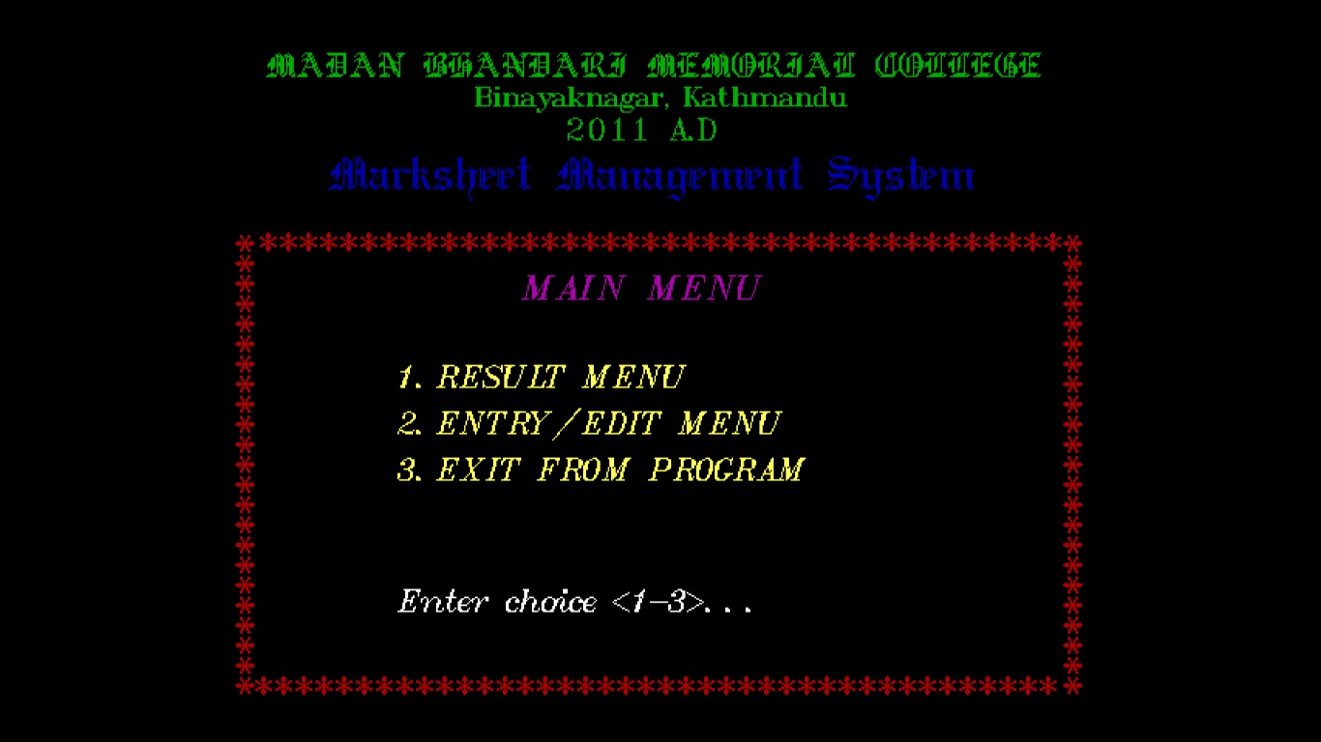

This is the 2nd phase of our project in this phase we will view the menu and the option to be carried out.

- Result menu phase of program
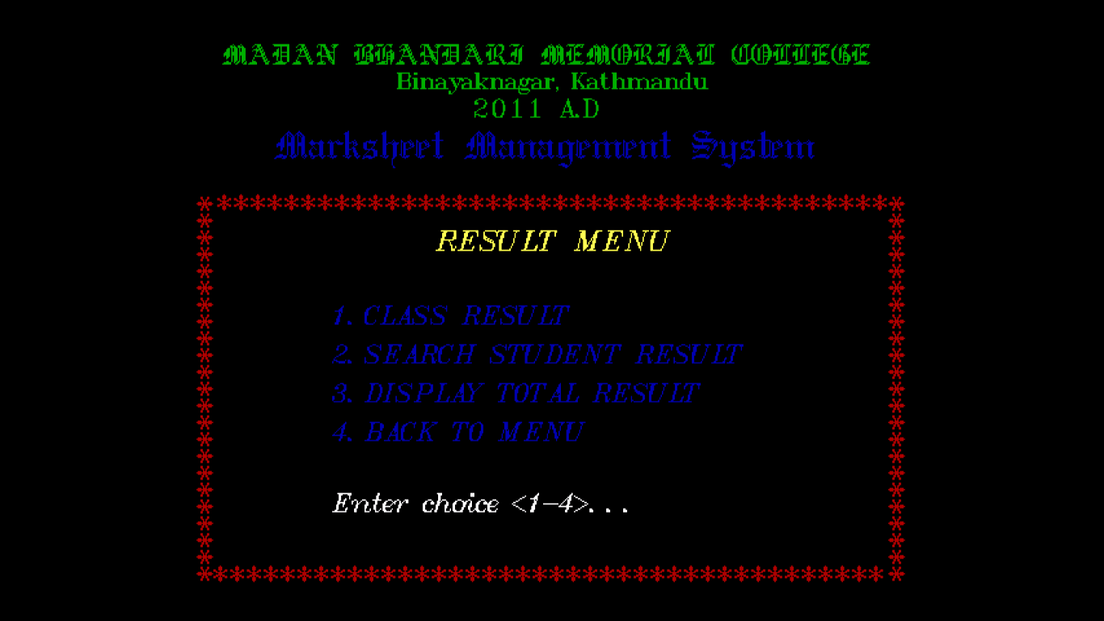
This is the 3rd phase of our project which contain result menu derived from main menu here we can view result by class, search specific student record via roll no. , view overall records.

- Entry-Edit menu phase of program

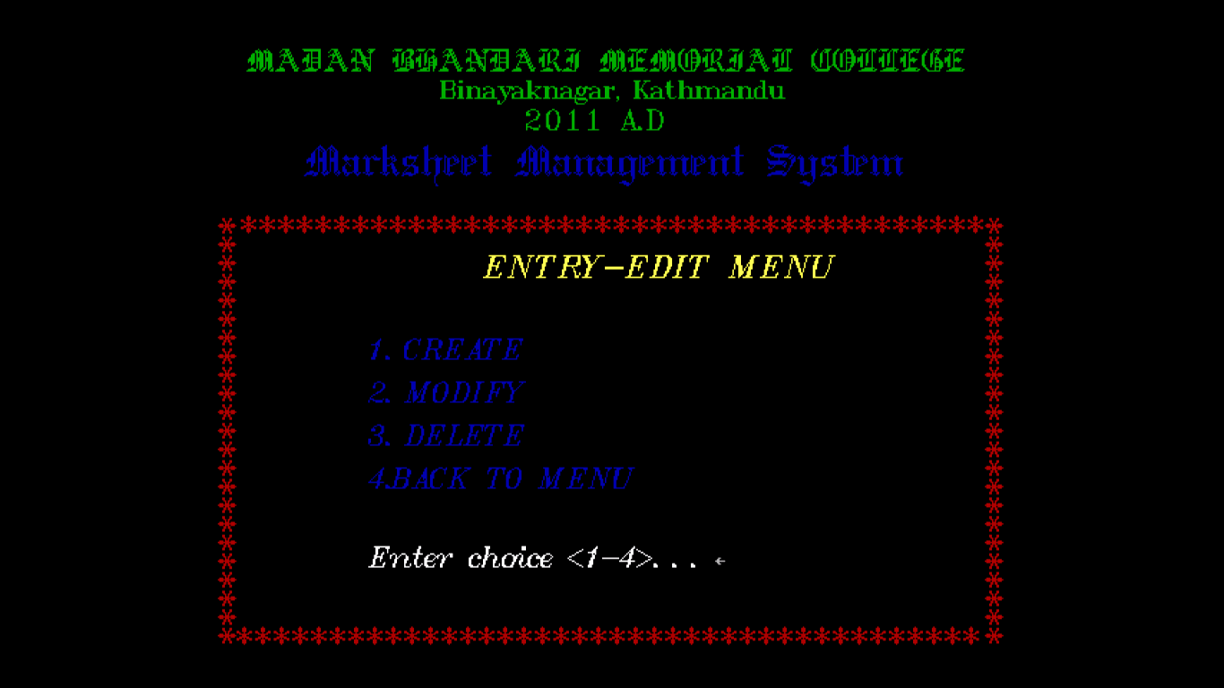
This is another part of 3rd phase of our project resulting in appearance of entry-edit menu which is also derived from main menu. From this part we can create new records, modify records, and delete unnecessary records.

- Create phase of program

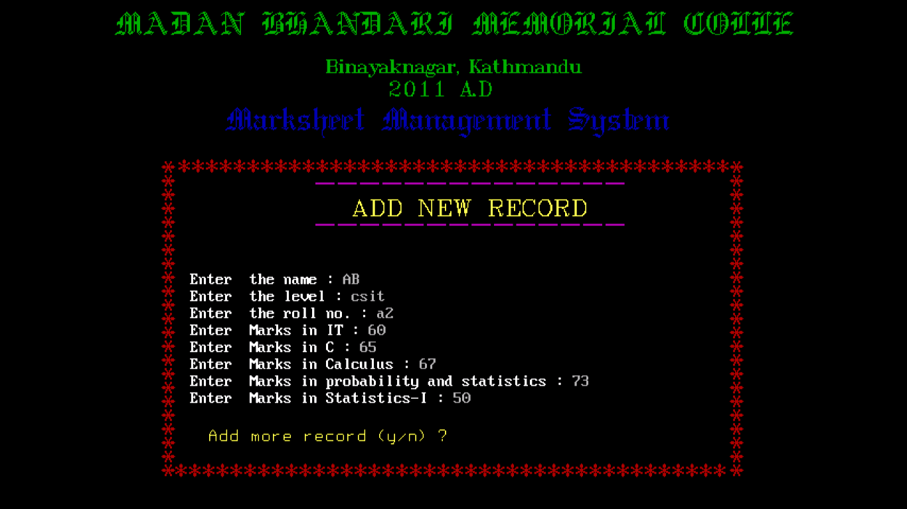

This is a phase of our project from which we can add new records to the file.

- Display phase of program

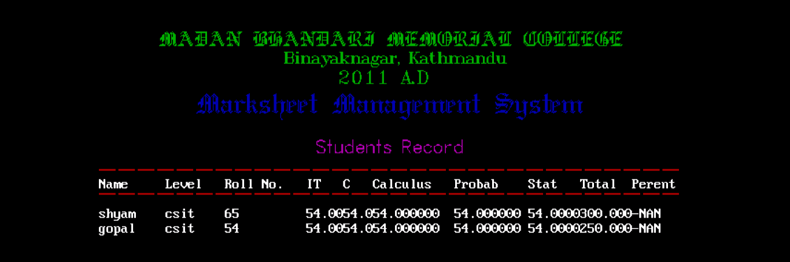
This phase of the project displays the overall mark sheet of all student.

- Display phase of program by class

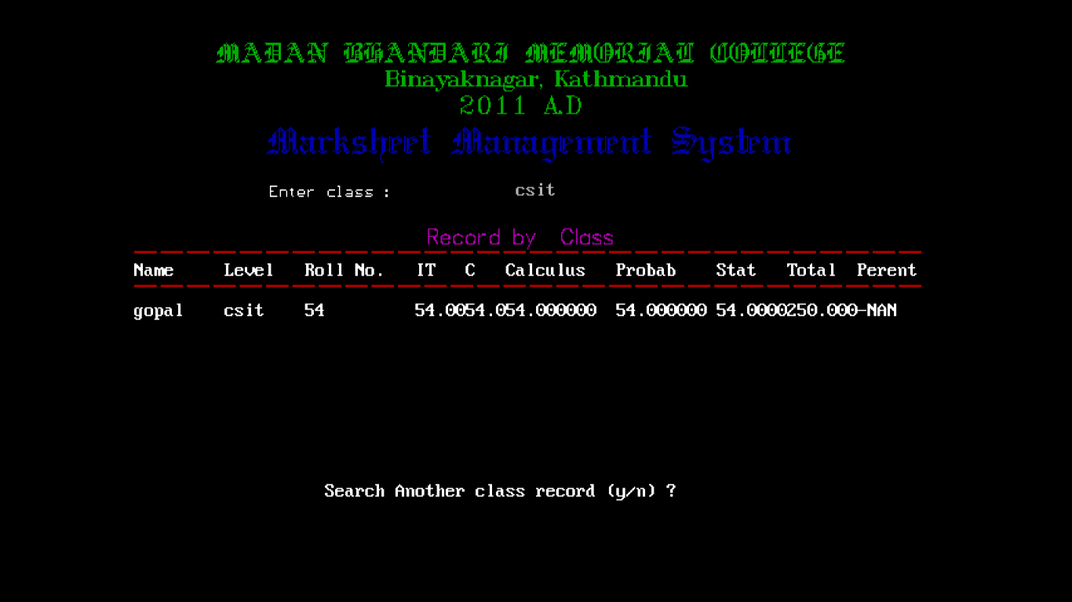
This phase helps us to view the result of overall class only.

- Search phase of program

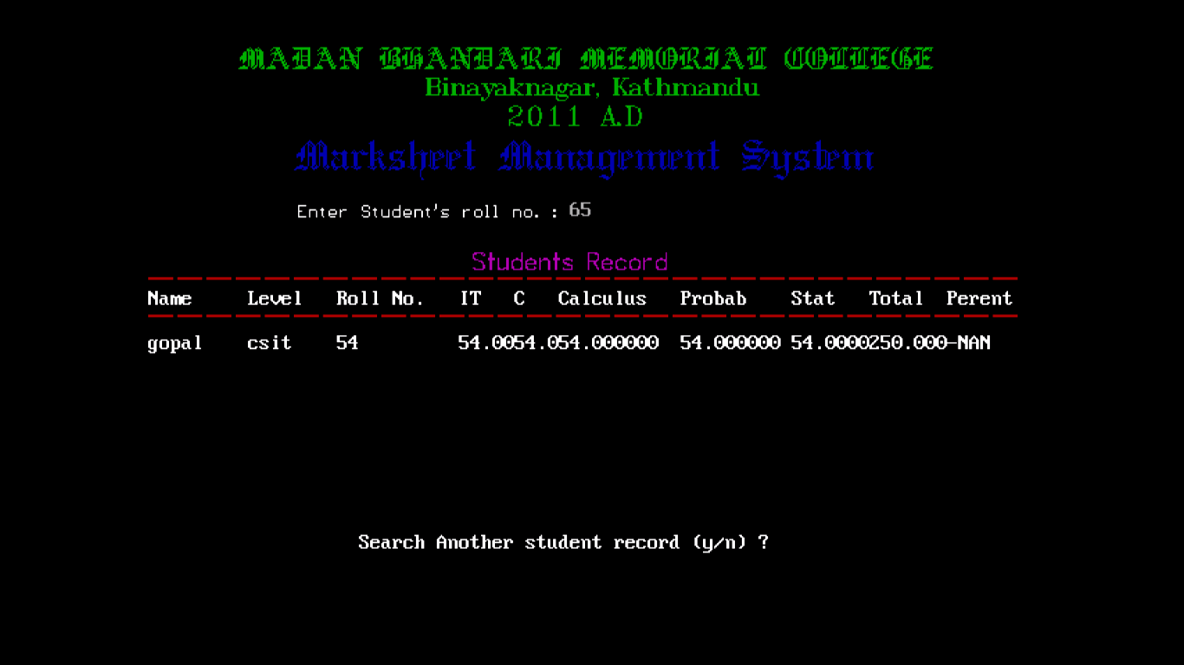
This part helps us to search the result of specific student by using roll.no

- Modify phase of program

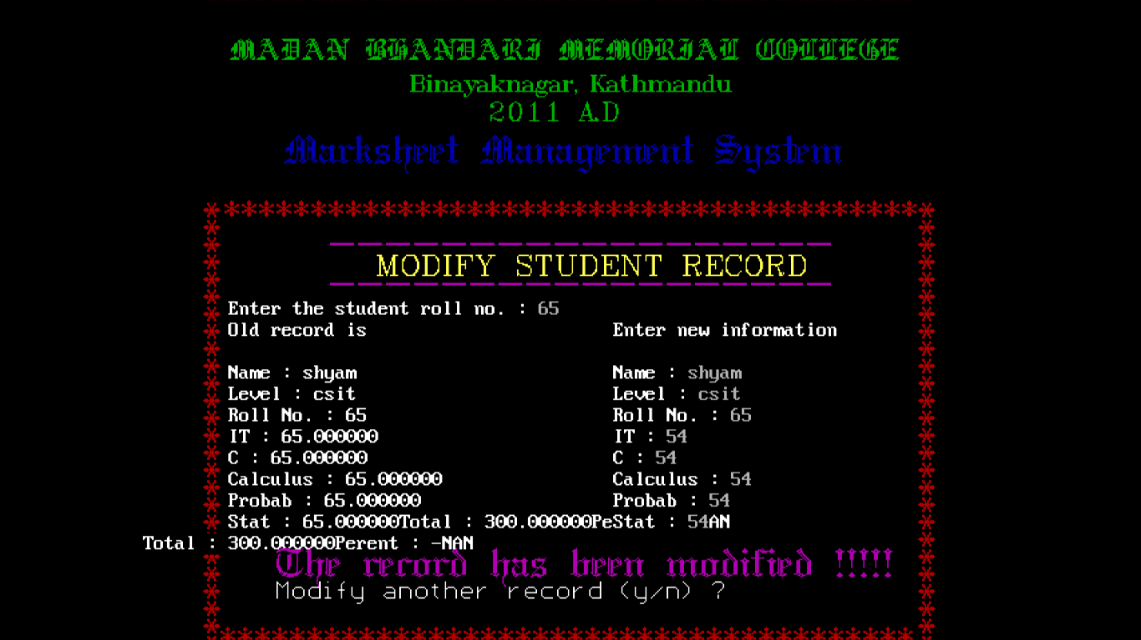
This phase of our project helps to modify the records stored in a file.

- Delete phase of program

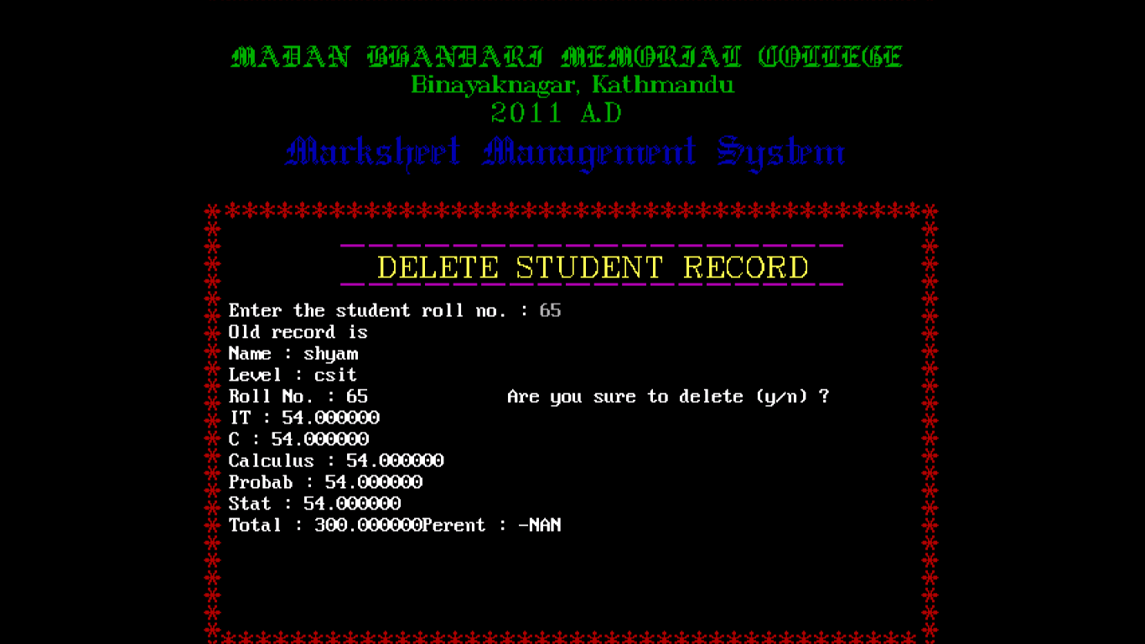
This phase of the program helps to delete the wrong record.

- Closing phase of program

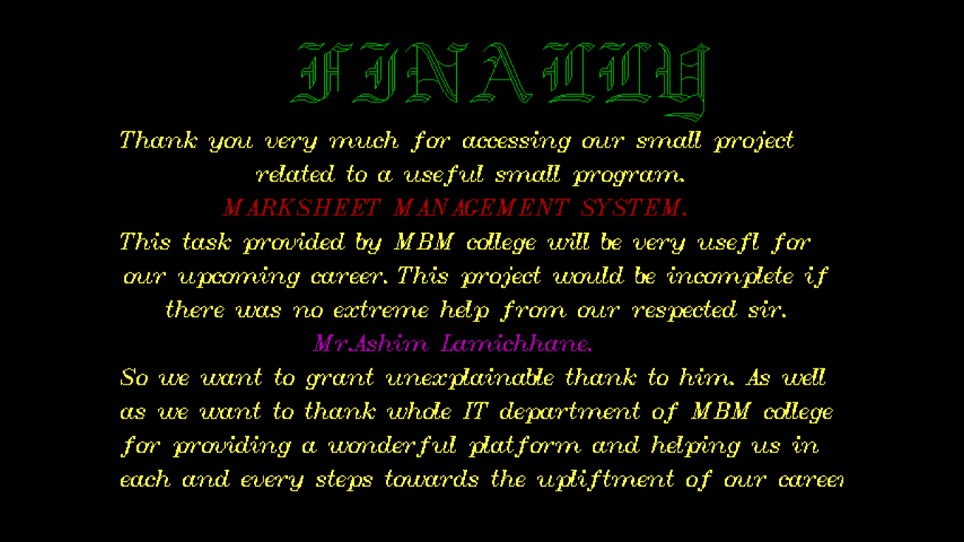
This is the final closing part of the program which appear after the program is going to be terminated.

8. Conclusion

After the detailed study of “Mark sheet Management System” of Madan Bhandari Memorial College, we have developed this system.

Bibliography

1. ANSI C programming by E.Balagurusamy
2. Let us C by Yashavant Kanetkar
3. A textbook of C programming by Ram Dutta Bhatta

