

**Department of Electronics and Electrical Engineering**

**Indian Institute of Technology Guwahati**

**EE 657: Pattern Recognition and Machine Learning**

**Assignment 2 Report**

**Group Details**

|  |  |
| --- | --- |
| **Name** | **Roll No.** |
| Rahul Ghosh | 120108027 |
| Ashima Jain | 120108051 |

**Question 1**

**Procedure**

* Read the images from gallery.zip and probe.zip. X_full consists of the images from the gallery whereas X_test consists of images from the probe. X consists the mean centred data.

• The sorted top 199 eigenvalues and eigenvectors of (X*X’/200) is found using the eigs () function.

• To find the eigenvectors of the eigenvectors of the covariance we multiply the eigenvectors already found with X’ and store them in W.

• **Part A**

* To display the eigenface images corresponding to the top 5 eigenvalues we obtain the projection using z = X*W(:,1:5)
* The 200 eigenfaces so obtained are displayed in figure 1.

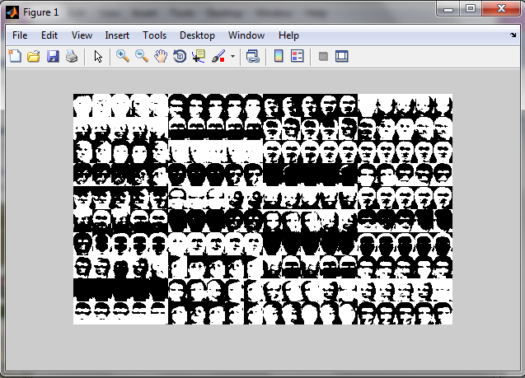

• **Part B**

* We find the eigenvalues of the covariance matrix of X.
* In figure 2 we plot the percentage of the total variance of the original data retained in the reduced space versus the number of dimensions.
* We observe that atleast 95% of the original data is retained for dimension >= 110.

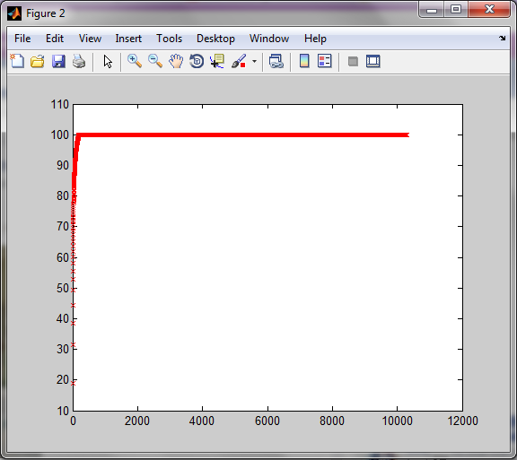

• **Part C**

* We first read the given image “face_input_1.pgm” and make it mean centered.
* Now we find the projections corresponding to the top 15 eigenvalues.
* Reconstructed image “recon_face_input_1.pgm” is shown in figure 3.

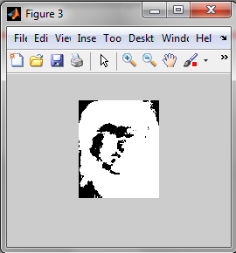

• Part D

* We obtain the projections of the data stored in X and also of the mean centered X_test in 25 dimensional subspace.
* For each of the image in X_test we find its Euclidean distance from the images of gallery(X).
* Now we use the 3 nearest neighbour classifier to classify the images.
* The percentage accuracy is calculated which comes out to be 85.5%.

**Question 2**

**Procedure**

• The projections corresponding to the top 199 eigenvecs are taken as components to do Fischer Discriminant Analysis. (z_ftrain (mean centered) and z_ftest (mean centered))

• SB and SW are calculated using the above data and the 39 eigenvectors of inv (SW)*SB are calculated.

• We obtain the projections of the data and store it in traind and also of the test data and store it in testd

• For each of the image in testd we find its Euclidean distance from the images of gallery(X) i.e traind.

• Now we use the 3 nearest neighbour classifier to classify the images.

• The percentage accuracy is calculated which comes out to be 87.5%.

Note : Q2.m uses variables from Q1.m and so will only run after running Q1.m such that all the variables are still stored in the workspace.

**Question 3**

**Procedure**

* We read the image “ski_image.jpg” and scale it by a factor of 0.5.
* We separate out the R G and B components of the image and stack them in the matrix X and normalize it.
* Using the given initial value of mean, covariance matrix and the weights first we find the responsibilities and then using EM algorithm we update them as well as calculate the log likelihood.
* This process is repeated for 70 iterations and we observe that the log likelihood starts converging from the 58th iteration The plot depicting the convergence of the log likelihood values is shown in Figure 2.

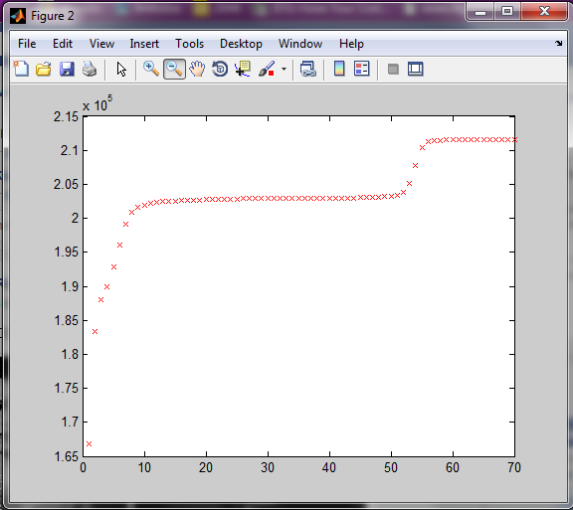

* To display the segmented output we use the K_Means Algorithm. It is shown in Figure 1.

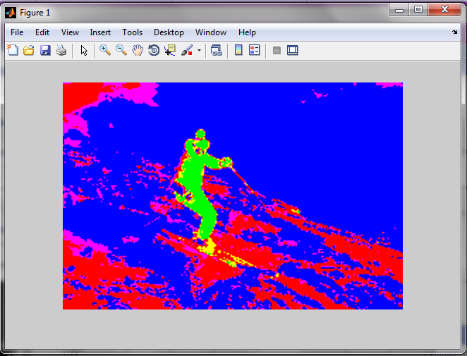

* The final values of the means, covariance matrices and the prior weights are also displayed.