Contents

Introduction 2

Technologies Used 2

Prerequisites 2

File Structure 3

Components 4

I. Login/Registration 4

II. Listing 6

III. Bidding 7

IV. Maintenance 8

# Introduction

**ShopOnline** is a web-based selling and buying system designed to facilitate transactions through the English Auction strategy. It comprises five essential components:

* Registration: Users can create accounts to access the platform, providing necessary details for identification and authentication.
* Login: Registered users can securely log in to their accounts, ensuring privacy and access control.
* Listing: Sellers can easily list their items for sale on the platform, providing descriptions and setting starting price, reserve price and instant buy price.
* Bidding: Buyers engage in competitive bidding for listed items, participating in auctions and placing bids based on their preferences.
* Maintenance: The platform allows admins to process auction items and generate revenue reports based on the items listed and sold in the platform.
* Utilizing XMLHttpRequest for client/server communication, ShopOnline offers a streamlined and interactive experience for both buyers and sellers, combining the convenience of online shopping with the excitement of traditional auctions.

# Technologies Used

* ShopOnline leverages the following technologies:
* Frontend: HTML, CSS, JavaScript (with XMLHttpRequest for client/server communication), XSL (for styling reports generated from XML files)
* Backend: PHP for server-side scripting
* Data Storage: XML documents for storing customer and item information.

# Prerequisites

To begin, please unzip the submitted project zip file and copy the XML files within the data folder and place it in such a way that it resides in *www/data* directory*.* If you are using XAMPP server locally, place it inside the data folder of *xampp/data* path. If the folder named data already exists in the specified path, you can just paste the XML files inside that folder and if not just paste the data folder itself.

# File Structure

The structuring of the files has been optimized by placing different file types in a distinctive folder. Here, all the htm files including the CSS & XSL stylesheet file have been placed in the root directory, then respective JavaScript and PHP files have been placed in the **“js”** and **“php”** folders. Finally, the XML files containing data of customers and items listed for bidding have been placed inside the **“data”** folder on the server root directory as instructed in the project description. i.e. *www/data* directory*.*

The following image represents the project file structure in detail.

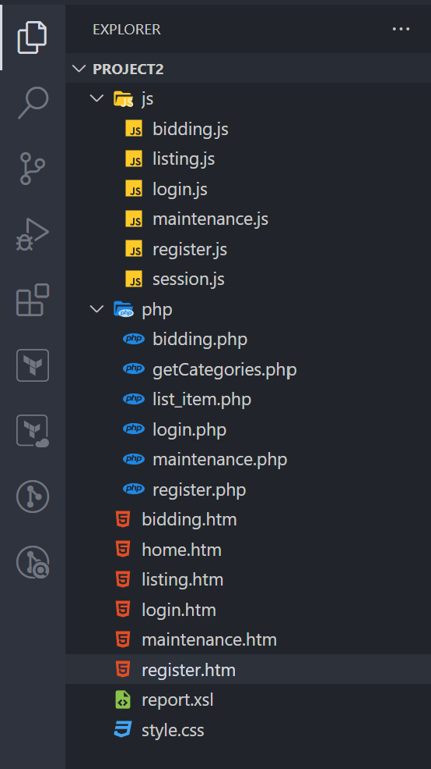

Figure 1: Project File Structure

# Components

## Login/Registration

To begin using ShopOnline, a user must have a registered account. If the user is new, then he/she can register via the registration page by following the steps below.

* **Fill Out Form:** Complete the registration form by providing your first name, last name, email address, password, and confirm password.
* **Validation:** Ensure all fields are filled out correctly and meet the required criteria (valid email format, matching passwords.).
* **Check Email Availability:** Verify that the email address you're using for registration is not already registered in the system.
* **Submit Form:** Click on the "Register" button to submit your registration details.
* **Wait for Confirmation:** Wait for the system to process your registration request.
* **Check Response:** After submission, you'll receive a response indicating whether your registration was successful or not.
* **Success:** If successful, you'll receive a confirmation message welcoming you to the system and user information is saved in the **customer.xml** file.
* **Login:** With the email address and password credentials used during registration, users can then login from the login page. If the credentials are correct, it will redirect users to the home page and from here users can choose if they want to list items or bid on listed items.

***Note:*** *I have created 2 users for now which can be viewed through* ***customers.xml*** *file and used their credentials to login and list some items.*

Figure 2: Registration Page.

Figure 3: Login Page.

Figure 4: Home Page.

## Listing

To list items for sale on ShopOnline, users can utilize the listing page. Follow these steps to create a new listing:

* **Navigate to Listing Page:** Access the listing page by clicking on the "Listing" option in the navigation menu after logging into your account.
* **Fill Out Listing Form:** Complete the listing form by providing the necessary details for your item, including:
* Item Name: Enter the name of your item.
* Category: Select the appropriate category for your item from the dropdown menu.
* Description: Provide a detailed description of your item.
* Start Price: Set the starting price for bidding.
* Reserve Price: Specify the minimum price at which you are willing to sell the item.
* Buy It Now Price: Optionally, set a price at which buyers can immediately purchase the item.
* Duration: Choose the duration of the listing (in days, hours, and minutes).
* **Validation:** Ensure all fields are properly filled out and meet the required criteria. Check for any validation messages and address them accordingly.
* **Submit Listing:** Click the "Submit" button to initiate the listing process.
* **Wait for Confirmation:** Allow the system to process your listing request.
* **Check Response:** Upon submission, you will receive a response indicating the status of your listing.
* If successful, you'll receive a confirmation message with the item number and details.
* If there are errors or missing information, you'll be prompted to review and correct them.
* **Success:** Upon successful listing, your item will be saved in the **auction.xml** file and available for bidding or immediate purchase by other users on ShopOnline.

Figure 5: Listing Page.

## Bidding

To participate in auctions and place bids on items in ShopOnline, follow these steps:

* **Navigate to Bidding Page:** Access the bidding page from the navigation menu or by clicking on the "Bidding" link.
* **View Available Items:** Browse through the list of items available for bidding. Each item will display details such as name, category, description, buy-it-now price, current bid price, and time left for bidding.
* **Place Bid:** If interested in an item, click on the "Place Bid" button associated with that item, and enter your bid price.
* **Validation and Submission:** Ensure your bid price is valid and greater than the current bid price, then submit your bid.
* **Wait for Confirmation:** After placing your bid, wait for the system to process it.
* **Check Response:** Once processed, you'll receive a response indicating whether your bid was successful or not.
* **Monitor Bidding Status:** Keep an eye on the bidding status of items you've bid on. You can continue to place bids until the bidding period ends.
* **Buy It Now Option:** Some items may also have a "Buy It Now" option. If you choose this option, the system will purchase the item immediately at the specified buy it now price.

Figure 6: Bidding Page.

## Maintenance

This page is primarily dedicated for admins/brokers so that they can easily process items that are sold or expired. However, in this project the restriction is not added so users can also access this page.

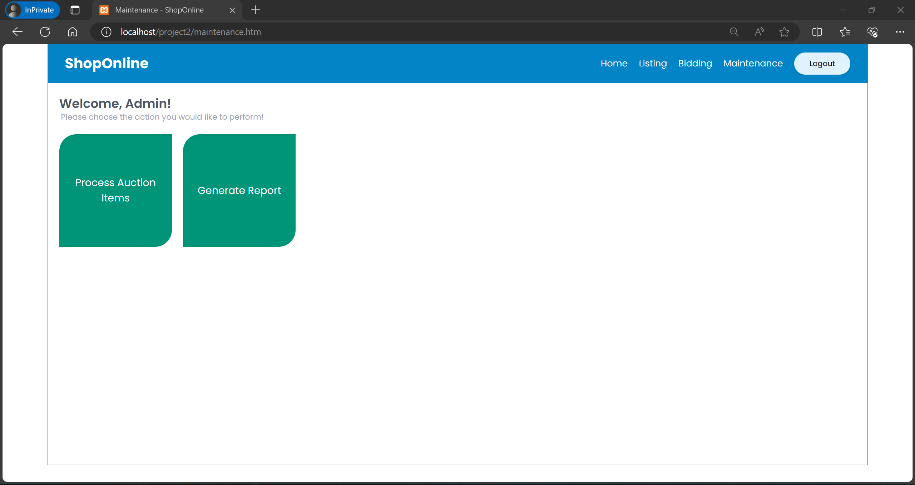

Figure 7: Maintenance Page.

It consists of two major tasks, and they are as follows:

1. **Process Auction Items:**

Clicking the button triggers the system to commence the assessment of auction items to ascertain their status, considering their present condition and expiration duration. Each item tagged with an "in_progress" status in the auction.xml file is scrutinized. If an item has reached its expiration time, the system appraises its bidding status and adjusts its state correspondingly, marking it either as "sold" or "failed". Upon completion of the processing, a notification is presented to confirm the conclusion of the operation.

1. **Generate Report:**

Clicking the button triggers the system to generate a comprehensive report summarizing auction activities, encompassing details regarding both sold and failed items. The system retrieves all sold or failed items from the auction.xml document. It proceeds to calculate the revenue generated from each sold item, considering a 3% commission on the sold price, and from each failed item, assuming a 1% charge on the reserved price. The resulting report presents the list of sold or failed items in a structured table format, containing item specifics (excluding descriptions) alongside the corresponding revenue. Additionally, the report includes the total count of sold and failed items, along with the overall revenue.

Figure 8: Auction Report in Maintenance Page.

Finally, the user can logout from the system which will delete the customer ID and first name saved in session storage which will end the session to ensure security.