Contents
Introduction (CabsOnline): 2
Files: 2
Setup Database: 3
How to Use: (Users) 4
How to Use: (Admin) 7

Introduction (CabsOnline):
CabsOnline is an online cab booking service which allows users to book taxi services. However, users require an account within the app to be able to do so. If they are new to the app, they can create an account and start booking cabs as required.

Files:
The list of all files used by this system are as follows:
- register.php
- login.php
- booking.php
- admin.php
- style.css (styling for all pages.)
- sql-commands.txt (SQL commands to create tables.)

Setup Database:
To setup a database to record all data of customers and bookings, we need to create a database server. For this project, we are using MySQL database server provided within XAMPP. Once, XAMPP is running and Apache & MySQL services are running, navigate to phpMyAdmin dashboard and create a new database named “cabsonline”. In this database, we need to create two tables, one to store customers data named “customers” table and another to store bookings data named “bookings” table as shown below.
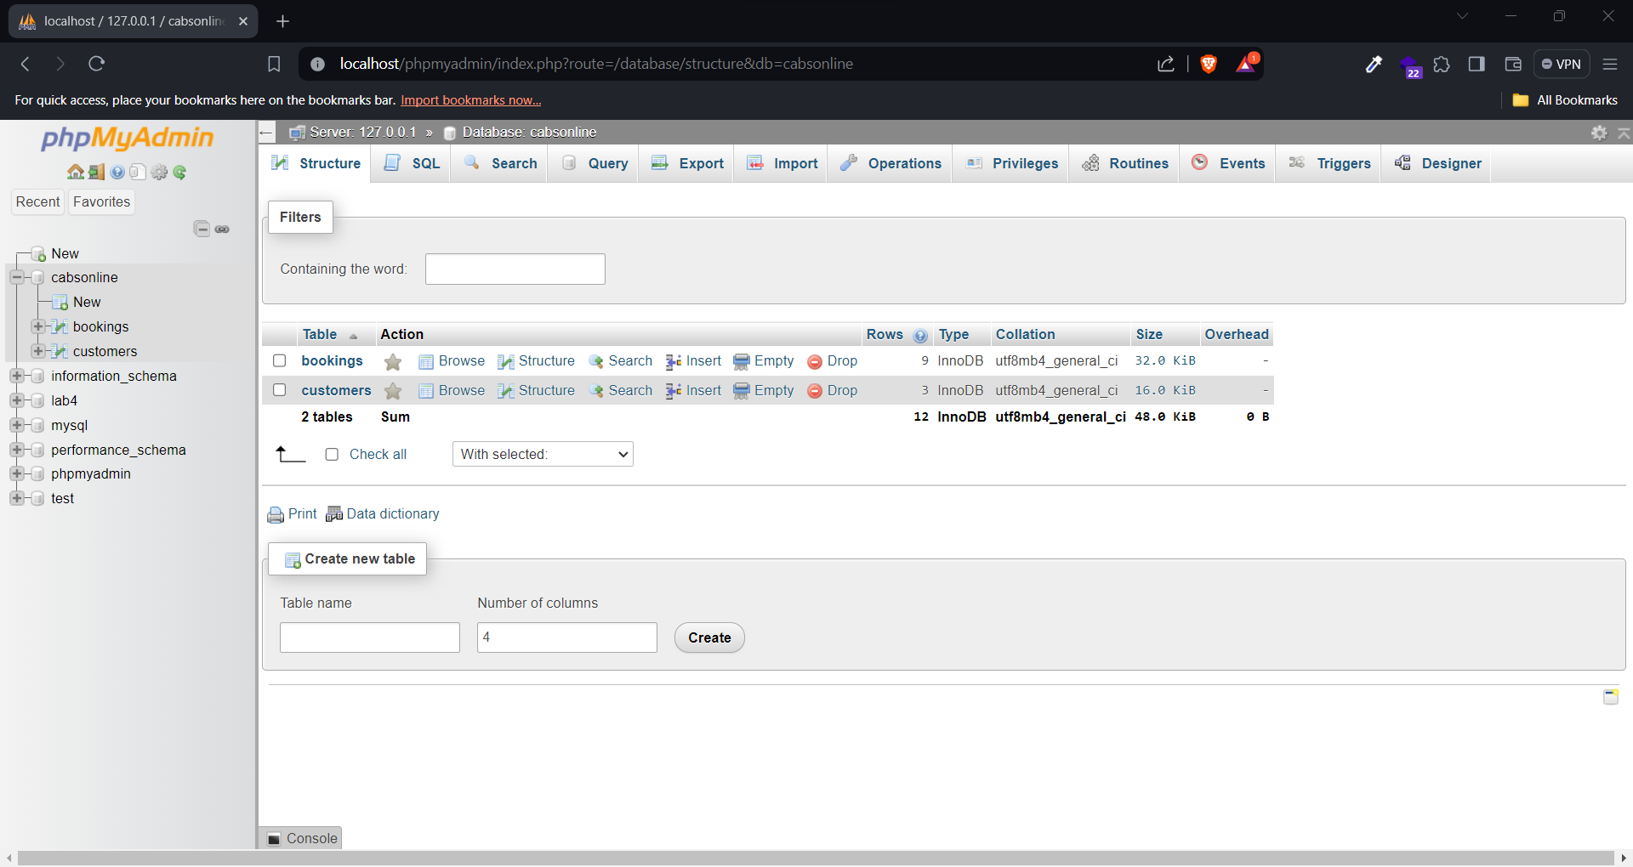
Figure 1: Creating database and tables.
To create these tables with required fields and their attributes, please use the provided sql-commands.txt file.

Note: Within the SQL commands text file, we can find a command to set time zone to Sydney/Australia. Please use this command as well so that the database server time and users time data will sync and is crucial to calculate time differences for further actions in booking and admin dashboard page.

How to Use: (Users)
To start booking, one must have an account so if you don’t have an account, please create an account by navigating to the register page. While registering, users need to fill in the following fields.
- Name
- Email
- Phone
- Password
Here, email must be unique meaning that one email will correspond to one customer. In a user tries to register with an already registered email, they will be informed that that email has already been used. Otherwise, it will register them successfully and redirect them to the booking page. The following is the snapshot of the register page.
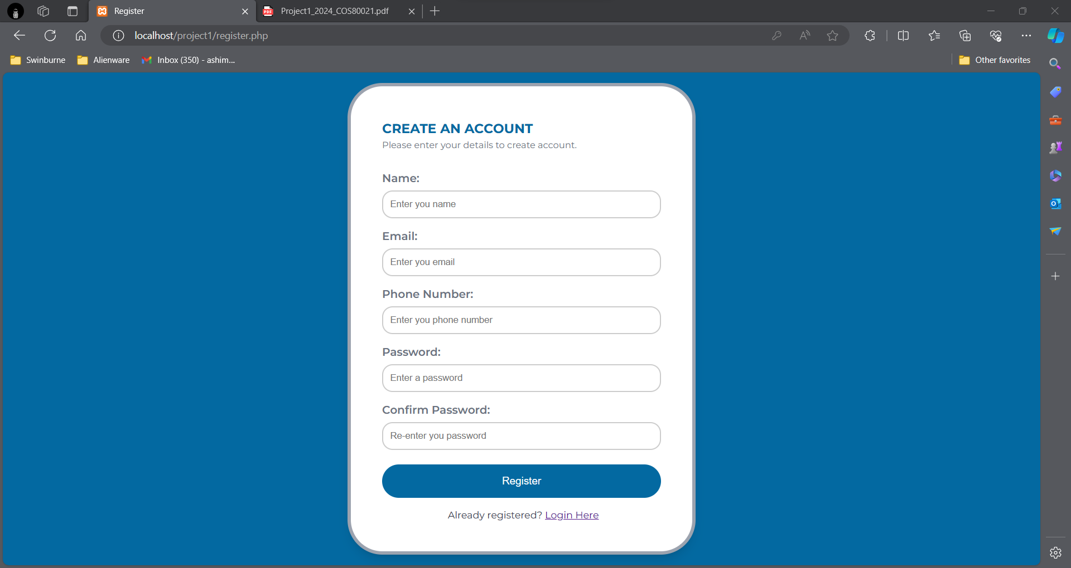
Figure 2: CabsOnline Register Page.

Once the user has created an account, they can directly login via their email and password they used during registration through the login page. However, the user must remember the correct email and password for successful authentication, otherwise the app will throw invalid username and password error. Here is the snapshot of login page.
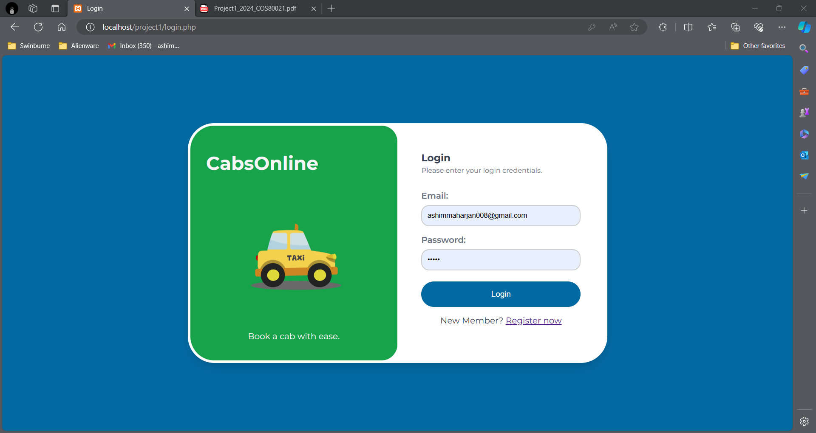
Figure 3: CabsOnline Login Page.
Once successfully logged in, users can perform the main task, i.e. Booking a cab. To do so, users must fill in the following fields.
- Passenger Name
- Contact Phone of Passenger
- Pickup Address:
  - Unit Number (Optional)
  - Street Number
  - Street Name
  - Suburb
- Destination Suburb
- Pickup date
- Pickup time

Note: The pickup date and time selected must be at least 40 minutes after the current time. Otherwise, users will be presented with this message as error.

The following is the snapshot of the booking page.
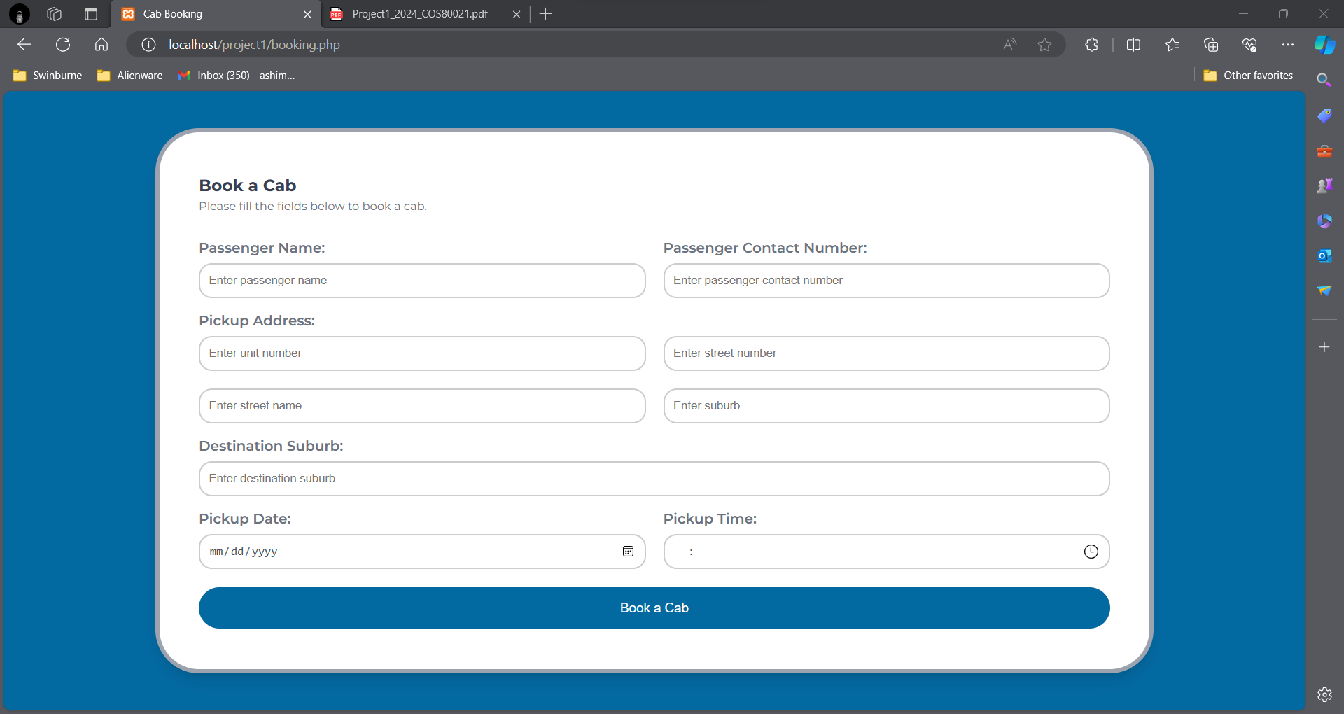
Figure 4: CabsOnline Booking Page.
After filling in the required fields along with valid pickup date and time, the system will generate a unique booking reference number and display it to the user. The booking request data is then inserted into the bookings table in the database. Additionally, an email to sent to the logged in user regarding the booking confirmation with booking reference number, pickup date and time. The following snapshot represents a successful booking process.
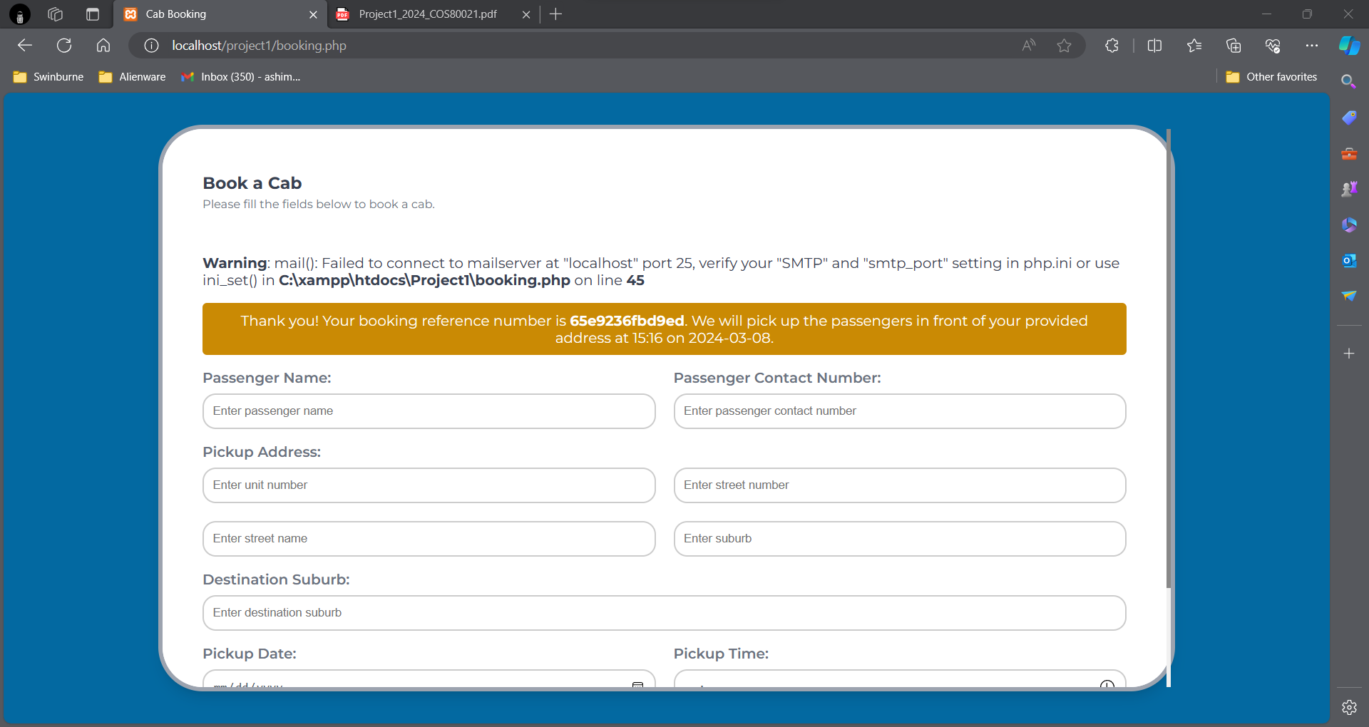
Figure 5: Successful booking example.

How to Use: (Admin)
For admin usage, we have created an admin page where admin can list all booking requests that are within 3 hours from current time. For this project, we have not implemented authentication as it was not required. Next, admin can update a booking request by assigning a taxi by entering the booking reference number in the provided input field and simply clicking on update button.
The following snapshots conclude the admin page functionalities.
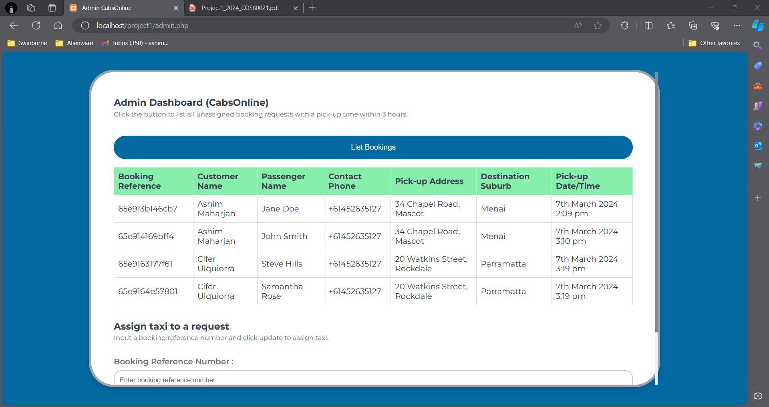
Figure 6: List booking requests within 3 hours from current time.
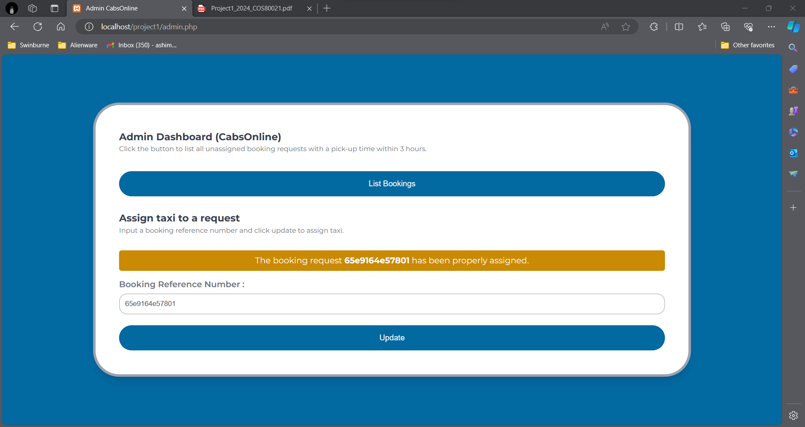
Figure 7: Assigning taxi to a booking request.

