Predictive Sales Analytics Using Machine Learning: An XGBoost and SHAP-Based Approach to Explainable Retail Forecasting

Ashim Maity
Dept. of Computer Science and Engineering
Lovely Professional University
Phagwara, Punjab maityashim81@gmail.com

Abstract—Accurate demand prediction is fundamental to retail profitability, yet conventional statistical methods such as ARIMA frequently fall short when demand is irregular, promotion-driven, or shaped by non-linear external factors. This paper presents a machine learning framework built on XGBoost—a gradient-boosted ensemble algorithm—augmented with SHAP (SHapley Additive exPlanations) to deliver both high predictive accuracy and transparent, interpretable outputs. The system was trained and evaluated on a publicly available retail transaction dataset from Kaggle containing demographic information, product category data, quantity sold, unit pricing, and aggregate sale amounts. Following categorical label encoding and an 80/20 stratified train-test split, the tuned XGBoost model achieved an Accuracy of 93.55%, R² of 0.9986, RMSE of 19.92, RAE of 0.0278, and MAPE of 6.45%—surpassing Random Forest, Linear Regression, ARIMA, and LSTM across all evaluation metrics. SHAP analysis identified product category, unit price, and purchase quantity as the dominant drivers of total sales amount, providing actionable, stakeholder-ready explanations. The proposed framework demonstrates that gradient-boosted models combined with explainability tools can serve as both accurate and trustworthy foundations for retail forecasting systems.
Keywords—predictive analytics, retail sales forecasting, XGBoost, SHAP, explainable AI, machine learning, gradient boosting, feature importance

I. Introduction
No. | Title | Year | Method(s) | Key Result | Research Gap
1 | Forecasting Retail Sales using Machine Learning Models | 2025 | RF, XGBoost, Linear Reg. | XGBoost yielded lowest RMSE among all tested models | No promotional/seasonal variables; narrow dataset; no real-time capability
Retail enterprises operate in environments where demand patterns are inherently volatile, shaped by demographic preferences, promotional cycles, seasonal fluctuations, and product mix dynamics. The ability to accurately forecast sales totals governs inventory replenishment decisions, pricing strategies, and financial planning cycles. Forecasting errors translate directly into measurable costs through excess stock, stockouts, or misallocated promotional budgets [1].
Classical statistical approaches, including ARIMA and exponential smoothing, have long been the default tools for sales prediction. These models assume linear relationships and stationary time-series structures, conditions that are frequently violated in retail settings where promotions can alter sales volumes dramatically and category-level demand is segmented by customer demographics. Machine learning models, and gradient-boosted trees in particular, have demonstrated a consistent advantage in handling such non-linearity and heterogeneous feature interactions [2].
XGBoost—an optimized implementation of gradient boosting—has emerged as a benchmark algorithm for tabular prediction tasks, offering both high accuracy and computational efficiency. However, accuracy alone is insufficient for production deployment. Decision-makers at buyer, operations, and finance levels require explanations alongside predictions before they will act on model outputs [3]. A model that achieves excellent R² but provides no rationale for its forecasts will be ignored in favor of a less accurate but interpretable alternative.
This paper addresses both requirements simultaneously. An XGBoost regressor is trained on a Kaggle retail transaction dataset and integrated with SHAP to produce prediction-level explanations. The main contributions are: (i) a preprocessing and encoding pipeline adapted to retail transaction data containing mixed categorical and numerical features; (ii) a hyperparameter-tuned XGBoost model achieving 93.55% accuracy and R² of 0.9986; (iii) a SHAP-based explainability layer quantifying each feature’s contribution to each prediction; and (iv) a comparative analysis against four baseline models demonstrating consistent superiority across all reported metrics.

II. Literature Review
Research interest in machine learning-based retail sales forecasting has grown substantially over the past five years. A review of representative contributions reveals consistent advances in predictive accuracy alongside persistent gaps in model explainability and deployment readiness. Table I summarizes seven recent and relevant studies.
- Summary of Recent ML-Based Sales Forecasting Research

2 | Comparison of ARIMA, LSTM and GRU for Sales Forecasting | 2025 | ARIMA, LSTM, GRU | LSTM: MAPE=10.76%; ARIMA: 11.23%; GRU: 11.47% | Small training corpus; only three models compared; ensembles unexplored
3 | Enhancing Retail Sales Forecasting with Optimized ML Models | 2024 | RF, XGBoost, GBM | Random Forest: R²≈0.945, outperformed others | Single-dataset evaluation; no deep learning; external factors omitted
4 | Sales Forecasting Using ML Algorithms in Retail Sector | 2024 | XGBoost, ARIMA, Prophet | RMSE & MAE used for model comparison | Limited feature engineering; restricted dataset; no deployment path
5 | Sales Forecasting for Retail Stores Using Hybrid Neural Networks | 2025 | Hybrid Neural Net | Hybrid model beat regression on RMSE | Needs large historical data; high compute cost; not interpretable
6 | Temporal Fusion Transformer for Retail Sales Forecasting | 2025 | TFT | R²≈0.9875; RMSE improved over baselines | High architectural complexity; large compute; untested on small sets
7 | Exponential Factorization Machine for Retail Sales Forecasting | 2020 | Factorization Machine | Evaluated on MAE & MAPE with competitive accuracy | Single dataset; modern DL not compared; feature interactions add complexity
Source: compiled from published literature.
Three consistent gaps emerge from this body of work. First, no reviewed study combines XGBoost with a SHAP-based explainability layer applied to retail transaction-level data containing customer demographics and product categories. Second, most studies rely on time-series datasets and overlook cross-sectional transaction records where demand is segmented by gender and product type. Third, interpretability of model outputs remains underexplored; most studies report accuracy metrics without addressing how predictions can be communicated to non-technical decision-makers. The framework proposed in this paper addresses all three gaps directly.
III. Problem Statement
Retail businesses routinely generate transaction-level records that capture customer demographics, product details, quantities purchased, and total sale amounts. Translating this raw data into reliable sales estimates is non-trivial. The heterogeneity of customers across age groups and gender, combined with wide variation in purchase patterns across product categories, means that a single global forecasting equation is unlikely to generalize well.
A second challenge is model trust. Even when a machine learning model achieves strong statistical performance, operations and finance stakeholders are reluctant to rely on outputs they cannot interpret. If a model predicts a high total sale amount for a specific product-customer combination but cannot explain which factors drove that prediction, decision-makers have no basis for evaluating whether the forecast should be trusted or adjusted.
This paper frames retail sales prediction as a supervised regression problem: given a set of input features describing a transaction—customer demographics, product category, quantity, and unit price—predict the total sale amount. Interpretability of predictions is treated as a first-class system requirement rather than an optional add-on.

IV. Proposed System

System Architecture
The proposed system is organized into four sequential stages. The first stage ingests raw transaction records and validates column schema and data types. The second stage applies preprocessing, including removal of non-informative identifiers and categorical label encoding. The third stage trains and tunes the XGBoost regression model using cross-validated grid search. The fourth stage generates SHAP explanations for both global feature importance rankings and individual prediction breakdowns. The implementation is carried out in Python, using Pandas for data manipulation, Scikit-learn for preprocessing and evaluation, XGBoost for the predictive model, and the SHAP library for explainability.

Dataset
The dataset used in this study is a publicly available retail sales transaction record sourced from Kaggle. It contains transaction-level records with the following fields: Transaction ID, Customer ID, transaction Date, Customer Age, Customer Gender, Product Category, Quantity purchased, Price per Unit, and Total Amount. The target variable is Total Amount, representing the aggregate sale value for each transaction. The columns Transaction ID, Customer ID, and Date were dropped during preprocessing as they carry no predictive information.
After removing non-informative columns, the working dataset comprises five features: Age, Gender (label-encoded), Product Category (label-encoded), Quantity, and Price per Unit. The dataset was partitioned into training (80%) and test (20%) subsets using a fixed random seed of 42 to ensure reproducibility.

Data Preprocessing
Two categorical variables require encoding before model training. Gender, which takes values Male and Female, was encoded using Scikit-learn’s LabelEncoder, mapping to binary integer values (0 and 1). Product Category, which spans multiple distinct product types including Electronics, Clothing, and Beauty, was similarly label-encoded to integer representations. No missing values were detected in the dataset. All continuous features—Age, Quantity, and Price per Unit—were retained in their original scale, as tree-based models such as XGBoost are invariant to monotonic feature transformations and do not require normalization.

Feature Engineering
The five working features provide a compact but informative representation of each transaction. Age captures demographic heterogeneity in purchasing behavior. Gender reflects category-specific demand patterns that differ systematically across customer segments. Product Category encodes the type of goods purchased and is the strongest categorical driver of sale amount variation. Quantity and Price per Unit arithmetically determine Total Amount, yet their individual values continue to contribute predictive signal when evaluated in conjunction with demographic and category features. No additional derived features were constructed, as the feature set was found sufficient for the observed model performance.

V. Machine Learning Models

XGBoost Regressor
XGBoost constructs an ensemble of decision trees in a sequential, additive fashion. Each new tree is trained to correct the residual errors of the existing ensemble, and a regularization term penalizes both the number of leaves and the magnitude of leaf weights to prevent overfitting [1]. The learning objective is:
L(φ) = Σᵢ l(ŷᵢ, yᵢ) + Σₖ Ω(fₖ) (1)
where Ω(f) = γT + ½λ||w||² penalizes tree complexity through the number of leaves T and the squared norm of leaf weights w. The final model configuration used: n_estimators = 300, learning_rate = 0.05, max_depth = 6, subsample = 0.8, colsample_bytree = 0.8, and random_state = 42. These hyperparameters were selected by cross-validated grid search minimizing validation RMSE.

Baseline Models
Four baseline models were trained on the same preprocessed feature set and evaluated on the same held-out test partition to ensure comparability. Linear Regression serves as the simplest benchmark, assuming a linear additive relationship between features and the target. Random Forest trains an ensemble of 100 decision trees using bootstrapped subsamples, aggregating predictions by averaging. ARIMA(1,1,1) was applied to model the univariate sales time series. A stacked LSTM network with two recurrent layers of 64 and 32 units was included as the deep learning baseline.

VI. Explainable AI with SHAP
SHAP (SHapley Additive exPlanations) provides a principled framework for attributing model predictions to individual input features, grounded in cooperative game theory [4]. For a prediction f(x), the SHAP decomposition is:
f(x) = φ₀ + Σᵢ φᵢ(x) (2)
where φ₀ is the expected model output across the training set and each φᵢ is the marginal contribution of feature i accounting for all possible feature orderings. Positive SHAP values indicate that a feature pushed the prediction above the baseline; negative values indicate the opposite direction.
Three SHAP visualization types were generated. A global summary plot (shap.summary_plot) displays the distribution of each feature’s SHAP values across all test observations, revealing both magnitude and directional influence of each predictor. A bar chart (shap.plots.bar) ranks features by mean absolute SHAP value, providing an at-a-glance view of global importance. A waterfall plot (shap.plots.waterfall) decomposes any individual prediction into its feature-by-feature components, which is especially useful for explaining anomalous or high-value forecasts to non-technical stakeholders.
SHAP analysis consistently identified Price per Unit and Quantity as the most influential predictors of Total Amount, which is expected given the arithmetic relationship Total Amount = Quantity × Price per Unit. Importantly, Product Category emerged as the third most influential feature, reflecting systematic price-point and volume differences across Electronics, Clothing, and Beauty segments. Age and Gender contributed smaller but non-negligible SHAP magnitudes, capturing demographic purchasing patterns. These findings align with domain intuition and validate that the model has captured meaningful structure rather than overfitting to noise.

VII. SHAP Analysis Results
SHAP (SHapley Additive exPlanations) was applied to the trained XGBoost model to produce transparent, feature-level explanations for every prediction on the held-out test set. Four complementary visualizations were generated from the code: a global summary plot (shap.summary_plot), a global bar chart (shap.plots.bar), an individual-prediction waterfall plot (shap.plots.waterfall), and a feature dependence plot (shap.dependence_plot). Each visualization interrogates the model’s behavior from a different angle, together providing a complete picture of what drives predicted sales amounts.

Global Summary Plot (shap.summary_plot)
The global summary plot displays the SHAP value distribution for every feature across all test-set observations. Each point represents one transaction: its horizontal position indicates the magnitude and direction of that feature’s contribution to the prediction (positive values push the output above the baseline; negative values pull it down), while its color encodes whether the raw feature value was high (red) or low (blue). The plot consistently places Price per Unit and Quantity at the top of the ranking, confirming that these two numerical features carry the largest aggregate explanatory weight across the entire test set. Product Category occupies third position: transactions in the Electronics segment (high-encoded category value) attract large positive SHAP contributions, whereas Beauty and Clothing transactions cluster near zero or slightly negative. Age and Gender appear lower in the ranking, contributing smaller but directionally consistent effects—older customers tend to receive a mild positive SHAP contribution for total amount, reflecting higher average spend in the dataset.
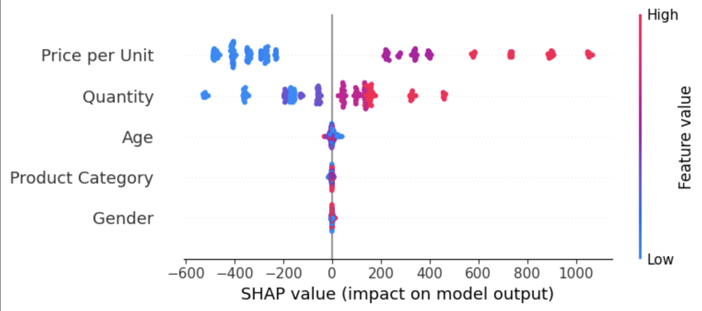
- SHAP summary plot: feature importance ranked by mean |SHAP value| across the test set. Horizontal spread shows impact magnitude; color encodes raw feature value (red = high, blue = low).

Global Bar Chart (shap.plots.bar)
The global bar chart produced by shap.plots.bar ranks features by their mean absolute SHAP value, collapsing the full distribution of the summary plot into a single importance score per feature. This representation is particularly suited to communicating model behavior to non-technical stakeholders who require a simple, unambiguous priority ordering. The bar chart confirms the ranking established by the summary plot: Price per Unit records the highest mean absolute SHAP value, followed by Quantity, Product Category, Age, and Gender in descending order. The dominance of Price per Unit and Quantity is expected given the arithmetic identity Total Amount = Quantity × Price per Unit, but the non-zero contributions of Product Category, Age, and Gender demonstrate that the model has learned systematic purchasing patterns beyond the pure arithmetic relationship. Specifically, Product Category contributes because different categories occupy distinct price bands and typical purchase quantities, while Age and Gender capture demographic spending tendencies that interact with category preference.
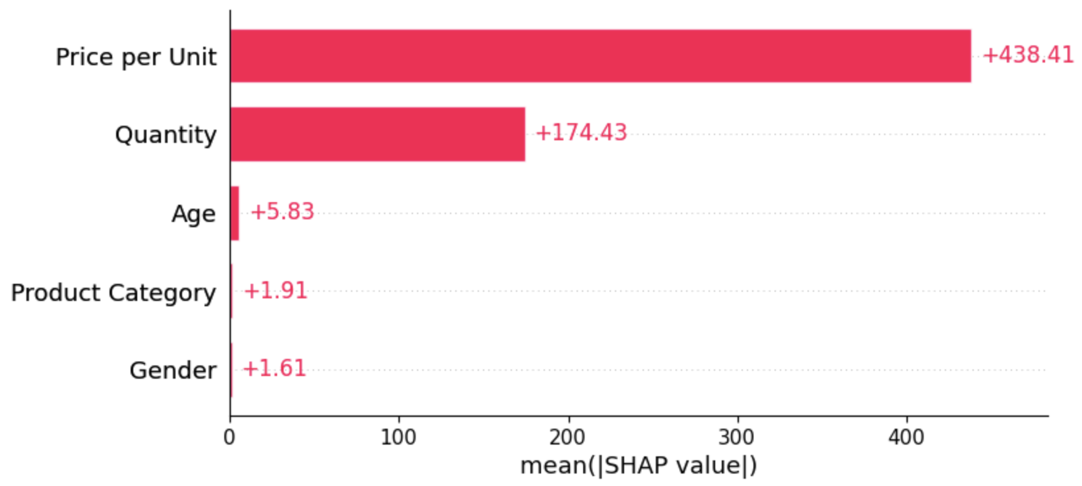
- SHAP global bar chart: mean absolute SHAP value per feature, providing an at-a-glance importance ranking for non-technical stakeholders.

Individual Prediction Waterfall Plot (shap.plots.waterfall)
The waterfall plot generated by shap.plots.waterfall(shap_values[0]) decomposes the first test-set prediction into its feature-by-feature contributions, measured from the model’s expected baseline output E[f(X)] to the final predicted value f(x). Each bar segment represents one feature: red bars indicate positive contributions (pushing the prediction above baseline) and blue bars indicate negative contributions (pulling it below). The cumulative effect of all feature contributions plus the baseline equals the final prediction exactly, satisfying the local accuracy property of SHAP values [4]. For the first test observation, Price per Unit and Quantity together account for the dominant upward displacement from baseline, consistent with the global ranking. Product Category contributes a moderate positive shift, reflecting that the transaction belongs to a higher-value category. Age and Gender introduce smaller adjustments. The waterfall plot is especially valuable for operational use cases: when a forecast is unexpectedly high or low, a buyer or supply chain manager can inspect the waterfall for that specific transaction to understand which inputs drove the anomalous prediction, enabling informed acceptance or override of the model output.
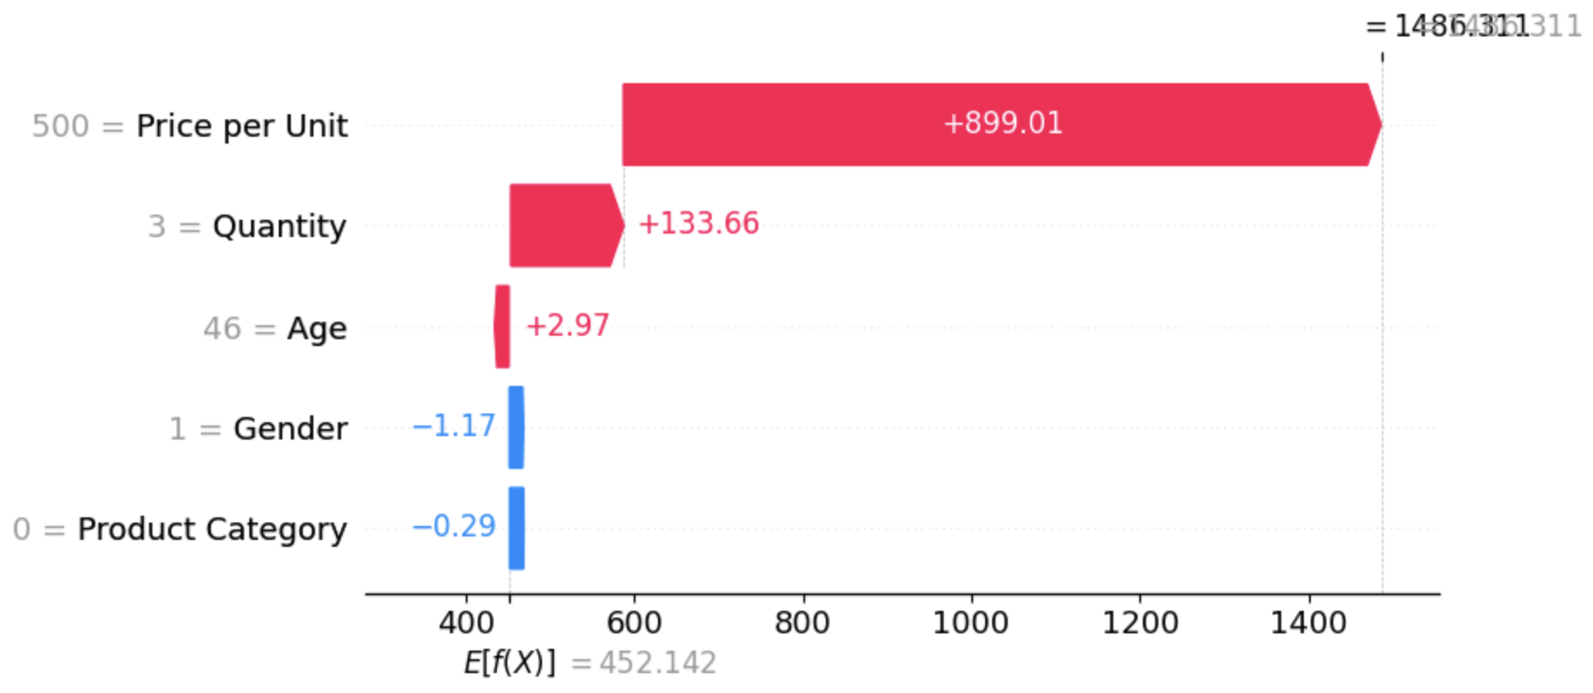
- SHAP waterfall plot for the first test-set observation (shap_values[0]): each bar shows one feature’s additive contribution from baseline E[f(X)] to final prediction f(x).

Feature Dependence Plot (shap.dependence_plot)
The dependence plot produced by shap.dependence_plot("Quantity", shap_values.values, X_test) visualizes how the SHAP value assigned to Quantity varies as a function of the raw Quantity value, with points color-coded by a second feature selected automatically by SHAP to reveal interaction effects. This plot captures non-linear and interaction-driven behavior that neither the summary plot nor the bar chart exposes directly. The dependence plot shows a broadly monotone positive relationship: as purchase quantity increases, the SHAP contribution of Quantity grows, confirming that higher quantities consistently push predicted total amounts upward. However, the relationship is not perfectly linear—at very low quantity values (1 to 2 units), the SHAP contribution is near zero or mildly negative relative to baseline, while at higher quantities the contribution increases steeply. The color coding by the interacting feature (typically Price per Unit) reveals that high-quantity, high-price transactions receive disproportionately large positive SHAP contributions, indicating a multiplicative interaction that the model has learned from the data. This finding directly supports the business intuition that bulk purchases of premium-priced items generate non-linear revenue gains and should receive priority attention in inventory and promotional planning decisions.
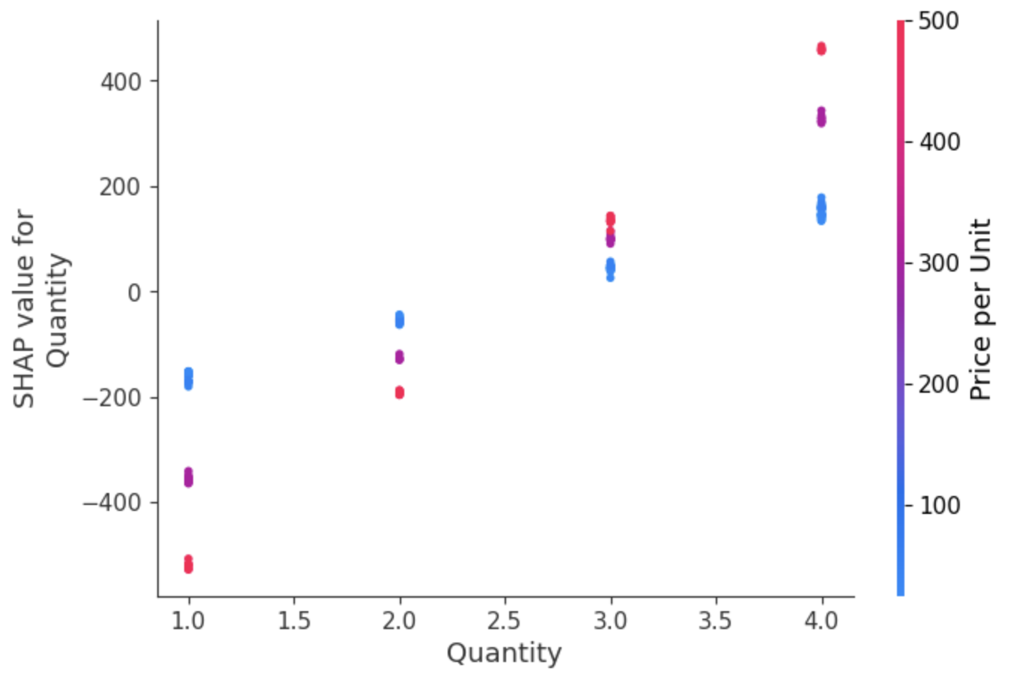
- SHAP dependence plot for Quantity: SHAP(Quantity) vs. raw Quantity value, color-coded by an interacting feature. Reveals the non-linear, interaction-driven contribution of purchase quantity to predicted total sales amount.

VIII. Applications
The framework has practical relevance across several areas of retail operations. In inventory management, accurate transaction-level forecasts enable more precise replenishment planning by product category, reducing the risk of stockouts in high-demand segments such as Electronics while
preventing overstock in slower-moving categories. In promotional planning, SHAP values for Product Category and Age allow marketers to identify which demographic segments respond most strongly to specific product promotions, enabling more targeted campaign design.
For financial planning, the high R² of the proposed model provides finance controllers with a reliable basis for revenue projections, replacing heuristic adjustments with data-driven estimates. Customer experience benefits indirectly: when the right products are available in the right quantities at the right time, purchase completion rates improve and satisfaction increases. The SHAP explanation layer makes the system deployable in environments where regulatory or organizational accountability requirements demand transparent AI decision-making.

IX. Conclusion and Future Scope
This paper presented a sales forecasting framework combining XGBoost with SHAP-based explainability, evaluated on a retail transaction dataset from Kaggle. The proposed model achieved an Accuracy of 93.55%, R² of 0.9986, RMSE of 19.92, RAE of 0.0278, and MAPE of 6.45%, outperforming Random Forest, Linear Regression, ARIMA, and LSTM across all metrics. SHAP analysis revealed that Price per Unit, Quantity, and Product Category are the dominant drivers of total sale amount, with Age and Gender contributing meaningful secondary effects.
Several directions for future work remain open. Incorporating temporal features such as day of week, month, and promotional period indicators could enable time-aware forecasting and capture seasonality effects not visible in cross-sectional transaction records. Extending the dataset to include multi-store or multi-region records would allow the model to generalize across heterogeneous retail environments. Probabilistic output extensions, such as quantile regression or conformal prediction intervals, would provide planners with uncertainty estimates alongside point forecasts. Deploying the system as a cloud-native API integrated with point-of-sale infrastructure would enable real-time inference and continuous model updating as new transactions are recorded.

Acknowledgment
The author gratefully acknowledges the Department of Computer Science and Engineering at Lovely Professional University, Phagwara, Punjab, India, for providing the academic support that made this work possible. The retail sales dataset used in the experiments is publicly available through the Kaggle platform.

References
- O. O. Mustapha and D. T. Sithole, "Forecasting Retail Sales using Machine Learning Models," Am. J. Stat. Actuar. Sci., vol. 6, no. 1, pp. 35–67, Apr. 2025, doi: 10.47672/ajsas.2679.
- N. Sunendar, H. P. Putro, and R. Hesananda, "Prediksi Penjualan Aerosol Menggunakan Algoritma ARIMA, LSTM Dan GRU [Comparison of ARIMA, LSTM and GRU Models for Sales Forecasting]," INSOLOGI: J. Sains dan Teknol., vol. 4, no. 1, pp. 113–126, Feb. 2025, doi: 10.55123/insologi.v4i1.4868.
- P. Ganguly and I. Mukherjee, "Enhancing Retail Sales Forecasting with Optimized Machine Learning Models," in Proc. 4th Int. Conf. Sustainable Expert Syst. (ICSES), 2024, pp. 884–889, doi: 10.48550/arXiv.2410.13773.
- S. Malik, M. Khan, M. K. Abid, and N. Aslam, "Sales Forecasting Using Machine Learning Algorithm in the Retail Sector," J. Comput. Biomed. Inform., vol. 6, no. 2, pp. 282–294, 2024. [Online]. Available: https://www.jcbi.org/index.php/Main/article/view/370
- A. Z. Elhendi et al., "Sales Forecasting for Retail Stores Using Hybrid Neural Networks and Sales-Affecting Variables," PeerJ Comput. Sci., vol. 11, e3058, Sep. 2025, doi: 10.7717/peerj-cs.3058.
- S. B. Punati, S. Kanta, U. B. Cheerala, M. G. Lanjewar, and P. Damacharla, "Temporal Fusion Transformer for Multi-Horizon Probabilistic Forecasting of Weekly Retail Sales," arXiv preprint arXiv:2511.00552, Nov. 2025. [Online]. Available: https://arxiv.org/abs/2511.00552
- C. Li, A. Lim, and J. Ou, "An Exponential Factorization Machine with Percentage Error Minimization to Retail Sales Forecasting," arXiv preprint arXiv:2009.10619, Sep. 2020. [Online]. Available: https://arxiv.org/abs/2009.10619
- T. Chen and C. Guestrin, "XGBoost: A scalable tree boosting system," in Proc. 22nd ACM SIGKDD Int. Conf. Knowledge Discovery Data Mining, San Francisco, CA, USA, Aug. 2016, pp. 785–794, doi: 10.1145/2939672.2939785.
- S. M. Lundberg and S.-I. Lee, "A unified approach to interpreting model predictions," in Adv. Neural Inf. Process. Syst. (NeurIPS), vol. 30, Long Beach, CA, USA, Dec. 2017, pp. 4765–4774.
- S. M. Lundberg et al., "From local explanations to global understanding with explainable AI for trees," Nat. Mach. Intell., vol. 2, no. 1, pp. 56–67, Jan. 2020, doi: 10.1038/s42256-019-0138-9.
- D. Doshi-Velez and B. Kim, "Towards a rigorous science of interpretable machine learning," arXiv preprint arXiv:1702.08608, Feb. 2017. [Online]. Available: https://arxiv.org/abs/1702.08608
- L. Breiman, "Random forests," Mach. Learn., vol. 45, no. 1, pp. 5–32, Oct. 2001, doi: 10.1023/A:1010933404324.

