HPSMS: WEB-BASED RECRUITMENT AND RECORD MANAGEMENT SYSTEM FOR HOTEL PRO SERVICES

A Capstone Project

Presented to the Faculty of the

Information and Communications Technology Program

STI College Sta. Maria

In Partial Fulfilment

of the Requirements for the Degree

Bachelor of Science in Information Technology

Rishon Vern N. Alejo

Michael Angelo G. Hibionada

Ned Christian Q. Mallari

Jan Jay I. Solemne

DECEMBER 08, 2023

ENDORSEMENT FORM FOR ORAL DEFENSE

TITLE OF RESEARCH: HPSMS: WEB-BASED RECRUITMENT AND RECORD MANAGEMENT SYSTEM FOR HOTEL PRO SERVICES

NAME OF PROPONENTS: Rishon Vern N. Alejo

Michael Angelo G. Hibionada

Ned Christian Q. Mallari

Jan Jay I. Solemne

In Partial Fulfilment of the Requirements

for the degree Bachelor of Science in Information Technology

has been examined and is recommended for Oral Defense.

ENDORSED BY:

Kid Bryan C. Valles

Capstone Project Adviser

APPROVED FOR ORAL DEFENSE:

Alfie Benito, MIT

Capstone Project Coordinator

NOTED BY:

Alfie Benito, MIT

Program Head

# December 08, 2023

# APPROVAL SHEET

This capstone project proposal titled: HPSMS: WEB-BASED RECRUITMENT AND RECORD MANAGEMENT SYSTEM FOR HOTEL PRO SERVICES prepared and submitted by Rishon Vern N. Alejo, Michael Angelo G. Hibionada, Ned Christian Q. Mallari, and Jan Jay I. Solemne, in partial fulfillment of the requirements for the degree of Bachelor of Science in Information Technology, has been examined and is recommended for acceptance and approval.

Kid Bryan C. Valles

Capstone Project Adviser

Accepted and approved by the Capstone Project Review Panel

in partial fulfillment of the requirements for the degree of

Bachelor of Science in Information Technology

|  |  |
| --- | --- |
| Sharmaine Cruz | Judilyn Belda |
| Panel Member | Panel Member |

Marjon Alarcon

Lead Panelist

Noted:

|  |  |
| --- | --- |
| Alfie Benito, MIT | Alfie Benito, MIT |
| Capstone Project Coordinator | Program Head |

December 08, 2023

# Acknowledgements

The Programmers would like to thank Sir Kid Bryan Valles, Capstone Adviser, for all of his help throughout the capstone project and encouragement made this capstone possible. His guidance and advice about the capstone project help the Programmers.

The Programmers would like to give a special thanks to Sir Alfie Bernado Benito teachings carried through all the stages of writing the Capstone project and arranging a mock defense for the Programmers to enhanced the knowledge about the Capstone project.

Finally, The Programmers would like to thank the Panelists, for giving us pointers and advice for the Capstone project. The Panelists advices help the Programmers to make this Capstone possible.

# Abstract

Title of research**: HPSMS: The Web Based Recruitment and Record Management System for Hotel Pro Servinces Inc.**

Researchers: Rishon Vern N. Alejo

Michael Angelo G. Hibionada

Ned Christian Q. Mallari

Jan Jay I. Solemne

Degree: Bachelor of Science in Information Technology

Date of Completion: 2024

Key words: Human Resources, Application Employment

This capstone project explores the integration of Information Technology in order to enhance applicant and employment processes of Hotel Pro Services has been in operation for years. In an era of digital transformation and innovation, hospitality industries face a paradigm shift towards automation and efficiency. This research focuses digitalization of manual processes associated with applicant and deployment management aiming to optimize workflows, reduce operational costs, and improve overall organizational effectiveness.

The study begins with an in-depth analysis of the current manual employment processes in Hotel Pro Services Inc., identifying pain points and areas for improvement. Subsequently, the research delves into the design and development of a comprehensive Hotel Pro Services Management System (HPSMS) module specifically tailored for helping Senior HR and HR Managers tasks related to applicant recruitment, deployment, performance management, and record-keeping.

Additionally, the capstone project will evaluate the impact of the digitalized applicant processes on key performance indicators, such as time efficiency, cost reduction, and client satisfaction. Real-world case studies and pilot implementations in collaboration with hotel industry partners will be utilized to validate the effectiveness and practicality of the proposed system.

The outcomes of this research aim to contribute to the broader discussion on the digital transformation of the Hotel Pro Services sector, offering insights and recommendations for HR managers, IT professionals, and other clients seeking to leverage technology for improved operational efficiency and employee management in the ever-evolving landscape of HPS management.

# Table of Contents

|  |  |  |
| --- | --- | --- |
|  | | Page |
| Title Page | | i |
| Endorsement form for Oral Defense | | ii |
| Abstract | | iii |
| Approval Sheet | | iv |
| Acknowledgments | | v |
| Table of Contents | | vi |
| List of Figures | | viii |
| List of Tables | | ix |
| Introduction | | 1 |
|  | Project Context | 1 |
|  | Purpose and Description of the Project | 3 |
|  | Objectives of the Study | 4 |
|  | Scope and Limitations of the Study | 6 |
| Review of Related Literature/Systems | | 9 |
|  | Related Literature | 9 |
|  | Related Studies and/or Systems  Synthesis | 15  16 |
| Technical Background | | 19 |
|  | Overview of Current Technologies to be Used in the System | 19 |
|  | Calendar of Activities | 20 |
|  | Resources | 22 |
| Methodology, Results, and Discussion | | 23 |
|  | Requirements Analysis | 23 |
|  | Requirements Documentation | 24 |
|  | Design of Software, System, Product, and/or Processes | 31 |
|  | Development and Testing | 44 |
|  | Testing and Evaluation Plan | 54 |
|  | Testing and Evaluation Results | 55 |
| Conclusions and Recommendations | | 64 |
| References | | 65 |
| Appendices | | 65 |
|  | Resource Persons | 67 |
|  | Grammar and Plagiarism Checker | 68 |
|  | Personal Technical Vitae | 69 |
|  | |  |

# List of figures

|  |  |  |
| --- | --- | --- |
| **Table** |  | **Page** |
| 1 | The Input-Process-Output Model | 17 |
| 2 | Login Module | 25 |
| 3 | Create Account |  |
| 4 | Home | 26 |
| 5 | Record Stage |  |
| 6 | Archive | 27 |
| 7 | Deployment | 28 |
| 8 | Account Settings |  |
| 9 | Audit Log | 29 |
| 10 | Senior HR StoryBoard | 30 |
| 11 | HR Storyboard |  |
| 12 | Coordinator StoryBoard | 31 |
| 13 | Employee Storyboard |  |
| 14 | Whole Human Resource Manager Process | 37 |
| 15 | Senior Human Resource Manager (admin) Process | 38 |
| 16 | Human Resource Process | 39 |
| 17 | Applicant | 40 |
| 18 | Entity Relationship Diagram (ERD) | 41 |
| 19 | Agile Development Methodology | 42 |
| 20 | Desktop view of the project | 45 |
| 21 | Mobile view of the project |  |
| 22 | Login Module | 46 |
| 23 | Senior HR and HR Dashboard |  |
| 24 | Coordinator Dashboard | 47 |
| 25 | Applicant Dashboard |  |
| 26 | Senior HR and HR Post Job list | 48 |
| 27 | Applicant’s Job list for application |  |
| 28 | Coordinator’s Job list | 49 |
| 29 | Coordinator’s Request Module |  |
| 30 | Senior HR and HR manager’s Post a Job module | 50 |
| 31 | Senior HR and HR manager’s Applicant’s List module |  |
| 32 | Senior HR and HR manager’s Queuing List module | 51 |
| 33 | Senior HR and HR manager’s Employee List module |  |
| 34 | Senior HR and HR manager’s Archive module | 52 |
| 35 | Senior HR and HR manager’s Request List module |  |
| 36 | Senior HR and HR manager’s User List module | 53 |

# List of tables

|  |  |  |
| --- | --- | --- |
| Table |  | Page |
| 1 | Benchmarking | 14 |
| 2 | Gantt Chart of Activities | 21 |
| 3 | Test Case | 44 |
| 4 | Functionality of HPSMS Web Application | 55 |
| 5 | Reliability of HPSMS Web Application | 56 |
| 6 | Usability of HPSMS Web Application | 57 |
| 7 | Efficiency of HPSMS Web Application | 58 |
| 8 | Maintainability of HPSMS Web Application | 59 |
| 9 | Portability of HPSMS Web Application | 60 |
| 10 | Summary Table of HPSMS Web Application | 61 |
| 11 | IT Specialist Evaluation Table | 62 |

# Introduction

## Project Context

The Hotel Pro Services, Inc. (HPS) has been catering manpower needs for five-star hotels since 1996 to Present, and is responsible for finding qualified, relevant candidates to fill job vacancies.They are located in Robinsons Equitable Tower, Ortigas Center, Pasig City, Philippines. HPS’s mandate is to deploy, supervise, and select all applicants applying in five-star hotels. They are committed to establishing a strong and lasting working relationship with their customers and employees and to meeting their unique requirements. They are a group of experienced professionals who have an extensive exposure in the hotel and restaurant operations, they have not only the expertise required by the meticulous and detailed arena of the hotel duties but also the integrity and commitment to establish a stable and lasting relationship with their valued clients-partners, Customer satisfaction is their commitment. Hotel Pro’s weekly recruitment goal is to attract approximately 200 well-qualified applicants. In the process, they typically review a total of around 450 applicants each week, including those who may not meet the necessary qualifications. From this pool of applicants, the company successfully hires approximately 44% of them, ensuring that their recruitment process remains competitive and selective in securing the most suitable candidates for their positions.

According to Mrs. Maria Judith Solemne, the senior HR of Hotel Pro Services, Inc., the current process of the services they provide in regards to the deployment of an applicant for five-star hotels is that they first post on their Facebook page and other social media platforms about the job hiring. When an applicant insists that they are interested, they need to send their resume via e-mail. The resume will be read and comprehended by the Human Resource(HR) for certain applicants to be accepted in the HPS. Choosing qualified applicants is the next phase, which in return asks the applicant to submit certain requirements such as the resume, birth certificate,Social Security System(SSS), National Bureau of Investigation clearance (NBI), and alike**,** to the HR. After passing their first interview and submitting the necessary requirements, they will receive right away their

located jobs where they will be deployed giving the Hotel’s address and time for the second interview. On the other hand, some applicants are added to the queuing for future jobs and notify them via e-mail or SMS (text message). After attending the orientation on their designated hotels, the applicant will go to their respected location and from there, they will be given their tasks.

After learning about the current process of HPS, the proponents have conducted an interview with the senior HR of HPS, Mrs. Maria Judith Solemne, she told the proponents about the current problems that they have, such as the piling up of the papers, which is taking up a lot of space in the office. Also, when it comes to the other processes, just like when they’re trying to sort out the files of the applicants and employees. They are having difficulty sorting it out, since there are too many files. Editing applicant information in Excel was also an inconvenient for them. The applicant lists are hard to edit since they must do it in every transaction with the hotels. The mobility of documents depends on the delivery personnel towards the hotel the applicant will be hired from. This results in time-consuming and expensive delivery fees that are not necessarily needed for operation.

Additionally, besides the interview questions that the proponents have made, which was necessary to get the specific information that they needed. They also asked them other questions which brought about the problems. In summary, HPS Human Resources have encountered several issues in their office processes. Firstly, the absence of an online database has resulted in the accumulation of hard copies of various files, making them vulnerable to damage. Secondly, there has been a challenge in effectively notifying applicants about their assigned hotels and orientation schedules. Thirdly, the storage room has posed difficulties in searching and organizing files for both applicants and employees. Lastly, the absence of an official web application has made it challenging to locate potential applicants. These problems collectively highlight the need for improvements in the office's file management system, communication methods, and online presence.

## Purpose and Description of the Project

The purpose of the Web-based Recruitment and Record Management system for Hotel Pro Services is to provide an efficient way of acquiring, recruiting and deploying an applicant for the agency. It is also a platform where job seekers may easily apply for open positions by filling up their resume online. This Web-Application will also link the HPS to a wider internet audience.

The proposed system for HPS is designed as a web-based system. The web application offers a user log-in for all type of users such as the Senior HR manager, HR managers, coordinators and employees or applicants to ensure security and prevent the modification of files. The search process of locating an applicants’ files is fast and efficient provided by a search bar. Also, the webs applicaton utilizes a database to store thousands of files without requiring a physical space. The system features a built-in e-mail messaging feature that would send an e-mail to the applicants with their schedule and designated hotels in order to reduce the tedious, time-consuming individual messaging with a mobile phone.

There are four different kinds of users who can access the system. The Senior HR and the HR manager, are in-charge of monitoring, hiring and deploying applicants into their designated hotels. Coordinators can request manpower to HPS and view lists of accepted employees. Applicants can view open positions, job description and details, on their accounts where they can apply online as well. Once an applicant has been accepted, their account will then become an employee account that can upload remaining necessary files in the webapplication.

The applicants can access the web application once they created an account. Only the Senior HR can create an account for the HR managers and coordinators. Applicants must input their name, e-mail, position. Then, the Senior HR and HR manager is able to view requirements by just searching the applicants name.

With the help of the system, the Human Resource can see the documents they needed easily using the platform. It will serve them as a tool that can be used by senior HR and HR manager in order to improve the overall management. It can be essential for the HR departments as it can be useful to improve the management of their documents. The aim of this project is to assist the HR for an efficient management of documents without going to storage room to search needed files.

Objectives of the Study

The General objective of the study is developing a tool that translates the operations of the Human Resource (HR) in processing applicants into online processes.

To developed an additional tool for faster process of accepting applicants’ data.

The developers developed a system that helps the HR in monitoring documents by making the applicants upload their files in a softcopy manner. The HR can search and retrieve applicant documents efficiently by just searching it in the search bar.

To implemented a feature that will be able to deploy applicants effectively.

This feature helps with faster deployment of the applicant by selecting and sending a list of employees for deployment to the coordinator. This feature assists an immediate deployment of applicants to hotels who requested manpower, deploying faster to replenish the lack of workers in hotels that needs additional workers.

To developed a feature that will archive and save valuable documents and information of the applicants.

Archiving records and secures the files of the hotel's valuable information into a database. The database can assist managers in centrally, precisely, and securely managing their company's increasing amounts of critical data

To implemented security feature to protect company's application and database.

Developed a security feature to protect crucial data in HPS by providing a user login. Only the Senior HR has the privilege to create an account for the HR managers and coordinators.

To implemented a feature to track applicants data

According to Hotel Pro Service Inc. applicants with incomplete requirements could also be accepted but the wage will be delayed until completion of their documents. The Senior HR and HR take time to check if the requirement is complete or not. In order to check if the data is complete or not, the developers implemented a feature that will track their records. It also adds status to the specific applicant’s completion of requirements.

Scope and Limitations of the Study

The study modernized and optimized the recruitment and record management system processes within Hotel Pro Services Inc., leading to improved efficiency, better applicant experience, and enhance decision-making of the Human Resources office consisting the Senior HR manager and the HR managers. The interview was conducted through Microsoft teams with the Senior HR manager, Mrs. Solemne.

The developers developed a recruitment and recording web-based application for Hotel Pro Services since they are still using manual system in their recruiting and deploying of applicants. There are four different kind of users who can access the system. The senior HR or Admin who is the first user and in charge of creating the accounts of HR managers and coordinators. Other user is the applicant or employee account that can apply online and pass their requirements digitally.

Throughout the study, here are the modules developed in the system:

Senior HR Manager

* Login – a module where the Senior HR manager can access the system by entering their email and password credentials.
* Applicants List – a module where the Senior HR manager can access and review the lists of job applicants.
* Deployment Module – a module is integrated to enable Senior HR manager to send e-mails to applicants, providing them with information about their schedules and assigned hotels.
* Dashboard – a module where the Senior HR manager can view available features.
* Account Management – a module that allows the Senior HR manager to generate user accounts for HR managers and coordinators. Additionally, this module provides the functionality for them to modify their account passwords.
* Employees List – A module is incorporated to facilitate the Senior HR manager’s access to a comprehensive list of employees and their respective assigned hotels.

HR Manager

* Login – a module where the HR manager can access the system by entering their e-mail and password credentials.
* Applicants List – a module where the HR manager can access and review the lists of job applicants.
* Deployment Module – a module is integrated to enable HR manager to send e-mails to applicants, providing them with information about their schedules and assigned hotels.
* Dashboard – a module where the HR manager can view available features.
* Employees List – A module is incorporated to facilitate the HR manager’s access to a comprehensive list of employees and their respective assigned hotels

Coordinator

* Login - a module where the coordinator can access the system by entering their e-mail and password credentials.
* Dashboard - a module where the coordinator can view available features.
* Request module - a module is implemented within the web application that enables coordinators to submit manpower requests to HPS by sending emails directly through the platform.
* Employees List – a module implemented to enable coordinators to access and view the list of employees that HPS is sending to them.

Employees or Applicants

* Login - a module where the employees or applicants can access the system by entering their e-mail and password credentials.
* Dashboard - a module is created to provide applicants with the ability to access and observe job openings.
* Upload module - a module is specifically designed to provide employees pass their necessary requirements digitally.

Limitations

The web-based management system for the Hotel Pro Services Inc., has certain limitations. Firstly, the system can only be used and accessed through compatible devices such as computers and smartphones. Finally, users will need access to a computer or smartphone with an internet connection to utilize the web-based system. Other devices, such as tablets or smart TVs, are not supported. The web application does not include the payroll, delivering files to coordinator and tracking of employee. Lastly, the web application can only be accessed by users who have accounts.

# review of related literature/systems

## Review of Related Literature

Data Processing

By utilizing data processing methods, managers can automate various tasks, analyze vast amounts of data, and base their decisions on data-driven insights. This leads to enhanced efficiency and effectiveness in managing their human resources. Data processing enables them to handle recruitment processes more efficiently by gathering and evaluating applicant data, leading to quicker candidate screening and selection.

According to Gupta B., (2013), The HR software is no longer just the data storage systems that we once knew, it is now packed with features and is independent. The recently established Human Resources Information System assists the organization with accurate and secure storing of employee data. HR professionals can now use modern HR Information Systems as tools on a regular basis for a variety of purposes. Companies used to track data using spreadsheets and paper in the past. With the development of technology, many businesses have realized the necessity of implementing advanced computerized systems, such as human resource information systems. Companies who convert to the Human Resources Information System are able to maintain more precise and up-to-date information, enabling them to better plan for future growth in their businesses. In most circumstances, an HRIS will also result in greater HR decision-making efficiency. The decisions implemented should also be of a greater quality; as a result, both managers' and employees' efficiency ought to increase.

Based on Ahaduzzaman M. (2023), the selection of the personnel for which an inventory is to be made, the cataloging of each employee's factual information, an organized and thorough evaluation of these employees, and a thorough examination of those who have growth potential are all steps in the process of creating a human resource inventory. Along with storing the number of employees, it involves categorizing the traits of the workers. In the manpower inventory, both current and potential employee qualities are listed. Choosing who will be included in the manpower inventory is the first stage. The second step that follows is to gather data on them. Age, experience, education, health, health-related reports, attitude, and other factual information will be noted from the records. The brief interviews with people will help in determining his capabilities, attitudes, goals, motivations, etc. Each person has a prepared summarized statement of information that is kept on hand for consultation. The data will assist management in identifying individuals within the company who are qualified to hold higher-level positions in the future. This will also make it possible for management to decide whether or not outside help will be needed in the future. The manager will be able to determine each person's potential in the present and the future, as well as their suitability for various positions, thanks to the manpower inventory.

Personio (2016), the application Personio was founded in 2015 by Hanno Renner, Roman Schumacher, Arseniy Vershinin, and Ignaz Forstmeier. Afterwards, Jonas Rieke joined the company. In a single piece of software, Personio automates and streamlines HR operations so that employees have enough time to focus on important human resources (HR) matters. Data and procedures that are efficiently integrated for their benefit. Statista sought a central tool with a certain amount of flexibility. Documents and data for HR operations should be kept in a single location and maintained centrally.

Deployment

The deployment of an employee module on the web application streamlines HR processes, improves efficiency, and enhances the user experience for both HR professionals and employees. It enables smoother onboarding, effective HR performance, and enable quick and timely access to huge datasets.

Oracle HRMS (2011), is a key part of the Oracle E-Business Suite of software. This automatically creates or modifies personnel records in the destination business group at the beginning of the deployment. Employee records in the source business group are deleted by HRMS if the transfer is permanent. The employee's present assignments are suspended if the transfer is temporary, according to HRMS. The employee's record in the destination business group is automatically terminated upon temporary deployment completion, and any suspended assignments are automatically reinstated in the source business group through HRMS.

According to the Human Resource Management (2011), an essential component of human resource management (HRM) is the hiring process. Without careful strategic planning, it cannot be completed. The definition of recruitment is a procedure that creates a pool of qualified job candidates for the business to select from. Companies must execute proper staffing strategies and forecasting to ascertain the number of employees they will require before hiring. The organization's annual budget as well as its short- to long-term intentions, such as potential expansion, will serve as the foundation for the forecast. The organizational life cycle will also be a consideration.

Real-Time Monitoring

Real-time monitoring helps the web application by providing immediate alerts and insights on performance issues, user activities, and server health, enabling the user to quickly address and resolve any problems to ensure smooth operations and optimal user experience.

According to Burnett, J., & Lisk, T. (2019), never before have businesses had as many opportunities to assess the productivity and efficacy of their employees. Leading businesses have been able to take use of new technologies that track productivity, sales, client satisfaction, work flows, quality, and workplace interactions frequently, sometimes in real time. Despite the fact that not all businesses have yet to adopt the tools and technology at their use. Additionally, with the more accessible availability of statistical modeling, machine learning technologies, and artificial intelligence applications in recent years, the tools to combine and evaluate this data have also evolved quickly. However, the majority of businesses still use conventional survey methods to measure and track employee engagement on an annual basis, if not longer. It is time to reconsider how organizations measure engagement and, more importantly, how the same digital tools can be used to increase the productivity, retention, and satisfaction of the workforce. These practices have given businesses wealth of insight into the dimensions and impact of engagement.

According to Joyce, K. (202), real-time analytics are increasingly being used, which is likely a continuation of the Human Resources adoption of data. Big data streaming systems are being used by more and more businesses to receive real-time analysis of their data. While most analytics have concentrated on using historical data to guide decisions in the future, event streaming can offer a real-time snapshot that companies can use right away. Instantaneous actionable insights are becoming increasingly crucial for businesses globally.

**Search Engine**

The integration of a search engine on the web application improves the overall usability and accessibility of information. It empowers users to find what they need quickly, promotes self-service, and enhances the effectiveness of HR processes and operations.

According to Laroui (2019), Users (especially decision makers) can utilize the data stored in their databases more easily and quickly when there is fast and simple access to big amounts of data. Advanced search engines can be an excellent tool for improving problem solving, learning, and decision making, whether to generate predictions based on previous data or to access old materials. Enterprise search engines are essential for enterprises because they enable quick and timely access to huge datasets, which helps companies increase productivity.

**Responsive**

A responsive web application design to ensures that the web application adapts and functions seamlessly across various devices, such as desktop computers, laptops, tablets, and smartphones. This flexibility in design allows HR professionals and employees to access the web application and its features with optimal user experience, regardless of the device they are using.

According to Newsome, B. (2015) Windows Forms applications offer benefits for specific types of systems. These typically include applications that need a fast and responsive interface, such as a retail point-of-sale system. Additionally, processor-intensive applications like games and graphics programs are generally better suited for a Windows Forms program. It's important to consider the specific requirements of a system and the capabilities of the development team when selecting the appropriate technology stack for a project.

Benchmarking Table

Table 1: Benchmarking Table

|  |  |  |  |  |  |  |
| --- | --- | --- | --- | --- | --- | --- |
| FEATURES | Personio | Oracle HRMS | BambooHR | Sprout Solution | Akrivia HCM | HPSMS: WEB-BASED RECRUITMENT AND RECORD MANAGEMENT SYSTEM FOR HOTEL PRO SERVICES |
| Data Processing | ✓ | ✓ | ✓ | ✓ | ✓ | ✓ |
| Deployment |  |  |  | ✓ |  | ✓ |
| Real-time Monitoring |  | ✓ |  | ✓ |  | ✓ |
| Search Engine | ✓ | ✓ | ✓ |  | ✓ | ✓ |
| Responsive |  |  | ✓ |  |  | ✓ |
| Recruitment | ✓ | ✓ | ✓ | ✓ | ✓ | ✓ |

## Related Studies and/ or Systems

Benchmarking serves as a valuable tool in evaluating and enhancing various aspects of a human resource web application for application and deployment. The developers utilize benchmarking to compare features with other applications, identifying strengths and areas for improvement to enhance the application's overall performance.

When comparing HPSMS with similar applications such as Applicant Tracking System, Human Resource Management Systems, and Recruitment Portals, it is evident that HPSMS stands out due to its simplicity and easy to understand functions. While the other applications share many features, HPSMS distinguishes itself by ensuring seamless access and monitoring of the requirements of applicants and their deployment.

HPSMS's flexibility is further highlighted by the addition on a job list on dashboard feature, allowing applicants to choose the jobs they want to apply to easilty with the complete requirements detailed on the job post. This feature empowers HR managers to help applicants apply faster and lesser delay time for deployment.

Critical features such as Reports, Queuing lists, Applicant list, and Requests provide essential information for developing faster deployment, devising effective and informed decisions. HPSMS’s comprehensive functionality and adaptability make it a standout tool for human resource managers, particularly in helping of the manual process of Hotel Pro Services Inc. in their recruitment and deployment.

**Synthesis**

This section discussed the systematic background information, essential features, and implementation of the Online Reservation and Inventory Management System to study and analyze other online systems. Studying other systems can aid in the development of a more complete and efficient system. These studies discuss how to implement a developed system. Excellent characteristics of the researched online reservation and inventory management system in the developed system.

The authors discuss different aspects of human resource management and its related technologies. Gupta (2013) notes that human resources information systems (HRIS) are now packed with features and can assist organizations in accurately and securely storing employee data. Ahaduzzaman (2023) explains that creating a human resource inventory involves selecting personnel, cataloging factual information, and evaluating current and potential employee traits to identify individuals with growth potential. Personio (2016) automates and streamlines HR operations to free up time for important HR matters. Oracle HRMS (2011) automatically creates or modifies personnel records in the destination business group at the beginning of the deployment. Human Resource Management (2011) emphasizes that recruitment requires proper staffing strategies and forecasting based on the organization's annual budget and short- to long-term goals. Laroui (2019) notes that enterprise search engines are essential for quick and timely access to huge datasets, improving productivity. Newsome (2015) highlights the benefits of Windows Forms applications for specific types of systems that require a fast and responsive interface, such as retail point-of-sale systems and processor-intensive applications. Real-time monitoring enables businesses to assess employee productivity and effectiveness by tracking various metrics in real time, according to Burnett and Lisk (2019). While some organizations still rely on conventional surveys, the availability of statistical modeling and AI has advanced data evaluation. Organizations should leverage digital tools to measure engagement and enhance productivity and retention. Additionally, Joyce (2020) emphasizes the growing use of real-time analytics in HR, where big data streaming systems provide instantaneous insights for immediate decision-making. This highlights the increasing significance of real-time actionable insights for businesses globally.

Conceptual Model of the Study

In this study, the developers employed the Input – Process – Output, or IPO Model. It refers to the representation of all the factors that comprise a process, including the materials and information required. The input is what goes in; the process is what causes the change, and the output is what comes out. The IPO model will serve as a general structure and guide for the study's direction.

INPUT PROCESS OUTPUT

Knowledge Requirements

• Data Gathering through

Interview with the

Senior HR

• Research and Related

Literature Studies and

System

Software Requirements

• HTML, CSS and JavaScript

• Visual Code

• Sql

Hardware Requirements

• Stable Internet

Connection

• Processor Intel(R)

Core(TM) i3-9th

CPU @ 2.50GHz, 2496

Mhz, 4 Core(s), 8

Logical Processor(s)

• Installed Physical

Memory (RAM) 4.00 GB

• Mouse Optical Mouse

Requirements

Design

Development

Testing

Deployment

Review

HPSMS: Web-based Recruitment and Record Management system for Hotel Pro Services

EVALUATION

Figure 1. The Input-Process-Output Model

In the IPO Model, the inputs are the materials or data gathered that are gained from human resources. In the processing steps, there will be a task that is required to affect the transformation of the inputs. Lastly, the outputs are the data and materials that came out of the transformation process is the result of the project. The developers used this methodology since it is a model approach that has been historically dominant, and it will be suited to do the projects

Input - The developers observed that one of the concerns in Hotel Pro Services INC is the concern of the HR about the slow process of the applicants. The HR has been struggling to document an applicants file and keeping the files safe.The proponents are thinking about how to utilize a web-based platform for speeding up the documentation of the applicants

Process - After the observation, the developers collect some data requirements from the Senior HR. The developers will design and develop a web-based application that is suitable for them. The proponents will use a methodology that will help the study be feasible and implement the project

Output - Lastly, the outcome of the web-based application Platform for Hotel Pro Services INC. helps the HR resolve their struggles regarding documenting, inventorying and deploying an application

## TECHNICAL BACKGROUND

## Overview of Current Technologies to be Used in the System

Managers typically seek alternative methods for filing documents in order to make them more easily accessible. Proper categorization of documents is crucial, with an emphasis on alphabetical or numerical order, color coding, labeling, and chronological organization. The HR department is responsible for organizing and maintaining these documents in a storage room for both employee and applicant records. This filing system allows for easy access to documents when needed, but it can be time-consuming to retrieve them.

The ability to access applicant documents is particularly important during periods of high mobilization or sudden increases in hiring needs. When numerous documents need to be retrieved and processed quickly, the abundance of paperwork can create difficulties in assembling and deploying candidates.

The developers decided to use SQL database as the primary database for their system due to its ability to efficiently handle and manage structured data. SQL databases offer robust data storage, retrieval, and management capabilities, making them ideal for storing and processing HR-related information. utilize. With SQL databases, proponents can ensure data integrity, enforce relationships between different HR entities, perform complex queries, and maintain a high level of data security. The structured nature of SQL databases provides a reliable foundation for the web application, facilitating efficient data organization, analysis, and decision-making processes.

## Calendar of Activities

The first meeting of the developers and capstone adviser was held on March 16, 2023, where-in Chapter 1 of the documentation was discussed and the preview of Chapter 2. Also, the day they discussed what will be title of the project. The next day, the professor gave the references and how the system work. After this discussion, the developers discussed what kind of system, it can do and presented it to the professor. After the presentation, the developers discussed if either web-based or just a windows form application will be used, and the chosen system is Web-based application.

The developers started the documentation after the system was approved. Also the proponents started to create the system and find a variety of sources to have online servers.In this case, the software will be known as a secured web-based by the application. In the 2nd week of March, the developers finished and revised Chapter 1of the documentation and in the 3rd week of March the proponents finished Chapter 2 and Chapter 3.

The developers have started the design and prototyping by the start of July creating progress and developing the front-end of the web application. At the 2nd of October the developers started the development and testing of the program for implementation and software deployment . after this the developers have started their review of the HPSMS Web Application at the 3rd week of November. Finalizing the proposed project.

**Gantt Chart of Activities**

|  |  |  |  |  |  |  |  |  |  |  |  |  |  |  |  |  |  |  |  |  |  |  |  |  |  |  |  |  |  |  |  |  |  |  |  |  |  |  |  |  |
| --- | --- | --- | --- | --- | --- | --- | --- | --- | --- | --- | --- | --- | --- | --- | --- | --- | --- | --- | --- | --- | --- | --- | --- | --- | --- | --- | --- | --- | --- | --- | --- | --- | --- | --- | --- | --- | --- | --- | --- | --- |
| MONTH | FEBRUARY | | | | MARCH | | | | APRIL | | | | MAY | | | | JUNE | | | | JULY | | | | AUGUST | | | | SEPTEMBER | | | | OCTOBER | | | | NOVEMBER | | | |
| ACTIVITY |
| Title Proposal |  |  |  |  |  |  |  |  |  |  |  |  |  |  |  |  |  |  |  |  |  |  |  |  |  |  |  |  |  |  |  |  |  |  |  |  |  |  |  |  |
| Final Title Proposal |  |  |  |  |  |  |  |  |  |  |  |  |  |  |  |  |  |  |  |  |  |  |  |  |  |  |  |  |  |  |  |  |  |  |  |  |  |  |  |  |
| Data Gathering |  |  |  |  |  |  |  |  |  |  |  |  |  |  |  |  |  |  |  |  |  |  |  |  |  |  |  |  |  |  |  |  |  |  |  |  |  |  |  |  |
| Chapter 1 |  |  |  |  |  |  |  |  |  |  |  |  |  |  |  |  |  |  |  |  |  |  |  |  |  |  |  |  |  |  |  |  |  |  |  |  |  |  |  |  |
| Chapter 1 Revision |  |  |  |  |  |  |  |  |  |  |  |  |  |  |  |  |  |  |  |  |  |  |  |  |  |  |  |  |  |  |  |  |  |  |  |  |  |  |  |  |
| Chapter 2 |  |  |  |  |  |  |  |  |  |  |  |  |  |  |  |  |  |  |  |  |  |  |  |  |  |  |  |  |  |  |  |  |  |  |  |  |  |  |  |  |
| Chapter 2 Revision |  |  |  |  |  |  |  |  |  |  |  |  |  |  |  |  |  |  |  |  |  |  |  |  |  |  |  |  |  |  |  |  |  |  |  |  |  |  |  |  |
| Requirments |  |  |  |  |  |  |  |  |  |  |  |  |  |  |  |  |  |  |  |  |  |  |  |  |  |  |  |  |  |  |  |  |  |  |  |  |  |  |  |  |
| Chapter 3 |  |  |  |  |  |  |  |  |  |  |  |  |  |  |  |  |  |  |  |  |  |  |  |  |  |  |  |  |  |  |  |  |  |  |  |  |  |  |  |  |
| Chapter 3 Revision |  |  |  |  |  |  |  |  |  |  |  |  |  |  |  |  |  |  |  |  |  |  |  |  |  |  |  |  |  |  |  |  |  |  |  |  |  |  |  |  |
| Review & Revision |  |  |  |  |  |  |  |  |  |  |  |  |  |  |  |  |  |  |  |  |  |  |  |  |  |  |  |  |  |  |  |  |  |  |  |  |  |  |  |  |
| Design & Prototyping |  |  |  |  |  |  |  |  |  |  |  |  |  |  |  |  |  |  |  |  |  |  |  |  |  |  |  |  |  |  |  |  |  |  |  |  |  |  |  |  |
| Prototyping Front-End UI |  |  |  |  |  |  |  |  |  |  |  |  |  |  |  |  |  |  |  |  |  |  |  |  |  |  |  |  |  |  |  |  |  |  |  |  |  |  |  |  |
| Prototyping Back-End UI |  |  |  |  |  |  |  |  |  |  |  |  |  |  |  |  |  |  |  |  |  |  |  |  |  |  |  |  |  |  |  |  |  |  |  |  |  |  |  |  |
| Programing Front -End UI |  |  |  |  |  |  |  |  |  |  |  |  |  |  |  |  |  |  |  |  |  |  |  |  |  |  |  |  |  |  |  |  |  |  |  |  |  |  |  |  |
| Programing Back -End UI |  |  |  |  |  |  |  |  |  |  |  |  |  |  |  |  |  |  |  |  |  |  |  |  |  |  |  |  |  |  |  |  |  |  |  |  |  |  |  |  |
| Main Programing |  |  |  |  |  |  |  |  |  |  |  |  |  |  |  |  |  |  |  |  |  |  |  |  |  |  |  |  |  |  |  |  |  |  |  |  |  |  |  |  |
| Testing |  |  |  |  |  |  |  |  |  |  |  |  |  |  |  |  |  |  |  |  |  |  |  |  |  |  |  |  |  |  |  |  |  |  |  |  |  |  |  |  |
| Software Deployment |  |  |  |  |  |  |  |  |  |  |  |  |  |  |  |  |  |  |  |  |  |  |  |  |  |  |  |  |  |  |  |  |  |  |  |  |  |  |  |  |
| Review |  |  |  |  |  |  |  |  |  |  |  |  |  |  |  |  |  |  |  |  |  |  |  |  |  |  |  |  |  |  |  |  |  |  |  |  |  |  |  |  |
|  |  |  |  |  |  |  |  |  |  |  |  |  |  |  |  |  |  |  |  |  |  |  |  |  |  |  |  |  |  |  |  |  |  |  |  |  |  |  |  |  |
|  |  |  |  |  |  |  |  |  |  |  |  |  |  |  |  |  |  |  |  |  |  |  |  |  |  |  |  |  |  |  |  |  |  |  |  |  |  |  |  |  |

## Resources

## Hardware - Recommended Hardware Specification

Intel Core(TM) i3 – 9th CPU @ 2.50GHz, 2496 Mhz 4 Core(s)

4GB RAM

500 GB Solid State Drive or Hard Disk Drive

## Software - Below are the software required in order for the developers to develop the project.

**Visual Studio Code 2022** - Visual Studio Code is a source-code editor that can be used with a variety of programming languages, including C, C#, C++, JavaScript, Python, and the like. It is based on the Electron framework, which is used to develop Node. js web applications that run on the Blink layout engine.

**Structured Query Language (SQL) -** is a standardized programming language used for managing and manipulating relational databases. It provides a set of commands and syntax for querying, inserting, updating, and deleting data within a database.

**C# Programming Language -** is a powerful, modern, and general-purpose programming language developed by Microsoft. It was first introduced in 2000 and has since become one of the most popular languages for building a wide range of applications, including desktop, web, mobile, and gaming applications.

# Methodology

## Requirements Analysis

Prior to development of Hotel Pro Services Managements Systems or HPSMS for Hotel Pro Services Inc., it is critical for the developers to evaluate and assess all the approaches required to provide beneficial solutions to the challenges posed at the start of the study. Recognizing the who, what, where, when and how is it vital.

HPSMS is a web application application based management system with deployment feature that provides Hotel Pro Services Inc. the capacity to manage it’s applicant’s deployment and manage applicant data. The application allows the admin to register all the necessary data, and accounts for the HR and Senior HR to use. Making it easier for the Human Resources Managers to accommodate and manage the required data coming from the applicants, while the applicants register their required data and requirements for applying to a hotel or event.

Aside from the developers who are tasked with the creation of HPSMS, the system will be implemented within HPS Inc. to provide easy to use and organized management system and deployment. The system was designed as a tool for HR to help them have an easier and foster interaction to provide effective and effieciency in applicant’s deployment.

The HPSMS web application is created and is exclusive for Hotel Pro Services Inc.’s benefit which is in Pasig City. The HPSMS currently operates manually as an agency that provides manpower for hotels and work for applicants for hotels and events. The company was established in 1996 with the primary goal of providing finding qualified, relevant candidates to fill job vacancies. The developers created the application according to the school timeline

The developers began gathering information follows by designing of the interface in the second term of 3rd year. Continuing the development of the application through the first term of 4th year.

In order to access the web application, the admin created a login to where it is already accessible for users with the accounts that will be registered by the admin for the staff to acess different modules. The sign up below the login is for applicants to register their data to be able to apply and see modules for requirements and deployment. The admin has access to all modules The Senior HR Manager has access to the Login, Applicant’s List, Deployment, Dashboard, Account Management, and Employees List Modules. The HR Manager has access to Login, Applicant’s List, Deployment, Dashboard, and Employees List Modules. The Coordinator has access to Login, Dashboard, Request, and Employee List Modules. And lastly, Employees or Applicants has access to Login, Dashboard, and Upload Modules.

## Requirements Documentation

The development of HPSMS: Hotel Pro Services Management Systems for Hotel Pro Services was solely based on the developers’ideas that were formulated after the extensive interviews varying to the process and problems that the restaurant faced and mastered, which were then presented to a defense panel of STI College Sta. Maria. Any changes made have been taken from suggestions given by the panellist to enhance the application process.

The HPSMS web application is a management system designed to help and monitor applicant activity and application creating fast and accurate results. Provided below is a wireframe with detailed explanation to describe the funtions of the HPSMS application

Figure 2: Login Module

The user have to acquire access to his or her account from the Senior HRin order to log in. The user must enter their e-mail and password to log in.

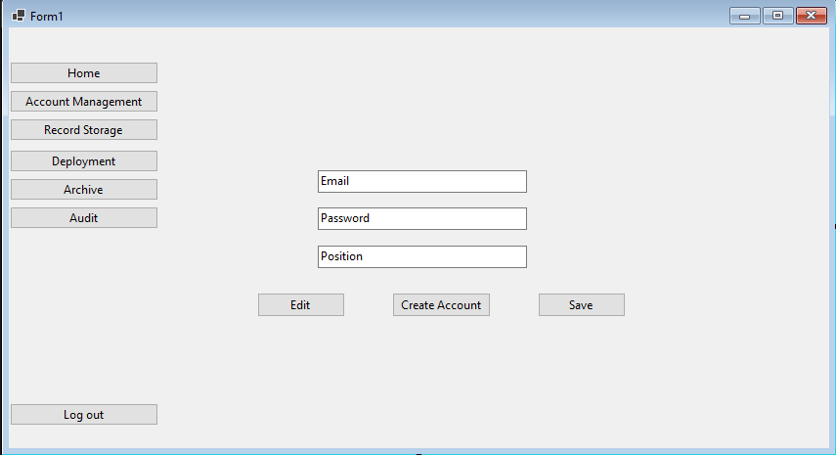

Figure 3: Create Account

Only the Senior HR or Admin can create and edit a user account to access the web application.

Figure 4: Home

The user can view the data and filter the files to see what they want to see.

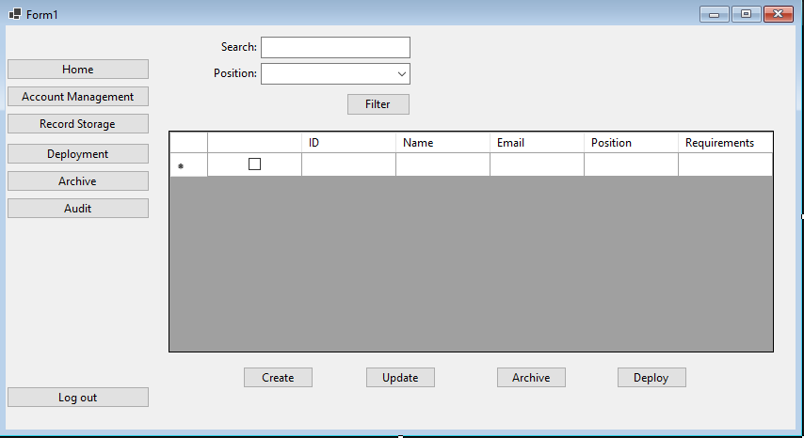

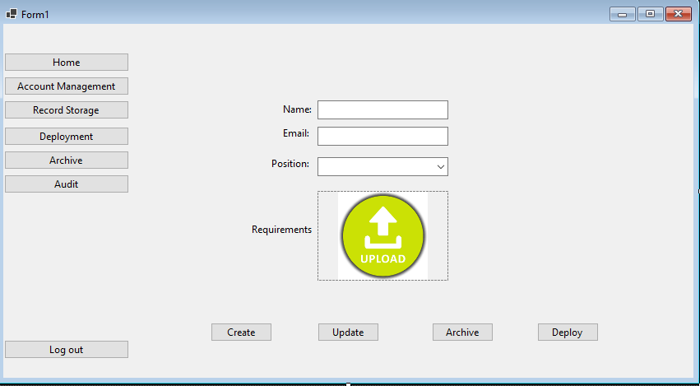

Figure 5: Record Storage

The user can create, update, and archive the applicant's data in file storage.

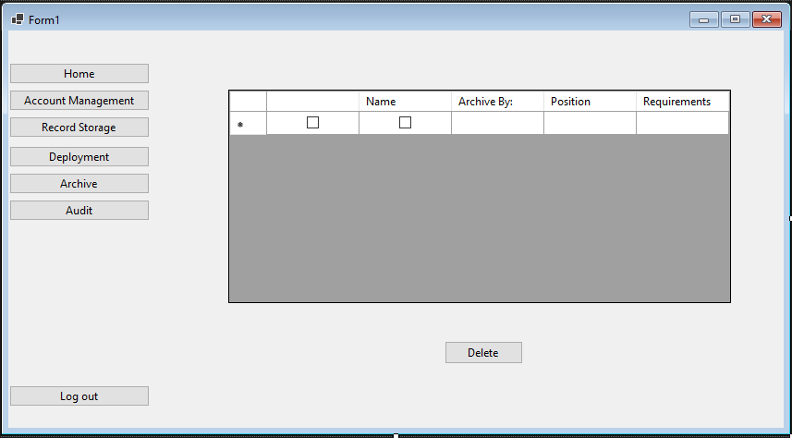

Figure 6: Archive

The user can view and delete the archive data.

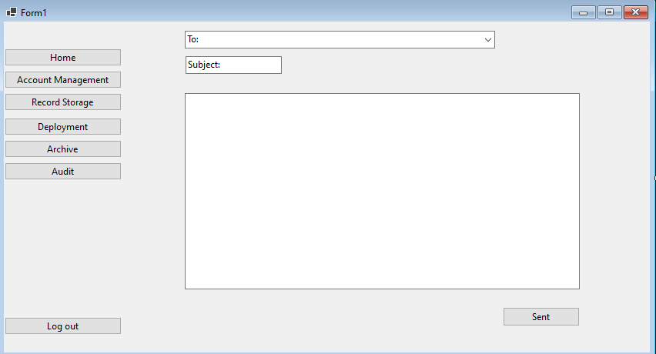

Figure 7: Deployment

A module where the HR can create a messages to send to the applicants in regards to their schedule and designated hotel.

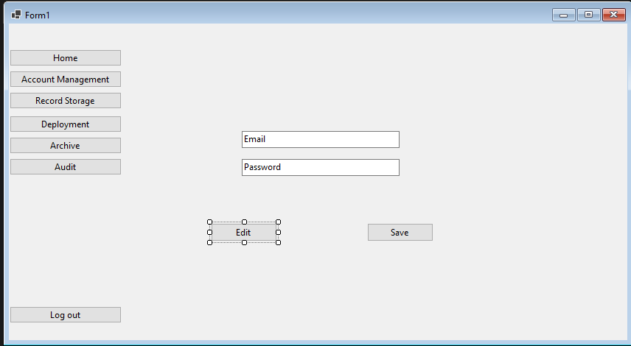

Figure 8: Account settings

A module where user can change the username, password and e-mail of the account

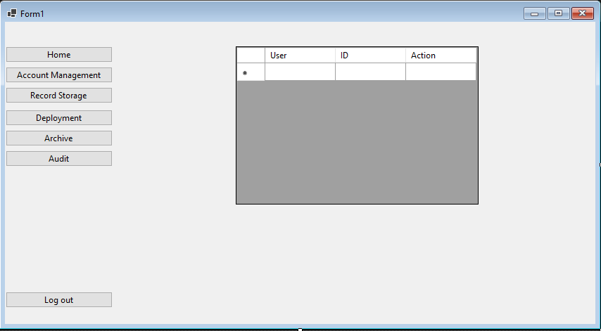

Figure 9: Audit Log

The admin or Senior HR can see who edit , delete and input the applicants data.

Figure 10: Senior HR Storyboard

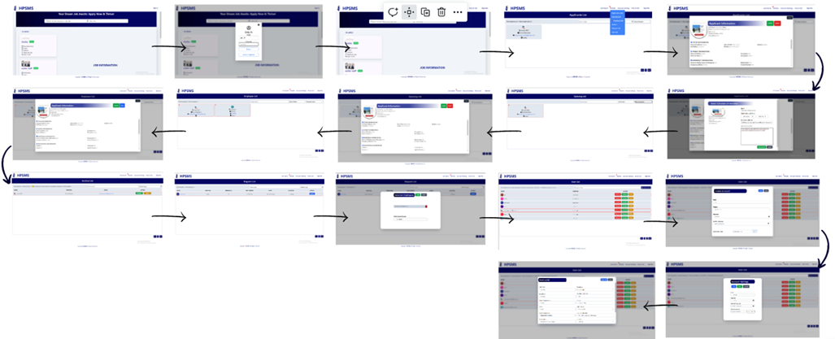

Figure 11: HR Storyboard

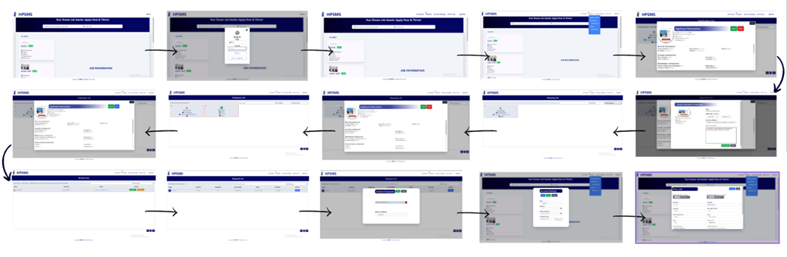

Figure 12: Coordinator Storyboard

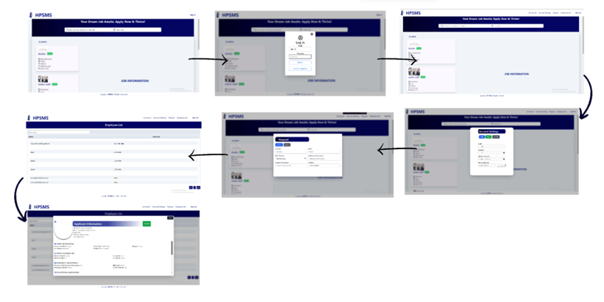

Figure 13: Employee Storyboard

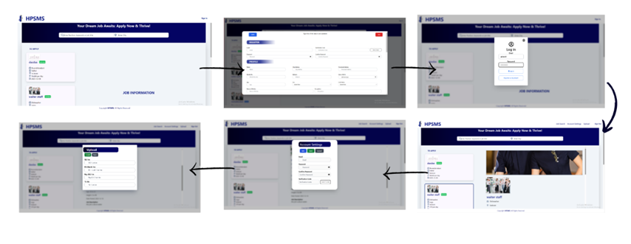

## Design of Software, System, Product, and/or Processes

## Below is an example of the form given through survey to all the respondents in evaluating the HPSMS application.

User Evaluation Tool

Name: Date:

Rate the system performance based on the following criteria:

5 = Excellent

4 = Very Satisfactory 3 = Satisfactory

2 = Poor

1 = Very Poor

|  |  |  |  |  |  |  |
| --- | --- | --- | --- | --- | --- | --- |
| **FUNCTIONALITY** | **STATEMENTS** | **5** | **4** | **3** | **2** | **1** |
| **Security** | 1. Administrators and users who have accounts can are the only ones that can access the system. |  |  |  |  |  |
| **Accuracy** | 2. The web application gives precise data about information about residents and statistics. |  |  |  |  |  |
| **Suitability** | 3. The web application is compatible with popular browsers like Windows, Firefox, and Safari. |  |  |  |  |  |
| **RELIABILITY** | **STATEMENTS** | **5** | **4** | **3** | **2** | **1** |
| **Maturity** | 4. The web application meets needs for reliability under normal operation |  |  |  |  |  |
| **Recoverability** | 5. The web application can regain updated records of the information of the residents from the database. |  |  |  |  |  |
| **Fault tolerance** | 6. The web application’s ability is to continue operate despite failure, or malfunctions. |  |  |  |  |  |
| **USABILITY** | **STATEMENTS** | **5** | **4** | **3** | **2** | **1** |
| **Clarity** | 7. The web application uses terminologies that can understand by the users. |  |  |  |  |  |
| **Learnability** | 8. The web application is user-friendly when it comes to interface and functions, less assistance from the developer. |  |  |  |  |  |

|  |  |  |  |  |  |  |
| --- | --- | --- | --- | --- | --- | --- |
| **Captivation** | 9. The web application is user – friendly and pleasing to the eyes of the end- users. |  |  |  |  |  |
| **Serviceable** | 10. The web application accessibility makes it easier for the end-user to comprehend. |  |  |  |  |  |
| **EFFICIENCY** | **STATEMENTS** | **5** | **4** | **3** | **2** | **1** |
| **Time Behavior** | 11. The web application reacts completely with every performance. |  |  |  |  |  |
| **Resource Utilization** | 12. The web application uses the same method of gathering information |  |  |  |  |  |
| **MAINTAINABLITY** | **STATEMENTS** | **5** | **4** | **3** | **2** | **1** |
| **Demonstrable** | 13. The web application can function completely with the user’s performance. |  |  |  |  |  |
| **Analyzability** | 14. Managing the system is not too difficult to apprehend |  |  |  |  |  |
| **Changeability** | 15. The web application’s flexibility of the system responds to the user thoroughly. |  |  |  |  |  |
| **Stability** | 16. Steadiness of the system is reliable. |  |  |  |  |  |
| **PORTABILITY** | **STATEMENTS** | **5** | **4** | **3** | **2** | **1** |
| **Flexibility** | 17. The web application can be moved to another operating system with ease. |  |  |  |  |  |
| **Variability** | 18. The web application does not require high end computer specification. |  |  |  |  |  |
| **Specification** | 19. The capacity of the web application depends on the users’ performance. |  |  |  |  |  |
| **Replaceability** | 20. The web application’s updates or data migration and system updating is essential. |  |  |  |  |  |

## IT Specialist Evaluation Form

Name: Date:

Rate the system performance based on the following criteria:

5 = Excellent

4 = Very Satisfactory 3 = Satisfactory

2 = Poor

1 = Very Poor

|  |  |  |  |  |  |
| --- | --- | --- | --- | --- | --- |
| **PERFORMANCE** | **5** | **4** | **3** | **2** | **1** |
| **READABILITY** | | | | | |
| Readability of the software source code |  |  |  |  |  |
| **Ease of Program Maintenance** | | | | | |
| Evaluate |  |  |  |  |  |
| Debugging |  |  |  |  |  |
| Requirements |  |  |  |  |  |
| **Adaptation of the Source Code to Enter** | | | | | |
| Version |  |  |  |  |  |
| Programming Language |  |  |  |  |  |
| **Other Consideration** | | | | | |
| Simplicity |  |  |  |  |  |
| Low Hardware resources consumption |  |  |  |  |  |
| Source code testing using fault injection |  |  |  |  |  |

The formula to calculate the Weighted Average Mean is as follows.

Where:

|  |  |
| --- | --- |
| WM | = Weighted Average Mean |
| E | = Excellent |
| VS | = Very Satisfactory |
| S | = Satisfactory |
| P | = Poor |
| VP | = Very Poor |
| TNR | = Total Number of Respondents |

Verbal Interpretation Numerical Value

|  |  |
| --- | --- |
| Numerical Value | Verbal Interpretation |
| 4.51 – 5.00 | Excellent |
| 3.51 – 4.50 | Very Satisfactory |
| 2.51 – 3.50 | Satisfactory |
| 1.51 – 2.50 | Poor |
| 1.00 – 1.50 | Very Poor |

## In developing the HPSMS application, the developer’s main focus was to ensure that all objectives are met, and that the application follows all the general standards set prior to such as:

* Identifiable Purpose: Regarding of the user interface of HPSMS web application, the user can easily determine the application is an application and deployment management system. The labelling of objects on the application is easy to understand.
* Ease of use: HPSMS application is relatively easy to use beacause of it’s user friendly and simplicity
* Reliability: Using HPSMS, users will find the application is reliable in helping them keep track of applicant progress and activity.

Flowchart

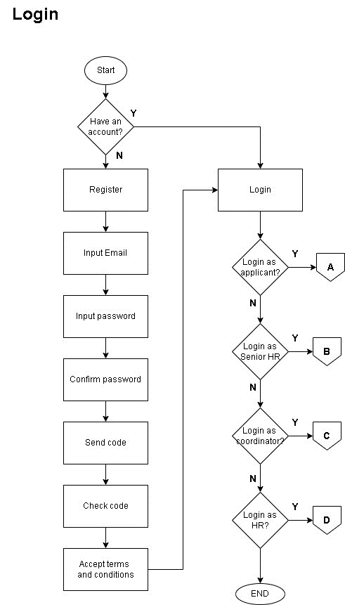

Figure 14: Whole Human Resource Manager Process

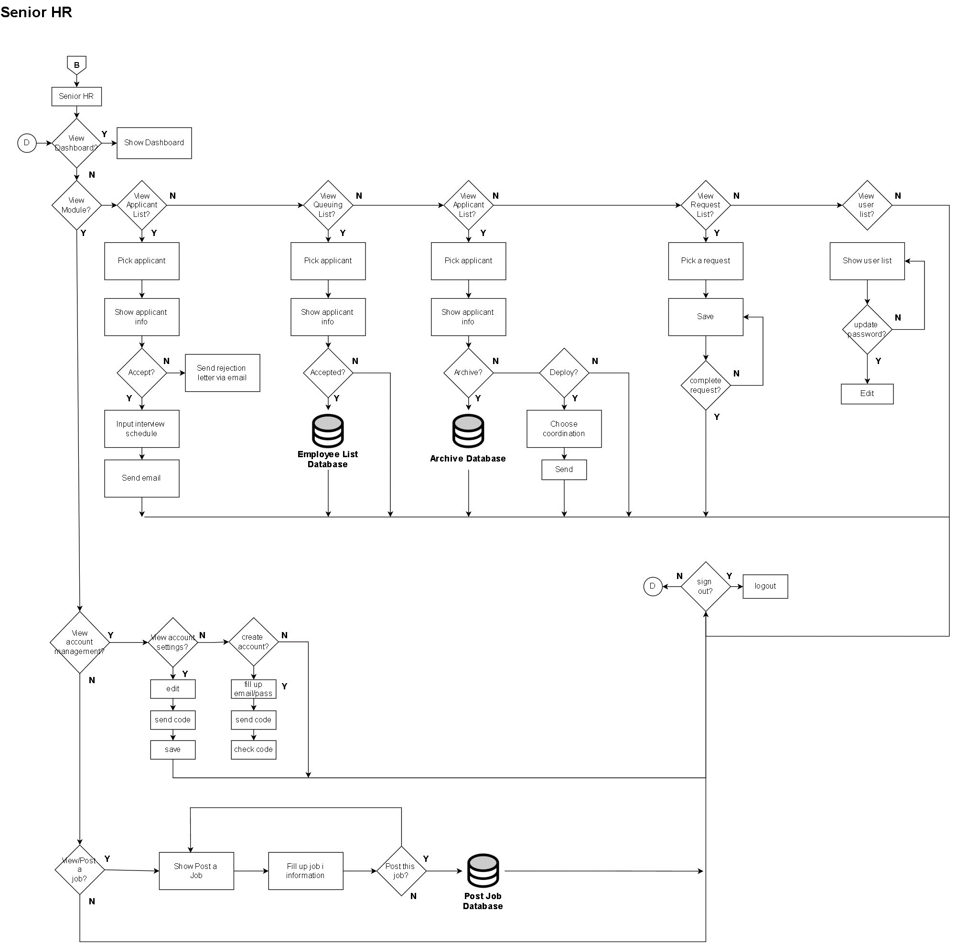

Figure 15:Senior Human Resource (admin) Process

Coordinator

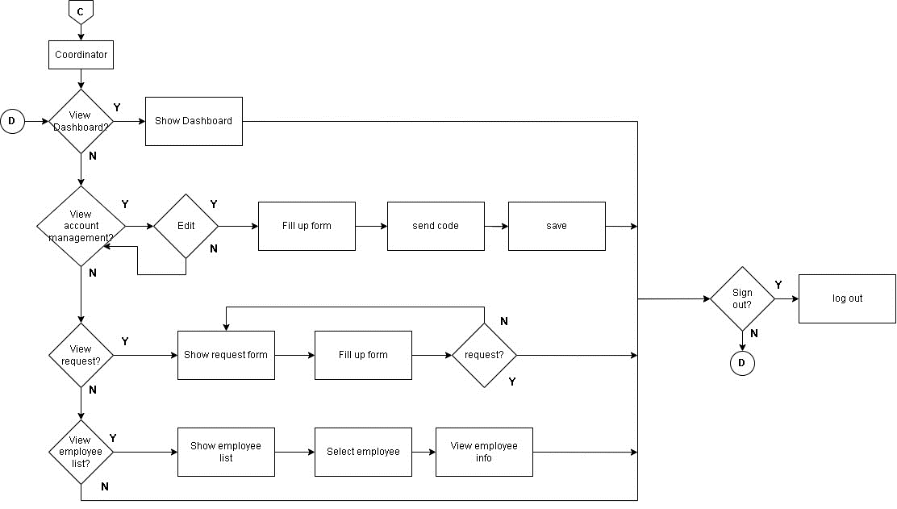

Figure 16:Human Resource Process

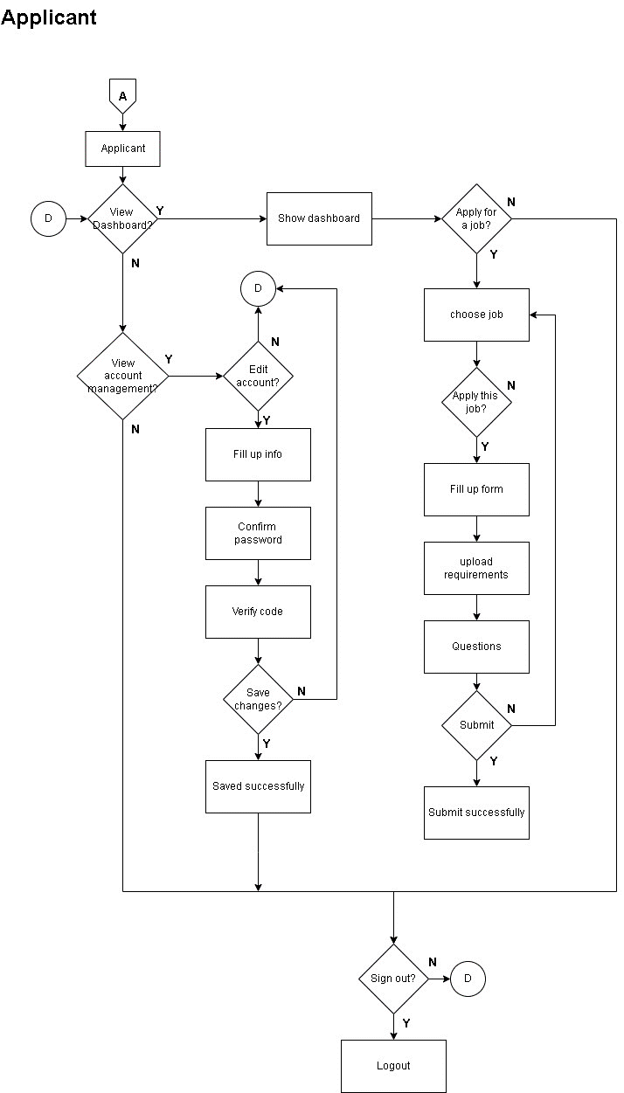

Figure 17: Applicant Process

Figure 18: Entity Relationship Diagram (ERD)

## In this phase the developers should create the design such as making a flowchart of the system, wireframing, user interface, databases and security that will be needed in the system.

## Development

The developers used the Agile Development Methodology for developing the Windows form application HPSMS: Web-based Recruitment and Record Management for Hotel Pro Services INC. This methodology allows the clients to interact and work with the functioning of the system and provide feedback on it. This approach allows the developers to take up changes more easily and make the module corrections if needed.

**Figure 19**. Agile Development Methodology

Below are the six (6) steps in an Agile Development Methodology:

1. **Requirements**

In this phase the developers collected some data by doing an interview from the Senior HR and HR manager to do some research that is needed for developing the systems. The developers have gathered data from the Senior HR and HR manager of Hotel Pro Services INC. that will be needed for the documentation and for the a system. This phase was done by identifying the project scope to determine the action plan for the systems

1. **Design**

In this phase the developers should create the design such as making a flowchart of the system, wireframing, user interface, databases and security that will be needed in the system.

1. **Development**

The developers did the program and utilize the modules. In this stage, the developers start doing the front-end of the system which is the design and then the back end of the system which is the behavior of each module. The developers used HTML,CSS, JavaScript and Sql for developing the system.

1. Testing

In this phase, the developers did a beta test if the system is working accurately. The developers did the Manual Test Case Scenario where they can test the functionality and reliability of the system that is to tested. In the Manual Test Case Scenario every module of the system is examined if it is working functional and accurately.

1. Deployment

In this phase, the proponents gave the system to the client. Once it is working functionally in the testing phase. The developers will do the ISO 25010 to evaluate if the systems meet the software product quality for the beneficiary. Also in this phase, the quality characteristics against which stated on quality requirements can be compared for the completeness of the system.

1. Review

The clients will make a review or feedback on the system that is deployed by the proponents. In these phases, the beneficiary will make an assessment if the system meets the expectation of the beneficiary.

**Development and testing**

**Table** 3: Test Case

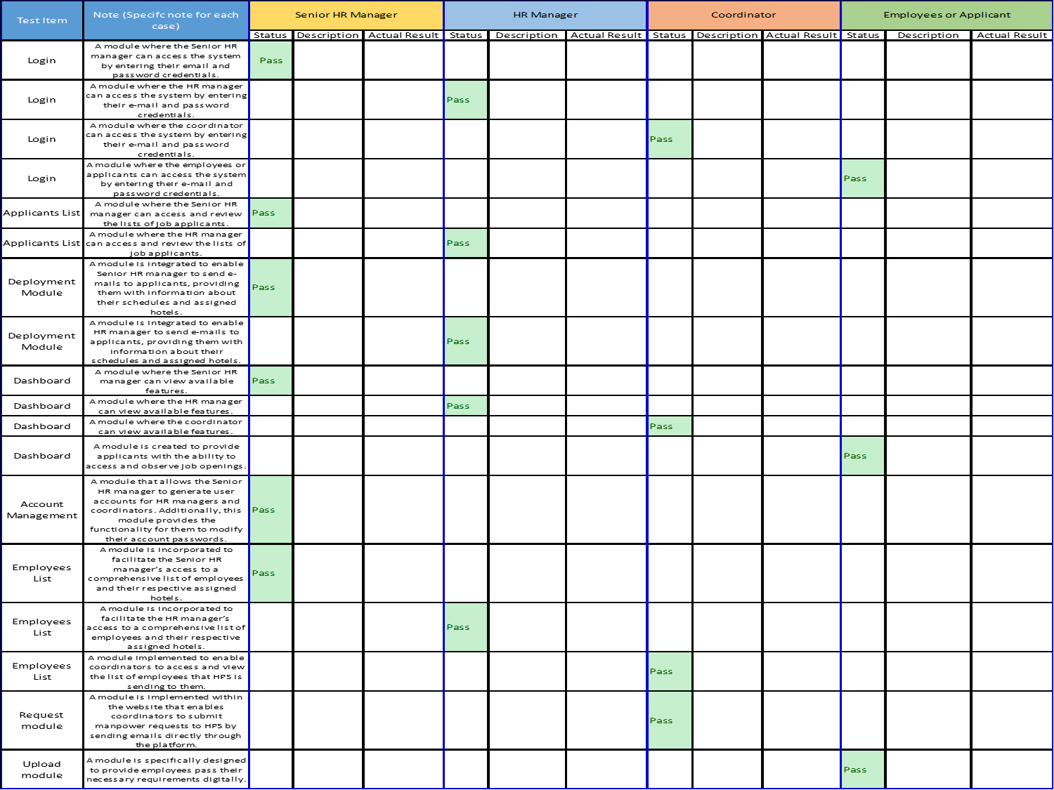

The HPSMS is functional on the following devices:

* Desktop and Mobile Devices since this is a web application.

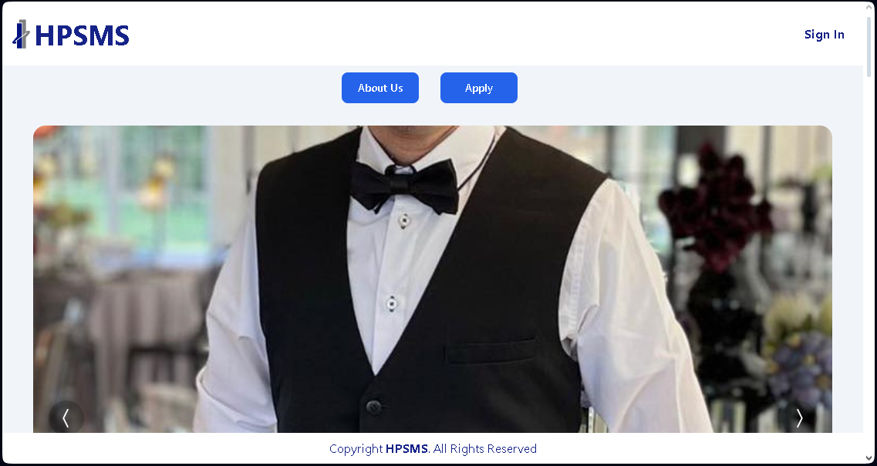

Figure 20: Desktop view of the project

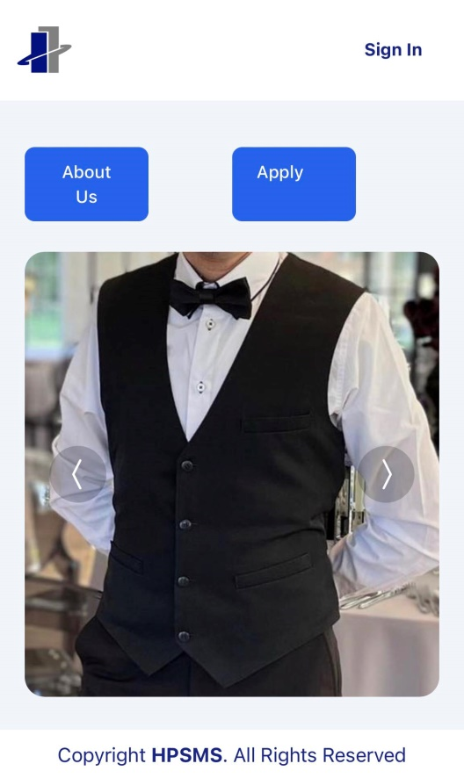

Figure 21: Mobile view of the project

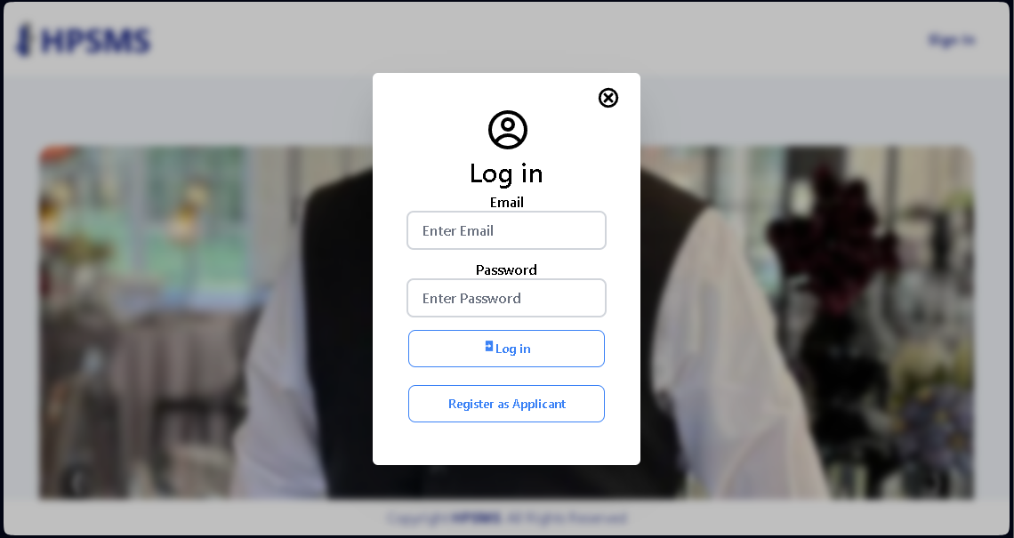

Figure 22: Login Module

Only the registered accounts for Senior HR and HR can login with their designated accounts using login. While applicants will need to sign up to create an account, this will be then redirected towards login and the applicant user will be directed to the home page.

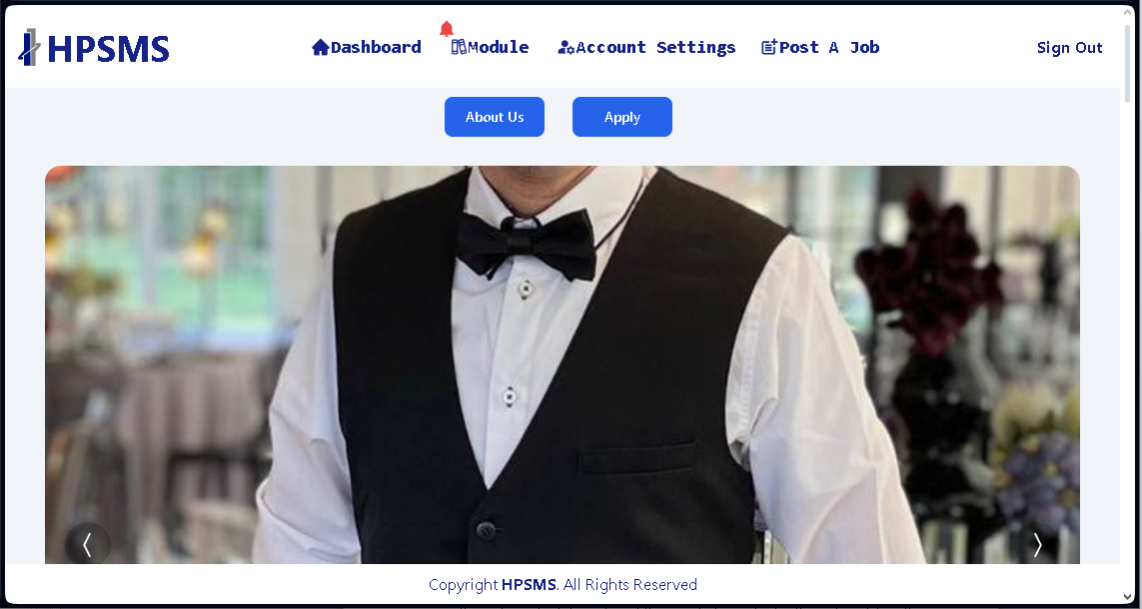

Figure 23: Senior HR and HR Dashboard

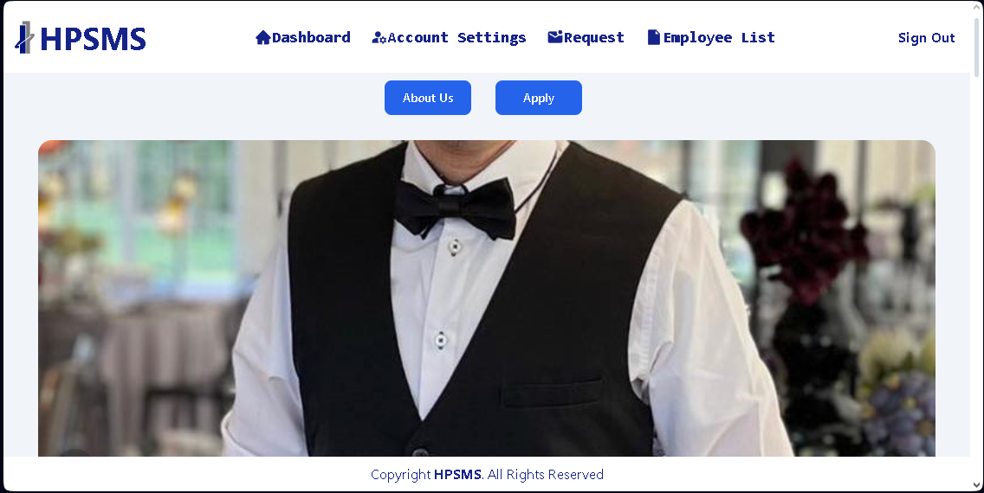

Figure 24: Coordinator Dashboard

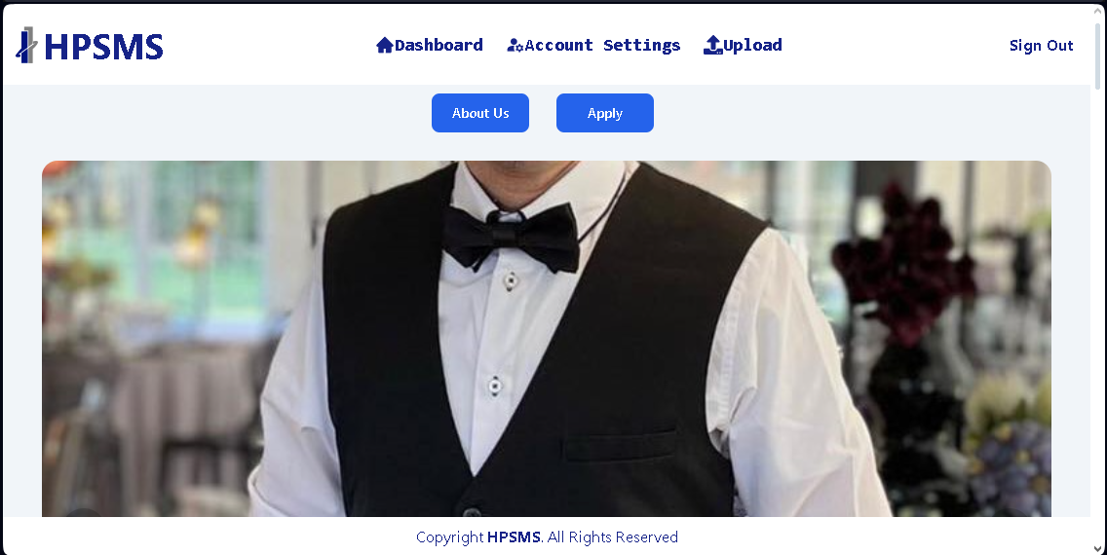

Figure 25: Applicant Dashboard

This page contains the modules for users to access and modify. Figure 17 is for Senior HR and HR, while figure 18 is for coordinators, and figure 19 is for applicants.

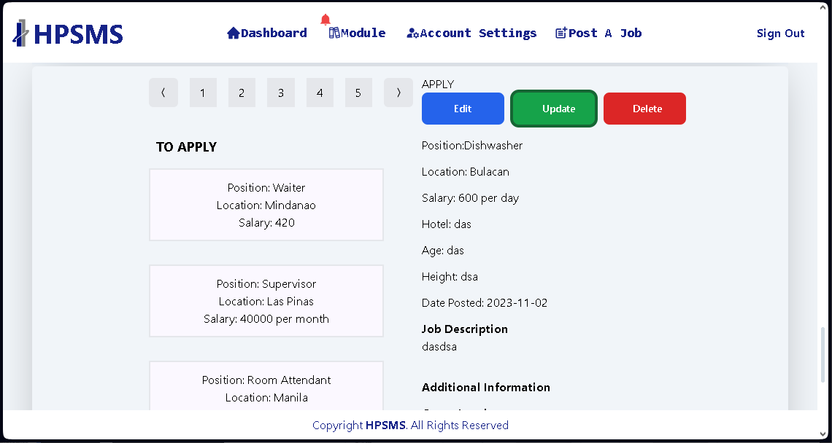

Figure 26: Senior HR and HR Post Job list

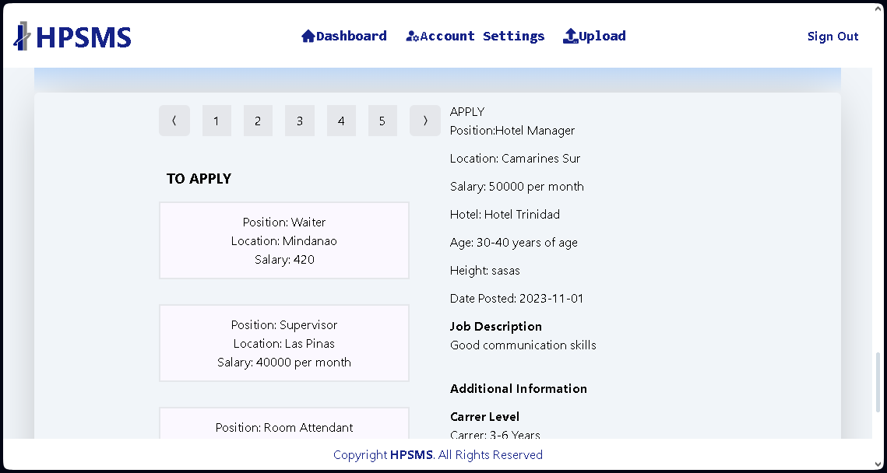

Figure 27: Applicant’s Job list for application

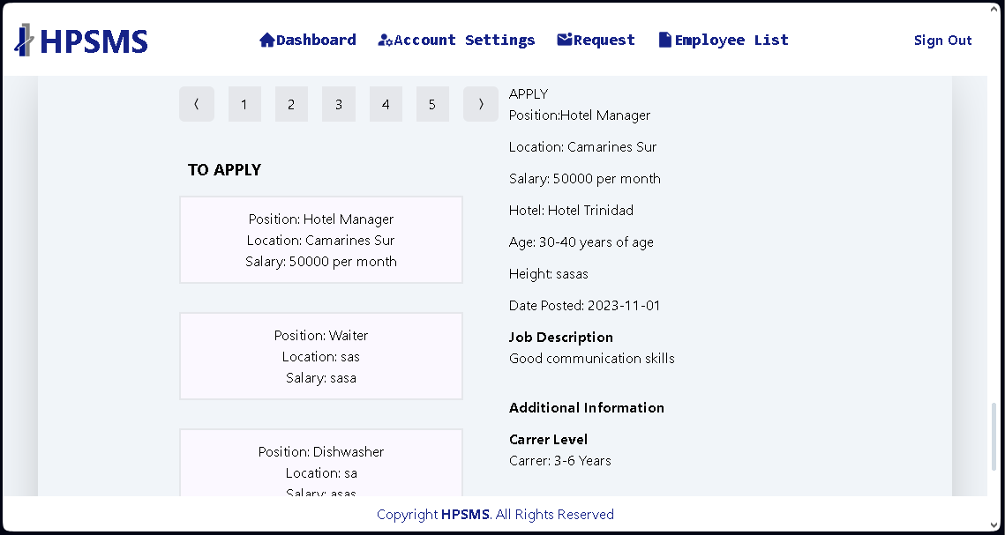

Figure 28: Coordinator’s Job List

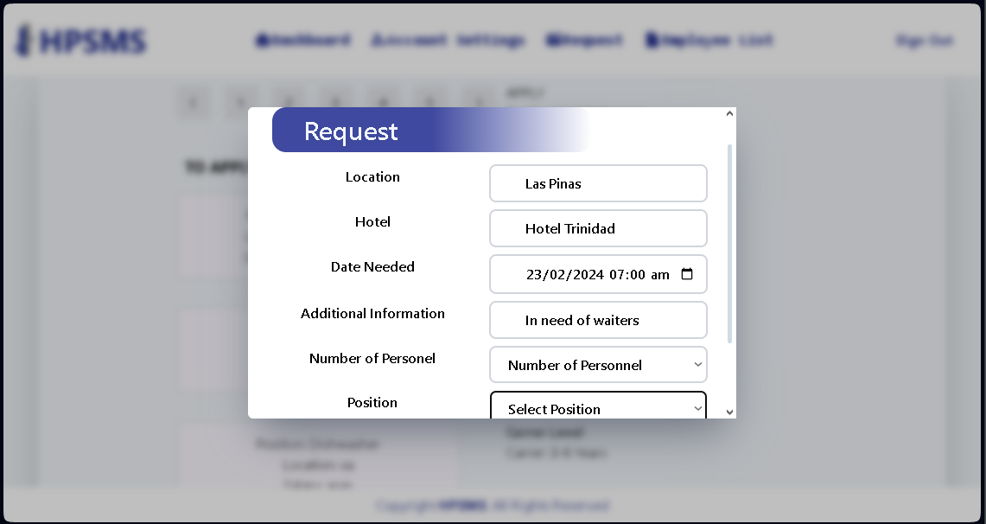

Figure 29: Coordinator’s Request Module

Only the Senior HR and HR can manage and post a job for application. Applicants can apply and submit their request for application towards the Senior HR and HR managers. Coordinators can also request Senior HR and HR managers for a batch of applicants for an upcoming event or day.

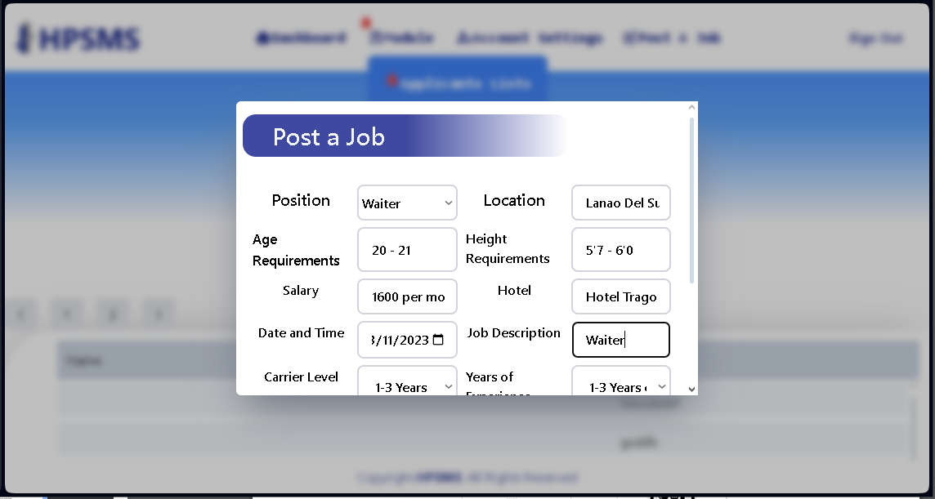

Figure 30: Senior HR and HR manager’s Post a Job module

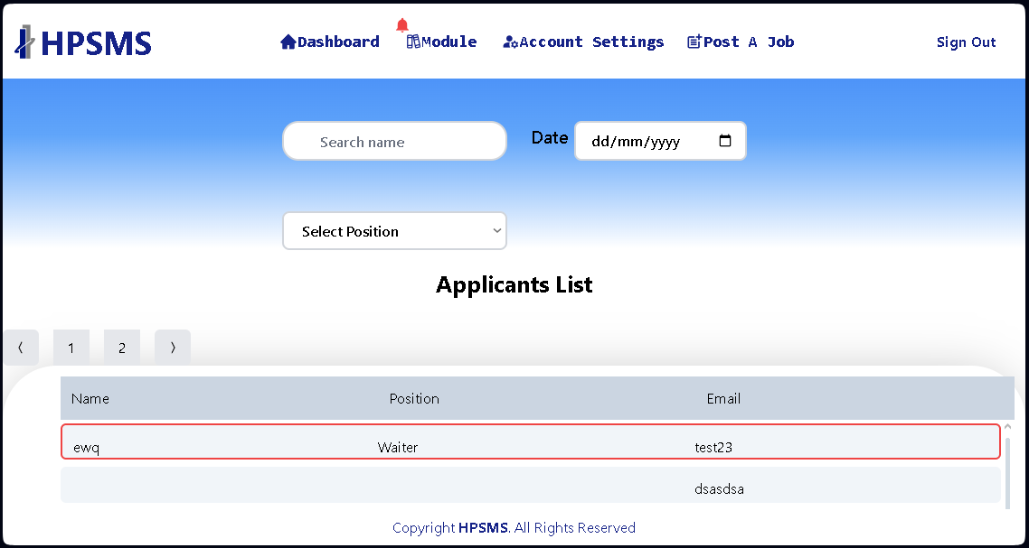

Figure 31: Senior HR and HR manager’s Applicant’s List module

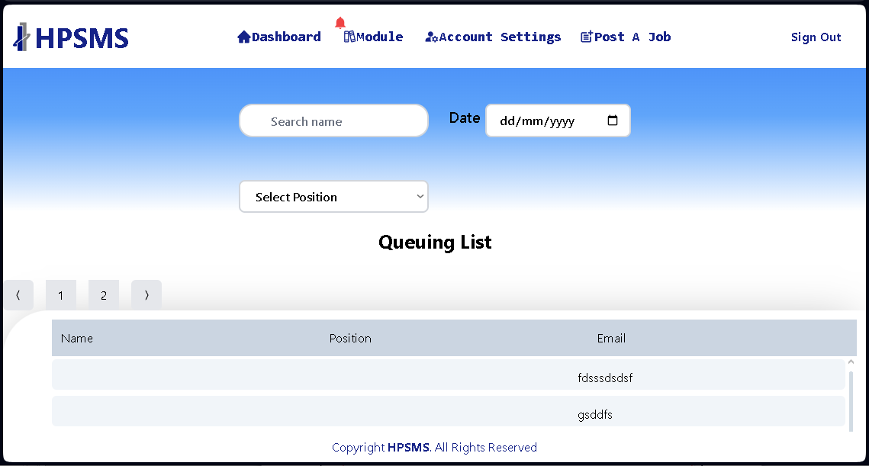

Figure 32: Senior HR and HR manager’s Queuing List module

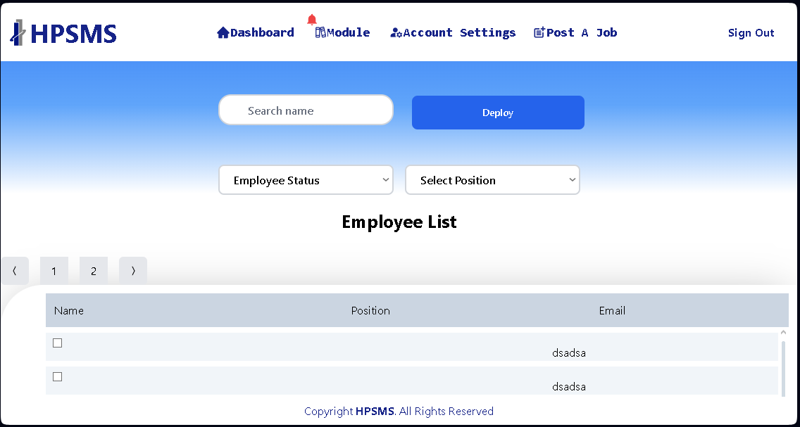

Figure 33: Senior HR and HR manager’s Employee List module

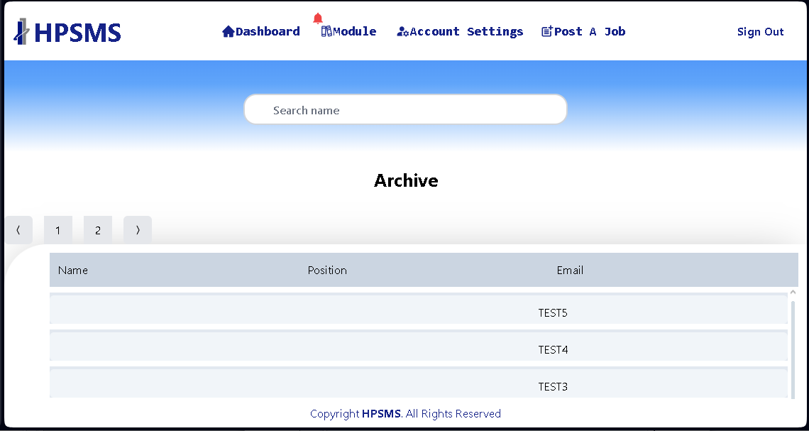

Figure 34: Senior HR and HR manager’s Archive module

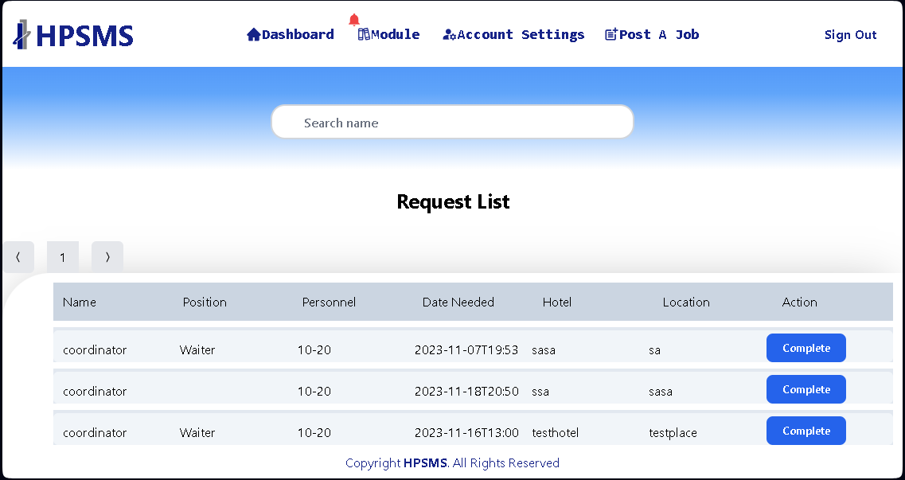

Figure 35: Senior HR and HR manager’s Request List module

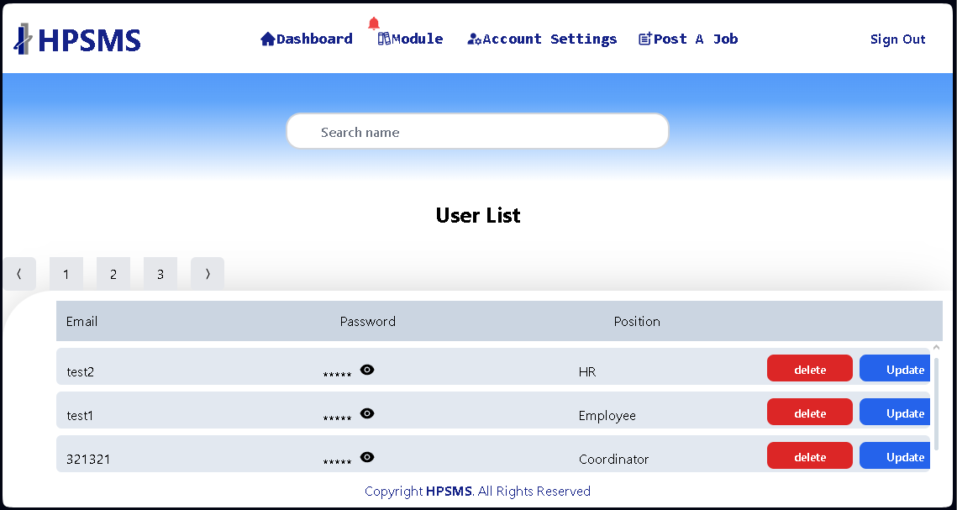

Figure 36: Senior HR and HR manager’s User List module

Only the Admin, Senior HR and HR Managers have the accounts to access and modify the modules of the web. Here they can create job posts where applicant users can apply.

## Testing and Evaluation Plan

HPSMS is a web-based system it is recommended that each Senior HR Manager, HR Manager, Coordinator and Employees or staff have been given login credentials be provided appropriate devices such as computer and smartphones to access the site and manage their respective dashboards. All other users may use whichever device they have as long it can access the internet given that it meets the minimum requirements listed for hardware devices. The HPSMS can be accessed by google chrome or any web browser in computer or smartphones, The Senior HR Manager, HR Manager, Coordinator , and Employees or Staffs must have at least 4gb RAM, Intel Core™ i3 – 9th CPU@ 2.50 GHz, 2496 Mhz 4 Core(s) and 500 GB Solid State Drive or Hard Disk Drive, The user can alternatively use smartphones devices that has internet access and a browser.

The Implementation Plan describes how the information system will be deployed, installed, and transitioned into an operational system. The plan contains an overview of the system, a brief description of the major tasks involved in the implementation, the overall resources needed to support the implementation effort (such as hardware, software, facilities, materials, and personnel), and any site-specific implementation requirements.

## Testing and Evaluation Result

HPSMS has a total of 6 HR Managers and a Senior HR Manager working with Applicants to find applicable jobs on entire hotels. The tables below display the result of the testing and evaluation process of the HPSMS Web Application which consists of 18 applicant respondents the 6 HR Managers and a Senior HR Manager.

**Table 4**. Functionality of HPSMS Web Application.

|  |  |  |  |
| --- | --- | --- | --- |
| # | Functionality | Weighted Mean | Verbal Intepretation |
| 1 | Security | 4.11 | Very Satisfactory |
| 2 | Accuracy | 3.94 | Very Satisfactory |
| 3 | Suitability | 4.05 | Very Satisfactory |
|  | OVERALL MEAN | 4.03 | Very Satisfactory |

Table 4 shows the results for functionality of HPSMS: Web-based Recruitment and Record Management system for Hotel Pro Services

**In the 1st item “Security”** – The application has security features that makes sure that only authorized users can access given accounts for Senior HR and HR managers. The results yielded a verbal interpretation of very satisfactory by respondents with a mean of 4.11.

**In the 2nd item “Accuracy”** - The web application has precise data about information about residents and statistics. The results yielded a verbal interpretation of very satisfactory by respondents with a mean of 3.94.

**In the 3rd item “Suitability”** - The web application is compatible with popular browsers like Windows, Firefox, and Safari. The results yielded a verbal interpretation of very satisfactory by respondents with a mean of 4.05.

The overall mean of the functionality yields a very satisfactory result by the respondents with a mean of 4.03.

**Table 5**. Reliability of HPSMS Web Application.

|  |  |  |  |
| --- | --- | --- | --- |
| # | Reliability | Weighted Mean | Verbal Intepretation |
| 4 | Maturity | 4.26 | Very Satisfactory |
| 5 | Recoverability | 4.11 | Very Satisfactory |
| 6 | Fault Tolerance | 3.79 | Very Satisfactory |
|  | OVERALL MEAN | 4.05 | Very Satisfactory |

Table 5 shows the results for reliability of HPSMS: Web-based Recruitment and Record Management system for Hotel Pro Services

**In the 4th item “Maturity”** - The web application meets the needs for reliability under normal operation. The results yielded a verbal interpretation of very satisfactory by respondents with a mean of 4.26.

**In the 5th item “Recoverability”**- The web application can regain updated records of the information of the residents from the database. The results yielded a verbal interpretation of very satisfactory by respondents with a mean of 4.11.

**In the 6th item “Fault Tolerance”**- The web application’s ability is to continue operate despite failure, or malfunctions. The results yielded a verbal interpretation of very satisfactory by respondents with a mean of 3.79.

The overall mean of the reliability yields a very satisfactory result by the respondents with a mean of 4.05.

**Table 6**. Usability of HPSMS Web Application.

|  |  |  |  |
| --- | --- | --- | --- |
| # | Usability | Weighted Mean | Verbal Intepretation |
| 7 | Clarity | 4.05 | Very Satisfactory |
| 8 | Learnability | 4.11 | Very Satisfactory |
| 9 | Captivation | 3.89 | Very Satisfactory |
| 10 | Serviceable | 3.84 | Very Satisfactory |
|  | OVERALL MEAN | 3.97 | Very Satisfactory |

Table 6 shows the results for usability of HPSMS: Web-based Recruitment and Record Management system for Hotel Pro Services

**In the 7th item “Clarity”** - The web application uses terminologies that can understand by the users. The results yielded a verbal interpretation of very satisfactory by respondents with a mean of 4.05.

**In the 8th item “Learnability”** - The web application is user-friendly when it comes to interface and functions, less assistance from the developer. The results yielded a verbal interpretation of very satisfactory by respondents with a mean of 4.11.

**In the 9th item “Captivation”** - The web application is user – friendly and pleasing to the eyes of the end- users. The results yielded a verbal interpretation of very satisfactory by respondents with a mean of 3.89.

**In the 10th item “Serviceable”**- The web application accessibility makes it easier for the end-user to comprehend. The results yielded a verbal interpretation of very satisfactory by respondents with a mean of 3.84.

The overall mean of the usability yields a very satisfactory result by the respondents with a mean of 3.97.

**Table 7**. Efficiency of HPSMS Web Application.

|  |  |  |  |
| --- | --- | --- | --- |
| # | Efficiency | Weighted Mean | Verbal Intepretation |
| 11 | Time Behavior | 4.47 | Very Satisfactory |
| 12 | Resource Utilization | 4.16 | Very Satisfactory |
|  | OVERALL MEAN | 4.32 | Very Satisfactory |

Table 4 shows the results for efficiency of HPSMS: Web-based Recruitment and Record Management system for Hotel Pro Services

**In the 11th item “Time Behavior”-** The web application reacts completely with every performance. The results yielded a verbal interpretation of very satisfactory by respondents with a mean of 4.47.

**In the 12th item “Resource Utilization”-** The web application uses the same method of gathering information. The results yielded a verbal interpretation of very satisfactory by respondents with a mean of 4.16.

The overall mean of the efficiency yields a very satisfactory result by the respondents with a mean of 4.32.

**Table 8**. Maintanability of HPSMS Web Application.

|  |  |  |  |
| --- | --- | --- | --- |
| # | Maintanability | Weighted Mean | Verbal Intepretation |
| 13 | Demonstrable | 4.11 | Very Satisfactory |
| 14 | Analyzability | 4.22 | Very Satisfactory |
| 15 | Changeability | 4.05 | Very Satisfactory |
| 16 | Stability | 3.84 | Very Satisfactory |
|  | OVERALL MEAN | 4.06 | Very Satisfactory |

Table 8 shows the results for functionality of HPSMS: Web-based Recruitment and Record Management system for Hotel Pro Services

**In the 13th item “Demonstrable”-** The web application can function completely with the user’s performance. The results yielded a verbal interpretation of very satisfactory by respondents with a mean of 4.11.

**In the 14th item “Analyzability”-** Managing the system is not too difficult to apprehend. The results yielded a verbal interpretation of very satisfactory by respondents with a mean of 4.22.

**In the 15th item “Changeability”-** The web application’s flexibility of the system responds to the user thoroughly. The results yielded a verbal interpretation of very satisfactory by respondents with a mean of 4.05

**In the 16th item “Stability”-** Steadiness of the system is reliable. The results yielded a verbal interpretation of very satisfactory by respondents with a mean of 3.84.

The overall mean of the maintability yields a very satisfactory result by the respondents with a mean of 4.06.

**Table 9**. Portability of HPSMS Web Application

|  |  |  |  |
| --- | --- | --- | --- |
| # | Portability | Weighted Mean | Verbal Intepretation |
| 17 | Flexibility | 4.26 | Very Satisfactory |
| 18 | Variability | 4.37 | Very Satisfactory |
| 19 | Specification | 3.89 | Very Satisfactory |
| 20 | Replaceability | 3.89 | Very Satisfactory |
|  | OVERALL MEAN | 4.10 | Very Satisfactory |

Table 9 shows the results for portability of HPSMS: Web-based Recruitment and Record Management system for Hotel Pro Services

**In the 17th item “Flexibility” -** The web application can be moved to another operating system with ease. The results yielded a verbal interpretation of very satisfactory by respondents with a mean of 4.26.

**In the 18th item “Variability”-** The web application does not require high end computer specification. The results yielded a verbal interpretation of very satisfactory by respondents with a mean of 4.37.

**In the 19th item “Specification” -** The capacity of the web application depends on the users’ performance. The results yielded a verbal interpretation of very satisfactory by respondents with a mean of 3.89.

**In the 20th item “Replaceability” -** The web application’s updates or data migration and system updating is essential. The results yielded a verbal interpretation of very satisfactory by respondents with a mean of 4.10.

The overall mean of the functionality yields a very satisfactory result by the respondents with a mean of 4.05.

**Table 10**. Summary Table of HPSMS Web Application.

|  |  |  |  |
| --- | --- | --- | --- |
| # | Functionality | Weighted Mean | Verbal Intepretation |
| 1 | Functionality | 4.03 | Very Satisfactory |
| 2 | Reliability | 4.05 | Very Satisfactory |
| 3 | Usability | 3.97 | Very Satisfactory |
| 4 | Efficiency | 4.32 | Very Satisfactory |
| 5 | Maintanability | 4.06 | Very Satisfactory |
| 6 | Portability | 4.10 | Very Satisfactory |
|  | OVERALL MEAN | 4.09 | Very Satisfactory |

Table 10 shows the summary of the testing results for HPSMS: Web-based Recruitment and Record Management system for Hotel Pro Services. According to 25 respondents among applicants, Senior HR Manager and HR Managers results show that functionality, reliability, usability, efficiency, maintainability and portability of HPSMS Web Application is very satisfactory with the overall mean of 4.09.

**Table 11**. IT Specialist Evaluation Table

|  |  |  |
| --- | --- | --- |
| Performance | Weighted Mean | Verbal Interpretation |
| Readability | | |
| Readability of the software source code | 4.00 | Very Satisfactory |
| Ease of Program Maintenance | | |
| Evaluate | 4.66 | Excellent |
| Debugging | 4.66 | Excellent |
| Requirements | 4.00 | Very Satisfactory |
| Adaptation of the Source Code to Enter | | |
| Version | 4.33 | Very Satisfactory |
| Programming Language | 4.66 | Excellent |
| Other Consideration | | |
| Simplicity | 4.00 | Very Satisfactory |
| Low Hardware resource consumption | 4.33 | Very Satisfactory |
| Source code tesing andusing fault injection | 4.33 | Very Satisfactory |

Table 11 shows the IT specialist application evaluation result of the HPSMS: Web-based Recruitment and Record Management system for Hotel Pro Services. The application is evaluated by three IT specialists from Wacom and Vellas Outsourcing.

The HPSMS Web Application source code is readable, according to the expert the program has a basic operation and flow, simple to control and understand. The readability of the program source code is a mean of 4.00, yielding a very satisfactory result.

In the category of ease of program maintenance, the IT specialists rate the ease to evaluate the program with a mean of 4.66, yielding a very satisfactory result. IT specialists then rate the ease of debugging, yielding a very satisfactory result with a mean of 4.20, and a very satisfactory result in modification with a mean of 4.66.

The adaptation of source code and programming languages to other versions yields a mean score of 4.33 with a very satisfactory result. Then the IT specialists rated the adaptation of source code in other programming languages which yields a mean score of 4.66, with a very satisfactory result.

In the category of other considerations, for low hardware resources consumption, and source code testing using fault injection received a very satisfactory result with a mean of 4.33. Due to the simplicity of the source code, the IT specialist’s evaluation of the HPSMS: Web-based Recruitment and Record Management system for Hotel Pro Services yielded a very satisfactory result with a mean of 4.33.

# Conclusions and Recommendations

Conclusions

Based on the findings the in accordance with the study’s objectives, this chapter will give the following conclusions and recommendations.

The developer’s main objective in developing HPSMS: The Web-based Recruitment and Record Management System for Hotel Pro Services Inc was to give Senior HR Manager, HR Manager, Coordinator, and Employees/ Applicants a suitable tool to provide an efficient way of acquiring, recruiting and deploying an applicant for the agency. It is also a platform where job seekers may easily apply for open positions by uploading their resume online.

The Senior HR Manager and HR Manager have access to Employee list, Applicants List, Deployment Module, and Account Management. The Senior HR Manager and HR Manager can access and review the lists of job applicants in Applicant List module.

Recommendations

The study aimed to determine how effective a Web-based system of Hotel Pro Services INC in managing the employees and applicants and to innovate the service with the help of technology. The study proves how effective a web application is for managing employees and applicants such as deploying to designated hotels or applying to hotels. Thus, for the researchers who will be going to research further about the effectiveness of technology to managing Human Resources for visualizing the hotel processed. We highly recommend that they must gather respondents in wider range since the study is focused on the responses of fifty (50) respondents only. Moreover, limited respondents may affect the precision of the result of the study. And To be User friendly and easy for the respondents or beneficiaries to understand the system. It will help a lot in explaining the functions and processes of the system.

# References

Ahaduzzaman, M. (2023). What is a Human Resource Inventory? [Lecture]. BBA Lecture. Retrieved from <https://www.bbalectures.com/what-is-human-resource-inventory/>

Almeida F., Duarte Santos , J., and Augusto Monteiro, J., (2020) *"The Challenges and Opportunities in the Digitalization of Companies in a Post-COVID-19 World,"* in IEEE Engineering Management Review, vol. 48, no. 3, pp. 97-103, 1 thirdquarter,Sept. 2020, doi: 10.1109/EMR.2020.3013206. Retrieved from: [https://ieeexplore.ieee.org/abstract/document/9153093/authors#authors](https://ieeexplore.ieee.org/abstract/document/9153093/authors%23authors)

BambooHR (2023). Bamboohr Security. Bamboohr. Retrieved from: <https://www.bamboohr.com/security/>

Burnett, J. R., & Lisk, T. C. (2019). The future of employee engagement: Real-time monitoring and digital tools for engaging a workforce. *International Studies of Management & Organization*, *49*(1), Retrieved from: <https://www.tandfonline.com/doi/abs/10.1080/00208825.2019.1565097108-119.>

Disa, S. (2022). How does an HR Management System (HRMS) Ensure Organizational Data Security? Topsourceworldwide. Retrieved from: <https://topsourceworldwide.com/how-does-hr-management-system-ensure-organizational-data-security/>

Gupta, B. B. (2013). *Human Resource Information System (HRIS): Important Element of Current Scenario.* Retrieved from: file:///C:/Users/userJ/Downloads/G01364146.pdf

Joyce, K. (2020), Big data streaming platforms empower real-time analytics Retrieved from: [https://www.techtarget.com/searchbusinessanalytics/ehandbook/Big-data-streaming-platforms-empower-real-time-analytics#](https://www.techtarget.com/searchbusinessanalytics/ehandbook/Big-data-streaming-platforms-empower-real-time-analytics%23)

Kapse, A. S., Patil, V. S., & Patil, N. V. (2012). E-recruitment. *International Journal of Engineering and Advanced Technology*, *1*(4), 82-86. Retrieved from:

<https://citeseerx.ist.psu.edu/document?repid=rep1&type=pdf&doi=b9d075273b9a339340318a041b344b7eeae57c2f>

Laroui F. (2019). *Benefits of Enterprise Search Engine as a key to improve productivity.* Exoplatform. Retrieved from:

[https://www.exoplatform.com /benefits-of-enterprise-search-engine-as-a-key-to-improve-productivity/](https://www.exoplatform.com/blog/benefits-of-enterprise-search-engine-as-a-key-to-improve-productivity/)

Newsome, B. (2015). *Beginning Visual Basics* (p. 487). Wiley. Retrieved from:

<https://www.google.com.ph/books/edition/Beginning_Visual_Basic_2015/Ax4FCAAAQBAJ?hl=en&gbpv=0>

Oracle, (2011). *Oracle HRMS Enterprise and Workforce Management Guide.* Retrieved from: <https://docs.oracle.com/cd/E18727_01/doc.121/e13511/T6652T6654.htm>

Personio, (2016). *The Secret to Systematic Growth.* Personio. Retrieved from: <https://www.personio.com/references/case-study-statista/>

Sprout Solution, (2015). *The Philippines’ first HR platform for the future of the work.* Retreived from: <https://sprout.ph/?utm_source=adwords&utm_medium=ppc&utm_campaign=Sprout%20Search>

*The Human Resource Management,* (2011). Retreived from : <https://open.lib.umn.edu/humanresourcemanagement/chapter/4-1-the-recruitment-process/>

Villeda, M., McCamey, R., Essien, E., & Amadi, C. (2019). *Use of social networking sites for recruiting and selecting in the hiring process*. International business research, *12*(3), 66-78. Retreieved from: <https://pdfs.semanticscholar.org/3f03/f1db77a7682af738befa63c49d85de7d6f29.pdf>

Resource Persons

Resource persons who contributed to the development of our research:

Mr Kid Bryan C. Valles Mrs. Maria Rowena Alejo

Capstone Project Adviser English Adviser

STI College Instructor Grace of Shekinah School Instructor

Ms Ma. Judith Solemne

Senior Human Resource

Hotel Pro Services INC.

**Plagiarism Report**



**Certification of Grammarian**

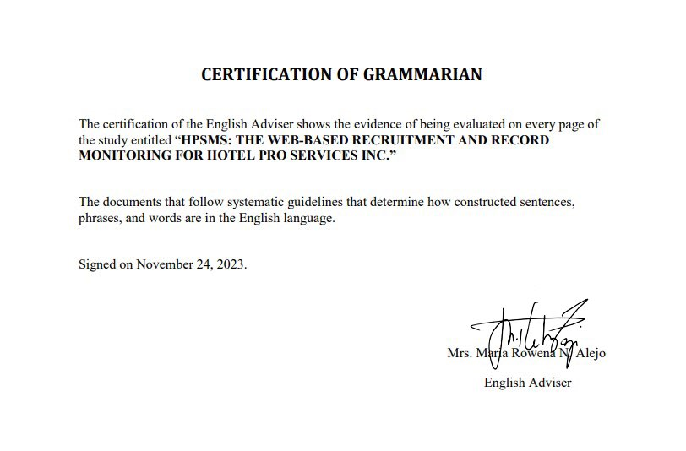

JAN JAY INOJALES SOLEMNE

BLK 26 LOT 113 BRIGHT HOMES CAYPOMBO STA.MARIA BULACAN

janjaysolemne@gmail.com

09392563833

EDUCATIONAL BACKGROUND

|  |  |  |
| --- | --- | --- |
| Level | Inclusive Dates | Name of school/ Institution |
| Tertiary | March 2019 | STI Global City |
| Vocational/Technical | March 2018 | University of Makati |
| High School | March 2016 | Liceo di San Lorenzo |
| Elementary | March 2012 | Liceo di San Lorenzo |

AFFILIATIONS

|  |  |  |
| --- | --- | --- |
| Inclusive Dates | Name of Organization | Position |
| September 2022 | Computer Society | Member |

SKILLS

|  |  |  |
| --- | --- | --- |
| SKILLS | Level of Competency | Date Acquired |
| C# | Intermediate | September 2021 |
| Java | Intermediate | September 2022 |
|  |  |  |

TRAININGS, SEMINARS, OR WORKSHOPS ATTENDED

|  |  |
| --- | --- |
| Inclusive Dates | Title of Training, Seminar, or Workshop |
| January 2019 | I.T On the Job training |

Curriculum Vitae of

MICHAEL ANGELO G. HIBIONADA

14 ARNICA ST. BLK 24 LOT 061 BRIGHT HOMES CAYPOMBO STA.MARIA BULACAN

mahibionada@gmail.com

0928 658 2840

EDUCATIONAL BACKGROUND

|  |  |  |
| --- | --- | --- |
| Level | Inclusive Dates | Name of school/ Institution |
| Tertiary | March 2023 | STI Collage Sta. Maria |
| Vocational/Technical | March 2020 | Pasay City South High School |
| High School | March 2018 | Pasay City South High School |
| Elementary | March 2013 | Villamor Air Base Elementary School |

AFFILIATIONS

|  |  |  |
| --- | --- | --- |
| Inclusive Dates | Name of Organization | Position |
| September 2020 | Computer Society | Member |

SKILLS

|  |  |  |
| --- | --- | --- |
| SKILLS | Level of Competency | Date Acquired |
| Java | Intermediate | September 2020 |
| C# | Intermediate | Feburary 2022 |

HTML/CSS Beginner Feburary 2023

TRAININGS, SEMINARS, OR WORKSHOPS ATTENDED

|  |  |
| --- | --- |
| Inclusive Dates | Title of Training, Seminar, or Workshop |
| April 2022 | ICT Festival '22 Webinar |

Curriculum Vitae of

ALEJO, RISHON VERN N.

7103 Mulawin Street, Phase 3 Garden Village Subdivisions, Pulong Buhangin, Santa Maria Bulacan.

alejorishon@gmail.com

0999-928-6329

EDUCATIONAL BACKGROUND

|  |  |  |
| --- | --- | --- |
| Level | Inclusive Dates | Name of school/ Institution |
| Tertiary | March 2023 | STI Global City |
| Vocational/Technical | March 2020 | Grace of Shekinah |
| High School | March 2018 | Grace of Shekinah |
| Elementary | March 2014 | Angelicum College |

PROFESSIONAL OR VOLUNTEER EXPERIENCE

|  |  |  |
| --- | --- | --- |
| Inclusive Dates | Nature of Experience/  Job Title | Name and Address of Company or Organization |
| October 2019 | Assistant Nurse | BMMG Hospital  1306 Gov Fortunato Halili Ave, Bocaue, 3018 Bulacan |

SKILLS

|  |  |  |
| --- | --- | --- |
| SKILLS | Level of Competency | Date Acquired |
| C# | Intermediate | September 2021 |
| Java | Intermediate | September 2022 |

Curriculum Vitae of

NED CHRISTIAN Q. MALLARI

032 Sto Niño St. Fatima IV. Area E City of San Jose Del Monte  
Bulacan

Ncmallari19@gmail.com

09924033605

EDUCATIONAL BACKGROUND

|  |  |  |
| --- | --- | --- |
| Level | Inclusive Dates | Name of school/ Institution |
| Tertiary | September 2020 | STI Collage Sta. Maria |
| Vocational/Technical | June 2018 | STI Collage Sta.Maria |
| High School | June 2014 | San Jose Del Monte National Trade School |
| Elementary | June 2008 | Bagong Buhay E Central School |

PROFESSIONAL OR VOLUNTEER EXPERIENCE

|  |  |  |
| --- | --- | --- |
| Inclusive Dates | Nature of Experience/  Job Title | Name and Address of Company or Organization |
| November 2019 | Immersion | STI Collage Sta.Maria |

AFFILIATIONS

|  |  |  |
| --- | --- | --- |
| Inclusive Dates | Name of Organization | Position |
| September 2020 | Computer Society | Member |
|  |  |  |

SKILLS

|  |  |  |
| --- | --- | --- |
| SKILLS | Level of Competency | Date Acquired |
| Java | Intermediate | September 2020 |
| C# | Intermediate | Februrary 2022 |
| HTML/CSS | Beginner | Februrary 2023 |

Python Beginner September 2022

SQL Beginner September 2021

Blender Beginner February 2023

TRAININGS, SEMINARS, OR WORKSHOPS ATTENDED

|  |  |
| --- | --- |
| Inclusive Dates | Title of Training, Seminar, or Workshop |
| April 2022 | ICT Festival '22 Webinar |
| November 2020 | 18th Youth Congress on Information Technology Webinar |
| October 2021 | Cybersecurity webinar hosted by Black Bear Securities |