1.Creating S3 bucket and uploading html file
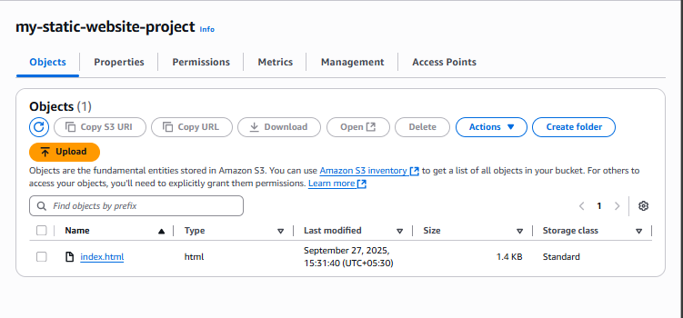
2.enabling static website hosting and also disabled "Block All Public Access" and enabled ACLs to allow public read access.

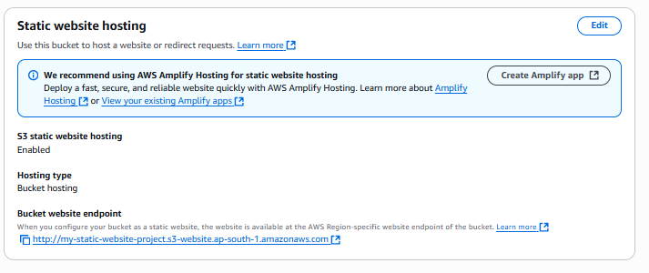
3. enable bucket versioning

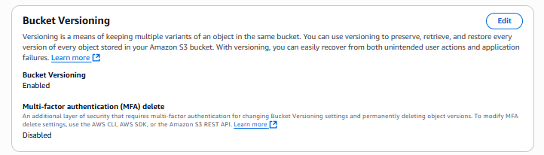
4.Now click on the link to view the website

