**SQL Questions and Queries**

1. Display customer's last name, first name, invoice number, and total amount paid by the customer. ordered, sorted by total amount by customer, in ascending order.

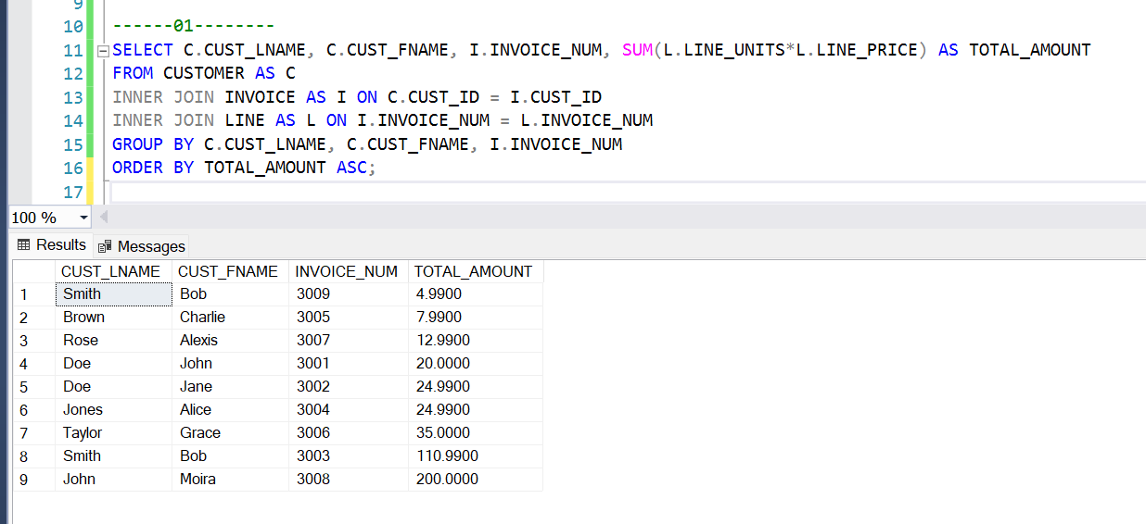

2. Display the salon ID and the number of customers (who came through walk-ins and booked appointments) in the salon area codes 48326 and 48084. ordered by customer last name in descending order.

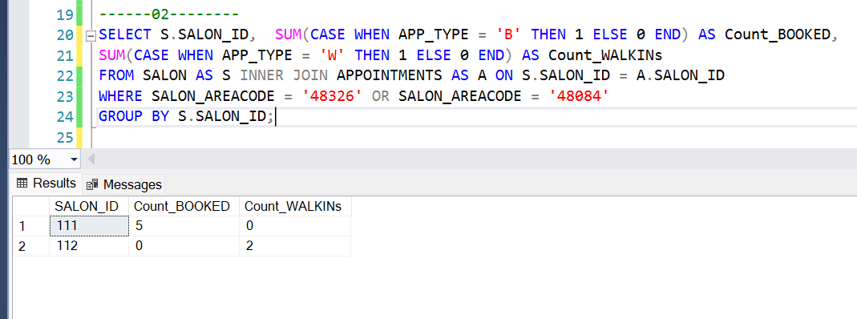

3. Display the beautician's last name, first name, and their manager’s last name and first name for all beauticians sorted in ascending order by beautician last name.

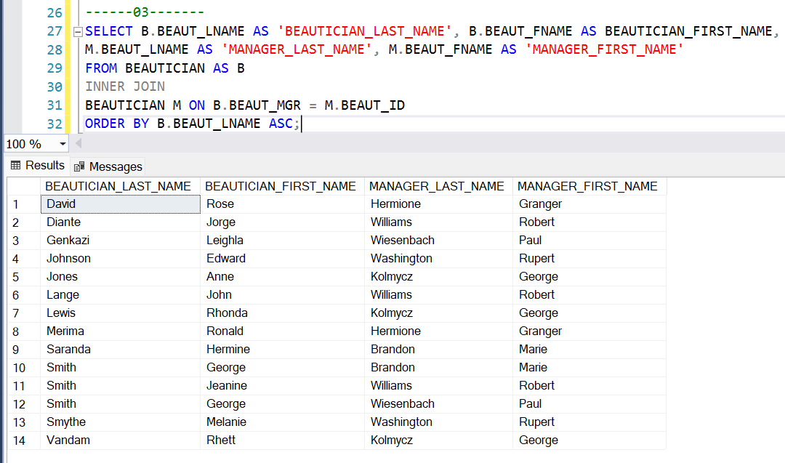

4. Display the beautician information that received the highest number of rewards by selling salon products. ordered and sorted by number of rewards in descending order.

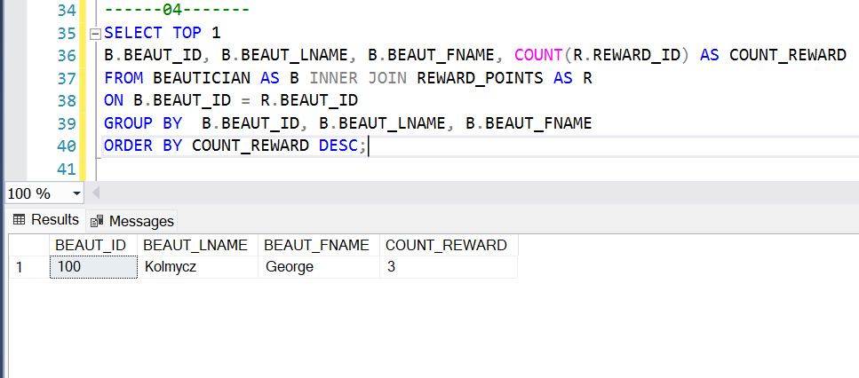

5. Display the top 3 salons where most of the customers go for salon services. ordered and sorted by number of customers in descending order.

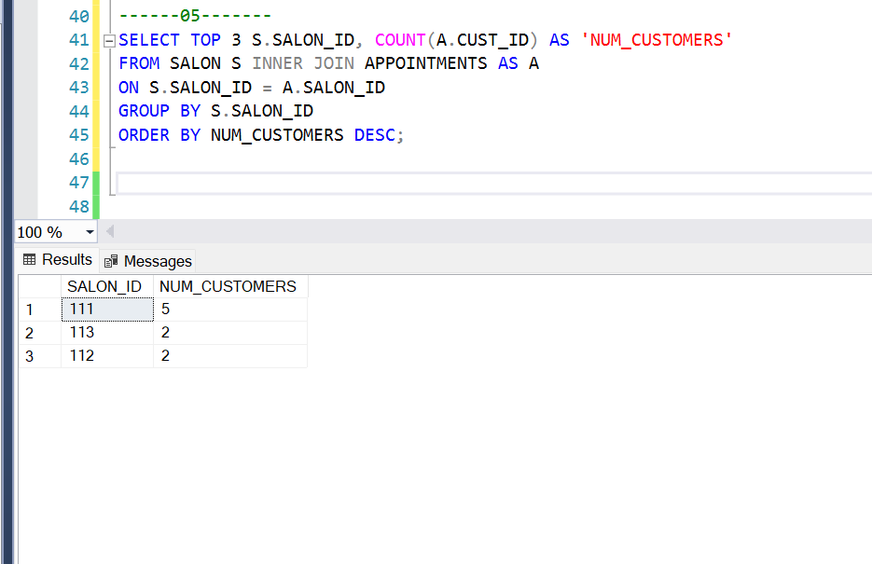

6. Which membership type is popular among members? Display information about the number of members in each type. ordered and sorted by the number of members in descending order.

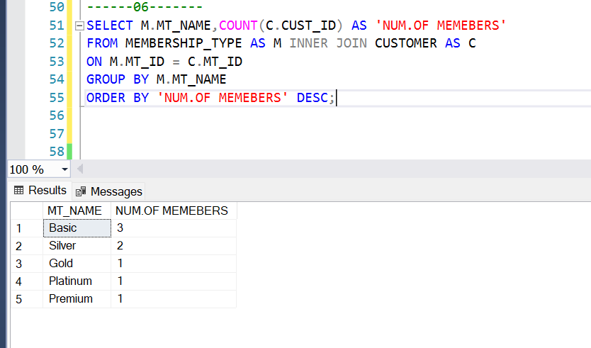

7. List customers who have paid the highest price. Show the last and first name(s) of each customer, along with the service_id and price of the highest priced item that they have paid. Sort the list in descending order based on the customers' last names.

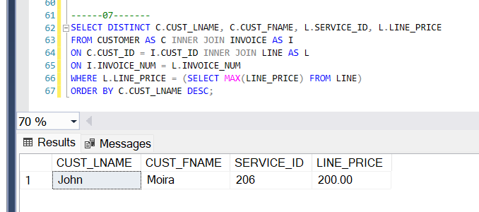

8. For each product invoiced and paid to salon 114, display the product details (P_CODE, P_NAME), the invoice date, and the total quantities of items sold (give a suitable column title) along with the total amount of sales (give a suitable column title and sort the results in descending order on this field). There should be one row displayed per product.

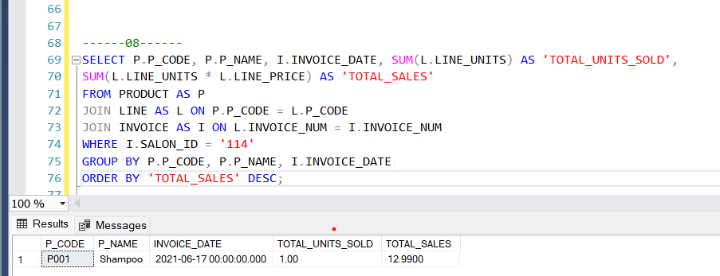

9.What is the average salary of beauticians across different salon branches?

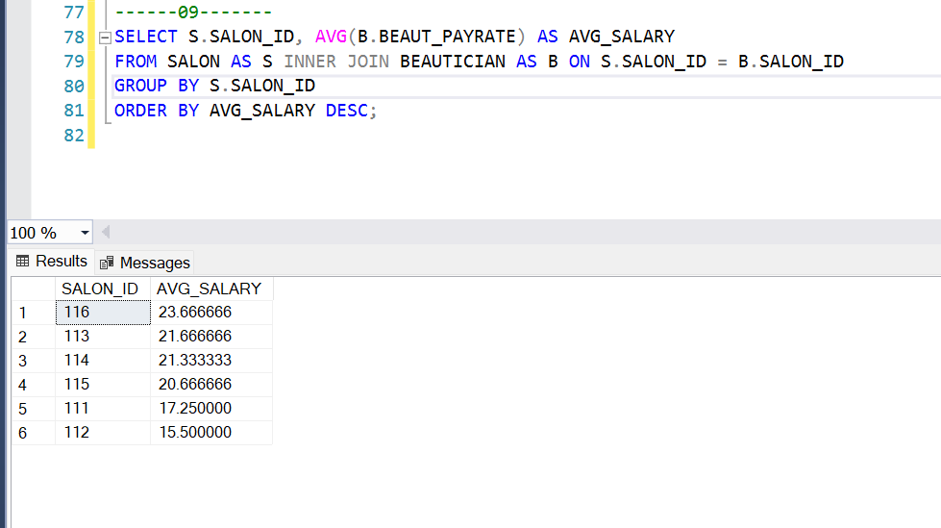

10. List customers who made payment through a credit card. Display Cust_Lname, Cust_Fname, Cust_ID, and Invoice_number along with the information about the credit card payment, number, and issuer. Order sorted Cust_Lname in ascending order.

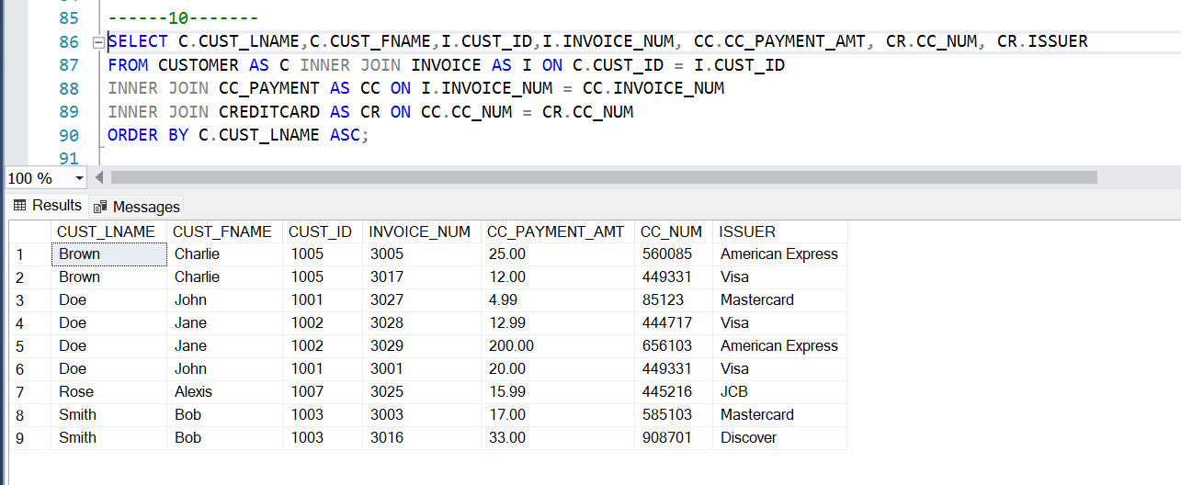

11. List customers who made payment through checks. Display Cust_Lname, Cust_Fname, Cust_ID, and Invoice_number along with the information about the check amount, check number, account number, and routing number. Order sorted Cust_Lname in ascending order.

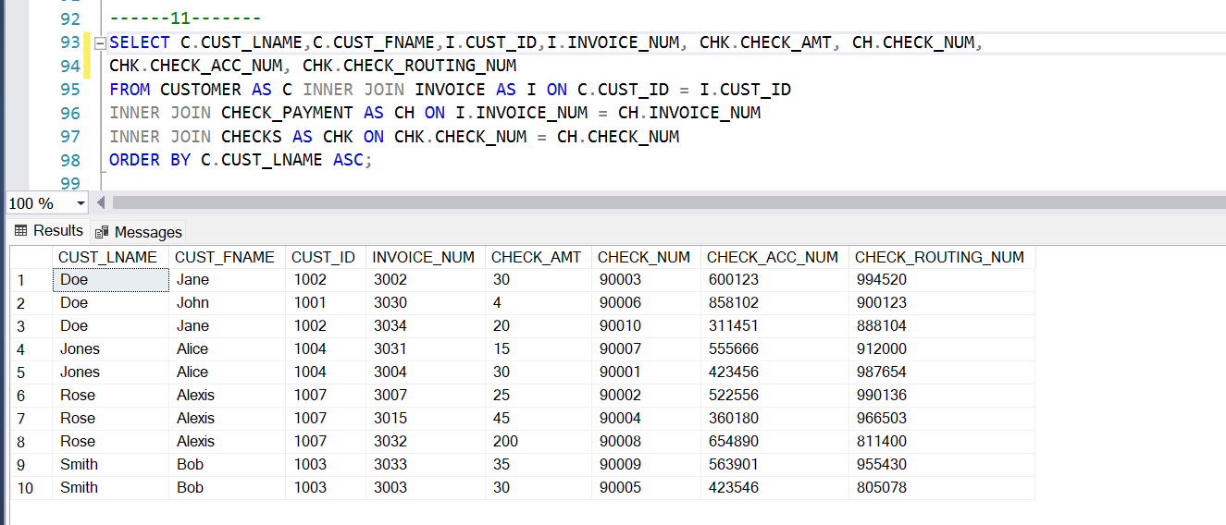

12. List all customers' information, including members and non-members of the salon.

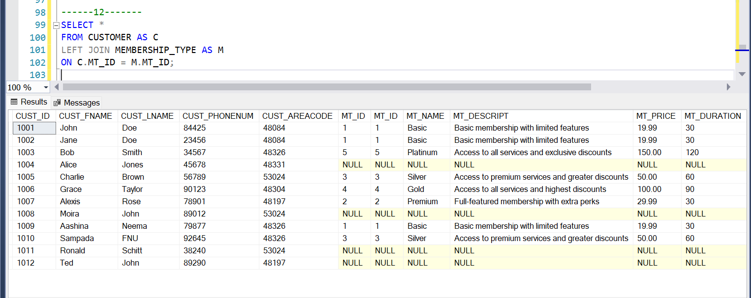

13(A). Which membership type has not received promotions? Display complete information about membership and promotions.

13(B) . Which membership type has not received promotions? Display MT_ID, MT_Name, MT_Descript, MT_Price, and MT_Durations for those who didn’t get promotions.

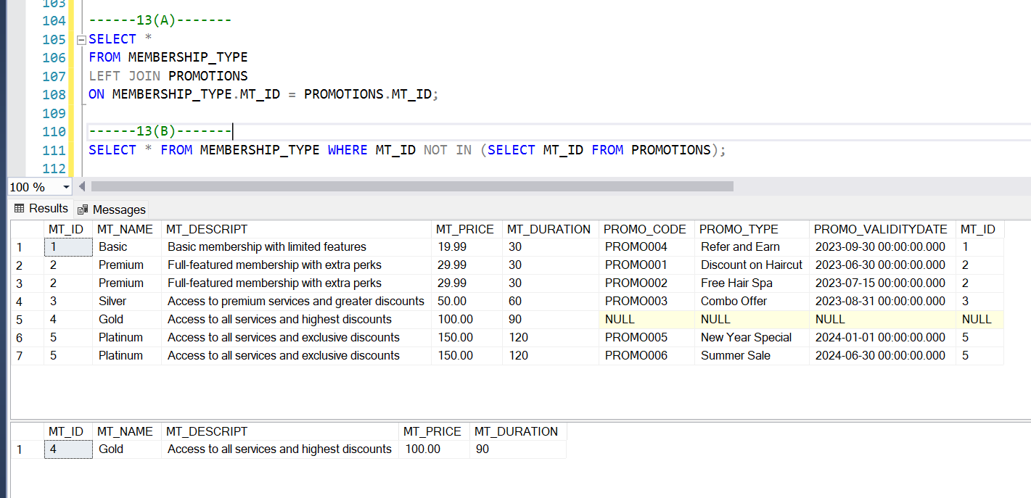

14. List all customer_ID, invoice number along with the cash receipt number and cash amount that has been paid by customer between 2022-01-01 to 2022-12-31. Ordered cash payment amount sorted in descending order.

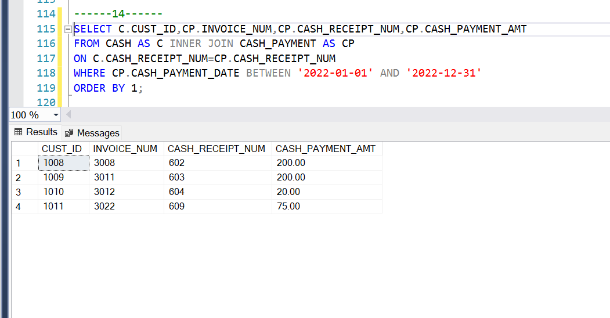

15. List the customers who have taken salon services that cost more than $20. Display the information of the customer ID, first names, last names of customers, service name, service prices.

