<<This is the manuscript template for Nucleic Acids Research. Instructions are included in red at relevant places in the text. Please delete this text before submitting your manuscript>>
SeqFea-Learn: a Python pipeline tool for feature extraction, feature selection, machine learning and deep learning based on DNA, RNA and protein sequence data
Name Surname^{1,}*, Name Surname² and Name Surname²
¹ Department, Institution, Town, State, Postcode, Country
² Department, Institution, Town, State, Postcode, Country
* To whom correspondence should be addressed. Tel: [insert phone number including country code]; Fax: [insert full number]; Email: [insert email address] <<no more than 3 corresponding authors. 2nd and 3rd corresponding authors (if included) will be introduced by “Correspondence may also be addressed to…”. All corresponding authors will be designated by an asterisk, and can appear at any place in the list of authors.>>
<<Joint first authorship is allowed, provided that the relevant boxes are completed during the initial online submission. The joint first authors must be the first names appearing in the list of authors, and the footnote should contain the statement: "The authors wish it to be known that, in their opinion, the first x authors should be regarded as joint First Authors". Other statements concerning joint authorship will not be published. Joint senior/last authorship is not permitted.>>
Present Address: [Author name], Department, Institution, Town, State, Postcode, Country
<<authors with changed affiliations can list them in this section>>

ABSTRACT
The faster and cheaper modern sequencing technology revolutionizes the genomic research and triggers explosive growth of DNA, RNA, and proteins sequencing data. Using bioinformatics tools to analyse and process the sequencing data efficiently and accurately has become a popular and challenging task in genomics and proteomics fields. With the development of experimental methods and statistical learning, an integrated and user-friendly tool containing the state-of-the-art data mining methods are needed. Here, we propose SeqFea-Learn, a comprehensive Python pipeline tool that integrating multiple steps: feature extraction, dimensionality reduction, feature selection, machine learning, and deep learning model’s construction to analyse DNA, RNA, protein sequencing data. We used DNA enhancers, RNA N6-methyladenosine sites and protein-protein interactions datasets to evaluate the validation of the package. SeqFea-Learn can effectively perform biological sequence analysis and predictor construction.
INTRODUCTION
The appearance of next-generation sequencing (NGS) technology has significantly improved the quantities and qualities of biological sequences (DNA, RNA, and protein). With NGS, the duration for sequencing an entire human genome is reduced from a decade to a single day (1) and its cost dropped from $300000 to less than $1000 (2). The recent released GenBank (the version of 232, released on June 15 2019) contains 213,387,758 sequences and WGS in NCBI includes 1,022,913,321 sequences (3). Unlike the microarrays, NGS can analyse and deep investigate the transcriptome for any species because it does not require species or transcript-specific probes. In addition, the technology provides much higher resolution and accuracy with a much lower variation. NGS is a powerful tool or platform which can sequence of thousands to millions of DNA molecules simultaneously (4). It provides researchers a precious opportunity to rapidly sequence whole genomes and study the structure and function from the perspective of biological sequences (5, 6). Analysing sequencing data help researches to explore disease diagnosis (7-9), biotechnology (10) and many other areas.
It is impossible to analyse sequencing data by human inspection alone. Therefore, sequencing data analysis deeply relies on computational tools. Recent research shows that machine learning methods and algorithms have been heavily applied to explore structural and functional properties of DNA, RNA and protein sequencing data (11). The analysis of biological sequence can be mainly regarded as binary and multi-class prediction tasks (12, 13), including DNA enhancers, DNA N6-methyladenosine site (14), DNA N4-methylcytosine site (15), RNA N6-methyladenosine site (16), RNA-binding protein identification (17), protein function site (18), protein fold recognition (19, 20), protein-protein interaction prediction (21-23), etc. For the process to construct predictors, the first step is feature extraction, which transforms the character sequence data into numeric vectors of the same length (24). The feature information in sequencing data can be classified as sequence-based, physicochemical property-based, evolution-based and structure-based biological information. After extracting feature vectors, selecting a suitable classifier algorithm is another step for the prediction model construction. Many popular models can be used for researchers to analyse the structure and function of sequencing data, such as XGBoost (25), support vector machine (SVM) (26) and k nearest neighbours (KNN) (27), and so on.
With the development of bioinformatics, some web servers and standalone packages are developed, including repDNA( 29), PROFEAT (32), Pse-in-one, PyFeat (31), POSSUM, iFeature for only feature extraction, BioSeq-Analysis, iLearn and BioSeq-Analysis2.0 for both feature extraction and predictor construction. At the same time, FeatureSelect and scikit-feature are designed for only feature selection. Although many bioinformatics tools are developed, there are still some obstacles need to be conquered. (i) The existing tools mainly fulfil individual steps in the process of biological sequence analysis, and this is not enough to study biological sequences. Most computational tools or web servers only focus on one individual step instead of integrating all functionalities for sequencing data analysis. For instance, repDNA is a python package to only generate various types of feature vectors from DNA sequences. Pse-in-one 2.0 (30), PyFeat and PROFEAT are generation tools for extracting different feature models from DNA, RNA, and protein sequences. (ii) Overfitting issues often exist during performing accurate predictions in machine learning (28). Based on our observation, extracted feature vectors from the feature extraction step often displays high dimensionality, especially some protein feature vectors display extremely high dimensionality which can cause time-consuming issues and poor accuracy of prediction. (iii) The available packages lack feature selection and dimensional dimensionality reduction methods and ignore some state-of-the-art machine learning methods. (v) Deep learning is a very powerful computational tool for classification tasks via layer by layer learning (36). However, the packages above lack the usages of deep learning theories.
Especially, high dimensionality will consume memory storage, significantly increase the execution time of model construction and hurt prediction accuracy. Feature selection methods just select those features that contribute most to predictions, including information-based, tree-based, regularization-based, statistic-based methods. Some popular and powerful feature selection algorithms are widely used such as the Chi-squared test [39], SVM-RFE [40], Lasso [41], Pearson correlation [42], ReliefF [43], and so on. For some feature vectors with extremely high dimensionalities, unsupervised dimension reduction methods are often involved in the sequencing data analysis to pre-filter vectors to reduce the time cost of model construction. Dimensionality reduction can project raw feature space with high dimensionality to a new feature space via the linear or non-linear combination. Dimensionality reduction and feature selection both can reduce the model’s complexity, computational resource cost and execution time, prevent overfitting issue and improve the accuracy of prediction to provide more reliable predictions.
Inspired by the above discussion, we propose a new Python pipeline, SeqFea-Learn, that integrated 60 feature descriptors of DNA, RNA and protein sequencing data, 20 feature selection methods, 16 dimensionality reduction methods and 13 classification models, Figure 1. Compared with other software packages or webservers, the proposed SeqFea-Learn has the following advantages: (i) A user-friendly software package to fulfill the sequence analysis via feature extraction, feature selection, dimensionality reduction, machine learning, deep learning classifiers construction and the evaluation of their performances. (ii) Sufficient feature selection methods and dimension reduction methods, including regularization-based, statistic-based, information-based, tree-based and recursive feature elimination-based approaches, which could determine the optimal feature subset and eliminate noisy, unrelated, and redundant information. (iii) Ten popular machine learning methods are provided and based on these methods, the user can choose appropriate classifiers to predict the sequence structure and function. In this way, the better predictor can be established through optimizing feature fusion, feature selection, and classifier construction. (iv) Three deep learning approaches: deep neural network (DNN) [44], convolutional neural network (CNN) [45], and recurrent neural network (RNN) [46] are provided. (v) In order to facilitate the application of SeqFea-Learn, seven cluster algorithms and five sampling methods are provided, which could serve more researchers. (vi) More abundant graphical display results, including box figure, ROC curves, and so on.
MATERIAL AND METHODS
The DNA, RNA and protein biological sequence with residues can be regarded as:
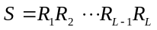 (1)
where 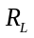 represents the 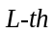 residue. And the biological sequence contains important and effective information of structure and function. How to analyze the attributes of sequence and construct useful predictors based on machine learning is necessary. The commonly steps for modeling the classifier based on DNA, RNA and protein sequence: (i) Feature extraction, which obtain the composition information, physiochemical information and evolutionary information and structural information; (ii) Feature selection and dimensionality reduction, which remove redundancy and noise from the extracted feature vectors and retain clean, effective and understandable feature information; (iii) Machine learning and deep learning, which could predict the structure and function of sequencing data via predictors; (iv) Models evaluation, which generate the prediction results of tables and figures.

Feature extraction
SeqFea-Learn directly extracts features from DNA, RNA or protein sequences based on a total of 60 different types of feature extraction methods. The step of feature extraction consists of 16 feature extraction methods for DNA, Table 1; 12 feature extraction methods for RNA, Table 2; 32 feature extraction methods for protein sequences, Table 3.
Table 1. List of 19 DNA feature extraction methods and their descriptions

Category | DNA feature extraction methods | Method description
Nucleic acid composition | Kmer | DNA sequence is represented as the occurrence frequencies of k neighboring nucleic acids [47, 48]
 | Reverse compliment kmer (RCKmer) | A variant of Kmer descriptor by removing the reverse compliment Kmer [47, 49]
 | Nucleic acid composition (NAC) | Calculating the frequency of each nucleic acid type in nucleotide sequence [34]
 | Di-nucleotide composition (DNC) | Obtaining composition information of di-nucleotide in DNA sequence[34]
 | Tri-Nucleotide Composition (TNC) | Obtaining composition information of tri-nucleotide [34]
 | Binary encoding (BE) | Basic binary descriptor i.e. basic one-hot descriptor
 | zCurve Mathematical Formula (zCurve) | Calculating three components in three axis in genomic sequence analysis [31]
Autocorrelation | Dinucleotide based auto covariance (DAC) | Measuring the correlation information of the same physicochemical index between two dinucleotides separated by lag along the sequence [52, 53]
 | Dinucleotide based cross covariance (DCC) | Measuring the correlation of two different physicochemical indices between two dinucleotides separated by lag nucleic acids [52, 53]
 | Di-nucleotide based auto-cross covariance (DACC) | Combining of DAC and DCC [52-53, 29]
 | Tri-nucleotide based auto covariance (TAC) | Measuring the correlation of the same physicochemical index between trinucleotides separated by lag nucleic acids [29]
 | Tri-nucleotide based cross covariance (TCC) | Measuring the correlation of two different physicochemical indices between two trinucleotides separated by lag nucleic acids [29]
 | Tri-nucleotide based auto-cross covariance (TACC) | Combination of TCC and TACC [29]
Position-specific tendency | Position-specific dinucleotide propensity (PSDNP) | Calculating the position-specific tendencies based on the dinucleotide propensity
 | Position-specific trinucleotide propensity (PSTNP) | Obtaining the position-specific tendencies based on trinucleotide propensity
MonoGap descriptor | MonoKGap theoretical description (MonoKGap) | Calculating features based on value of kgap [31]
 | MonoDiKGap theoretical description (MonodiKGap) | Calculating features based on value of 4*kgap [31]
Pseudo nucleotide composition | Pseudo di-nucleotide composition (PseDNC) | Incorporating the contiguous local sequence-order and global sequence-order information [50]
 | Pseudo k-tuple nucleotide composition (PseKNC) | Extending the PseDNC by incorporating k-tuple nucleotide composition [51]

Table 2. List of 15 RNA feature extraction methods and their descriptions

Category | RNA feature extraction methods | Method description
Nucleic acid composition | Kmer | DNA sequence is represented as the occurrence frequencies of k neighboring nucleic acids [47, 48]
 | Reverse compliment kmer (RCKmer) | A variant of Kmer descriptor by removing the reverse compliment Kmer [47, 49]
 | Nucleic acid composition (NAC) | Calculating the frequency of each nucleic acid type in nucleotide sequence [34]
 | Di-nucleotide composition (DNC) | Obtaining composition information of di-nucleotide in DNA sequence[34]
 | Tri-Nucleotide Composition (TNC) | Obtaining composition information of tri-nucleotide [34]
 | Binary encoding (BE) | Basic binary descriptor i.e. basic one-hot descriptor
 | zCurve Mathematical Formula (zCurve) | Calculating three components in three axis in genomic sequence analysis [31]
Autocorrelation | Dinucleotide based auto covariance (DAC) | Measuring the correlation information of the same physicochemical index between two dinucleotides separated by lag along the sequence [52, 53]
 | Dinucleotide based cross covariance (DCC) | Measuring the correlation of two different physicochemical indices between two dinucleotides separated by lag nucleic acids [52, 53]
 | Di-nucleotide based auto-cross covariance (DACC) | Combining of DAC and DCC [52-53, 29]
Position-specific tendency | Position-specific dinucleotide propensity (PSDNP) | Calculating the position-specific tendencies based on the dinucleotide propensity
 | Position-specific trinucleotide propensity (PSTNP) | Obtaining the position-specific tendencies based on trinucleotide propensity
MonoGap descriptor | MonoKGap theoretical description (MonoKGap) | Calculating features based on value of kgap [31]
 | MonoDiKGap theoretical description (MonodiKGap) | Calculating features based on value of 4*kgap [31]
Pseudo nucleotide composition | Pseudo di-nucleotide composition (PseDNC) | Incorporating the contiguous local sequence-order and global sequence-order information [50]

Table 3. List of 32 Protein feature extraction methods and their descriptions

Category | Protein feature extraction methods | Method description
Amino acid composition information-based descriptors | Amino acid composition (AAC) | Calculating the frequencies of 20 kinds of amino acids [54]
 | Dipeptide composition (DC) | Calculating the frequencies of 400 kinds of dipeptide [54]
 | Composition of k-spaced amino acid pairs (CKSAAP) | The frequencies information of k-spaced amino acid pairs [55-57]
Grouped amino acid composition-based descriptors | Grouped dipeptide composition (GDC) | A variation of the DPC descriptor based on grouped sequence[58]
 | Grouped tripeptide composition (GTC) | The frequencies of tripeptide based on grouped amino acid sequence [58]
 | Conjoint triad (CT) | Calculating the frequency of occurrence of each triad [60]
 | K-spaced conjoint triad (KSCTriad) | Combining CT and considers the continuous amino acid units that are separated by k residues [60]
 | Composition (C) | Calculating composition descriptors
 | Transition (T) | Calculating transition descriptors
 | Distribution (D) | Calculating distribution descriptors [61-63]
 | Encoding based on grouped weight (EBGW) | Capturing the continuity and discontinuity features based on grouped weight coding [64]
Physicochemical information-based descriptors | Auto covariance (AC) | Measuring the correlation of the physicochemical property between two residues separated by interval [65]
 | Moreau-Broto autocorrelation (Morean-Broto) | Measuring the physiochemical and position information between two amino acid [66]
 | Moran autocorrelation (Moran) | Measuring the physiochemical information of adjacent amino acid [67]
 | Geary autocorrelation (Geary) | Measuring the physiochemical information and generate positive values [68, 69]
 | Quasi-sequence-order (QSO) | Obtaining the sequence distribution patters for a specific physicochemical property [70]
 | Pseudo-amino acid composition (PseAAC) | Extracting the physicochemical information and sequence order information [71, 72]
 | Amphiphilic pseudo-amino acid composition (APAAC) | Extracting the type-2 pseudo amino acid composition [71, 72]
Evolutionary information-based descriptors | Amino acid composition PSSM (AAC-PSSM) | Calculating process of amino acid composition PSSM [73, 74]
 | Dipeptide composition PSSM (DPC-PSSM) | Extracting the dipeptide composition information in the PSSM [74]
 | Bi-gram PSSM (Bi-PSSM) | Calculating the frequency of the transition between two amino acids [75]
 | Auto covariance PSSM (AC-PSSM) | Measuring the correlation information between two residues separated by interval in the PSSM [76]
 | Pseudo PSSM (PsePSSM) | Calculating the psePSSM feature vector according to the pseudo amino acid composition [77]
 | AB-PSSM | Calculating feature vector based on averaged PSSM over blocks [78]
Structural information-based descriptors | Secondary structure composition (SSC) | Calculating feature based normalized count of frequency of the structural motifs present at the amino-acid residue positions [79]
 | Accessible surface area composition (ASA) | Calculating feature based on normalized sum of accessible surface area [79]
 | Torsional angles composition (TAC) | Calculating features based four different types of torsional angles [79]
 | Torsional angles bigram (TA-bigram) | Calculating feature based on the bigram of the torsional angles [79]
 | Structural probabilities bigram (SP-bigram) | Calculating feature based on structural probabilities for each position of amino acid residue [79]
 | Torsional angles auto-covariance (TAAC) | Calculating feature from the torsional auto-covariance [79]
 | Structural probabilities auto-covariance (SPAC) | Calculating feature from the structural probabilities [79]

Feature selection and dimensionality reduction
The dimension of feature vectors after feature extraction and feature fusion could be extremely high. Take the composition of k-spaced amino acid pairs (CKSAAP) for example, when the parameter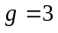, the size of dimension could be 1200. At the same time, autocorrelation descriptors using physicochemical properties to extract sequence information. The AAindex database contains 554 physicochemical properties. Therefore, SeqFea-Learn integrated steps of feature selection and dimensionality reduction. Selecting those features which contribute most to the prediction can effectively improve prediction accuracy and reduce the implementation time. Only wanted the number of top-ranking features will be selected in the step of feature selection, Table 4. Dimensionality reduction methods can be applied for extremely high dimensionality dataset to reduce data preparation time for model constructions, Table 5.
Table 4. Feature selection methods and their descriptions
Category | Feature selection methods | Method description
Regularization-based methods | LASSO | Using LASSO based on L1-norm to select features[41, 80]
 | Elastic net (EN) | Using the combination of L1-norm and L2 norm [81]
 | L1-SVM | Using SVM with L1 penalty model to determine the optimal feature subset[82]
 | L1-LR | Using logistic regression with L1 penalty to select the optimal feature subset
RFE-based methods | Extra-Trees-RFE | Using Extra-Trees model to recursively eliminate features [84]
 | XGBosst-RFE | Using XGBoost model to recursively eliminate features [25. 85]
 | SVM-RFE | Using linear SVM model to recursively eliminate features [40, 86]
 | LR-RFE | Using logistic regression model to recursively eliminate features [87]
Information theory-based methods | Mutual information (MI) | Retrieving best features based mutual information [88]
 | Minimum redundancy maximum relevance (MRMR) | Selecting features that still having high correlation to the classification variable  with minimum redundancy [90]
 | Joint mutual information (JMI) | Retrieving best features based joint mutual information [91]
 | Maximum relevance maximum distance (MRMD) | Retrieving best features by measuring relevance and redundancy between features via distance [92]
 | Information gain (IG) | Retrieving best features based on their information gain [106]
Statistic-based methods | Chi-square test (CHI2)c | Retrieving best features based on chi-square test [39, 83]
 | Pearson correlation (Pearson) | Retrieving best features based on Pearson correlation [42]
 | ReliefF | Retrieving best features by calculating and ranking a feature score for each feature [43]
 | Trace Ratio | Retrieving best features by calculating the corresponding score in trace ratio form [93]
 | Gini Index | Retrieving best features by constructing the measure function based on Gini-Index [94]
 | Spectral Feature Selection (SPEC) | Retrieving best features based on structure induced [95]
 | Fisher Score | Retrieving best features based on scores of features under the Fisher criterion [96]
 | T-Score | Retrieving best features based on their t-score

Table 5. Dimensionality reduction methods and their descriptions
Category | Dimensionality Reduction Methods | Method description
Principal component analysis | Principal component analysis (PCA) | Linear dimensionality reduction using singular value decomposition [100]
 | Kernel PCA (KPCA) | Non-linear dimensionality reduction through use of kernels [100]
Manifold learning | Locally linear embedding (LLE) | Reducing dimension of data which preserves distances within local neighborhoods [101]
 | Multi-dimensional scaling (MDS)
 | t-distributed stochastic neighbor embedding (T-SNE) | Visualizing high-dimensional data [99]
Matrix factorization | Truncated singular value decomposition (SVD) | Linear dimensionality reduction by means of truncated singular value decomposition [102]
 | Non-negative matrix factorization (NMF) | Reducing dimension by finding two non-negative metrices [103]
Random projection | Gaussian random projection (GRP) | Reducing the dimension by projecting the original input space using the Gaussian distribution [109]
 | Sparse random projection (SRP) | Reducing dimension by projecting the original input space using a sparse random matrix [110]
 | Independent component analysis (ICA) | Reducing dimension by finding components with some sparsity [105]
 | Factor analysis (FA) | Reducing dimension by performing a maximum likelihood estimate [107]
 | Agglomerate feature (AF) | Recursively merges feature instead of samples [108]
Autoencoder | Autoencoder | Reducing the dimension using encode and decode neural network [111]
 | Gaussian noise autoencoder | Corrupting input before being passed to autoencoder neural network [112]
 | Variational autoencoder | Neural network can be trained with stochastic gradient descent [113]

Clustering and sampling methods
In the analysis of single-cell RNA sequencing data, the cluster algorithms are employed to fulfil the identification of single-cell types. At the same time, there are class-imbalanced problems in bioinformatics, the number of protein function sites (positive samples) is higher than non-sites (negative samples). Inspired by this,we integrate 7 kinds of cluster algorithms and 5 kinds of sampling techniques to facilitate the application of SeqFea-Learn. The clustering and sampling approaches in the proposed pipeline SeqFea-Learn are listed in Table 6.
Table 6 The clustering and sampling methods and their descriptions
Category | Clustering and sampling methods | Method description
Clustering methods | K-means | Clustering data by separating samples in groups of equal variances [98]
 | Spectral Clustering | Creating cluster through a projection of the normalized Laplacian
 | Gaussian Mixture Clustering | Creating clusters through representation of a Gaussian mixture model probability distribution
 | Affinity Propagation Clustering | Creating clusters by performing affinity propagation clustering of data
 | Mean Shift | Creating clusters by discovering blobs in a smooth density of samples
 | DBSCAN | Creating clusters using density-based spatial clustering with noise
 | OPTICS | Creating clusters by estimating structure from feature vector
Sampling methods | Random over sampling  (ROS) | Generating new samples by randomly sampling with replacement the current available samples
 | Synthetic minority oversampling technique (SMOTE) | An oversampling method which uses a small number of samples to control the generation and distribution of artificial samples to achieve dataset class balance
 | Adaptive synthetic (ADASYN) | Adaptive synthetic oversampling approach for imbalanced learning
 | Random under sampling (RUS) | Balancing the data by randomly selecting a subset of data for the targeted classes
 | Neighbourhood cleaning rule (NCR) | Focusing on cleaning the data based on their neighbourhoods

Machine learning and deep learning
Selecting suitable machine learning or deep learning methods is a key step for predictor construction. Support vector machine (SVM) is a kernel-based classifier through constructing the optimal hyperplane. Random forest (RF) is a tree-based machine learning method. Recently, gradient boosting decision tree (GBDT) [117], XGBoost and LightGBM are demonstrated to be excellent classifiers via gradient boosting algorithm. SeqFea-Learn integrated 10 popular machine learning methods SVM, KNN, RF, LightGBM, XGBoost, Adaboost [118], Extra-Trees, Gaussian Naïve Bayes (GNB) [119], GBDT. Deep learning can explore essential sequences represent information via hierarchical structure, which can accurately, effectively perform the sequences classification tasks. The tool integrated three deep learning methods, including deep neural network (DNN), convolutional neural network (CNN), and recurrent neural network (RNN). The description of different classifier can be shown in Table 7.
Table 7 The machine learning and deep learning methods and their descriptions

Classifier | Description
Support vector machine (SVM) | Constructing the optimal hyperplane based on kernel
K-nearest neighbor (KNN) | Predicting sample label based on the distance among its neighbors
Random forest (RF) | Bagging ensemble classifier using random bootstrap
Extremely randomized trees (Extra-Trees) | Ensemble method whose base decision tree grows at each node by randomly selecting a feature
Gradient boosting decision tree (GBDT) | GBDT fits residual of regression tree at each iteration using negative gradient values of loss
XGBoost | It uses not only the first derivative but also the second derivative of the loss function for second-order derivation
LightGBM | Improving GBDT based on gradient-based one-side sampling and exclusive feature bundling
Bagging classifier (Bagging) | Using Bagging sampling algorithm and voting principle to construct classifier
AdaBoost | Constructing classifier via boosting algorithm
Gaussian Naïve Bayes (GNB) | Classification algorithm based on probability theory
Deep neural network (DNN) | A deep learning framework using fully-layer network
Convolutional neural network (CNN) | A deep learning framework using convolution and pooling process
Recurrent neural network (RNN) | A deep learning framework using long and short time memory neural network

Cross-validation and Model evaluation
In ALLFEATURE, K-fold cross-validation, leave-one-out cross-validation, and hold-out evaluation methods are all used for evaluating classification models. Meanwhile, in order to measure the designed statistical prediction model, sensitivity is also the recall rate (SE), specificity (SP), accuracy (ACC), Matthew's correlation coefficient (MCC), precision (PRE), and F-measure (F1) are sued to evaluate the model performance.
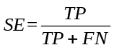 (2)
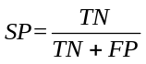 (3)
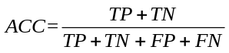 (4)
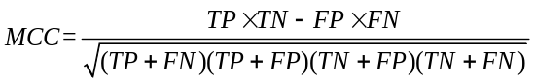 (5)
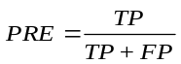 (6)
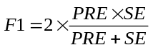 (7)
where TP, TN, FP and FN in the above equations represent true positive, true negative, false positive and false negative, respectively. The Receiver Operating Characteristic (ROC) curve, the Precision-Recall (PR) curve and their corresponding AUC (area under the ROC curve) and AUPR (area under the PR curve) are also important indicators for evaluating the classifier.

The pipeline of SeqFea-Learn and predictor constrution
In this paper, we proposed SeqFea-Learn to perform the analysis of sequence feature, which includes feature extraction, feature selection, dimensionality reduction, cluster, sampling methods, machine leaning and deep learning. The pipeline are shown in Figure 1.
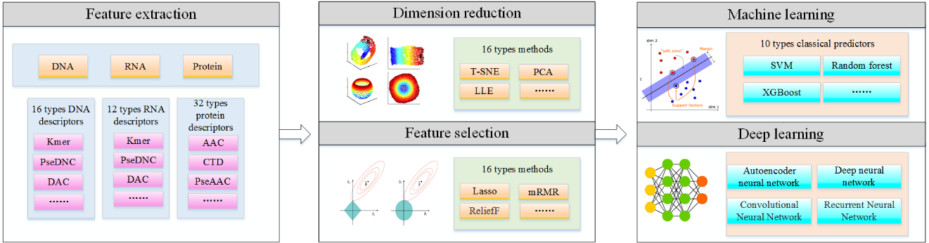
Figure 1. The pipeline of ALLFEATURE. The python package contains feature extraction, feature selection, machine learning, deep learning, and performance evaluation. The input is the DNA, RNA or protein sequences with FASTA format or the high-dimension matrix with CSV format. The outputs of the pipeline will provide generated feature vectors, prediction accuracy comparison, and suggestion of the best model for researchers.

RESULTS and Discussion
Application of SeqFea-Learn
Our user-friendly tool will generate feature vectors from raw sequencing data in FASTA format, apply feature selection method and construct predicting model based on the user’s choice. For testing the usage of our pipeline tool, three prediction tasks were performed for DNA, RNA and protein sequences, respectively. In this paper, we use DNA enhancers, RNA N6-methyladenosine sites and protein-protein interactions datasets to evaluate the validation of models. These prediction performances are comparable and even more effective than the state-of-the-art approaches, which indicate our proposed python package is competitive for the analysis of biological sequences.
DNA enhancers prediction.
DNA enhancers data plays an important role in analyzing gene expression and to identify enhancers is a challenging task [120]. The dataset contains 1484 enhancer samples and 1484 non-enhancer samples. We applied five DNA feature extraction methods: PSTNP, Kmer, pseDNC, BE and DNC to construct predictors. In addition, we also found that fusing these feature descriptors as one mixed descriptor can effectively represent the information of the dataset and improve classification performance. The highest classification accuracies of 13 predictors are shown in Table 8.
Table 8. Predicting accuracies of different feature descriptors (DNA)
Feature Extraction | PSTNP | PseDNC | Kmer | BE | DNC | Fusion
Highest Classification Accuracy of 13 Predictors | 81.90% (SVM) | 75.77% (DNN) | 76.72% (SVM) | 75.17% (GNB) | 75.97% (RNN) | 84.06%  (DNN)

According to Table 8, we used the fused feature vector to implement the step of feature selection. All of 20 Feature Selection methods are applied and these selected feature vectors are used for constructing models to find the best classifier. Based on our observation and comparison, the selected feature vector using the Extra-Tree feature selection method can achieve better prediction performance, Figure 2. And the execution time of modelling is significantly reduced, Table 9.
Table 9. Comparison of number of features and modeling execution time of DNA enhancers
 | Fused feature vector | Selected feature vector based Extra-Tree
Number of Features | 1296 | 50
Execution Time | 34m 42s | 4m 5s

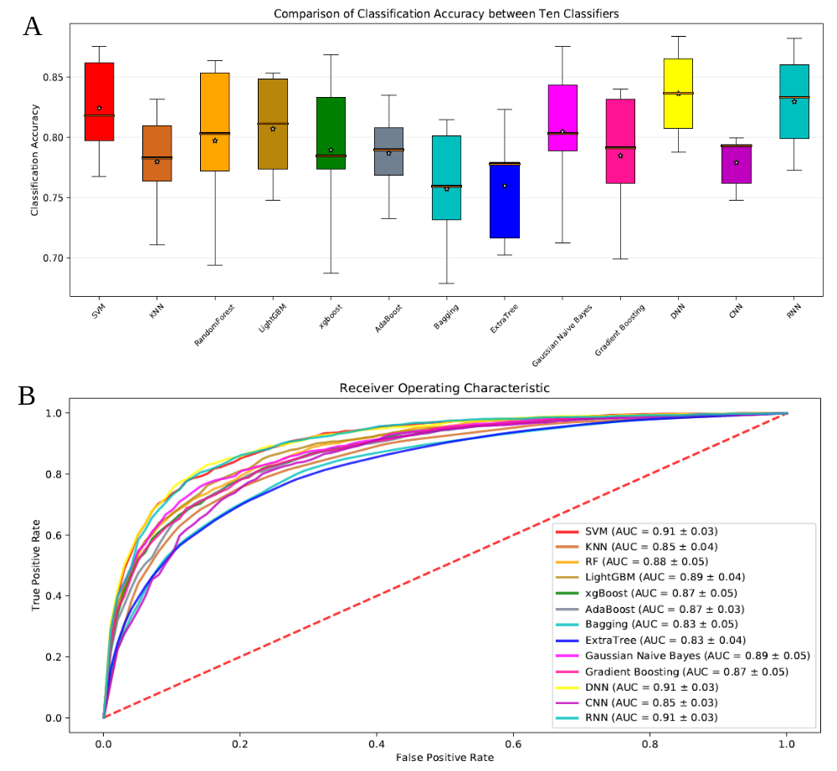
Figure 2. The boxplot of classification accuracies (A) and ROC curves (B) of DNA enhancers using various classifiers with Extra-Tree feature selection method. (A) 13 classifiers all achieve satisfactory accuracy, and SVM, DNN, RNN obtain superior performance than other classifiers. (B) The ROC curves of 13 classifier indicate DNN and RNN achieved better results.
RNA N6-methyladenine sites prediction
N6-methyladenosine (m6A) refers to methylation of the adenosine nucleotide acid at the nitrogen-6 position. It is highly related to a series of biological processes, such as splicing events, mRNA exporting, nascent mRNA synthesis, nuclear translocation and translation process [17]. Therefore, constructing an effective predicting model to identify RNA N6-methyladenine sites becomes an essential task. In this paper, the m6A dataset contains 2614 sequences, where 1307 represents true methyladenosine sites, and the remaining 1307 are false methyladenosine sites. Instead of using a single feature extraction method, the fused feature vector shows a better classification performance, Table 9. We used pseDNC, PSTNP, Kmer, TNC and MonoKGap five feature extraction methods to construct initial feature vectors. In order to evaluate the effectiveness of feature selection, we applied all feature selection methods to determine the optimal feature subset. The feature subset using the ReliefF feature selection method displays better predictions, Figure 3. And the execution time of modeling is significantly reduced, Table 10.
Table 9. Classification accuracies based on different feature descriptors of RNA N6-methyladenine sites
Feature extraction | PSTNP | PseDNC | TNC | DNC | MonoKGap | Fusion
Highest Classification Accuracy of 13 Predictors | 80.64%  (SVM) | 63.77%  (SVM) | 65.91%  (DNN) | 63.88%  (DNN) | 61.63%  (DNN) | 81.36%  (SVM)

Table 10. Comparison of number of features and modeling execution time of RNA 6mA data
 | Fused feature vector | Selected feature vector based Extra-Trees
Number of Features | 186 | 50
Execution Time | 6m 13s | 4m 26s

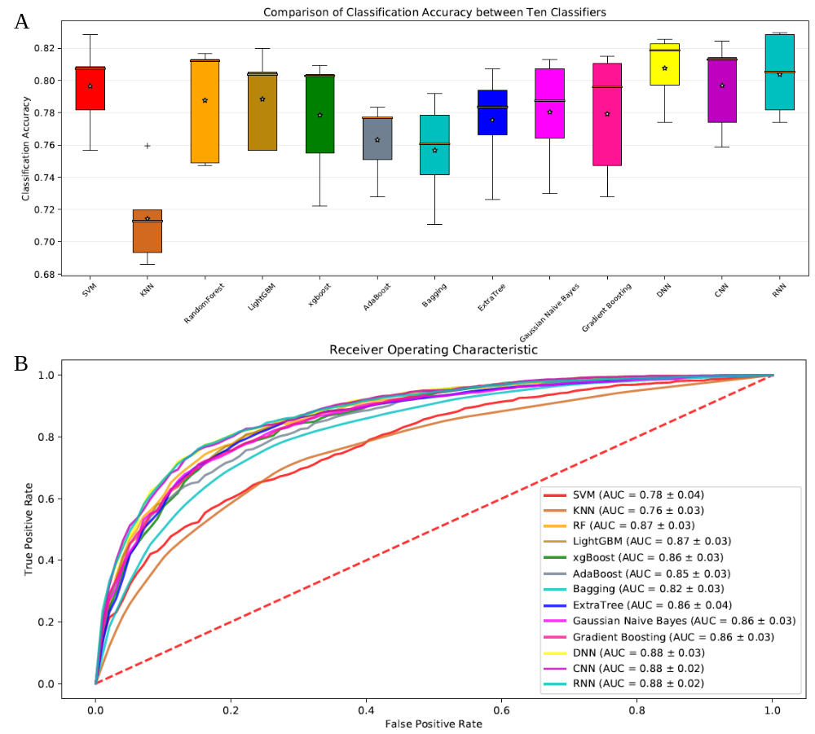
Figure 3. The boxplot accuracies (A) and ROC curves (B) under different classifiers on RNA N6-methyladenine sites dataset via ReliefF feature selection. (A) The boxplot of 13 classifiers and deep learning methods achieve better performance and the KNN is the worst. (B) The ROC curves of 13 classifier and DNN, CNN and RNN obtain the best prediction performance.
Protein-protein interactions prediction
The analysis of protein-protein interactions (PPIs) can help to understand the protein function, construct the complete interactome and study the signaling pathways. The limitations of experiments lead to the development of computational prediction methods. These approaches can help us to encode, integrate and predict the PPIs. In this section, we use S. cerevisae collected by Guo et al to evaluate ALLFEATURE, and S. cerevisae includes 5594 PPIs samples and 5594 non-PPIs samples. For feature extraction, we fused CTDC, CTDT, CTDD, EBGW, Geary, PseAAC, PsePSSM, abPSSM to obtain the feature representation information. After comparing all selected feature vectors’ predicting performances (Table 11 and 12), the MRMR feature selection method shows a better performance, Figure 4.
Table 11. Classification accuracies based on different feature descriptors of protein-protein interactions data
Feature Extraction Methods | CTDC | CTDT | EBGW | Geary | PseAAC | PsePSSM | abPSSM | Five Descriptors Fusion
Highest Classification Accuracy of 13 Predictors | 0.95  (GBDT) | 0.94  (GBDT) | 0.94  (GBDT) | 0.95  (xgBoost) | 0.95  (xgBoost) | 0.94  (xgBoost) | 0.95  (LightGBM) |  | 0.98  (xgBoost)

Table 12. Comparison of number of features and modeling execution time of PPIs
 | Fused feature vector | Selected feature vector based MRMR
Number of Features | 2066 | 200
Execution Time | 1006m 20s | 110m 30s

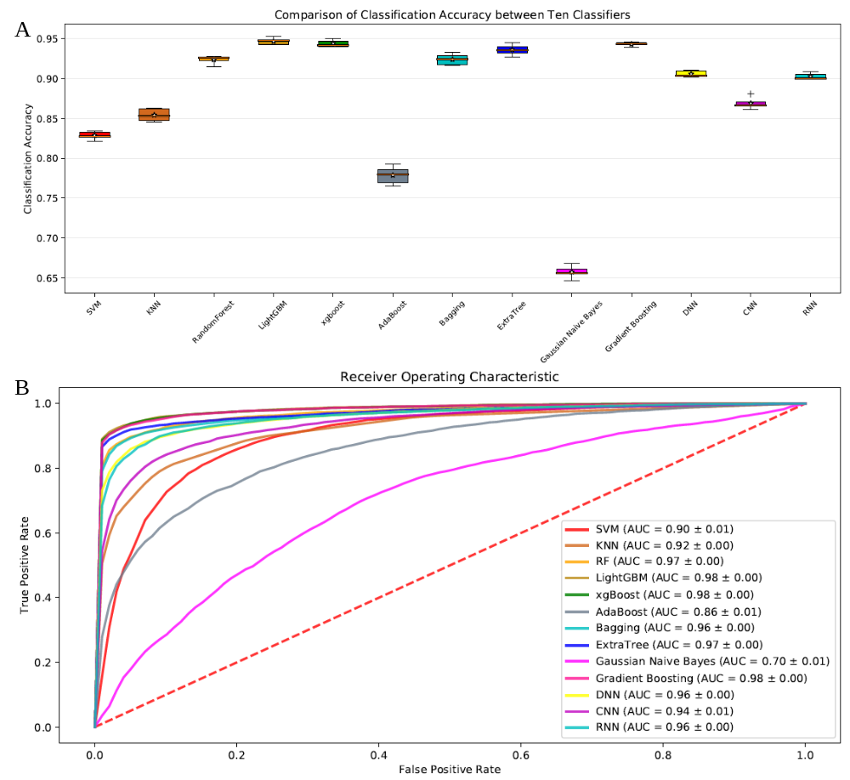
Figure 4. The boxplot accuracies (A) and ROC curves (B) under different classifiers on protein-protein interactions dataset via MRMR feature selection. (A) The boxplot of 13 classifiers and LightGBM achieve better performance and the GNB is the worst. (B) The ROC curves of 13 classifier and LightGBM and xgBoost obtain the best prediction performance.
DISCUSSION
With the rapid increase of DNA, RNA and protein sequence data, the analysis and process of the biological sequence are urgently needed. In this paper, we introduce an intuitive and comprehensive Python package and web server called SeqFea-Learn to perform steps of feature extraction, feature selection, dimensionality reduction, and model construction to predict the sequence structure and function of unseen samples. SeqFea-Learn for the first time integrated 20 types of feature selection methods and 16 kinds of dimensionality reduction approach to deal with dimensionality disaster and prevent overfitting issues. SeqFea-Learn also offers 10 popular classifiers and 3 deep learning frameworks to satisfy users’ needs. The tool will generate visible results to provide a user clear idea to compare and select the best classifier. To further test the validity of SeqFea-Learn, we perform three predicting tasks: DNA enhancers, RNA N6-methyladenine sites and protein-protein interactions prediction. Integrated feature selection and dimensionality reduction methods can reduce modeling time without hurting the prediction accuracy. The classification performances indicate ALLFEAURE is an effective and accurate biological sequencing pipeline tool for bioinformatics and computational biology compared with other state-of-the-art approaches.

AVAILABILITY
ALLFEATURE Python pipeline tool can be implemented in both Linux and Windows operating system. The download link and tutorial can be found in https://github.com/ashinandjay/FeatureSelection The Webserver is in developing and will be released to public soon.
ACCESSION NUMBERS
<<Please list here all the public repository accession numbers (e.g. PDB, GEO). An example is provided below>>
Atomic coordinates and structure factors for the reported crystal structures have been deposited with the Protein Data bank under accession number XXXX.

SUPPLEMENTARY DATA
<<Supplementary data should consist of electronic files and should not merely be a link to another web site. All supplementary data MUST be referred to in the main manuscript at an appropriate point in the text. The supplementary data should preferably be saved as one single PDF file, including all text, figures, tables and legends. If this is not possible, a maximum of 10 files is acceptable to make up the supplementary data unit for the article (see below). The maximum size per file should not exceed 1.5 MBytes, and files must be as small as possible so that they can be downloaded quickly.
- Pick a common cross-platform (PC, Mac, Linux/UNIX, Amiga, etc.) format for your Supplementary data to allow the greatest access.
- If you cannot convert all your files to PDF (.pdf), please provide the following:
- text files in MS Word (.doc), HTML (.html) or RTF (.rtf) format.
- spreadsheet files in MS Excel (.xls) or CSV format. Where possible, combine all tables into a single Excel workbook, saving individual tables on separate clearly labelled worksheets (tabs).
- image files in tif, gif or jpg format. Images should be a maximum size of 640 x 480 pixels (9 x 6.8 inches at 72 pixels per inch).
- sound clips in mp3 format.
- movie clips in mpeg format
Supplementary Data statement:
If applicable, the following statement must be added at the end of the manuscript>>
Supplementary Data are available at NAR online.

ACKNOWLEDGEMENT
The quick brown fox jumps over the lazy dog. The quick brown fox jumps over the lazy dog. The quick brown fox jumps over the lazy dog. The quick brown fox jumps over the lazy dog. The quick brown fox jumps over the lazy dog.

FUNDING
<< Details of all funding sources for the work in question, and for the Open Access charge, should be given. An example is shown below.
The following rules should be followed:
- The full official funding agency name should be given, i.e. ‘National Institutes of Health’, not ‘NIH’ (full RIN-approved list of UK funding agencies) Grant numbers should be given in brackets as follows: ‘[grant number xxxx]’
- Multiple grant numbers should be separated by a comma as follows: ‘[grant numbers xxxx, yyyy]’
- Agencies should be separated by a semi-colon (plus ‘and’ before the last funding agency)
- Where individuals need to be specified for certain sources of funding the following text should be added after the relevant agency or grant number 'to [author initials]'>>
- The statement should end with ‘Funding for open access charge: [insert grant agency name/number]’>>
This work was supported by the National Institutes of Health [AA123456 to A.B., BB123456 to C.D.]; and the Alcohol & Education Research Council [abcde123456]. Funding for open access charge: National Institutes of Health.

CONFLICT OF INTEREST
<<Please disclose any financial interests or connections, direct or indirect, or other situations that might raise the question of bias in the work reported or the conclusions, implications, or opinions stated - including pertinent commercial or other sources of funding for the individual author(s) or for the associated department(s) or organization(s), personal relationships, or direct academic competition. Further information is available at https://academic.oup.com/journals/pages/authors/authors_faqs/conflicts_of_interest>>

REFERENCES
<<These should be cited in the text by sequential number only, in order of appearance, and listed numerically in the References section. Online references should be cited as in example 5, below. Please see examples 6 and 7 for papers that have been published online in more than one version. The initial version of a paper published in this way can be cited by the Digital Object Identifier (doi) but, if available, the reference should also include the citation of the final version. Authors should check all references carefully, and in particular ensure that all references in the Reference section are cited in the text. Note that multiple references or page spans under one number are not allowed. Personal communications, unpublished results, manuscripts submitted or in preparation, statistical packages, computer programs and web sites should be cited in the text only, NOT included in the References section. Citations should conform to the following examples. Journal names should be abbreviated in the style of Chemical Abstracts. Where the list of authors is extensive it is acceptable to list the first 10 authors followed by et al. NOTE THAT FULL TITLES OF JOURNAL ARTICLES MUST BE PROVIDED>>

References
- Selvaraj, S. and J. Natarajan, Microarray Data Analysis and Mining Tools. Bioinformation, 2011. 6(3): p. 95-99.
- Garber, M., et al., Computational methods for transcriptome annotation and quantification using RNA-seq. Nature methods, 2011. 8(6): p. 469-477.
- Behjati, S., & Tarpey, P. S. (2013). What is next generation sequencing? Archives of Disease in Childhood - Education & Practice Edition, 98(6), 236–238. doi: 10.1136/archdischild-2013-304340.
- Cost of Next-Generation Sequencing. (n.d.). Retrieved from https://www.illumina.com/science/technology/next-generation-sequencing/beginners/ngs-cost.html.
- GenBank and WGS Statistics. (n.d.). Retrieved from https://www.ncbi.nlm.nih.gov/genbank/statistics/.
- Wang, Z., M. Gerstein, and M. Snyder, RNA-Seq: a revolutionary tool for transcriptomics. Nature reviews genetics, 2009. 10(1): p. 57-63.
- Ozsolak, F. and P.M. Milos, RNA sequencing: advances, challenges and opportunities. Nature reviews genetics, 2011. 12(2): p. 87-98.
- Prince, M.E., et al., Identification of a subpopulation of cells with cancer stem cell properties in head and neck squamous cell carcinoma. Proc Natl Acad Sci U S A, 2007. 104(3): p. 973-8.
- Navin, N., et al., Tumour evolution inferred by single-cell sequencing. Nature, 2011. 472(7341): p. 90-4.
- Xu, X., et al., Single-cell exome sequencing reveals single-nucleotide mutation characteristics of a kidney tumor. Cell, 2012. 148(5): p. 886-95.
- D’Agaro, E. (2017). NGS genome annotation profiling using data analysis workflows. Journal of Biotechnology, 256. doi: 10.1016/j.jbiotec.2017.06.039.
- Libbrecht, M. W., & Noble, W. S. (2015). Machine learning applications in genetics and genomics. Nature Reviews Genetics, 16(6), 321–332. doi: 10.1038/nrg3920.
- Karchin, R., Karplus, K., & Haussler, D. (2002). Classifying G-protein coupled receptors with support vector machines. Bioinformatics, 18(1), 147–159. doi: 10.1093/bioinformatics/18.1.147.
- Cai, C. (2003). SVM-Prot: web-based support vector machine software for functional classification of a protein from its primary sequence. Nucleic Acids Research, 31(13), 3692–3697. doi: 10.1093/nar/gkg600.
- Feng, P., Yang, H., Ding, H., Lin, H., Chen, W., & Chou, K.-C. (2019). iDNA6mA-PseKNC: Identifying DNA N6-methyladenosine sites by incorporating nucleotide physicochemical properties into PseKNC. Genomics, 111(1), 96–102. doi: 10.1016/j.ygeno.2018.01.005.
- Sasnauskas, G. (2018). DNA binding domain of restriction endonuclease McrBC in complex with N4-methylcytosine DNA. doi: 10.2210/pdb6gcf/pdb.
- Lynch, S., & Kool, E. (2015). N6-Methyladenosine RNA. doi: 10.2210/pdb2mvs/pdb.
- Han, L. Y. (2004). Prediction of RNA-binding proteins from primary sequence by a support vector machine approach. Rna, 10(3), 355–368. doi: 10.1261/rna.5890304.
- Lee, J. S., & Ondrechen, M. J. (2011). Electrostatic Properties for Protein Functional Site Prediction. Protein Function Prediction for Omics Era, 183–196. doi: 10.1007/978-94-007-0881-5_10.
- Fischer, D., & Eisenberg, D. (2008). Protein fold recognition using sequence-derived predictions. Protein Science, 5(5), 947–955. doi: 10.1002/pro.5560050516.
- Yan, K., Xu, Y., Fang, X., Zheng, C., & Liu, B. (2017). Protein fold recognition based on sparse representation based classification. Artificial Intelligence in Medicine, 79, 1–8. doi: 10.1016/j.artmed.2017.03.006.
- Han, M., Song, Y., Qian, J., & Ming, D. (2018). Sequence-based prediction of physicochemical interactions at protein functional sites using a function-and-interaction-annotated domain profile database. BMC Bioinformatics, 19(1). doi: 10.1186/s12859-018-2206-2.
- Lo, S. L., Cai, C. Z., Chen, Y. Z., & Chung, M. C. M. (2005). Effect of training datasets on support vector machine prediction of protein-protein interactions. Proteomics, 5(4), 876–884. doi: 10.1002/pmic.200401118.
- Constructing Reliable Protein-Protein Interaction (PPI) Networks. (2017). Computational Prediction of Protein Complexes from Protein Interaction Networks, 15. doi: 10.1145/3064650.3064653.
- Zhang, H. (2016). Overview of Sequence Data Formats. Methods in Molecular Biology Statistical Genomics, 3–17. doi: 10.1007/978-1-4939-3578-9_1.
- Feature Extraction and Classification. (2014). Medical Diagnosis Using Artificial Neural Networks, 159–169. doi: 10.4018/978-1-4666-6146-2.ch011.
- Deep Learning in Python: Preventing Overfitting. (2019). doi: 10.4135/9781526493453.
- Introduction to Feature and Gene Selection. (2011). Feature Selection and Ensemble Methods for Bioinformatics, 117–122. doi: 10.4018/978-1-60960-557-5.ch008.
- An Introduction to the Chi-Square Test. (2017). doi: 10.4135/9781473980525.
- Wang, J., Shan, G., Duan, X., & Wen, B. (2011). Improved SVM-RFE feature selection method for multi-SVM classifier. 2011 International Conference on Electrical and Control Engineering. doi: 10.1109/iceceng.2011.6058060.
- Missing-Value, M.-V. (n.d.). The Lasso for Linear Models. Statistical Learning with Sparsity, 22–43. doi: 10.1201/b18401-4.
- Applications Of Pearson Correlation To Measurement Theory. (n.d.). Correlation and Regression, 67–96. doi: 10.4135/9781412983815.n4.
- Yang, F., Cheng, W., Dou, R., & Zhou, N. (2011). An improved feature selection approach based on ReliefF and Mutual Information. International Conference on Information Science and Technology. doi: 10.1109/icist.2011.5765246.
- Suryavanshi, A. S. (2016). A Survey Paper on Modified Approach for Kmeans Algorithm. International Journal of Emerging Trends in Science and Technology. doi: 10.18535/ijetst/v3i02.04.
- A Comparative Studyon Kernel PCA and PCA Methods for Face Recognition. (2016). International Journal of Science and Research (IJSR), 5(5), 1844–1847. doi: 10.21275/v5i5.nov163830.
- Priam, R. (2018). Symmetric Generative Methods and tSNE: A Short Survey. Proceedings of the 13th International Joint Conference on Computer Vision, Imaging and Computer Graphics Theory and Applications. doi: 10.5220/0006684303560363.
- Qi, X., Silvestrov, S., & Nazir, T. (2017). Data classification with support vector machine and generalized support vector machine. doi: 10.1063/1.4972718.
- Vanicek, T. (2019). Classification in major depressive disorder using randomForest and various cortical and subcortical gray matter measures. Intrinsic Activity, 7(Suppl. 1). doi: 10.25006/ia.7.s1-a3.49.
- Wang, D., Zhang, Y., & Zhao, Y. (2017). LightGBM. Proceedings of the 2017 International Conference on Computational Biology and Bioinformatics - ICCBB 2017. doi: 10.1145/3155077.3155079.
- Sun, J., Wang, S., & Du, J. (2017). Research on Classification Model of Equipment Support Personnel Based on Collaborative Filtering and Xgboost Algorithm. 2017 International Conference on Computer Systems, Electronics and Control (ICCSEC). doi: 10.1109/iccsec.2017.8446746
- Zhang, Y., & He, P. (2010). A revised AdaBoost algorithm: FM-AdaBoost. 2010 International Conference on Computer Application and System Modeling (ICCASM 2010). doi: 10.1109/iccasm.2010.5623209.
- Kramer, O. (2013). K-Nearest Neighbors. Dimensionality Reduction with Unsupervised Nearest Neighbors Intelligent Systems Reference Library, 13–23. doi: 10.1007/978-3-642-38652-7_2.
- Liu, B., Liu, F., Fang, L., Wang, X., & Chou, K.-C. (2014). repDNA: a Python package to generate various modes of feature vectors for DNA sequences by incorporating user-defined physicochemical properties and sequence-order effects. Bioinformatics, 31(8), 1307–1309. doi: 10.1093/bioinformatics/btu820.
- Liu, B., Wu, H., & Chou, K.-C. (2017). Pse-in-One 2.0: An Improved Package of Web Servers for Generating Various Modes of Pseudo Components of DNA, RNA, and Protein Sequences. Natural Science, 09(04), 67–91. doi: 10.4236/ns.2017.94007.
- Muhammod, R., Ahmed, S., Farid, D. M., Shatabda, S., Sharma, A., & Dehzangi, A. (2019). PyFeat: a Python-based effective feature generation tool for DNA, RNA and protein sequences. Bioinformatics, 35(19), 3831–3833. doi: 10.1093/bioinformatics/btz165.
- Li, Z. R., Lin, H. H., Han, L. Y., Jiang, L., Chen, X., & Chen, Y. Z. (2006). PROFEAT: a web server for computing structural and physicochemical features of proteins and peptides from amino acid sequence. Nucleic Acids Research, 34(Web Server). doi: 10.1093/nar/gkl305.
- Chen, Z., Zhao, P., Li, F., Leier, A., Marquez-Lago, T. T., Wang, Y., … Song, J. (2018). iFeature: a Python package and web server for features extraction and selection from protein and peptide sequences. Bioinformatics, 34(14), 2499–2502. doi: 10.1093/bioinformatics/bty140.
- Chen, Z., Zhao, P., Li, F., Marquez-Lago, T. T., Leier, A., Revote, J., … Song, J. (2019). iLearn: an integrated platform and meta-learner for feature engineering, machine-learning analysis and modeling of DNA, RNA and protein sequence data. Briefings in Bioinformatics. doi: 10.1093/bib/bbz041.
- Liu, B., Gao, X., & Zhang, H. (2019). BioSeq-Analysis2.0: an updated platform for analyzing DNA, RNA and protein sequences at sequence level and residue level based on machine learning approaches. Nucleic Acids Research. doi: 10.1093/nar/gkz740.
- Ketkar, N. (2017). Introduction to Deep Learning. Deep Learning with Python, 1–5. doi: 10.1007/978-1-4842-2766-4_1.
- Deep Learning in Python: Different Types of Deep Learning Network. (2019). doi: 10.4135/9781526493439.
- Komorowski, J., Kurzejamski, G., & Sarwas, G. (2019). DeepBall: Deep Neural-Network Ball Detector. Proceedings of the 14th International Joint Conference on Computer Vision, Imaging and Computer Graphics Theory and Applications. doi: 10.5220/0007348902970304.
- Convolutional Neural Network. (2018). Encyclopedia of Social Network Analysis and Mining, 418–418. doi: 10.1007/978-1-4939-7131-2_100208.
- Gelenbe, E. (1992). Learning in the Recurrent Random Neural Network. Neural Networks, 1–12. doi: 10.1016/b978-0-444-89330-7.50004-1.
- Noble, W.S., Kuehn, S., Thurman, R., Yu, M., and Stamatoyannopoulos, J. (2005) Predicting the in vivo signature of human gene regulatory sequences. Bioinformatics, 21, i338-343.
- Lee, D., Karchin, R. and Beer, M.A. (2011) Discriminative prediction of mammalian enhancers from DNA sequence. Genome research, 21, 2167-2180.
- Gupta, S., Dennis, J., Thurman, R.E., Kingston, R., Stamatoyannopoulos, J. and Noble, W.S. (2008) Predicting human nucleosome occupancy from primary sequence. PLoS computational biology, 4, e1000134.
- Chen, W., Feng, P.M., Lin, H. and Chou, K.C. (2013) iRSpot-PseDNC: identify recombination spots with pseudo dinucleotide composition. Nucleic Acids Res, 41, e68.
- Guo, S.H., Deng, E.Z., Xu, L.Q., Ding, H., Lin, H., Chen, W. and Chou, K.C. (2014) iNuc-PseKNC: a sequence-based predictor for predicting nucleosome positioning in genomes with pseudo k-tuple nucleotide composition. Bioinformatics, 30, 1522-1529.
- Dong, Q., Zhou, S. and Guan, J. (2009) A new taxonomy-based protein fold recognition approach based on autocross-covariance transformation. Bioinformatics, 25, 2655-2662.
- Guo Y., Yu L., Wen Z. and Li, M. (2008) Using support vector machine combined with auto covariance to predict protein-protein interactions from protein sequences. Nucleic Acids Res. 36, 3025-3030.
- Bhasin, M. and Raghava, G.P. (2004) Classification of nuclear receptors based on amino acid composition and dipeptide composition. J. Biol. Chem., 279, 23262-23266.
- Chen, K., Jiang Y., Du, L., Kurgan, L. and (2009) Prediction of integral membrane protein type by collocated hydrophobic amino acid pairs. J. Comput. Chem., 30, 163-172.
- Chen, K., Kurgan, L. and Rahbari, M. (2007) Prediction of protein crystallization using collocation of amino acid pairs. Biochem. Biophys. Res. Commun., 355, 764-769.
- Chen, K., Kurgan, L.A. and Ruan, J. (2007) Prediction of flexible/rigid regions from protein sequences using k-spaced amino acid pairs. BMC Struct. Biol., 7, 25.
- Lee, T.Y., Lin, Z.Q., Hsieh, S.J., Bretaña, N.A. and Lu, C.T. (2011) Exploiting maximal dependence decomposition to identify conserved motifs from a group of aligned signal sequences. Bioinformatics, 27, 1780-1787.
- Shen, J., Zhang, J., Luo, X., Zhu, W., Yu, K., Chen, K., Li Y. and Jiang, H. (2007) Predicting protein-protein interactions based only on sequences information. Proc. Natl. Acad. Sci. U. S. A., 104, 4337-4341.
- Göktepe, Y.E. and Kodaz, H. (2018) Prediction of protein-protein interactions using an effective sequence based combined method. Neurocomputing, 303, 68-74.
- Cai, C.Z., Han, L.Y., Ji, Z.L., Chen, X., and Chen, Y. Z. (2003) SVM-Prot: Web-based support vector machine software for functional classification of a protein from its primary sequence. Nucleic Acids Res., 31, 3692-3697.
- Cai, C.Z., Han, L.Y., Ji, Z.L. and Chen, Y.Z. (2004) Enzyme family classification by support vector machines. Proteins, 55, 66-76.
- Dubchak, I., Muchnik, I., Holbrook, S.R. and Kim, S.H. (1995) Prediction of protein folding class using global description of amino acid sequence. Proc. Natl. Acad. Sci. U. S. A., 92, 8700-8704.
- Zhang, Z.H., Wang, Z.H., Zhang, Z.R. and Wang, Y. X. (2006) A novel method for apoptosis protein subcellular localization prediction combining encoding based on grouped weight and support vector machine. FEBS Lett., 580, 6169-6174.
- Guo Y., Yu L., Wen Z. and Li, M. (2008) Using support vector machine combined with auto covariance to predict protein-protein interactions from protein sequences. Nucleic Acids Res. 36, 3025-3030.
- Horne, D.S. (1988) Prediction of protein helix content from an autocorrelation analysis of sequence hydrophobicities. Biopolymers, 27, 451-477.
- Sokal, R.R. and Thomson, B.A. (2006) Population structure inferred by local spatial autocorrelation: an example from an Amerindian tribal population. Am. J. Phys. Anthropol, 129, 121-131.
- Feng, Z.P. and Zhang, C.T. (2000) Prediction of membrane protein types based on the hydrophobic index of amino acids. J. Protein Chem., 19, 269-275.
- Lin, Z. and Pan, X.M. (2001) Accurate prediction of protein secondary structural content. J. Protein Chem., 20, 217-220.
- Du, X., Sun, S., Hu, C., Yao, Y., Yan, Y. and Zhang Y. (2017) DeepPPI: boosting prediction of protein-protein interactions with deep neural networks. J. Chem. Inf. Model, 57, 1499-1510.
- Chou K.C. (2001) Prediction of protein cellular attributes using pseudo-amino acid composition. Proteins, 43, 246-255.
- Chou, K.C. (2005) Using amphiphilic pseudo amino acid composition to predict enzyme subfamily classes. Bioinformatics, 21, 10-19.
- Liu, T., Geng, X., Zheng, X., Li, R. and Wang, J. (2012) Accurate prediction of protein structural class using auto covariance transformation of PSI-BLAST profiles. Amino acids, 42, 2243-2249.
- Liu, T., Zheng, X. and Wang, J. (2010) Prediction of protein structural class for low-similarity sequences using support vector machine and PSI-BLAST profile, Biochimie, 92, 1330-1334.
- Saini, H. Raicar, G., Lal, S.P. Dehzangi, A., Imoto, S. and Sharma, A. (2016) Protein fold recognition using genetic algorithm optimized voting scheme and profile bigram. J Softw., 11, 756–767.
- Dong, Q., Zhou, S. and Guan, J. (2009) A new taxonomy-based protein fold recognition approach based on autocross-covariance transformation. Bioinformatics, 25, 2655-2662.
- Shen, H.B., and Chou, K.C. (2007) Nuc-PLoc: a new web-server for predicting protein subnuclear localization by fusing PseAA composition and PsePSSM. Protein Eng. Des. Sel. 20, 561.
- Jeong, J.C., Lin, X. and Chen, X.W. (2011) On position-specific scoring matrix for protein function prediction. IEEE/ACM transactions on computational biology and bioinformatics, 8, 308-315.
- Rayhan, F., Ahmed S., Shatabda S., Farid D.M., Mousavian Z., Dehzangi A. and Rahman M.S. (2017) iDTI-ESBoost: identification of drug target interaction using evolutionary and structural features with boosting. Sci. Rep., 7, 17731.
- Libal, U. (2011). Feature selection for pattern recognition by LASSO and thresholding methods - a comparison. 2011 16th International Conference on Methods & Models in Automation & Robotics. doi: 10.1109/mmar.2011.6031338.
- Teisseyre, P. (2017). CCnet: Joint multi-label classification and feature selection using classifier chains and elastic net regularization. Neurocomputing, 235, 98–111. doi: 10.1016/j.neucom.2017.01.004.
- Maldonado, S., Montoya, R., & López, J. (2016). Embedded heterogeneous feature selection for conjoint analysis: A SVM approach using L1 penalty. Applied Intelligence, 46(4), 775–787. doi: 10.1007/s10489-016-0852-5.
- Liu, H., & Setiono, R. (n.d.). Chi2: feature selection and discretization of numeric attributes. Proceedings of 7th IEEE International Conference on Tools with Artificial Intelligence. doi: 10.1109/tai.1995.479783.
- Tree-Structured Classifier. (n.d.). SpringerReference. doi: 10.1007/springerreference_66000.
- Li, J. (2018). Analysis of the Rise and Fall of International Futures Based on Xgboost Algorithm. Finance, 08(05), 211–220. doi: 10.12677/fin.2018.85025.
- Introduction to the Logistic Regression Model. (2005). Applied Logistic Regression, 1–30. doi: 10.1002/0471722146.ch1.
- Lajevardi, S. M., & Hussain, Z. M. (2009). Feature selection for facial expression recognition based on mutual information. Exhibition. doi: 10.1109/ieeegcc.2009.5734265.
- Zhao, X.-M. (2013). Maximum Relevance/Minimum Redundancy (MRMR). Encyclopedia of Systems Biology, 1191–1192. doi: 10.1007/978-1-4419-9863-7_432.
- Liu, H., & Ditzler, G. (2017). A fast information-theoretic approximation of joint mutual information feature selection. 2017 International Joint Conference on Neural Networks (IJCNN). doi: 10.1109/ijcnn.2017.7966441.
- Shirzad, M. B., & Keyvanpour, M. R. (2015). A feature selection method based on minimum redundancy maximum relevance for learning to rank. 2015 AI & Robotics (IRANOPEN). doi: 10.1109/rios.2015.7270735.
- Wang, H., Yan, S., Xu, D., Tang, X., & Huang, T. (2007). Trace Ratio vs. Ratio Trace for Dimensionality Reduction. 2007 IEEE Conference on Computer Vision and Pattern Recognition. doi: 10.1109/cvpr.2007.382983.
- Test, E., Zigic, L., & Kecman, V. (2013). Feature ranking using Gini index, scatter ratios, and nonlinear SVM RFE. 2013 Proceedings of IEEE Southeastcon. doi: 10.1109/secon.2013.6567380.
- Zhao, Z. A., & Liu, H. (2011). Spectral Feature Selection for Data Mining. doi: 10.1201/b11426.
- A Hybrid Feature Selection Method Based On Fisher Score And Genetic Algorithm. (2016). Journal of Mathematical Sciences: Advances and Applications, 37(1), 51–78. doi: 10.18642/jmsaa_7100121627.
- Polat, K., & Güneş, S. (2009). A new feature selection method on classification of medical datasets: Kernel F-score feature selection. Expert Systems with Applications, 36(7), 10367–10373. doi: 10.1016/j.eswa.2009.01.041.
- Dhir, C. S., Iqbal, N., & Lee, S.-Y. (2007). Efficient feature selection based on information gain criterion for face recognition. 2007 International Conference on Information Acquisition. doi: 10.1109/icia.2007.4295788.
- Sun, X., & Lu, Y. (2016). Locally Linear Embedding based on Rank-order Distance. Proceedings of the 5th International Conference on Pattern Recognition Applications and Methods. doi: 10.5220/0005658601620169.
- Garnadi, A. D. (2017). Kompresi Citra Menggunakan Truncated Singular Value Decomposition (TSVD), Sebuah Eksplorasi Numerik. doi: 10.31227/osf.io/uqrwe.
- Larsen, J. S., & Clemmensen, L. K. H. (2015). Non-negative Matrix Factorization for Binary Data. Proceedings of the 7th International Joint Conference on Knowledge Discovery, Knowledge Engineering and Knowledge Management. doi: 10.5220/0005614805550563.
- Chen, Y. (n.d.). Multi-dimensional scaling and MODELLER based evolutionary algorithms for protein model refinement. doi: 10.32469/10355/43046.
- R., G. (2012). Introduction: Independent Component Analysis. Independent Component Analysis for Audio and Biosignal Applications. doi: 10.5772/52324.
- Data Reduction: Factor Analysis and Cluster Analysis. (n.d.). Statistical Methods for Geography, 193–209. doi: 10.4135/9781849209953.n10.
- Clustering: Practice - Agglomerative Clustering. (2018). doi: 10.4135/9781526469205.
- Fong, H., Zhang, Q., & Wei, S. (2007). Image Reconstruction Based on Sub-Gaussian Random Projection. Fourth International Conference on Image and Graphics (ICIG 2007). doi: 10.1109/icig.2007.28.
- Kim, Y., & Toh, K.-A. (2008). Sparse random projection for efficient cancelable face feature extraction. 2008 3rd IEEE Conference on Industrial Electronics and Applications. doi: 10.1109/iciea.2008.4582897.
- Yu, J., Huang, Y., & Liu, C. (2017). Classification method for uncertain data based on sparse denoising autoencoder neural network. Advances in Modelling and Analysis B, 60(1), 210–223. doi: 10.18280/ama_b.600113.
- Gualtierotti, A. F. (2015). Likelihoods for Signal Plus Gaussian Noise Versus Gaussian Noise. Detection of Random Signals in Dependent Gaussian Noise, 1087–1160. doi: 10.1007/978-3-319-22315-5_17.
- Hsu, W.-N., & Glass, J. (2018). Scalable Factorized Hierarchical Variational Autoencoder Training. Interspeech 2018. doi: 10.21437/interspeech.2018-1034.
- Al-Timemy, A. H. (2017). Boosting-based decision tree for improved screening of vibroarthrographic signals. 2017 Fourth International Conference on Advances in Biomedical Engineering (ICABME). doi: 10.1109/icabme.2017.8167551.
- Grossmann, E. (2004). AdaTree: Boosting a Weak Classifier into a Decision Tree. 2004 Conference on Computer Vision and Pattern Recognition Workshop. doi: 10.1109/cvpr.2004.296.
- Padmanaban, H. (2016). Comparative Analysis of Naive Bayes and Tree Augmented Naive Bayes Models. doi: 10.31979/etd.n7jg-e3uh.
- Gruskin, E. A., & Rich, A. (1993). B-DNA to Z-DNA structural transitions in the SV40 enhancer: Stabilization of Z-DNA in negatively supercoiled DNA minicircles. Biochemistry, 32(9), 2167–2176. doi: 10.1021/bi00060a007.

TABLE AND FIGURES LEGENDS
<<Figures and tables should be submitted Tagged Image File Format (.tif), Encapsulated PostScript (.eps), Graphics Interchange Format (.gif), Adobe Illustrator (.ai) (please save your files in Illustrator's EPS format), Portable Network Graphics (.png), Microsoft Word (.doc), Rich Text Format (.rtf), PowerPoint (.ppt), Excel (.xls) and editable Portable Document Format (PDF). Authors must submit original figures or source permissions for republication both online and in print of figures and tables that have been previously published. Further information is available at: https://academic.oup.com/journals/pages/access_purchase/rights_and_permissions>>

Table 1. List of 16 DNA feature extraction methods and their descriptions.
Table 2. List of 12 RNA feature extraction methods and their descriptions.
Table 3. List of 32 Protein feature extraction methods and their descriptions.
Table 4. Feature selection methods and their descriptions.
Table 5. Dimensionality reduction methods and their descriptions.
Table 6. Classification accuracies based on different feature descriptors of DNA enhancers.
Table 7. Comparison of number of features and modelling execution time of DNA enhancers.
Table 8. Classification accuracies based on different feature descriptors of RNA N6-methyladenine sites.
Table 9. Comparison of number of features and modelling execution time of RNA 6mA data.
Table 10. Classification accuracies based on different feature descriptors of protein-protein interactions data.
Table 11. Comparison of number of features and modelling execution time of PPIs.
Figure 1. The pipeline of ALLFEATURE. The python package contains feature extraction, feature selection, machine learning, deep learning, and performance evaluation. The input is the DNA, RNA or protein sequences with FASTA format or the high-dimension matrix with csv format. The outputs of the pipeline will provide generated feature vectors, prediction accuracy comparison, and suggestion of the best model for researchers.
Figure 2. The boxplot of classification accuracies (A) and ROC curves (B) of DNA enhancers using various classifiers with Extra-Tree feature selection method. (A) 13 classifiers all achieve satisfactory accuracy, and SVM, DNN, RNN obtain superior performance than other classifiers. (B) The ROC curves of 13 classifier indicate DNN and RNN achieved better results.
Figure 3. The boxplot accuracies (A) and ROC curves (B) under different classifiers on RNA N6-methyladenine sites dataset via ReliefF feature selection. (A) The boxplot of 13 classifiers and deep learning methods achieve better performance and the KNN is the worst. (B) The ROC curves of 13 classifier and DNN, CNN and RNN obtain the best prediction performance.
Figure 4. The boxplot accuracies (A) and ROC curves (B) under different classifiers on protein-protein interactions dataset via MRMR feature selection. (A) The boxplot of 13 classifiers and LightGBM achieve better performance and the GNB is the worst. (B) The ROC curves of 13 classifier and LightGBM and xgBoost obtain the best prediction performance.

