HELP DOCUMENT

XBRL Implementation

|  |
| --- |
|  |
|  |

Table of Contents

1 overview of XBRL E-filing Portal 1

2 Filer Section 2

2.1 Generate XBRL File 2

2.1.1 Generating XBRL file using iFile Tool 2

2.1.2 Generating XBRL file using Third Party Tool *(Like Broker Vision)* 3

2.2 XBRL E-Filing Platform 5

2.2.1 Submitting XBRL Financial filing 5

2.2.2 Company Auditor Association 6

2.2.3 Submitting Non Financial disclosures *(For Listed Entities)* 7

3 Auditor Section 8

3.1 Process Flow 8

# overview of XBRL E-filing Portal

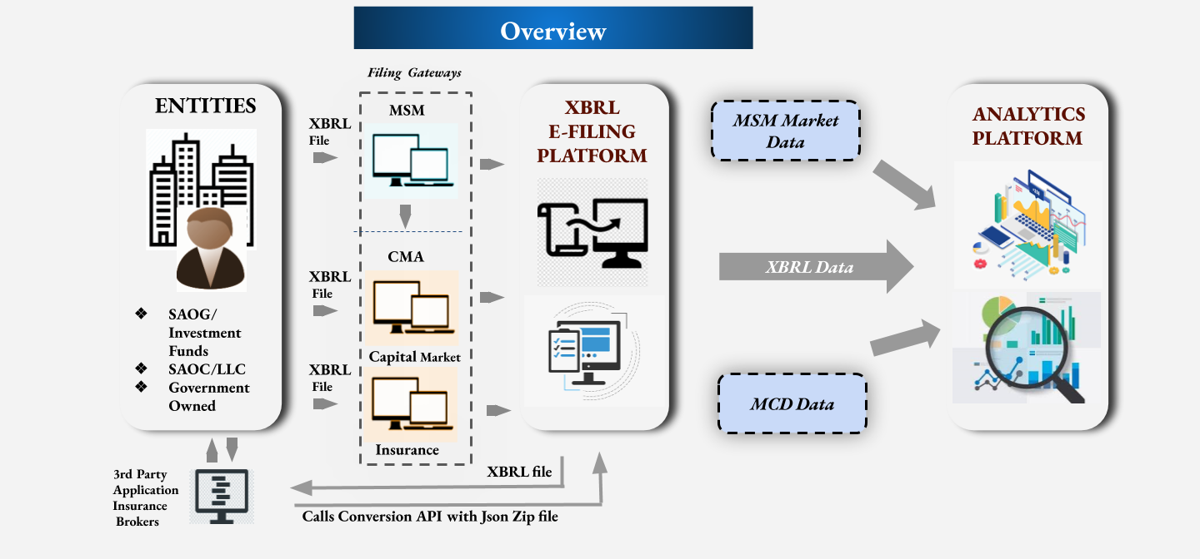

**Entities:** The entities both listed and unlisted like SAOG, SAOC/LLC, Investment funds, and government owned entities would prepare their financials in XBRL, using ifile tool (online/offline).

The entities like insurance brokers using Third party tools (Like broker vision) would require to integrate this third party tools with XBRL system using API to create the XBRL filing.

**Filing Gateways**:

* The Listed entities would upload their XBRL financial filings and non financial disclosures on XBRL E-filing platform via MSM portal.
* The Unlisted entities would submit their XBRL financial filings on XBRL E-Filing platform via CMA portal.

The XBRL Financials data submitted by the entities on the XBRL E-Filing platform along with the data available on the MSM and MCD portal related to the entities would be made available on the Analytics platform.

# Filer Section

## Generate XBRL File

### Generating XBRL file using iFile Tool

The XBRL File (XBRL instance document), for accomplishing this creation there are two options:

* + iFile Client Tool (Offline): This offline Excel based tool can be downloaded from the portal and installed on the systems. This is embedded with the taxonomies for each entry point, which can be duly filled by the filers to generate the XBRL file.
  + iFile Web Tool (Web): This has templates available online on the portal that is embedded with taxonomies designed for the entry points, which can be duly filled by the filers to generate the XBRL file.

### Generating XBRL file using Third Party Tool *(Like Broker Vision)*

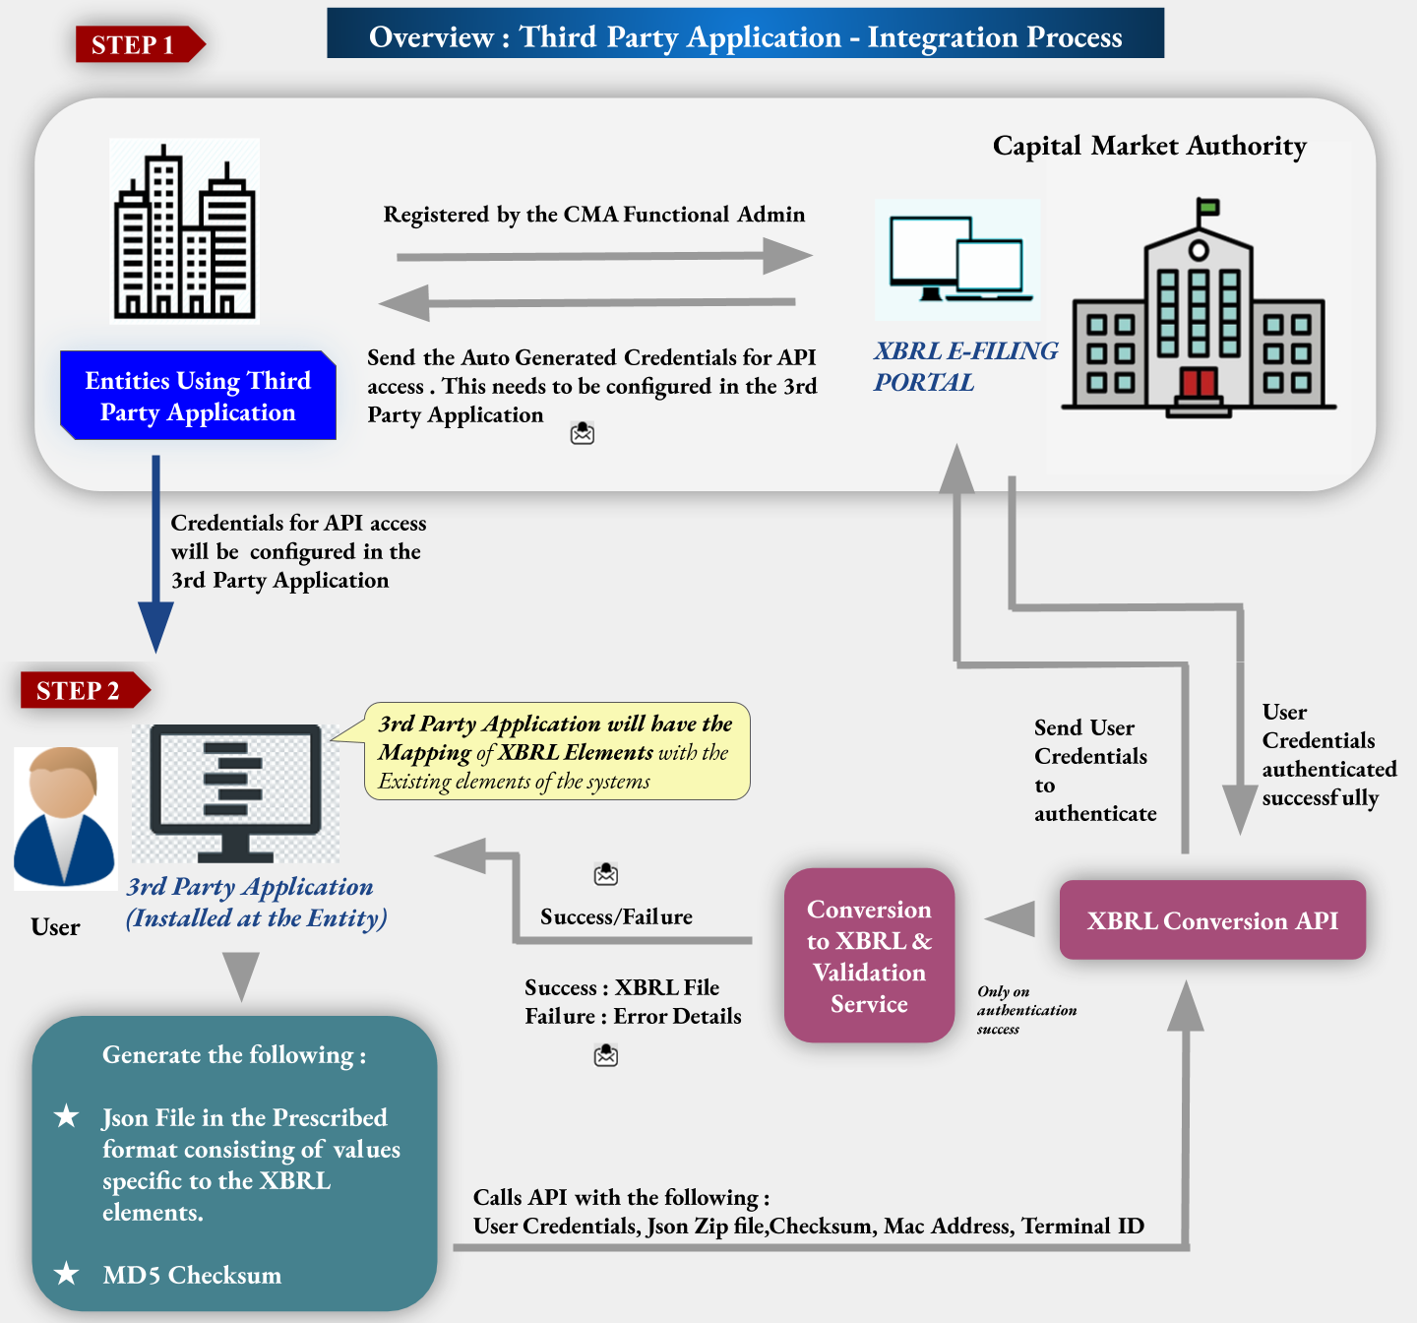

**Registering Entities using Third Party Tool:** The entities which are using third party application will be registered on the XBRL E-Filing portal. After successful registration, the credentials will be sent to the entity. These credentials will be used to access the API for conversion into XBRL file. This converted XBRL file will be submitted by the filer on the XBRL E-Filing Platform.

**Generate Json File:** The Filing done using Third Party application needs to be converted into provided sample Json format. This json file will be zipped and the MD5 checksum will be calculated for this zip file.

**API Call:** The zip file along with the other input parameters i.e. User credentials, MD5 checksum, MAC Address, and Terminal ID will be passed to the API. This API will authenticate the Input parameters and the file conversion process begins.

**XBRL Conversion and Validation:**  The json file will be converted into Valid XBRL file. Also, the XBRL rules and Business rules validations will be processed on the XBRL file. If the file is failed during the conversion process, the email notification will be sent on the registered email ID of the user requesting for conversion. If the conversion is successful, then the email notification on the same registered email ID along with the Converted XBRL zip file and PDF files generated for each statement for the submitted financial filing.

## XBRL E-Filing Platform

### Submitting XBRL Financial filing

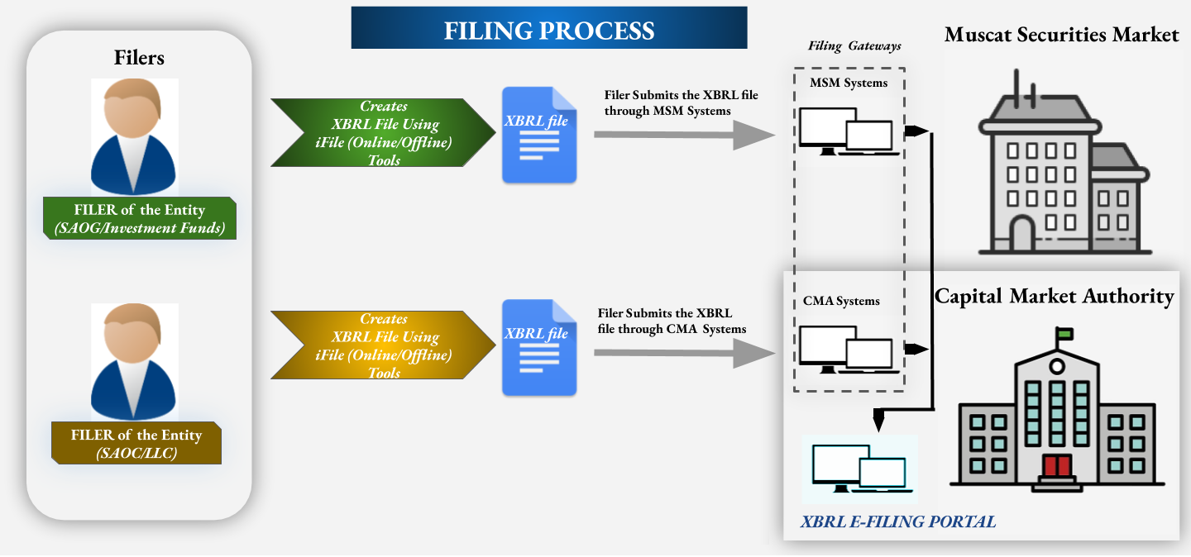

* **Filer**: The filer of the Entity shall create the XBRL file (Instance document) using the iFile Tools (Offline/Online).
* **Upload XBRL File**: The XBRL file will be uploaded on XBRL E-Filing platform by unlisted entities filer through CMA System. The listed entities filer will submit through MSM System. The Company Super User (CSU) registered on the portal will upload the filing.
* **XBRL E-Filing Portal**: The XBRL filings are managed on XBRL E-filing portal. Also, the other features like managing inquiries raised by regulator, form association with audit firm, view filing calendar, download Taxonomy and download Installer are also available on the portal for the Company super user (CSU).

### Company - Auditor Association

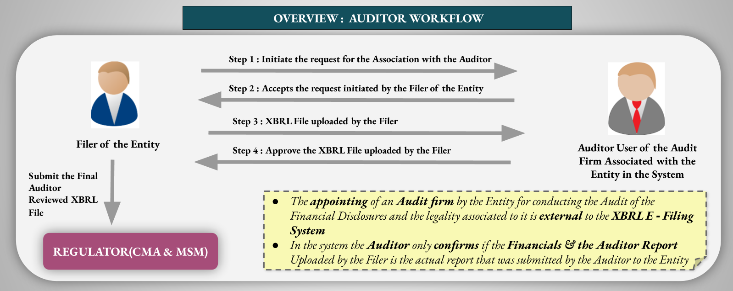

***Overview of Auditor Workflow***

* The Filer will initiate the request for the association with the auditor from whom the filer needs to review their filings
* This auditor will be the one who has audited company’s financial outside of XBRL E-Filing portal. Company will associate with the same auditor on XBRL E-filing portal and get their financial XBRL filing reviewed from the same auditor on this platform.
* After the successful association between the Filer and the Auditor is created in the system, the Auditor will receive the notification, when the Filer submits the Filing in the System and needs to be reviewed from the auditor.
* The Auditor can review the Filing submitted by the Filer of the Entity and mark the same as Approved.
* Post the Auditor approves the filing the same can be finally reviewed by the Filer of the Entity
* After the Final review of the File is done the same can be submitted to the Regulator (CMA/MSM) by the Filer for further Processes.

### Submitting Non-Financial disclosures *(For Listed Entities)*

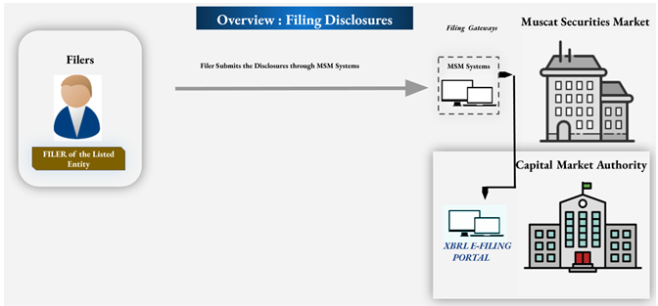

* **Filer**: The filer of the Listed Entity will login into XBRL E-Filing portal via MSM portal and access the disclosures available on the portal for submission.
* **XBRL E-Filing Portal**: The disclosure filings are managed on XBRL E-filing portal. The XBRL E-Filing portal is integrated at Capital Market Authority.

The XBRL E-filing portal will have forms designed to capture disclosure data from the listed entities. This disclosure filing will be submitted by the filer of the listed entity registered on XBRL E-filing portal. Post submission, the disclosure filings will be routed to the concerned departments in MSM and CMA regulators for their review.

* **MSM Regulator:** The MSM regulator users will access the XBRL E-Filing portal via MSM portal. The MSM regulator can review disclosure filings.
* **CMA Regulator:** The disclosure filings submitted by listed entities will be made available to the CMA regulator for their review and take actions on the same.

# Auditor Section

## Process Flow



***Overview of Auditor Workflow***

* The Filer will initiate the request for the association with the auditor from whom the filer needs to review their filings
* This auditor will be the one who has audited company’s financial outside of XBRL E-Filing portal. Company will associate with the same auditor on XBRL E-filing portal and get their financial XBRL filing reviewed from the same auditor on the on this platform.
* After the successful association between the Filer and the Auditor is created in the system, the Auditor will receive the notification, when the Filer submits the Filing in the System and needs to be reviewed from the auditor.
* The Auditor can review the Filing submitted by the Filer of the Entity and mark the same as Approved.
* Post the Auditor approves the filing the same can be finally reviewed by the Filer of the Entity
* After the Final review of the File is done the same can be submitted to the Regulator (CMA/MSM) by the Filer for further Processes.