Hi,
I am Juliette, data scientist for Smarter AI consulting.

We have been contacted from Neo Bank to help on the churn problem.

Given the provided dataset we created a benchmark that might help for further discussion. Here is the design of our approach:

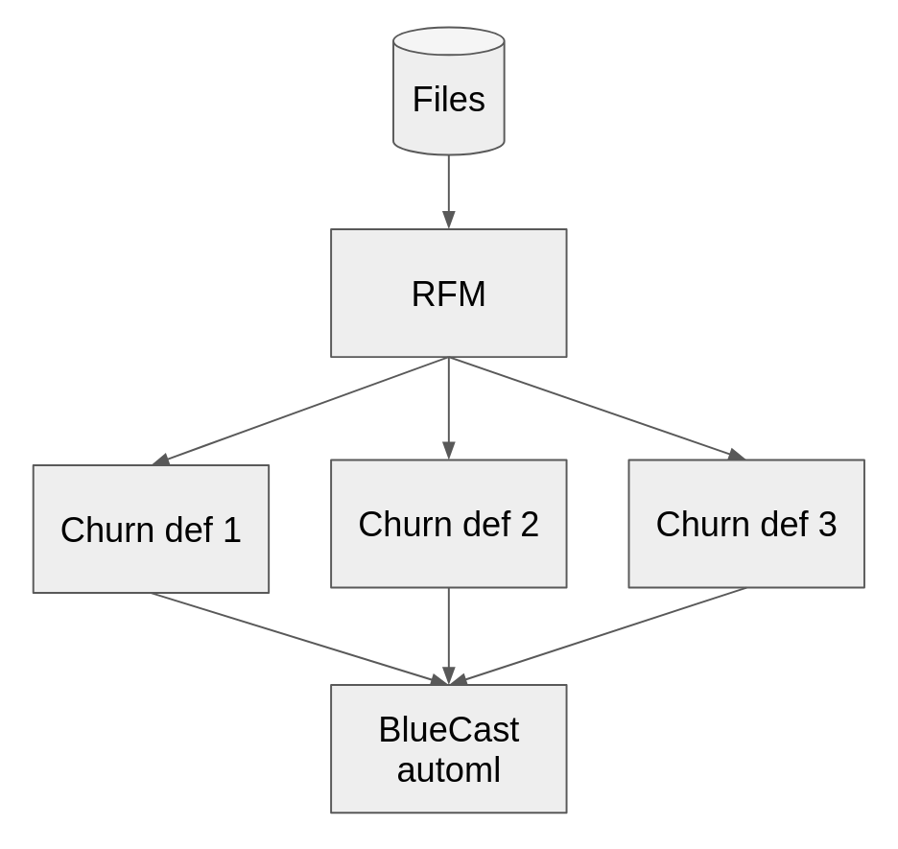
We used RFM to define multiple churn definitions, separate for each segment. Then we used AutoMl to create a baseline model. No feature engineering has been used on our side.

Gladly we share the best hyperparameters we have found:

Best params: {'validate_parameters': False, 'objective': 'multi:softprob', 'booster': 'gbtree', 'eval_metric': 'mlogloss', 'num_class': 2, 'max_depth': 4, 'alpha': 3.46594730767323e-05, 'lambda': 1.4389993657424414, 'gamma': 0.001007463739042713, 'min_child_weight': 1.4648544100876435, 'subsample': 1.0, 'colsample_bytree': 0.36571404793680207, 'colsample_bylevel': 0.9203042425793195, 'eta': 0.11687251134883345, 'steps': 147, 'tree_method': 'hist', 'device': 'cuda', 'grow_policy': 'depthwise', 'max_bin': 784}

And we would like to share the feature importances as well.
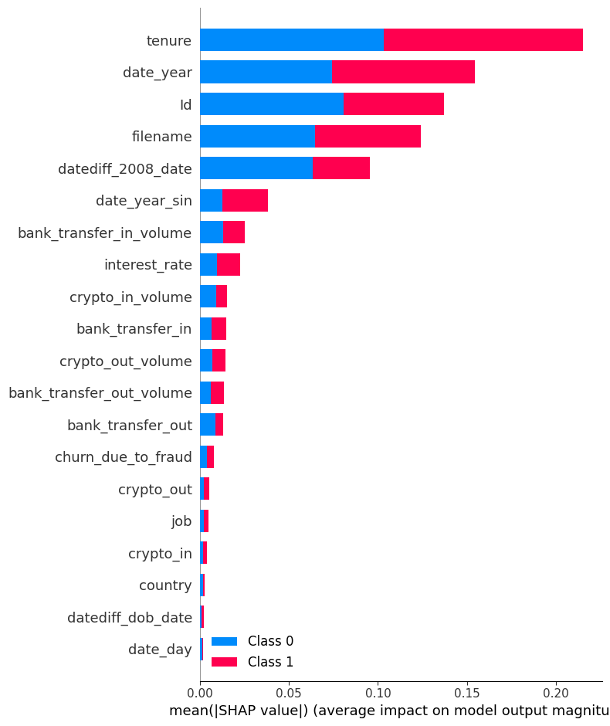

This looks promising. The logloss in our 5-fold CV was 0.30. Let us know if you would like to schedule a call to discuss the approach in detail. Also please share with us your experiments and the progress so far.

Have a nice day!

