Section D — AI-Augmented Learning

Cisco Packet Tracer — Router-on-a-Stick Practical

STEP 1 · BUILD WITH AI
AI Tool Used: ChatGPT

Exact Prompt Given to AI
I am doing a Cisco Packet Tracer practical. Generate a complete Cisco IOS configuration for a Router-on-a-Stick topology.

Requirements:
  - Configure VLAN 10 and VLAN 20 on the switch.
  - Assign switch ports to VLAN 10 and VLAN 20.
  - Configure an 802.1Q trunk between the switch and router.
  - Configure Router-on-a-Stick sub-interfaces on the router for VLAN 10 and VLAN 20.
  - Configure IP addresses/gateways so that a PC in VLAN 10 can communicate with a PC in VLAN 20.
  - Provide complete switch and router commands.
  - Explain how to configure the PCs.
  - The final configuration should allow successful ping between the VLAN 10 and VLAN 20 hosts.

AI Original Configuration Script
Topology:
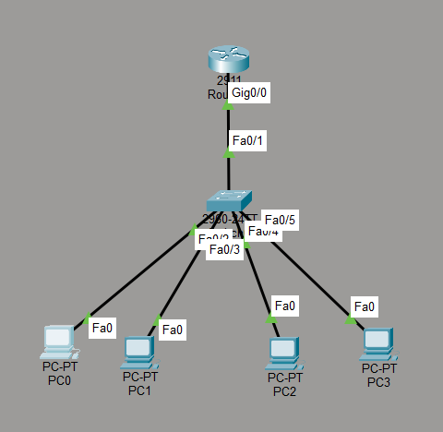

IP Address Plan:

Device | VLAN | IP Address | Subnet Mask | Gateway
PC0 | 10 | 192.168.10.10 | 255.255.255.0 | 192.168.10.1
PC1 | 20 | 192.168.20.10 | 255.255.255.0 | 192.168.20.1
Router Sub-interface | 10 | 192.168.10.1 | 255.255.255.0 | —
Router Sub-interface | 20 | 192.168.20.1 | 255.255.255.0 | —
Switch — AI Original:
enable
configure terminal

vlan 10
name VLAN10 exit

vlan 20
name VLAN20 exit

interface fastEthernet 0/1 switchport mode access switchport access vlan 10 no shutdown
exit

interface fastEthernet 0/2 switchport mode access switchport access vlan 20 no shutdown
exit

interface gigabitEthernet 0/1 switchport mode trunk
no shutdown exit

end
write memory
Router — AI Original:
enable
configure terminal

interface gigabitEthernet 0/0 no shutdown
exit

interface gigabitEthernet 0/0.10 encapsulation dot1Q 10
ip address 192.168.10.1 255.255.255.0
exit

interface gigabitEthernet 0/0.20 encapsulation dot1Q 20
ip address 192.168.20.1 255.255.255.0
exit

end
write memory

Testing in Packet Tracer
PC0 Configuration:

IP Address: 192.168.10.10
Subnet Mask: 255.255.255.0
Default Gateway: 192.168.10.1 PC1 Configuration:
IP Address: 192.168.20.10
Subnet Mask: 255.255.255.0
Default Gateway: 192.168.20.1 Test command from PC0:
ping 192.168.20.10

STEP 2 · TEST & DEBUG (WITHOUT AI)
Example bug found during testing: the trunk must carry both VLAN 10 and VLAN 20. If the trunk is restricted to only VLAN 10, VLAN 20 traffic cannot cross the switch-router trunk.
Corrected Switch Trunk Configuration:
interface gigabitEthernet 0/1 switchport mode trunk
switchport trunk allowed vlan 10,20 no shutdown
exit

Corrected Version — Complete Switch Configuration
enable
configure terminal

vlan 10
name VLAN10 exit

vlan 20
name VLAN20 exit

interface fastEthernet 0/1 switchport mode access switchport access vlan 10 no shutdown
exit

interface fastEthernet 0/2 switchport mode access switchport access vlan 20 no shutdown
exit

interface gigabitEthernet 0/1 switchport mode trunk
switchport trunk allowed vlan 10,20 no shutdown
exit

end
write memory

Corrected Version — Router Configuration
enable
configure terminal

interface gigabitEthernet 0/0 no shutdown
exit

interface gigabitEthernet 0/0.10 encapsulation dot1Q 10
ip address 192.168.10.1 255.255.255.0
exit

interface gigabitEthernet 0/0.20 encapsulation dot1Q 20
ip address 192.168.20.1 255.255.255.0
exit

end
write memory

3–4 Line Debugging Note
I tested the AI-generated configuration in Cisco Packet Tracer and found that the trunk needed to carry both VLAN 10 and VLAN 20. I corrected the trunk configuration by explicitly allowing VLANs 10 and 20. After making the correction, the Router-on-a-Stick configuration worked correctly and PC0 in VLAN 10 successfully pinged PC1 in VLAN 20. This was necessary because inter-VLAN traffic must be carried through the trunk for both VLANs.

