1.Draw a labeled diagram of a desktop PC, clearly marking the motherboard, CPU, RAM, GPU, and both HDD and SSD storage components.
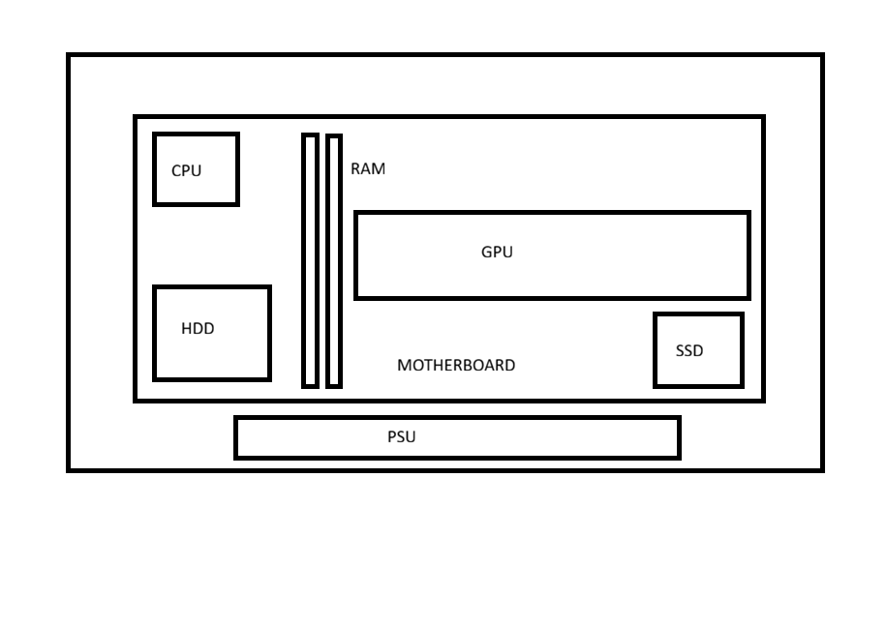2.Create a comparison table showing the main differences between HDD and SSD storage in terms of speed, durability, and typical use cases.<br><br><em><strong>Hint:</strong> Think about which one is faster, which is more shock-resistant, and where you would usually find each type (laptop, gaming PC, etc.).</em>

Feature | HDD (Hard Disk Drive) | SSD (Solid State Drive)
Speed | HDD has slower data read/write speeds. | SSD has much faster data read/write speeds.
Boot Time | HDD takes longer to start the computer. | SSD starts the computer quickly.
Durability | HDD is less durable due to its moving mechanical parts. | SSD is more durable because it has no moving parts.
Shock Resistance | HDD can be easily damaged by shocks or drops. | SSD is highly resistant to shocks and vibrations.
Noise | HDD produces noise while operating. | SSD operates silently.
Power Consumption | HDD consumes more power. | SSD consumes less power.
Storage Capacity | HDD is available in larger capacities at a lower cost. | SSD is usually more expensive for the same storage capacity.
Typical Use Cases | Used in desktop PCs, backup storage, and large file storage. | Used in laptops, gaming PCs, high-performance computers, and smartphones.
Cost | HDD is cheaper per GB. | SSD is more expensive per GB.

3.Write a short explanation (2-3 sentences each) describing the role of the CPU, RAM, and GPU in running a game like PUBG or Free Fire on a PC.

CPU
- The CPU is like the brain of the computer that handles all the main game logic and calculations.
- In games like PUBG or Free Fire, it calculates bullet shots, player movements, and controls the bots in real-time.
- If the CPU is weak, the game will lag a lot and freeze during intense fights.
RAM
- RAM works like a super-fast short-term memory that holds all the active game files while you play.
- It stores the map layout, weapon models, and player locations so the computer can read them instantly without any delay.
- If you run out of RAM, your game will stutter badly because the PC has to load things from the slow hard drive.
GPU
- The GPU is the graphics card that draws everything you actually see on your monitor, like characters, shadows, and trees.
- It takes data from the CPU and turns it into smooth, high-quality picture frames every second.
- Having a good GPU gives you higher FPS, which helps you spot enemies quickly and aim much better.

4.Imagine you want to upgrade your PC to run the latest version of FIFA smoothly. List which hardware components you would consider upgrading and explain why for each.

Hardware Components I Would Upgrade to Run the Latest FIFA Smoothly
- Graphics Card (GPU)

- I would upgrade the GPU because FIFA requires good graphics performance for smooth gameplay. A better graphics card will improve the game's visuals and increase FPS (Frames Per Second).
- RAM

- I would increase the RAM to at least 16 GB so that the game can run without lag. More RAM also helps when other applications are running in the background.
- Processor (CPU)

- I would upgrade the CPU because it handles game calculations and player actions. A faster processor helps the game run more smoothly, especially during matches with many players on the screen.
- SSD (Solid State Drive)

- I would replace an HDD with an SSD because it loads games much faster. This reduces waiting time and improves overall system performance.
- Power Supply (PSU)

- If I upgrade the GPU and CPU, I may also need a better power supply. A good PSU provides stable power to all the components and keeps the system running safely.

